Project Structure Documentation
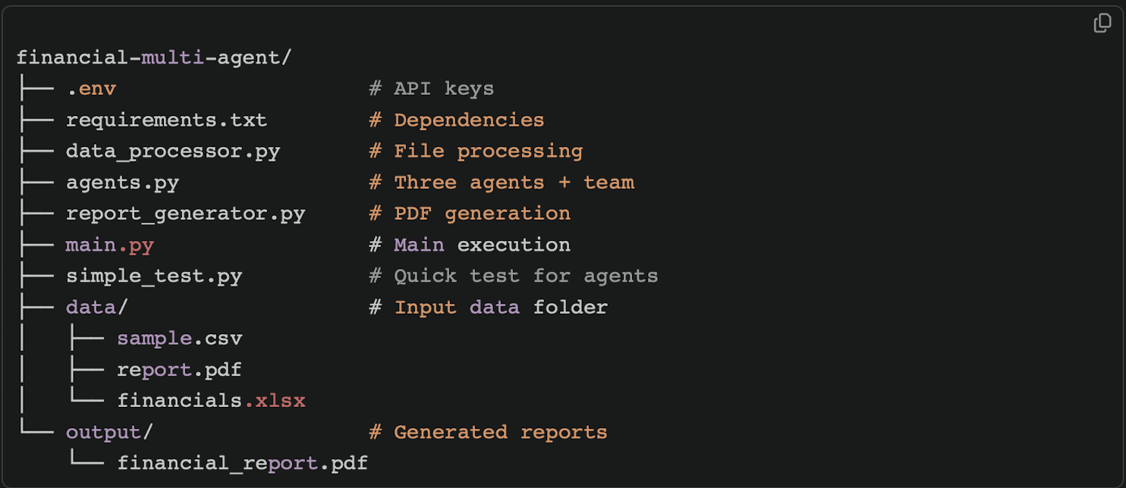

.env
• Holds your Groq API Key (never share publicly!).
requirements.txt
• Lists all pip-installable packages required (e.g., agno, groq, pandas, reportlab).
data_processor.py
• Contains functions to read/process CSV, Excel, PDF, or DOCX files.
• Summarizes and prepares data for agent analysis.
agents.py
• Defines three specialized agents:
- Data Analyst: Extracts and analyzes financial metrics.
- Risk Analyst: Evaluates financial stability and risks.
- Strategy Advisor: Synthesizes recommendations.
• Combines agents into an Agno Team for collaborative analysis.
report_generator.py
• Generates PDF reports (including summary analysis or methodology letters).
• Customize for content, formatting, and output location.
main.py
• Core script for running the multi-agent analysis.
• Orchestrates reading input, running agents, and saving output.
simple_test.py
• Minimal script to quickly verify each agent works as expected.
• Useful for sanity-checks after cloning or updating.
data/
• Folder for input files
- financials.xlsx: Spreadsheet with sample financials.
output/
• Folder for generated results and documentation.
- financial_report.pdf: Main output report after analysis.

