ASSIGNMENT - 3

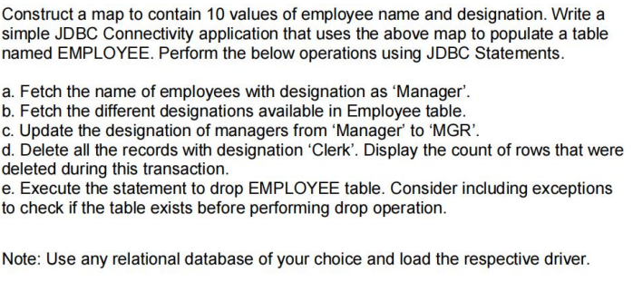

import java.sql.*;

import java.util.HashMap;

import java.util.Map;

public class q1 {

public static void main(String[] args) {

try {

Class.forName("com.mysql.jdbc.Driver");

Connection conn =

DriverManager.getConnection("jdbc:mysql://localhost:3000/hritz", "root","1420");

String createTable = "Create table employee(name varchar(30),designation varchar(30))

";

Statement st = conn.createStatement();

st.executeUpdate(createTable);

Map < String, String > map = new HashMap < > ();

map.put("Hritik", "Manager");

map.put("Ankur", "Manager");

map.put("Harshit", "Clerk");

map.put("Manisha", "Manager");

map.put("Abhay", "Clerk");

map.put("Daksh", "Manager");

map.put("Aniket", "Clerk");

map.put("Doofus", "Clerk");

PreparedStatement pmt = conn.prepareStatement("Insert into

employee

values( ? , ? )

");

for (String key: map.keySet()) {

pmt.setString(1, key);

pmt.setString(2, map.get(key));

pmt.executeUpdate();

}

String manager_names = "Select name from employee where

designation = 'Manager'

";

Statement mt = conn.createStatement(); ResultSet rs =

mt.executeQuery(manager_names); System.out.println("Manager's name list:");while (rs.next()) {

System.out.println(rs.getString("name"));

}

String designations = "Select distinct(designation) as

designation

from employee ";

Statement dt = conn.createStatement(); ResultSet rdt =

dt.executeQuery(designations); System.out.println("Distinct designationlist:");

while (rdt.next()) {

System.out.println(rdt.getString("designation"));

}

String update_Query = "Update employee set designation='MGR'where

designation = 'Manager'

";

Statement ustmt = conn.createStatement(); int updated =

ustmt.executeUpdate(update_Query); System.out.println("Rows Updated:"+updated); String delete_query = "delete from employee where

designation = 'Clerk'

";

Statement dstmt = conn.createStatement(); int malCount =ustmt.executeUpdate(delete_query); System.out.println("Rows Deleted:"+malCount); String drop_table = "Drop table if exists employee"; Statementdrstmt = conn.createStatement(); drstmt.executeUpdate(drop_table);

}

catch (ClassNotFoundException e) {

// TODO Auto-generated catch block

e.printStackTrace();

} catch (SQLException e) {

// TODO Auto-generated catch block

e.printStackTrace();

}

}

}

OUTPUT

