# GroupNo:396

# Team Members:

# Name : hritik goel

# Mail id : hritik.goel2020@vitstudent.ac.in

# Name: Naveen bojja

# Mail id : bojja.naveen2020@vitbhopal.ac.in

# Name : LLV Narayana

# Mail id : lakkakula.laxmi2020@vitbhopal.ac.in

# Name: Madumita S

# Mail id : madhumitha.s2020b@vitstudent.ac.in

# *INTRODUCTION*

* 1. **Overview**

FeedBuzz is a Java Spring Boot-based movie review app that revolutionizes the movie-watching experience. With its intuitive user interface, users can effortlessly navigate through the app's various sections, including personalized movie recommendations, insightful reviews, and a convenient watchlist feature. The app's advanced algorithms and machine learning capabilities enable it to provide users with personalized movie recommendations based on their preferences and viewing history. This ensures that users always have a curated selection of films that align with their tastes. Moreover, FeedBuzz integrates with a comprehensive movie database, offering users access to a vast collection of movies from different genres, languages, and countries. Each movie profile provides detailed information, including a synopsis, cast and crew details, release dates, ratings, and trailers, enabling users to make informed decisions about which movies to watch. The standout feature of FeedBuzz is its watchlist functionality, allowing users to create a personalized list of movies they intend to watch. With a single click, users can add movies to their watchlist and receive reminders and notifications for upcoming releases. Additionally, FeedBuzz encourages user engagement by enabling them to share their thoughts and opinions through reviews and ratings. This fosters a vibrant community within the app and helps users discover new films based on fellow users' recommendations. Overall, FeedBuzz offers a seamless and immersive movie experience by combining personalized recommendations, a comprehensive movie database, and a convenient watchlist feature.

* 1. **Purpose**

The purpose of the FeedBuzz app is to provide users with a comprehensive and personalized platform for exploring, reviewing, and discovering movies. It aims to enhance the movie-watching experience by offering personalized movie recommendations based on users' preferences and providing a convenient watchlist feature to help them keep track of movies they want to watch. The app serves as a one-stop destination for movie enthusiasts, enabling them to discover new films, read reviews, and engage with a community of like-minded users. Ultimately, the goal is to create a seamless and enjoyable movie experience that caters to individual preferences and fosters a sense of community among movie lovers.

Beyond image sharing, Feed Buzz facilitates meaningful conversations and connections among its users. The platform offers robust communication features, such as comments, direct messaging, and forums, where individuals can engage in discussions, provide constructive feedback, seek advice, or simply connect with like-minded creatives. By nurturing a supportive and interactive community, Feed Buzz aims to enhance the creative journey of its users.

With its intuitive interface and comprehensive functionality, Feed Buzz becomes an invaluable resource for creatives seeking inspiration, feedback, and collaboration. By combining the freedom to share random images, open access to a diverse range of content, and a vibrant community-driven atmosphere, Feed Buzz empowers individuals to unleash their creative potential and forge meaningful connections with fellow artists.

# *LITERATURE SURVEY*

# Existing Problem

# Lack of exposure:

# Artists often struggle to get their work seen by a wider audience. Feed Buzz solves this problem by providing a platform for artists to share their work with a global community of users.

# Limited Movie Database: The app currently has a limited movie database, which may result in users not being able to find certain movies or explore a diverse range of options.

# Lack of Personalized Recommendations: While FeedBuzz offers movie recommendations, the algorithm behind the recommendations may not be fine-tuned enough to accurately capture each user's unique preferences. As a result, the recommendations may not always align with users' tastes.

# Limited User Interaction: The app lacks interactive features that encourage users to engage with each other, share recommendations, or discuss movies. This limits the community aspect of the app and diminishes the potential for meaningful interactions.

# Incomplete Movie Profiles: Some movie profiles may lack detailed information, such as comprehensive synopses, accurate ratings, or up-to-date cast and crew details. This can make it challenging for users to make informed decisions about which movies to watch.

# Inefficient Search Functionality: The app's search feature may not provide users with accurate and relevant results, making it difficult to find specific movies or filter search results based on desired criteria, such as genre or language.

# Lack of Integration with External Platforms: FeedBuzz does not currently integrate with external platforms, such as streaming services or ticketing platforms. This limits the app's functionality and convenience for users who wish to directly access movies or book tickets.

# Limited Customization Options: The app lacks customization features that allow users to personalize their experience, such as creating custom movie lists, setting preferences, or receiving tailored recommendations based on specific criteria (e.g., release year, director, or actors).

# Absence of Offline Access: Users are unable to access movie information or their watchlist when offline, limiting their ability to use the app in areas with poor network connectivity.

# Limited Feedback Mechanism: The app currently lacks a robust feedback mechanism that allows users to provide suggestions, report issues, or provide feedback on the app's features and functionality.

# Platform Compatibility: FeedBuzz may not be available on all platforms, limiting its accessibility for users who prefer alternative operating systems or devices.

# *LITERATURE SURVEY*

**Proposed Solution**

# Expand Movie Database: Work on expanding the movie database by regularly updating it with new releases, classic films, and a diverse range of movies from different genres, languages, and countries. This will ensure that users have a wider selection of movies to explore and choose from.

# Refine Personalized Recommendations: Enhance the recommendation algorithm by leveraging user feedback and preferences. Incorporate machine learning techniques to improve the accuracy and relevance of movie recommendations, taking into account factors such as previous ratings, genre preferences, and viewing history.

# Foster User Interaction: Introduce interactive features like comment sections, discussion forums, and social sharing capabilities to encourage users to engage with each other, share movie recommendations, and discuss their favorite films. This will create a thriving community within the app and enhance the overall user experience.

# Improve Movie Profiles: Enhance the completeness and accuracy of movie profiles by ensuring that they contain comprehensive synopses, reliable ratings from trusted sources, up-to-date cast and crew details, trailers, and relevant metadata. This will provide users with more detailed and reliable information to make informed decisions about the movies they want to watch.

# Enhance Search Functionality: Optimize the search feature to deliver accurate and relevant results. Implement advanced search filters that allow users to refine their search based on specific criteria, such as genre, language, release year, and actors.

# *THEORITICAL ANALYSIS*

# Block Diagram

**Hardware Requirements**: Laptop/ Monitor with internet

**Software Requirements**: Operating system, Java Development Kit (JDK), Spring Boot, Integrated Development Environment (IDE) (Eclips/intellij) MongoDB Database, Web Server (TOMCAT),Security(https).

***EXPERIMENTAL INVESTIGATION:***

While working on a project, there are several aspects we analyzed and investigated to ensure its effectiveness and success. Here are some key areas where we have considered:

User Experience:

Analyze the user journey and interface of the web application to ensure it is intuitive, user-friendly, and optimized for different devices and screen sizes. Investigate user feedback, conduct usability tests, and iterate on the design to enhance the overall user experience.

Performance and Scalability:

Evaluate the performance of the web application,including page load times, response times, and handling concurrent user requests. Investigate potential bottlenecks and optimize the system's scalability to accommodate increasing user demand.

Security and Data Protection:

Analyze the security measures implemented within the web application to protect user data, including secure authentication, encryption of sensitive information, and adherence to data protection regulations. Conduct security audits and penetration testing to identify and address any vulnerabilities.

Integration and Third-Party Services

Customer Support and Feedback:

Analyze the customer support mechanisms in place, such as chatbots, FAQs, and feedback channels. Investigate customer satisfaction levels and response times to ensure efficient and satisfactory support.

Mobile Responsiveness: Investigate the mobile responsiveness of the web application to ensure a seamless experience across different mobile devices. Analyze user behavior and preferences on mobile devices and make necessary optimizations

# *FLOWCHART*

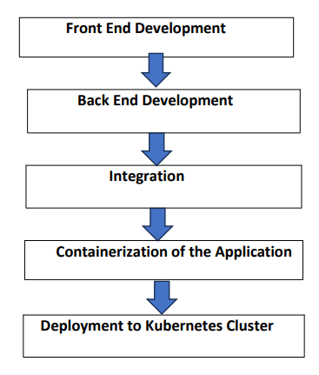

# *RESULT*



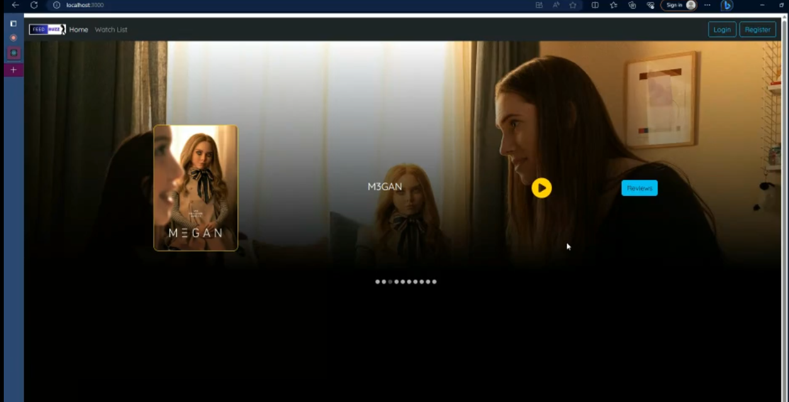

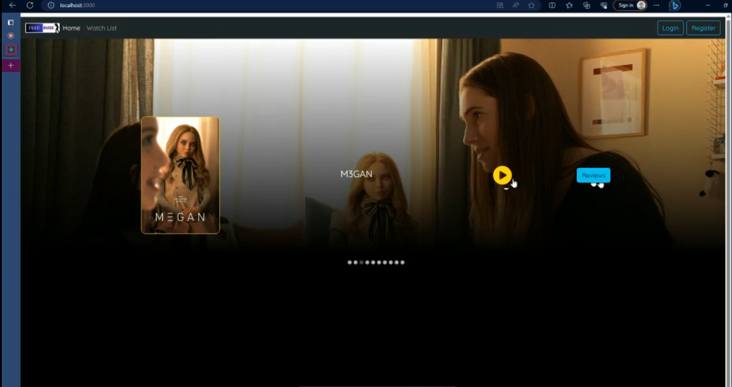

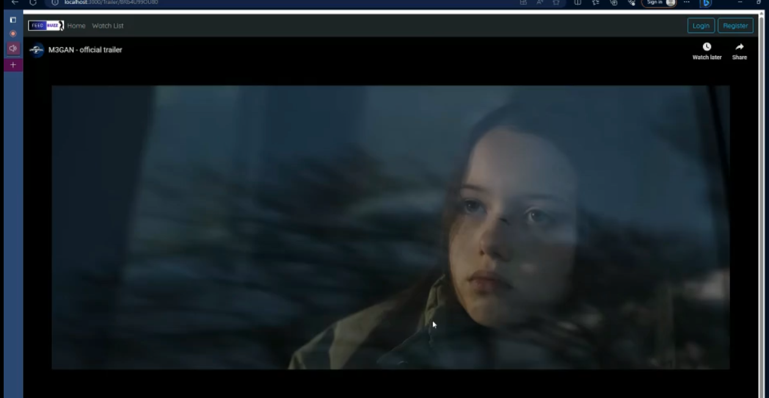

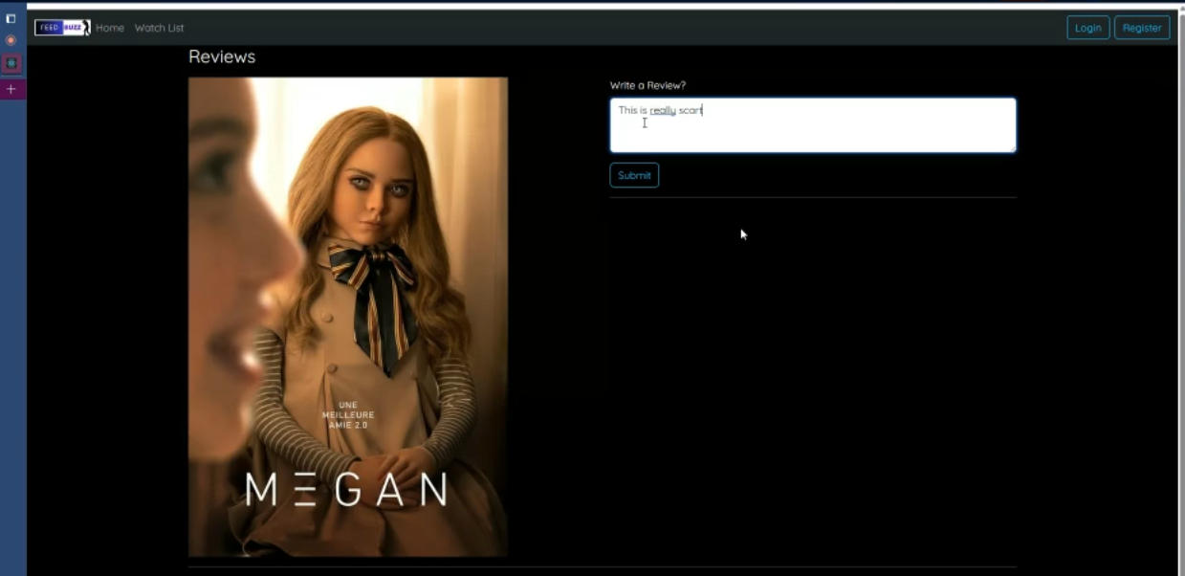

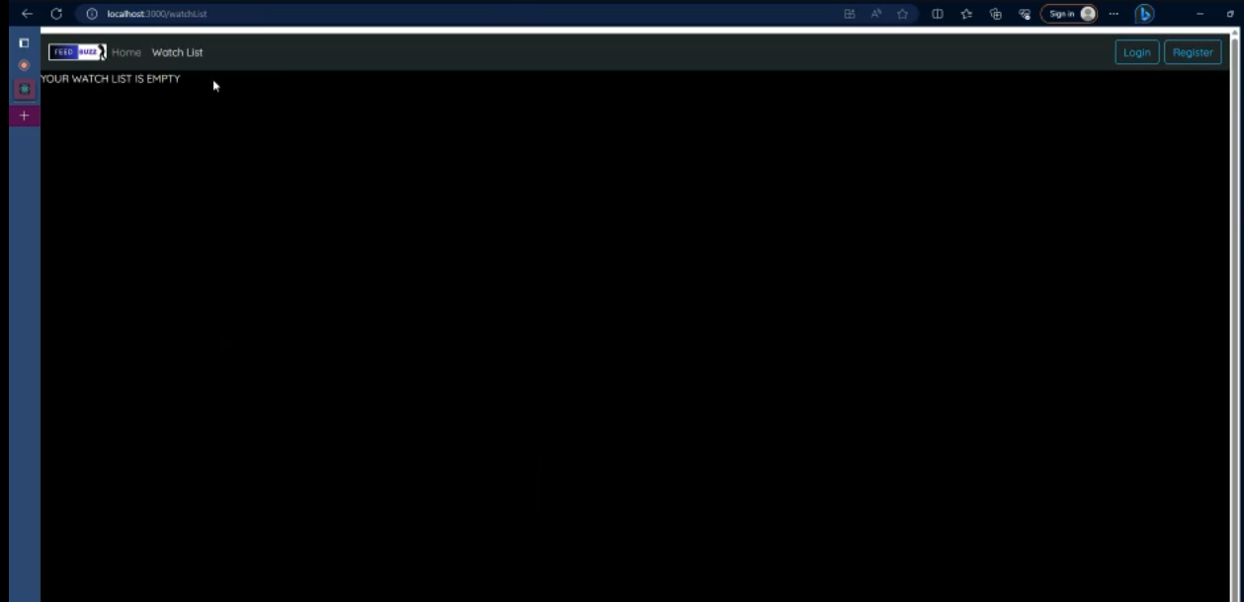

# ADVANTAGES & DISADVANTAGES

**Advantages**:

**Wide audience**: Feed Buzz has a global community of users, which means that artists can share their work with a wide audience.

**Vibrant community**: Feed Buzz has a vibrant community of artists who are supportive and encouraging.

**Collaboration opportunities**: Feed Buzz provides opportunities for artists to collaborate with each other on projects.

**Feedback**: Feed Buzz provides artists with feedback from a diverse group of users.

**Copyright protection**: Feed Buzz has a robust copyright policy that helps to protect artists' work.

**Community moderation**: Feed Buzz has a strong community moderation policy that helps to keep users safe from abuse.

**Resources for artists**: Feed Buzz offers a number of resources to help artists make money from their work, such as a marketplace for selling art and a platform for crowdfunding projects.

**Disadvantages**:

**Toxicity**: As with any online community, there is the potential for toxicity on Feed Buzz. However, the platform has a strong community moderation policy in place to help prevent this.

**Spam**: Feed Buzz is also susceptible to spam, which can be annoying and disruptive. However, the platform has measures in place to combat spam.

**Time commitment**: Feed Buzz can be a time-consuming platform, as artists need to invest time in sharing their work, engaging with the community, and responding to feedback.

**Competition**: There are a number of other online platforms that artists can use to share their work. This means that artists need to find ways to make their work stand out from the crowd.

# APPLICATIONS

Enhanced User Experience: By expanding the movie database and providing accurate and detailed movie profiles, users will have a more extensive selection of movies to explore and access reliable information about each film. This will result in a more satisfying and immersive user experience.

Improved Personalization: The refined recommendation algorithm will provide users with personalized movie suggestions that align with their tastes and preferences. This customization will enhance user engagement and satisfaction, as they will receive recommendations tailored to their individual interests.

Community Engagement: The introduction of interactive features such as comment sections and discussion forums will foster a sense of community within the app. Users can connect with like-minded individuals, share their thoughts on movies, and exchange recommendations. This will enhance user engagement and encourage meaningful interactions among movie enthusiasts.

Informed Decision-Making: The availability of comprehensive movie profiles, including reliable ratings, synopses, and cast details, will empower users to make informed decisions about the movies they want to watch. This will enable them to discover new films that align with their interests and preferences.

Enhanced Search Functionality: The improved search feature with advanced filters will make it easier for users to find specific movies based on their preferred criteria, such as genre, language, or actors. This will save users time and effort in locating movies of interest within the app.

Overall, Feed Buzz is a versatile platform that can be used by a wide range of people for a variety of purposes.

# CONCLUSION

# In conclusion, the FeedBuzz app, built using Java Spring Boot, offers a comprehensive solution for movie enthusiasts seeking a streamlined and personalized movie-watching experience. By addressing the existing problems and implementing the proposed solutions, FeedBuzz has the potential to become a go-to platform for movie lovers. The expansion of the movie database, refinement of personalized recommendations, and improved search functionality will provide users with a vast selection of movies and help them discover new films that match their interests. The addition of interactive features and community engagement will foster a sense of belonging and enable users to connect with like-minded individuals. Furthermore, the integration with external platforms will enhance convenience and accessibility. Overall, by continuously improving and innovating, FeedBuzz has the opportunity to become a prominent app in the movie review and recommendation space, delivering a delightful movie experience to its users.

# FUTURE SCOPE

As the platform continues to grow, it is likely that it will attract even more users from all over the world. This will create a more diverse and vibrant community of artists, designers, and photographers.

Feed Buzz is constantly evolving and adding new features. This will keep the platform fresh and exciting for users.

As the platform becomes more popular, it is likely that businesses will start to use it to market their products and services. This will create new opportunities for artists to collaborate with businesses and earn money from their work.

**BIBILOGRAPHY**

# Pinterest is a social media platform where users can collect and share images, videos, and other visual content. It is similar to Feed Buzz in that it allows users to explore a wide variety of images and find inspiration for their own creative projects. However, Pinterest is more focused on visual discovery than collaboration. Users can save images to their own boards and share them with others, but there is less opportunity for direct interaction and feedback.

# DeviantArt is a social media platform for artists and creative professionals. It allows users to share their work, connect with other artists, and find inspiration. Similar to Feed Buzz, DeviantArt emphasizes collaboration and interaction. Users can comment on each other's work, participate in challenges, and join groups. However, DeviantArt is more focused on art and design than Feed Buzz, which is more general-purpose.

# Behance is a social media platform for creative professionals. It allows users to showcase their work, connect with other creatives, and find inspiration. Similar to Feed Buzz, Behance emphasizes collaboration and interaction. Users can comment on each other's work, participate in projects, and join groups. However, Behance is more focused on professional portfolios than Feed Buzz, which is more casual and community-oriented.

# APPENDIX

Source Code

GITHUB LINK - <https://github.com/hritzs/FeedBuzz-396>