A Rotating-Disk Intensity Modulation Method for Inferring Light Propagation Speed Assessed via Monte Carlo Simulation

Hrivu Prasun Halder
Department of Nuclear Engineering
University of Dhaka, Bangladesh
Email: hrivuprasun-09-2021311497@ne.du.ac.bd

Abstract
Determining the speed of light has historically relied on time-of-flight or interference techniques, including the classical Fizeau experiment. This work presents a conceptual proposal for estimating the speed of light propagation using a rotating disk. In the proposed configuration, a toothed rotating disk is placed in the path of a laser beam. The baseline intensity (I)₀ is measured when the disk is stationary and the laser is passing though the gap. Rotation of the toothed disk produces measurable variations in transmitted intensity (I) and the ratio I/ I₀ is interpreted as the probability that a photon successfully passes through the rotating structure to the detector. A theoretical framework is developed in which this transmission probability is expressed in terms of the disk geometry, and rotation parameters. Using this framework, a mathematical relationship is derived that allows the determination of the speed of light from the measured intensity ratio. This approach differs from classical timing-based measurements, such as the Fizeau experiment, by relying solely on intensity modulation, offering an approach that isolates propagation characteristics along a single path without explicit reliance on time-of-flight or synchronization conventions. To evaluate the robustness of the framework, Monte Carlo simulations were performed, confirming the consistency of the derived equations and clarifying the conceptual feasibility of the method. The proposed approach thus combines theoretical analysis with simulation-based validation, offering a theoretical framework for analyzing light propagation through intensity-based modulation systems.

1. Introduction
Measuring the speed of light has been a cornerstone of physics for centuries. Classical methods, including time-of-flight and interferometric techniques, were pioneered by Hippolyte Fizeau [1] and later refined by Albert Michelson [2]. These experiments typically rely on round-trip measurements and require precise timing, high-speed detectors, and careful synchronization. While effective, such methods are fundamentally tied to temporal measurement frameworks and synchronization conventions.
Direct determination of light propagation over a single path presents conceptual challenges. Most methods require synchronized clocks at different locations, but clock synchronization itself depends on assumptions from Special Relativity [3]. As a result, many historically significant experiments effectively measure round-trip or averaged light behavior rather than isolating propagation in a single direction.
A notable early attempt to measure the speed of light was the Fizeau experiment [1], which employed a rapidly rotating toothed wheel to intermittently block and transmit a light beam traveling to a distant mirror and back. The speed of light was inferred from the rotation rate at which returning light was extinguished by the wheel tooth. Crucially, this method inherently involved a forward and backward path, meaning the measured quantity corresponds to the average speed over a round trip rather than a single path propagation.
Similarly, the Michelson–Morley experiment [4] utilized an interferometric setup in which a beam of light was split into two perpendicular paths, reflected back, and recombined to produce interference fringes. Any difference in propagation time along the two arms would manifest as a shift in the interference pattern. However, because each beam traverses its path in both directions before recombination, the experiment effectively compares round-trip travel times. The null result, historically interpreted as evidence against the existence of a luminiferous aether, is therefore fundamentally based on averaged two-way light speeds.
These experiments, while highly influential, share a common limitation: their reliance on closed optical paths eliminates the need for independent clock synchronization but simultaneously restricts the measurement to round-trip quantities. Attempts to extract one-way propagation information from such configurations inevitably reintroduce synchronization assumptions, as any comparison between spatially separated events requires a convention for defining simultaneity.
A one-way speed of light experiment was conducted by Greaves et al. [5] by analyzing the phase difference of an amplitude-modulated laser beam over distance achieving results within 0.4% of the accepted value of the speed of light. Finkelstein [6] later argued the experiment was actually a round-trip measurement because calculating the “one-way” speed relied on an implicit synchronization convention: assuming a known, fixed signal speed for the return trip through the coaxial cable.
In this work, a rotating-disk intensity modulation framework is proposed as a means to investigate light propagation without direct reliance on time-of-flight measurements or clock synchronization. Instead of measuring transit time, the method examines variations in transmitted intensity as a function of controlled mechanical modulation. A laser beam passes through a toothed rotating disk: when stationary, the detector records a baseline intensity; when rotating, the transmitted intensity is modified due to the dynamic obstruction pattern. The resulting intensity ratio encodes information about the interaction between light propagation and the disk’s motion, providing a route to infer propagation characteristics without invoking explicit temporal measurement.
A key contribution of this study is the integration of Monte Carlo simulations to validate the analytical framework. By randomly sampling particle trajectories across thousands of rotations, the simulation reproduces the probabilistic transmission behavior of photons through the rotating disk. The results consistently match the analytical predictions to three decimal places, demonstrating both the robustness of the model and the power of stochastic methods in physics education. This not only strengthens confidence in the theoretical derivation but also showcases how computational experiments can complement classical thought experiments.
Beyond its scientific implications, the paper also has pedagogical value. The rotating-disk framework, combined with Monte Carlo validation, provides a clear and intuitive teaching example for students learning about light propagation, probability, and numerical methods. It bridges historical experiments—such as Fizeau’s rotating wheel and Michelson’s rotating mirror—with modern computational approaches, offering a hands-on way to explore how randomness and statistics can reveal fundamental constants like the speed of light. The objectives of this paper are:
- To develop a theoretical model linking transmission probability to disk geometry, rotational parameters, and light speed.
- To verify the theoretical model using Monte Carlo simulations, demonstrating accuracy and reproducibility.
- To highlight the differences between this method and classical timing-based experiments.
- To provide a foundation for both future experimental verification and pedagogical use in physics education.

2. Experimental Concept
The proposed experimental system consists of three primary components: a laser source, a toothed rotating wheel and a laser intensity detector.
A continuous-wave laser producing source is needed, from which we get the initial intensity. The laser beam must remain well confined within the disk gaps to minimize diffraction effects. For a Gaussian beam with waist radius ω₀, the far field divergence angle (radians) is given by [7] $θ=\frac{λ}{πω_{0}}$; where, $λ$ is wavelength of the laser. Thus, shorter wavelength and larger beam waist are preferred. Also the beam radius after travelling distance z, is [8]: ω(z) = ω₀$\sqrt{1+{(\frac{z}{z_{R}})}^{2}}$ , where, the Rayleigh range, z_{R} =$\frac{π{ω_{0}}^{2}}{λ}$. Inside this distance the beam barely spreads. These considerations ensure that the beam radius remains significantly smaller than the disk gap width throughout the propagation distance.
A toothed disk of radius R contains N teeth and the same number of gaps. Figure 1 represents the structure of the toothed rotating disk. The teeth are square prism-shaped, with tooth width = tooth length = gap length = b for simplicity in derivation. Although the tooth height, h, is not strictly defined, it should be sufficiently large to ensure that the entire laser beam remains confined within the vertical extent of the gap and no portion of the beam can pass above the teeth when the beam is incident on a tooth region. The entire disk should be coated with a black, absorptive material to minimize unwanted reflections and stray light, ensuring that light incident on the teeth is largely absorbed rather than scattered toward the detector.
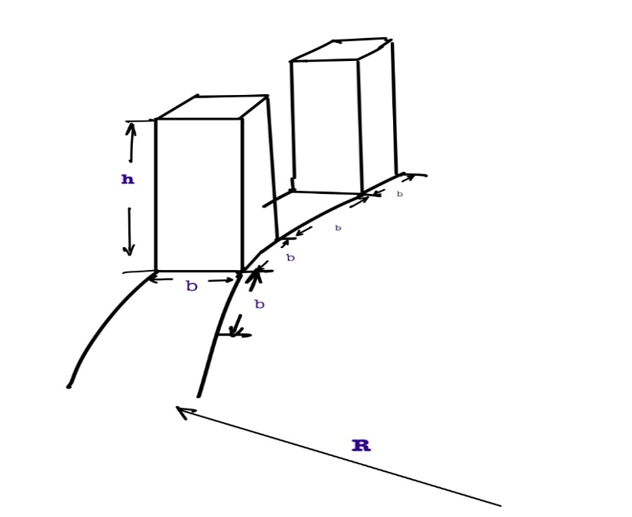

Figure 1. Structure of the Toothed Rotating Disk.

A detector measures the transmitted laser intensity after modulation by the disk. Several types of detectors with high sensitivity can be used for this regard. We are suggesting Photodiode Detectors, as output photocurrent is nearly proportional to incident optical intensity over a wide linear operating range [9]. Figure 2 represents the complete setup for the proposed experiment
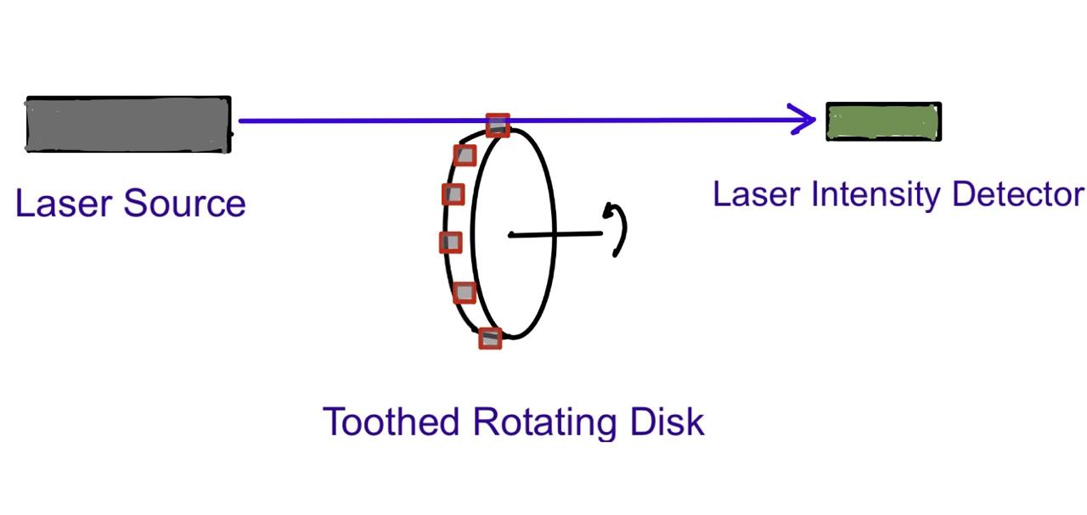
Figure 2. Schematic Diagram of the Experimental Setup.

3. Theoretical Framework
The transmission probability model is used to determine the speed of light. It is a probabilistic framework that describes the likelihood that a particle, wave, or signal incident on a barrier, interface, or medium is transmitted through it rather than being reflected, absorbed, or otherwise attenuated.
Let ω be the angular velocity of the disk, and let the laser be aligned such that the beam passes sufficiently above the gap surface and sufficiently below the tooth tip. The transmitted intensity (I) measured at the detector depends on the probability that photons successfully pass through the rotating disk. The baseline intensity when the disk is stationary is (I₀).
We interpret the intensity ratio as a photon transmission probability:
$P${transmission} = $\frac{I}{I_{0}}$ (1)
A photon must encounter a gap rather than a tooth as it reaches the disk.
Thus, the probability of intersecting a gap, $P_{g}$ =$\frac{number of gaps in the disk}{total number of gaps and teeth}$=$\frac{N}{ 2N}$= 1/2 (2)

Even after intersecting a gap, complete and partial obstruction from moving the tooth can occur assuming ideal alignment and minimal diffraction. This probability is almost equal to 1. Probability of unobstructed propagation after touching the gap, $P_{p}$ = f($b$,$N$,ω,$c$,$R$)
The total transmission probability is given by the product of individual probabilities
$P$ {transmission} = $P_{g}× P_{p}$(3)
Thus, the measurable intensity ratio from Eqs. (1), (2), and (3),
$\frac{I}{I_{0}}$ = $P_{g}× P_{p}$ = $\frac{P_{p}}{2}$ (4)

From Figure 3, let the disk rotate about an axis parallel to the plane of the paper, such that the upper edge of the disk moves upward during rotation. The direction of rotation is chosen so that the teeth move upward across the path of the laser beam. Let x_{max} denote the maximum vertical distance from the upper tooth edge at which a photon can still pass through the gap. For any distance greater than x_{max}, the photon will be intercepted by the lower tooth, which moves upward as the disk rotates.
Now, distance travelled by the tooth = b = velocity of the disk $×$ time required for the photon to pass through tooth width, b
Time required for the photon to pass through tooth width, b = $\frac{b}{c}$
The time b/c is not independently measured or synchronized across frames, but emerges as a local interaction timescale inferred from the overlap between photon propagation and mechanical motion.
We get, $b-x_{max}$ $=$ ω$×R×\frac{b}{c}$ (5)
Thus, $x_{max}$ = $b-\frac{ωRb}{c}$ (6)
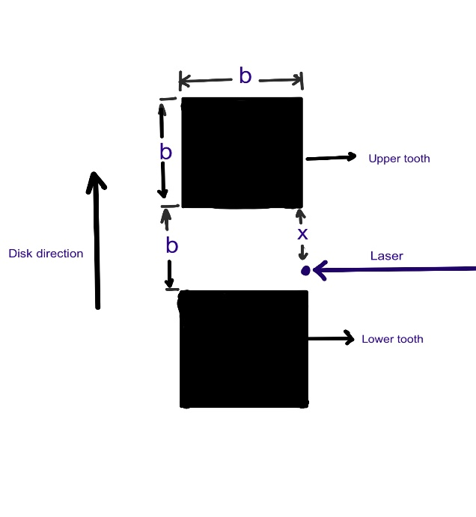
Figure 3. Top view of the Toothed Rotating Disk.

Now, the probability of hitting any point of the gap = $\frac{1}{b}$
Probability of passing after hitting the gap =$x_{max}$ × $\frac{1}{b}$ = Probability of unobstructed propagation after touching the gap $(P_{p})$ (7)
From Eqs. (6) and (7),
$P_{p}$ ₌ $\frac{ b - \frac{ωRb}{c} }{b}$ ₌ $1- \frac{ωR}{c}$ = f(ω, $c$,$R$) (8)

From Eqs. (4) and (8), considering minimal diffraction, reflection and scattering ,
$\frac{I}{I_{0}}$ = $P_{g}× P_{p }=$ $\frac{P_{p}}{2}$ =$\frac{1}{2}$ ($1-\frac{ωR}{c}$ ) (9)
If angular velocity ω$≈$0, $\frac{I}{I_{0}}$ becomes 0.5 which matches our intuition.

Equation (9) can be written as
c = $\frac{ωR}{1-2(\frac{I}{I_{0}})}$ (10)
Here, $ω=angular velocity of the disk$
R = radius of the disk, excluding tooth height
I = Detected intensity when the disk rotates
I₀ = Intensity detected when the disk is stationary

From Eq. (10), it is clear that the speed of light is independent of the tooth number or gap number N and the tooth or gap width b.

A question may arise as to whether the equation remains the same if the laser is aimed not adjacent to the gap surface but at a height $h$above it.
If the photon hits at height, h above the gap surface, Eq. (5) becomes,
$b^{'}-x_{max}'= ω\left(R+h\right)×\frac{b}{v}$ (11)
Now, $b=Rθ$ (12)
Again, $b^{'}=\left(R+h\right)θ$ (13)
From Eqs. (12) and (13),
$b^{'}=b+ \frac{bh}{R}$ (14)
From Eqs. (11) and (14),
$x_{max}'$ = b + $\frac{bh}{R}- ω(R+h)\frac{b}{v}$
Thus, $P\left(Transmission\right)= \frac{I}{I_{0}}= \frac{1}{2} × \frac{x_{max}'}{b'}$
$= \frac{1}{2}×\frac{b(1+ \frac{h}{R} - \frac{ω\left(R +h\right)}{v})}{b(1+ \frac{h}{R})}$
So, $\frac{I}{I_{0}}$ $= \frac{1}{2} ×(1- \frac{ωR}{v})$ (15)

From Eqs. (9) and (15) it is crystal clear that the equation remains identical in both situations.

4. Monte Carlo Simulation and Model Validation

4.1 Monte Carlo Simulation Setup
To examine the validity of the proposed transmission probability model, a Monte Carlo simulation was implemented to numerically reproduce the interaction between photon propagation and the motion of the rotating disk.
Assuming that regions 0–1, 2–3, 4–5, 6–7, and so on represent tooth regions, while regions 1–2, 3–4, 5–6, 7–8, and so forth represent gap regions, the simulation was performed accordingly. For each trial, a random integer within the range of available segments and a random fraction between 0 and b (the gap length) are generated. If the integer is odd, the particle is considered to strike a gap, since the sum of the odd integer and the random fraction lies within the gap range. However, the particle only passes if the fraction is less than xmax. If the fraction exceeds xmax, or if the integer is even, the particle does not pass. Thus, only when the integer is odd and the fraction is less than xmax does the particle successfully pass through the toothed rotating disk. The number of successful passes is counted, and the process is repeated for a large number of particles to ensure statistical reliability. This procedure is carried out for each rotation, and the disk is assumed to undergo multiple rotations during the simulation. The transmission probability is calculated as the ratio of the number of particles that successfully pass to the total number of particles sent across all rotations.

4.2 Comparison of Analytical and Simulation Results
To validate the analytical expression
$\frac{I}{I_{0}}$ $= \frac{1}{2} ×(1- \frac{ωR}{v})$,
Simulation results were compared with the deterministic model over a range of particle velocities. The intensity ratio varies significantly in the lower velocity range, from about 300 to 20,000 m/s; therefore, this range was used for analysis. In contrast, at sub-light to light speeds, the intensity ratio remains nearly constant, close to 0.49.
The disk was modeled with 100 segments, and each rotation involved 5,000 particles. The simulation was repeated for 500 rotations to ensure statistical reliability. The angular velocity was set to ω = 3141.6 rad/s (equivalent to 30,000 rpm), with the disk radius fixed at 6 cm. The chosen rpm remains within humanly achievable limits, although higher angular velocities or larger radii would have produced more robust results. The choice of 5,000 particles per rotation was made to adequately cover the velocity range while avoiding excessive computation time or unnecessary oversampling.
The following figure 4 illustrates the transmission probability obtained from the analytical equation alongside the results of the Monte Carlo simulation, plotted against velocity. This comparison highlights how closely the simulation reproduces the theoretical prediction.
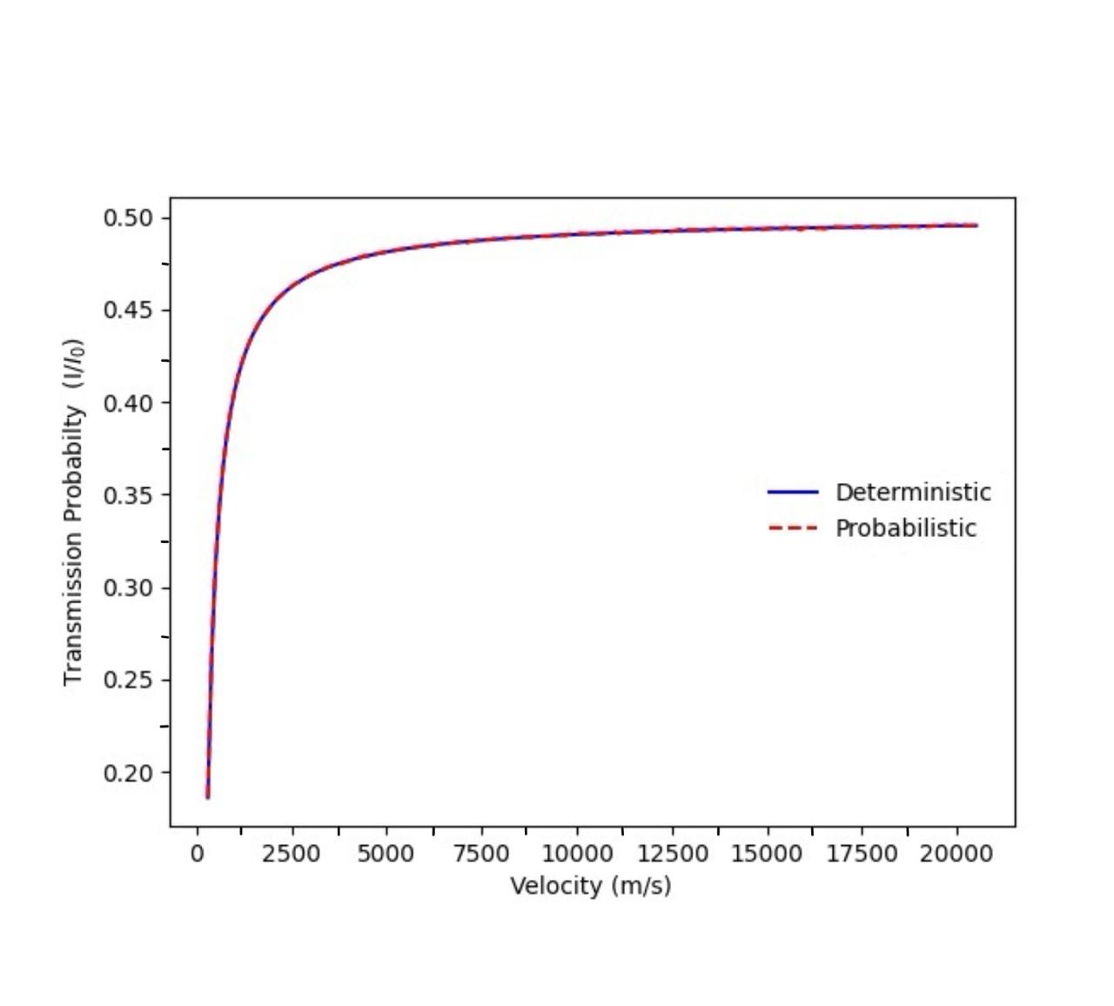

Figure 4. Analytical Equation vs. Monte Carlo Simulation Results

The analytical transmission probability and the Monte Carlo simulation results show excellent agreement across the velocity range. For instance, at v = 300 m/s, the deterministic value is 0.18584, while the simulated probability is 0.18627. Similarly, at v = 1000 m/s, the analytical result is 0.40575, compared to the simulation value of 0.40564. Even at higher velocities, such as v = 2000 m/s, the two remain consistent (0.45288 vs. 0.45270). This close correspondence demonstrates that the simulation reliably reproduces the theoretical prediction, validating the model across the tested velocity range.

4.3 Simulation Constraints and Light Speed Determination
In the validation runs, we used 5,000 particles per rotation, an angular velocity of ω = 3141 rad/s (≈30,000 rpm), and a disk radius of 6 cm. These parameters are sufficient for lower velocities in the range of 300 to 20,000 m/s, because in this regime the value of xmax remains relatively small. When xmax is small, many randomly generated fractions fall outside the xmax region, meaning that even particles striking the gap are intercepted by the rotating disk. This behaviour closely mimics the real physical case.
At near-light speeds, however, xmax becomes very large. With only 5,000 particles per rotation, almost all random fractions fall within the xmax region, so most particles pass. In this case, the outcome depends primarily on whether the particle hits a gap or not, which statistically approaches 0.5. As a result, the intensity ratio fluctuates around 0.5, sometimes slightly above and sometimes below, as a random effect. Logically, though, the intensity ratio must always remain below 0.5, since some photons striking the gap will still be intercepted by the toothed disk. To capture this effect accurately, a much larger number of particles per rotation would be required, ensuring that enough random fractions exceed xmax and yield an intensity ratio consistently below 0.5. However, such high particle counts are computationally expensive and time-consuming.
To make the simulation feasible, we therefore increase the angular velocity and disk radius to values that are difficult, if not impossible, to achieve experimentally. A higher ω and larger radius reduce xmax, ensuring that many random fractions exceed it, so particles are intercepted as they should be in real experiments. This adjustment allows us to obtain realistic intensity ratios even with lower particle counts per rotation. Consequently, the simulation remains viable for determining the speed of light by tracking how the intensity rises from 0 toward 0.5 and identifying the velocity at which the light-speed condition is reached.
In this extended simulation, the number of particles per rotation was kept at 5,000, while the angular velocity was increased to ω = 55,000,000 rad/s and the radius of the toothed rotating disk was set to 1 m. All other parameters remained unchanged. Under these conditions, the analytical equation predicts an intensity ratio of 0.4082. The Monte Carlo simulation consistently reproduced this value, yielding results around 0.408 (e.g., 0.4081, 0.4082, 0.4084). Thus, up to three decimal places, the simulation matches the analytical prediction with excellent accuracy.
This consistency demonstrates that even with a relatively modest particle count per rotation, the combination of very high angular velocity and large disk radius ensures that xmax is sufficiently constrained. As a result, random fractions frequently exceed xmax, leading to realistic interception events and producing intensity ratios that align with the theoretical expectation. This validates the feasibility of the simulation setup and confirms that the model can reliably reproduce the analytical results under extreme but computationally practical conditions.
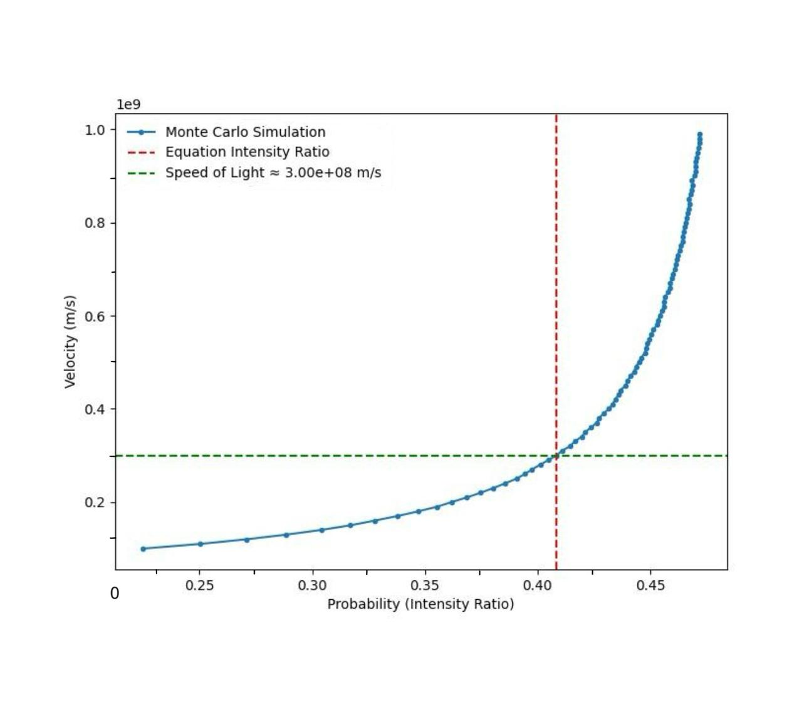
Figure 5. Determination of the Speed of Light

The figure 5 data clearly demonstrates the close agreement between the Monte Carlo simulation and the analytical equation across the tested velocity range. At lower velocities (e.g., 1.0 × 10⁸ m/s, probability ≈ 0.225), the transmission probability is well below 0.5, reflecting the expected interception of many particles by the toothed disk. As velocity increases, the probability rises steadily, reaching 0.4085 at 3.0 × 10⁸ m/s, which matches the analytical prediction of 0.4082 to three decimal places. Beyond this point, the probability continues to approach ~0.47 as velocities near 1.0 × 10⁹ m/s, but the critical intersection occurs at approximately 3.0 × 10⁸ m/s—the known speed of light. This consistency confirms that the simulation framework is robust.

5. Practical Considerations
From Eq. (9) for low values of $ωR$, the deviation of I/I₀ from 0.5 is minimal for conventional light speed, making it difficult to resolve experimentally. Increasing $ω$ or $R$ proportionally increases this deviation, yielding a larger, more measurable effect. Therefore, maximizing the angular velocity and radius enhances the precision of the light speed determination.
From Eq. (10) while the final expression for c is independent of the number of teeth and gaps N, a large value of N is preferable in practice. For a disk of fixed radius R, increasing N decreases the arc length associated with each tooth and gap, allowing the local edge geometry to be approximated as linear over the beam interaction region. This reduces curvature-induced deviations from the idealized model used in the derivation.
The workflow for this experiment is as follows: First, put a laser at on side of the disk. Second, measure the baseline intensity from the other side of the disk through the gap while the disk is stationary. Third, rotate the disk with known ω. Then, measure transmitted intensity. Finally, compute I/I₀ and substitute it into Eq. (10) to obtain the speed of light in that direction.
The accuracy of the proposed method depends on several practical factors that may introduce uncertainty in the measured parameters. Since the derived expression for c depends on the intensity ratio I/I₀, the disk radius R, and the angular velocity ω, any measurement error in these quantities will propagate into the final result. Variations in laser output power, detector noise, and limited photodetector sensitivity may affect the measured intensity ratio. Diffraction at the edges of the disk gaps and imperfect alignment of the laser beam relative to the gaps may also alter the effective transmission probability. Mechanical factors such as disk wobble, fluctuations in rotational speed, and manufacturing imperfections in the tooth and gap geometry can further introduce deviations from the idealized model used in the derivation. Additional contributions may arise from scattering or reflection of light from the disk surface and from environmental effects such as air turbulence or dust in the beam path. Careful control of these factors is therefore required to ensure that the measured intensity ratio accurately represents the transmission probability assumed in the theoretical formulation.

6. Comparison with previous light speed measuring experiments
Several classical experiments have been performed to determine the speed of light, beginning with the rotating wheel experiment of Hippolyte Fizeau¹ and later refinements by Albert Michelson². In these methods, light travels to a distant reflector and returns to the source, allowing the measurement of round-trip travel time. Consequently, these experiments determine the two-way speed of light rather than the propagation speed in a single direction. The limitation arises because measuring the travel time between two spatially separated points requires synchronized clocks, and clock synchronization itself depends on assumptions within Special Relativity.
The method proposed in this work differs conceptually from these approaches. Instead of measuring time of flight, it analyzes intensity modulation produced by a rotating disk. The transmitted intensity ratio (I/I₀) is interpreted as the probability of photon transmission, from which the propagation speed can be inferred using the derived theoretical relation. This framework, therefore, avoids direct timing measurements and provides a conceptual basis for estimating light propagation using intensity-based analysis.

7. Conclusions
This work presents a conceptual framework for estimating the speed of light using intensity modulation produced by a rotating disk. A laser beam passing through the gaps of the rotating structure generates measurable variations in transmitted intensity. By interpreting the intensity ratio as a transmission probability, a theoretical relationship was derived linking the propagation speed of light to measurable parameters including disk radius, angular velocity, and transmitted intensity.
Building on this theoretical foundation, a Monte Carlo simulation was implemented to validate the model. The simulation reproduced the analytical predictions with high accuracy: for example, at 3.0 × 10⁸ m/s, the analytical intensity ratio of 0.4082 was matched by simulation values consistently around 0.408, agreeing to three decimal places. The data further confirms this consistency, showing a smooth increase in transmission probability from ~0.225 at 1.0 × 10⁸ m/s to ~0.471 at 9.9 × 10⁸ m/s, with the critical intersection occurring at approximately 3.0 × 10⁸ m/s—the known speed of light.
Unlike classical measurements such as the rotating wheel experiment of Hippolyte Fizeau [1] and the rotating mirror experiments of Albert Michelson [2], which rely on round-trip propagation and time-of-flight measurements, the proposed approach uses intensity-based analysis and does not require synchronized clocks at spatially separated locations.
Although the present work remains theoretical and experimental verification has not yet been performed, the combined analytical and simulation framework outlines a viable approach for investigating light propagation through intensity modulation. Future experimental implementation may help evaluate the feasibility, precision, and practical limitations of this method.
This study also has pedagogical significance. By combining a rotating-disk framework with Monte Carlo simulations, it offers a clear and accessible example for teaching optics, probability, and computational methods. The approach bridges classical experiments with modern simulation, making it a valuable tool for both research and education.

Author Declarations
Conflict of Interest
The authors have no conflicts to disclose.

References

[1] Hippolyte Fizeau, “Sur une expérience relative à la vitesse de propagation de la lumière,” Comptes Rendus de l'Académie des Sciences, vol. 29, pp. 90–92, 1849.
[2] Albert A. Michelson, “Experimental Determination of the Velocity of Light,” Proceedings of the American Academy of Arts and Sciences, vol. 12, pp. 213–228, 1877.
[3] Albert Einstein, “On the Electrodynamics of Moving Bodies,” Annalen der Physik, vol. 17, pp. 891–921, 1905.
[4] Albert A. Michelson and Edward W. Morley, “On the Relative Motion of the Earth and the Luminiferous Ether,” American Journal of Science, vol. 34, pp. 333–345, 1887.
[5] E. D. Greaves, A. M. Rodríguez, and J. Ruiz‑Camacho, “A one‑way speed of light experiment,” American Journal of Physics, vol. 77, no. 10, pp. 894–896, Oct. 2009.
[6] J. Finkelstein, “Comment on ‘A one‑way speed of light experiment’,” American Journal of Physics, vol. 78, p. 877, 2010.
[7] Anthony E. Siegman, Lasers, University Science Books, 1986 — Chapter 17 (Gaussian beam propagation and divergence).
[8] Eugene Hecht, Optics, 5th ed., Pearson, 2017 — section on Gaussian beams and Rayleigh range.
[9] Eugene Hecht, Optics, 5th ed., Pearson, 2017 — sections on detectors and photoelectric detection

