Obi-Wan ‘Ben’ Kenobi

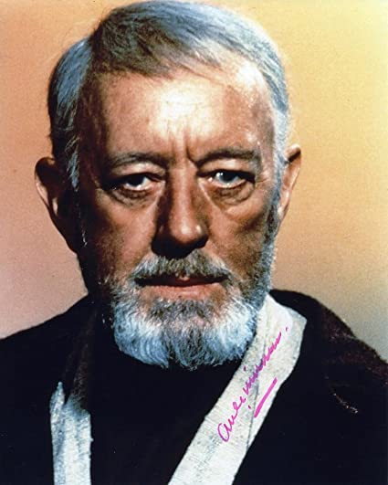

# Education

|  |  |
| --- | --- |
| *Year* | *Position* |
| **40 BBY** | Padawan apprenticeship with Jedi Master Qui-Gon Jinn |
| **54 BBY** | Began training at the Jedi Temple, Coruscant |

# Employment

* **0 BBY**: Rebel Alliance
* **19 BBY**: Custodian of Luke Skywalker, Tatooine, Arkanis, Outer Rim
* **22 BBY**: General, Republic Military, Clone Wars[1]
* **32 BBY**: Jedi Knight, Invasion of Naboo, Chommell, Mid Rim

# Quotes

Luke, you’re going to find that many of the truths we cling to depend greatly on our own point of view. The truth is often what we make of it; you heard what you wanted to hear, believed what you wanted to believe.

Only a Sith deals in absolutes.

1. 7th Sky Corps and 501st Legion