**[DS 5660 Fall 2023] Model and Machine Learning II**

**Assignment 4: Transfer learning and model fine-tuning In PyTorch**

## I. Purpose:

This assignment aims to perform the best practice of PyTorch with model fine-tuning instead of starting from scratch.

## II. Tasks

Task 1. Be able to run the main.py for training (resnet18)

i) Run the main.py and be able to see the training process.



Show a screenshot of you have loaded the CIFAR-10 or mini CIFAR-10 in the data folder.(10’)

Show a screenshot of the final loss after finish training 5 epoch. (20’)

Task 2. Fine-tune the pretrained model (resnet18)

i) we provide one of pretrained weights (“resnet18_Weights_IMAGENET1K_V1.pth”). Load the pretrained weight or others you find for resnet18.

Explain code line 103 and 104. What are those? (10’)



Explain code line 105 and 106. What are those? (10’)



Task 3. Run fine_tune.py with model fine-tuning

i) We provide a simplified Resnet (resnet.py) in this homework. Please fine tune the model by modifying the code.

Show a screenshot that you have successfully run the Resnet18. If the Resnet18 is successfully run, you will see similar information as the example below. (10’)

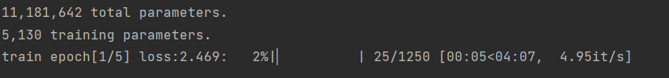

Show a screenshot of the final loss after finish training 5 epoch. (20’)

Task 4. Compare the results

i) Please comparing results of Task1 and Task3, and answer the question:

What you find from the results about difference between training from scratch and training with model fine-tuning (10’)

Task 5. Correct naming, organization, and submission of the homework (10’)

* The assignment should be submitted with two files:
  + 1. A single PDF report file should be submitted to Brightspace with last name and VUID (e.g., “Huo_huoy1.pdf”). The PDF contains the screenshot for Task 1, 2, and 3.
    2. All source code should be submitted to Brightspace as a single zip file with last name and VUID (e.g., “Huo_huoy1.zip”). Please submit all source code that you are using to run ResNet18 in Task 4, including . Please do not upload the Data.
* The deadline of submission is on the course website <https://hrlblab.github.io/DS5660.html>

## III. Grading and Submission

* The assignment will be evaluated in a total of 100 points. The basic scores are generally given based on the following table.

For each 5’ or 10’ or 50’ scale.

Get 100% = perfectly correct

Get 80% = minor flaw

Get 60% = mostly incorrect

Get 40% = totally incorrect

Get 20% = do something

Get 0%=not do anything