- Github:
  - Create Original
  - Add member
  - Create repository
  - Clone
  - Commit initial code
- Technical in use:
  - spring webmvc
  - spring data rest webmvc
  - spring data jpa
  - hibernate entitymanager
  - javax servlet
  - mysql
  - Log4j
  - Spring security
- Model
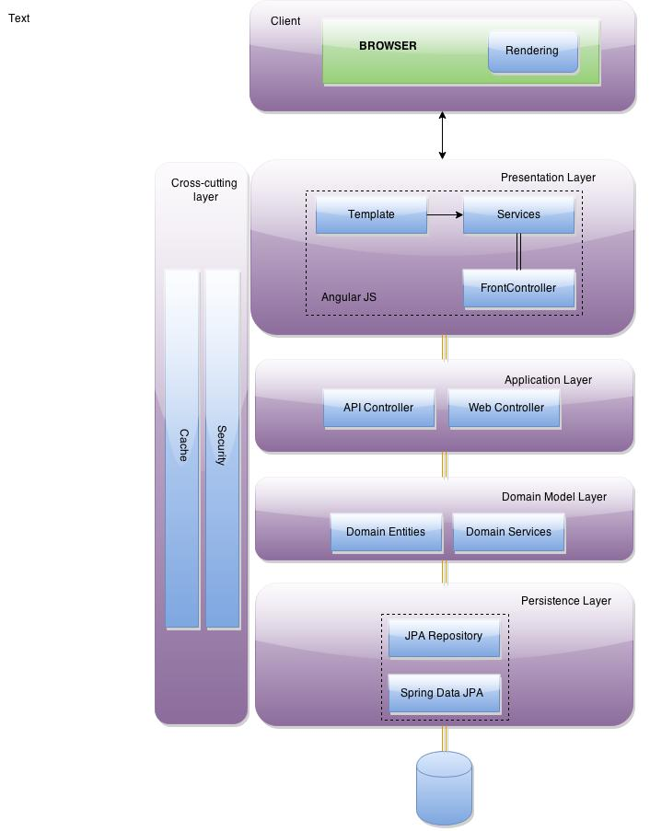
- Working dev. environments

