Technical in use:
  - Maven
  - Bower
  - Jenkin CI
  - Spring webmvc
  - Spring data rest webmvc
  - Spring data jpa
  - Spring security
  - Hibernate entitymanager
  - Javax servlet
  - Mysql
  - Log4j

Model
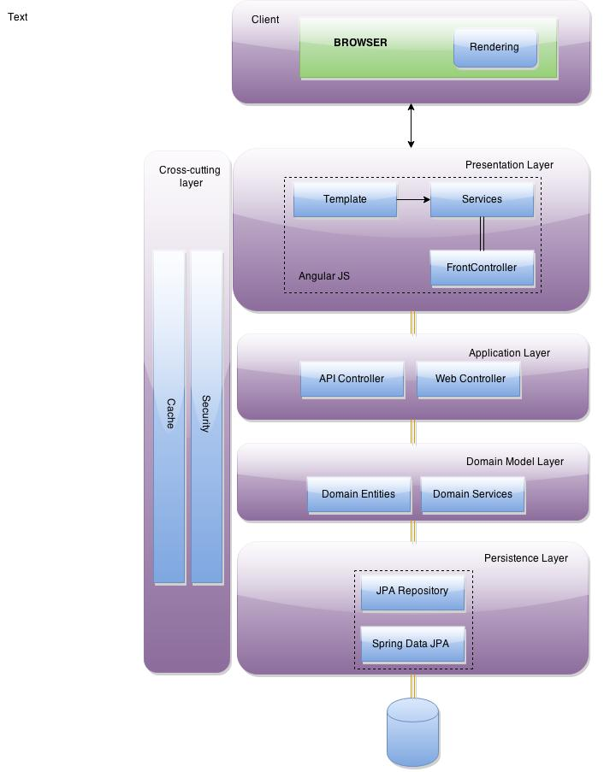

Working Environments
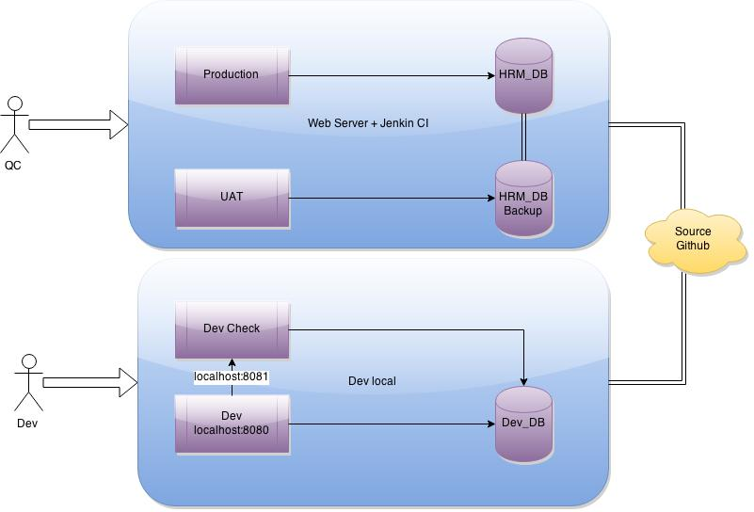

Dev
VMW:
      - Window 7 x64
      - Java (JDK)
      - Maven
      - Tomcat
      - Wamp server (MySQL DB)
      - Node JS (+Bower)
      - Git

UAT & Production
VMW server:
      - Ubuntu
      - Jenkin
      - Tomcat
      - MySQL server

Project template

