CODING CONVENTIONS FORMAT FOR ECLIPSE

Contents

1. Java Coding Conventions 2

2. JavaScript Coding Conventions 3

3. HTML Conventions 5

4. CSS Conventions 6

5. XML Conventions 7

# Java Coding Conventions

* 1. Windows / Preferences
  2. Navigate to Java / Code Style / Formatter
  3. Import **java-conventions.xml** (located in directory: doc/guide)

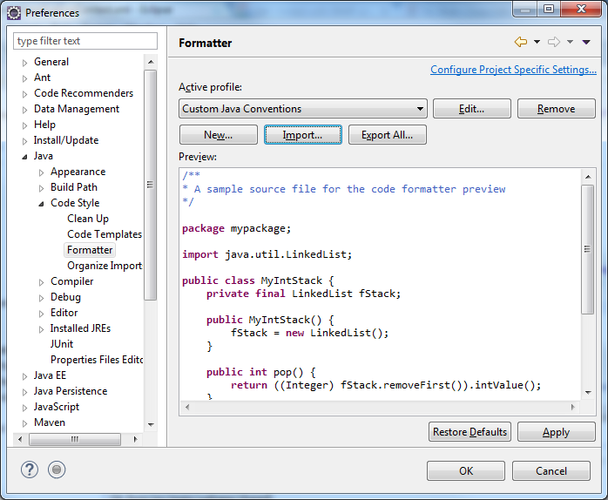

# JavaScript Coding Conventions

* 1. Windows / Preferences
  2. Navigate to JavaScript / Code Style / Formatter

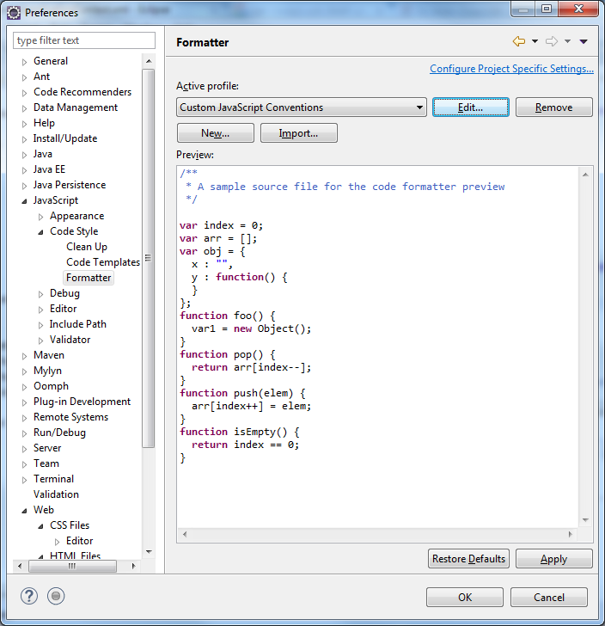

* 1. Create new profile:
     1. Name: Custom JavaScript Conventions
     2. Open the edit dialog now: Checked
     3. Initialize settings with the following profile

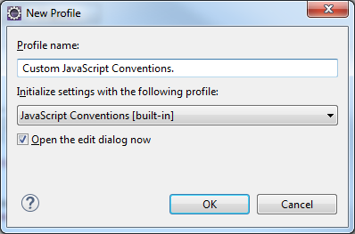

* + 1. In Edit Profile dialog, change following parameters:
       1. Tab Indentation:

1. Tab policy: Spaces Only
2. Indentation size: 2
3. Tab size: 4
   * + 1. Tab Line Wrapping:
4. Maximum line width: 120
   * + 1. Tab Comments:
5. Maximum line width for comments: 120

# HTML Conventions

* 1. Windows / Preferences
  2. Navigate to Web / HTML Files / Editor

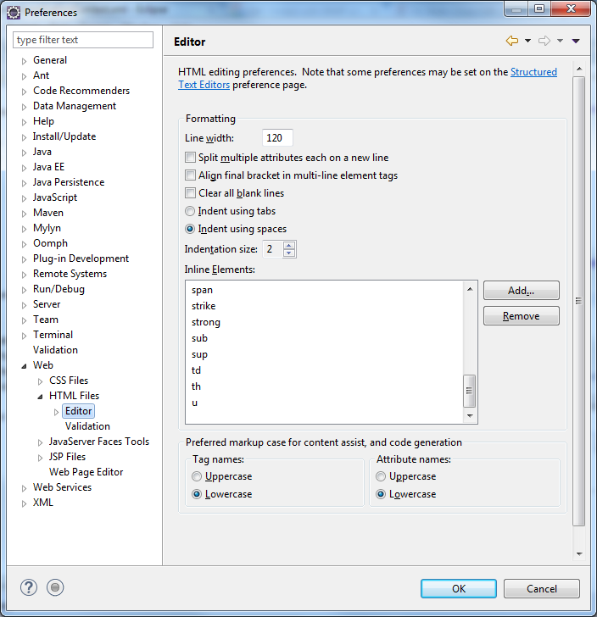

* 1. Change following parameters:
     1. Line width: 120
     2. **Indent using spaces: checked**
     3. Indentation size: 2
     4. Inline Elements: remove following items (if exist): div, head, input, title, ul, title

# CSS Conventions

* 1. Windows / Preferences
  2. Navigate to Web / CSS Files / Editor

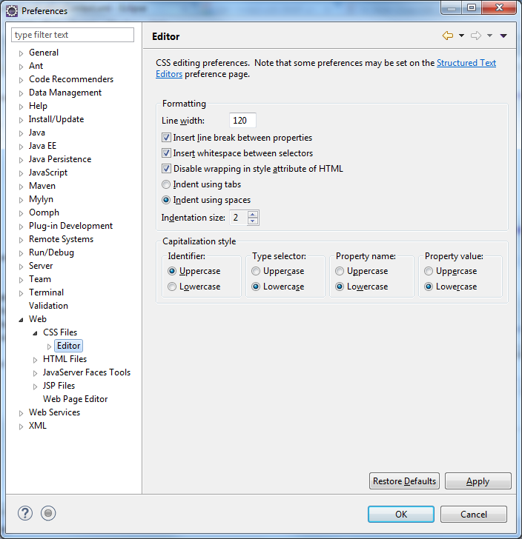

* 1. Change following parameters:
     1. Line width: 120
     2. **Indent using spaces: checked**
     3. Indentation size: 2

# XML Conventions

* 1. Windows / Preferences
  2. Navigate to XML / XML Files / Editor

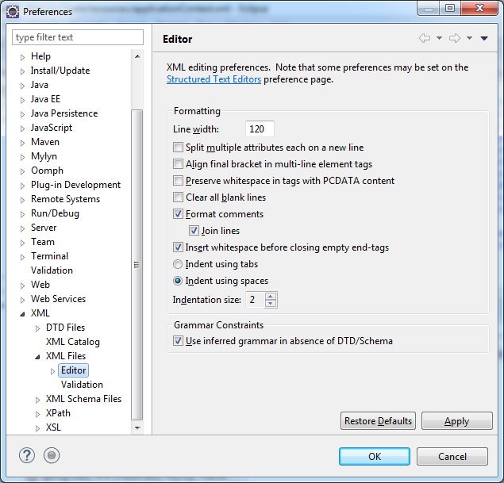

* 1. Change following parameters:
     1. Line width: 120
     2. **Indent using spaces: checked**
     3. Indentation size: 2