Ch 5 Exercises – Instruction Sheet

# Part 1: (10 points)

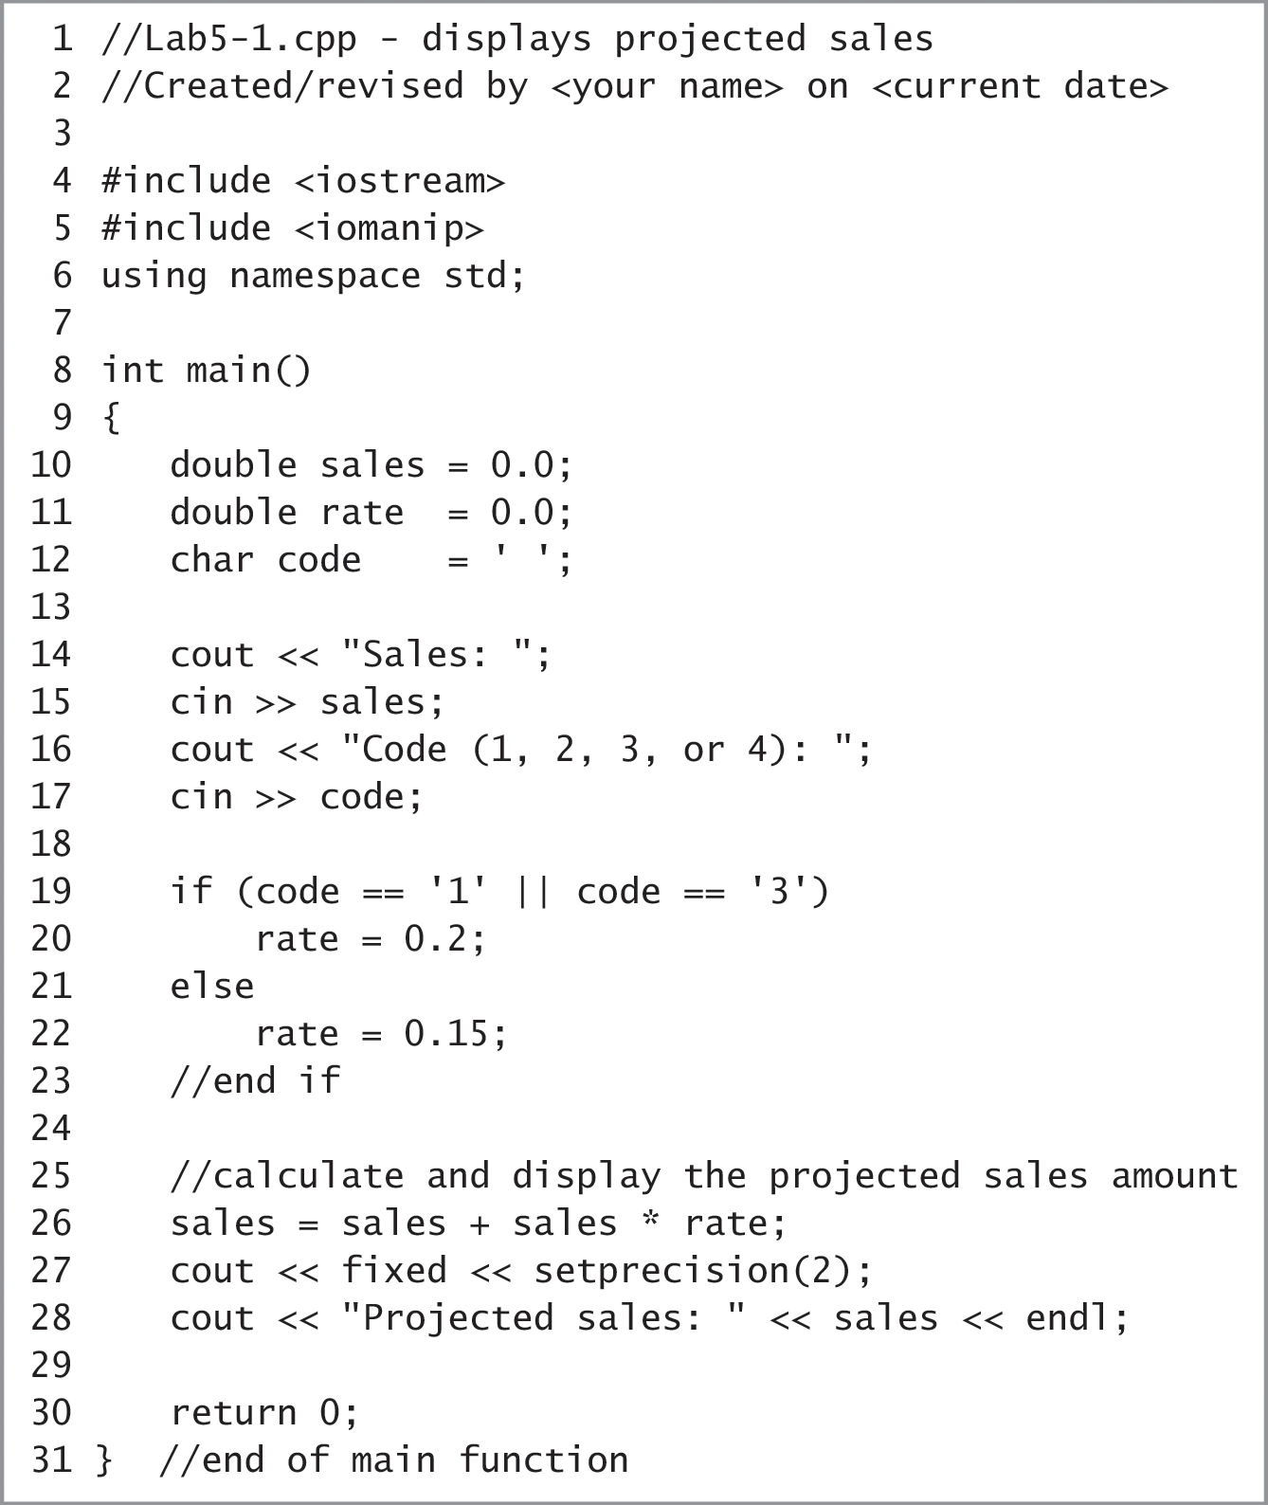

1. What rate will be assigned to the rate variable when the user enters the following codes:  
   1 0.2 3 0.2 2 0.15 4 0.15 and 5 0.15
2. Is the directive on Line 5 necessary? Yes/No   
   Explain your response:

Yes, in order to use the setprecision stream manipulator you must include <iomanip>

1. Why are the literal constants on Line 19 enclosed in single quotation marks?

The data type for 1 and 3 is char.

1. How would you rewrite the **if** statement on Lines 19-23 to use the != operator in the condition?

if (code != ‘1’ || code != ‘3’)

rate = 0.15;

else

rate = 0.2;

1. How else could you write the statement on Line 26?

sales += (rate * sales);

# Part 2: (20 points)

Use the **Lab5-4.cpp** file inside your \Chap05\Lab5-4 Project directory to complete the following:

The program in this lab should display the total price of the tickets purchased by a customer. A maximum number of 10 tickets can be purchased.

* Put the C++ instructions in the proper order and add any missing instructions
* Test the program three times using the following data: 8, 12, and -3. Make sure the program works as expected.
* Save the executable file as tickets.exe.

# Part 3: (20 points)

Use the **Lab5-6.cpp** file inside your \Chap05\Lab5-4 Project directory to complete the following:

* Read the comments at the beginning of the file.
* Test the program using codes 1, 2, and 3. Use 100 as the purchase price.
* Debug the program as necessary so it works as expected.
* Save the executable file as serviceCharge.exe.

# Part 4: (25 points)

Complete Introductory 12 computer exercise on page 150-151. You do NOT have to create the folder structure as indicated nor do you have to submit an IPO chart. You need only to submit a .ccp file named **Ch5Intro12.cpp**.

# Part 5: (25 points)

Complete Intermediate 14 computer exercise on page 151-152. You do NOT have to create the folder structure as indicated nor do you have to submit an IPO chart. You need only to submit a .ccp file named **Ch5Inter14.cpp**.

# What to submit:

This file with responses to Part 1.

Lab5-4.cpp

Lab5-6.cpp

Ch5Intro12.cpp

Ch5Inter14.cpp

Create a directory named yourname and the chapter (example: mrodenCh5), copy the files into the directory and zip it. Upload the zip into the Ch5 Exercises assignment area.