Social Media Icons Plugin

The Social Media Icons Plugin is a WordPress plugin that allows admins to enter links for Facebook, Twitter, Instagram, Tumblr, YouTube, Pinterest, and Google + accounts to allow users to quickly navigate to those pages. Admins can also choose the color of the icons to display. The icons can be placed on any post or page using the [social_media] shortcode.

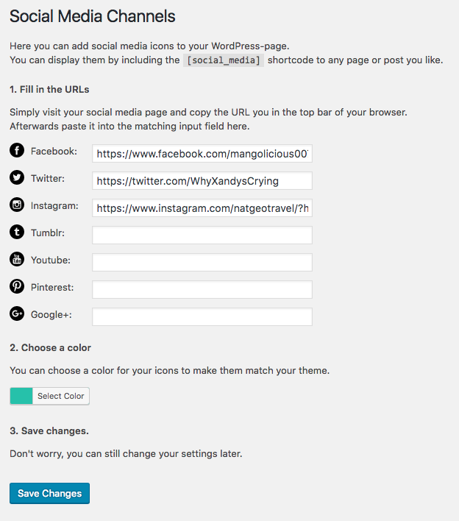

To install, drag the social-media-icons folder into the plugins folder that is located inside of the wp-content folder of your WordPress site. Activate this plugin on the Plugins category on the admin page of your WordPress site and then the Social Media Icons Category will show up on the left toolbar of your admin dashboard. Click that option to enter your social media links.

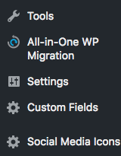

To insert your social media icons in a page or post, simply type *[social_media]* wherever you would like to insert it.

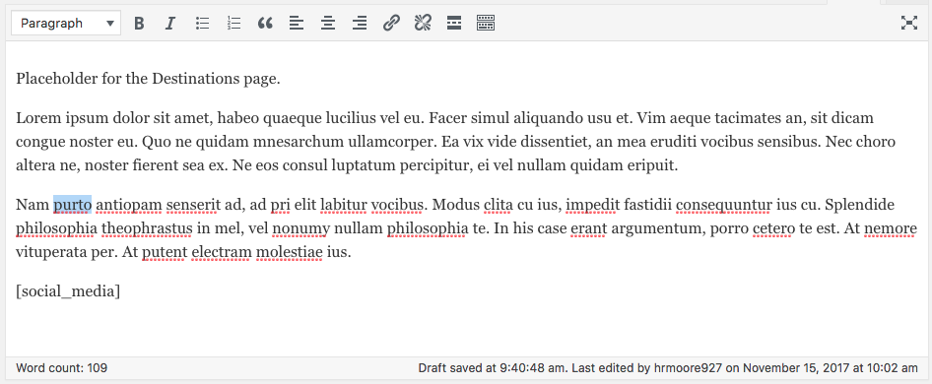

Now when you view your page, you will see your social media icons that link to the sites that you listed in the icons.

