Installing Drupal

Drupal is an open-source and free content management system written in PHP and used by more than 1 million developers, designers, trainers, strategists, coordinators, editors, and sponsors worldwide. Drupal is flexible and highly scalable. This article will go through a step-by-step instruction on how to install Drupal to your web server.

**INSTALLATION**

**STEP 1**

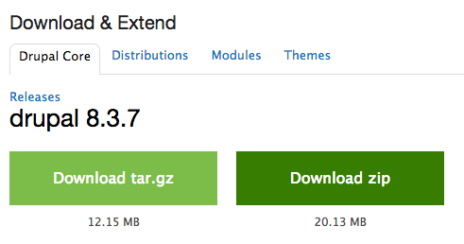In your browser of choice, navigate over to the [Drupal download](https://www.drupal.org/download" \t "_blank) page and click Download Drupal 8.3.7. This is the most current version at the time writing this blog post. On the next page, download and unzip the Drupal folder.

**STEP 2**

Next you'll need to transfer this folder to your webhost. I'm using [Filezilla](https://filezilla-project.org/" \t "_blank) and have transferred the Drupal folder (which I also renamed from "Drupal-8.3.7" to simply "Drupal") over to my public\_html folder of my webhost.

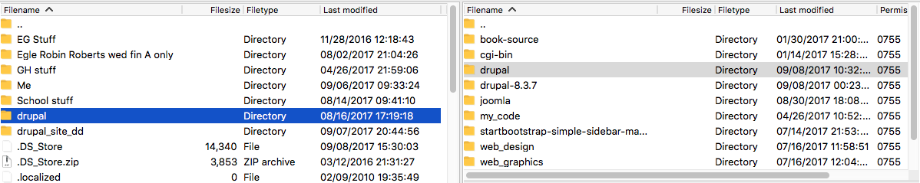

**STEP 3**

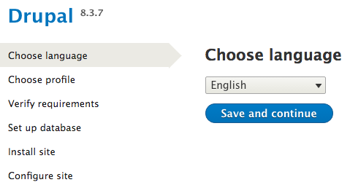Once everything has transferred successfully, hop over to your browser again and type */drupal* after your website URL(or */drupal-8.3.7* if you didn't rename your folder). This will bring you to \*drum roll please\* the installation screen! Choose your language and let's get started.

**STEP 4**

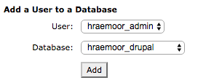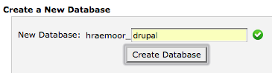We need to pause on the installation for a second and get a database set up for this new site. On your webhost's cPanel, you want to choose the MySQL Databases icon. The next screen will allow you to create a new database. I've named mine "Drupal" but you can name yours whatever you would like..."DrupalDoopal" "DrizzleHizzle" "DrippityDrupal" just remember that information for the next step in the installation. Once you have your database created, you need to assign a user access to that database. Since this is my admin user, I'm assigning it all privileges on this database. Again, remember this information so for the next step in the installation.

**STEP 5**

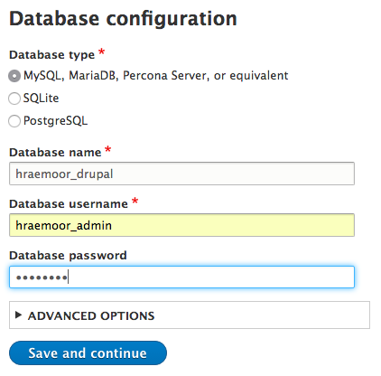When you are finished with the database, jump back over to your Drupal page in your browser and enter that information into the fields on the database configuration page.

**STEP 6**

I promise you, we’re almost at the good stuff. Ok, after you have set up your database, Drupal will install your site, giving you a progress bar to show its status. This should only take a few seconds.

On the next screen, you will configure your new page giving it a site name, connecting it to an email address, and assigning an administrator. You can also choose the default country and time zone. Click Save and Continue. Congratulations, you are finished with the installation!

**USING DRUPAL**

**ADMINISTRATOR TOOLBAR**

When you first begin with your new Drupal site, you will have a somewhat blank canvas.

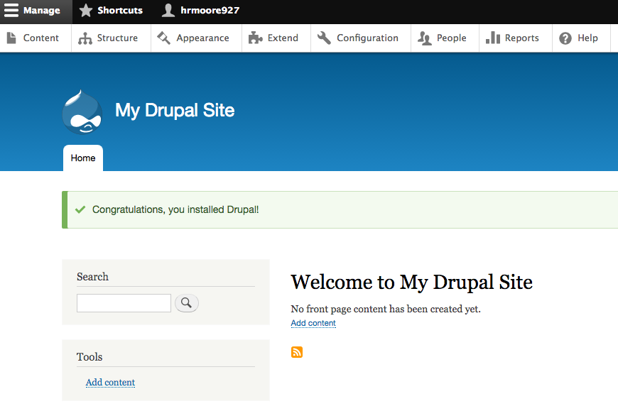

Let’s first take a look at the administrator’s toolbar. You’ll see a few options to edit your site:

* Content – this is where you will add and manage your content
* Structure – here you will have access to edit the actual structure of your page such as block layout, content types, display modes, menus, and views
* Appearance – this tab will give you the ability to customize the visual aspects of your page by setting colors or adding a theme
* Extend – this is where you will add and manage the different modules or extensions on your site
* Configuration – here you will have access to the metadata of your site
* People – users of your site are listed under this tab and you will be able to add users and edit their information
* Reports – this panel gives you reports on your site including log messages, status reports, top errors, top search phrases, and plugin reports.

We want to add content so go ahead and click on the *Content* tab.

**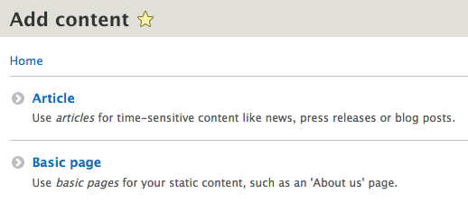ADDING AN ARTICLE**

On this page, you’ll see that you do not have any content listed. We are going to add an article so click *Add Content.* This will send you to a page were you have the option of adding an article or a basic page. We haven’t created any other type of content yet so these are the only two options. Choose *Article* to get started. Just like WordPress or Joomla, you will enter a title, the body of your article, tags, and an image for your article. When you are finished filling out your article fields, click *Save and publish* to publish this article to your page. You will now see your new article on your home page with tabs to view, edit, and delete as well as a comment section for users to comment on your article.

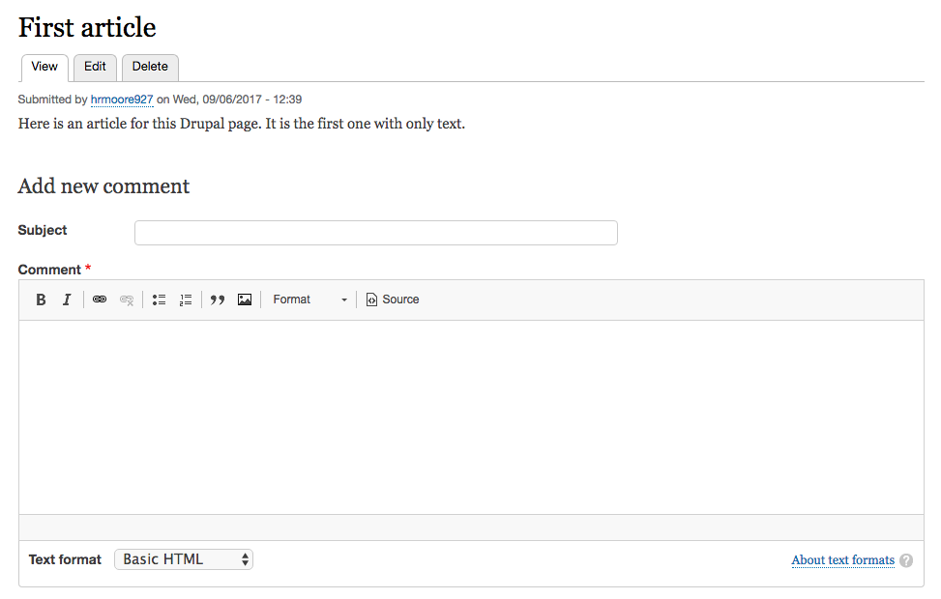

**ADDING A PAGE**

Now you’ve got an article, but let’s go back and add a new page. Click on *Content* again, *Add Content*, and this time choose *Basic Page*. The format here looks a lot like the article page except that there isn’t space to add an image or tags. This is because we are creating a new page where we can add more content. I’m going to make an “About Me” page but you can create whatever you would like. Click *Save and publish* when you are finished and you will see your new page.

**ADDING A NEW TAB**

You’ve created a new page but you want it to show up as a tab to easily access it on your site. Click on *Structure* and then *Menu*. Here you will see all of the default menus that you can edit. You want to target the Main Navigation so to the right of that one click *Edit Menu.* On the Main Navigation edit page, you will see that your navigation currently has only one link for your Home page. Click *Add link* and you will see a screen where you can enter the menu link title, link it to your previously created page, and add a description. Click *Save* when you are finished and you will see that your new menu link has been added to your Main Navigation. You can reorder the list to have your Home link on the left by just dragging the cross arrows next to Home above your new menu link.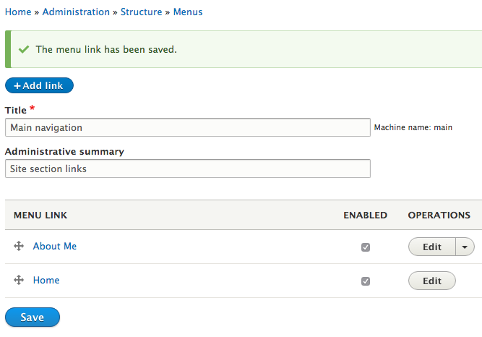

**ADDING AN ARTICLE WITH A LINK**

Begin by navigating back to the article option by clicking *Content, Add Content,* then *Article.* Here you will fill out the article the same as before but to add a link, simply click the chain icon that is the third from the left and entering in your desired URL. Click *Save and publish* when you are finished.

**ADDING AN EXTENSION**

Let’s take a look at expanding the functions of your Drupal site. In your browser, navigate over to *Drupal.org* and click on *Download & Extend.* On this screen, scroll down to find Modules and click on that. Here you have the option to search through the over 38,000 different modules that are offered for Drupal. Let’s look for a module that allows adding video to your articles. In the search filters, you’ll want to change the Maintenance status to “Actively maintained”, the Core compatibility to “8.x” since we are using Drupal 8, and enter “Video” in the search box. When you search those options, you will be left with 208 modules to choose from. Scroll down and find the module “Video Embed Field” and click on that. On this page, you’ll find an in-depth description of the module including information about how many sites are using it and download options. Right click on the .zip file for version 8.x-15 and choose *Copy Link Address*.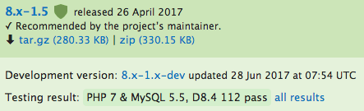 After you have done that, hop back over to your Drupal page and click on *Extend.* You will see a button at the top of the page to install a new module that will take you to a screen that gives you the option to install from a URL or to upload a module file. Paste your previously copied link into the URL box then click *Install.* Once the installation is complete, you will be given some options for the next step. You’ll want to enable the 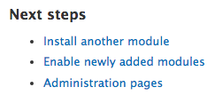new module so choose that option. You’ll be taken back to the screen that displays all the modules currently associated with your site so just type “Video” into the filter textbox to find the new Video Embed Field module. Click the checkbox next to the module and select Install. Your new module is now enabled! Just be aware that some modules require other modules to be installed as well. For example, the Video Embed Field module requires Media\_entity, which also requires Entity. If that is the case, just repeat the previous steps to install and enable these also.

**CONCLUSION**

These are just a few of the endless possibilities that you have available with Drupal. The learning curve is a little steep but it is well worth it to take the time and explore what all you can create with this content management system. After you delve in a bit, you’ll see why this is one of the most popular applications being used today.

\*\*\*\*\*\*\*\*\*\*\*\*\*COMMENTS\*\*\*\*\*\*\*\*\*\*\*\*\*\*

Initially I did step-by-step instruction on how to install Acquia Dev Desktop to use Drupal. However, after completing my page I found out that Acquia doesn’t allow hosting on the free account. I tried to export the Drupal page but after spending an entire night trying to figure out how to get it onto my webhost, I gave up and decided to rewrite the installation using just the Drupal.org download. It’s more straightforward and simple.

On my Drupal site I created an article with only text, an article with a link, an article with a photo, an article with an embedded image, and a separate “About Me” page with a navigation tab.

Link to live WordPress blog:

<https://hraemoore.wordpress.com/2017/09/07/installing-and-using-drupal/>

Link to live Drupal page:

<http://hraemoore.com/drupal-site/>