Installing and Using Joomla

Joomla is a mobile-ready and user-friendly content management system. I’ve chosen it because of its simple installation and easy interface navigation. This blog post will show you a step-by-step guide of how to install Joomla and how to get started on your first page.

**INSTALLATION**

**STEP 1**

First, you’ll navigate to Joomla.org to download Joomla to your computer. Click on the “Download Joomla” button, which will take you to a page to choose the version to download.

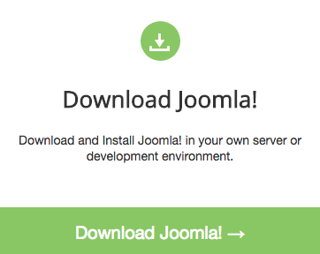

You’ll want the most recent version, Joomla 3.7.5. Click on that and download the files to your computer.

**STEP 2**

After the zip file downloads, you want to unzip that and upload the Joomla folder to your server. To make it easier, I’ve renamed this folder from “Joomla_3.7.5-Stable-Full_Package” to simply “joomla” and I’ve moved it from my computer to my public_html folder on my webhost in Filezilla.

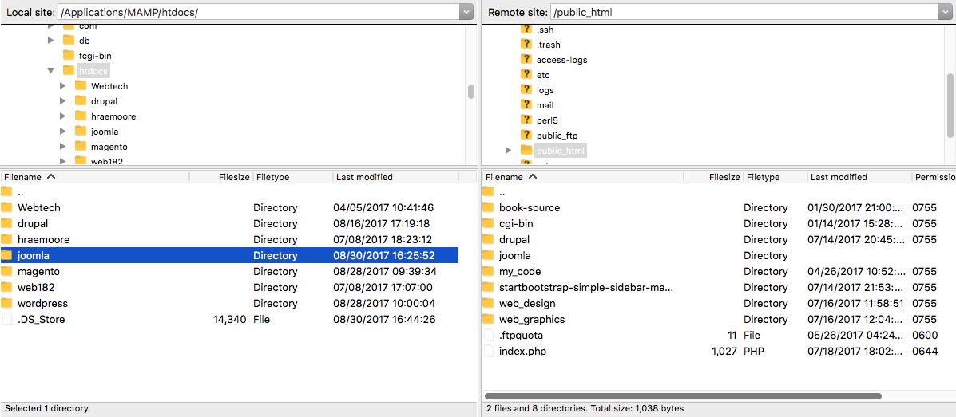

This will allow you to install from the browser, so go ahead and fire up your browser of choice. In the address bar, after typing your domain name, add /joomla (or whatever you ended up naming that folder) to the end of that address. This will automatically start the installation process.

**STEP 3**

Great job! You’re almost done! From here, we just have to fill out a few fields.

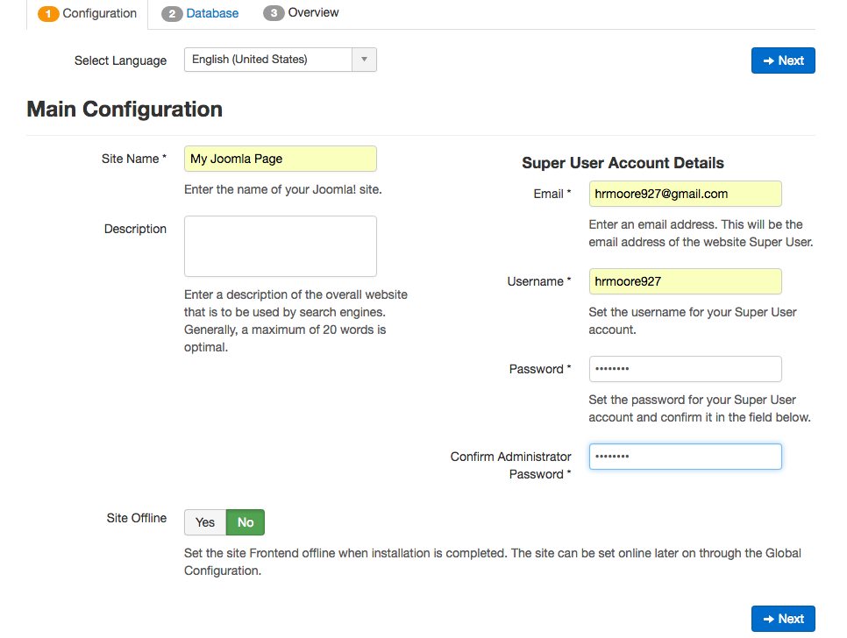

Everything on this first page is pretty self-explanatory. You’ll give your site a name and assign credentials for your super user aka administrator. You can also choose if you would like the site offline or not.

After this page, you’ll want to head over to the cPanel of your webhost and click on MySQL Databases. Here you will create a new database for all of your data for your new joomla page.

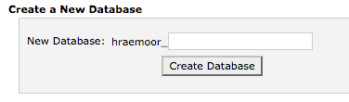

After you have created your database, you will want to give your user privileges to that database.

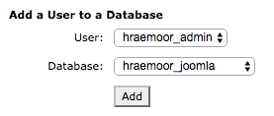

This will take you to a screen were you can select some or all privileges for that user. Since I’m using this as my administrator, I selected all privileges. When you are finished with that, hop back over to your Joomla installation page.

On this next page, you’ll configure the database. The only thing you need to fill out here is the user name, password, and the database name from the database that you just created. You can change the table prefix if you like.

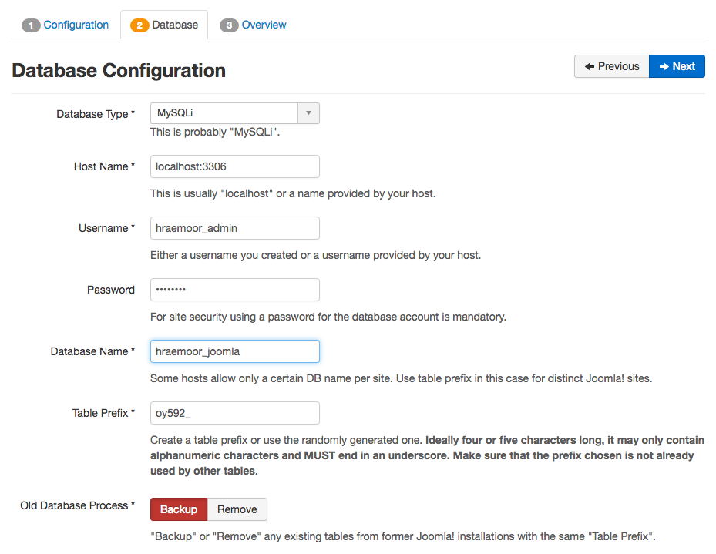

**STEP 4**

The final step in the installation is to choose if you want to also install any of the sample data. If you are just beginning, this sample data might help you get a feel for how to manage content in Joomla. After that, just click “Install” and you are all set. Joomla will give you a status bar of its installation progress and even give you an option to remove the installation folder once it is done.

Congratulations! You now have Joomla installed! From here, you have the option to view your newly created page or move on to the administrator options where you will make the magic happen.

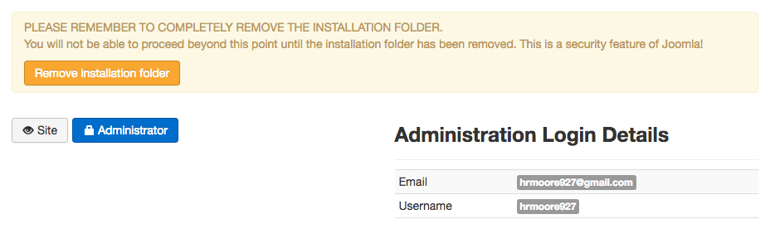

Now whenever you want to edit the page you will simply navigate to your browser and type /administrator after your page name. Let’s get started adding content!

**USING JOOMLA**

When you first look at your new Joomla page, it will look at little empty.

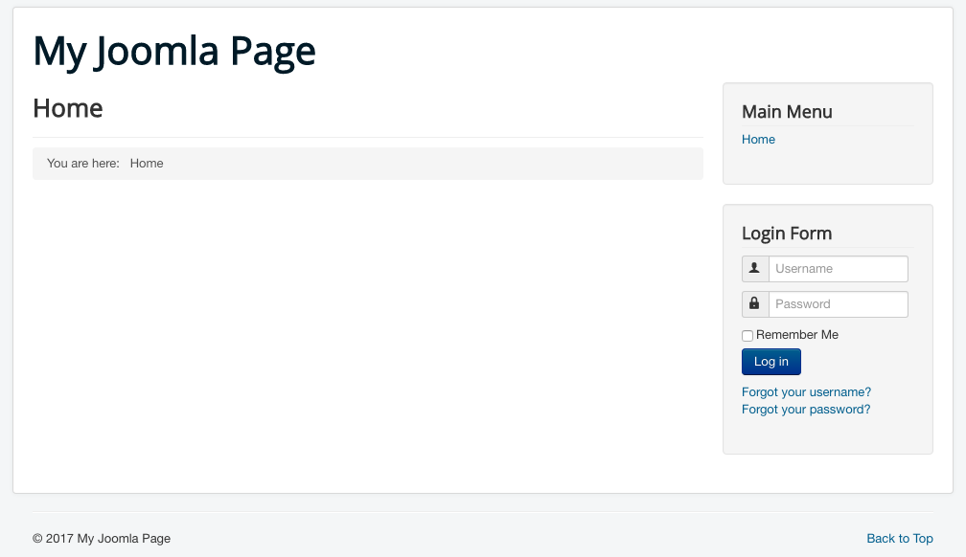

You’ll have a large heading with your site name, a smaller heading showing you that you are on the home page, a navigation section, and a login form on the side. Not much to look at, but we’ll fix that!

First, let’s navigate over to the control panel. If you remember from the installation, you’ll get there by adding /administrator after your page URL. This will pull up a login screen where you will enter the information that you assigned for the super user during installation. Once you are logged in, the administrator’s control panel will be available.

**ADDING AN ARTICLE**

On the left sidebar, you will notice quite a few options all grouped by categories like Content, Structure, Users, Configuration, Extensions, and Maintenance. We want to look at Content. This category is where you will actually add content to your page. Click on Articles and have a look at all the options here. Click on New to add a new article. On the next page, you will add a title and body for this article. When you are finished, click Save & Close. This will publish your article as well as bring you back to the Article category main page.

One thing to note here, your new article won’t show up on your home page just yet. The default setting on the home page only shows the featured articles. You can toggle the featured article option from the Articles main page by clicking the star next the article you just created.

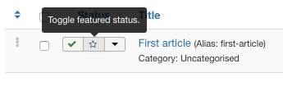

Now you should see your featured article on your home page.

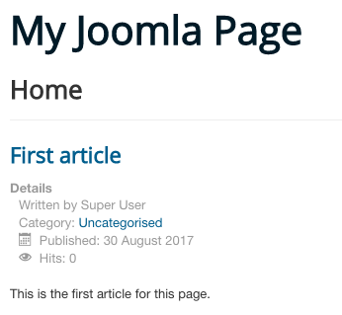

**ADDING AN IMAGE**

To add an image to an article, click on the “Images and Links” tab above the body. On this next screen you have two options. The intro image displays as a thumbnail in the article summary or in a list of articles. The full article image displays on the single article page. Choose whichever you would like. A popup will show with options for the image. You can choose an image from a folder, URL, or upload from your computer. Choose your image and then click Insert. When you are finished with this article, click Save & Close.

**ADDING A LINK**

Adding a link to an article is very simple. Just locate the link icon in the body (the fourth from the right on the top row) and that will activate a popup where you can enter the URL and text to display. You can also set the target to open the link in a new window.

**CONCLUSSION**

This is just a brief glimpse at what you can do with Joomla. In addition to adding content, you can browse the massive library of extensions that add even more features to the control panel. The user-friendly interface makes Joomla one of the more straightforward content management systems for anyone new to this type of software.

***********COMMENTS************

This article took a bit longer to put together than the first article just by having to stop writing, screenshot what I was doing, and paste that in the article. However, this gave me a better understanding of the installation process and how to describe it to someone else. I like the similarity of Joomla to Drupal or Wordpress, although it looks a bit more limited. It would be a good one for someone just starting out and wanting a simple blog.

Live link to Joomla site:

<http://hraemoore.com/joomla/>

Live link to wordpress article:

<https://hraemoore.wordpress.com/2017/08/31/installing-and-using-joomla/>

Screenshot of Joomla home page:

