Installing and Using WordPress

WordPress began in 2003 with a minimal amount of code and the idea of enhancing everyday writing. It has quickly become the most popular blogging tool and content management system. It is used by millions of sites and seen by tens of million of people everyday. This blog post will give a step-by-step installation and how to use WordPress.

# INSTALLATION

## STEP 1

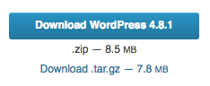

First, open your browser and hop over to the [WordPress.org download](https://wordpress.org/download/) page. Here you will see a button to download the most recent version of WordPress. Download and unzip this folder.

## STEP 2

Screen Shot 2017-09-14 at 1.25.20 PM.pngNow you need to setup a database for your new WordPress site so in your browser, navigate over to your webhost and click on the “MySQL Databases” icon. Under the “Databases” tab, you’ll see a textbox where you can create your database. You also want to make sure that you give your admin user all privileges for this database.

## STEP 3

For the next step, launch your FTP application. I'm using [Filezilla](https://filezilla-project.org/). Here, you will want to drag the files and folders in your previously downloaded WordPress folder into the public_html folder of your live hosted website. Depending on your Internet connection, it might take a few minutes...feel free to pause here and grab an adult beverage.

## STEP 4

In your browser, navigate to your site URL and the WordPress installation will begin. You will start by selecting your language. This will bring you to a page where you will enter your database information from the database you just created.

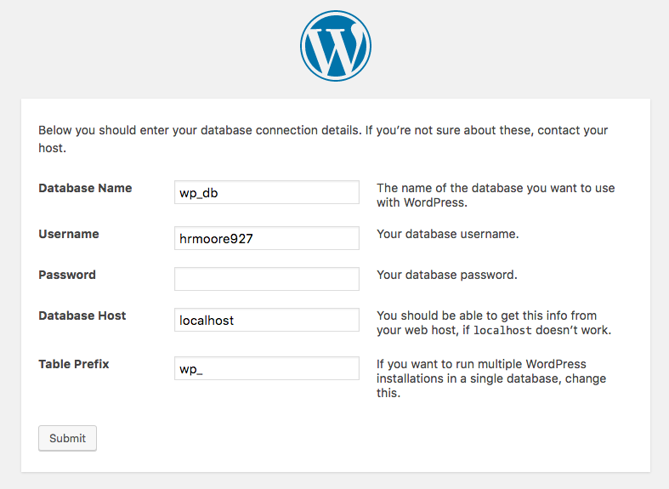

## STEP 5

On this next screen, you will enter the initial information for your site including your site title, username and password for your WordPress login, and your email address. That’s it! Your new WordPress site is all ready to go. Gotta love that 5 minute install!

# USING WORDPRESS

## ADMINISTRATOR TOOLBAR

Before you start adding content to your site, let’s take a look at the toolbar. You’ll see it located on the left side with a few options to choose from:

* Dashboard – the dashboard gives you a little overview of your site with a brief look at your current activity, a form to add a quick draft, and WordPress events and news
* Updates – this will show you any updates that are available as far as your version of WordPress, any plugins, or themes that you have installed
* Posts – here is where all of your posted content will be with the options to add, edit, or delete content, categories, and tags
* Media – this page is where you will control all of the media that you have added to your site
* Pages – this tab will allow you to add, edit, or delete pages
* Comments – here you will be able to approve, reply to, edit, and delete comments that you and other users have left on your posts
* Appearance – your installed themes and a button to add new themes is located here
* Plugins – any installed plugins are in this tab with the option to activate, edit, or delete
* Users – users registered to your site are in this tab
* Tools – you can add and customize WordPress tools here
* Settings – your page settings are located in this tab giving the admin the ability to edit those

## ADDING A POST

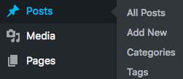This is probably the easiest thing you will do with your WordPress site. To add an article, simply mouse over “Posts” on your admin toolbar and click “Add New” when the pop up menu shows up. On this next page, you’ll be able to add a title, content, an excerpt, a featured image, categories, and tags for your new post. When you’re finished with your post, click “Publish” on the right-hand toolbar.

## ADDING A PAGE

Screen Shot 2017-09-18 at 10.37.03 AM.pngThe next thing you probably want to look at is adding a new page. This is almost the exact same as adding an article. You’ll just mouse over “Pages” on the admin toolbar and select “Add New”. Again, you will have the ability to add a title, content, and a featured image, however this time you won’t have the option to select a category or tags since this will be an actual page and not a blog post. When you are finished, click “Publish” in the right-hand toolbar.

## CHANGING THE APPEARANCE

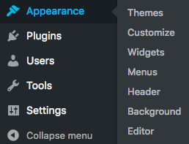So you probably don’t want to keep the default theme as your page appearance. We can fix that. All of your installed themes will be located in the “Themes” category when you mouse over the “Appearance” tab on the admin toolbar. WordPress comes installed with three default themes but you can add more. Just click “Add New” at the top of the page or you can enter the name of your desired theme if you know it in the search bar. On the “Add Themes” page, you can browse through some popular and featured themes to find one that you like. You can also click on the preview image to view details and see a preview of the actual theme. When you find the one you like best, just click “Install” to add that theme to your site. You’re not done just yet…you still need to activate this new theme to have it appear on your page. Click “Activate” on the new theme and it will be applied to your site. You can also delete any of the themes installed on your site by simply selecting the theme and then choosing “Delete” in the bottom right corner.

## INSTALLING A PLUGIN

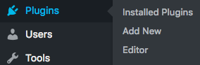As you can tell by now, installing anything on WordPress is as easy as selecting the tab from the admin toolbar and clicking “Add New”. Plugin installation begins the same way. On the “Add Plugins” page, just like the themes, you will be able to search through featured and popular plugins to find what you are looking for. You can view the details of a plugin by choosing “More Details” under the installation button. When you find the right plugin for your site, click “Install” to download it to your page and then “Activate” to get it to work on your page.

## CONCLUSION

It’s easy to see why WordPress is the most popular content management system. The amazing usability of the admin toolbar and the ease of adding content gives accessibility to almost any user who wants to create a dynamic and visually appealing website. Try it out for yourself!