Search Engine Protocols Assignment

The purpose of this assignment is to help you understand Google Webmaster Tools, Robots.txt files, sitemaps, and structured data. You will need access to your Google Webmaster console to complete the assignment.

Complete the tasks below. Type information and insert screenshots when instructed.

# Objectives

* Add a property to the dashboard of Search Console
* Learn the syntax used in Robots.txt files
* Test uploading an xml sitemap and see how Google interprets it.
* Work with the Structured Data Highlighter to markup a webpage and provide an easier understanding of search engines to interpret the data on the webpage.
* Use the Structured Data Markup Helper to see how the markup looks when inserted into HTML code.
* Use the Structured Data Testing Tool to verify that Google has interpreted your markup the way you intended.

# Add Your Website (Property) Google Search Console

1. Login to [Webmaster Tools](https://www.google.com/webmasters/tools/)
2. Add your website as a property. Make sure you add it as http://

# Working with Robots.txt

1. Once added in, select your website.
2. From the menu on the left, select Crawl 🡪 robots.txt Tester.
3. You will something similar to the image below. But yours may say not found.
4. Replace the image below with a screen shot of your tester.

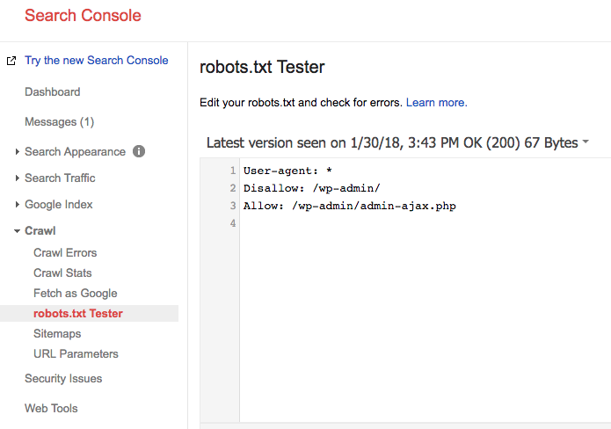

1. Click Learn more. And then click Create a Robots.txt file
2. Read the article.
3. Answer the following questions.
4. What does the “User-agent: *” mean?

The user-agent is whom the rule applies to. Examples of user-agents are Googlebot, AdsBot-Google, or the wildcard *.

1. What does the “Disallow: /wp-admin/” mean?

Disallow: /wp-admin/ tells the crawler not to crawl that selected directory.

1. What syntax would you use to add a sitemap to the robots.txt file?

To add a site map, you would include *Sitemap: http://yoursitename.com/sitemap.xml* to the robots.txt file.

1. **NOTE**: If you want to create a robots.txt file for your site you can.  
   Example robots.txt file, in a text file, type the following and save as robots.txt into your root folder on your website.  
     
   User-agent: *

Disallow: /wp-admin/

# Working with Sitemaps

1. From the menu on the left, select Crawl 🡪 Sitemaps
2. Follow the instructions to add a sitemap.
   1. You will need to verify your site. You can do this by adding the html code to your header.php file in WordPress.
   2. Make sure you have Yoast SEO/XML sitemaps enabled in the Yoast Plug-in in your WordPress dashboard.
3. Add the file sitemap_index.xml
4. After you have added your site map(s) you will see something similar to the image below.
5. Replace the image below with a screen shot of yours.

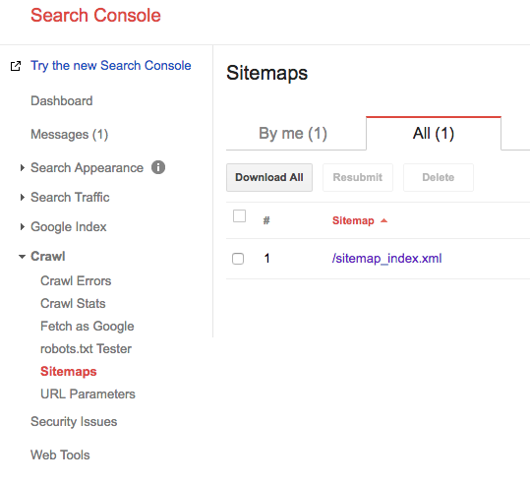

1. Answer the following questions using your data.
   1. How many sitemaps have been submitted?

One sitemap has been submitted

* 1. What is the URL for the sitemap?

The URL for the sitemap is http://hraemoore.com/sitemap_index.xml

* 1. How many web pages were submitted from the sitemap?

1. Click on the link for the sitemap.



1. Click the “Sitemap Index link”. You should see something similar to the image below.



1. Answer the following questions.
   1. How many additional sitemaps are there?

There are 4 additional sitemaps.

* 1. Click on the “post-sitemap.xml” link.



1. Click on the “post-sitemap.xml sitemap info link. This opens a new window.
2. If available, what is the priority of the blog?

Not available



1. Copy the URL for the posts sitemap and go back to the Google Search console. Crawl/Sitemaps
2. Click the red “ADD/TEST SITEMAP” BUTTON
3. Paste the URL into the text box (removing the root portion of the URL and click the “Test Sitemap” Button.   
   **DO NOT click the “submit sitemap” button.**
4. Once the test is complete, click the blue “View test results” button.
5. How many web pages were submitted? 9 webpages
6. How many images were submitted? 17 images
7. Click the “Close sitemap test” button.

# Working with Data Highlighter

1. From the Google Search Console, select “Search Appearance 🡪 Data Highlighter”
2. Select the “Start Highlighting” button.
3. Type in the URL that contains your contact information and choose the “Local Business” type and select “Tag just this page”. Then click “OK”
4. Highlight each of the following pieces of information and apply a tag.

*Name:

*Address:

*Telephone:

1. Take a screenshot and paste it below.

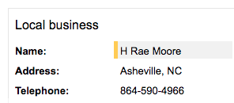

# Working with Structured Data Markup Helper Tool

1. From the Google Search Console, select “Other Resources”.
2. Click the “Structured Data Markup Helper” link.
3. Select “Local Businesses”.
4. Input your URL
5. Select “Start Tagging”
6. Highlight each of the following pieces of information and apply a tag just as you did in the last exercise.

*Name:

*Address:

*Telephone:

1. Select the “CREATE HTML” button.
2. Select the dropdown next to “microdata” and set it to JSON-LD. Paste the generated code below:
3. Click “Finish”. In the box that appears, click the “Structured Data Testing Tool” link.
4. Paste the JSON-LD code into the first box and click the “RUN TEST” button.
5. Take a screenshot of the results page and paste it below.

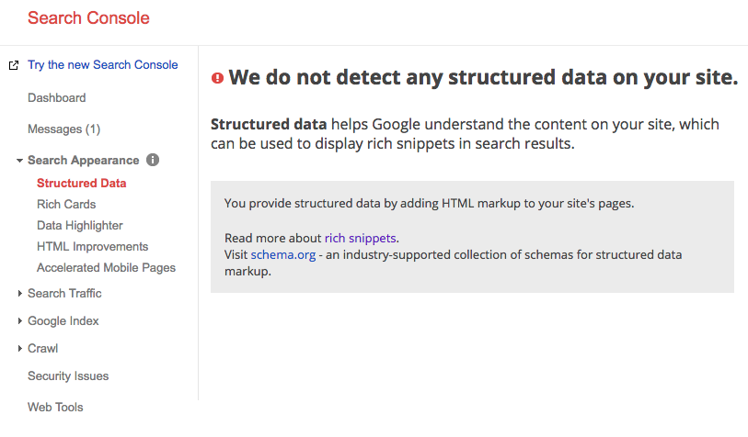

# Submit Your Assignment

For this assignment, you will need to turn in the 3 items below:

1. This completed document with the file name **Last-First-Protocols.docx**