CIS 115 Test 2
Open the Test2.zip file (under Test 2 in Moodle) and extract the files into your xammplite/htdocs/Webtech/coursework/Exam2 folder (the sample.css file that is unzipped can replace the sample.css file that is already in the folder). Be sure to run your server and test your work, for example the URL to test Exercise 1 is: http://localhost/Webtech/coursework/Exam2/mySales.html
These four exercises assume you are a musician who sells CDs online. Follow the instructions carefully.
EXERCISE 1: You have been provided with a data file named mySales.txt which contains the number of CD’s you sold each month in 2014. The file contains 12 lines, so there is one number on each line.
Open mySales.html and mySales.php. You do not have to change mySales.html. Complete mySales.php so that this program reads the twelve numbers from the file, then calculates and displays the total number of CD’s sold for the year and the total sales amount (assume that each CD sells for $8.50 so this is just the number of CD’s multiplied by 8.50). Use the number_format function so that the total sales income is displayed to 2 decimal places.
If the total number of CD’s sold for the year is greater than 1200, display a paragraph with the message “Good news: Your 2014 sales are higher than 2013. Let’s achieve even higher sales in 2015!“, otherwise display a paragraph with the message “Sales have slowed since 2013, it’s important to determine why and take action to increase your online visibility.“
The total number of CDs sold should be 1253, with total sales income $10,650.50. Now change the first number in the mySales.txt file from 103 to 50 so that the total will be reduced to 1200 (and income will be $10,200.00) to test if your other message displays correctly.
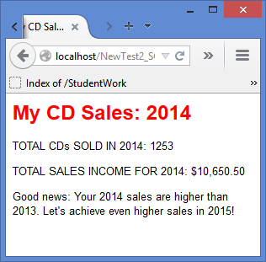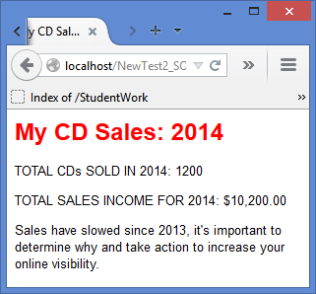
Output with 1253 CD’s Sold Output with 1200 CD’s Sold
EXERCISE 2: You have been provided with a data file named myCDs.txt. This file contains three lines as follows:
2010:Hip:450:7.50
2011:Hep:725:8.50
2013:Hop:620:8.50

Each line contains the year the CD was produced, the title of the CD, the number sold so far, and the sale price.
Open myCDs.html and myCDs.php. You do not need to change myCDs.html. Complete myCDs.php so that this program reads the three lines from the file and then extracts the four values from each of these three lines. The code to display the results in a table has already been provided so be sure to use the same variable names in the code that you add! Your output should look like this:
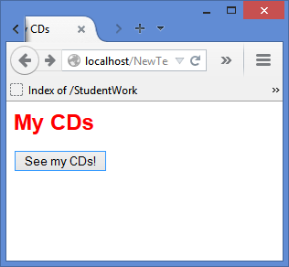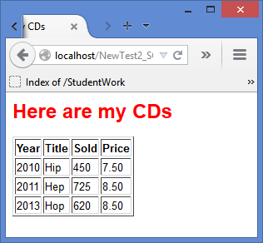

The following two exercises test your understanding of single and multiple IF..ELSE Structures. Take your time to review the chapters and develop your code. If you have problems, look for syntax errors, such missing braces, correct use of braces, missing semi-colons, mis-spelled variables (especially upper- or lower-case letters), missing quotes in print statements, etc. Appendix D (Debgugging Help) in the text book can be useful and so can the chapter Hints and Help pages (see Moodle). Your solutions should have the same appearance as the screenshots.

EXERCISE 3: You have been provided with orderForm1.html and orderForm1.php to process CD orders. You do not need to change orderForm1.html.
You will see that orderForm1.html provides a form that asks the user to select a CD (the CD titles are “Hip”, “Hep”, or “Hop”), and then asks for the number of CDs to purchase. Note that the form only allows the user to choose one CD title, but can order any number of that title.
Complete orderForm1.php so that this program displays the order details, as shown in the screenshots below, and calculates and displays the total cost of the CD’s. The total cost should be calculated by multiplying the price of the CD that was selected by the number of CDs being ordered, and adding a standard shipping cost of 2.50 (the shipping is 2.50 no matter how many CD’s are ordered). “Hip” CD’s cost 7.50 each, “Hep” and “Hop” both cost 8.50 each, so you will need to test the title to determine which cost to apply.. Be sure that your numeric output is formatted to two places (see examples below).
Here are three tests to be sure your program works correctly:
- Enter 1 for the number of CD’s and choose “Hip”. The total cost should be $10.00
- Enter 5 for the number of CD’s and choose “Hep”. The total cost should be $45.00
- Enter 10 for the number of CD’s and choose “Hop”. The total cost should be $87.50

SAMPLE OUTPUT (YOUR OUTPUT SHOULD LOOK THE SAME):
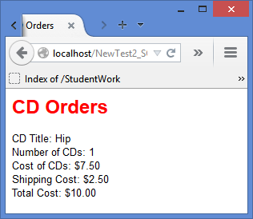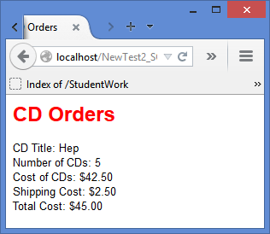
Test 1: One Hip CD ticket Test 2: 5 Hep CD’s

Test 3 will look the same except the title will be “Hop”, cost of CDs will be $85.00, shipping cost will be $2.50 and total cost will be $87.50.
4. You have been provided with orderForm2.html and orderForm2.php to process CD orders. You do not need to change orderForm2.html. Note that the form now tells the user that there is free shipping for orders of 5 or more CDs.

Complete orderForm2.php so that, if the user requests less than 1 CD, the program only displays an error message “ERROR! YOU MUST ORDER AT LEAST 1 CD!” and provides a link back to orderForm2.html (see screenshot below), otherwise if the user requests between 1 and 4 CD’s, the program should process the order in the same way as exercise 3 with a shipping cost of 2.50, and if the user orders at least 5 CD’s the shipping cost should be 0.00 instead of 2.50. To save time, you can copy and paste code from orderForm2.php into orderForm2.php and then modify this as needed. Be sure that your numeric output is formatted to two places. See the screenshots below to see how your output should appear.
Run orderForm2.html and use these three tests to be sure your program works as expected:
- Enter 0 for the number of CD’s and choose any CD title. The program should display an error message and a link back to the form (see the screenshot below).
- Enter 4 for the number of CD’s and choose "Hip” for the CD. The program should perform the necessary calculations and display the title, the number of CD’s ordered, the cost of the CDs ($30.00), the shipping cost ($2.50), and the total cost of $32.50.
- Enter 5 for the number of tickets and choose “Hop”. The program should perform the necessary calculations and display the title, the number of CD’s ordered, the cost of the CDs, the shipping cost of $0.00, and the total cost of $42.50.

SAMPLE OUTPUT (YOUR OUTPUT SHOULD LOOK THE SAME):
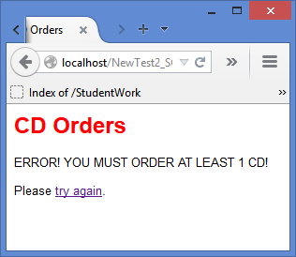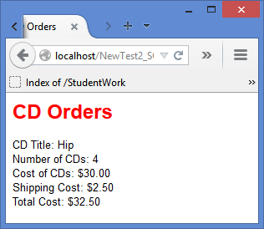
Test 1: User requests 0 CD’s Test 2: User requests 4 Hip CD’s
Test 3 will be similar to Test 2 except the title will be “Hop”, the number of CDs will be 5, the cost of CDs will be $42.50, the shipping cost will be $0.00, and the total cost will be $42.50.
When you are done zip and submit the Exam2 folder which must contain ALL your work including the .txt files and sample.css file! All work MUST be submitted by the deadline.

