CIS 115 Test 3
REQUIREMENTS:
Read the instructions for each exercise carefully and allow yourself time to complete all four exercises. Be sure to submit ALL files, including the .txt files and .css file.
EXERCISE 1: Annual CD Orders Report. Your folder includes cdOrders.html, cdOrders.php and cdOrders.txt. Your cdOrders.txt file contains 52 lines, one for each week of the year. Each line contains the number of CDs you sold that week. Well done! ☺

Complete cdOrders.php as follows. Use a FOR loop to read the lines from the file and generate a report. The report should provide the total number of CDs sold, the number of weeks with 5 or more CDs sold, the most CD's sold in any week, and the average number of CDs sold in a week, rounded to the nearest whole number (the average is the total number of CDs divided by 52). So you will need to add code in your FOR loop to calculate these, and code after the loop to calculate the average. Here is how your results should appear:

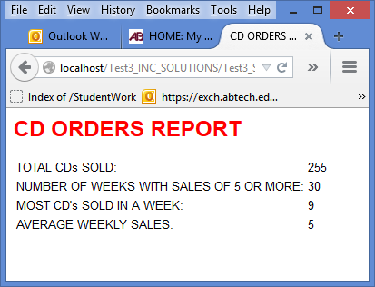

EXERCISE 2: My Upcoming Performances. Your folder includes a file named performances.txt. Each performance record is stored on a single line and contains the performance date, the venue, the city, and the ticket price. For example the first entry is:
2/15/2015:Tressas Downtown Jazz and Blues Club:Asheville:8.50
Your folder also contains performances.html and performances.php. You do not need to change performances.html. Complete performances.php so that it uses a WHILE NOT EOF loop to process all the lines in the performances.txt file and display the performances in a table (the table headings have already been provided). The program should ALSO count and display the total number of performances and the number of Asheville performances. If your code works correctly, these numbers should be 6 and 4.
Now add another selection structure to your loop so that, if the ticket price is less than 10.00, the price will be followed by an asterisk (see the screen shot below). You will have to think about how to display this in the column (skip this if you can't figure out how to do it).
NOTE: when you explode each record, you only have to worry about the items separated by colons. The entire date is a single item, and so is the name of the venue.
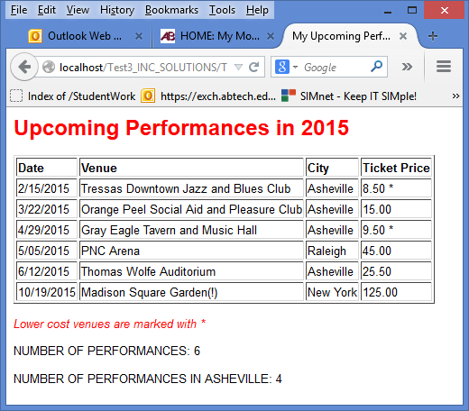
EXERCISE 3: CD Sales Report. Your folder includes cdSales.html and cdSales.php. Your cdSales.php file already contains an array with 12 monthly sales figures. You do not need to change cdSales.html.
Complete cdSales.php so that it uses a FOR loop to process the array as follows: accumulates the total sales; counts the number of months with 0 sales (weeks where the number is 0). Also calculate the average weekly sales amount and round this to the nearest whole number. Use the sizeof() function in your FOR loop heading and in your average calculation.
Now calculate the total sales for November and December (remember that the array index begins with 0 and not 1). There are different ways to do this, you can use a selection statement in your loop, or you can simply add the values of these two array elements in an assignment statement after the loop.
The program should then display the total sales, number of months with 0 sales, average monthly sales, and the total for the sales for November and December only. BE SURE TO USE FOR LOOPS FOR THIS EXERCISE, NOT WHILE LOOPS. Here is a screenshot:

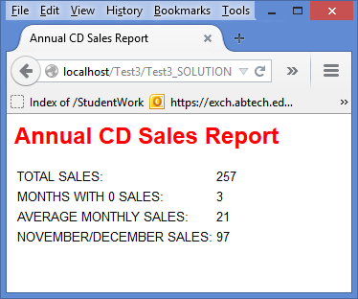
EXERCISE 4: Animal Lifespans. Now for something different. Your folder includes lifespans.html and lifespans.php. The code in lifespans.html asks the user to choose an animal and does not need to be changed. Complete lifespans.php to display the animal's lifespan as follows.

Create a function named averageLife() in lifespans.php that receives the name of an animal and returns the animal's average life span. The function will need a selection structure and should be able to return the life span of any of the following animals, depending on which name it receives:

Mouse has an average lifespan of 4 years
Queen Bee has an average lifespan of 5 years
Squirrel has an average lifespan of 20 years
Rattlesnake has an average lifespan of 22 years
Pheasant has an average lifespan of 27 years
Mallard Duck has an average lifespan of 29 years
Bear has an average lifespan of 40 years
Box Turtle has an average lifespan of 123 years

The function should return just the number. So for example if the program called the function as follows averageLife(“Mallard Duck”), the function would return 29.

Now add a line of code in lifespans.php that calls the averageLife() function with the name of whichever animal the user submitted from the dropdown list in lifespans.html, and receives the number that is returned by the function. Now add a print statement to display the result as shown in the screen shot below.

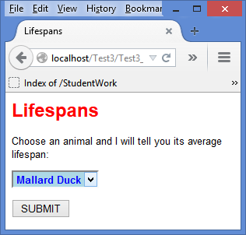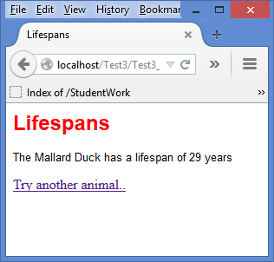

When you are ready, zip the entire Test3 folder and submit. Be sure to include all the files, including .css and .txt files.

