InterMedia XD Design Walkthrough

This is an introduction to the Adobe XD design of the InterMedia app used to catalog your personal collection of books, music, and movies. This app is available for mobile, tablet, and smartwatches. InterMedia gives you the ability to create a profile, search items in the database via text or a barcode scanner, and add items to your collection. You will also have the option to submit items to the database to help expand the InterMedia library for other users.

**Mobile/Tablet Design**

**Sign In/Sign Up**

The mobile and tablet design offer the full range of options to the user. You will begin with a Sign In page where registered users can enter their username and password to login to the app. New users will have the option of clicking a link to Sign Up for an account.

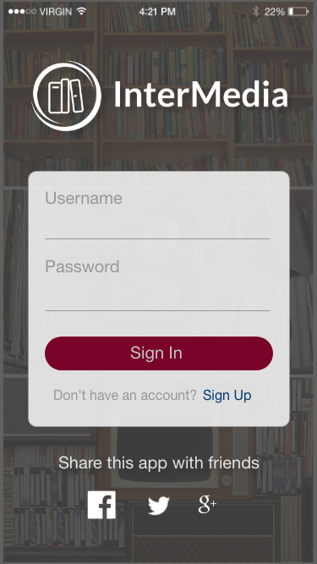 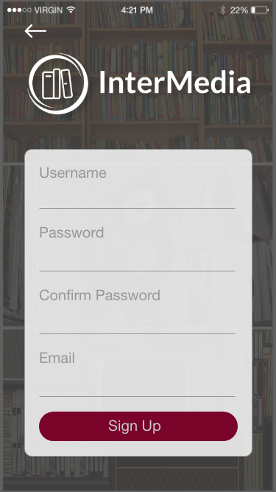

Users of the InterMedia app need to be signed in because everything will run off of their unique profile. There is also an option on the Sign In page to share the app through Facebook, Twitter, and Google +. The Sign Up page has a back arrow at the top left in case the user does not need to sign up and would like the return to the Sign In page. Both pages will take the users to the Dashboard page upon submitting the user info.

**Dashboard/Books/Movies/Music**

Upon sign in/sign up, the user is taken to the Dashboard, which is the main page of the app. The Dashboard, Books, Movies, and Music pages all have a similar layout. This is where the user will be able to browse through their collections. The Dashboard page will hold the entire collection while the other three pages will hold the different types of media’s collections.

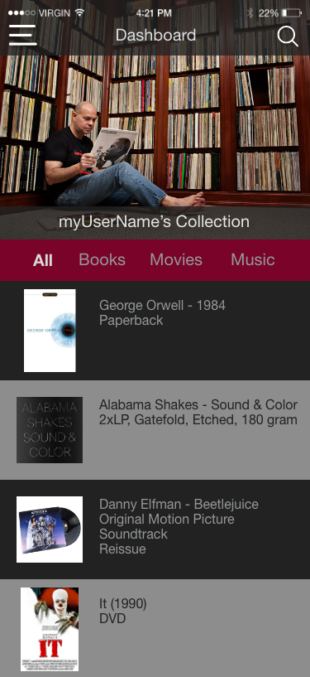 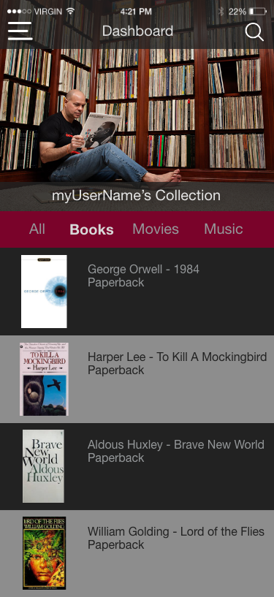

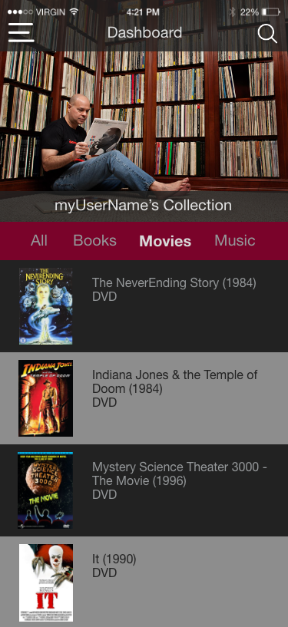 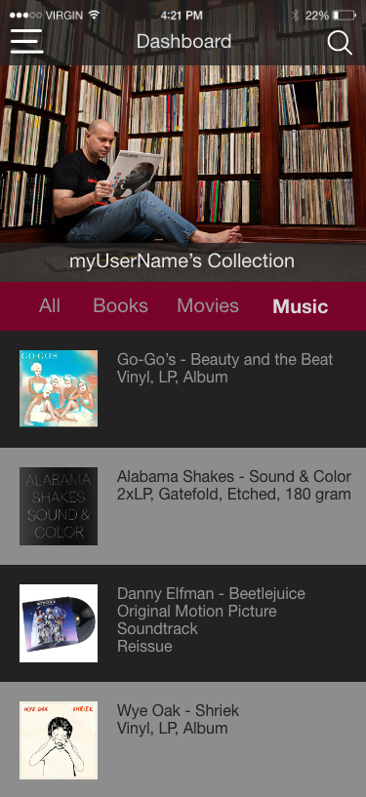

These pages allow the user to scroll through the items in their collection and click on an item to view it’s details. On the top of the page there is a menu icon on the left, sending users to a navigation page, and a search icon on the right that will take users to a search page. The Dashboard, Books, Movies, and Music pages all have a menu to navigate between the four pages, allowing users to view their entire collection or just the selected media types.

**Navigation**

The hamburger menu icon in the top left of all of the screens takes users to the navigation page. This will allow users to quickly switch to the dashboard, profile page, submission page, or search page. The navigation screen also allows users to logout of their account and return to the Sign In page. To exit the navigation page, users can click on the arrow in the top left corner.

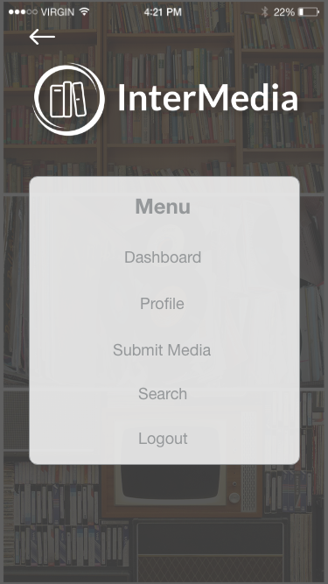

**Profile**

The profile page contains information about the user. Here you can change your profile photo, update information, and link social media accounts. Users also have access to the navigation menu and search page through the icons at the top of the page.

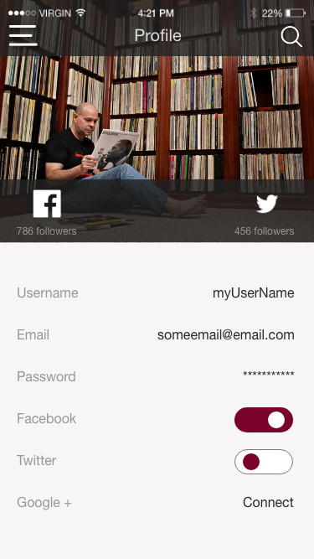

**Search**

The search page gives users the ability to search for items in the database with text input or a barcode scanner. From here, the user will be taken to the selection page for whatever item they searched for.

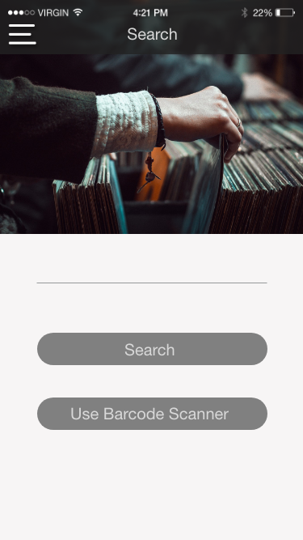

**Selection**

From the search page or by selecting an item in the dashboard, books, movies, or music page, the user is taken to the selection page. Here you can view all of the information listed for the selected item. Multiple photos may be available to view of the item. You will also have the option to add the item to your collection. If it is already in your collection, information about that will be listed under the item specifics.

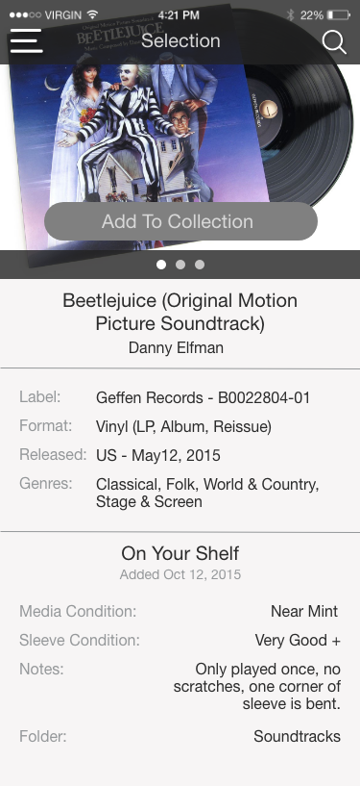

**Submit Media**

On this page, users will have the ability to submit an item to the database. You can upload multiple images and list the information for the selection. Users will have the capability to help build the community database.

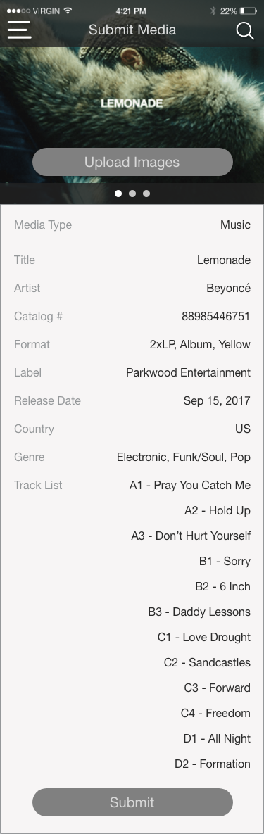

**Smartwatch**

The smartwatch design is a little more limited in it’s abilities because of the smaller screen size. Users will be able to sign in and view their dashboard, books, movies, and music in there collection. The search, submit, profile, and individual selections screens are not available for the smartwatch version.

**Sign In**

The sign in screen allows users to sign in to their accounts. The Sign Up page will not be available for the smartwatch. If guests would like to sign up for an account, they must do so on a tablet or mobile device. The screen for signing in is similar to the mobile and tablet versions featuring inputs for both the username and password.

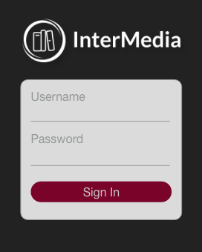

**Dashboard/Books/Movies/Music**

Upon signing in, just like the mobile and tablet versions, users will be taken to their dashboard containing all of the items in their collection. Users will be able to scroll up and down through the individual items. The Books, Movies, and Music pages all have a similar layout and navigation. To navigate between the pages, users can click on the menu button in the top left of the screen to go to the Navigation page.

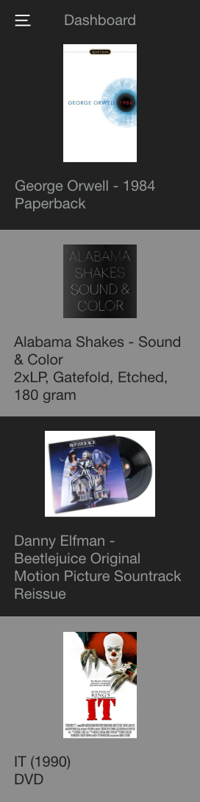 

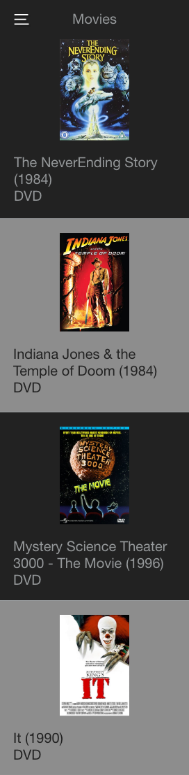 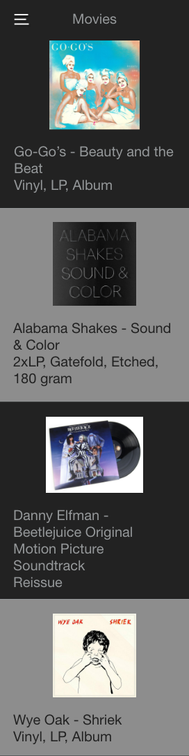

**Navigation**

The navigation page on the smartwatch version contains links to the Dashboard, Books, Movies, Music, and Logout which will take users back to the Sign In page. To exit the navigation page, users can click the left arrow location in the top left corner. This will bring users back to the Dashboard.

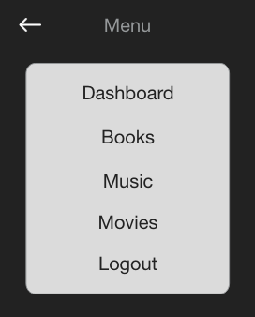**Conclusion**

The goal of InterMedia is to create a collaborative community of individuals who can contribute to the ever-growing database of different types of media. Expanding on the concept of other data storage apps, the InterMedia app allows users to catalog their entire collection in one place. Regardless if you are just starting your collection or you are a seasoned veteran, you can benefit from the features of InterMedia.