InterMedia XD Design Walkthrough

This is an introduction to the Adobe XD design of the InterMedia app used to catalog your personal collection of books, music, and movies. This app will be available for mobile, tablet, and smartwatches. InterMedia gives you the ability to create a profile, search items in the database via text or a barcode scanner, and add items to your collection. You will also have the option to submit items to the database to help expand the InterMedia library for other users.

**Mobile/Tablet Design**

**Sign In/Sign Up**

The mobile and tablet design offer the full range of options to the user. You will begin with a Sign In page where registered users can enter their username and password to login to the app. New users will have the option of clicking a link to Sign Up for an account.

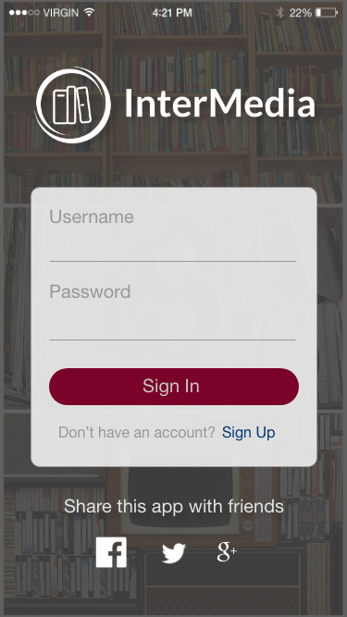 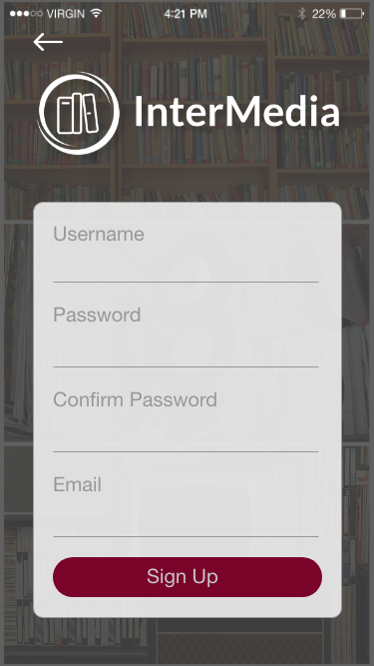

Users of the InterMedia app need to be signed in because everything will run off of your unique profile. There is also an option on the Sign In page to share the app through Facebook, Twitter, and Google +. The Sign Up page has a back arrow at the top left in case the user does not need to sign up and would like the return to the Sign In page. Both pages will take the users to the Dashboard page upon submitting the user info.

**Dashboard/Books/Movies/Music**

Upon sign in/up, the user is taken to the Dashboard or the main page of the app. The Dashboard, Books, Movies, and Music pages all have a similar layout. This is where the user will be able to browse through their collections. The Dashboard page will hold the entire collection while the other three pages will hold the different types of media’s collections.

