**ERRORS 29/9/2020**

1. CANNOT PUNCH IN AFTER PUNCH OUT (STILL NOT WORKING).
2. DASHBOARD WITH WRONG DATA
3. STILL NO CODE ON GITHUB!!! https://github.com/hrmsmaxx/HRMS-Maxx/projects
4. CANNOT CREATE PROJECT WITHOUT CLIENT (THIS WAS AND OLD REQUIREMENT)

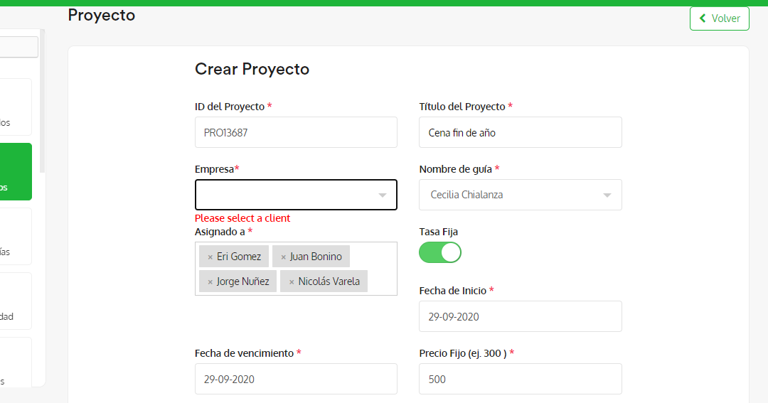

1. CHAT SEARCH BAR IS NOT WORKING PROPERLY.

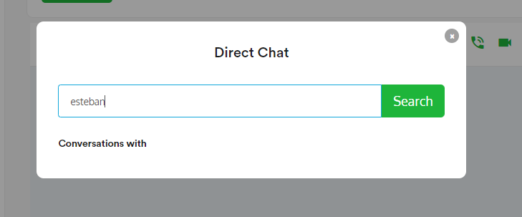

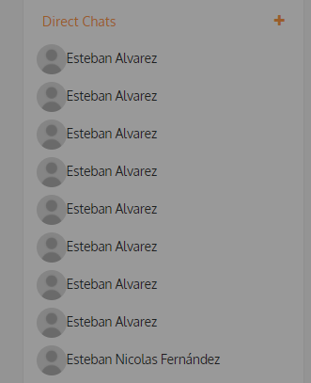it should dropdown a list with the employees to select one and chat with him.

6. CANNOT EDIT DESIGNATION OF EMPLOYEE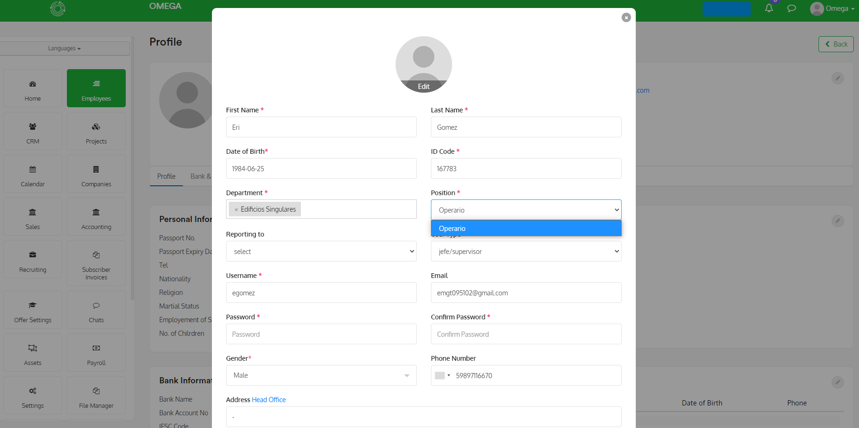

7. SYSTEM IS TOO SLOW, WE NEED TO OPTIMIZE IT.