# REPORTS

## Day report

### Description

This report has 2 columns:

* **Employee**
* **Status of the employee in the day (Present, Absent, Already left)**

The status of the employee tells us if the employee is present in the facilities (Present), if it never came (Absent) or if already left (Already left).

To obtain this information we extract the attendance logs of the employee and group them in pairs to check if it is inside the facilities, if it left the building and so on.

The order of the table is by the status of the employees.

### Filters

This report can be filtered by:

* **Employee’s code/Employee**
* **Departament**
* **Office**
* **Employee’s boss**
* **Range of time**
* **24 hours workdays**

### Graphs

This report contains graphs showing the amount of employees present in the facilities, the once who left, and the ones who are absent (never came).

### Example

|  |  |
| --- | --- |
| **Employee** | **Status** |
| Code 1 - First Name Last Name | Present |
| Code 2 - First Name Last Name | Left |
| Code 3 - First Name Last Name | Abscent |

## Access report

### Description

This report shows the information about the acces and movements of people through the facilities on a date.

It has 3 columns which are:

* **Employee’s code**
* **Employee**
* **Time**

And it also has two types of rows which are:

* One with the default information of the columns displaying the employee information with they time of access, (this gets grouped in pairs per attendances for each employee)
* If there is a pair of attendances for an employee, a new row its added displaying the time the employee was inside the building.

The order of the table is by the time of entrance (first attendance in each pair of attendances).

### Filters

We can filter this report by:

* **Device**
* **Range of time**
* **Employee’s code**
* **Employee**
* **Departament**
* **Office**
* **Employee’s boss**
* **24 hours workdays**

### Example

|  |  |  |
| --- | --- | --- |
| **Code** | **Employee** | **Time** |
| Code 1 | First Name Last Name | → 06:38:00 |
| Code 1 | First Name Last Name | ← 14:24:56 |
| Attendance time | 7:47 |  |
| Code 2 | First Name Last Name | → 06:42:00 |
| Code 3 | First Name Last Name | → 07:20:00 |

## Absences report

### Description

This report is a ranking of employees who were most or least absent depending in the filters we choose. It also has a counter for how much time they were absent in total.

It has 4 columns which are:

* **Employee’s code**
* **Employee**
* **Amount of absences**
* **Accumulated time**

The order of the table might be altered by the filter. The default order is by most absences.

### Filters

This report can be filtered by:

* **Range of time**
* **Type of order (most absences or least absences)**
* **24 hours workdays**

### Example

|  |  |  |  |
| --- | --- | --- | --- |
| **Code** | **Employee** | **Abscences** | **Accumulated time** |
| Code 1 | First Name Last Name | 2 | 16:00 |
| Code 2 | First Name Last Name | 2 | 9:00 |
| Code 3 | First Name Last Name | 0 | 0:00 |

## Late arrival report

### Description

This report is similar to the absences one, but instead it is a ranking of the late arrivals of employees. It also has a counter of how much time the employee was absent in total.

It has 4 columns which are:

* **Employee’s code**
* **Employee**
* **Number of late arrivals**
* **Accumulated time**

The order of the table is defined by the filter too, the default order is by the employees with more late arrivals.

### Filters

This report can be filtered by:

* **Range of time**
* **Type of order (most late arrivals, less late arrivals)**
* **24 hours workdays**

### Example

|  |  |  |  |
| --- | --- | --- | --- |
| **Code** | **Employee** | **Late arrivals** | **Accumulated time** |
| Code 1 | First Name Last Name | 2 | 00:25 |
| Code 2 | First Name Last Name | 1 | 0:05 |
| Code 3 | First Name Last Name | 0 | 0:00 |

## Work Code report

### Description

This report is a ranking of the most or less used work codes in a range of time.

It has 3 columns which are:

* **Work Code’s code**
* **Work Code name**
* **Times used**

The order of the table depends on the filter, the default value is the most used work codes.

### Filters

This report can be filtered by:

* **Range of time**
* **Type of order (most used or less used)**
* **24 hours workdays**

### Example

|  |  |  |
| --- | --- | --- |
| **Code** | **Name** | **Amount of uses** |
| 1 | Lunch | 20 |
| 2 | Medical appointment | 3 |
| 3 | Other | 0 |

## Extraordinary events report

### Description

This report shows the information of the days an employee had an extraordinary event such as a work time or not completing the time of their workday (due to late arrival or early leaving).

The report is divided in rows which each row has the information of each extraordinary event for each employee showing the days the employee had that event, and how much time it took.

It has 8 columns which are:

* **Employee**
* **Office**
* **Departament**
* **Days**
* **MIssing time from workdays**
* **Work code**
* **Work code time**
* **Comments**

### Filters

This report can be filtered by:

* **Range of time**
* **Employee’s code**
* **Employee**
* **Employee’s boss**
* **Departament**
* **Office**
* **Work Codes that are accepted as work time (Yes/No)**

### Example

|  |  |  |  |  |  |  |  |
| --- | --- | --- | --- | --- | --- | --- | --- |
| **Employee** | **Office** | **Departament** | **Days** | **Missing time** | **Work Code** | **Work Code time** | **Comments** |
| Code 1 - First Name Last Name | 1 - Office 1 | 1 - Administration | 1,2,6,7 | 12:00 |  |  |  |
| Code 2 - First Name Last Name | 2 - Office 2 | 2 - Marketing | 2,9,10,13 | 8:12 |  |  |  |
| Code 2 - First Name Last Name | 2 - Office 2 | 2 - Marketing | 1,2,3,4,5 | 0 | Lunch | 5:30 |  |
| Code 3 - First Name Last Name | 1 - Office 1 | 1 - Administration | 1,2,5 | 1 | Medic | 6:24 |  |

## Departament workday report

### Description

This report shows the information about work days of a departament and how much time they worked, how much time they were late, as how much time they missed of the work day.

It has a header with filtered information:

* **Departament**
* **Range of time**

And has 5 columns:

* **Workday**
* **Amount of work time**
* **Amount of late arrivals**
* **Amount of missing work time**
* **Employee’s codes from late arrivals and missing work time.**

### Filters

It can be filtered by:

* **Departament**
* **Range of time**

### Example

|  |  |  |  |  |
| --- | --- | --- | --- | --- |
| Departament | All | Dates | 06/01/2020 00:00 - 07/01/2020 00:00 |  |
| Workday | Work | Late arrivals | Missing work | Faulty employee’s |
| 1 - Workday 1 | 11:50 | 00:10 | 3:10 | Code 3 |
| 1 - Workday 2 | 15:00 | 00:00 | 0:00 |  |

## Attendance report (can be configured)

### Description

This report shows the information of the attendances for each employee with all its information broken down. It can be configured by the user, automatically applying filters to it as to choose which columns and in what order they want it to display them.

The columns available with the default order are:

* **Date**
* **Workday:** information of the workday for the date (time of entrance and leave, and the amount of time required to work) Also if its absence without a justification it should mark it as that, as if the day is marked with a justification it should display the justification.
* **Amount of work**
* **Amount of late arrival**
* **Amount of missing work**
* **Amount of extra time**
* **Work codes:** it has all the totals of time of each work code used per date

Each page of the report shows the information of an employee.

In the header of each page we have the basic information of an employee: Code - First Name Last Name

Each next row is a date from the range of time selected, if the date has attendances it will have an extra row below showing the information of each attendance (time of arrival and time of leave of each one)

At the bottom of the page, there are rows displaying the total values of each columns and other information such as:

* **Total of reported days**
* **Days the employee should have worked**
* **Days the employee actually worked**
* **Days the employee was absent**
* **Total of time that the employee should have worked**
* **Total of amounts of time for all the work codes used**
* **Totals for the columns configured**: below each column of work/ late arrival/ missing time/ extra time it should display the sum of each.

### Filters

This report can be filtered by:

* **Employee’s code**
* **Employee**
* **Work code**
* **Departament**
* **Office**
* **Employee’s boss**
* **Range of time**
* **Day**
* **Type of day**
* **Round attendances**: round time of attendance to exact time of entrance and leave for each workday
* **Hide attendance logs**:
* **Just totals**
* **24 hours workdays**

### Example

|  |  |  |  |  |  |  |
| --- | --- | --- | --- | --- | --- | --- |
| Date | Workday | Work | Late arrival | Missing work | Extra time | Work code |
| Code 1 - First Name Last Name | | | | | | |
| 01-01-2020 - Friday | Turno 1 (06:00) | 7:52 |  |  | 1:52 | Work code 1: 7:52 |
|  | → 10:04:18 (Work code 1) | ← 17:56:01 (Work code 1) | | | | | |
| 02-01-2020 - Saturday |  |  |  |  |  |  |
| 03-01-2020 - Sunday |  |  |  |  |  |  |
| 04-01-2020 - Monday | Unjustified absence |  |  | 06:00 |  |  |

## Attendance period closing

### Description

This report shows in a practical way the result of the attendance report, but with the ability to edit these attendances and close them to mark them and prevent them from being edited in the future.

It has the next columns:

* Employee
* Dates (each next column is a date of the period of time)

In each date we can see displayed a set of icons:

* **Green check**: this means the employee completed the amount of time it should work this date (work time >= workday time).
  + **Orange check**: This is also displayed if it did more than it should have done (extra time ==> work time > workday time).
* **Yellow check**: this means the employee had a late arrival.
* **Red cross:** this means the employee did not completed the amount of time it should have worked in the date (work time < workday time)

If the user clicks on any tick, it will prompt a modal with the information of attendance for the date of the check mark where we could see each attendance record, add new ones, or edit them.

The user closing and the user supervising the date to be closed can accept the extra time of the day (if it has) or decline it, making it for the system to count this extra time this day or not.

Finally it can also mark the day as closed, which will inform the boss of the user to supervise this day to mark it as completed.

### Filters

This report can be filtered by:

* **Employee’s code**
* **Employee**
* **Departament**
* **Turn**
* **Year**
* **Period (can be configured for the company, can be weeks, biweeks, a month, daily, etc)**

### Example

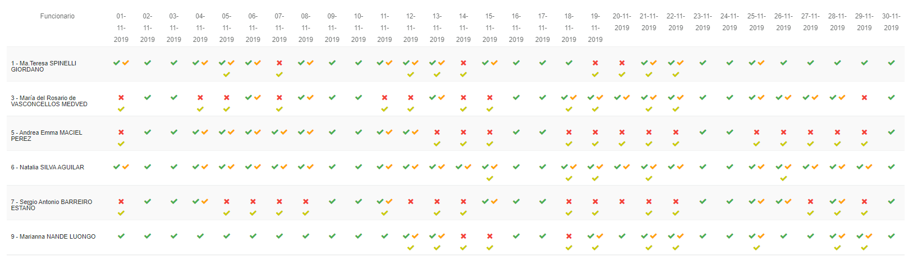

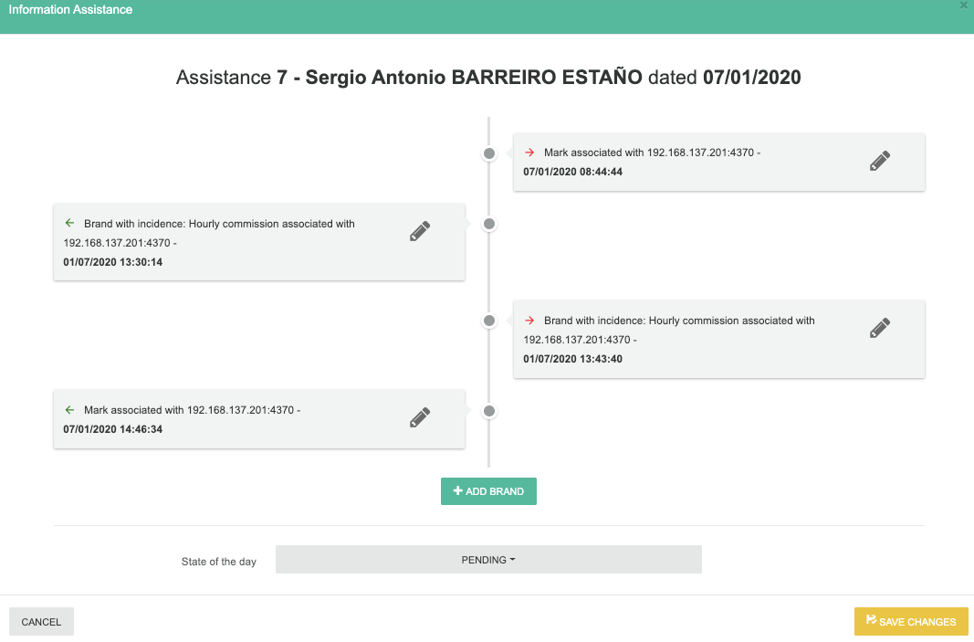

## Standard report

### Description

This report shows the information about the configured standards in the company of departaments and shows the comparison between the standard and the real value of time it had.

It has 1 defined column and a set of variables extra column:

* **Date**
* **And after, a column per each standard defined**

### Filters

This report can be filtered by:

* **Range of time**
* **Departament**
* **Workday**
* **Location**

### 

### 

### Example

|  |  |  |
| --- | --- | --- |
|  | 1- Workday 1 07:00/15:00 1 - Departament 1 | 1 - Location 1  STANDARD/REAL | 2- Workday 1 15:00/21:00 1 - Departament 1 | 1 - Location 1  STANDARD/REAL |
| 01-01-2020 - Wednesday | 8/8 | 8/0 |
| 02-01-2020 - Thursday | 8/9 | 9/0 |
| 03-01-2020 - Friday | 8/8 | 10/10 |

## Horizontal Attendance report

### Description

This report shows the information of the attendances for each employee with all its information broken down. It can be configured by the user, automatically applying filters to it as to choose which columns and in what order they want it to display them.

The columns available with the default order are:

* **Employee’s code**
* **Employee’s first name**
* **Employee’s last name**
* **Office**
* **Departament**
* **Job title/Position**
* **Attendance device**
* **Date**
* **Workday:** information of the workday for the date (time of entrance and leave, and the amount of time required to work) Also if its absence without a justification it should mark it as that, as if the day is marked with a justification it should display the justification.
* **Workday amount of hours expected**
* **A column for each attendance log displaying the time of the attendance log**
* **Amount of work**
* **Amount of late arrival**
* **Amount of missing work**
* **Amount of extra time**
* **Work codes:** it has all the totals of time of each work code used per date
* **Amount of week hours**
* **Amount of month hours**

### Filters

This report can be filtered by:

* **Employee’s code**
* **Employee**
* **Work code**
* **Departament**
* **Office**
* **Employee’s boss**
* **Range of time**
* **Day**
* **Type of day**

### Example

|  |  |  |  |  |  |  |  |  |  |  |  |  |  |  |  |  |  |  |
| --- | --- | --- | --- | --- | --- | --- | --- | --- | --- | --- | --- | --- | --- | --- | --- | --- | --- | --- |
| **Code** | **First name** | **Last name** | **Office** | **Dep.** | **Position** | **Device** | **Date** | **Workday** | **Expected work** | **Att. time 1** | **Att. time 2** | **Amount of work** | **Late arrival** | **Missing work** | **Extra time** | **Work**  **Code** | **Week hours** | **Month hours** |
| 1 | First name | Last name | 1 | 1- Dep | 1 - Pos | 1- Att. clock | 01/01/2020 | 09:00 to 18:30 | 8:30 | 9:00 | 18:30 | 9:30 | - | - | - | - | - | - |
| 2 | First name | Last name | 1 | 1- Dep | 2 - Pos | 1- Att. clock | 02/01/2020 | 08:00 to 17:30 | 8:30 | 8:00 | 17:30 | 9:30 | - | - | - | - | - | - |

## Employee used workcodes report

This report aims to display all the information about the used work codes of employees, with the amount of time used per work code.

The columns available with the default order are:

* **Employee’s code**
* **Employee’s first name**
* **Employee’s last name**
* **Office**
* **Work Code name**
* **Work Code code**
* **Amount of time used**

### Filters

This report can be filtered by:

* **Employee’s code**
* **Employee**
* **Work code**
* **Departament**
* **Office**
* **Employee’s boss**
* **Range of time**

### Example

|  |  |  |  |  |  |  |
| --- | --- | --- | --- | --- | --- | --- |
| Code | First name | Last name | Office | Work Code’s name | Work Code’s code | Amount of time |
| 1 | First name | Last name | 1 - Main | Lunch | 1 | 00:30 |

## Access statistics dashboard

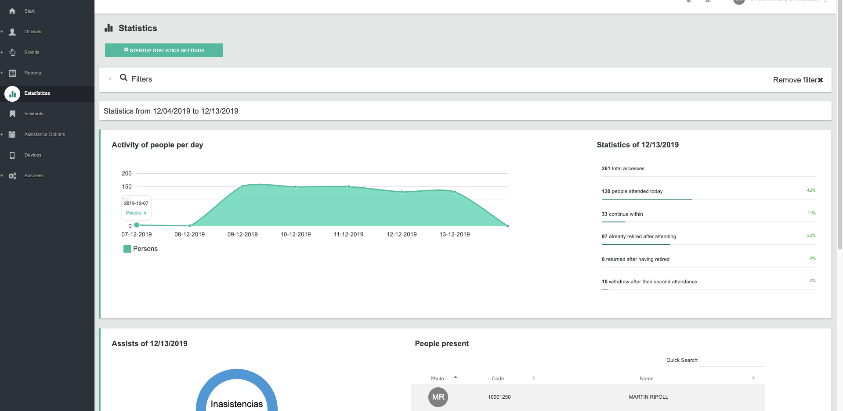

There is a dashboard with statistics of access that works filtering the information of attendances per day.

In the graph from above we can see the amount of people that logged an attendance in the current week, and in the back to that the same graph with the previous week to contrast the difference between the two weeks.

In the right column, there is a list of information displayed:

* Total of attendances logged today
* Total of people that attended today
* Total of people that are currently inside
* Total of people that left after coming (were inside but left)
* Total of people that came back after leaving
* Total of people that left after coming back.

Below this, we can see a real time listing of device events, such as the report explained next to this one

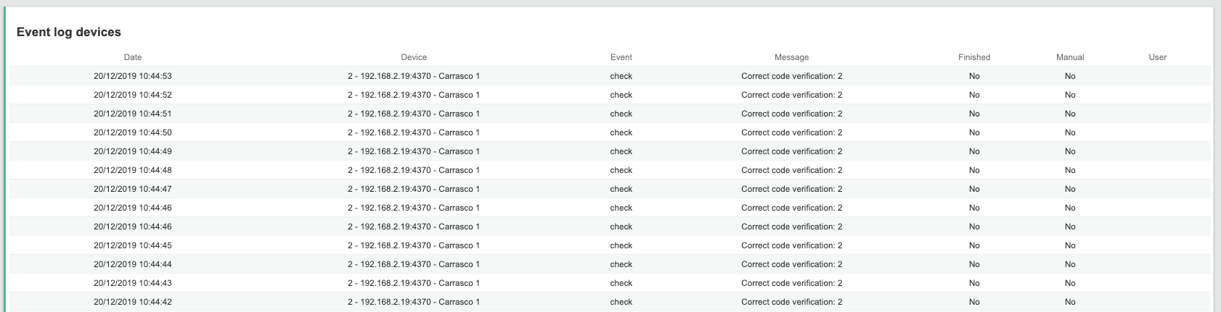

These rows are configured to show or hide them as the next modal displays.

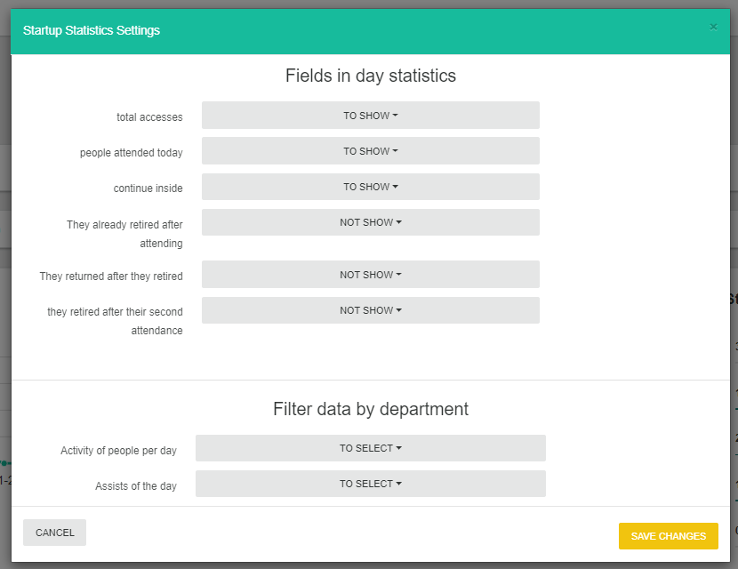

We can also filter all the dashboard information by department, and other filters may apply, such as offices, bosses, etc.

In the part below in the dashboard we can see two things.

On the left is another type of pie chart showing the totals of people who are present, that left and that are absent.

And at the right we have some tables (that we can change clicking the menu buttons above) that lists the people by the next things:

* Currently present
* Had a late arrival
* Absent
* Already left

In this same panel we get blocks of alerts:

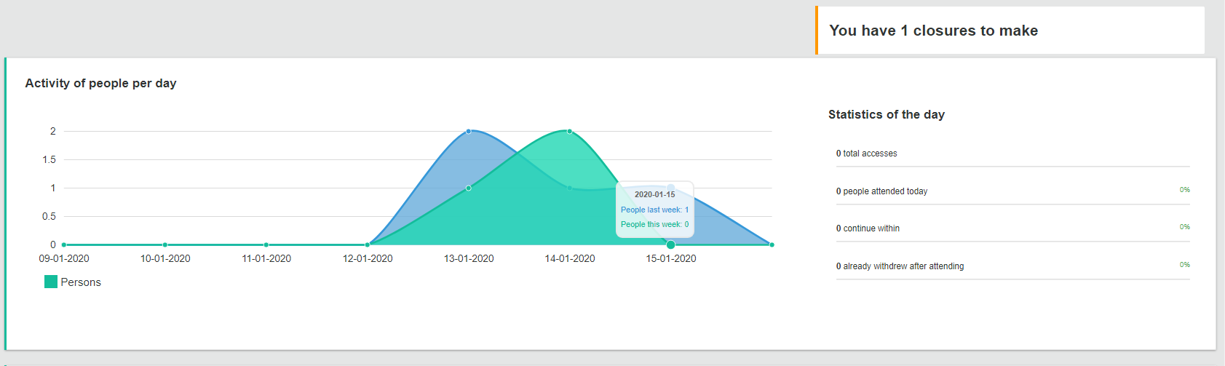

* First one is if you have any attendance closure to fill, as the system expects people to confirm the attendances of the day and close them with the closure report.
* The second one is an alert by a date of liquidation of salaries.

Both things are defined for the company in their configuration

Setting for attendance closure

## 

Salaries alert

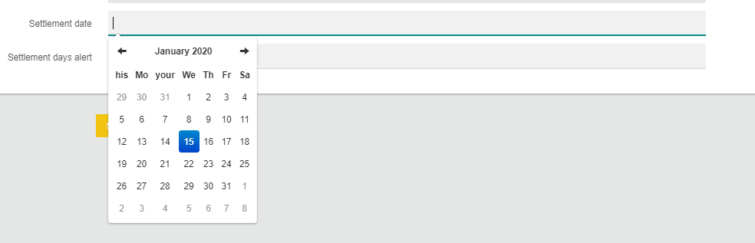

## Device events report

### Description

This report shows the information about all the events that occured in devices.

It has 1 defined column and a set of variables extra column:

* **Date**
* **Time**
* **Device**
* **Event**
* **Message**
* **Finished (Yes/No)**
* **Manual (Yes/No)**
* **User that executed it**

### Filters

This report can be filtered by:

* **Range of time**
* **Device**
* **Event**
* **Type of event**

### Example

|  |  |  |  |  |  |  |  |
| --- | --- | --- | --- | --- | --- | --- | --- |
| Date | Time | Device | Event | Message | Finished | Manual | User |
| 21/01/2020 | 10:48:55 | 1- 192.168.1.100 | Attendance log consumption | 34 attendance downloaded | Yes | No | - |
| 22/01/2020 | 10:45:32 | 1- 192.168.1.100 | Attendance log consumption | 40 attendances downloaded | Yes | No | - |

## 

## Automatically sending reports

Employees can have configured in their company profiles an email and an extra configuration where it can be set to send automatically a type of report, usually attendance records with the filter of the employee for it to be aware of the attendances he/she has registered and keep up with them if there are any errors. This automation can be configured by any period of time desired.