**INDEX**

Those are the changes we want to make; please check point by point before start and your determinate what you must do first in order to minimize the time of development!

1. **- SHIFT ADJUSTMENTS**
   1. **MULTIPLE SHIFT**
   2. **Recurring shift**
   3. **Free shift**
2. **- implementations and bug fixes**
   1. **FIRST POINT: SHIFTS**
   2. **SECOND POINT: *MODEL AN INSTANCE WITH SEVERAL VIEWS***
   3. **THIRD POINT: *DEPARTMENT MULTIPLE CHOICE***
   4. **FOURTH POINT: *LOG MESSAGE***
3. **- ROLLS & PERMISSIONS (DEPTARTAMENT EDIT/VIEW)**

**SHIFT ADJUSTMENTS**

* **MULTIPLE SHIFT: are not working properly**

*In the Recovery document we asked for this:*

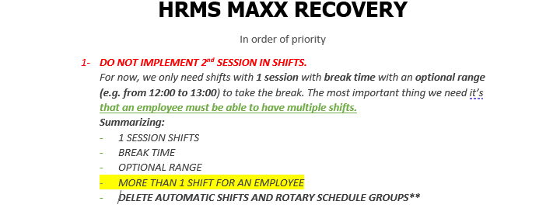

**But** in Asana Anupriya wrote this:

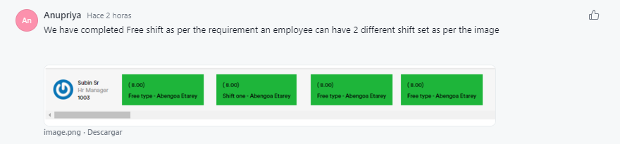

Quote: “an employee can have 2 different shift”, this is not what we required.

An employee can have multiple shifts, for example: in the morning from 8 AM - 3 PM (from monday to friday) and another in the night from 10 PM - 1 AM (from thursday to saturday).

And in the schedule this is how it should be displayed:

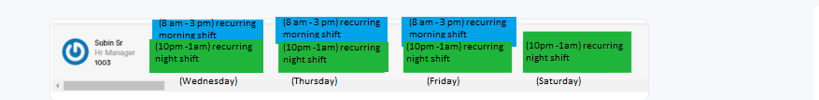

* **Recurring shift** ERROR**:**

The situation is this:

When we select "recurring shift" what we want to create, it is a shift that can go from Monday to Sunday and can select a single day, or more.

Examples:

**1 -** Work on Mondays and Wednesdays from 8am to 12pm

**2 -** Work on Saturdays form 10 am to 16pm

Currently, the recurring shift only allows to create a shift that is between Monday and Friday and has a minimum of 3 days, if not I get the following message in red:

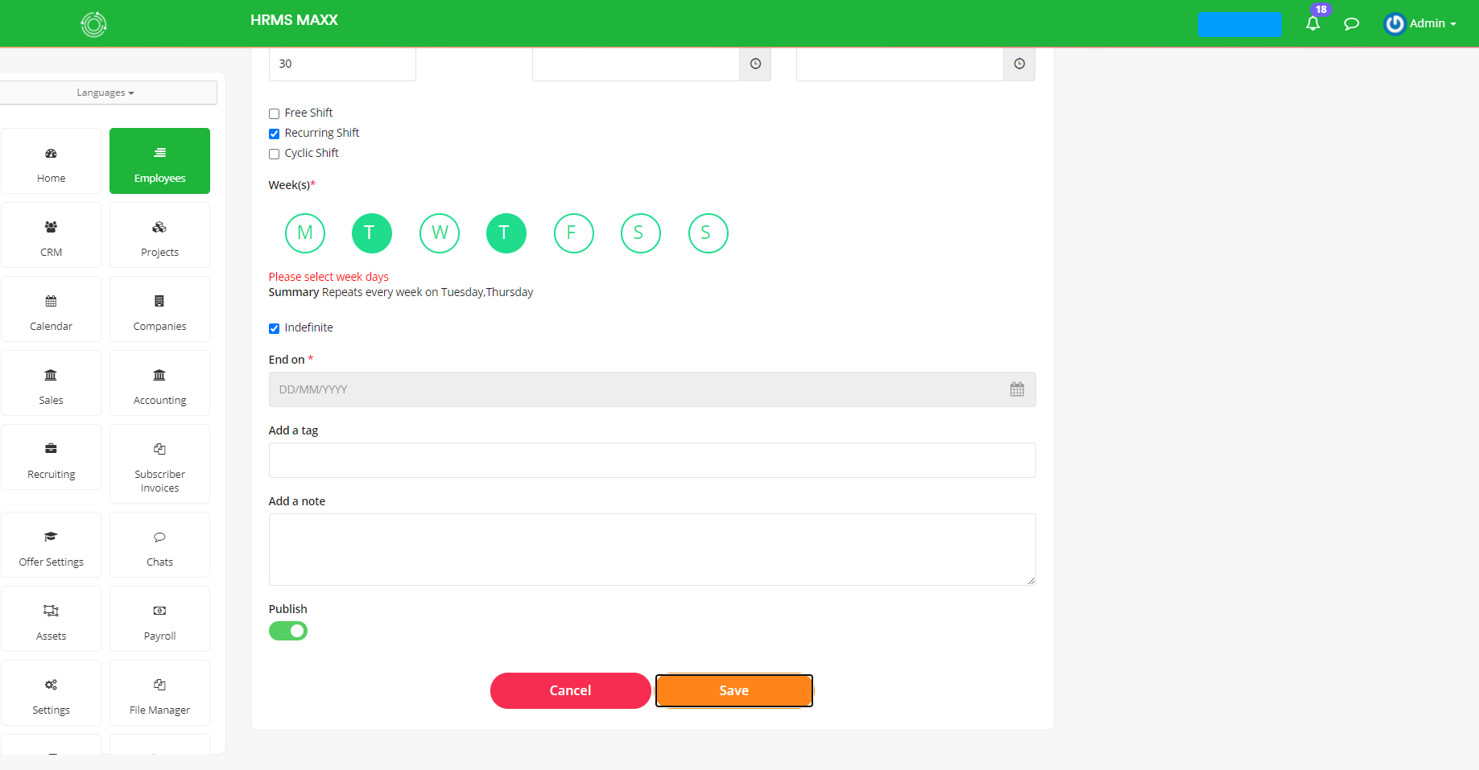

* **Free shift** ERROR**:**

The situation is this:

When we create a "free shift" it is a shift like any other, so we have to be able to determine day or the days (like in “recurring shift”) the shift will be applied, the amount of hours the employee must to complete along the day or also in determinate range that should be OPTIONAL.

Example:

An employee who works on Monday, Wednesday and Friday has a fixed schedule (a recurring schedule) but on Tuesday and Thursday he only has to *comply with 6 hours of work in the afternoon,* so in this case we want to create a *free shift* that ONLY applies on Thursday and Friday and has a range from *14:00 to 18:00*.

Free shift turn should look like this:

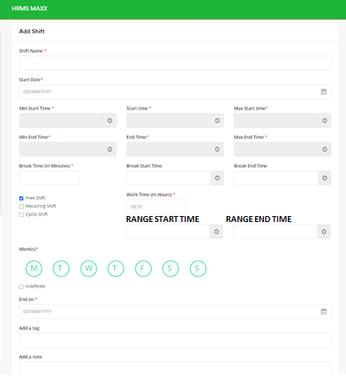

**implementations and bug fixes:**

**FIRST POINT: SHIFTS**

**TYPES:**

* **Free**
* **Recurring**
* **Cyclic**

**CHARACTERISTICS IN COMMON:**

* All of them should allow multiple assignments
* All of them, also should have the option to be assigned to a Project*

About this point *, we want to implement this in order to see in timesheet to see the hours that each employee dedicated to each project.

Nowadays, there is already a way to do this and that is for each employee to enter the TIMESHEET module and enter the number of hours that they dedicate to each project, but now we want to implement a **new way** of doing it.

**NEW WAY:**

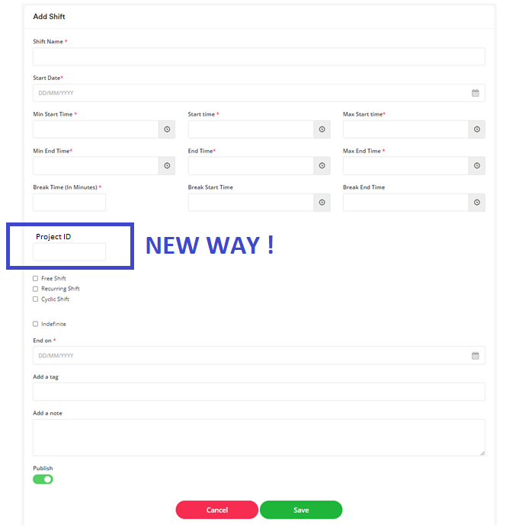

Making this connection, it will be able see the hours that each employee dedicated to each project reflected in TIMESHEET.

Example 1:

If Cristian Rodriguez has the shift assigned with id = 1 and said shift has the Project with id = PRO72184, as the days go by, the hours dedicated to said project will AUTOMATICALLY increase.

DAY 1: Cristian works 10 hours

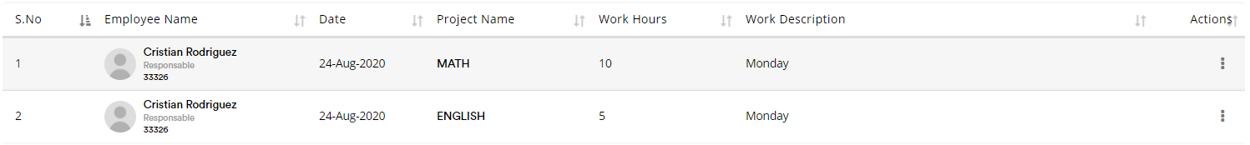

DAY 2: Cristian works 5 hours, so the hours dedicated until the moment are 15

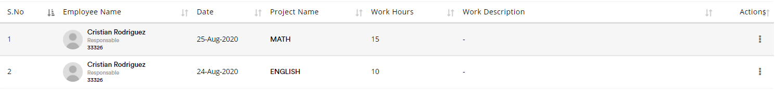

As employees can have more than one assigned shift, therefore they can have more than one assigned project. For this reason, another good example would be the following.

Example 2:

If today Cristian works 10 hours in the PROJECT "Mathematics" and 5 hours in the PROJECT "English", the TIME SHEET should look like this:



But if tomorrow, Cristian works 5 hours in the "Mathematics" PROJECT and 10 hours in the "English" PROJECT, the DATE must be updated in the TIME SHEET and the WORKING HOURS must increase the value as follows: HOURS OF CURRENT JOB + HOURS OF WORK TODAY.



At the end of the month, we are going to want to download a REPORT or an EXCEL, which tells how many hours each employee spent on each project.

Later that, based on this information, different payment receipts will be generated:

* OPTION 1: One pay stub per project
* OPTION 2: A single salary receipt but that details the amount of hours that were dedicated to each project and if you earn different $ per project that is detailed for example: "300 hours x 255 $", then a final result of hours and money and from there, the necessary deductions are made
* OPTION 3: A single salary receipt that specifies the number of hours that were dedicated to each project and that the total hours are multiplied by a single value, example: "total hours x $ 200"

**NOTE: We want to make OPTIONAL that a Project belongs to a Company**

This is another example of what we want to represent connecting Shifts with Projects:

* 8.00 / 12.00
* 13.00 / 17.00

=123

DEPARTAMENTS

KINDERGARDEN

BELONGING TO

PROJECTS

* LEVEL 4
* LEVEL 5

WORKS IN

HAS THE FOLLOWING SCHEDULES

EMPLOYEE

SHIFTS

TEACHER

CONNECT SHIFTS WHIT PROJECT

**SECOND POINT: *MODEL AN INSTANCE WITH SEVERAL VIEWS***

BUSINESS SITUATION:

**INSTANCE**

**VIEW 1**

**VIEW 2**

**VIEW 3**

EXAMPLE:

There is a business that wants to implement the system HRMS MAXX in one instance but they have 3 different branch office so, they want 3 different view in such a way that only the employees who belong to each view can see it.

Points to consider:

* Sometimes one employee works in more than one branch office so in that case, those employee need access the view of each branch.
* There must be one *superadmin* who can see every view of the company with only one user.
* We need to make reports filtering by locations.

ALSO, exist the case in which several businesses (an economic group)belong to one but them are independent of each other so we are going to need a *hiperadmin* who with the same username can sign in into the different instances and views.

*\*Color reference: hiperadmin – superadmin - views*

**THIRD POINT: *DEPARTMENT MULTIPLE CHOICE***

We want to be able to put an employee in more than one Department, so we require a multiple choice like this:

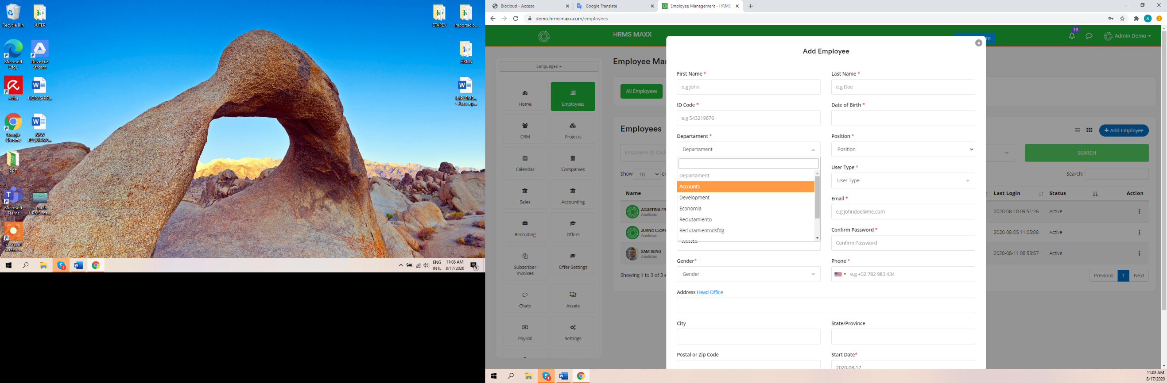

This, must be reflected in the employee shit data import to in certain way like if a put “Maintenance, Support” in Department column, the system recognize that this employee belong to the department “Maintenance” and “Support”.

*\*We also want that in the column “Department” in the file “Employee data import” put “1,2,3” and the system recognize that I am putting this employee in the departments id=1 and id=2 and id=3.*

**FOURTH POINT: *LOG MESSAGE***

*We want a LOG MESSAGE after making an importation who tells us if everything was imported well or in which rows was found an error.*

*For example, when we import the shifts and the column “Min End Time” and “End Time” were not imported well, a log message should notice us about it.*

*We want 4 different way can see/know the entire output error:*

* *pop-up windows*
* *mail to* [*soporte@hrmsmaxx.com*](mailto:soporte@hrmsmaxx.com) *with the message and the log output error file*
* *log output which we can download as a .txt*
* *put the log as a notification*

LOG MESSASGE EXAMPLE: **SUSCRIBE**

*We want a pop-up windows that ask us “Do you want to overwrite the existing data?” when we made an importation and the data base recognize that some data fields already exist.*

# **ROLLS & PERMISSIONS (DEPTARTAMENT EDIT/VIEW)**

We have a situation we need to modulate.

We have a company.

The boss (admin) can manage & edit the entire instance company.hrmsmaxx.com, but below the boss there a supervisors (leaders) for different departments.

For example: Sup 1 leads dept 1, sup 2 leads dept 2, etc.

What we want is that employees can view, edit info, edit/assign shifts, edit/add incidents, add attachments ONLY FOR EMPLOYEES UNDER THEM.

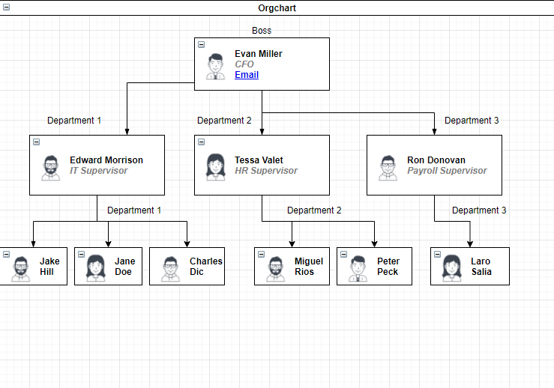

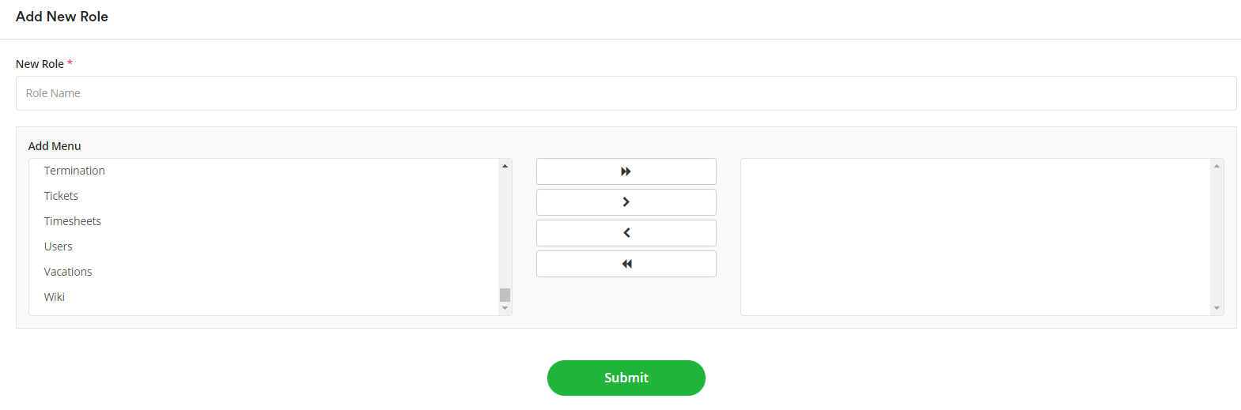I think we can modulate this making some changes in Role & Permissions.

Here we tried creating a roll for Edward Morrison (Supervisor Department 1) that only allows him to view and edit (edit info, edit/assign shifts, edit/add incidents, add attachments) the employees from department 1, which are: Jake, Jane and Carlos. But the only options from the menu we tried for the roll did not work as planned; “Departments”, “All Employees”, “Shift and Schedule” gave Edward access to view and edit every employee, even the boss Evan Miller.

We want to have in the Menu the next options: “Department 1”, “Department 2” and “Department 3”. So, we can create a roll for Edward with the permission to department 1 so he can ONLY VIEW/EDIT the selected department, he must not view or edit any other employee.

***Idea:***

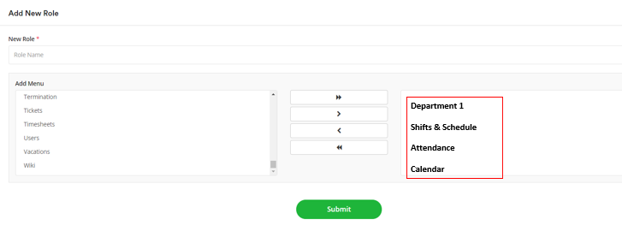

Note: if it gives you problems. The view is not mandatory. If Edward can see all the employees from the company is not a problem**, but he must be able to only edit the ones from the department selected in his roll.**

**IN ADDITON:**

When creating a new employee “A” we have the option “reports to:” where we can insert the id of an employee “B” that “A” will report to. This could also give “B” the authorization to edit and view “A”.