CAPSTONE PROJECT WEEKLY ACCOMPLISHMENT REPORT
Team Name: SysIgnite Section: 3D Date: August 10-14, 2026
Project Title: DocuTrack: An Integrated HRMS for Digital Document Tracking and Routing in Government Offices

Accomplishment for the week
Task / Activity | Description of Work Done | Output / Evidence
Notification and Escalation Monitoring | Reviewed DocuTracker notifications for overdue documents, failed auto-routing, and items requiring administrator intervention. | 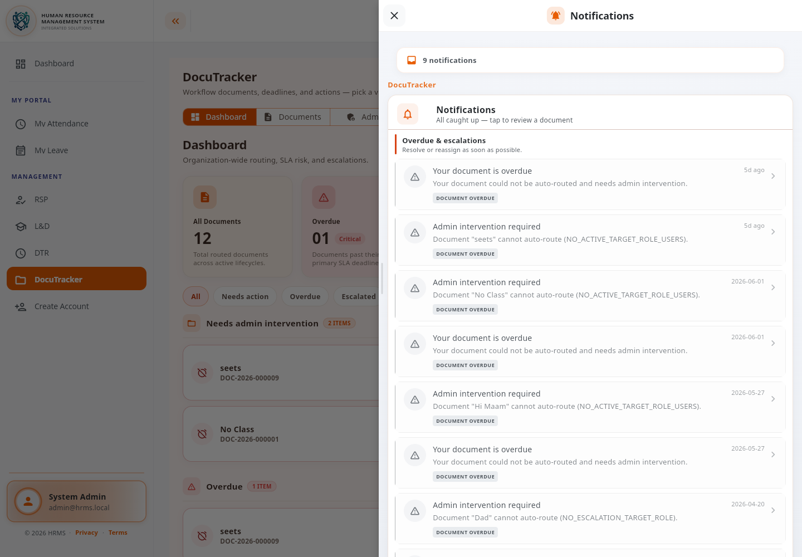
Document Routing and Workflow Review | Reviewed the full document route, active and pending workflow steps, assigned reviewers, and document status progression. | 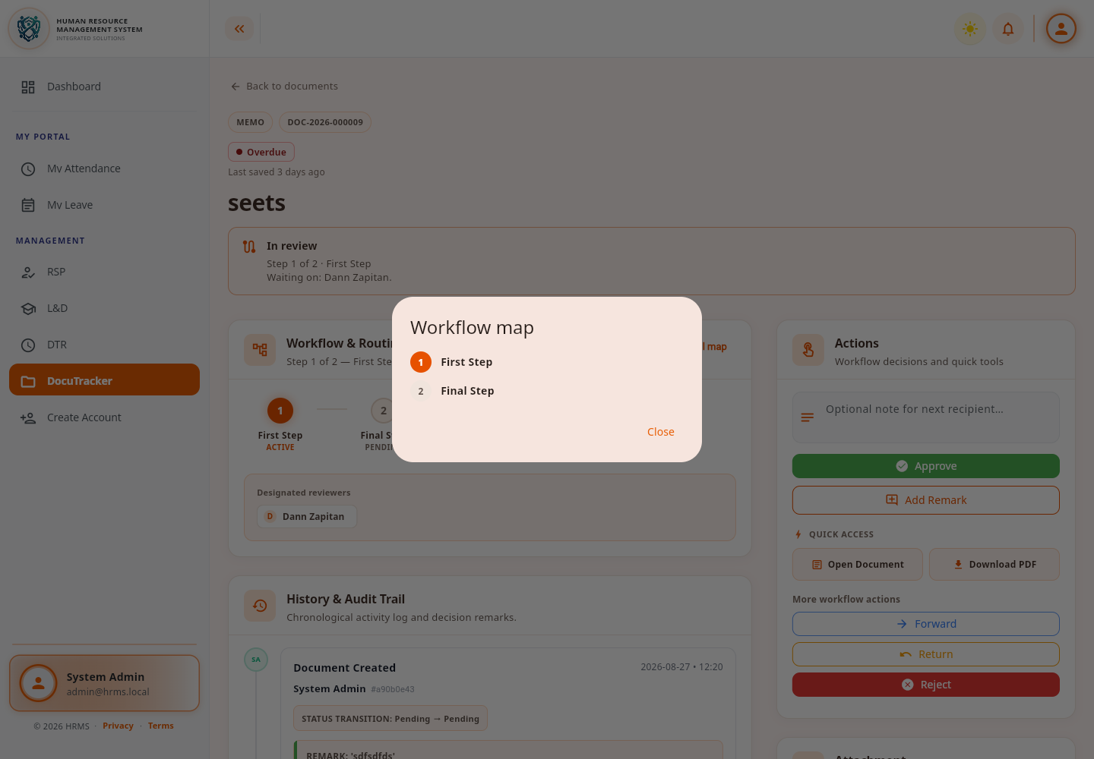
Workflow Assignee Configuration | Reviewed and configured primary and backup reviewers and the actions allowed for each workflow step. | 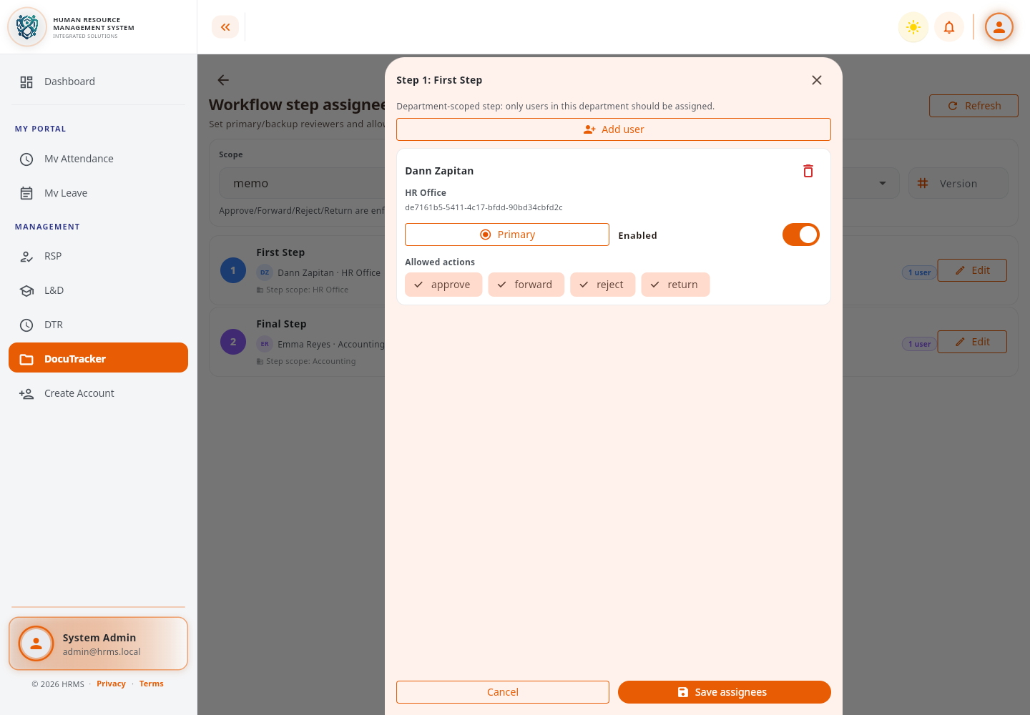

Individual Contribution
Team Member | Contribution
Dann Kristoffer D. Zapitan | Reviewed and configured DocuTracker notifications, document routing, workflow steps, and assignee settings.
Cathrina Gallemit | Tested the system and provided feedback on the implemented features.
Ryza Mae Bongcac | Tested DocuTracker functions and contributed to reviewing the project output.
Edgar Jr. Tac-an | Assisted in system testing and contributed general feedback for improvement.

Issues Encountered and actions taken
Issues / Concerns | Action Taken
Some overdue documents required administrator intervention. | Reviewed the notifications and identified routing or escalation settings requiring correction.
Some workflow steps had incomplete or unclear reviewer assignments. | Reviewed the route map and verified the designated reviewers for each step.
Assignee roles and allowed actions needed to be checked for consistency. | Reviewed the step-assignee configuration and documented the required updates.

Plan for the next week
Plans for Next Week | Expected Output
Continue validating document routing, notifications, and assignee settings. | More reliable DocuTracker workflow behavior.
Review document lists, statuses, deadlines, and administrative controls. | Verified document monitoring and workflow-management screens.

Adviser's Remarks

Reviewed by:
Mr. Ginbert A. Fernandez
Capstone Project Adviser
Date Signed:

