CAPSTONE PROJECT WEEKLY ACCOMPLISHMENT REPORT
Team Name: SysIgnite Section: 3D Date: August 17-20, 2026
Project Title: DocuTrack: An Integrated HRMS for Digital Document Tracking and Routing in Government Offices

Accomplishment for the week
Task / Activity | Description of Work Done | Output / Evidence
Document Workflow Review | Reviewed the document list and detail views, including document types, statuses, deadlines, and current holders. | 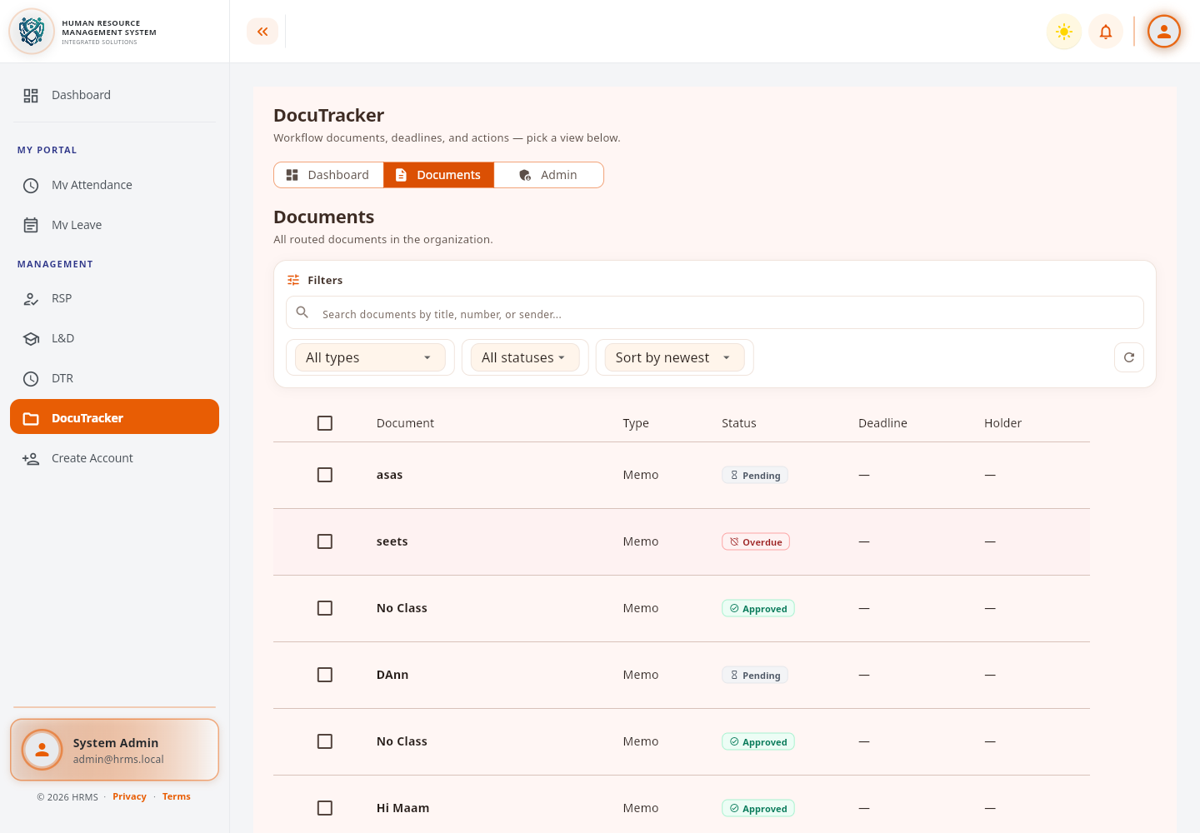
Dashboard and Notification Checking | Checked dashboard alerts for overdue escalations and rejected documents and recorded cases needing follow-up. | 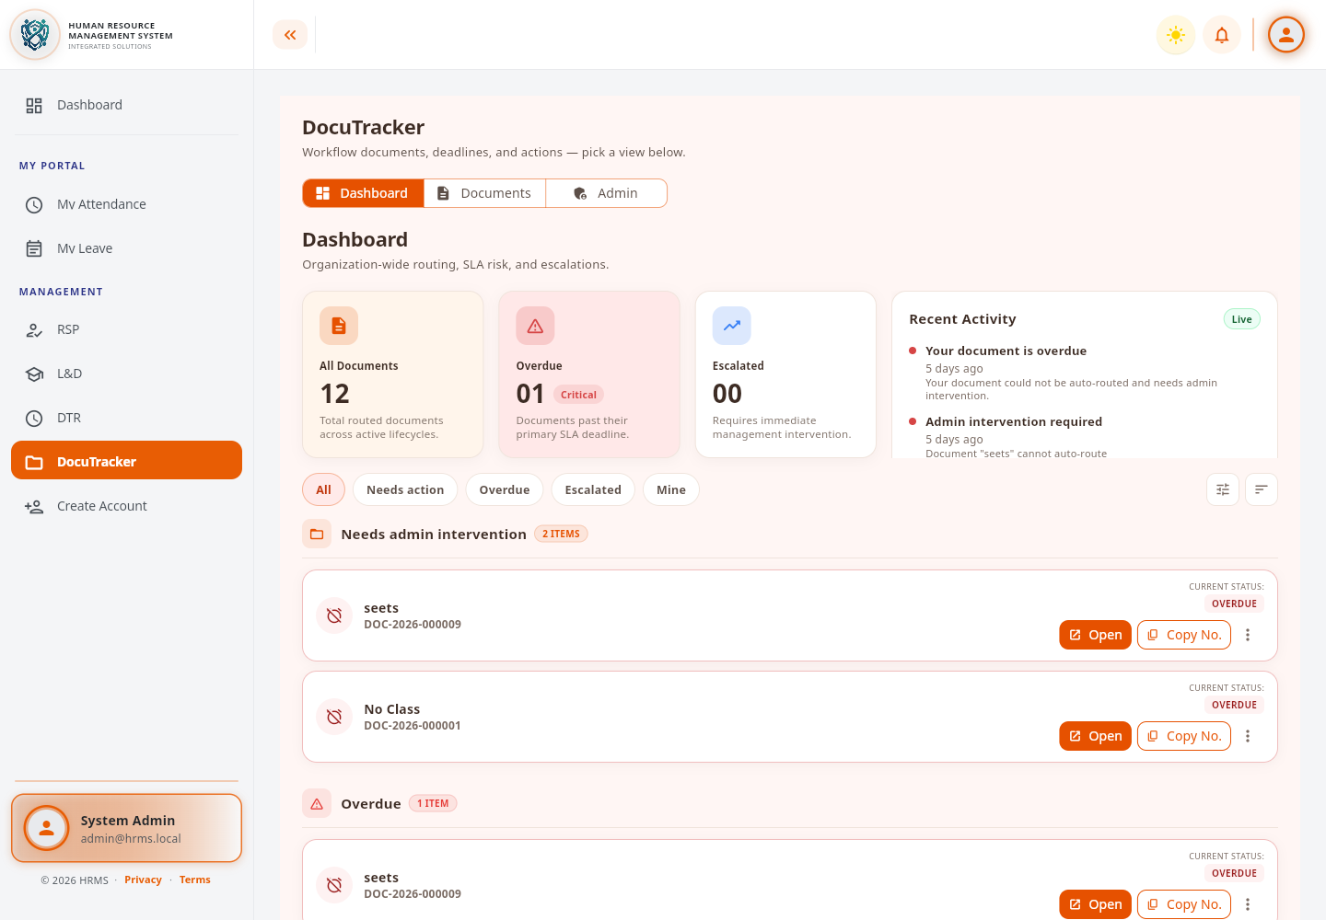
Workflow Step Assignee Review | Reviewed memo workflow steps and their assigned users to identify missing or inconsistent routing assignments. | 

Individual Contribution
Team Member | Contribution
Dann Kristoffer D. Zapitan | Reviewed and tested the DocuTracker document list, dashboard notifications, workflow routing, and step-assignee configuration.
Cathrina Gallemit | Tested the system and provided feedback on the implemented features.
Ryza Mae Bongcac | Tested DocuTracker functions and contributed to reviewing the project output.
Edgar Jr. Tac-an | Assisted in system testing and contributed general feedback for improvement.

Issues Encountered and actions taken
Issues / Concerns | Action Taken
Some overdue documents had no current holder or deadline. | Recorded the affected cases and recommended assigning a holder and valid deadline.
Some routing steps had incomplete escalation target information. | Documented the missing configuration for correction in the workflow setup.
Workflow assignee settings needed consistency checks. | Reviewed the configured users per step and listed the assignments requiring updates.

Plan for the next week
Plans for Next Week | Expected Output
Correct workflow assignee and escalation configuration issues. | More reliable document routing and escalation behavior.
Review DocuTracker permissions, audit behavior, and database scripts. | Validated access rules and an organized implementation plan.

Adviser's Remarks

Reviewed by:
Mr. Ginbert A. Fernandez
Capstone Project Adviser
Date Signed:

