CAPSTONE PROJECT WEEKLY ACCOMPLISHMENT REPORT
Team Name: SysIgnite Section: 3D Date: August 24-28, 2026
Project Title: DocuTrack: An Integrated HRMS for Digital Document Tracking and Routing in Government Offices

Accomplishment for the week
Task / Activity | Description of Work Done | Output / Evidence
Governance Audit and Workflow Controls | Implemented and reviewed governance-audit records, permission-related screens, and strict workflow action handling. | 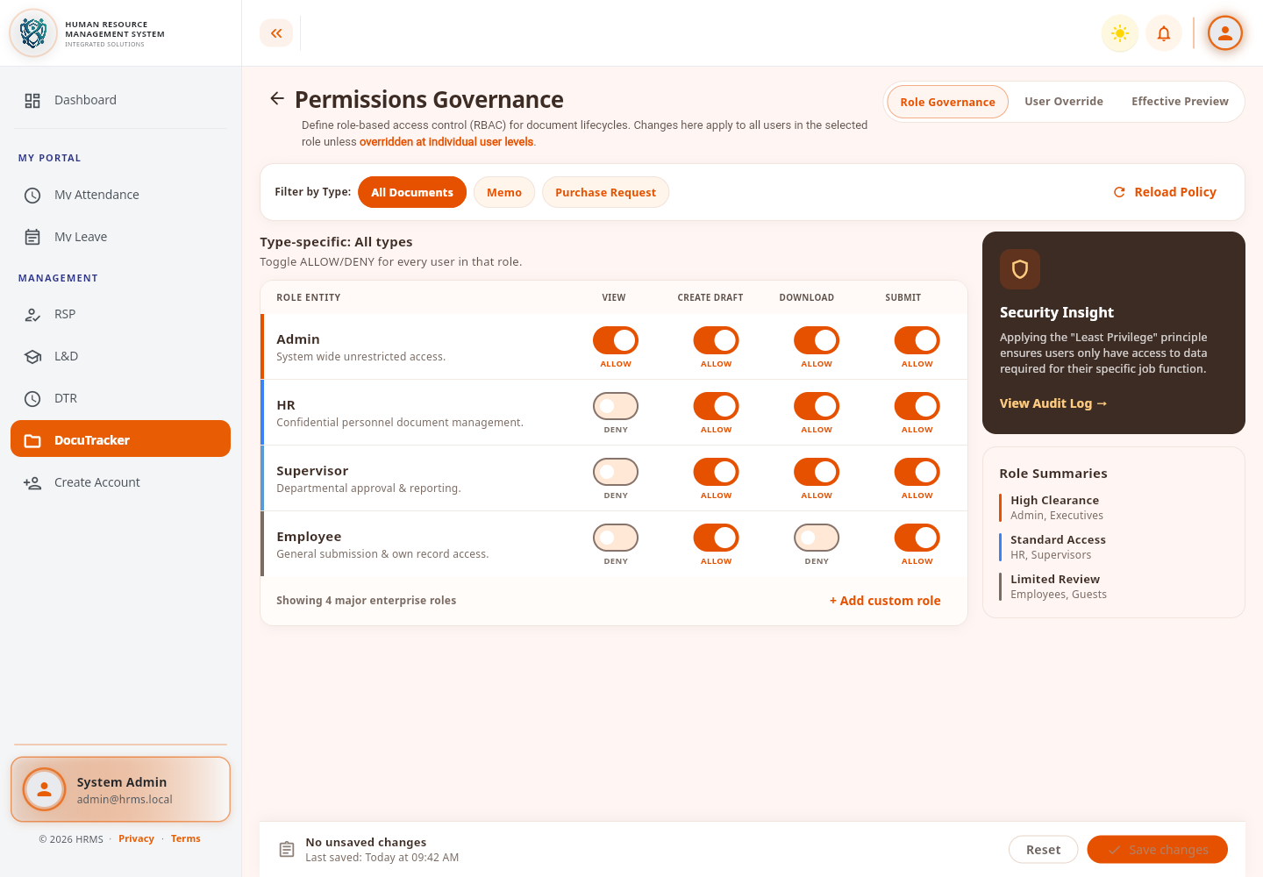
Step Assignees, Escalation, and Database Setup | Fixed primary-assignee deletion behavior, improved escalation configuration, organized DocuTracker SQL migrations, and validated the configured database migration. | 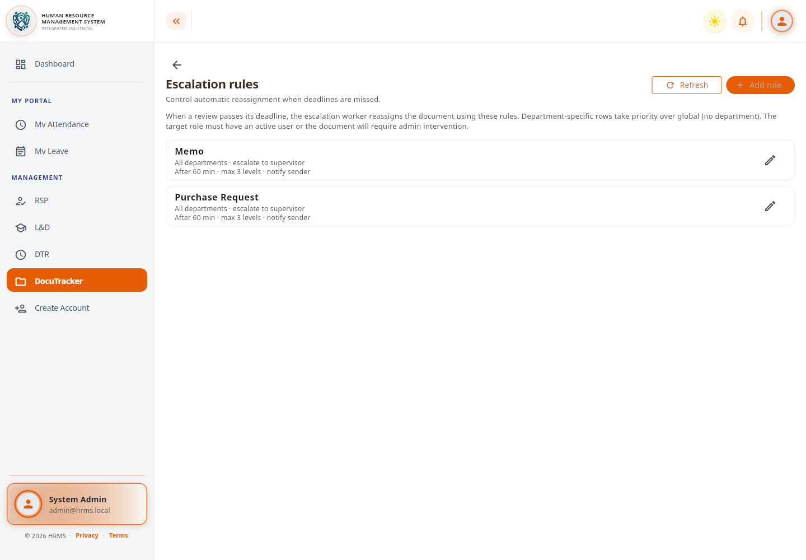
Document Builder and E-signature Placement | Implemented the document builder with signature-field placement and connected the frontend, API, workflow service, and database migration. | 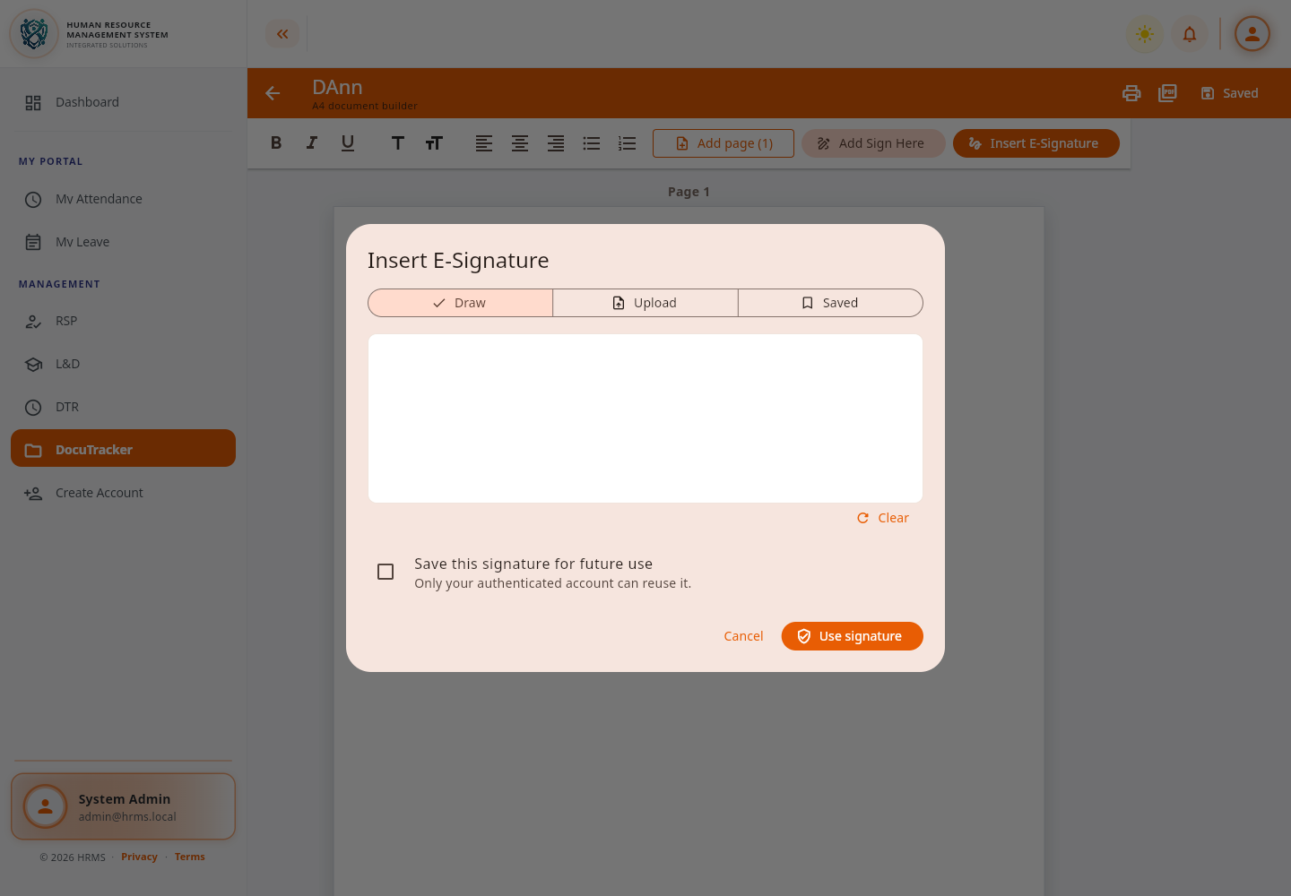

Individual Contribution
Team Member | Contribution
Dann Kristoffer D. Zapitan | Implemented the DocuTracker governance, permission, escalation, workflow-assignee, database, document-builder, and e-signature improvements.
Cathrina Gallemit | Tested the system and provided feedback on the implemented features.
Ryza Mae Bongcac | Tested DocuTracker functions and contributed to reviewing the project output.
Edgar Jr. Tac-an | Assisted in system testing and contributed general feedback for improvement.

Issues Encountered and actions taken
Issues / Concerns | Action Taken
Deleting a primary workflow assignee could leave an invalid assignment state. | Added safeguards and corrected the step-assignee deletion behavior.
DocuTracker SQL scripts were scattered and difficult to apply in order. | Created a dedicated migration folder and an ordered installation process, then verified the migration.
The document builder needed persistent signature placement and traceable signed actions. | Added signature placement support, related migration changes, workflow integration, and tests.

Plan for the next week
Plans for Next Week | Expected Output
Refine document-builder export and signature rendering. | Consistent document and signature appearance in generated PDF files.
Expand builder tests and update API/schema documentation. | Better regression coverage and documentation aligned with the implementation.

Adviser's Remarks

Reviewed by:
Mr. Ginbert A. Fernandez
Capstone Project Adviser
Date Signed:

