CAPSTONE PROJECT WEEKLY ACCOMPLISHMENT REPORT
Team Name: SysIgnite Section: 3D Date: August 31-September 4, 2026
Project Title: DocuTrack: An Integrated HRMS for Digital Document Tracking and Routing in Government Offices

Accomplishment for the week
Task / Activity | Description of Work Done | Output / Evidence
Document Builder Refinement | Improved the document-builder editing flow and synchronized builder data between the provider, repository, backend route, and generation service. | 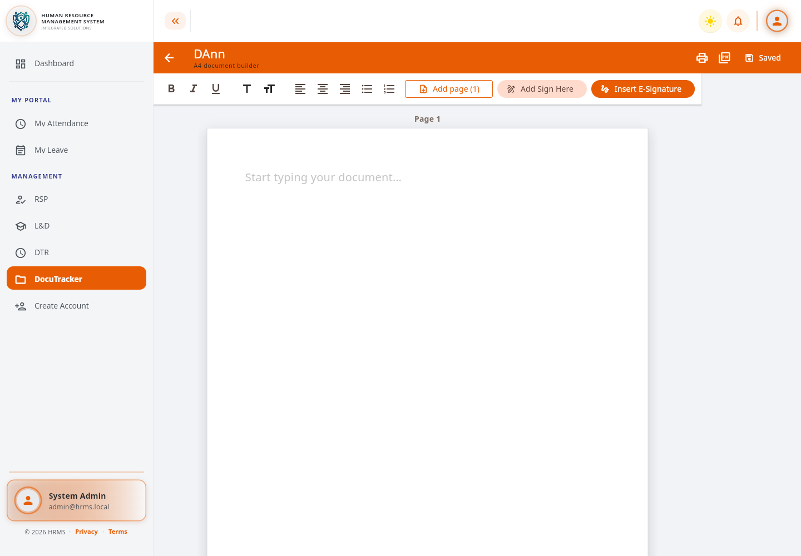
PDF Export and Signature Geometry | Added PDF export support and reusable signature-position calculations so signature fields retain their intended placement in generated documents. | 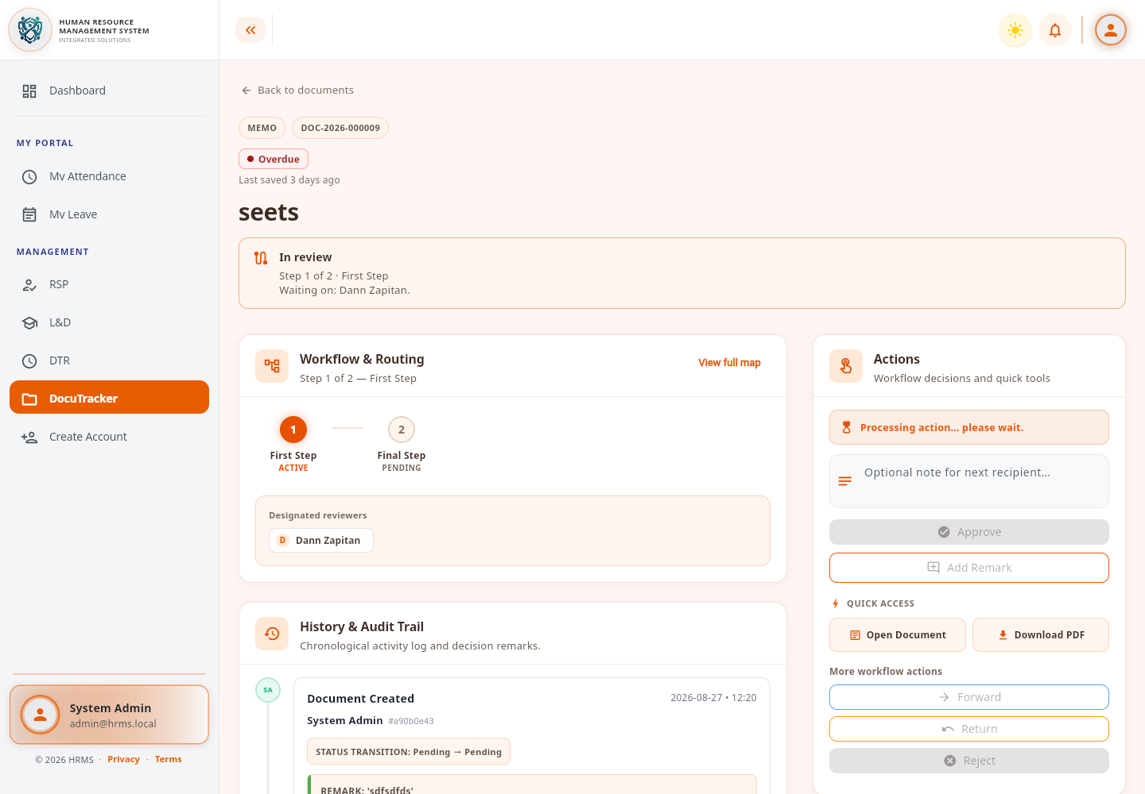
Workflow and Permission Integration Review | Reviewed document routing, workflow actions, permission behavior, and document-builder access after the latest changes. | 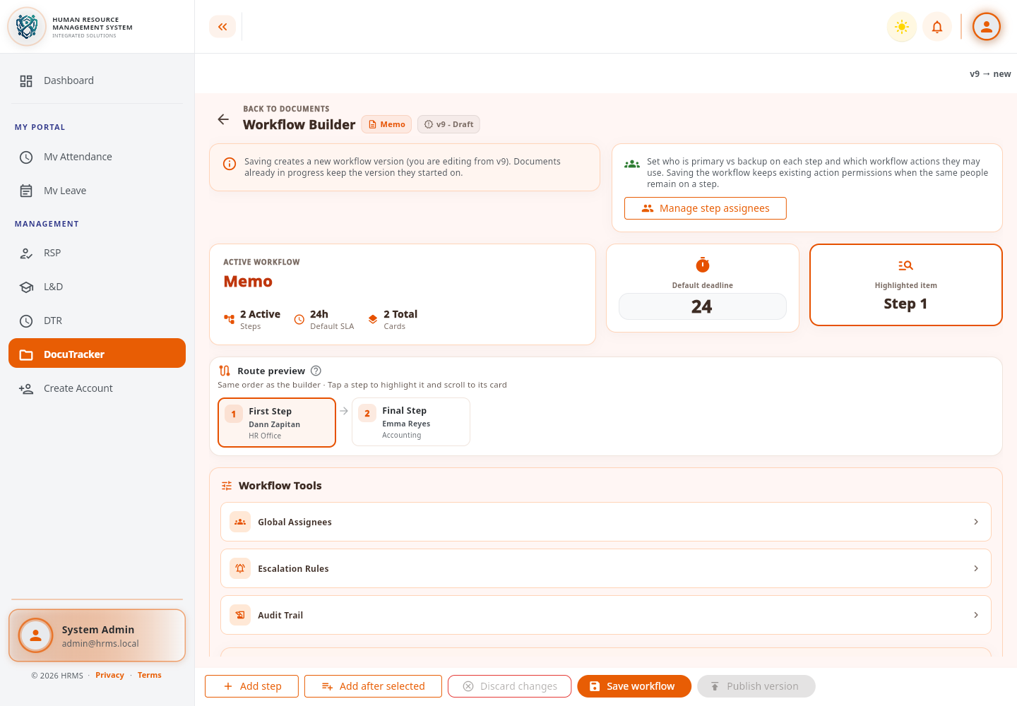

Individual Contribution
Team Member | Contribution
Dann Kristoffer D. Zapitan | Refined the document builder, signature handling, PDF access, workflow integration, tests, and technical documentation.
Cathrina Gallemit | Tested the system and provided feedback on the implemented features.
Ryza Mae Bongcac | Tested DocuTracker functions and contributed to reviewing the project output.
Edgar Jr. Tac-an | Assisted in system testing and contributed general feedback for improvement.

Issues Encountered and actions taken
Issues / Concerns | Action Taken
Signature fields could appear at inconsistent positions between the editor and exported document. | Centralized signature geometry calculations and added a reusable field visual.
Builder export behavior needed stronger regression coverage. | Added focused export and document-builder tests for the updated behavior.
Frontend and backend builder contracts needed to remain synchronized. | Updated the model, provider, repository, route, service, and API/schema documentation together.

Plan for the next week
Plans for Next Week | Expected Output
Complete end-to-end testing of document creation, signing, and PDF export. | A verified builder workflow across supported screen sizes and user roles.
Finalize documentation, evidence, and remaining manuscript updates. | Submission-ready technical documentation and accomplishment evidence.

Adviser's Remarks

Reviewed by:
Mr. Ginbert A. Fernandez
Capstone Project Adviser
Date Signed:

