CHAPTER IV

RESULTS AND DISSCUSSIONS

- Discussions
This study aimed to develop DocuTrack, the digital document tracking and routing module of UNITY PILLAR, for government offices. The module focuses on electronic document registration, configurable routing, monitoring, review, and recording of document transactions. It is intended to address difficulties in manual document processing, including delayed routing, misplaced files, limited status visibility, and reliance on paper-based follow-up. The following discussions present the major objectives of the study and explain how the documented DocuTrack functions respond to the identified needs.
Discussion No. 1. To provide a centralized digital platform for document registration, submission, and storage.
The document creation and submission features allow authorized personnel to record document information, attach supporting files, and prepare documents for electronic processing. A centralized record is intended to make transaction information easier to locate and to reduce dependence on manually updated logbooks. Document-scanning capabilities should be described as a completed result only after verifying them in the actual system.
Discussion No. 2. To facilitate organized document routing, review, and approval across authorized personnel.
DocuTrack is designed to support a configurable sequence of document-processing steps. Based on the workflow described in Chapter III, designated personnel can receive assigned documents, provide remarks, and perform permitted actions such as approval, forwarding, returning, or rejection. Workflow configurations and role-based permissions help determine who is allowed to act at each stage. The documented design supports accountability by associating document actions with the users responsible for them.
Discussion No. 3. To provide document status monitoring, transaction history, and timely updates.
The document tracking and history functions are intended to let authorized personnel view the current status of a document, its assigned reviewer, and the actions recorded during processing. Notification functions are designed to inform users about assignments or relevant changes. These functions may help reduce repeated manual inquiries; however, the pilot questionnaires alone cannot establish actual reductions in processing time or delays.

4.2 Screen Design
This section presents the DocuTrack interfaces by feature and user role. Like the format used in the companion UNITY PILLAR manuscript, each screen is identified with a numbered figure and followed by a brief description of its purpose. The researchers should replace the labeled screenshot spaces with actual captures from the working DocuTrack application. The feature descriptions are based on Chapter III; functions not yet implemented or verified must be revised or omitted before final submission.

4.2.1 System Login and Authentication

Figure 20. DocuTrack Login Interface

Figure 20 shows the DocuTrack login interface for authorized personnel. Registered users enter their credentials to access system functions associated with their accounts. Access restrictions help ensure that confidential documents and administrative controls are available only to permitted users.

4.2.2 Administrator Dashboard
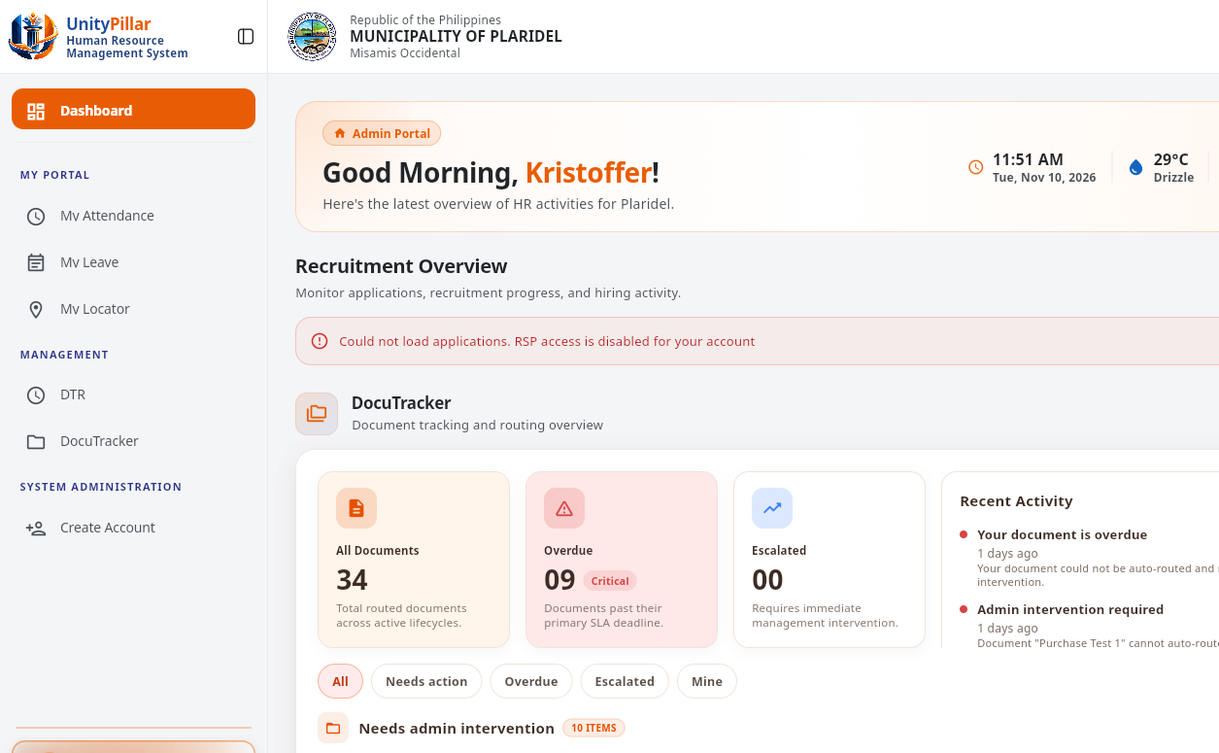
Figure 21. DocuTrack Administrator Dashboard

Figure 21 shows the administrator DocuTracker home after sign-in. The summary presents document volume, overdue and escalated counts, and recent activity.

4.2.3 Employee Dashboard
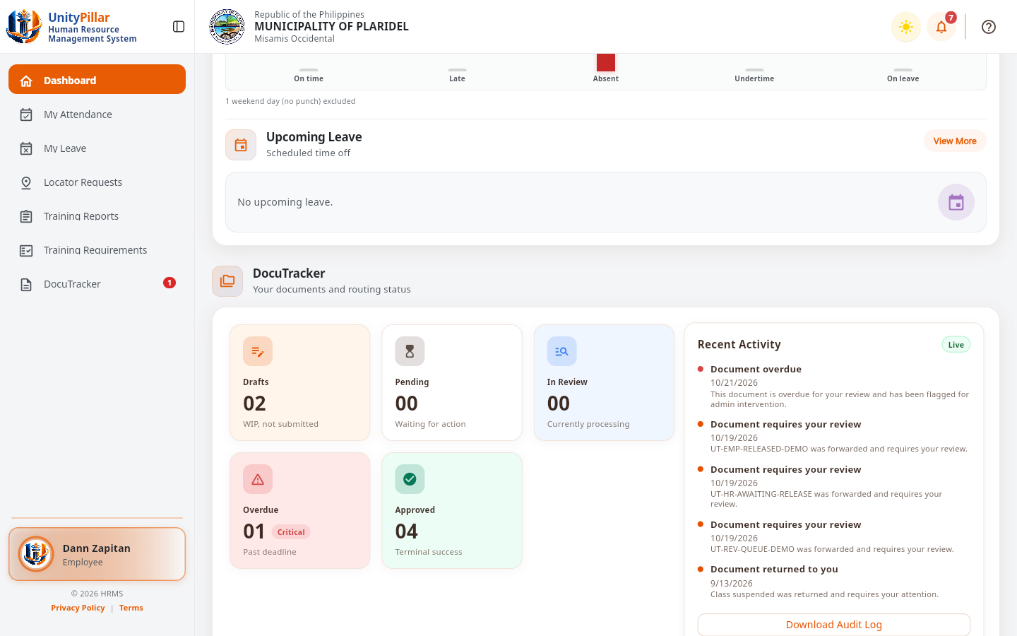
Figure 22. DocuTrack Employee Dashboard

Figure 22 shows the employee portal dashboard for Dann Zapitan. The DocuTracker card summarizes drafts, pending, in-review, overdue, and approved documents, along with recent DocuTracker activity.

4.2.4 Document Creation and Submission
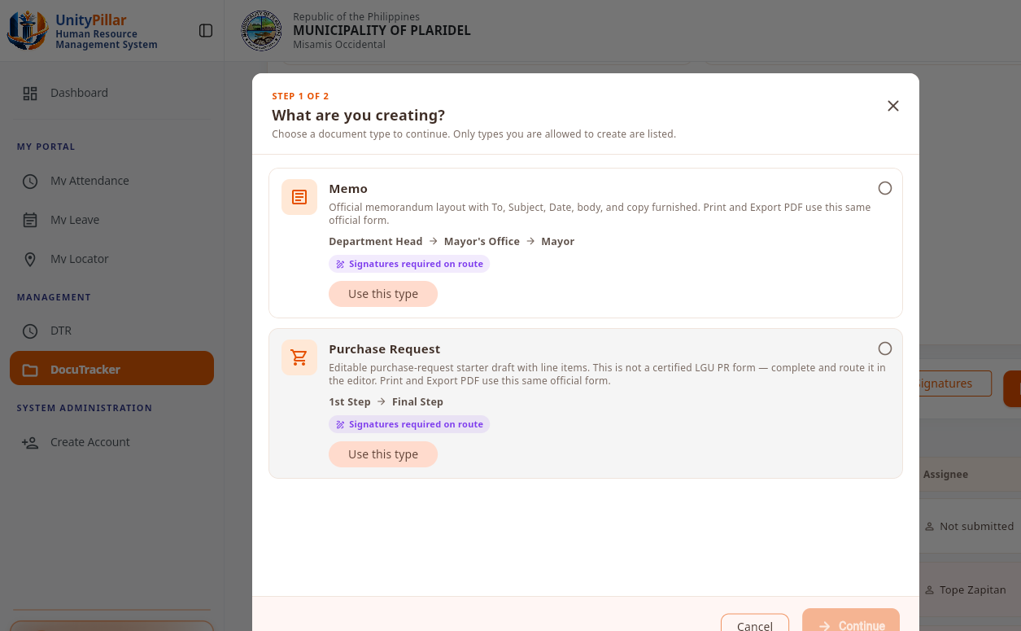
Figure 23. Document Creation and Submission Interface

Figure 23 shows the Create Draft type picker. The available native types in this screen are Memorandum and Purchase Request. The draft was not created during this capture.

4.2.5 Document Management and File Attachments
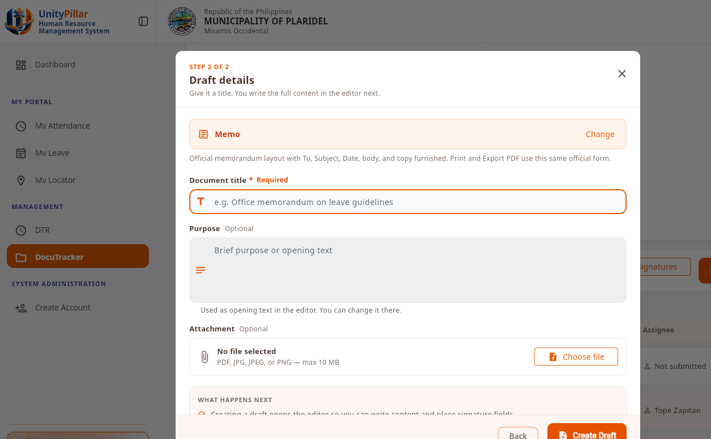
Figure 24. Document Management and File Attachments Interface

Figure 24 shows the draft details step, including the optional attachment field. Accepted attachment types are PDF, JPG, JPEG, and PNG, with a maximum size of 10 MB.

4.2.6 Document Routing and Workflow Configuration
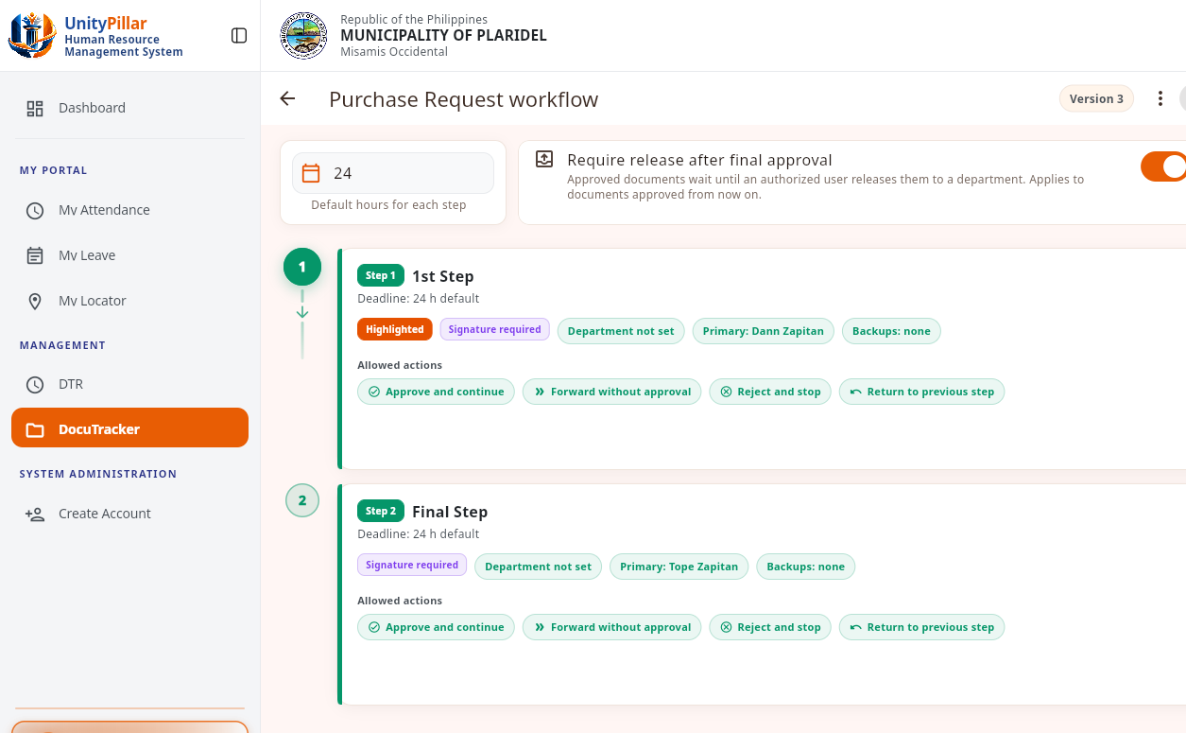
Figure 25. Workflow Configuration and Routing Interface

Figure 25 shows the Purchase Request workflow editor. Each step names a primary assignee and the allowed actions: approve and continue, forward, reject, and return.

4.2.7 Document Review and Approval
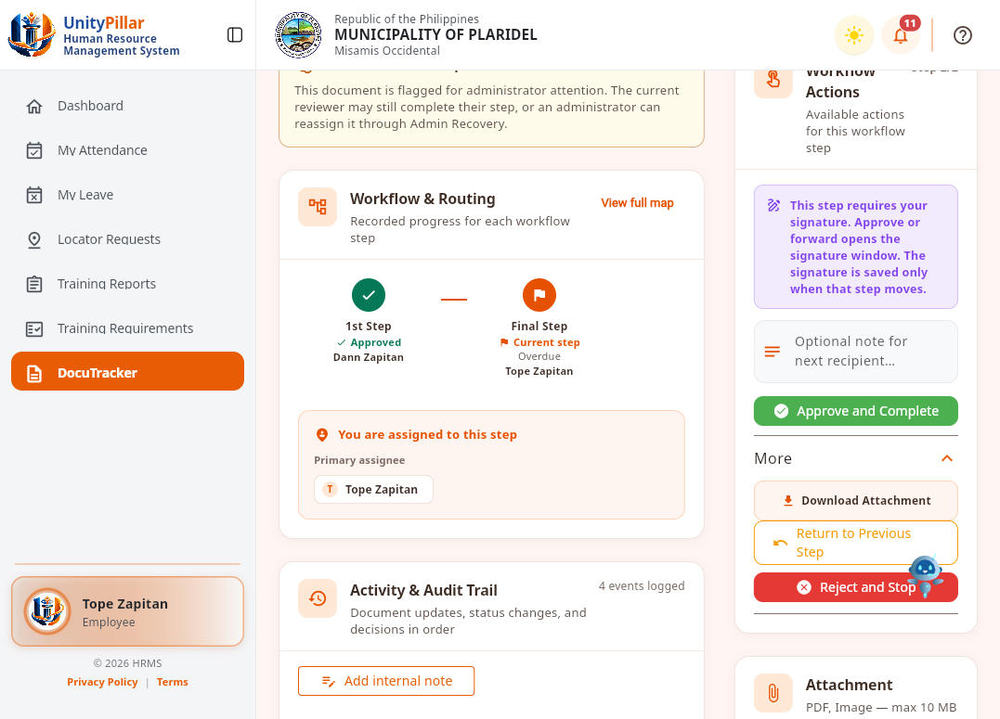
Figure 26. Document Review and Approval Interface

Figure 26 shows Purchase Test 1 while it is the current reviewer's turn. The purchase request is on the final step and is past its deadline. The first step was approved by Dann Zapitan, and the current assignee is Tope Zapitan. Approve and Complete is available. More opens Download Attachment, Return to Previous Step, and Reject and Stop. Those dialogs were opened and cancelled, and the document stayed overdue.

4.2.8 Document Tracking and Status Monitoring
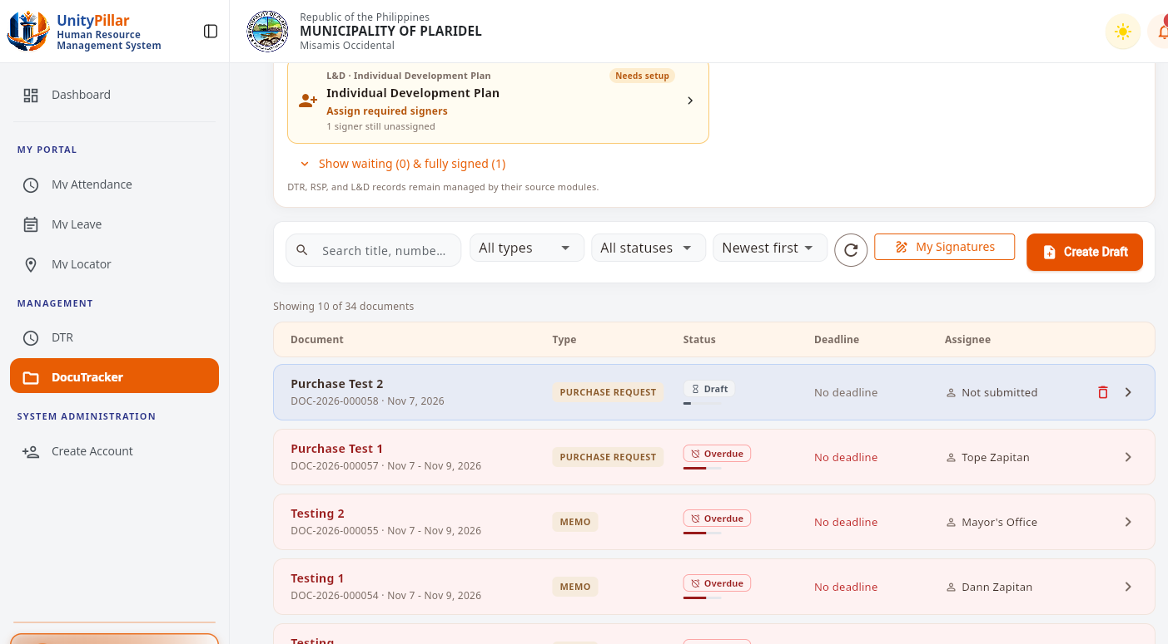
Figure 27. Document Status Tracking Interface

Figure 27 shows the document list used for status monitoring. Each row shows the document type, status, deadline, and current assignee.

4.2.9 Notifications and Status Updates
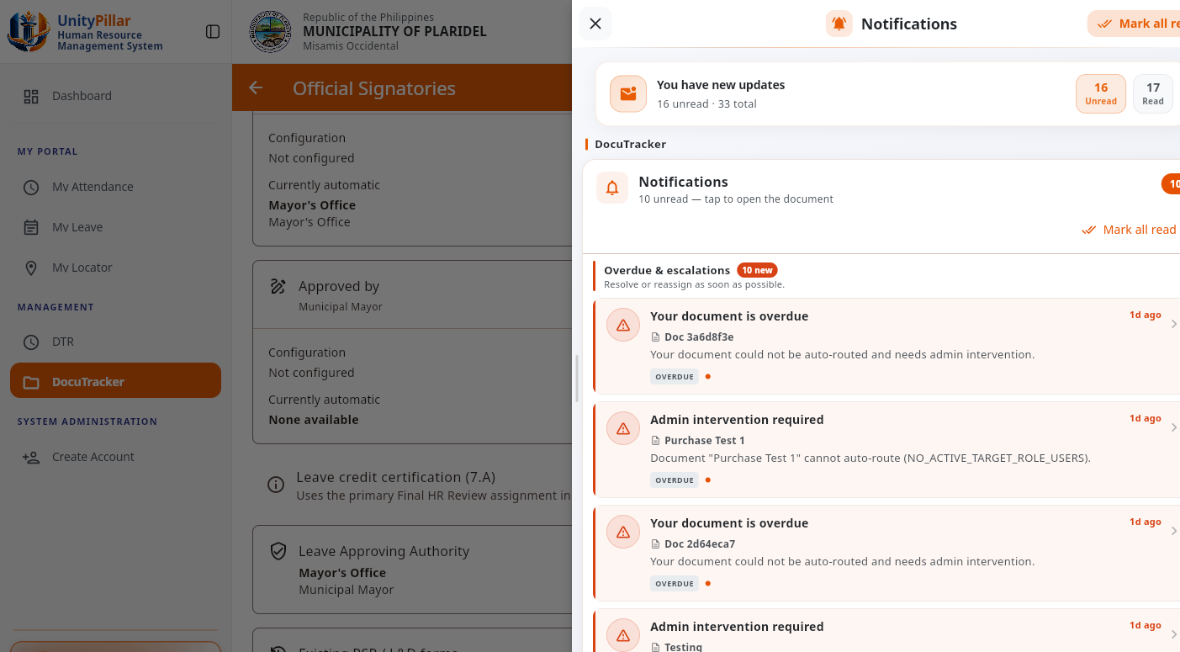
Figure 28. Document Notifications Interface

Figure 28 shows the notifications drawer. DocuTracker overdue notices identify documents that need admin intervention, including items that could not be auto-routed.

4.2.10 User Roles and Permissions Management
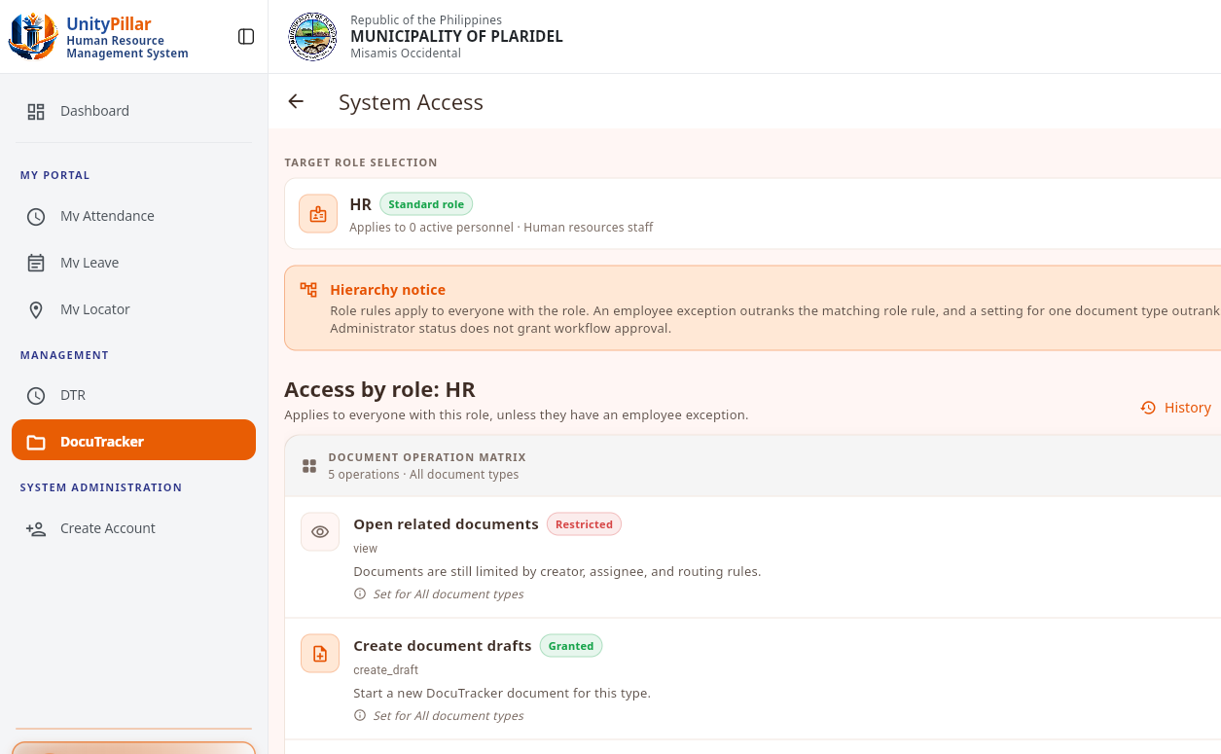
Figure 29. User Roles and Permissions Interface

Figure 29 shows the System Access role matrix. Granted and restricted capabilities are set by role. Administrator status does not by itself grant workflow approval.

4.2.11 Document Search and Filtering
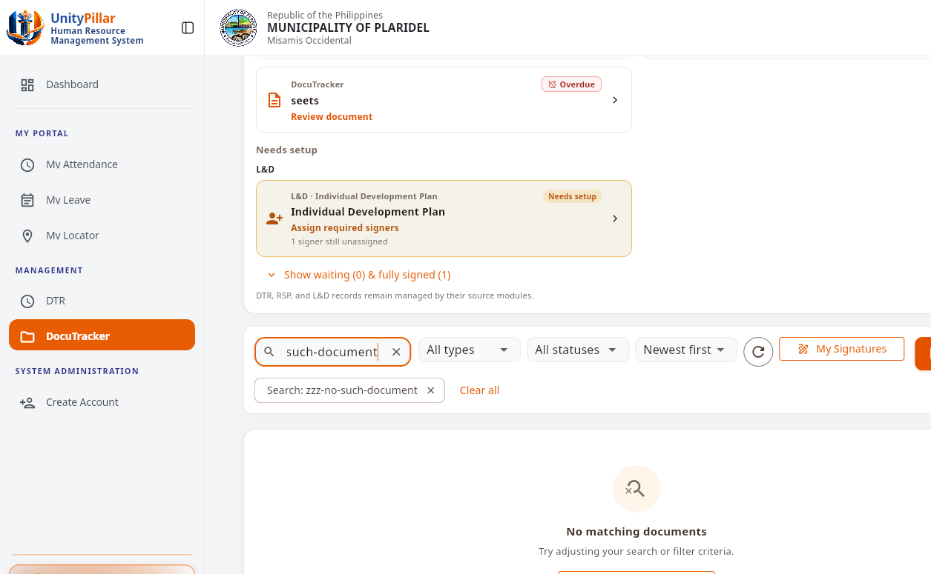
Figure 30. Document Search and Filtering Interface

Figure 30 shows document search. A search that matches no title, number, sender, or assignee returns an empty result and can be cleared without changing stored records.

4.2.12 Document History and Audit Trail
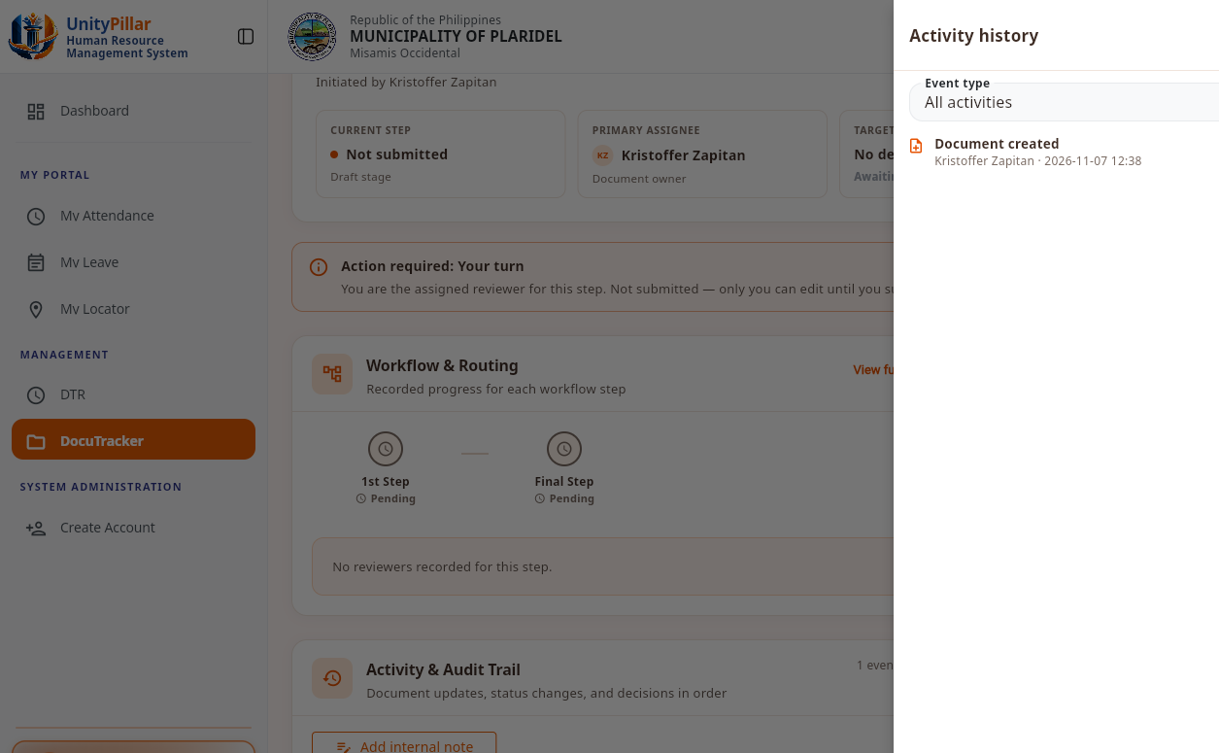
Figure 31. Document History and Audit Trail Interface

Figure 31 shows the document activity history. The recorded event identifies the action, the user, and the date and time. History is written by the system.

4.2.13 Overdue Document Monitoring and Escalation
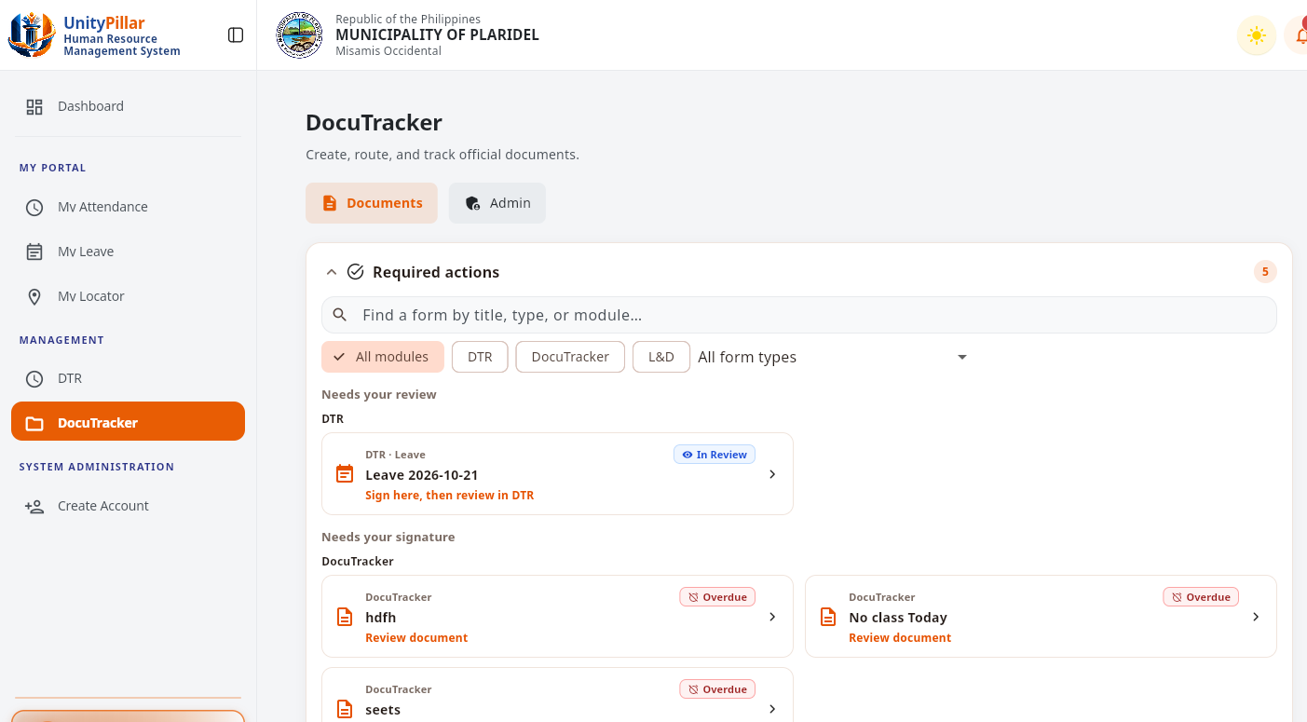
Figure 32. Overdue Document Monitoring Interface

Figure 32 shows the Required actions queue. Overdue DocuTracker items are listed for review, separate from source-module items such as DTR leave.

4.2.14 Reports and Document Transaction Monitoring
Figure 33. Document Transaction Reports Interface

Figure 33 shows the same administrator monitoring summary used for day-to-day transaction awareness: document volume, overdue and escalated counts, and recent activity. A separate printable report generator is not part of this screen.
4.2.15 Memorandum Document
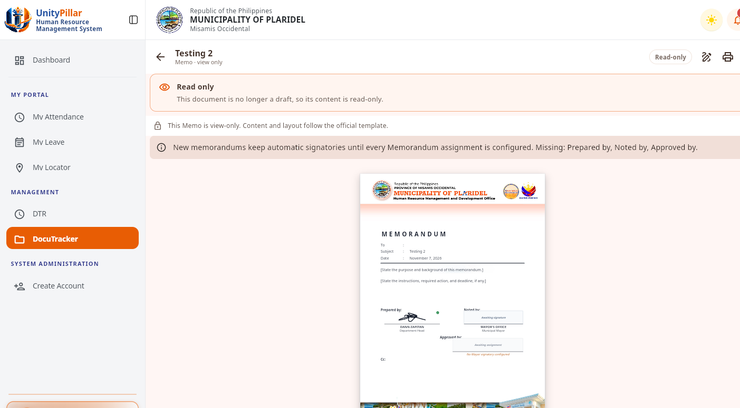
Figure 34. Memorandum Document, View Only
Figure 34 shows an existing memorandum opened view-only. The official template includes Prepared by, Noted by, and Approved by. Approved by stays unassigned until a distinct Municipal Mayor signatory is configured.
4.2.16 Purchase Request Form
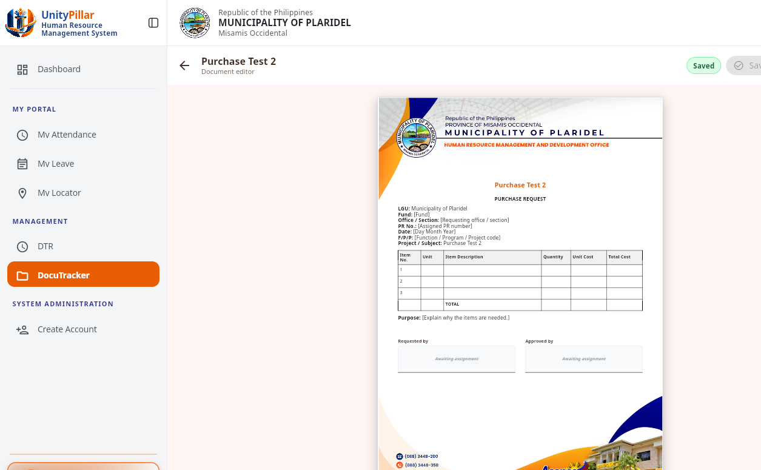
Figure 35. Purchase Request Form
Figure 35 shows a one-page purchase request in the document editor, including the item table and the Requested by and Approved by areas.
4.2.17 Official Signatories
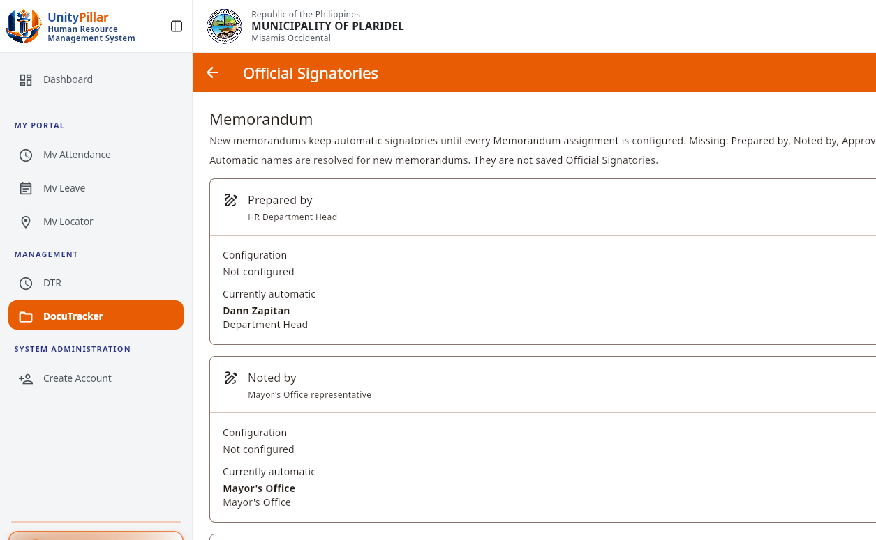
Figure 36. Memorandum Official Signatories
Figure 36 shows the Official Signatories screen for memorandums. Prepared by, Noted by, and Approved by remain on automatic resolution until all three assignments are configured.
4.2.18 Escalation Rules
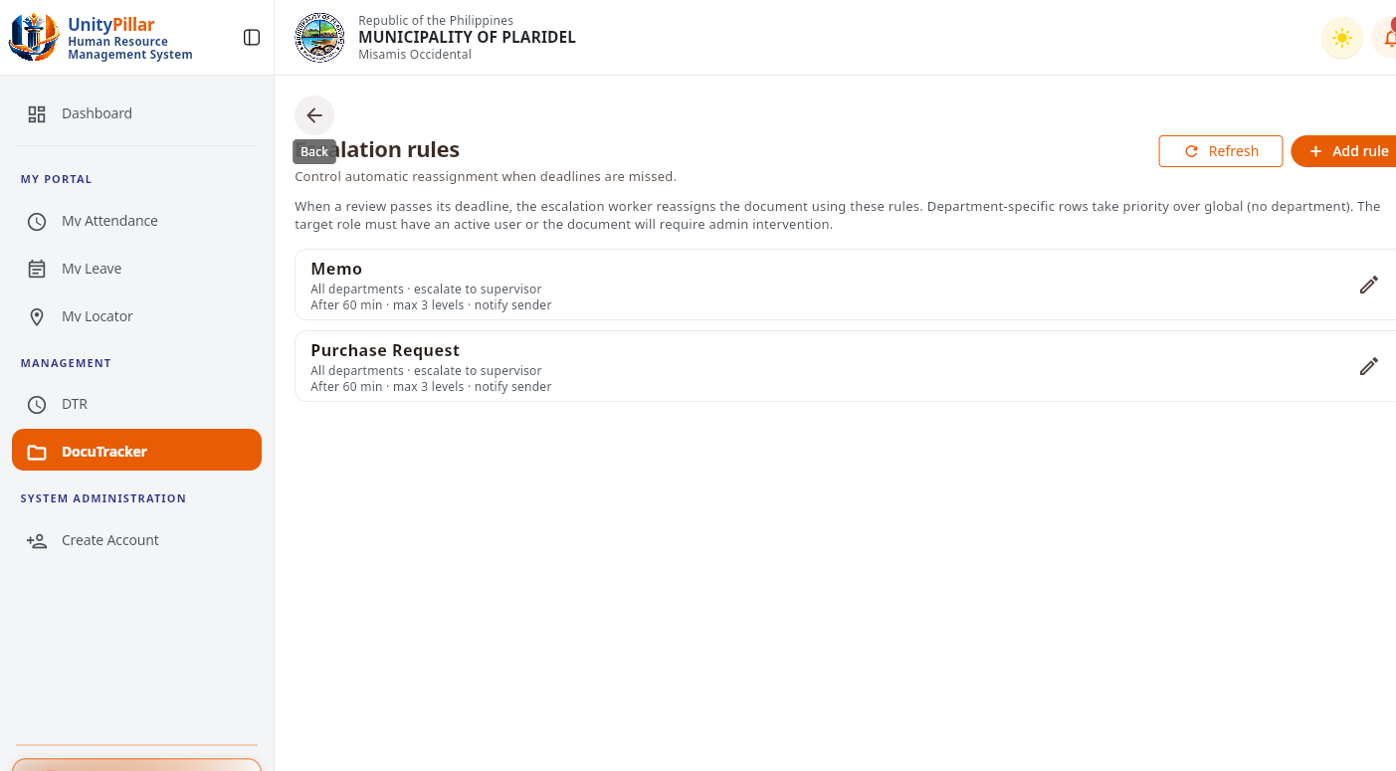
Figure 37. Escalation Rules
Figure 37 shows the escalation rules for Memorandum and Purchase Request. Each rule escalates to the supervisor after 60 minutes, for up to three levels, and notifies the sender.
4.2.19 Configuration Audit Log
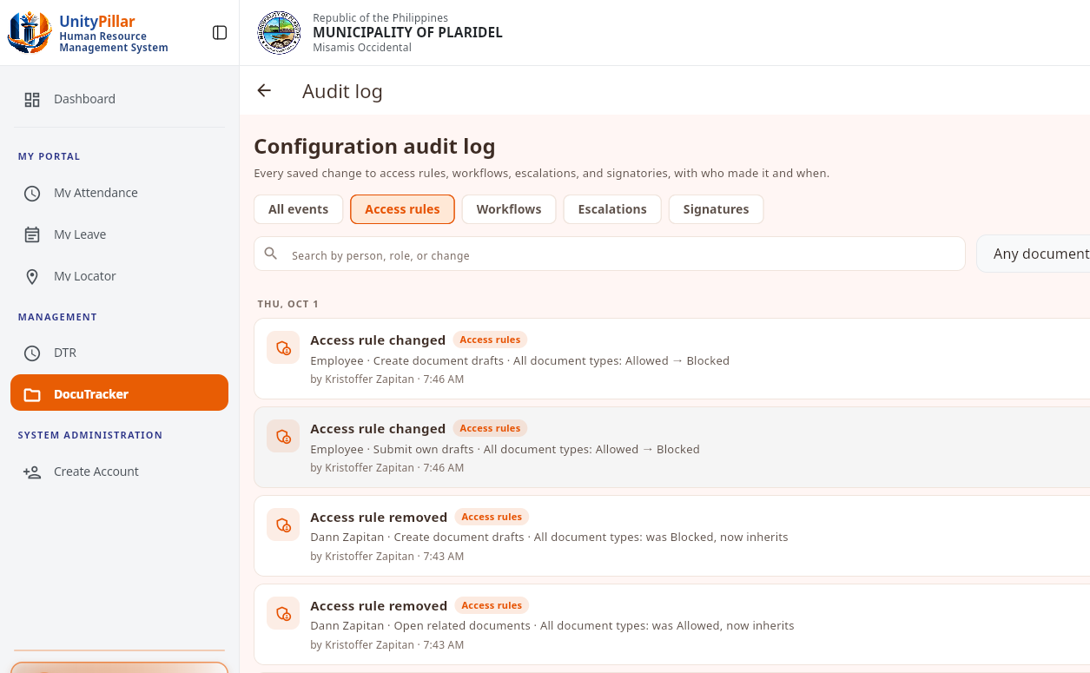
Figure 38. Configuration Audit Log
Figure 38 shows the configuration audit log for access-rule changes, including the actor and the time of each recorded change.
4.2.20 Employee Access Directory
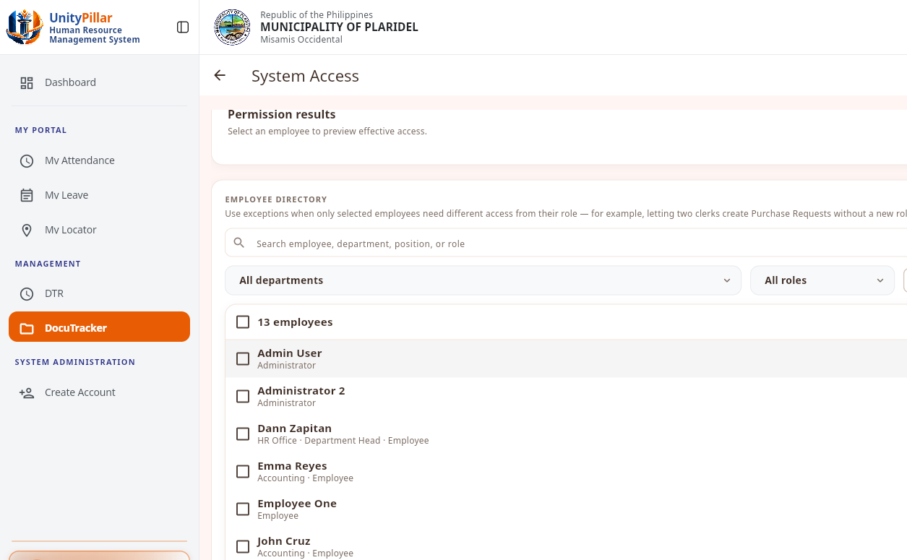
Figure 39. Employee Access Directory
Figure 39 shows the employee directory used when reviewing per-employee access exceptions. No exception was changed during this capture.
4.2.21 Signature Confirmation
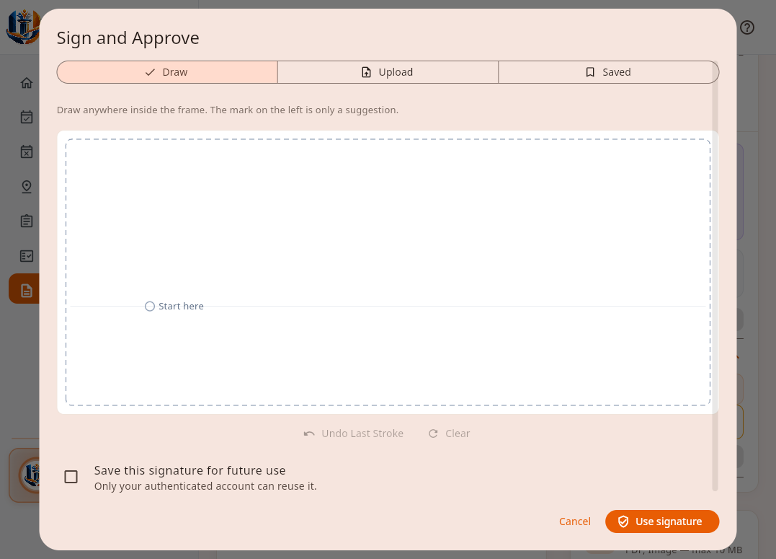
Figure 40. Sign and Approve Dialog
Figure 40 shows the signature dialog that opens before Approve and Complete when the step requires a signature. The Draw tab is selected and the canvas is empty. Cancel closed the dialog. No stroke was saved, and the document was not approved.
4.2.22 Return to the Previous Step
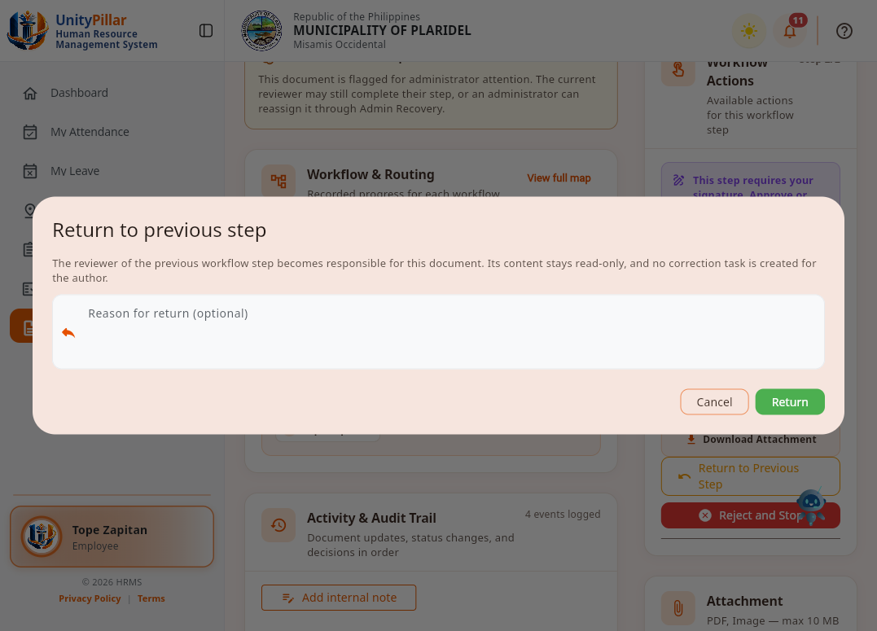
Figure 41. Return to Previous Step Dialog
Figure 41 shows the return dialog. The previous step's reviewer becomes responsible, the content stays read-only, and no correction task is created for the author. A reason is optional. Cancel closed the dialog, and the document was not returned.
4.2.23 Reject and Stop
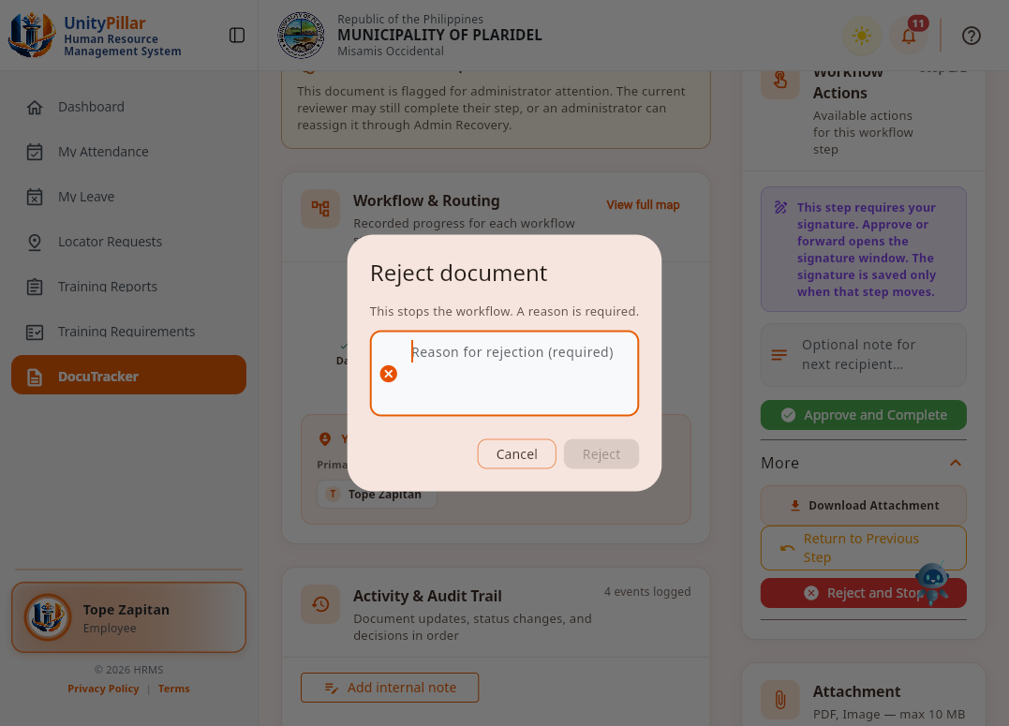
Figure 42. Reject Document Dialog
Figure 42 shows the reject dialog. Rejecting stops the workflow, and a reason is required. No reason was entered. Cancel closed the dialog, and the document was not rejected.
4.2.24 Released Document
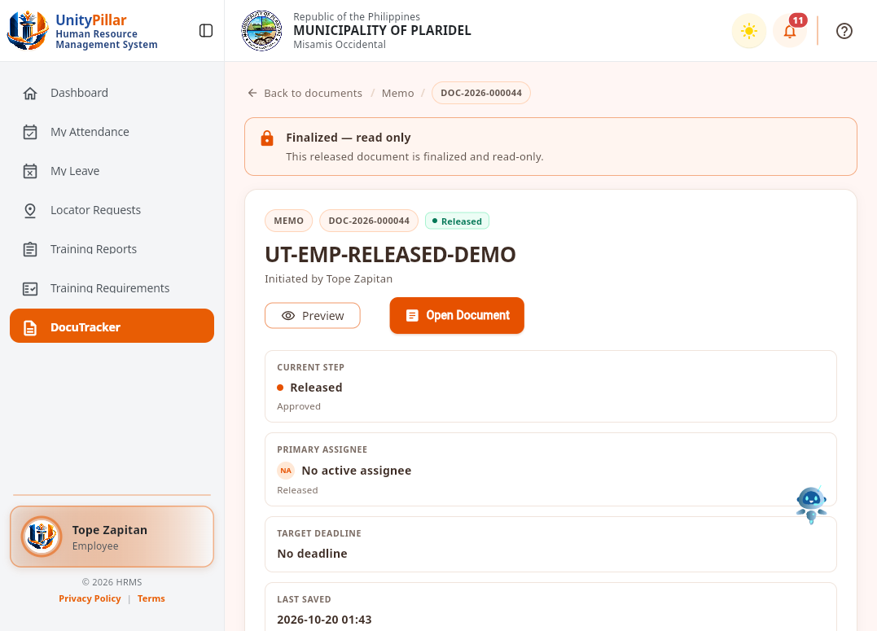
Figure 43. Released Memorandum
Figure 43 shows UT-EMP-RELEASED-DEMO after release. The screen states that the released document is finalized and read-only. The current step is Released, there is no active assignee, and this employee account has no release control.
4.2.25 Document Awaiting Release
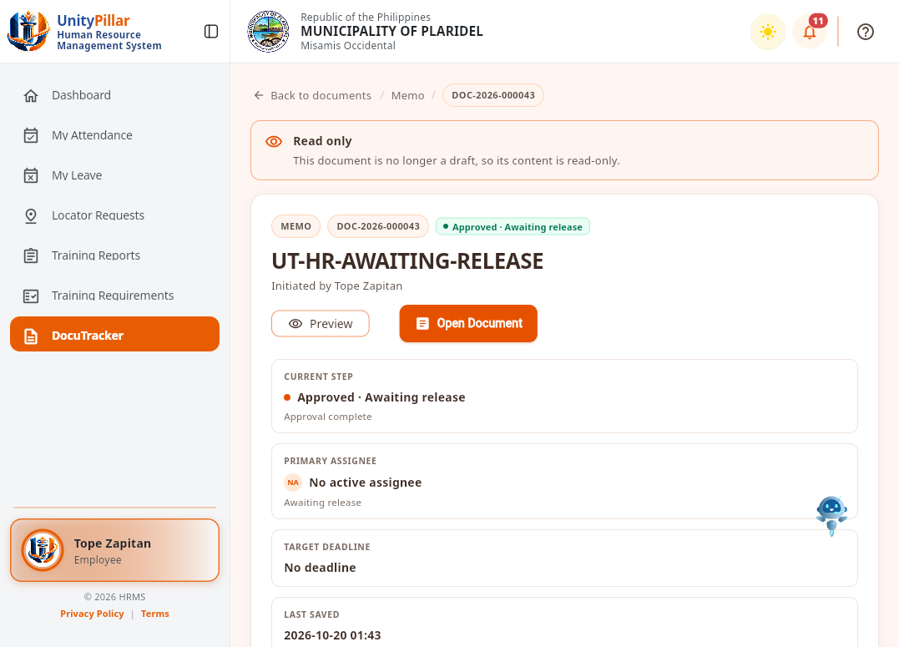
Figure 44. Memorandum Awaiting Release
Figure 44 shows UT-HR-AWAITING-RELEASE after approval and before release. The status is Approved, Awaiting release. The current step is Approval complete, and there is no active assignee. The employee account cannot release the document, and release was not confirmed.
4.2.26 Released and Awaiting Release in the Document List
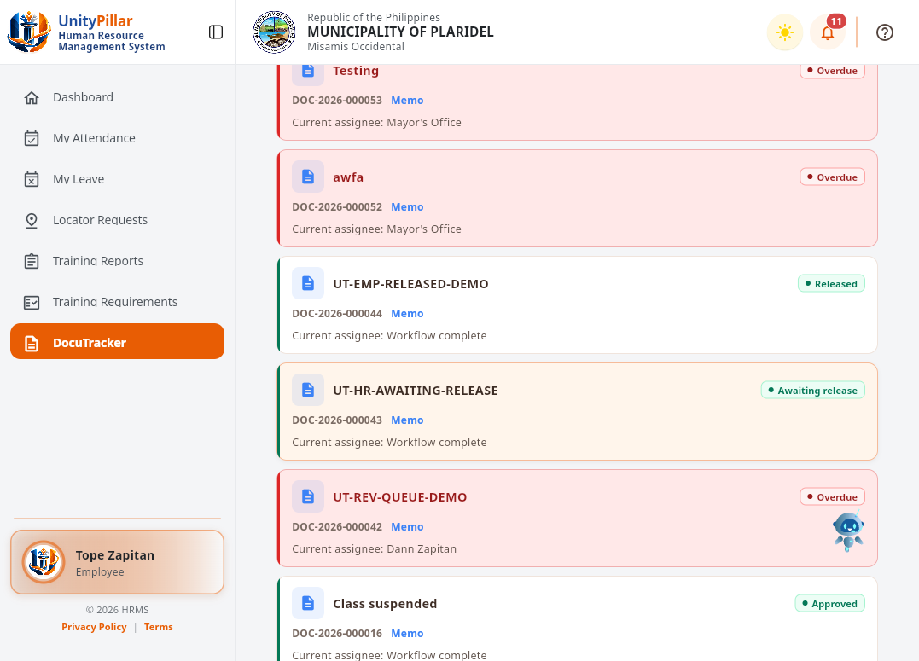
Figure 45. Document List with Released and Awaiting Release
Figure 45 shows the employee document list. A released memorandum and a memorandum awaiting release appear with overdue documents that are still in review. Completed records stay in this list.
4.2.27 Shared Approval Workflows
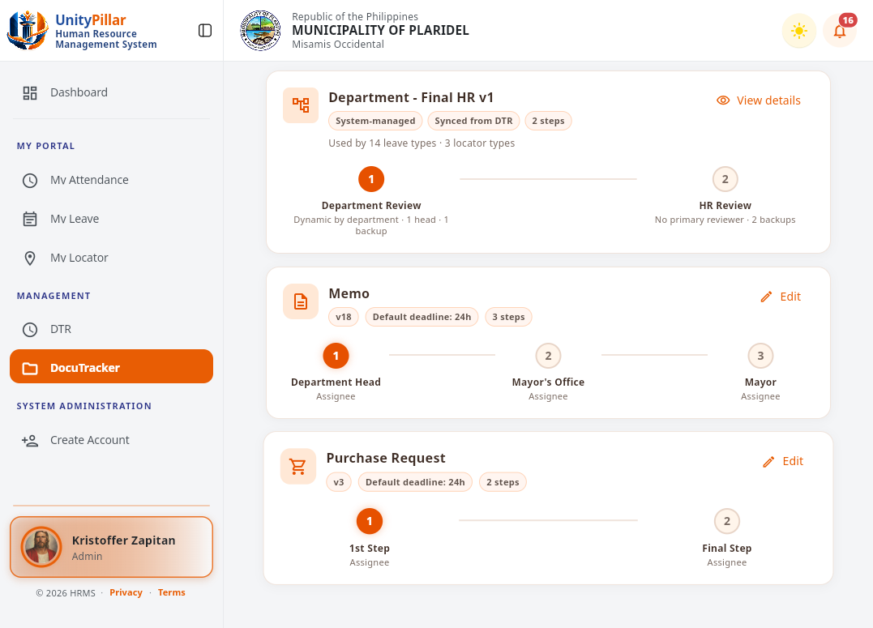
Figure 46. Approval Workflow Catalog
Figure 46 shows the shared approval workflows. Department - Final HR is system-managed and synced from DTR. Memo version 18 has three steps: Department Head, Mayor's Office, and Mayor. Purchase Request version 3 has a first step and a final step. No workflow was created.
4.2.28 Memorandum Workflow Configuration
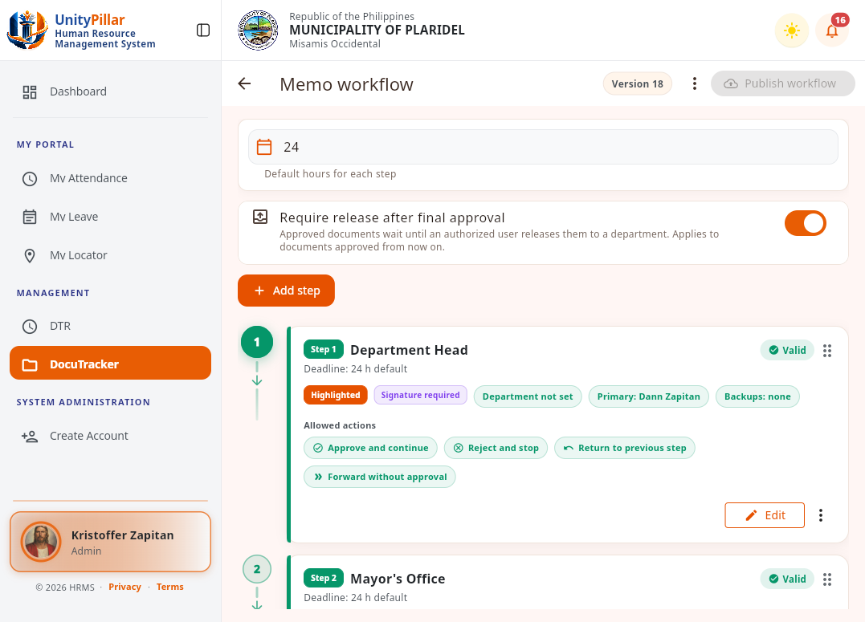
Figure 47. Memorandum Workflow Editor
Figure 47 shows Memo workflow version 18. The default deadline is 24 hours, and release after final approval is required. Step 1 is Department Head, with a signature required and Dann Zapitan as the primary assignee. Allowed actions include approve and continue, reject and stop, return to previous step, and forward without approval. Steps 2 and 3 are Mayor's Office and Mayor. The workflow was not published.
4.2.29 Effective Access Preview
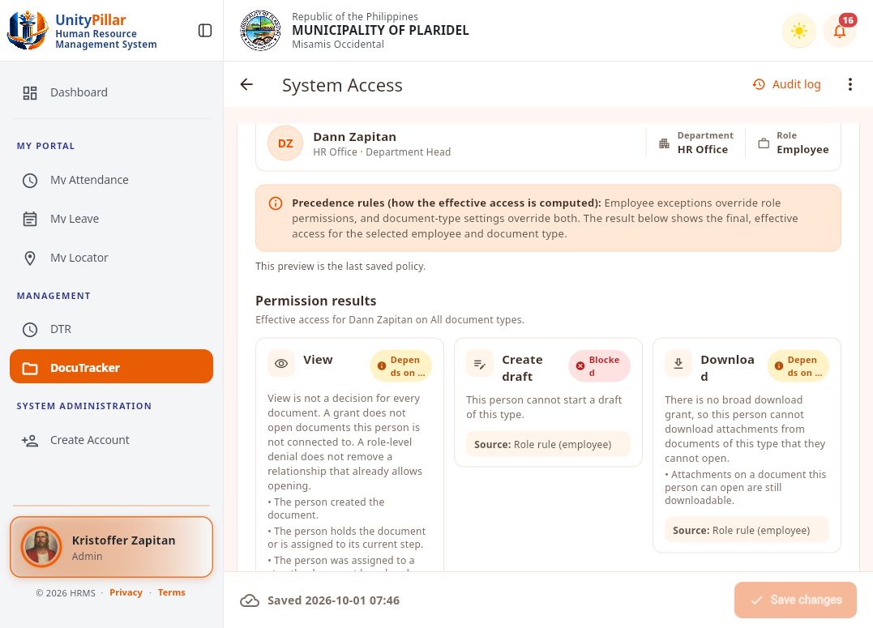
Figure 48. Effective Access Preview for One Employee
Figure 48 shows the read-only effective access preview for Dann Zapitan on all document types. View and download depend on the person's relationship to the document. Create draft is blocked by the employee role rule. Save changes was not used.
4.2.30 Employee Required Actions
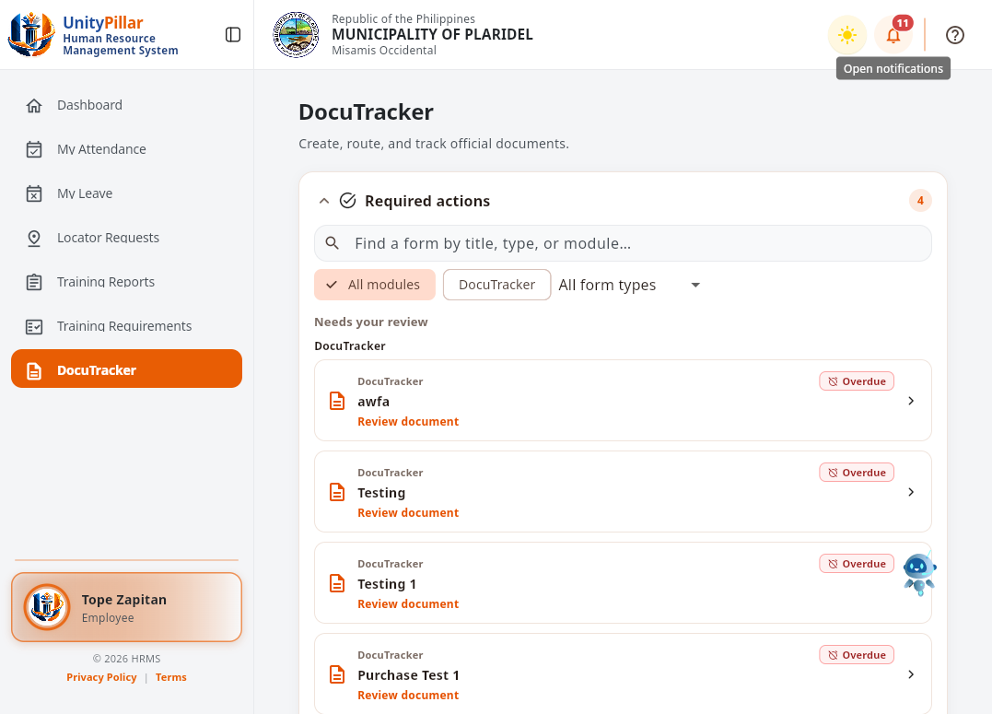
Figure 49. Employee Required Actions
Figure 49 shows the required-actions queue for the employee account. Overdue DocuTracker documents assigned for review are listed separately from the administrator queue.

4.3 Testing and Results
This section presents the preliminary results of the DocuTrack pilot-testing questionnaires. Six identifiable questionnaires were provided: three Employee Respondent Forms and three HR/Admin and Operational Personnel Forms. The respondents rated their experience using a five-point scale, from 5 (Strongly Agree) to 1 (Strongly Disagree). The evaluation covers Functional Suitability, Usability, and Performance Efficiency. The Employee questionnaire contains 15 statements, while the HR/Admin questionnaire contains 20 statements. Unlike the interviews discussed in Chapter III, these pilot-testing forms evaluate the developed module from the respondents’ perspective.
The weighted mean was computed using the formula: Mean = Σ(f × x) / N, where f is the frequency of a rating, x is the numerical rating, and N is the number of valid responses for the statement. For provisional interpretation, scores from 4.21 to 5.00 are Strongly Agree, 3.41 to 4.20 Agree, 2.61 to 3.40 Neutral, 1.81 to 2.60 Disagree, and 1.00 to 1.80 Strongly Disagree. The original questionnaires must be checked before the results are submitted as final.
A. Functional Suitability Results
Functional suitability evaluates whether the system provides appropriate document actions and performs tasks such as document handling, workflow routing, review, and access control in a manner consistent with assigned roles.

Table 6. Functional Suitability Results – Employee Respondents
Question | Weighted Mean | Interpretation
The system correctly displays documents assigned or available to me. | 4.00 | Agree
The system allows me to open and review documents assigned to me. | 4.67 | Strongly Agree
The system allows me to add remarks or action notes when permitted. | 4.67 | Strongly Agree
The system allows me to update or route an assigned document using actions allowed by the workflow. | 4.67 | Strongly Agree
The system prevents me from acting on documents or workflow steps that are not allowed for my role. | 4.00 | Agree
Overall Weighted Mean | 4.40 | Strongly Agree

Question | Weighted Mean | Interpretation
The system allows authorized personnel to create and save document records correctly. | 4.33 | Strongly Agree
The system allows authorized personnel to upload and attach required document files successfully. | 4.67 | Strongly Agree
The system allows authorized personnel to assign or route documents to the appropriate employee or office. | 4.67 | Strongly Agree
The system correctly displays the current assignee, workflow status, and document action history. | 4.67 | Strongly Agree
The system allows authorized personnel to locate document records using the available search and filtering functions. | 4.67 | Strongly Agree
The system correctly applies workflow and permission rules when administrative actions are performed. | 4.67 | Strongly Agree
The system provides the information needed to review document assignments, routing, status, and history. | 4.33 | Strongly Agree
Administrative actions are limited according to the user’s assigned authority. | 4.33 | Strongly Agree
Table 7. Functional Suitability Results – HR/Admin Respondents

Interpretation: The employee respondents obtained a functional-suitability mean of 4.40, and HR/Admin respondents obtained a mean of 4.54. Both fall within the provisional
“Strongly Agree” category. These results indicate favorable respondent assessments of the available document functions and authorized workflow actions during pilot testing.
B. Usability Results
Usability evaluates whether users can understand menus, labels, current workflow information, and feedback messages, and whether they can complete their assigned tasks with minimal assistance.

Table 8. Usability Results – Employee Respondents
Question | Weighted Mean | Interpretation
The system’s DocuTracker menus and navigation are easy to understand. | 4.00 | Agree
The labels, buttons, status labels, and workflow instructions clearly describe their purpose. | 4.33 | Strongly Agree
The current assignee, workflow status, and document history are easy to understand. | 4.33 | Strongly Agree
The system provides clear messages when an action succeeds, fails, or is restricted. | 4.00 | Agree
I can perform my assigned DocuTracker Employee tasks with minimal assistance. | 3.67 | Agree
Overall Weighted Mean | 4.07 | Agree

Table 9. Usability Results – HR/Admin Respondents
Question | Weighted Mean | Interpretation
The system’s menus and administrative DocuTracker functions are easy to locate. | 4.00 | Agree
The labels, buttons, filters, status indicators, and instructions clearly describe their purpose. | 4.33 | Strongly Agree
Document registration, file attachment, assignment, and routing can be completed without unnecessary steps. | 4.33 | Strongly Agree
The system provides clear confirmation, validation, and restriction messages after each action. | 4.00 | Agree
The document status, current assignee, and action history are easy to understand. | 4.00 | Agree
I can perform my assigned DocuTracker administrative tasks with minimal assistance. | 4.00 | Agree
Overall Weighted Mean | 4.11 | Agree

Interpretation: The employee usability mean was 4.07, and the HR/Admin usability mean was 4.11, both interpreted provisionally as “Agree.” These ratings are lower than the functional-suitability means and suggest that navigation, instructions, and task guidance are practical areas for further refinement.
C. Performance Efficiency Results
Performance efficiency concerns users’ perceptions of loading time, responsiveness, saving actions, file operations, and completion of ordinary document workflow tasks.

Table 10. Performance Efficiency Results – Employee Respondents
Question | Weighted Mean | Interpretation
The system loads my assigned documents and document records within an acceptable amount of time. | 4.33 | Strongly Agree
The system opens document details and attached files within an acceptable amount of time. | 4.50 | Strongly Agree
Remarks, workflow actions, and status updates are saved within an acceptable amount of time. | 4.67 | Strongly Agree
The system remains responsive while I move between DocuTracker pages and document records. | 4.33 | Strongly Agree
The system responds to my Employees actions without noticeable delays during the assigned tasks. | 4.33 | Strongly Agree
Overall Weighted Mean | 4.43 | Strongly Agree

Table 11. Performance Efficiency Results – HR/Admin Respondents
Question | Weighted Mean | Interpretation
Document lists and document records load within an acceptable amount of time. | 4.00 | Agree
Document files can be uploaded and opened within an acceptable amount of time. | 4.00 | Agree
The system processes document assignment, routing, and workflow actions within an acceptable amount of time. | 4.00 | Agree
Search and filtering results are displayed within an acceptable amount of time. | 4.00 | Agree
The system remains responsive while working with multiple document records. | 4.00 | Agree
The system performs reliably during normal daily DocuTracker operations. | 4.00 | Agree
Overall Weighted Mean | 4.00 | Agree

Interpretation: The employee performance-efficiency mean was 4.43, interpreted as “Strongly Agree,” based on 14 visible ratings. The HR/Admin mean was 4.00, interpreted as “Agree,” based on 12 visible ratings. These are user ratings and should not be presented as actual system response-time measurements.
D. Overall Pilot Testing Results
Table 12. Overall Pilot Testing Summary
Respondent Group | Valid Ratings | Mean | Interpretation
Employee | 44 | 4.30 | Strongly Agree
HR/Admin and Operational Personnel | 54 | 4.28 | Strongly Agree
Combined valid ratings | 98 | 4.29 | Strongly Agree

The overall pooled mean of the 98 visible ratings was 4.29, provisionally interpreted as “Strongly Agree.” Of the 105 possible responses on six questionnaire forms, seven are missing from the available photographs: one Employee Performance Efficiency response (Item 12) and the six HR/Admin Performance Efficiency responses on one respondent’s form. The combined value pools distinct questionnaire statements and is therefore only a descriptive summary, not a standardized comparison of the two roles.
The results suggest that the six respondents generally evaluated the DocuTrack module positively in terms of its documented functionality, usability, and performance during the pilot activities. Nevertheless, the small respondent group, differences between the questionnaires, and missing marks limit the strength of the conclusions. More extensive testing, complete response verification, and actual system screenshots are recommended before final manuscript submission.

