UNITY PILLAR: AN INTEGRATED DIGITAL DOCUMENT TRACKING AND ROUTING SYSTEM FOR GOVERNMENT OFFICES

A Capstone Project and Research Study and Proposal
Presented to the
Department of Information Technology
University of Science and Technology of Southern Philippines
Oroquieta City

In Partial Fulfillment of the Requirements for
Capstone Project and Research Study Leading to the Degree in
Bachelor of Science in Information Technology

Ryza Mae G. Bongcac
Cathrina E. Gallemit
Edgar, Jr. C. Tac-an
Dann Kristoffer D. Zapitan

April 2026

APPROVAL SHEET
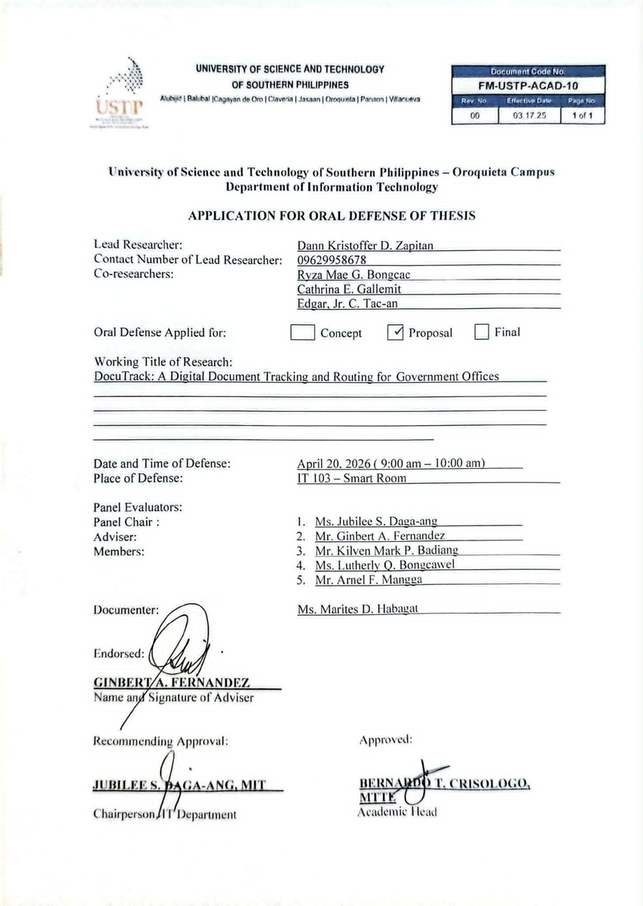

ABSTRACT

Government offices often face problems with lost documents, slow processing, and difficulty tracking files. This study aimed to develop UNITY PILLAR: An Integrated Digital Document Tracking and Routing System for Government Offices, specifically its DocuTrack module, to make document management easier and more organized in government offices in Northern Poblacion.
The system allows authorized employees to submit, store, route, and track documents digitally. The researchers used the Agile System Development Life Cycle (SDLC) method and gathered information through interviews, observations, and document reviews.
Six respondents evaluated the system, and the results showed an overall mean of 4.29, interpreted as “Strongly Agree.” This indicates positive feedback on the system’s features and usability.
Overall, DocuTrack provides a digital way to help government offices manage documents more efficiently and improve document monitoring and accountability.
.

DEDICATION

The researchers dedicate this study to Almighty God, whose guidance and blessings made the completion of this research possible.
To our parents and families, we express our sincere gratitude for their endless love, sacrifices, support, and encouragement throughout our educational journey. Your guidance has given us strength and motivation to overcome challenges and continue working toward our goals.
We also dedicate this study to our friends, classmates, and mentors who shared their time, knowledge, and support throughout the research process. Your encouragement and assistance contributed to the successful completion of this study.
We would also like to thank our research committee members for their valuable suggestions, comments, and insights, which helped improve the quality of this research.
Finally, we dedicate this work to everyone who has been part of our journey. Your support and guidance have taught us the importance of faith, hard work, and perseverance.

ACKNOWLEDGEMENT

We, the researchers, would like to express our sincere gratitude to Almighty God for His guidance, blessings, and strength throughout the completion of this study.
We are deeply thankful to our parents and families for their love, patience, understanding, and continuous support. Their encouragement motivated us to keep going, especially during times when we faced difficulties and challenges.
We would also like to express their sincere gratitude to their adviser, Mr. Ginbert A. Fernandez, for her patience, guidance, encouragement, and valuable suggestions. Her support helped the researchers improve their project, learn from their experiences, and face challenges with confidence.
We also grateful to our client, Mr. Marcelo B. Cañares, Administrative Officer V (HRMO III), for his trust, cooperation, and helpful feedback. His knowledge and suggestions helped the researchers develop Docutrack to improve document tracking and routing processes in government offices. We would also like to thank the panelists for their comments, suggestions, and guidance, which helped improve the quality of the project.
Finally, we are grateful to everyone who supported us throughout this journey. Their kindness and guidance have taught us the importance of faith, hard work, and perseverance, which helped us complete this study successfully.

TABLE OF CONTENTS
TITLE PAGE i
APPROVAL SHEET ii
DEDICATION iii
ACKNOWLEDGEMENT iv
TABLE OF CONTENTS 3
CHAPTER I: INTRODUCTION 8
1.1 Background of the Study 8
1.1 Statement of the Problem 9
1.2 Statement of Objectives 11
1.3.1 General Objectives 11
1.3.2 Specific Objectives 11
1.3 Significance of the Study 12
1.4 Scope and Limitation of the Study 13
1.5Definition of Terms 14
CHAPTER II: REVIEW OF RELATED LITERATURES 16
2.1 Review of Literature 16
2.1.1 Human Resource Management Systems (HRMS) 18
2.1.2 Digital Document Tracking Systems 18
2.1.3 Document Routing System 19
2.1.4 Real-Time Monitoring Systems 19
2.1.5 Cloud-Based Data Management 20
2.1.6 Workflow Automation Systems 20
2.1.7 Digital Transformation in Government Offices 20
2.2 Review of Related Application 21
2.2.1 Google Drive 22
2.2.2 Dropbox 23
2.2.4 Microsoft SharePoint 25
2.2.5 Notion (Basic Setup) 26
2.3 Comparison Table of Related Application 27
2.4 Synthesis and Gap Analysis 28
CHAPTER III: METHODOLOGY 31
3.1 Research Methodology 31
3.2 Data Gathering Procedure 37
3.2.1 Research Instrument 38
3.2.2 Sampling Method 39
3.2.3 Statistical Treatment of Data 40
3.2.4 Data Analysis (Qualitative Treatment of Data) 41
3.3 Description of the Current System (Information Gathering) 42
3.4 System Architecture and Development 44
3.5 Overview of the Proposed System 45
3.6 System Objectives 46
3.6.1 General Objectives 46
3.6.2 Specific Objectives 46
3.7 System Tools and Requirements 47
3.8 Programming Languages 48
3.9 Hardware Requirements 49
3.9.1 Server Requirements 49
3.9.2 Client Requirements 50
3.9.3 Software Requirements 51
3.10 System Flow/Functions 52
3.11 Sequence Diagram 54
3.12 Scope and Limitation of the System 58
3.13 Calendar of Activities 61
3.14 Conceptual Design andImplementation 63
3.14.2 Entity Relationship Diagram 65
3.14.3 System Design 67
3.14 Sequence Diagram 69
3.15 Use Case Diagram 71
3.16 Data Flow Diagram 73
CHAPTER IV: RESULTS AND DISCUSSIONS 77
4.1 Discussions 77
4.2 Screen Design 78
4.2.1 System Login and Authentication 79
4.2.2 Administrator Dashboard 79
4.2.3 Employee Dashboard 80
4.2.4 Document Creation and Submission 80
4.2.5 Document Management and File Attachments 81
4.2.6 Document Routing and Workflow Configuration 81
4.2.7 Document Review and Approval 82
4.2.8 Document Tracking and Status Monitoring 82
4.2.9 Notifications and Status Updates 83
4.2.10 User Roles and Permissions Management 83
4.2.11 Document Search and Filtering 84
4.2.12 Document History and Audit Trail 84
4.2.13 Overdue Document Monitoring and Escalation 85
4.2.14 Document Archiving and Records Management 85
4.2.15 Reports and Document Transaction Monitoring 86
4.3 Testing and Results 86
CHAPTER V: CONCLUSIONS AND RECOMMENDATIONS 97
5.1 Conclusions 97
5.2 Recommendations 98
REFERENCES: 100
APPENDIX A 106
APPENDIX B 108
APPENDIX C 112

LIST OF TABLES

Table 1. Comparison Table of Related Application 26
Table 2. Synthesis and Gap Analysis 27
Table 3. Programming Language 47
Table 4. Server Requirements 48
Table 5. Client Requirements 49
Table 6. Software Requirements 50

LIST OF FIGURES

Figure 1. Google Drive (Website) 21
Figure 2. Dropbox (Website) 22
Figure 3. Trello (Website) 23
Figure 4. Microsoft Sharepoint (Website) 24
Figure 5. Notion (Basic Setup) (Website) 25
Figure 6. Agile Model for the System Development Life Cycle (SDLC) 31
Figure 7. System Architecture Diagram 43
Figure 8. System Flow/Functions 51
Figure 9. Administer Sequence Diagram 53
Figure 10. User Sequence Diagram 54
Figure 11. Sequence Diagram (Escalation Worker) 56
Figure 12. Gantt Chart 60
Figure 13. Database Design (ERD) 62
Figure 14. Entity Relationship Diagram 64
Figure 15. System Design 66
Figure 16. Administrator Sequence Diagram 68
Figure 17. Use Case Diagram 70
Figure 18. Data Flow Diagram (Level 0) 72
Figure 19. Data Flow Diagram (Level 1) 74

CHAPTER I
INTRODUCTION

  - Background of the Study
Government offices often have trouble managing documents. Manual and semi-manual methods are prone to errors, data loss, and slow processing. These problems hinder the ability to provide good services, which can lead to less satisfied clients. Based on research conducted within digital document management systems, it is evident that digital document management systems enhance document search performance, speed, and offer superb document tracking throughout the entire life cycle of the document (eDALAYON: A Document Management and Monitoring System, 2024).
However, manually managing the documents usually results in inefficient operations for organizations in the form of delays, misplaced documents, non-accountability, and corruption. In order to resolve such drawbacks, this solution implements the use of tracking technology within the document processing procedure through the use of RFID, microcontroller, and wireless technology. Syed Sumiya (June 19, 2025).
Through further study on document tracking systems, one can find out that inefficiencies, duplication of records, constant reminders, and lack of transparency arise due to the lack of automation and centralization of these systems Document Management System with Tracking and Monitoring (2021). As such, this reinforces the need for an effective digital document tracking system like DocuTrack PH in order to improve the efficiency of service delivery.
This study proposes a document management and monitoring system to address inefficient document handling in the government sector, specifically at DILG Negros Occidental. Developed using Agile Scrum, the system includes modules for user access, document management, tracking, and reporting. Findings show that it reduces workload and retrieval time while improving collaboration, security, and overall efficiency through digitalization and cloud-based features. Rodriguez (2024).
Requisitioners at Cavite State University (CvSU) face difficulties tracking document status due to manual processes and high document volume in the Records Office. To address this, two versions of a document tracking system were developed using an iterative-agile approach. The first version introduced barcode-based tracking, while the second improved functionality and user experience based on feedback. Results show enhanced tracking, faster status retrieval, and increased user satisfaction, highlighting the effectiveness of iterative system development. Malicsi (2025).

  - Statement of the Problem
Many government offices still rely on manual and paper-based systems, which often lead to various operational difficulties. These include the risk of lost or misplaced files, frequent human errors, and delays in the review, approval, and release of documents. Accessing important records quickly also becomes challenging, especially when documents are stored in different locations or formats. Moreover, the lack of a fully digitalized tracking system limits transparency and accountability within the workplace. This makes it difficult to monitor document status, identify responsible personnel, track processing delays, and generate reliable performance reports. As a result, the overall efficiency of office operations is affected, which may reduce client satisfaction and weaken public trust in government services.
Specifically, this study seeks to answer the following questions:
- How can the system make document tracking and monitoring easier within the organization?
- How effective is the system in tracking documents from submission up to approval or release?
- How does the system improve document management compared to manual methods?
- How efficient is the system in creating digitalize reports for document transactions and status updates?
- How effective is the system in providing notifications for document updates, pending actions, and deadlines?

Statement of Objectives

1.3.1 General Objectives
The general objective of this study is to design and develop DocuTrack, a digital document tracking and routing system for government offices in Northern Poblacion. The system aims to improve the efficiency of document handling and office communication by providing an organized and accessible platform for tracking and routing documents. It also seeks to enhance accountability, optimize the use of office resources, and improve the quality and delivery of public services.

1.3.2 Specific Objectives
The specific objectives of this study are the following:
- To design a digital document tracking and routing system with document scanning capabilities to improve the recording, monitoring, and movement of documents within the government offices of Northern Poblacion.
- To develop DocuTrack as a centralized digital platform that enhances efficiency, transparency, accountability, accessibility, and secure document management in office transactions.
- To test and evaluate the functionality, usability, and effectiveness of the system in improving document scanning, processing, tracking accuracy, and overall service delivery within the municipal offices.

Significance of the Study
Government Employees – The system will assist government employees in managing and monitoring documents more efficiently. Through the digitalized tracking and routing process, employees can easily monitor document movement, receive real-time status updates, and process files more quickly. In addition, the system promotes accountability by recording document transactions, including the personnel involved, the actions taken, and the time spent in processing each document.
Municipal Offices of Northern Poblacion – The implementation of DocuTrack will help improve the overall document management process within municipal offices. The system replaces time-consuming manual procedures with a more organized and reliable digitalized process, making document handling, monitoring, and retrieval more accurate and efficient.
Citizens and Clients – The study will also benefit citizens and clients who rely on government services. By improving the efficiency of document processing, the system can help reduce delays in transactions, approvals, and requests. Faster and more reliable public service delivery may increase client satisfaction and strengthen public trust in government offices.
Developers – The development of the system will enhance the researchers’ and developers’ knowledge and skills in system analysis, database management, programming, and information systems development. The study may also serve as a useful reference for future researchers who plan to conduct related studies involving document tracking and management systems.
Local Government Units (LGUs) – The study may contribute to the improvement of administrative operations within Local Government Units by promoting a more efficient and transparent document management process. Through digitalization, LGUs can improve workflow coordination, strengthen accountability, and provide better public service to the community.

Scope and Limitation of the Study
This study focuses on the development and implementation of DocuTrack, a digital document tracking and routing system for the municipal offices of Northern Poblacion. The system is designed to improve the process of recording, tracking, routing, and monitoring official documents within the municipality. It uses a centralized database to store document records, allowing authorized personnel to easily access and monitor documents. Office staff can only access documents related to their assigned departments, while the system administrator manages user accounts, monitors document activities, and maintains system security and data integrity.
However, the study is limited only to the government offices located in Northern Poblacion. The system does not support document transactions involving external agencies, private institutions, or other municipalities. In addition, the functionality of the system is limited to document tracking and routing only. Features such as online public submissions, inter-municipal integration, advanced digital archiving, and mobile application support are not included in the scope of the study.

Definition of Terms
Document Tracking System – It refers to a computer-based system used to monitor and record the movement of documents within the office. It enables users to track the status, location, and processing history of documents from creation to completion, helping improve efficiency, transparency, and organization in document handling.
Document Routing – It refers to the process of transferring documents electronically from one office, department, or personnel to another for review, approval, or appropriate action. This feature helps ensure that documents are processed in the correct order and reach the responsible individuals on time.
User Access Control – It refers to the system feature that manages and restricts user access based on assigned roles and permissions. It is used to protect confidential information by ensuring that only authorized users can view, edit, or process specific documents and system functions.
System Administrator – This refers to the authorized personnel responsible for managing and maintaining the system. The System Administrator oversees user accounts, grants access permissions, monitors system performance, and ensures that the database and other system functions operate properly.
Accountability – It refers to the ability to identify and monitor the personnel responsible for handling a document at every stage of the process. This helps promote transparency, responsibility, and proper monitoring of document transactions.
Document Digitalization – This refers to the use of digital technology to manage, store, track, and process documents electronically instead of relying solely on manual paper-based methods.
Data Security – This refers to the protection of digital records and information stored in the system from unauthorized access, loss, or modification. Security measures such as user authentication and access restrictions are implemented to ensure the confidentiality and integrity of documents.
Public Service Delivery – This refers to the manner in which government offices provide services and respond to the needs of the public. Through the implementation of the system, public service delivery can be improved by making document processing faster, more organized, transparent, and efficient.

CHAPTER II
REVIEW OF RELATED LITERATURES

Review of Literature
This chapter offers a comprehensive review of the extant literature, publications, and scholarly works pertinent to the proposed system, DocuTrack: A Digital Document Tracking and Routing System for Government Offices. The analysis that is to be carried out will focus on current research pertaining to document management systems, digital tracking systems, workflow automation, and information systems utilized by public sector organizations. In the above-mentioned paper, important conclusions are drawn with supporting evidence that clearly explains the benefits of having a digital system in place to track and route documents. This kind of system provides an illustration of the benefits of efficiency, decreased loss, enhanced transparency, and better communication.
Furthermore, recent research emphasizes the replacement of manual and semi-automated processes with automation, which often experience delays, inaccuracies, and operational inefficiencies. This chapter will also identify the weaknesses and limitations of current systems. The main problems are a lack of real-time tracking, poor collaboration between departments, and limited access to document records.
Marinai et al. (2024) created a system for finding document images in digital libraries. The method used for document image retrieval involved both layout- and word-based approaches. Due to this model, one could easily retrieve the relevant documents without having to use OCR since this process could be rather challenging.
The paper points out that applying various approaches makes the search more accurate and efficient as well as helps avoid possible limitations. This is caused by the fact that in complex digital libraries the documents have much variance, and therefore conventional methods fail to perform effectively.
Rodriguez et al. (2023) a system was developed for digital document management systems. These systems provide a unified platform for efficiently storing, retrieving, and sharing information. Productivity will be increased by enabling the user to access files and carry out modifications fast and efficiently.
The tracking of documents would greatly improve through the use of technology such as databases, workflow automation, and QR codes. In doing so, access to information becomes much easier, departmental communication becomes simpler, and documents become trackable. Ultimately, decisions become better, customer service improves, and data becomes more secure.
Malicsi (2024). Document Tracking System. The use of document tracking as explained by Malicsi (2024) goes on to explain why the need for such a system is important. Conventional systems such as those involving the use of log books and paper-based document tracking systems are very manual and thus prone to losses and operation difficulties.
According to researchers, it would be advisable to incorporate automated and digitalized document tracking systems. Such systems involve the use of database software and real-time tracking, among other methods. The aim here would be to improve efficiency and accountability in the documentation process.

2.1.1 Human Resource Management Systems (HRMS)
According to Luciano et al. (2023), Human Resource Management Systems help organizations manage employee records, attendance, and other HR-related processes more efficiently through digital technology. The study emphasized that HRMS improves productivity, reduces manual paperwork, and enhances the management of employee information in government offices. Similarly, Santos (2023) explained that HRMS supports faster processing of employee data and improves organizational workflow through centralized record management.

2.1.2 Digital Document Tracking Systems
According to Wong et al. (2025), digital document tracking systems improve the monitoring and routing of official documents in government agencies. Their study highlighted that document tracking systems reduce delays, prevent document loss, and increase transparency in office transactions. Likewise, Susyanto et al. (2017) stated that document tracking technologies help organizations monitor document movement efficiently within distributed information systems.

2.1.3 Document Routing System
According to the study “Document Routing and Tracking System using Workflow Management Algorithm” (2024), document routing systems help automate the transfer of files from one department to another. The researchers explained that workflow management improves communication, minimizes delays, and increases the efficiency of document handling. Furthermore, Wong et al. (2025) emphasized that routing systems enhance approval processes and improve office productivity.

2.1.4 Real-Time Monitoring Systems
According to Suba et al. (2024), real-time monitoring systems allow administrators to instantly track the status and location of documents and field activities. The study explained that real-time tracking improves decision-making, increases accountability, and enhances productivity in government offices. Similarly, tracking technologies with QR codes provide faster monitoring and more accurate document updates.

2.1.5 Cloud-Based Data Management
According to Google Drive and Dropbox studies on cloud-based systems (2024), cloud storage technologies improve accessibility and centralized document management. Researchers explained that cloud-based management allows users to store, access, and share files online while reducing the risk of data loss. Moreover, cloud systems provide backup, accessibility, and secure storage for important office records.

2.1.6 Workflow Automation Systems
According to the study on Project Management Expert Systems with Advanced Document Management (2023), workflow automation systems reduce manual office tasks by automating document processing and approvals. The researchers stated that automation improves office productivity, minimizes delays, and enhances operational efficiency. Similarly, workflow algorithms in document routing systems support faster processing and better coordination among offices.

2.1.7 Digital Transformation in Government Offices
According to the study on Digital Archive Management in the Administration of International Missions Police Bureau (2023), digital transformation helps government offices shift from manual processes to computerized systems. The researchers explained that digital systems improve transparency, reduce paperwork, and enhance public service delivery. Likewise, studies on e-government systems emphasized that digital transformation increases efficiency and supports better management of government transactions.

Review of Related Application
This section discusses existing systems and applications that are similar to DocuTrack: An Integrated HRMS for Digital Document Tracking and Routing in Government Offices. It looks at their purpose, strengths, and weaknesses to better understand how they work and what features they offer. By reviewing these applications, the researchers can identify common problems and gaps that DocuTrack aims to improve by providing a more efficient and user-friendly document tracking system.

2.2.1 Google Drive
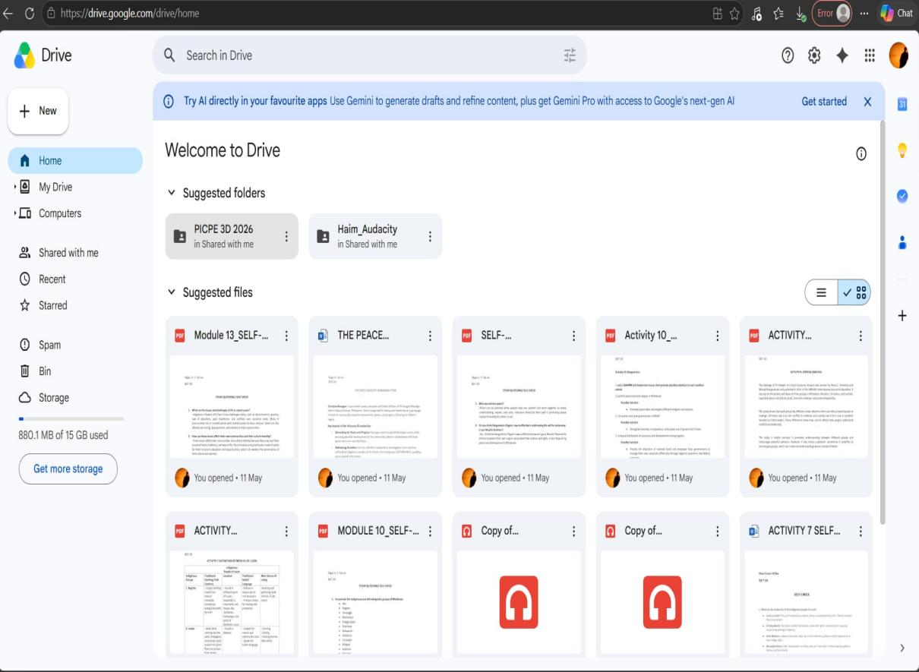Figure 1. Google Drive (Website)
Figure 1 shows the Google Drive application, which is widely used for storing and sharing digital documents online. It allows users to upload, organize, and access files anytime through cloud storage. The system also supports collaboration by enabling users to share documents with others easily. However, Google Drive mainly focuses on file storage and sharing and does not provide built-in document routing, tracking, and HR management features needed in organizational processes.

2.2.2 Dropbox
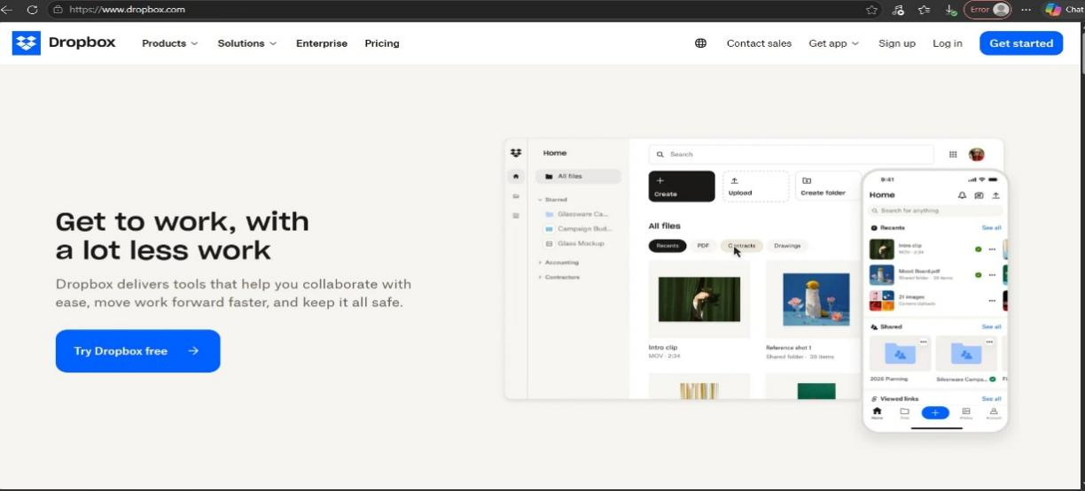
Figure 2. Dropbox (Website)
Figure 2 shows the Dropbox application, a cloud-based platform used for file storage and sharing. It enables users to upload documents, synchronize files across devices, and access records conveniently. The application is useful for collaboration and backup of important files. However, Dropbox lacks real-time document routing, monitoring, and integrated HR management functions that are essential for efficient document tracking systems.
2.2.3 Trello
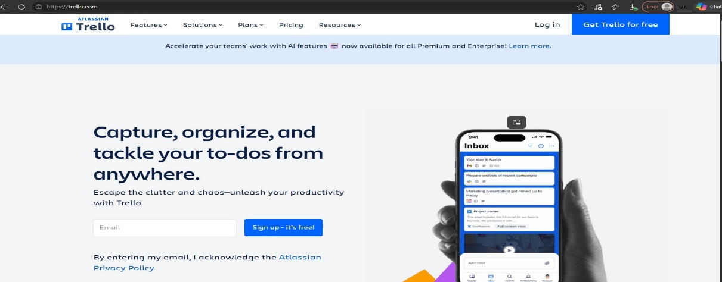
Figure 3. Trello (Website)

Figure 3 shows the Trello application, which is designed for task and workflow management. It helps users organize activities, assign tasks, and monitor progress through boards and cards. The system is effective for team collaboration and project monitoring. However, Trello mainly focuses on task management and does not provide centralized document tracking, storage, and HR-related features.

2.2.4 Microsoft SharePoint
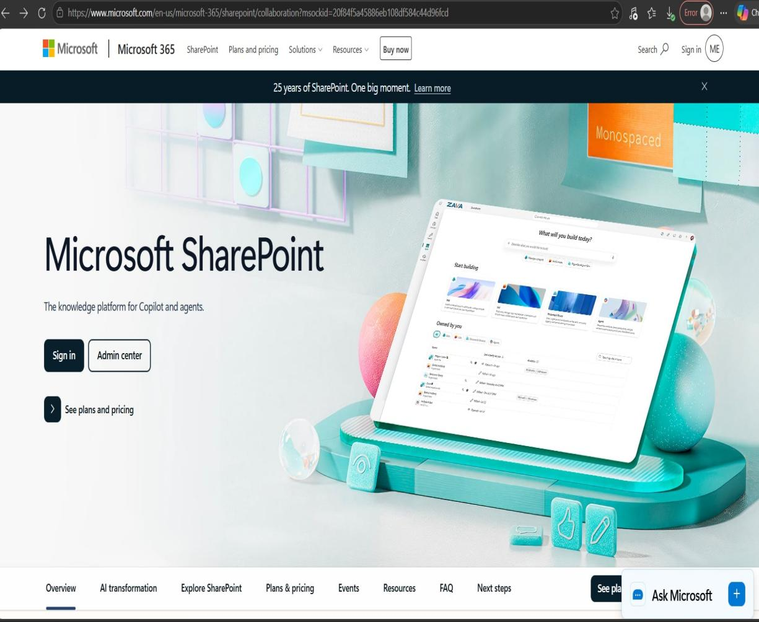Figure 4. Microsoft SharePoint (Website)

Figure 4 shows the Microsoft SharePoint platform, which is used for collaboration, document management, and workflow organization. It allows organizations to share files, manage records, and improve communication among employees. While the system offers strong document management features, some of its functions may be complex and difficult to use for smaller offices or organizations with limited technical resources.

2.2.5 Notion (Basic Setup)
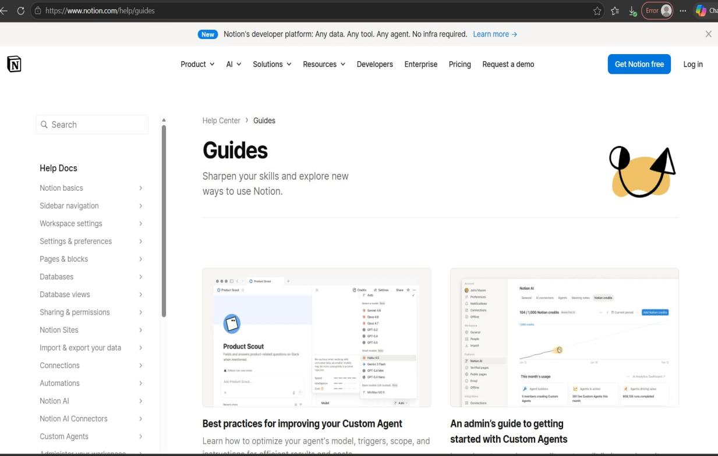
Figure 5. Notion (Basic Setup) (Website)

Figure 5 shows the Notion application, a productivity and workspace platform used for organizing information, notes, tasks, and documents. Its basic setup allows users to create pages, databases, and simple workflows for managing records and team activities. The application is useful for collaboration, planning, and organizing data in one workspace. However, Notion mainly focuses on productivity and information organization and lacks advanced document routing, tracking, and integrated HR management features required for efficient organizational document processes.

Comparison Table of Related Application
Table 1: Comparison Table of Related Application
TITLE | Digital Storage | Workflow Tracking | Limited Status View | Activity Logs
Google Drive | ✔️ | ✖️ | ✖️ | ✔️
Dropbox | ✔️ | ✖️ | ✖️ | ✔️
Trello (for  tracking) | ✖️ | ✔️ | ✖️ | ✖️
Microsoft SharePoint | ✔️ | ✔️ | ✖️ | ✖️
Notion (basic  setup) | ✔️ | ✔️ | ✖️ | ✖️
DocuTrack | ✔️ | ✔️ | ✔️ | ✔️
Table 1 presents the comparison between the proposed DocuTrack system and existing document management and workflow applications such as Google Drive, Dropbox, Trello, Microsoft SharePoint, and Notion. The comparison is based on several key features, including digital storage, workflow tracking, limited status view, and activity logs. As shown in the table, the proposed DocuTrack system integrates all of the mentioned features in a single platform, while the existing applications only provide selected functionalities and lack some important features such as limited status view and activity logs.

Synthesis and Gap Analysis
Table 2. Synthesis and Gap Analysis
No. | Research Title / Application | Key Contribution | Identified Gap
1 | Rodriguez et al. (2023) Digital Document Management System | Enhanced storage, retrieval, and sharing of documents | Lacked real-time tracking and centralized HR functions
2 | Malicsi (2024) Document Tracking System | Promoted digitalized and automated document tracking | Did not integrate cloud-based collaboration and HRMS
3 | Luciano et al. (2023) Human Resource Management System | Improved employee record management and productivity  No document routing and tracking capabilities | No document routing and tracking capabilities
4 | Wong et al. (2025) Digital Document Tracking System | Improved monitoring and transparency of documents | Limited integration with HR management systems
5 | Workflow Management Algorithm Study (2024) | Automated document routing and approval processes | Did not provide centralized employee management
6 | Google Drive | Provided cloud storage and file sharing features | No document routing, tracking, and HR integration
7 | Dropbox | Enabled file synchronization and online storage | Lacked workflow automation and real-time document monitoring
8 | Trello | Improved task and workflow organization | No centralized document tracking and HR management
9 | Microsoft SharePoint | Supported collaboration and document management | Complex for smaller government offices and lacks simplified integrated HRMS
10 | Notion | Helped organize tasks, notes, and documents | No advanced document routing and HR-related features

Table 2 shows that document management and human resource systems help improve the storage, tracking, and management of records. However, the gap analysis shows that these systems do not combine document management and human resource functions in one platform. Some systems also lack real-time document tracking, automated document routing and approval, and centralized employee records. To address these gaps, the proposed system aims to develop a web-based application that manages employee records, tracks documents in real time, automates document routing and approval, provides secure document storage, and generates reports. This system is expected to make document processing and human resource management easier, faster, and more organized.

CHAPTER III
METHODOLOGY

3.1 Research Methodology
The proposed DocuTrack system, a digital document tracking and routing system designed for government offices in Northern Poblacion, was developed using the Agile Model for System Development Life. This methodology provided a systematic and organized process in planning, analyzing, designing, developing, testing, and implementing the system. Through the use of SDLC, the researchers ensured that the proposed system addressed the objectives of improving document handling, monitoring, routing, accountability, accessibility, and service delivery within the municipal offices.
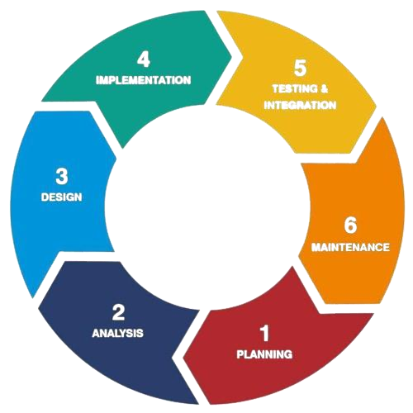
AGILE
METHODOLOGY

Figure 6. Agile Model for the System Development Life Cycle (SDLC)

The methodological approach of the study consists of the following phases:
Planning
The planning phase involved identifying the existing problems encountered in document handling and routing within the government offices of Northern Poblacion. The researchers analyzed the current manual process and identified issues such as delayed document processing, difficulty in tracking document status, lack of transparency, poor document monitoring, and inefficient office communication.
Based on these identified problems, the researchers established the objectives of developing DocuTrack as a digital document tracking and routing system capable of improving the monitoring, movement, and management of documents. During this phase, the appropriate tools and technologies for system development were also selected, including the use of Dart SDK for frontend development and Supabase with PostgreSQL for database management and backend services.
Analysis
During the analysis phase, the researchers conducted a detailed study of the document management processes within the municipal offices. The workflow of document creation, scanning, routing, approval, monitoring, and storage was examined to determine the necessary features and functions of the system.
The analysis identified several important system requirements such as document scanning capabilities, workflow tracking, role-based access, document status monitoring, activity logs, notification features, and secure document storage. These requirements supported the study’s objective of developing a centralized digital platform that improves transparency, accountability, accessibility, and efficiency in document management and office transactions.
Design
In the design phase, the structure, architecture, and interface of the DocuTrack system were created. The researchers designed the database structure, workflow process, and user interface to ensure efficient document tracking and routing within the organization.
Several system diagrams were developed to illustrate the structure and flow of the proposed system, including the System Architecture Diagram, System Flow Diagram, Use Case Diagram, and Entity Relationship Diagram (ERD). The database design included tables necessary for managing documents, user accounts, workflow routes, notifications, permissions, and activity logs. The interface design focused on creating a user-friendly and accessible platform for employees and administrators.
Development
The development phase focused on building the actual DocuTrack system using modern software technologies. The frontend interface was developed using the Dart SDK programming language to create a responsive and interactive web-based application.
For backend development and database management, Supabase integrated with PostgreSQL was utilized to securely store and manage document records, workflow configurations, notifications, permissions, and activity logs. The system was developed with features such as document scanning, document routing, workflow tracking, status monitoring, user management, and audit trail recording.
This phase ensured that the system fulfilled the study’s objectives of creating a centralized and secure digital document management platform capable of improving office efficiency, document tracking accuracy, and overall public service delivery.
Testing
The testing phase evaluated the functionality, usability, and effectiveness of the proposed system. Different tests were conducted to verify whether the system operated correctly and met the intended objectives of the study.
The researchers tested document scanning, document creation, workflow routing, status tracking, notification functions, permissions and access controls, and activity logging features. Usability testing was also conducted to determine whether users could easily navigate and operate the system. Errors and system issues identified during testing were corrected and improved to ensure reliable system performance and accurate document processing.
Implementation
The implementation phase involved deploying the DocuTrack system for actual use within the government offices of Northern Poblacion. During this phase, the configured workflows, document routes, permissions, and user roles were integrated into the system to support daily office operations.
The system was introduced as a centralized platform where employees and administrators could digitally create, scan, track, route, and monitor documents in real time. Through the implementation of DocuTrack, the researchers aimed to improve transparency, accountability, accessibility, and efficiency in handling office documents while supporting better communication and service delivery within the municipal offices.
Maintenance
The maintenance phase focuses on keeping the DocuTrack system functional, secure, and reliable after its implementation in the government offices of Northern Poblacion. During this phase, the researchers monitor the system’s performance, check for errors, and make necessary updates to ensure that its features continue to work properly.
Regular maintenance includes fixing technical issues, updating system features when needed, checking database performance, maintaining user access and permissions, and ensuring that document records remain secure and accessible. Feedback from employees and administrators may also be collected to identify areas for improvement. This phase aims to ensure that DocuTrack continues to support efficient document scanning, routing, tracking, and monitoring while maintaining the accuracy, security, and reliability of document management within the municipal offices.

3.2 Data Gathering Procedure
The research utilized the following methods:
Interviews: The research team conducted structured and semi-structured interviews with a group of individuals from various governmental departments involved in document processing and routing. The purpose of conducting these interviews was to gain an insight into what their duties involved, their document workflow system, and the problems that they experienced when manually handling or partly automating their work. The interview questions were formulated such that they could capture issues concerning document processing, routing procedures, approval methods, delays, and record keeping.
Observation: The observation involved observing how the documents were processed in the office setting. This included observing how documents came into the office, how they were recorded and how they were routed to their final destinations, which involved storing them in designated places. Some practical issues in relation to the work process were discovered through the conducted research by the team.
Data Analysis: It comprised in-depth analysis of the documents. Such documents as routing slips, log books, transmittal sheets, and all other pertinent documents were taken into account in order to understand how information is recorded, tracked and managed throughout its whole life cycle.
In addition to that, this study helped uncover important details on data structure, as well as the demands for the suggested solution implementation. As a result of data acquisition techniques used during the investigation, a clear understanding of the current document management system was attained. In this way, the results of the research became a strong basis for building and implementing DocuTrack.

3.2.1 Research Instrument
The research tools used in this study were carefully developed in order to make sure that the process of data collection with respect to DocuTrack: A Digital Document Tracking and Routing System for Government Offices would be accomplished easily. Such tools played a vital role in helping the researchers collect relevant data.
There were a number of methodological tools used in the process of data collection:
Interview Guide Questionnaire - As a guide to the interview process, it refers to the series of questions selected with care for the purpose of controlling the interview conversation. The main purpose was to obtain comprehensive data on the existing document tracking and routing, as well as the challenges faced and user specifications concerning the new DocuTrack system.
Observation Checklist – As a tool for conducting systematic observations of the office activities, it helped to make sure that each stage in the document handling process was duly noted. These instruments served as the necessary means through which the researchers were able to collect accurate and appropriate information regarding the existing procedures for document management and routing in the office.
Document Review Guide - This instrument was employed by the researchers in order to review existing forms, documents, and records pertaining to document management. Through this process, the researchers were able to study the existing arrangement of the documentation and identify areas for improvement in relation to the DocuTrack system.

3.2.2 Sampling Method
In this section, the researchers describe the participants involved in the data gathering process and explain the method used in selecting them. The study employed a purposive sampling technique, a non-probability sampling method commonly used in studies where participants are selected based on their knowledge, experience, and involvement related to the subject being investigated.
The participants of this study consisted of selected government employees and office personnel from the municipal offices of Northern Poblacion who are directly involved in document processing, routing, and record management. These individuals were chosen because of their firsthand experience with the existing manual and semi-digitalized document handling procedures used in their respective offices.
The total number of participants who took part in the study was three (3). The criteria used in selecting the participants were the following: (1) currently working in a municipal office involved in document handling and processing, and (2) willingness to participate in the study.
Furthermore, the use of purposive sampling enabled the researchers to gather relevant and meaningful information necessary for the development of the DocuTrack system. By selecting participants with direct experience and knowledge of the current document management process, the researchers were able to identify existing challenges, understand actual office practices, and obtain valuable insights that contributed to the improvement and design of the proposed system.

3.2.3 Statistical Treatment of Data
The gathered data were subjected to thematic analysis, which is widely used in qualitative studies. Thematic analysis may prove helpful in identifying, analyzing, and understanding themes in the data.
The thematic analysis followed a number of systematic steps:
Organization of data – The data gathered through interviews, observation, and document analysis was systematically gathered, organized, and analyzed for its accuracy.
Data Coding – In this stage, the process included identifying and categorizing statements and responses that would be considered relevant.
Theme Identification – For the identification of themes, similar codes were put together in bigger categories. The identified themes such as inefficiency in operations, data management issues, and processing delays allowed for a clearer understanding of the common problems in the present system.
Interpretation – Through interpretation of the identified themes, it was possible to make clear the existing problems and requirements of the organization.
With the aid of the above-discussed approach, the researchers were able to identify the problems clearly, and based on the identified problems, design a new system.

3.2.4 Data Analysis (Qualitative Treatment of Data)
The gathered data were analyzed using the thematic analysis technique, which is usually applied in qualitative studies.
The analysis proceeded through a series of methodical stages:
Data Organization – The data from interviews, observations, and document reviews was systematically collected, organized, and carefully examined to ensure both completeness and accuracy.
Data Coding Stage - The step consisted of noting the significant statements and responses and observations.
Theme Identification - In order to find the theme, similar codes were grouped together into bigger themes. These themes that included inefficiencies in operations, poor data management, and delays in processing provided insight into what the common issues were for the current system.
Interpretation - Through the interpretation of the themes, it was possible to gain an understanding of the common problems and needs of the organization. Through the above approach, the researchers were able to pinpoint the major issues and design the new system accordingly.

3.3 Description of the Current System (Information Gathering)

The existing document management process largely depends on manual activities and physical documentation. The processes include physical submission of paperwork, manual registration of information in the logbook, physical movement of the paperwork between different offices, and physical storage of information in folders and filing cabinets.
Document processing is a process that includes several stages. First, the documents must be received; secondly, their important information must be registered. Thirdly, the paperwork must be delivered to the corresponding department or individual, where approval or signature will be obtained.
Moreover, the process of routing and monitoring documents is managed through manual tracking and the use of paper records. Tracking the location of the documents, their present condition, and the progress of their movement poses quite a problem.
Problems found by the research group in the present system include:
- The process of processing and routing the documents takes time.
- It is difficult to track the status of the document.
- Documents may be lost.
- Access to the documents is restricted

3.4 System Architecture and Development
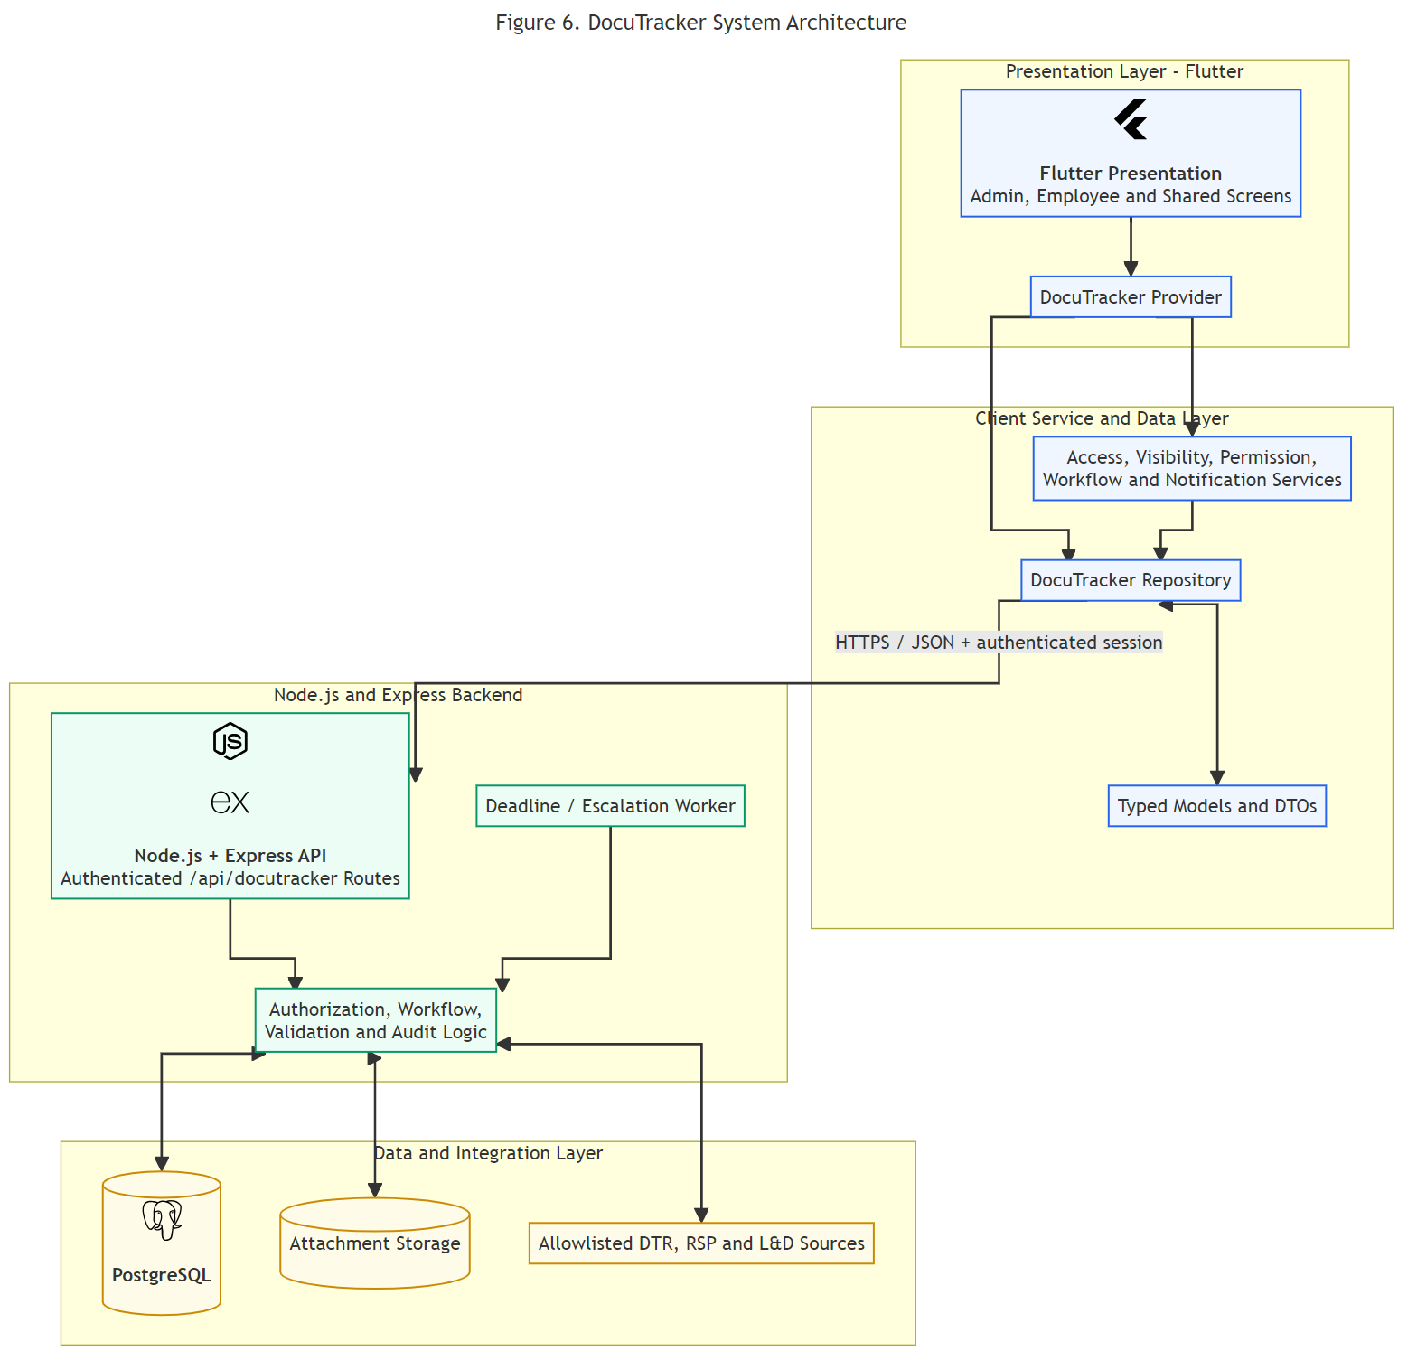
Figure 7: System Architecture Diagram

Figure 7 shows the DocuTracker system follows a top-to-bottom layered architecture where the primary users, namely the Employee, Reviewer, and Administrator, interact with the system through a frontend interface developed using Flutter SDK. The client layer sends user requests to the backend server developed with Node.js and Express.js, which processes workflow logic, validates permissions, and manages document routing, approvals, and notifications. The processed information is then securely stored in PostgreSQL, while uploaded attachments are saved in the system’s file storage service. Additionally, the system may optionally integrate with HRMS source modules such as Learning and Development (L&D), Daily Time Record (DTR), and Recruitment, Selection, and Placement (RSP) to support centralized and efficient document management operations.

3.5 Overview of the Proposed System
The proposed system is a web-based Digital Document Tracking and Routing System. Its main objective is to digitalize document processing within government offices, allowing a more organized and efficient way of handling official records. The system enables authorized users to create, upload, access, and monitor the status of documents through an online platform. Through this digitalized approach, employees can easily track document movement and stay updated on its current status in real time. The system also features an integrated database that stores document information, records its progress, and maintains a complete workflow history. Overall, this system enhances office operations by reducing reliance on manual paper-based processes and improving the speed, accuracy, and accessibility of document management.

3.6 System Objectives

3.6.1 General Objectives
DocuTrack, a digital document tracking and routing system designed for government offices, is fundamentally focused on establishing a centralized, web-based platform. The system aims to simplify and improve document management through a fully digitalized process. It is designed to enhance efficiency, accuracy, and transparency in handling official documents by enabling a more organized flow of information. Furthermore, the system is expected to reduce inefficiencies, minimize the risk of lost or misplaced documents, and support managers in effectively overseeing workflow processes. Through this digitalized approach, document handling becomes more structured, accessible, and easier to monitor within government operations.

Specific Objectives
The proposed DocuTrack system, designed for government use, has several main goals:
- The system allows users to create, submit, and track documents electronically within a centralized digital platform to improve accessibility and efficiency in document handling.
- The system enables managers to configure workflows, assign user permissions, and monitor document routing to ensure proper control, transparency, and accountability in the process.
- The system maintains a secure electronic database that organizes all documents, supports easy retrieval, and generates reports for management use and performance evaluation, while reducing the risks of loss, misplacement, or duplication of records.

System Tools and Requirements
In order to successfully design and implement the proposed DocuTrack system for tracking and routing electronic documents within the government agency, appropriate tools and requirements must be provided to ensure efficiency, reliability, and smooth system operation.
The following tools and requirements are necessary for the effective deployment and maintenance of the system:
- Web-Based Portal – Provides accessible and centralized document tracking and routing services across different office sites.
- Database Management System (DBMS) – Securely stores, manages, and organizes document information and transaction records.
- User and Administrator Interface – Allows authorized users and administrators to efficiently monitor, manage, and route documents within the system.
- Reliable Internet Connection – Ensures real-time document tracking, synchronization, and communication between offices.
- Hardware Resources – Includes computers, servers, and related devices capable of processing and handling digital documents efficiently.
- Software Resources – Consists of the required operating systems, browsers, development tools, and application software needed for system functionality and maintenance.

Programming Languages
Table 3. Programming Language

Programming Language | Version
Dart | Dart 3.9.0
Javascript | Node 18+

Table 3 is developed using modern programming technologies to ensure a reliable, efficient, and user-friendly application. It utilizes Dart for building a responsive and interactive interface that enhances user experience across the system. For backend development and server-side functionality, JavaScript is used together with Node.js, which supports efficient data handling and smooth system operations. The integration of these programming tools allows the system to perform effectively in managing, tracking, and routing documents in a digitalized environment within government offices.

Hardware Requirements

Server Requirements
Table 4. Server Requirements

Components | Specification
Processor | Intel Core i3 or higher
RAM | 8 GB or higher
Storage | 256 GB SSD or higher
Network | Stable broadband internet connection
Monitor | 1366 x 763 resolution

Table 4 is intended to operate in a standard computing environment with moderate to high-performance hardware to ensure smooth functionality and responsiveness. It requires a capable processor to handle processing tasks efficiently, along with sufficient memory to support multitasking and stable runtime performance. Fast and reliable storage is recommended to enhance data access speed and overall system responsiveness. A consistent internet connection is necessary to support network-based operations and maintain uninterrupted communication between system components.

Client Requirements
Table 5. Client Requirements

Components | Specification
Processor | Intel Core i5 or higher
RAM | 4 GB minimum
Storage | 64 GB available storage or higher
Display | 1366 × 768 screen resolution or higher
Browser | Modern web browser such as Google Chrome, Microsoft Edge
Network | Stable internet connection
XP-Pen | Star G430S

Table 5 presents the client requirements needed to ensure the proper functionality and smooth performance of the proposed DocuTrack system. The system requires at least an Intel Core i5 processor, 4 GB of RAM, and 64 GB of available storage to support efficient document processing and workflow operations. A display resolution of 1366 × 768 or higher is recommended to provide a clear and user-friendly interface.

Software Requirements
Table 6. Software Requirements

Application | Version
Flutter SDK | Version 3.41.2
Dart SDK | Version 3.11.0
Visual Studio | Latest Stable Version
PostgreSQL | Version 18.3
Git
  Latest Stable Version
Windows | Windows 10 or Windows 11
Web Browser | Latest Brower

Table 6 presents the software requirements needed for the development and operation of the proposed DocuTrack system. The application is developed using the Flutter SDK Version 3.41.2 together with the Dart SDK Version 3.11.0 to create a responsive and efficient user interface. For system development and coding, the latest stable version of Visual Studio is utilized. The system also uses Supabase as its cloud platform service for backend support and database management, integrated with PostgreSQL Version 18.3 for reliable data storage and retrieval.

System Flow/Functions
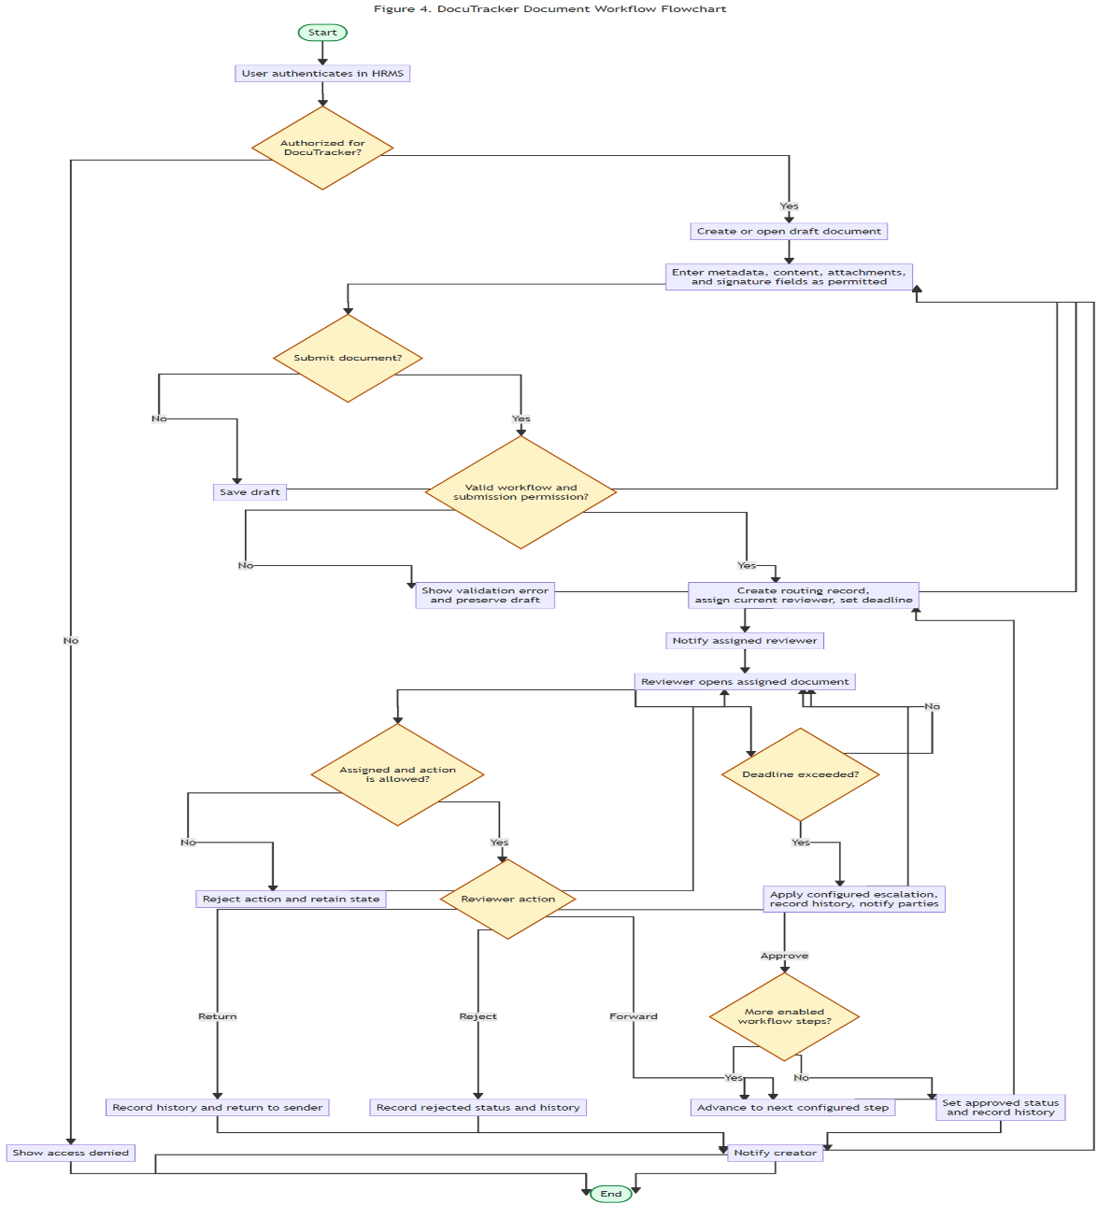Figure 8: System Flow/Functions
Figure 8 presents the sequential workflow experienced by DocuTracker users. The process begins when a user opens the module and chooses to create a new document, open an existing one, or configure the system as an administrator. New documents start as drafts that only the creator may edit until submission. Upon submission, the document enters multi-step review, where assigned reviewers may approve, forward, return, or reject it. Approval on the final step completes the workflow, while rejection ends it. Returned documents re-enter review at an earlier step. If review deadlines are exceeded, the system escalates the document or marks it overdue for administrator intervention. This flowchart complements Figures 2 and 3 by showing the order of user actions and decision points, whereas the DFD diagrams show data movement and system components.

Sequence Diagram
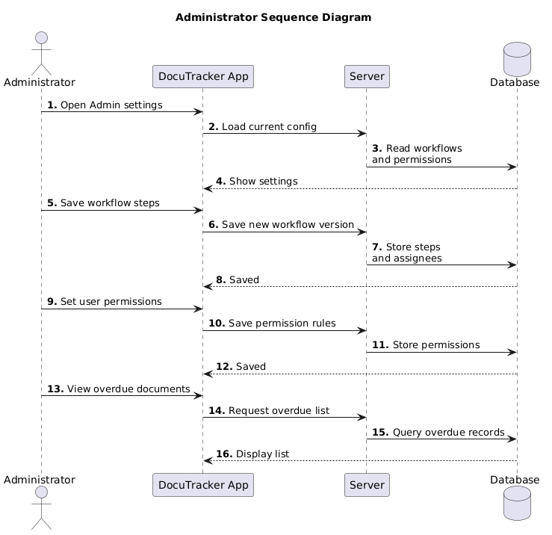
Figure 9. Administer Sequence Diagram

Figure 9 shows how a document is created in the DocuTracker system. Employee submits the document details using the Flutter app. The request is sent to the backend API. Workflow service handles the request and performs actions such as retrieving workflow configuration, figuring out the assignee of the workflow, and then saves the document, routing, history, and notifications into the database as a single database transaction. This process is concluded with a message about a successful document creation.

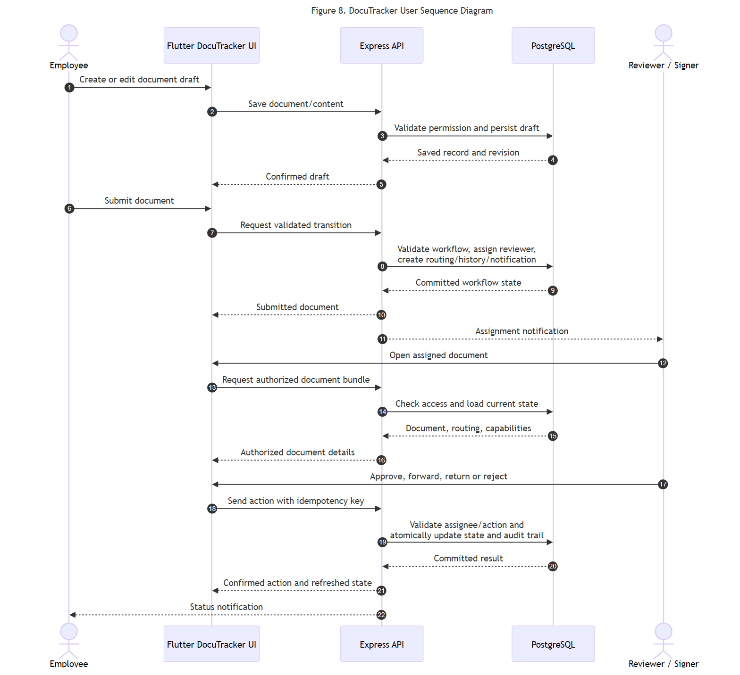
Figure 10. User Sequence Diagram

Figure 10 illustrates how the system processes document workflow actions. Every time the reviewer performs an action, the request gets passed to the back-end API through the Flutter app and goes through the workflow engine process. This process makes sure that the action performed is correct, and permissions, workflows, and document statuses are checked before any notification can be sent regarding the update on the document.

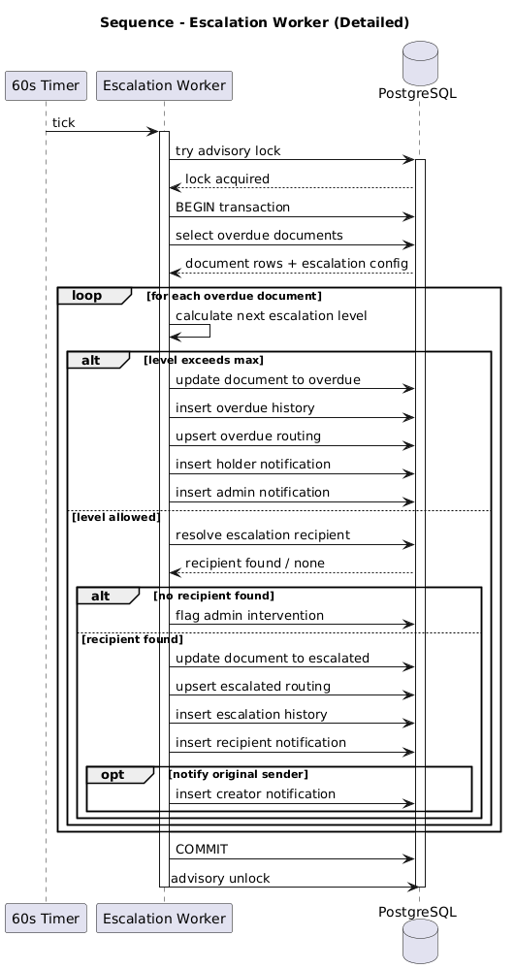
Figure 11. Sequence Diagram (Escalation Worker)
Figure 11 describes the automated escalation process for overdue documents. An event is fired by the timer, which causes the escalation worker to be invoked periodically. This task examines each document that has missed its deadline, deciding if it should be escalated or put through administrative intervention. The document’s details such as status, routing information, and history will be updated in a single transaction.
This diagram illustrates the complete workflow of the DocuTracker system, from document creation to final processing. After logging in, a user prepares a document that is then assigned to the reviewer depending on the configuration settings of the system. A reviewer may choose to either approve, reject, return, or forward a document; any such decision will update the status of the document, notify other concerned parties, and keep track of the progress made.

Scope and Limitation of the System
The proposed system serves two primary user groups: the Administrator/Records
Personnel and the Office Staff/End Users. It is a web-based Digital Document Tracking and Routing System designed to improve the efficiency and effectiveness of document management within government offices. The system covers the complete document lifecycle, including document submission, routing, tracking, monitoring of movements, and final storage or archiving once documents are no longer actively required.
The scope of the system for office staff and end users is limited to user-level functionalities within the system interface. Users are allowed to submit documents, upload necessary files, and monitor the status of their documents in real time. They can also manage documents that are assigned to them, view document locations, and access records of documents they have created or previously handled.
However, the system is limited in terms of access and control for end users, as administrative functions are restricted to authorized personnel only. Office staff cannot modify system settings, manage user accounts, or alter document routing rules. Additionally, the system is dependent on internet connectivity and does not include offline functionality, which may limit access during network interruptions.
Administrator / Record Personnel - Access privilege covers all the tabs under the administrative module that takes care of managing document processes. The administrative module consists of the following:
Dashboard – Demonstrates all system activities, such as document intake and outtakes, pending document routes, completed transactions, and last-updated documents.
Document management - systems empower authorized users to encode, upload, and classify documents. Also, they offer an ability to trace how a document progresses, beginning from the point when it is uploaded until the time it is finally removed.
Document Routing Module – It helps the record staff to route their documents, which can be transferred between different offices, departments, or even specific people. This depends on what workflow must be followed or what must be done.
Document Tracking – Allows following the track of a document’s progress from the moment it comes into existence till its final destination. Here you can find out where your document is at this very moment and how it got there.
User Management – It is used to administer users, define office locations, and handle access rights. All the information that may be needed is stored in one centralized database. Record archiving – Storing documents, which have been completed or are archived, in a centralized and properly organized database.
Notifications and status updates - keep you in the loop. You'll always know what's happening with your documents, from the moment they arrive to when they're on their way, pending your review, or completed. Conversely, the user and office staff experience offers these features:
Dashboard – A centralized view of announcements, document updates, files awaiting action, and recent document activity.
Documents Submission Module – Upload necessary documents in an online submission process.
Document Status Tracking – Monitor the status of the document you have submitted or assigned to you. This involves a number of steps: receipt, review, routing, completion, and finally archiving.
Routing Acknowledgment – Receive an acknowledge routed documents assigned to their office or account.

  - Calendar of Activities
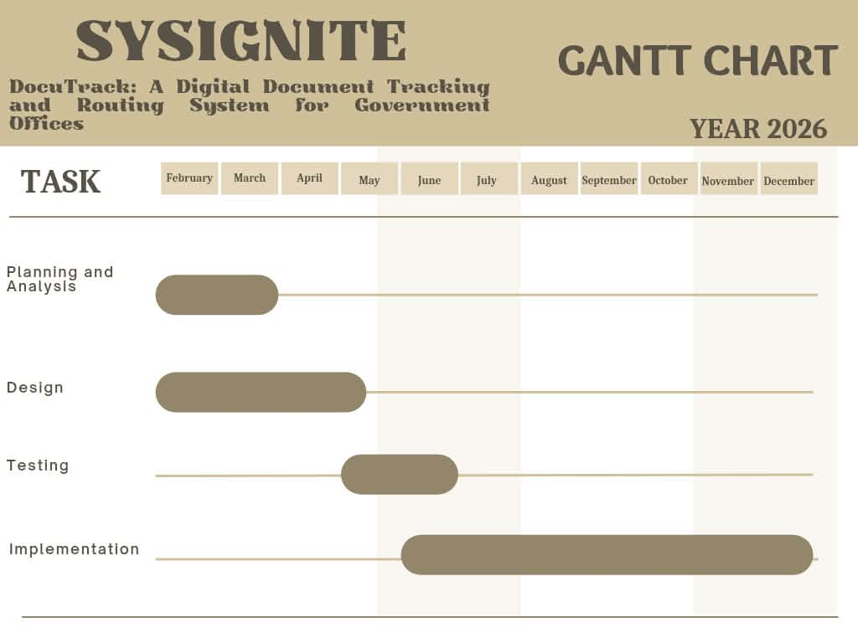
Figure 12. Gantt Chart
Figure 12 illustrates the development timeline of the DocuTrack: A Digital Document Tracking and Routing System for Government Offices for the year 2026. It presents the project schedule in a structured format across the months of February to January, showing the duration and overlap of each major phase. The project begins with the Planning and Analysis phase, which is carried out in the early months, followed by the Design phase that extends slightly longer into the mid-year period. The Testing phase is scheduled after the design stage and focuses on evaluating system functionality and performance. Finally, the Implementation phase spans the longest duration, running from mid-year until the end of the year, indicating system deployment and full operational integration. Overall, the chart provides a clear visual representation of the sequential and overlapping activities involved in completing the system within the planned timeframe.

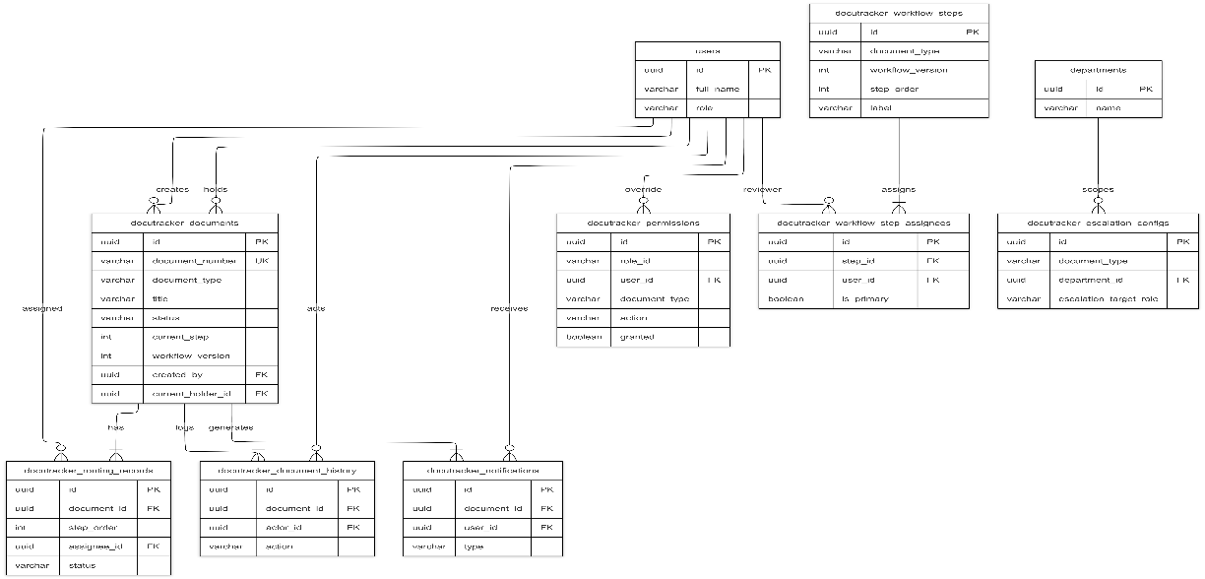
3.14.1 Database Design

3.14 Conceptual Design andImplementation

Figure 13. Database Design (ERD)

Figure 13 presents a simplified view of the DocuTracker database structure. The central entity is docutracker_documents, which stores document metadata, workflow status, and assignee information. Each document is linked to a user as creator and may have a current holder as reviewer. Related entities include routing records for step-by-step execution, document history for audit logging, and notifications for user alerts. Workflow configuration is represented through workflow steps and step assignees, while permissions and escalation configs govern access and deadline handling. Shared HRMS tables (users and departments) appear as external references. This overview diagram omits detailed columns and auxiliary tables so the overall data model can be understood at a glance.

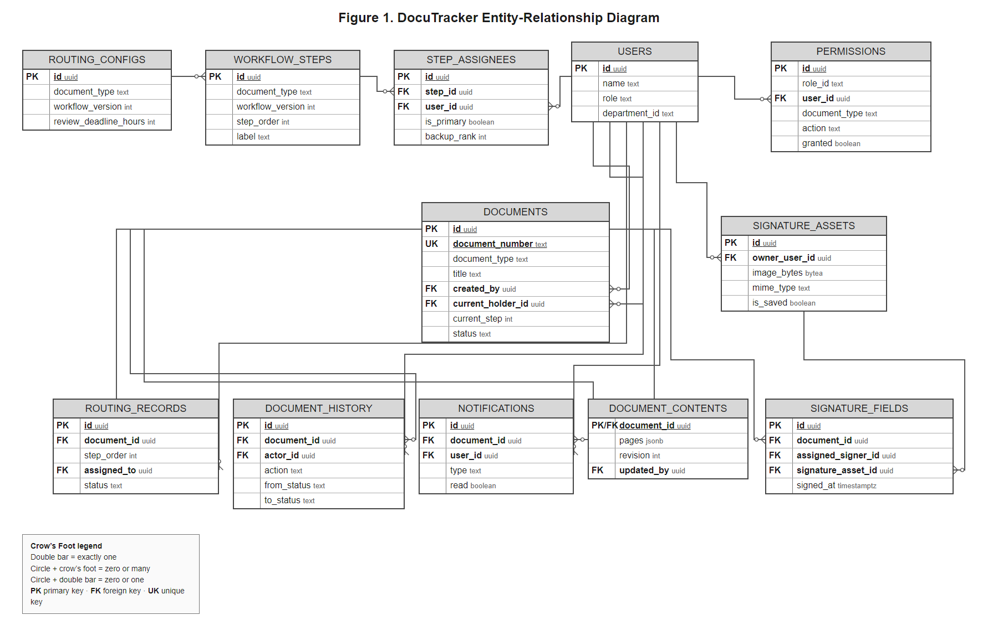
Figure 14. Entity Relationship Diagram

3.14.2 Entity Relationship Diagram

Figure 14 illustrates the database structure of the DocuTracker system and the relationships between its tables. It includes tables for users, documents, routing configurations, workflow steps, permissions, notifications, document history, and digital signatures. These tables work together to manage document tracking, routing, approval processes, user access, and activity records. The diagram also shows the primary keys and foreign keys used to connect related data and maintain data consistency. Overall, the ERD serves as a guide for organizing and managing the information needed for the system to operate efficiently.

Figure 15. System Design

3.14.3 System Design

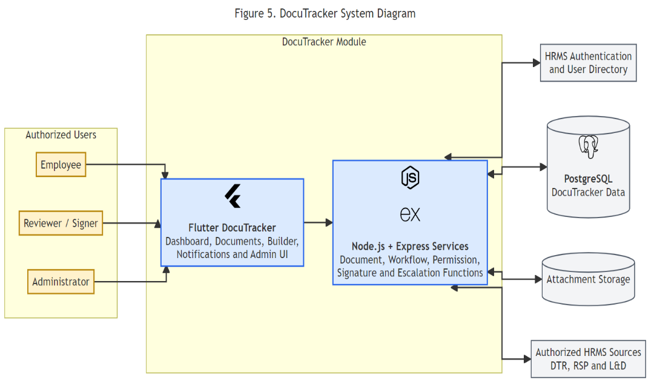
Figure 15 shows that DocuTracker uses a layered client-server architecture where users interact with the system through a frontend interface developed using Flutter SDK, while the business logic and workflow processing are handled through backend services. The system utilizes PostgreSQL for storing workflow records, user information, document data, and activity logs, with integrated file storage support for document attachments and records management. Figure illustrates the Use Case Diagram of the DocuTracker system, showing the interaction of the three primary actors: Employee, Reviewer, and Administrator. Employees are responsible for creating and submitting documents, managing attachments, tracking document status, and viewing notifications. Reviewers evaluate assigned documents, provide remarks, and perform actions such as approving, forwarding, returning, or rejecting documents. Administrators manage workflow configurations, assign permissions, monitor overdue documents, and oversee system operations. The system also includes access validation and permission controls to ensure that only authorized users can perform specific actions within the document workflow process.

Sequence Diagram
Figure 16. Administrator Sequence Diagram
Figure 16 shows how an administrator configures and monitors DocuTracker. In steps 1 through 4, the administrator opens the admin section; the application requests the current configuration from the server, which reads workflow and permission data from the database and displays it on screen. In steps 5 through 8, the administrator saves workflow steps; the server stores a new workflow version together with step assignees in the database. In steps 9 through 12, the administrator sets user or role permissions; the server saves the permission rules to the database. In steps 13 through 16, the administrator views overdue documents; the server queries records that have passed their deadline or require intervention and returns the list to the application for display. Together, these steps describe how the system is prepared before employees and reviewers use the workflow shown in Figure 6.

Use Case Diagram
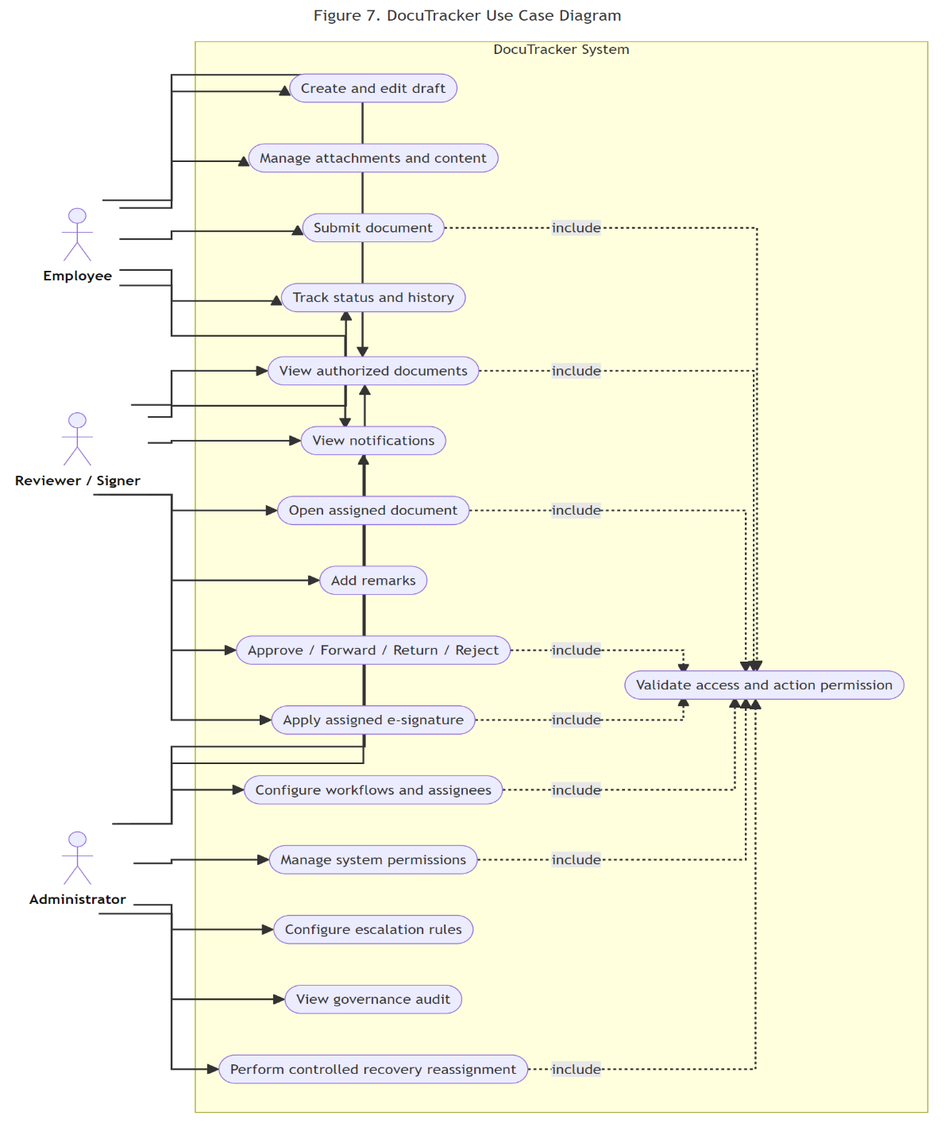
Figure 17. Use Case Diagram
Figure 17 shows the main interactions of employees, reviewers, and administrators with the DocuTracker system. It focuses on user-level functions such as document creation, review actions, notification handling, workflow management, and overdue document processing. Optional actions such as adding remarks and manual intervention are represented using extend relationships.

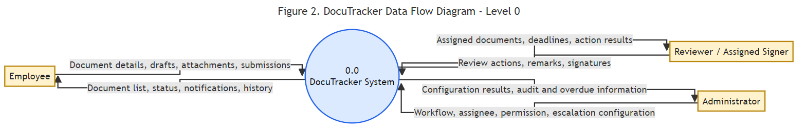
Figure 18. Data Flow Diagram (Level 0)

Data Flow Diagram

Figure 18 shows the context-level view of DocuTracker. The entire module is represented as a single process (0.0) bounded by two external entities: the User, who creates and reviews documents, and the Administrator, who configures the system. The User sends document data such as draft content, attachments, submission requests, and workflow decisions including approve, forward, return, and reject. In response, the system returns document lists, status updates, and notifications. The Administrator sends configuration data such as workflow routes, permissions, and assignee settings, and receives saved configuration confirmations and overdue document reports. At this level, internal processes and data stores are not shown, which keeps the diagram focused on how DocuTracker interacts with its environment.
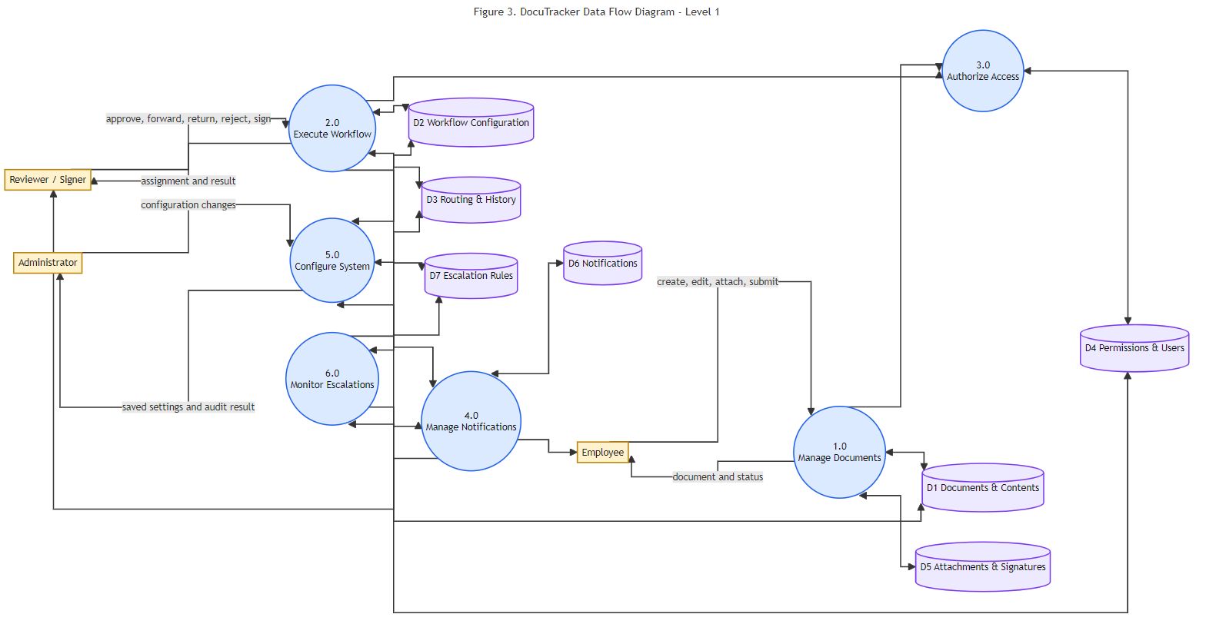
Figure 19. Data Flow Diagram (Level 1)

Figure 19 expands process 0.0 into three major functions. Process 1.0 Manage Documents handles document creation, viewing, editing, attachment management, and retrieval of document lists and details, reading and writing to data store D1 Documents. Process 2.0 Process Workflow handles submission and reviewer actions, updates document status and routing steps using D1 and D2 Workflow Data, and records notifications and escalation events in D3 System Settings. Process 3.0 Configure System is used by the Administrator to define workflow routes, permissions, assignees, and escalation rules stored in D2 and D3. Access validation and notification delivery are handled internally within these processes to keep the diagram readable while still representing the system accurately.

CHAPTER IV

RESULTS AND DISSCUSSIONS

- Discussions
This study aimed to develop DocuTrack, the digital document tracking and routing module of UNITY PILLAR, for government offices. The module focuses on electronic document registration, configurable routing, monitoring, review, and recording of document transactions. It is intended to address difficulties in manual document processing, including delayed routing, misplaced files, limited status visibility, and reliance on paper-based follow-up. The following discussions present the major objectives of the study and explain how the documented DocuTrack functions respond to the identified needs.
Discussion No. 1. To provide a centralized digital platform for document registration, submission, and storage.
The document creation and submission features allow authorized personnel to record document information, attach supporting files, and prepare documents for electronic processing. A centralized record is intended to make transaction information easier to locate and to reduce dependence on manually updated logbooks. Document-scanning capabilities should be described as a completed result only after verifying them in the actual system.
Discussion No. 2. To facilitate organized document routing, review, and approval across authorized personnel.
DocuTrack is designed to support a configurable sequence of document-processing steps. Based on the workflow described in Chapter III, designated personnel can receive assigned documents, provide remarks, and perform permitted actions such as approval, forwarding, returning, or rejection. Workflow configurations and role-based permissions help determine who is allowed to act at each stage. The documented design supports accountability by associating document actions with the users responsible for them.
Discussion No. 3. To provide document status monitoring, transaction history, and timely updates.
The document tracking and history functions are intended to let authorized personnel view the current status of a document, its assigned reviewer, and the actions recorded during processing. Notification functions are designed to inform users about assignments or relevant changes. These functions may help reduce repeated manual inquiries; however, the pilot questionnaires alone cannot establish actual reductions in processing time or delays.

4.2 Screen Design
This section presents the DocuTrack interfaces by feature and user role. Like the format used in the companion UNITY PILLAR manuscript, each screen is identified with a numbered figure and followed by a brief description of its purpose. The researchers should replace the labeled screenshot spaces with actual captures from the working DocuTrack application. The feature descriptions are based on Chapter III; functions not yet implemented or verified must be revised or omitted before final submission.

4.2.1 System Login and Authentication
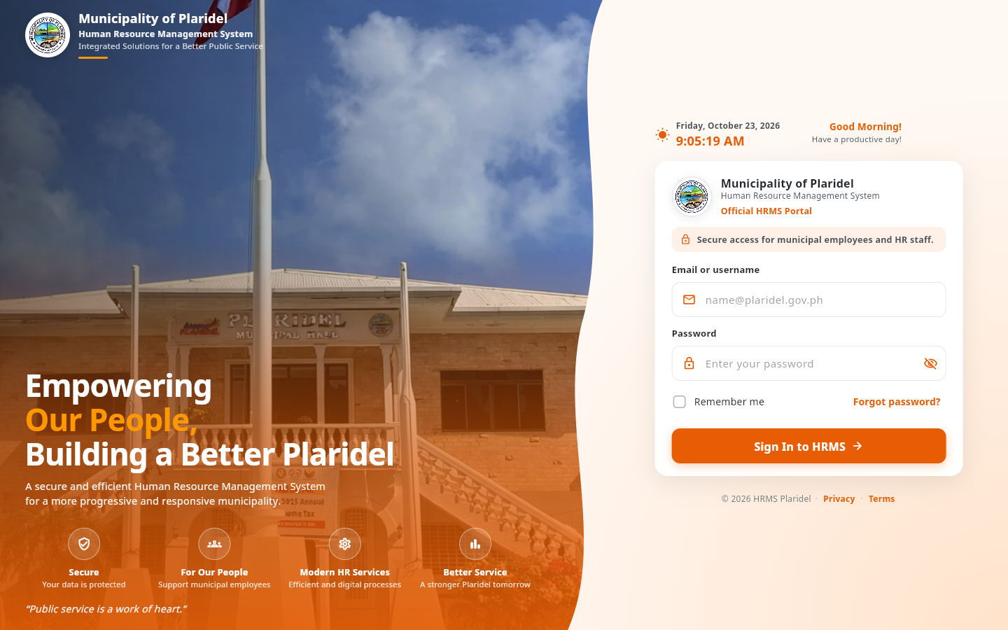
Figure 20. DocuTrack Login Interface

Figure 20 shows the DocuTrack login interface for authorized personnel. Registered users enter their credentials to access system functions associated with their accounts. Access restrictions help ensure that confidential documents and administrative controls are available only to permitted users.

4.2.2 Administrator Dashboard
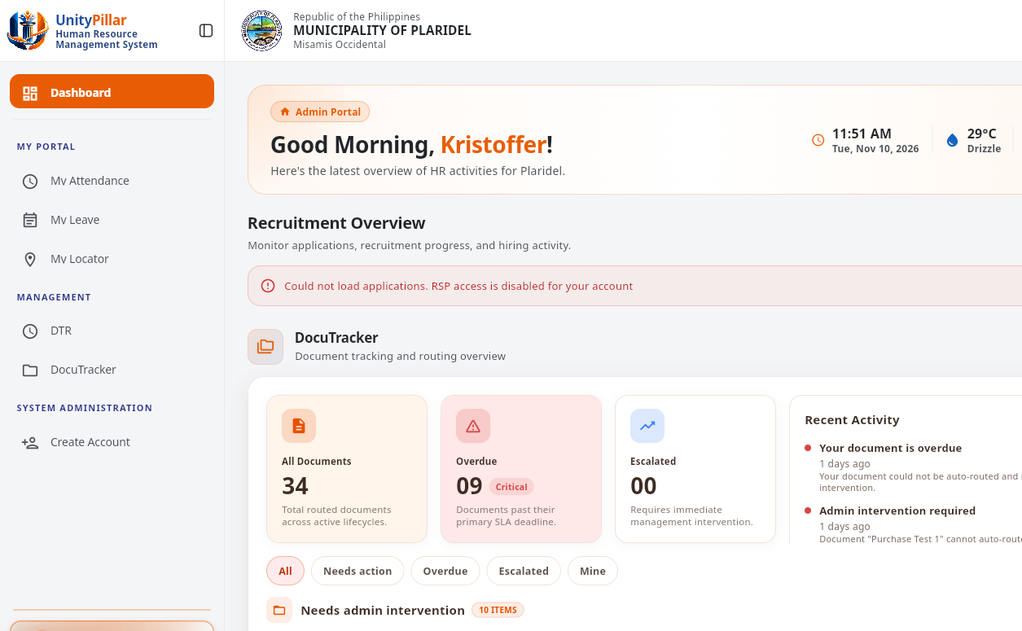
Figure 21. DocuTrack Administrator Dashboard

Figure 21 shows the administrator DocuTracker home after sign-in. The summary presents document volume, overdue and escalated counts, and recent activity.

4.2.3 Employee Dashboard
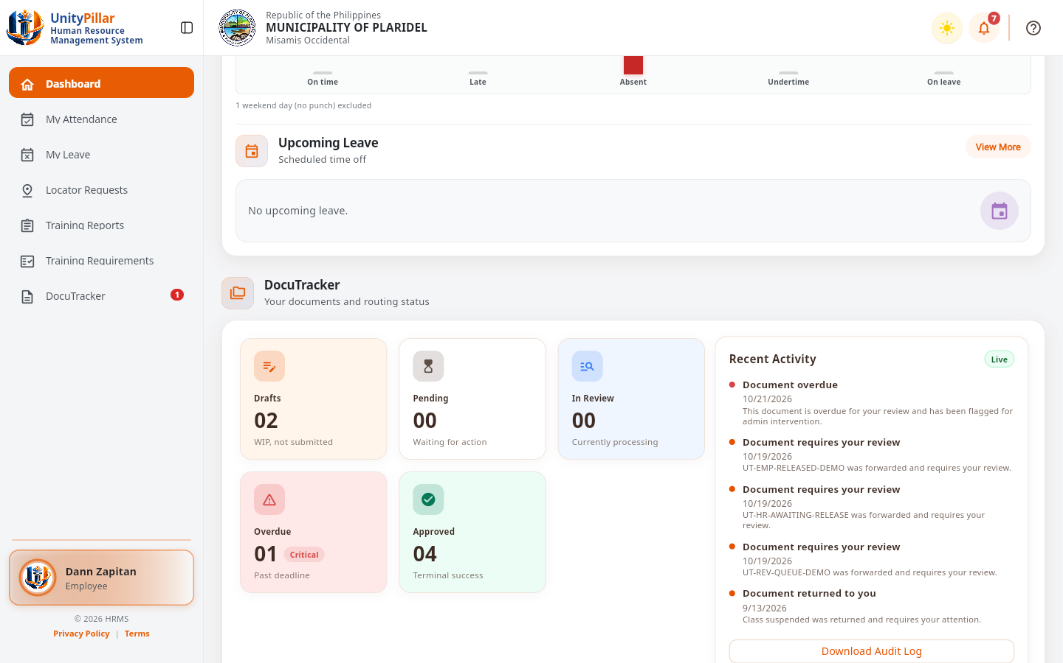
Figure 22. DocuTrack Employee Dashboard

Figure 22 shows the employee portal dashboard for Dann Zapitan. The DocuTracker card summarizes drafts, pending, in-review, overdue, and approved documents, along with recent DocuTracker activity.

4.2.4 Document Creation and Submission
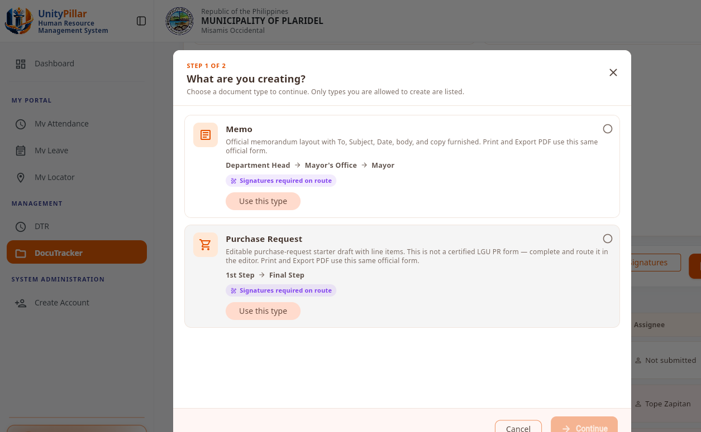
Figure 23. Document Creation and Submission Interface

Figure 23 shows the Create Draft type picker. The available native types in this screen are Memorandum and Purchase Request. The draft was not created during this capture.

4.2.5 Document Management and File Attachments
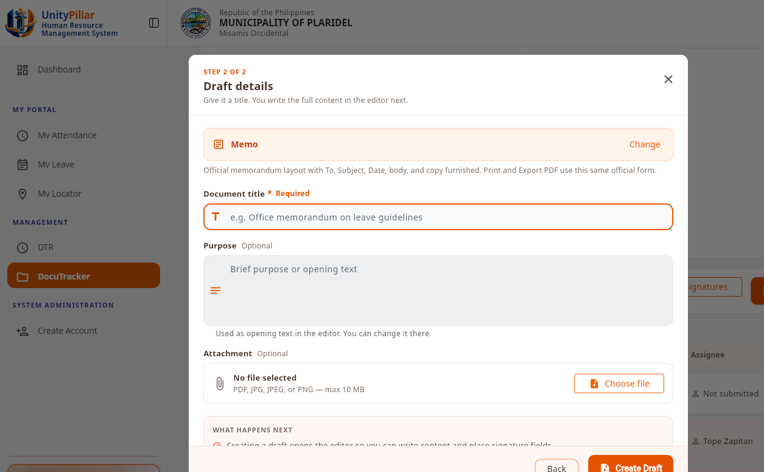
Figure 24. Document Management and File Attachments Interface

Figure 24 shows the draft details step, including the optional attachment field. Accepted attachment types are PDF, JPG, JPEG, and PNG, with a maximum size of 10 MB.

4.2.6 Document Routing and Workflow Configuration
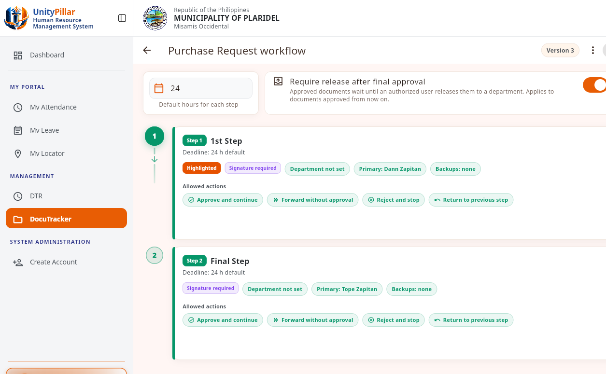
Figure 25. Workflow Configuration and Routing Interface

Figure 25 shows the Purchase Request workflow editor. Each step names a primary assignee and the allowed actions: approve and continue, forward, reject, and return.

4.2.7 Document Review and Approval
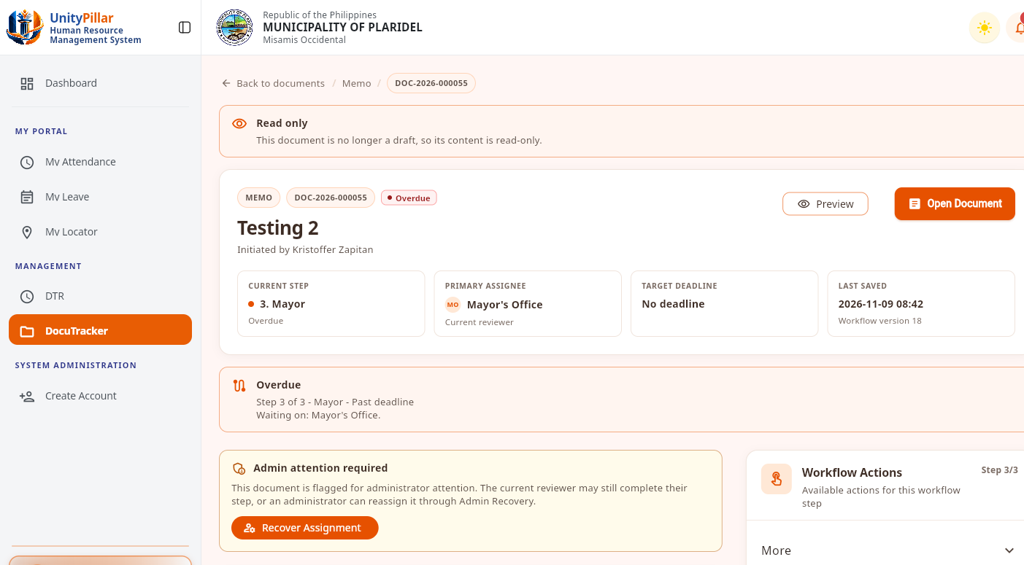
Figure 26. Document Review and Approval Interface

Figure 26 shows a submitted memorandum that is overdue at the Mayor step. The content is read-only for this administrator because the current reviewer is the Mayor's Office.

4.2.8 Document Tracking and Status Monitoring
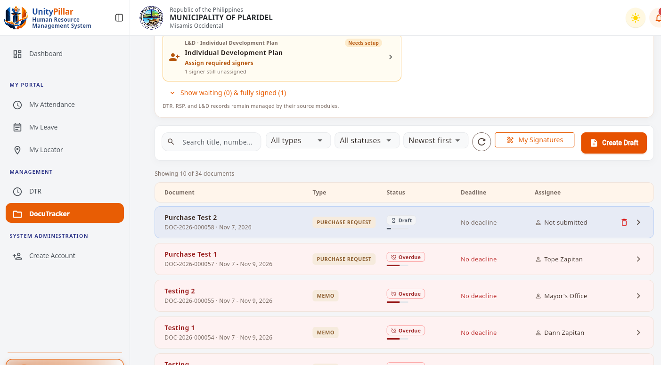
Figure 27. Document Status Tracking Interface

Figure 27 shows the document list used for status monitoring. Each row shows the document type, status, deadline, and current assignee.

4.2.9 Notifications and Status Updates
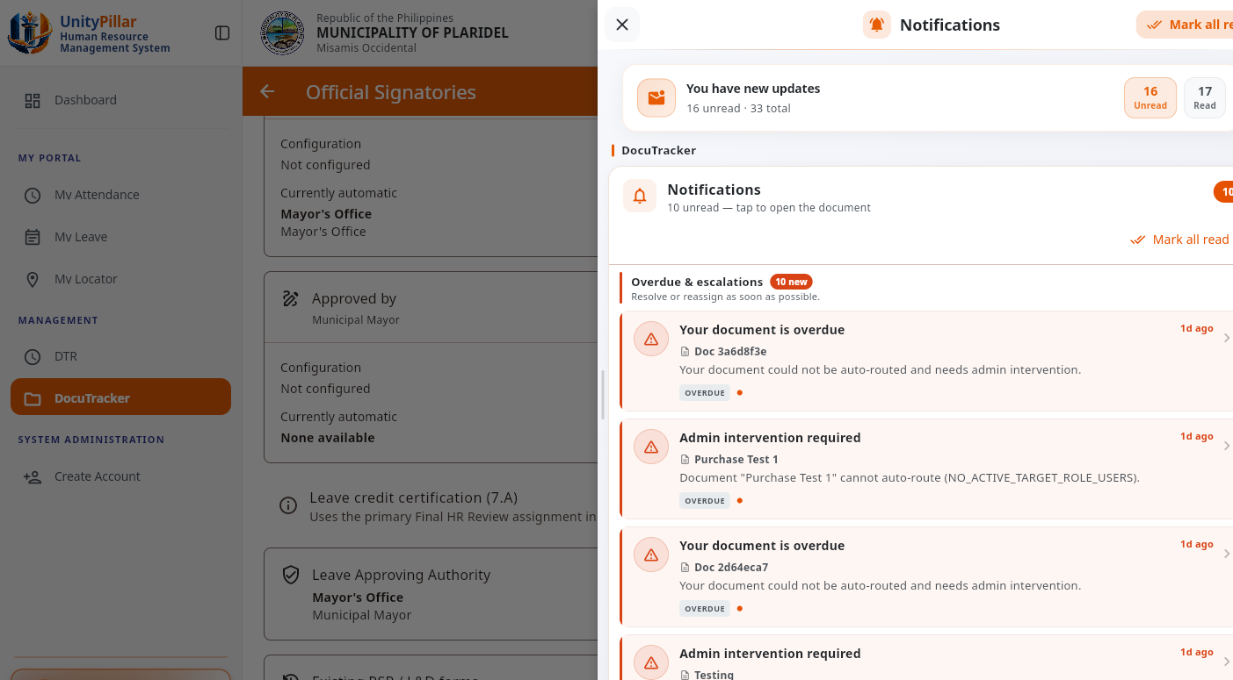
Figure 28. Document Notifications Interface

Figure 28 shows the notifications drawer. DocuTracker overdue notices identify documents that need admin intervention, including items that could not be auto-routed.

4.2.10 User Roles and Permissions Management
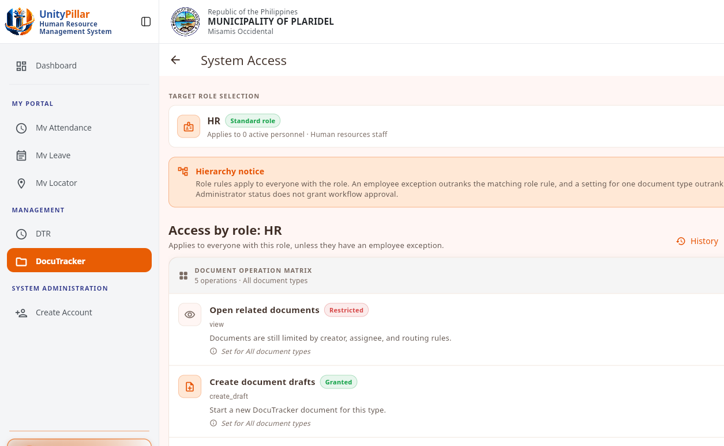
Figure 29. User Roles and Permissions Interface

Figure 29 shows the System Access role matrix. Granted and restricted capabilities are set by role. Administrator status does not by itself grant workflow approval.

4.2.11 Document Search and Filtering
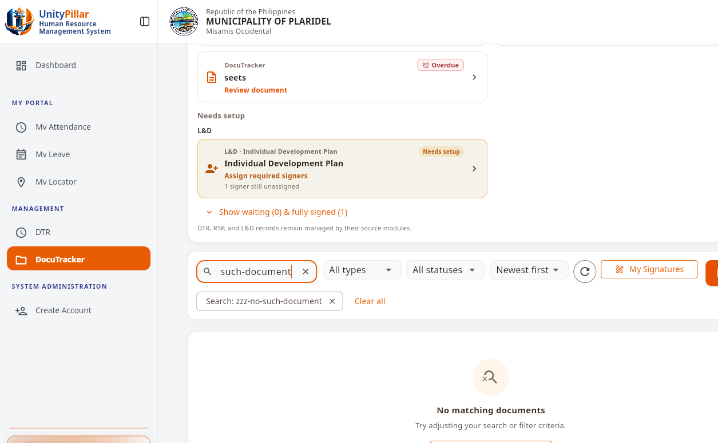
Figure 30. Document Search and Filtering Interface

Figure 30 shows document search. A search that matches no title, number, sender, or assignee returns an empty result and can be cleared without changing stored records.

4.2.12 Document History and Audit Trail
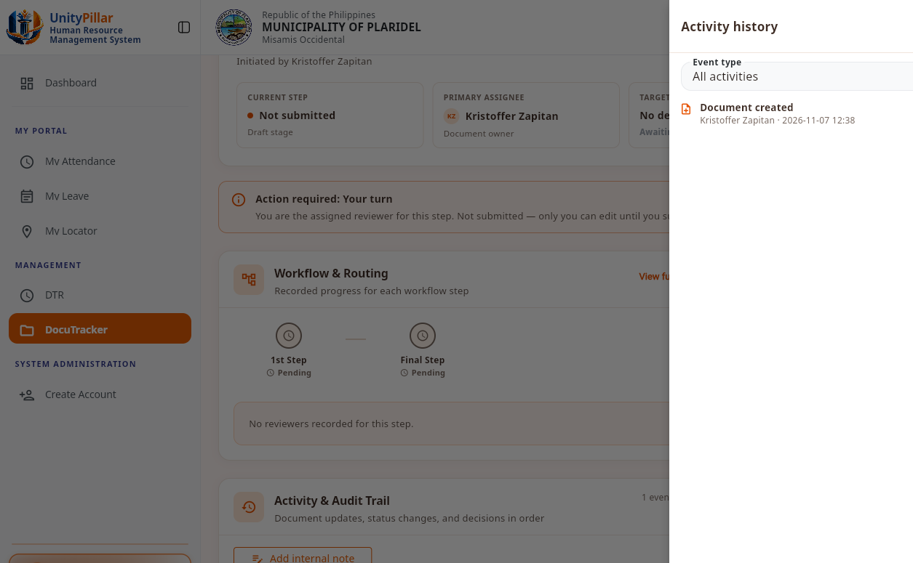
Figure 31. Document History and Audit Trail Interface

Figure 31 shows the document activity history. The recorded event identifies the action, the user, and the date and time. History is written by the system.

4.2.13 Overdue Document Monitoring and Escalation
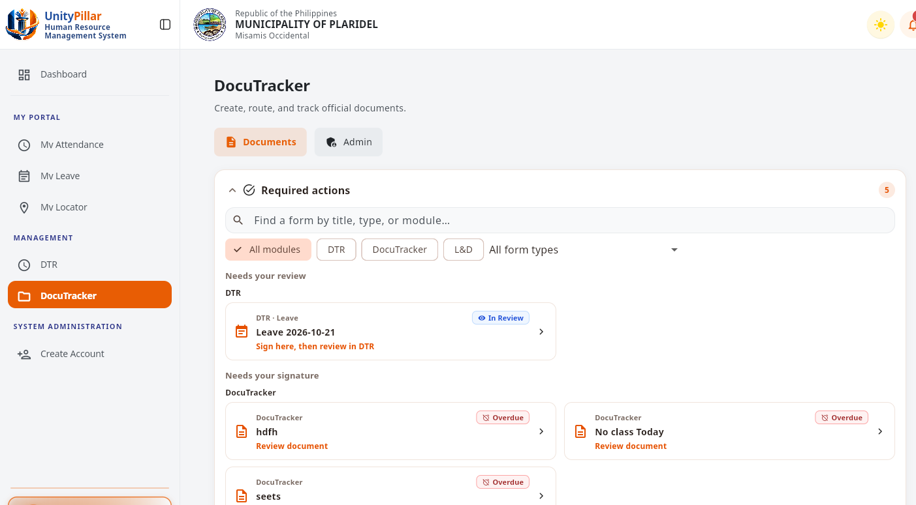
Figure 32. Overdue Document Monitoring Interface

Figure 32 shows the Required actions queue. Overdue DocuTracker items are listed for review, separate from source-module items such as DTR leave.

4.2.14 Document Archiving and Records Management

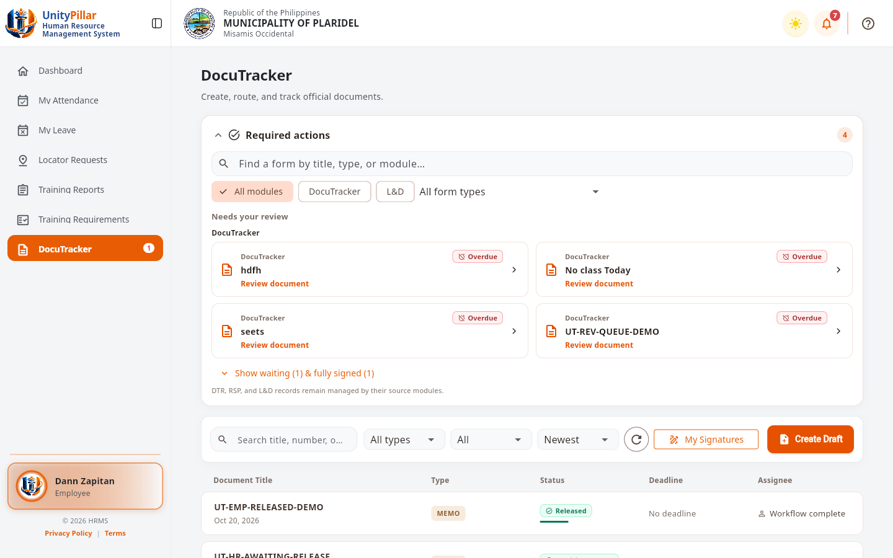
INSERT ACTUAL DOCUTRACK SCREENSHOT HERE
Completed and Archived Document Records Interface
Figure 33. Released Document Remaining in the Document List
Figure 33 shows a released memorandum still listed for the employee after workflow processing. DocuTracker does not use a separate archive screen; completed records stay in the document list.

4.2.15 Reports and Document Transaction Monitoring
Figure 34. Document Transaction Reports Interface

Figure 34 shows the same administrator monitoring summary used for day-to-day transaction awareness: document volume, overdue and escalated counts, and recent activity. A separate printable report generator is not part of this screen.
4.2.16 Memorandum Document
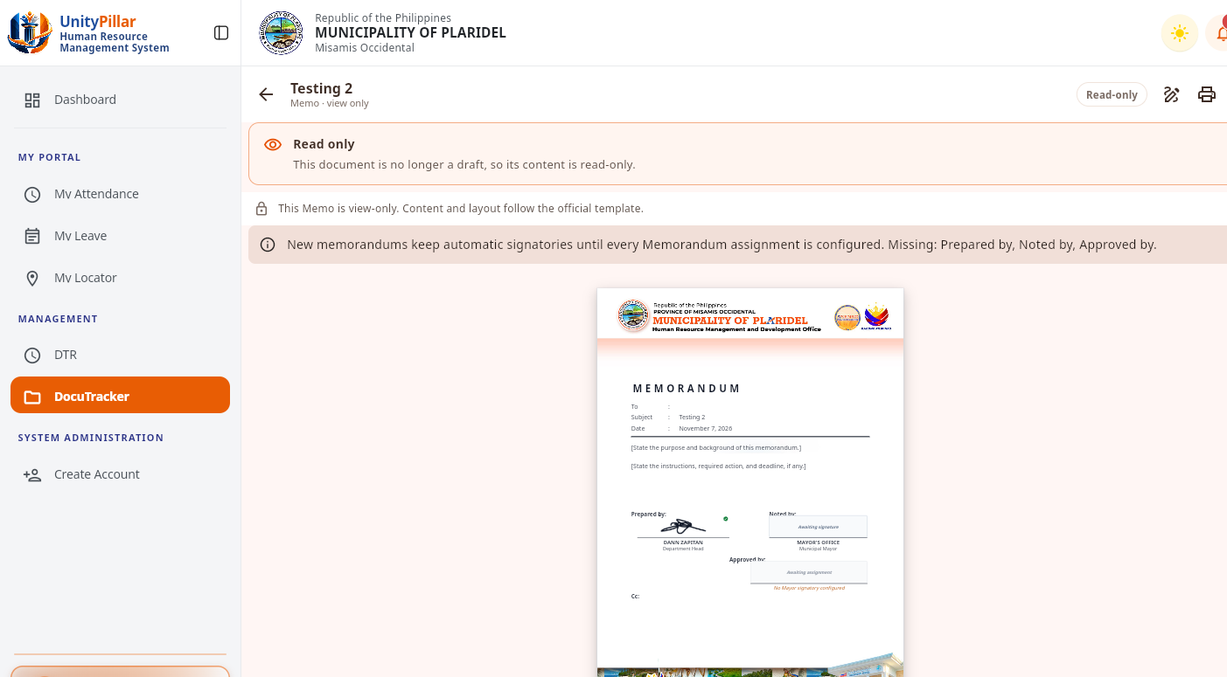
Figure 35. Memorandum Document, View Only
Figure 35 shows an existing memorandum opened view-only. The official template includes Prepared by, Noted by, and Approved by. Approved by stays unassigned until a distinct Municipal Mayor signatory is configured.
4.2.17 Purchase Request Form
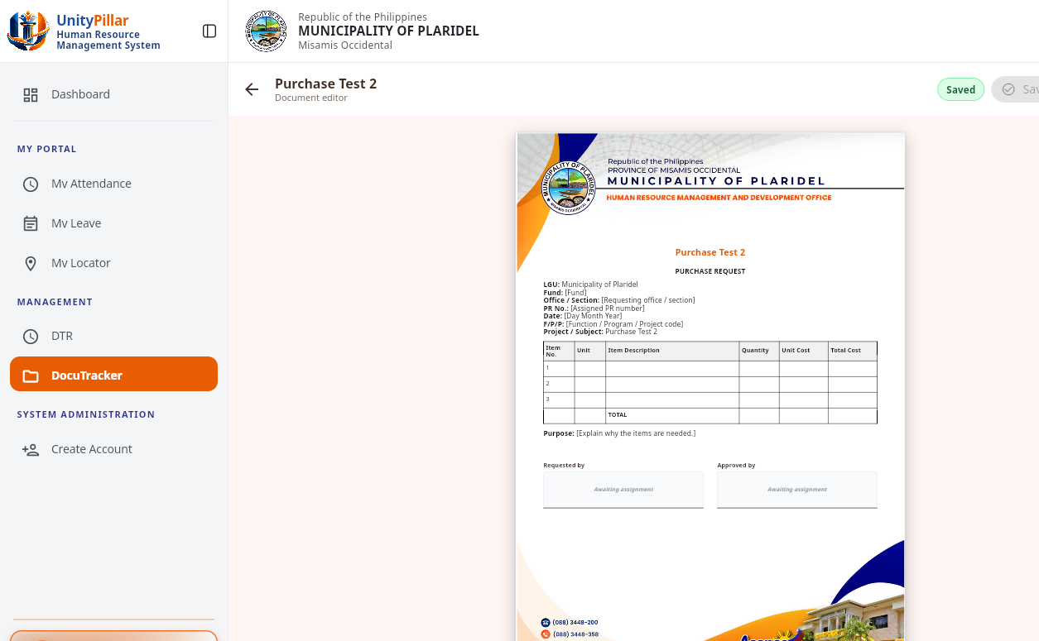
Figure 36. Purchase Request Form
Figure 36 shows a one-page purchase request in the document editor, including the item table and the Requested by and Approved by areas.
4.2.18 Official Signatories
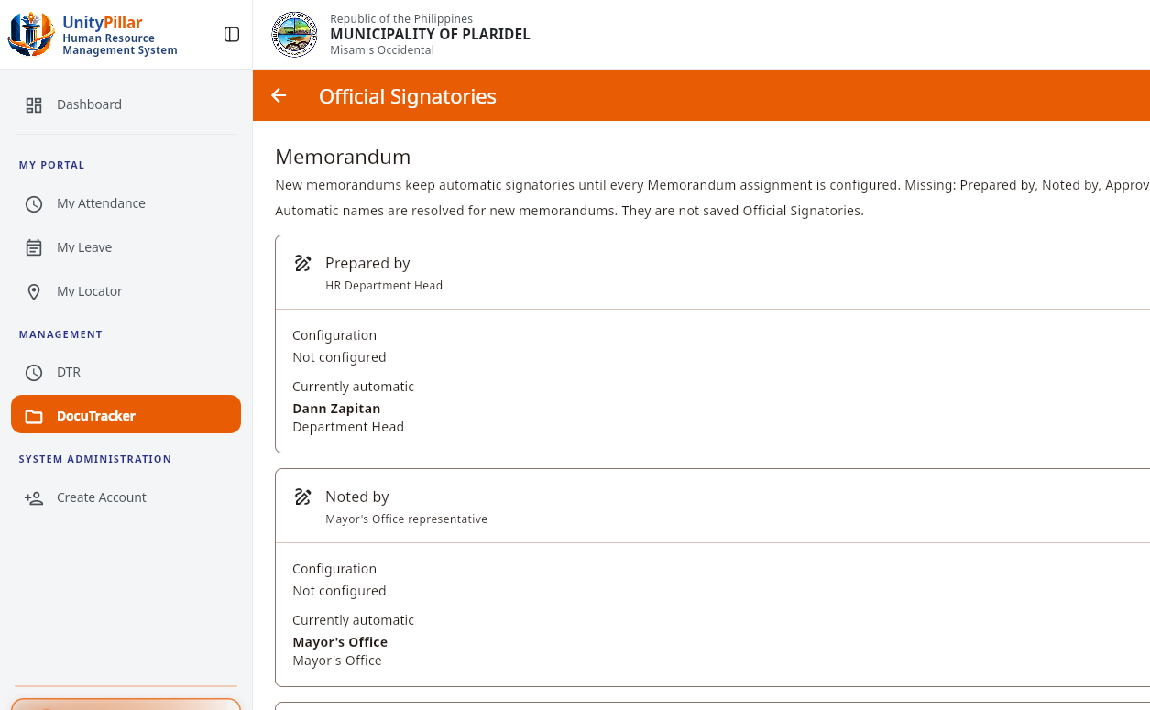
Figure 37. Memorandum Official Signatories
Figure 37 shows the Official Signatories screen for memorandums. Prepared by, Noted by, and Approved by remain on automatic resolution until all three assignments are configured.
4.2.19 Escalation Rules
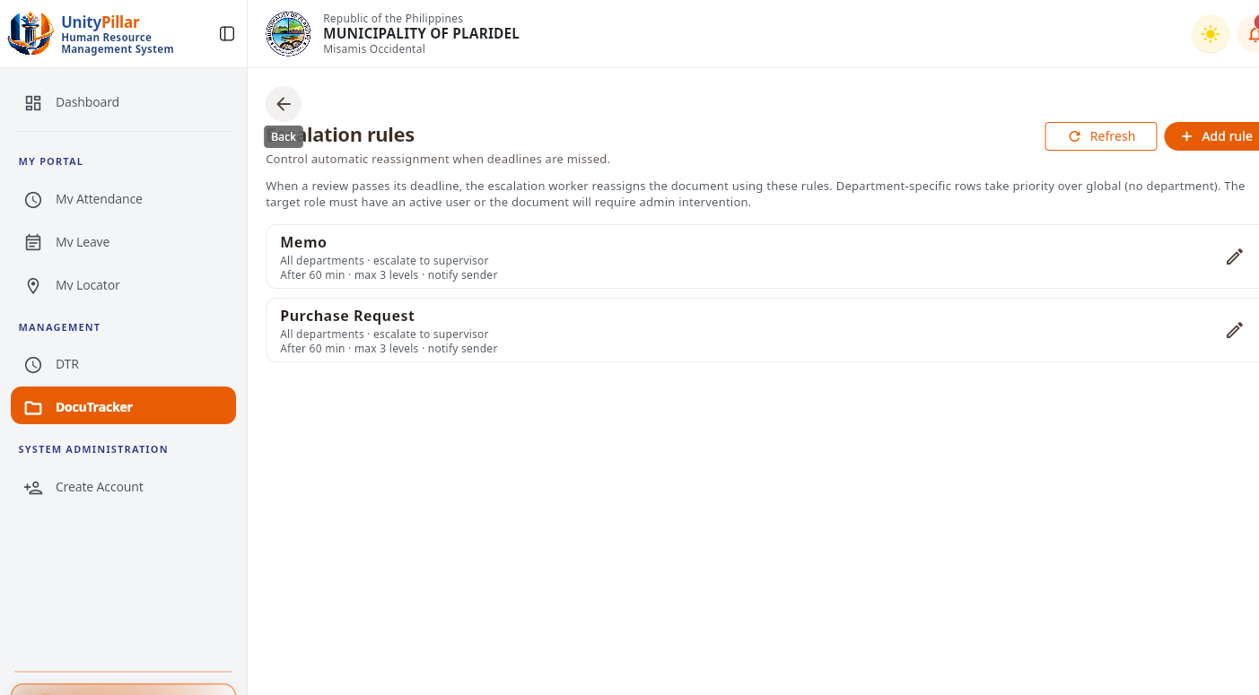
Figure 38. Escalation Rules
Figure 38 shows the escalation rules for Memorandum and Purchase Request. Each rule escalates to the supervisor after 60 minutes, for up to three levels, and notifies the sender.
4.2.20 Configuration Audit Log
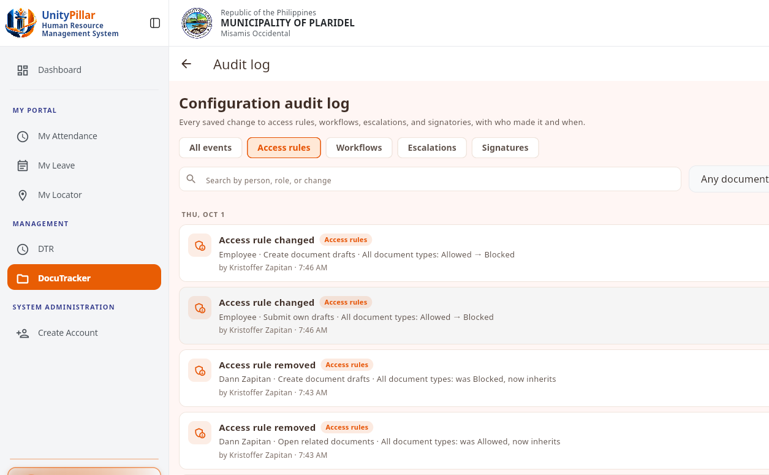
Figure 39. Configuration Audit Log
Figure 39 shows the configuration audit log for access-rule changes, including the actor and the time of each recorded change.
4.2.21 Employee Access Directory
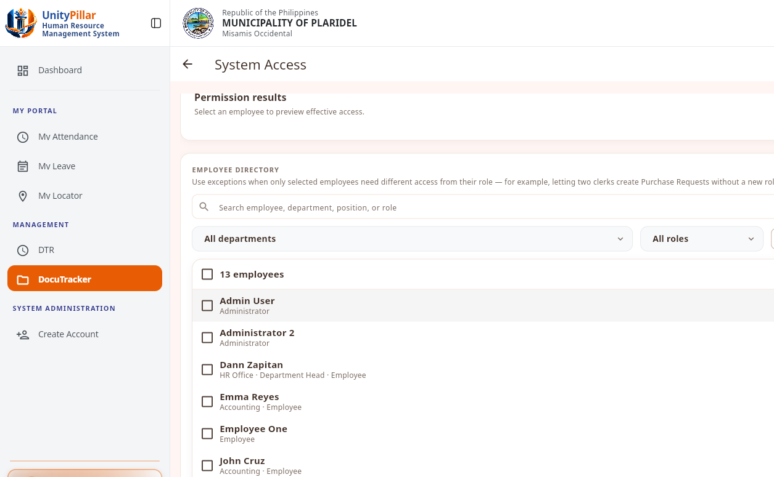
Figure 40. Employee Access Directory
Figure 40 shows the employee directory used when reviewing per-employee access exceptions. No exception was changed during this capture.

4.3 Testing and Results
This section presents the preliminary results of the DocuTrack pilot-testing questionnaires. Six identifiable questionnaires were provided: three Employee Respondent Forms and three HR/Admin and Operational Personnel Forms. The respondents rated their experience using a five-point scale, from 5 (Strongly Agree) to 1 (Strongly Disagree). The evaluation covers Functional Suitability, Usability, and Performance Efficiency. The Employee questionnaire contains 15 statements, while the HR/Admin questionnaire contains 20 statements. Unlike the interviews discussed in Chapter III, these pilot-testing forms evaluate the developed module from the respondents’ perspective.
The weighted mean was computed using the formula: Mean = Σ(f × x) / N, where f is the frequency of a rating, x is the numerical rating, and N is the number of valid responses for the statement. For provisional interpretation, scores from 4.21 to 5.00 are Strongly Agree, 3.41 to 4.20 Agree, 2.61 to 3.40 Neutral, 1.81 to 2.60 Disagree, and 1.00 to 1.80 Strongly Disagree. The original questionnaires must be checked before the results are submitted as final.
A. Functional Suitability Results
Functional suitability evaluates whether the system provides appropriate document actions and performs tasks such as document handling, workflow routing, review, and access control in a manner consistent with assigned roles.

Table 6. Functional Suitability Results – Employee Respondents
Question | Weighted Mean | Interpretation
The system correctly displays documents assigned or available to me. | 4.00 | Agree
The system allows me to open and review documents assigned to me. | 4.67 | Strongly Agree
The system allows me to add remarks or action notes when permitted. | 4.67 | Strongly Agree
The system allows me to update or route an assigned document using actions allowed by the workflow. | 4.67 | Strongly Agree
The system prevents me from acting on documents or workflow steps that are not allowed for my role. | 4.00 | Agree
Overall Weighted Mean | 4.40 | Strongly Agree

Question | Weighted Mean | Interpretation
The system allows authorized personnel to create and save document records correctly. | 4.33 | Strongly Agree
The system allows authorized personnel to upload and attach required document files successfully. | 4.67 | Strongly Agree
The system allows authorized personnel to assign or route documents to the appropriate employee or office. | 4.67 | Strongly Agree
The system correctly displays the current assignee, workflow status, and document action history. | 4.67 | Strongly Agree
The system allows authorized personnel to locate document records using the available search and filtering functions. | 4.67 | Strongly Agree
The system correctly applies workflow and permission rules when administrative actions are performed. | 4.67 | Strongly Agree
The system provides the information needed to review document assignments, routing, status, and history. | 4.33 | Strongly Agree
Administrative actions are limited according to the user’s assigned authority. | 4.33 | Strongly Agree
Table 7. Functional Suitability Results – HR/Admin Respondents

Interpretation: The employee respondents obtained a functional-suitability mean of 4.40, and HR/Admin respondents obtained a mean of 4.54. Both fall within the provisional
“Strongly Agree” category. These results indicate favorable respondent assessments of the available document functions and authorized workflow actions during pilot testing.
B. Usability Results
Usability evaluates whether users can understand menus, labels, current workflow information, and feedback messages, and whether they can complete their assigned tasks with minimal assistance.

Table 8. Usability Results – Employee Respondents
Question | Weighted Mean | Interpretation
The system’s DocuTracker menus and navigation are easy to understand. | 4.00 | Agree
The labels, buttons, status labels, and workflow instructions clearly describe their purpose. | 4.33 | Strongly Agree
The current assignee, workflow status, and document history are easy to understand. | 4.33 | Strongly Agree
The system provides clear messages when an action succeeds, fails, or is restricted. | 4.00 | Agree
I can perform my assigned DocuTracker Employee tasks with minimal assistance. | 3.67 | Agree
Overall Weighted Mean | 4.07 | Agree

Table 9. Usability Results – HR/Admin Respondents
Question | Weighted Mean | Interpretation
The system’s menus and administrative DocuTracker functions are easy to locate. | 4.00 | Agree
The labels, buttons, filters, status indicators, and instructions clearly describe their purpose. | 4.33 | Strongly Agree
Document registration, file attachment, assignment, and routing can be completed without unnecessary steps. | 4.33 | Strongly Agree
The system provides clear confirmation, validation, and restriction messages after each action. | 4.00 | Agree
The document status, current assignee, and action history are easy to understand. | 4.00 | Agree
I can perform my assigned DocuTracker administrative tasks with minimal assistance. | 4.00 | Agree
Overall Weighted Mean | 4.11 | Agree

Interpretation: The employee usability mean was 4.07, and the HR/Admin usability mean was 4.11, both interpreted provisionally as “Agree.” These ratings are lower than the functional-suitability means and suggest that navigation, instructions, and task guidance are practical areas for further refinement.
C. Performance Efficiency Results
Performance efficiency concerns users’ perceptions of loading time, responsiveness, saving actions, file operations, and completion of ordinary document workflow tasks.

Table 10. Performance Efficiency Results – Employee Respondents
Question | Weighted Mean | Interpretation
The system loads my assigned documents and document records within an acceptable amount of time. | 4.33 | Strongly Agree
The system opens document details and attached files within an acceptable amount of time. | 4.50 | Strongly Agree
Remarks, workflow actions, and status updates are saved within an acceptable amount of time. | 4.67 | Strongly Agree
The system remains responsive while I move between DocuTracker pages and document records. | 4.33 | Strongly Agree
The system responds to my Employees actions without noticeable delays during the assigned tasks. | 4.33 | Strongly Agree
Overall Weighted Mean | 4.43 | Strongly Agree

Table 11. Performance Efficiency Results – HR/Admin Respondents
Question | Weighted Mean | Interpretation
Document lists and document records load within an acceptable amount of time. | 4.00 | Agree
Document files can be uploaded and opened within an acceptable amount of time. | 4.00 | Agree
The system processes document assignment, routing, and workflow actions within an acceptable amount of time. | 4.00 | Agree
Search and filtering results are displayed within an acceptable amount of time. | 4.00 | Agree
The system remains responsive while working with multiple document records. | 4.00 | Agree
The system performs reliably during normal daily DocuTracker operations. | 4.00 | Agree
Overall Weighted Mean | 4.00 | Agree

Interpretation: The employee performance-efficiency mean was 4.43, interpreted as “Strongly Agree,” based on 14 visible ratings. The HR/Admin mean was 4.00, interpreted as “Agree,” based on 12 visible ratings. These are user ratings and should not be presented as actual system response-time measurements.
D. Overall Pilot Testing Results
Table 12. Overall Pilot Testing Summary
Respondent Group | Valid Ratings | Mean | Interpretation
Employee | 44 | 4.30 | Strongly Agree
HR/Admin and Operational Personnel | 54 | 4.28 | Strongly Agree
Combined valid ratings | 98 | 4.29 | Strongly Agree

The overall pooled mean of the 98 visible ratings was 4.29, provisionally interpreted as “Strongly Agree.” Of the 105 possible responses on six questionnaire forms, seven are missing from the available photographs: one Employee Performance Efficiency response (Item 12) and the six HR/Admin Performance Efficiency responses on one respondent’s form. The combined value pools distinct questionnaire statements and is therefore only a descriptive summary, not a standardized comparison of the two roles.
The results suggest that the six respondents generally evaluated the DocuTrack module positively in terms of its documented functionality, usability, and performance during the pilot activities. Nevertheless, the small respondent group, differences between the questionnaires, and missing marks limit the strength of the conclusions. More extensive testing, complete response verification, and actual system screenshots are recommended before final manuscript submission.

CHAPTER V
CONCLUSION AND RECOMMENDATIONS

5.1 Conclusions
The study focused on designing and developing DocuTrack, a digital document tracking and routing module under UNITY PILLAR, for use in government offices. Based on the objectives and system description presented in Chapters I and III, DocuTrack is intended to address challenges involving manual document registration, physical routing, difficulty in monitoring document status, and limited accountability. The documented module design provides a centralized environment for creating, submitting, routing, reviewing, and tracking official document transactions.
The pilot testing conducted with three Employee respondents and three HR/Admin or Operational Personnel respondents provided preliminary feedback on system quality. Using the 98 ratings visible in the supplied questionnaires, the overall pooled mean was 4.29, provisionally interpreted as “Strongly Agree.” The respondents gave positive assessments of functional suitability and performance, while usability obtained comparatively lower ratings. These results suggest that respondents were generally satisfied with the tested tasks while still indicating opportunities to improve screen clarity, task guidance, and ease of navigation.
The pilot-testing evidence supports a limited conclusion about participants’ perceptions of the module. It does not, by itself, establish a measurable reduction in document processing time, errors, or paper usage when compared with manual procedures. Further confirmation using the final application, complete pilot questionnaires, and relevant document transaction records is needed to establish the system’s operational effectiveness.

5.2 Recommendations
Based on the findings, the researchers recommend continuing to refine the DocuTrack interface, especially the navigation menus, labels, status explanations, confirmation messages, and instructions used in document routing and review. Making these elements easier to understand may help employees and administrative personnel complete their assigned tasks with less assistance.
The researchers also recommend validating all workflow rules, document permissions, attachments, approval actions, and audit-trail records through additional practical tests. Overdue-document escalation, archiving, and reporting functions should be tested separately and described as completed features only when supported by actual execution evidence. Regular system maintenance, secure handling of official documents, and access-control reviews should remain priorities.
Further pilot testing with a larger and more diverse group of government-office users is recommended. All questionnaire marks should be checked against the original forms, incomplete responses should be obtained where possible, and actual completion times may be collected when comparing digital and manual processes. The interview responses and observation records should also be analyzed separately to strengthen the discussion of existing office practices and user requirements.
For future researchers and developers, possible enhancements include more efficient document search, improved tracking of overdue workflow steps, clearer audit-trail filtering, and additional reporting options appropriate to authorized users. Broader integration with other UNITY PILLAR modules or external systems should be considered only in accordance with the approved study scope and applicable confidentiality requirements.

REFERENCES:
Abbas, D. S., Ismail, T., Taqi, M., & Yazid, H. (2022). Management audit on HR recruitment and employee performance. Jurnal Riset Akuntansi Kontemporer. https://journal.unpas.ac.id/index.php/jrak/article/view/5941

Al-Alawi, A. I., Messaadia, M., Mehrotra, A., Sanosi, S. K., Elias, H., & Althawadi, A. H. (2023). Digital transformation in human resource management during COVID-19. Arab Gulf Journal of Scientific Research. https://www.emerald.com/agjsr/article/41/4/446/15202

Bankins, S., Ocampo, A. C., Marrone, M., Restubog, S. L. D., & Woo, S. E. (2024). Artificial intelligence's role within organizations. Journal of Organizational Behavior. https://onlinelibrary.wiley.com/doi/full/10.1002/job.2735

Bhatt, B., & Muduli, K. (2023). Artificial intelligence in learning and development. European Journal of Training and Development. https://www.emerald.com/ejtd/article-abstract/47/78/677/83334/Artificial-intelligence-in-learning-and

Judijanto, L., Rolando, B., & Al-Amin. (2024). Performance management in modern organizations. International Journal of Financial Economics. https://wikep.net/index.php/IJEFE/article/view/825

Kristiadi, A., Eschenhagen, R., & Hennig, P. (2022). Posterior refinement improves sample efficiency in Bayesian neural networks. https://doi.org/10.48550/arXiv.2205.10041

Kwon, J., & Iedema, A. (2022). Body and the senses in spatial experience: The implications of kinesthetic and synesthetic perceptions for design thinking. Frontiers in Psychology, 13. https://doi.org/10.3389/fpsyg.2022.864009

Mendoza, F. A. M. (2023). Assessing needs for developing a multisensory room design with Javanese gestures for older adults. Public Health of Indonesia, 9(4), 177–185. https://doi.org/10.36685/phi.v9i4.757
.
Nindiya, M., & Nasution, I. H. (2023). Recruitment, selection, and employee performance. MAR-Ekonomi: Jurnal Manajemen, Akuntansi dan Rumpun IlmuEkonomi.https://jurnal.seaninstitute.or.id/index.php/marekonomi/article/view/218/136

Ogbeibu, S., Emelifeonwu, J., Pereira, V., Oseghale, R., Gaskin, J., Sivarajah, U., & Gunasekaran, A. (2024). Smart technology and AI in green HRM. Business Strategy and the Environment. https://onlinelibrary.wiley.com/doi/full/10.1002/bse.3495

Prayuda, P., & Asfari, A. (2025). Digital transformation and HR development. International Journal of Accounting, Business and Organization. https://ijabo.a3i.or.id/index.php/ijabo/article/view/477/254

Parliament of Sri Lanka. (2022). Personal Data Protection Act, No. 9 of 2022. https://www.parliament.lk/uploads/acts/gbills/english/6332.pdf

Ripamonti, J. P. (2024). Does being informed about government transparency boost trust? Exploring an overlooked mechanism. Government Information Quarterly, 41(4), 101960. https://doi.org/10.1016/j.giq.2024.101960

Sanders, K., Nguyen, P. T., Bouckenooghe, D., Rafferty, A. E., & Schwarz, G. (2024). HRM system strength in times of crisis. Journal of Business Research.https://www.sciencedirect.com/science/article/pii/S0148296323007245

Suringa, M. N. (2024). SUPREME HRM and social equity practices. Asian Review of Public Administration. https://journal.eropa-

Talukder, S. K. (2021). Effectiveness and challenges of scaling up e-mutation in Bangladesh. BRAC Institute of Governance and Development. https://bigd.bracu.ac.bd/study/effectiveness-and-challenges-of-scaling-up-e-mutation-in-bangladesh/
The Business Standard. (2021). Land ministry wins United Nations Public Service Award 2020. The Business Standard. https://www.tbsnews.net/bangladesh/land-ministry-wins-united-nations-public-service-award-2020-343168

Wardhani, W., Sa’diah, K., Simanjuntak, V. C., Ekawati, Y. A., & Nasution, S. W. P. (2025). Human resource competence via learning and development. The Journal of Academic Science.
http://thejoas.com/index.php/thejoas/article/view/324

Zhang, J., & Chen, Z. (2023). Digital transformation of HRM in the digital era. Journal of the Knowledge Economy.
https://link.springer.com/article/10.1007/s13132-023-01214-y

SAP SuccessFactors. (n.d.). SAP SuccessFactors (web application). Retrieved from https://www.sap.com/products/hcm.html

Zoho Corporation. (n.d.). Zoho Recruit (web application). Retrieved from
https://www.zoho.com

OrangeHRM, Inc. (n.d.). OrangeHRM (web application). Retrieved from
https://orangehrm.com/

Workday, Inc. (n.d.). Workday Human Capital Management (web application). Retrieved from https://www.workday.com/en-us/products/human-capital-

Widiyawati, A. T., Putri, A. A., Aminaturrokhiyah, A., Kumkong, P., & Prasetyo, A. H. (2023). The role of records and archives in public service policy decision-making (Case study at the institution of archives and library Mataram). In Proceedings of the International Conference of Public Administration and Governance (ICOPAG 2022) (pp. 37–50). Atlantis Press SARL. https://doi.org/10.2991/978-2-38476-082-4

APPENDICES

APPENDIX A
Semi-Structured Interview Guide Questionnaire

This interview guide was developed to gather relevant information regarding the current document tracking, routing, and management processes within government offices. The questions are designed to obtain insights from office personnel concerning existing procedures, challenges encountered, and system requirements for the proposed DocuTrack: A Digital Document Tracking and Routing System for Government Offices.
In addition, a Privacy Letter was included so as to inform the participants that any information collected from the interviews would be handled in a confidential manner and would only be used for academic and system development purposes.
For Administrator / Records Personnel
1.Can you describe the current process of document handling and routing in your office?
2.How are documents currently submitted, recorded, and stored in your office?
3.What methods do you use to monitor and track the movement of documents?
4.How do you currently verify and approve documents before routing them to another office or department?
5.What challenges do you commonly encounter in managing document records and routing activities?
6.How do you prepare reports related to document processing and routing?
7.What methods are used to ensure the security and confidentiality of documents?
8.How do you currently manage archived or completed documents?
9.How do you monitor the status and progress of documents during processing?
10.What difficulties do you encounter in tracking overdue or delayed documents?
11.What recommendations can you provide for the development of the proposed DocuTrack system?

APPENDIX B
Observation Checklist

This observation checklist was developed to examine the existing document tracking, routing, and management processes within government offices. The checklist serves as a guide in documenting actual practices, workflows, and challenges encountered during document handling and routing operations.

Activities/Processes Observed | Observed (✓) | Not Observed (✓)
Documents are manually submitted by employees or office personnel. | 
Incoming documents are manually recorded in logbooks or record books.

Documents are physically routed from one office to another.

Personnel manually verify and review submitted documents.

Document status updates are tracked manually.

Office personnel experience delays in locating documents.
Documents are stored in folders, cabinets, or physical archives.

Reports related to document processing are manually prepared.

Notifications regarding document status are not automated
Retrieval of records requires significant manual effort.
Delays occur during document approval and routing.

Monitoring overdue documents is difficult.

Employees rely on manual communication for document follow-up.

No centralized database is available for document tracking.

Document records are prone to loss or misplacement.

APPENDIX C
Documents Gathered During Data Collection

This appendix contains copies of the forms, records, and documents obtained from the government offices during the conduct of interviews, observations, and document reviews. These documents served as references in identifying the existing document handling procedures, workflow processes, and system requirements for the development of the proposed DocuTrack: A Digital Document Tracking and Routing System for Government Offices.

CLIENT INTERVIEW
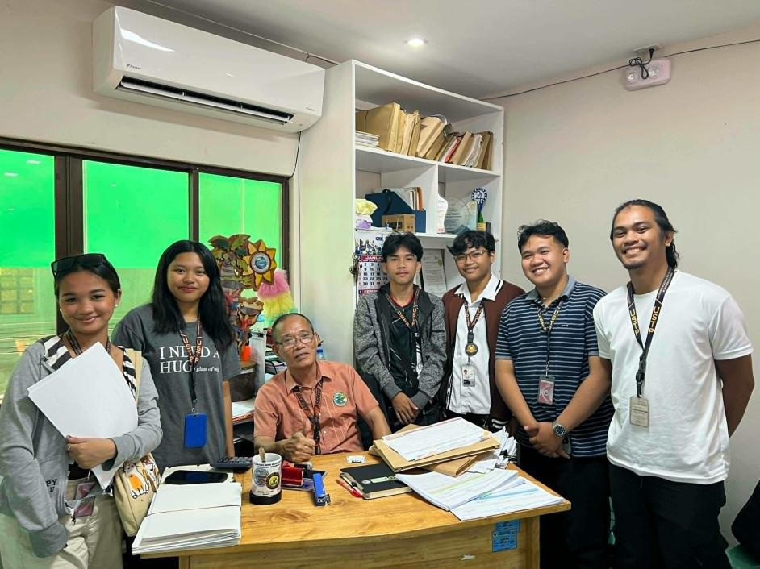

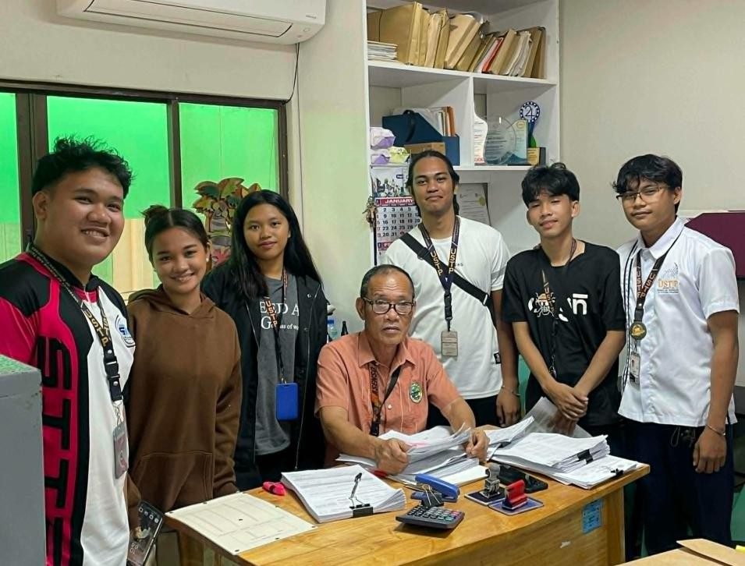
UNITY PILLAR-DOCUTRACKER PILOT TESTING QUESTIONNAIRE

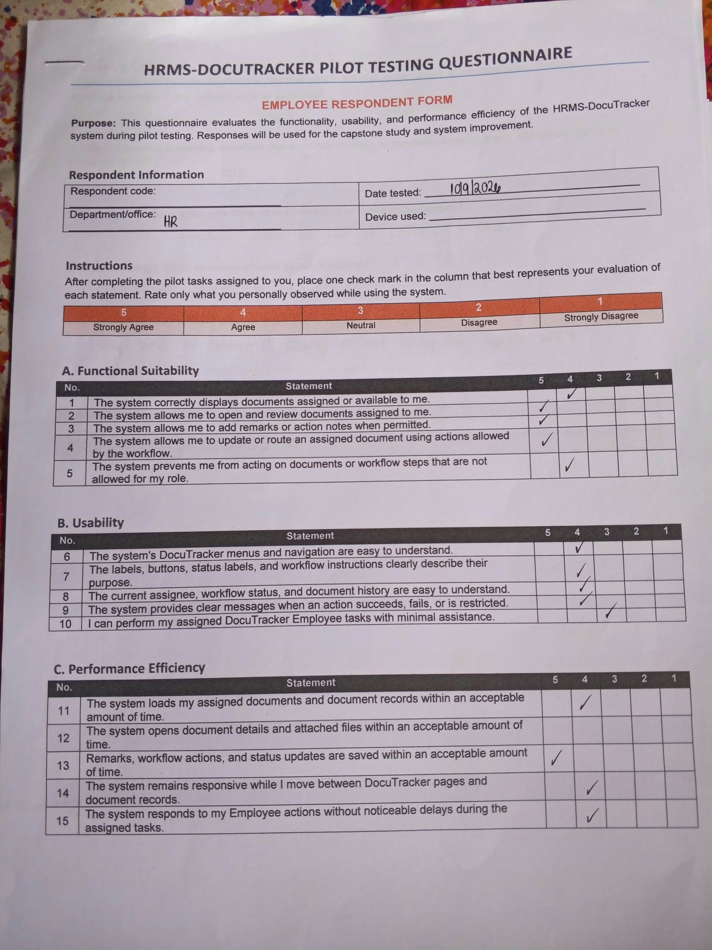

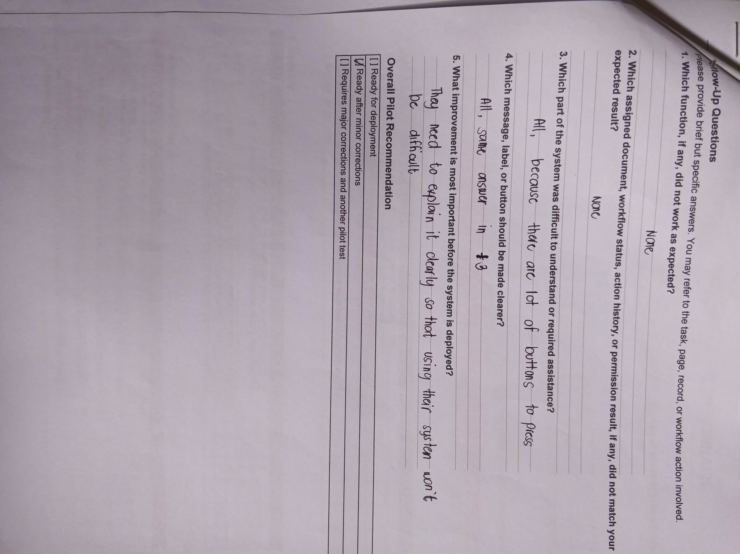

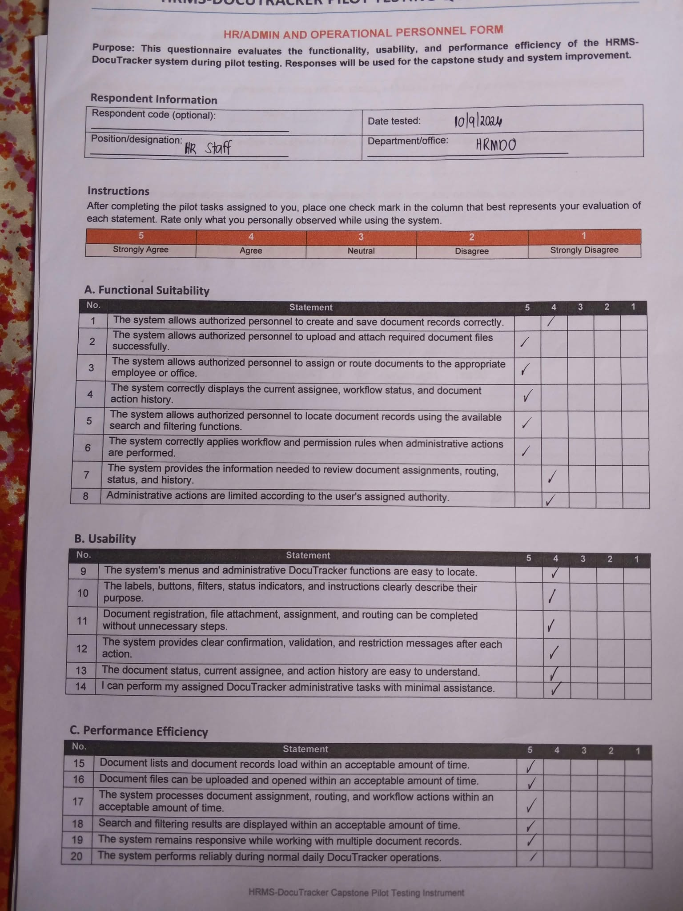

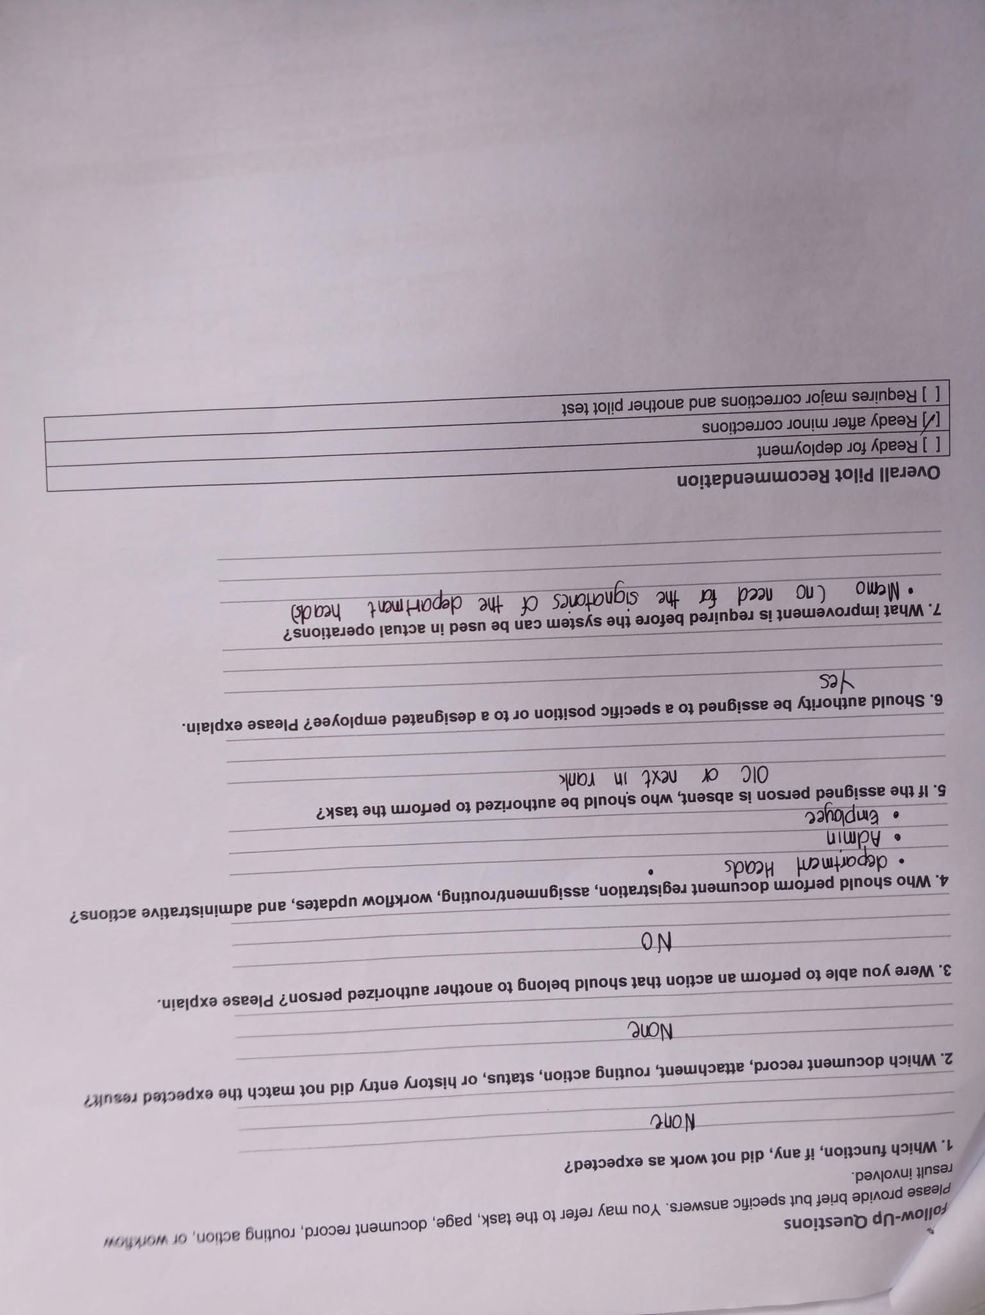

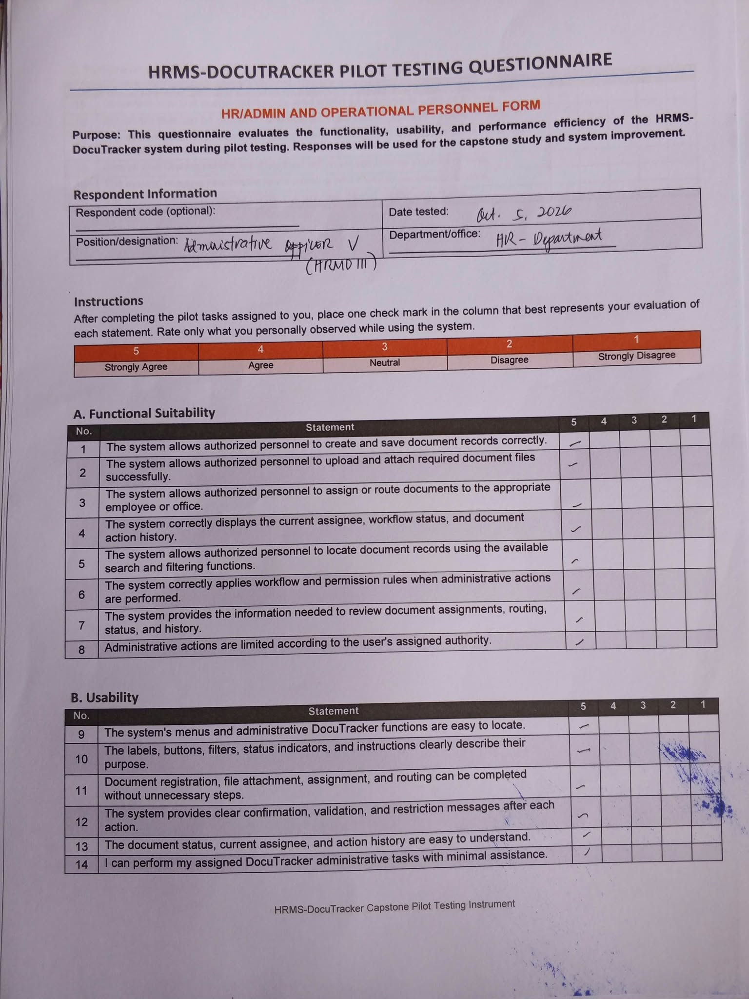

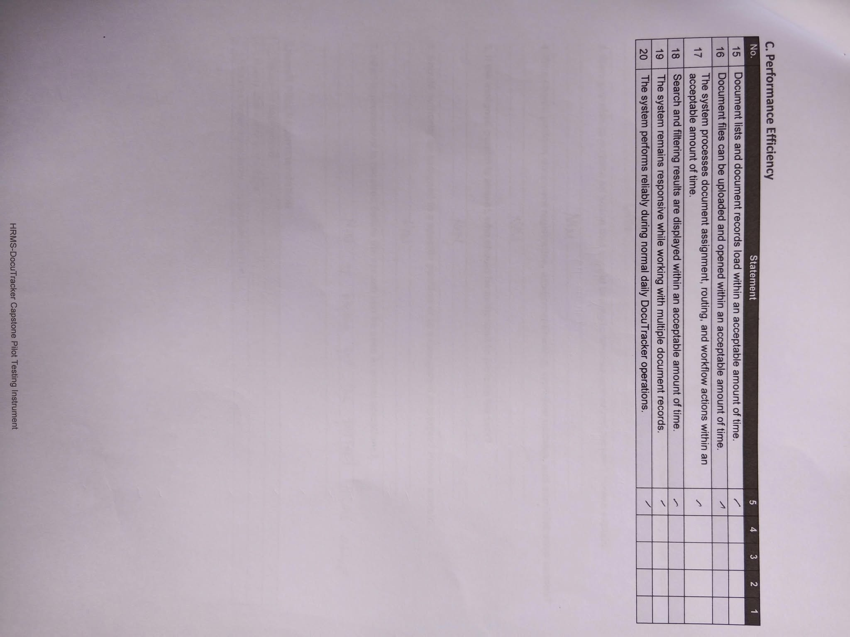

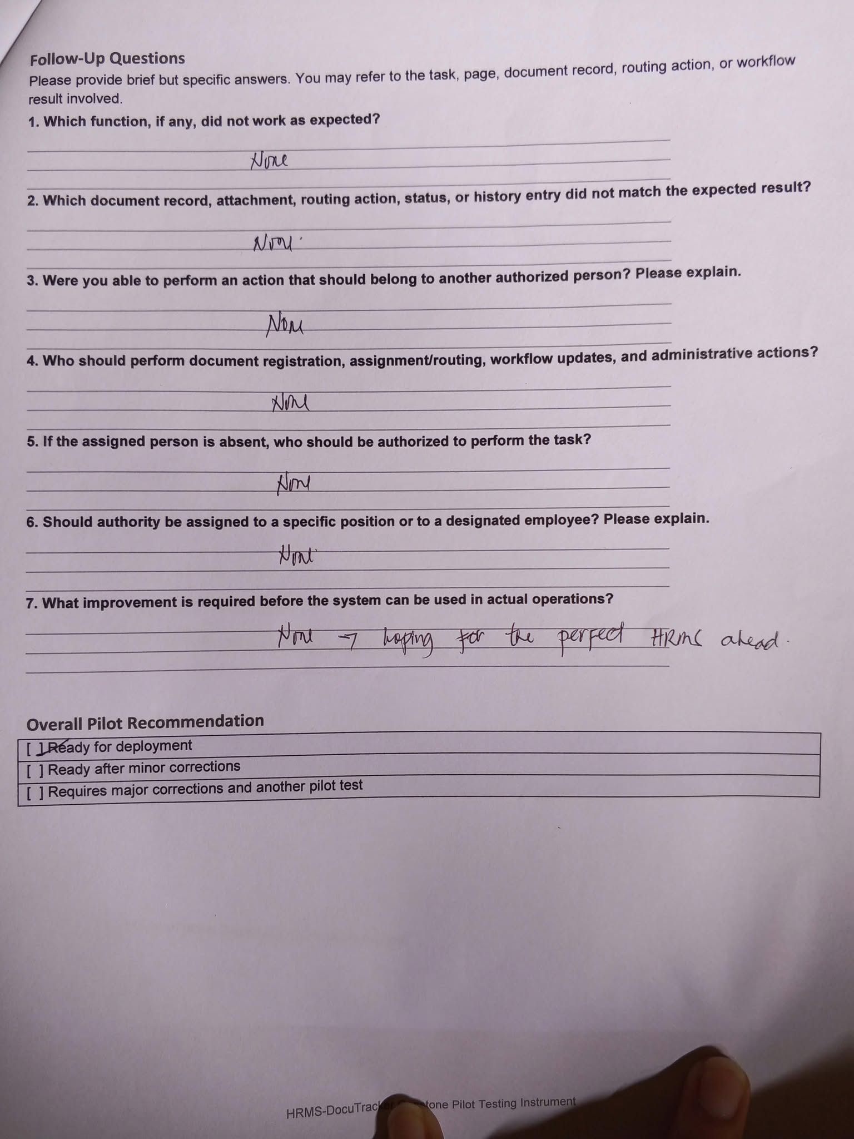

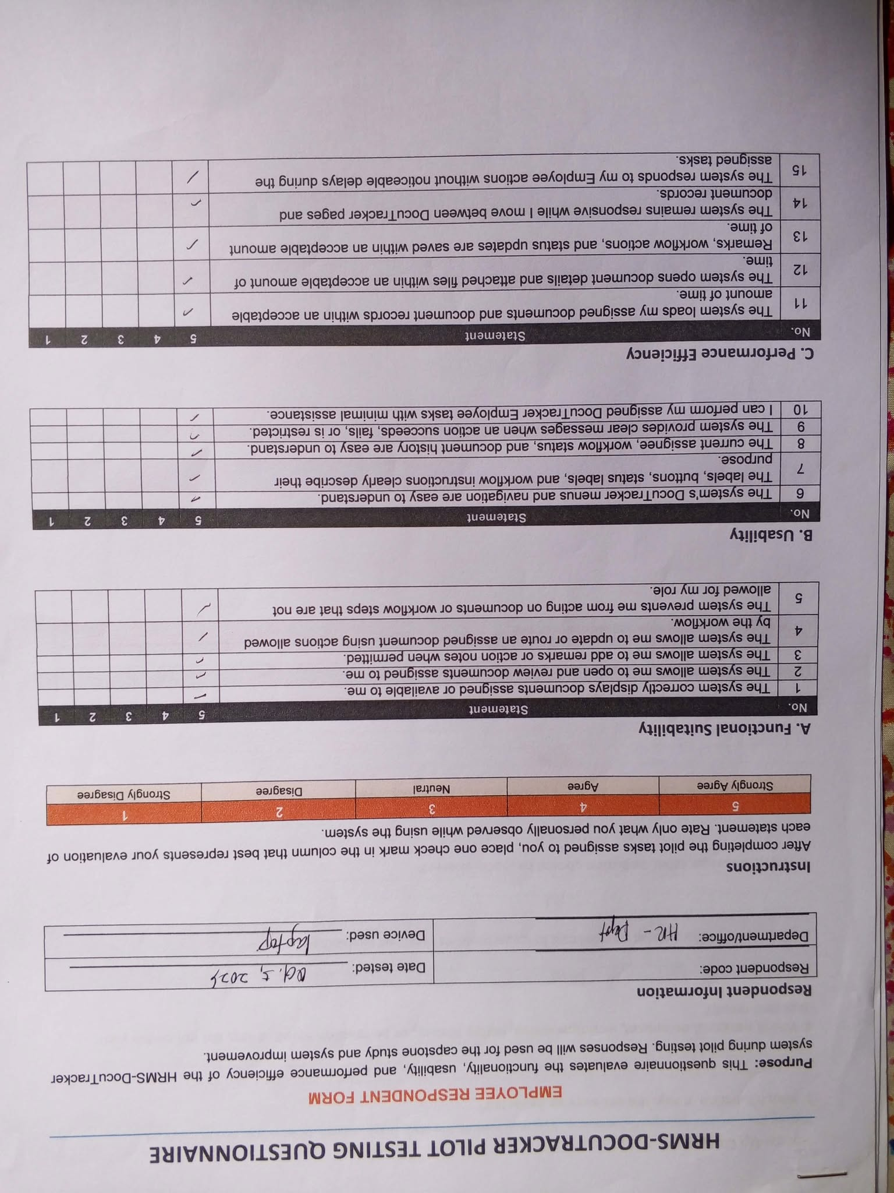

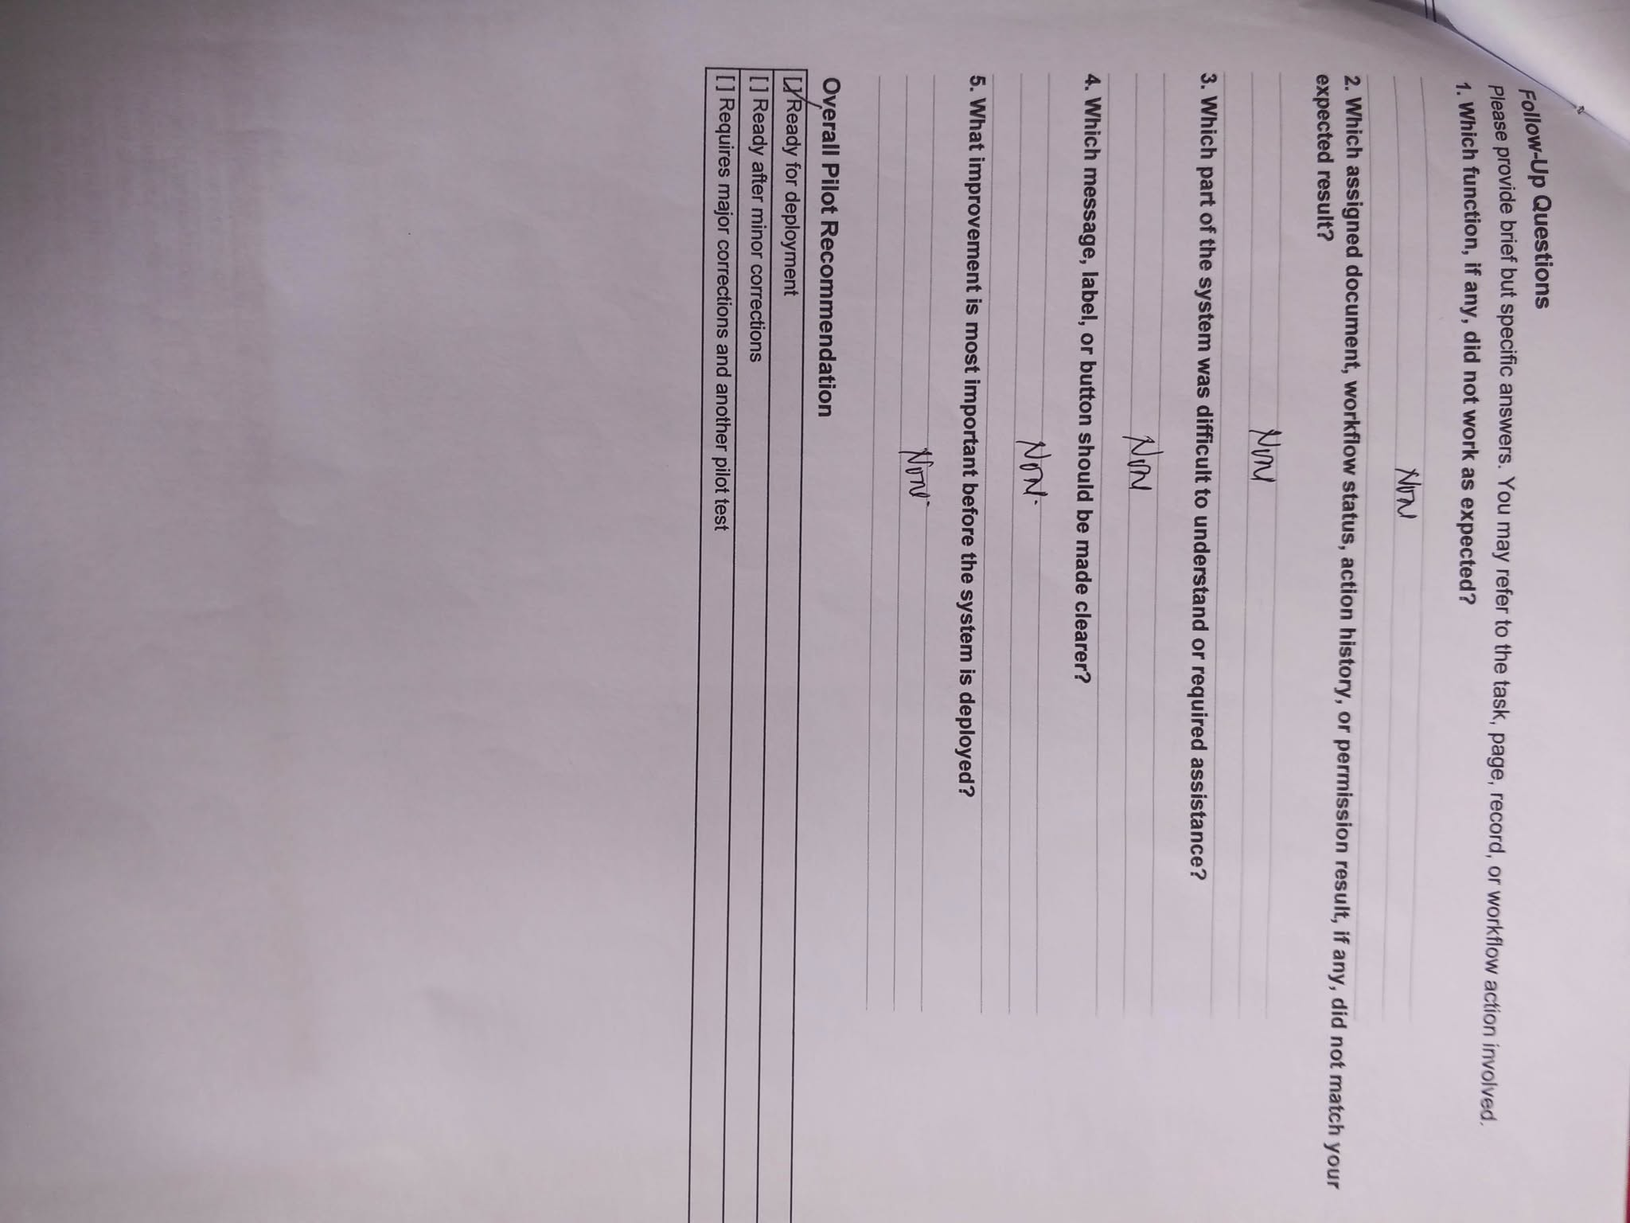

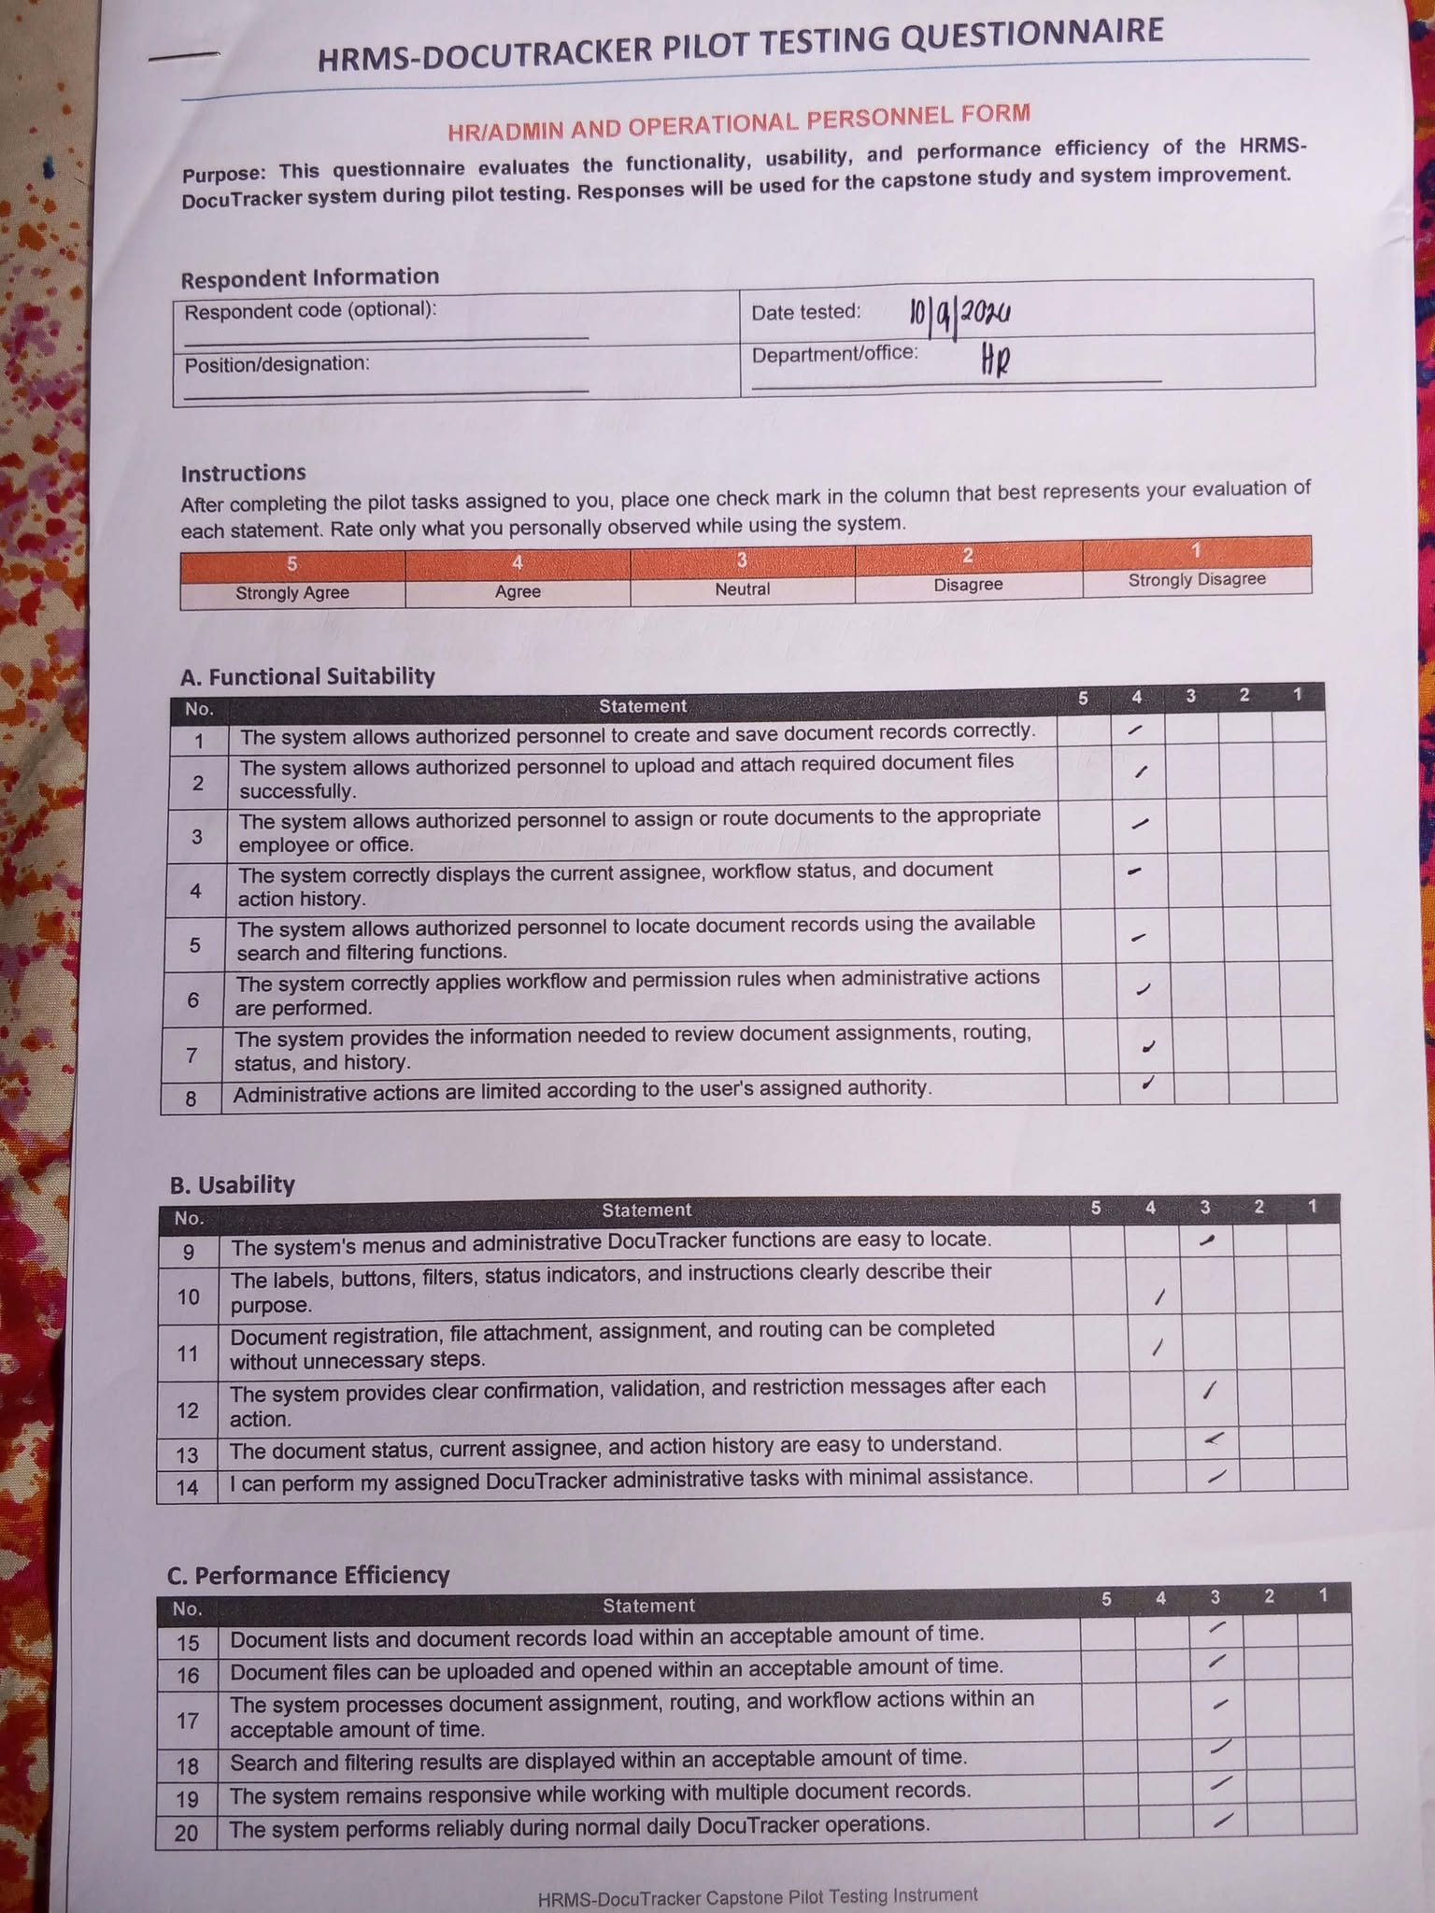

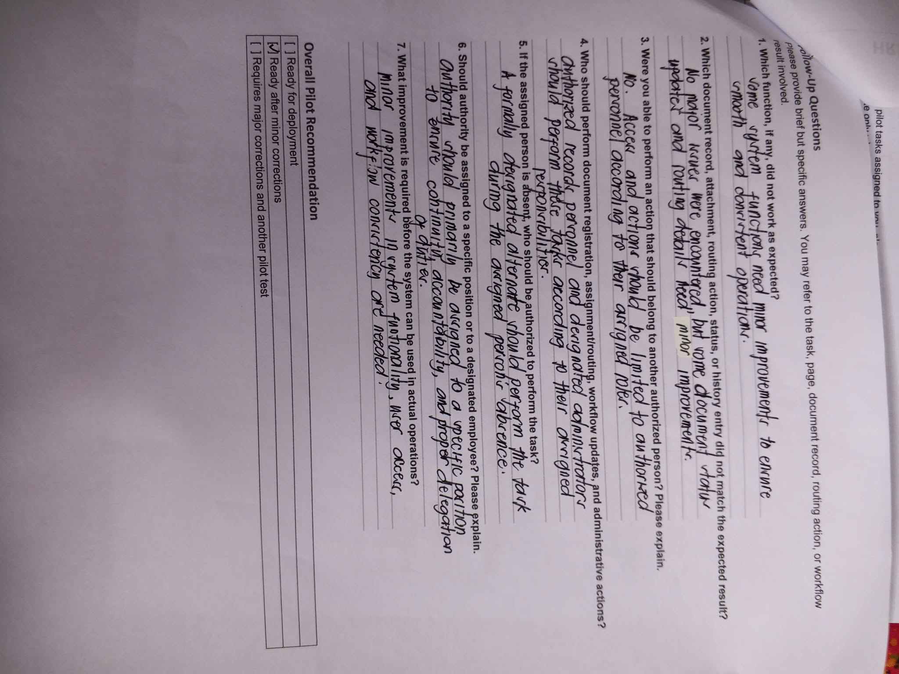

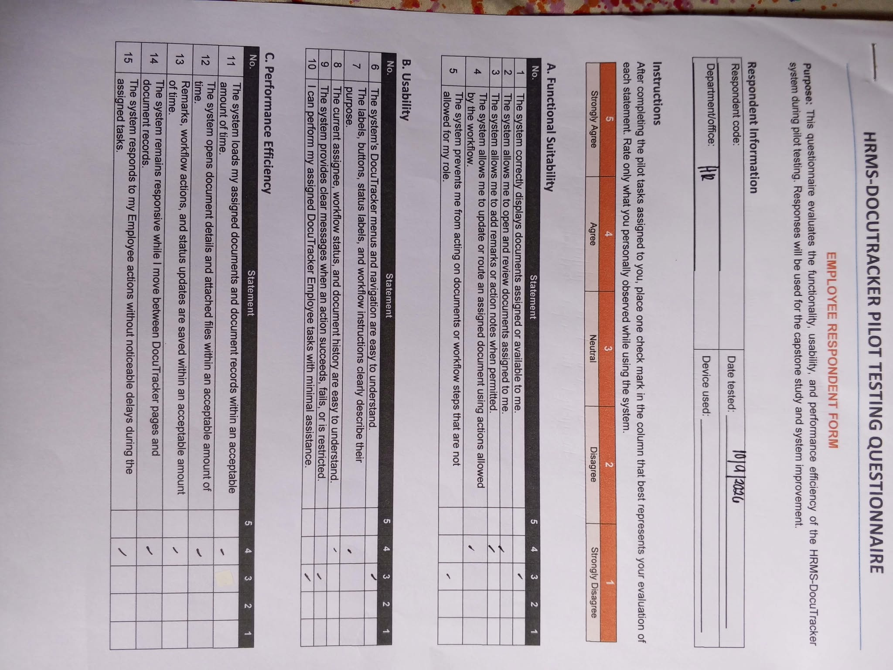

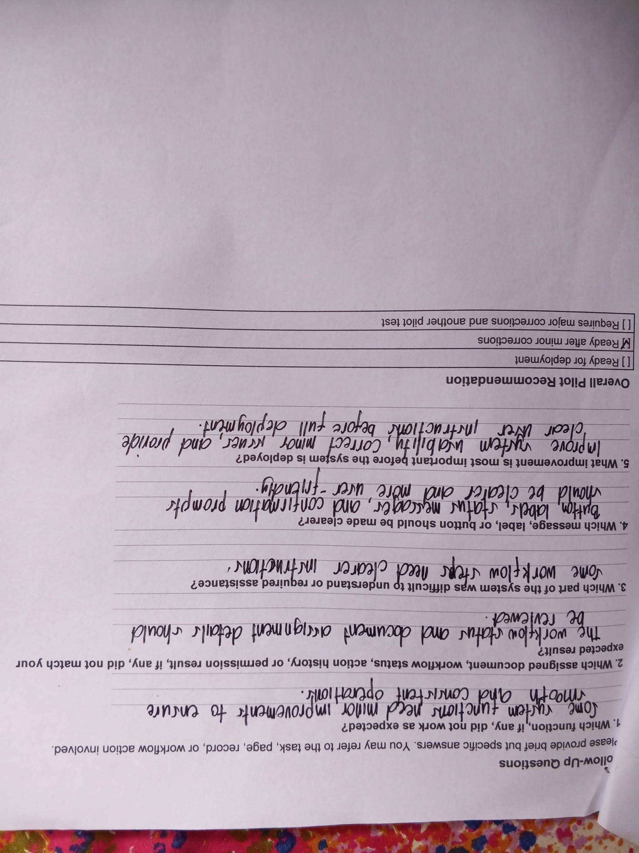

DOCUMENT TRACKING AND ROUTING MODULE

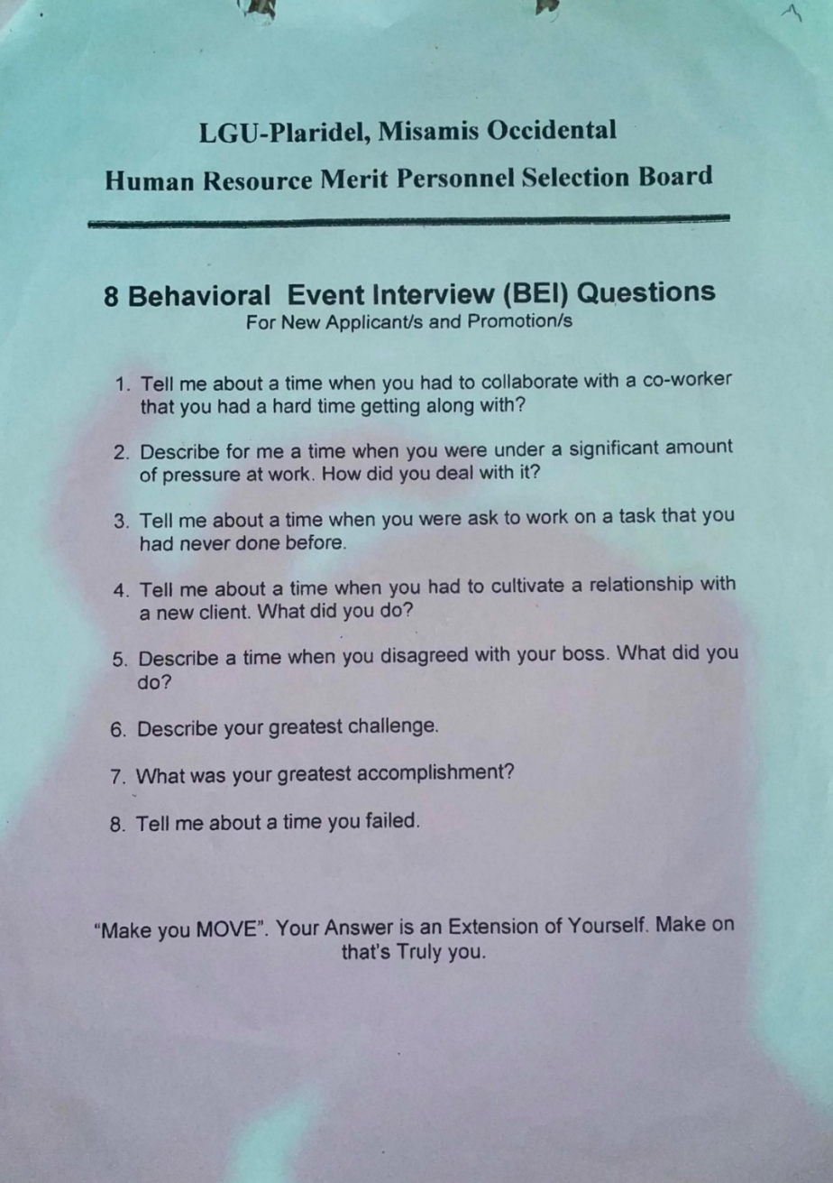
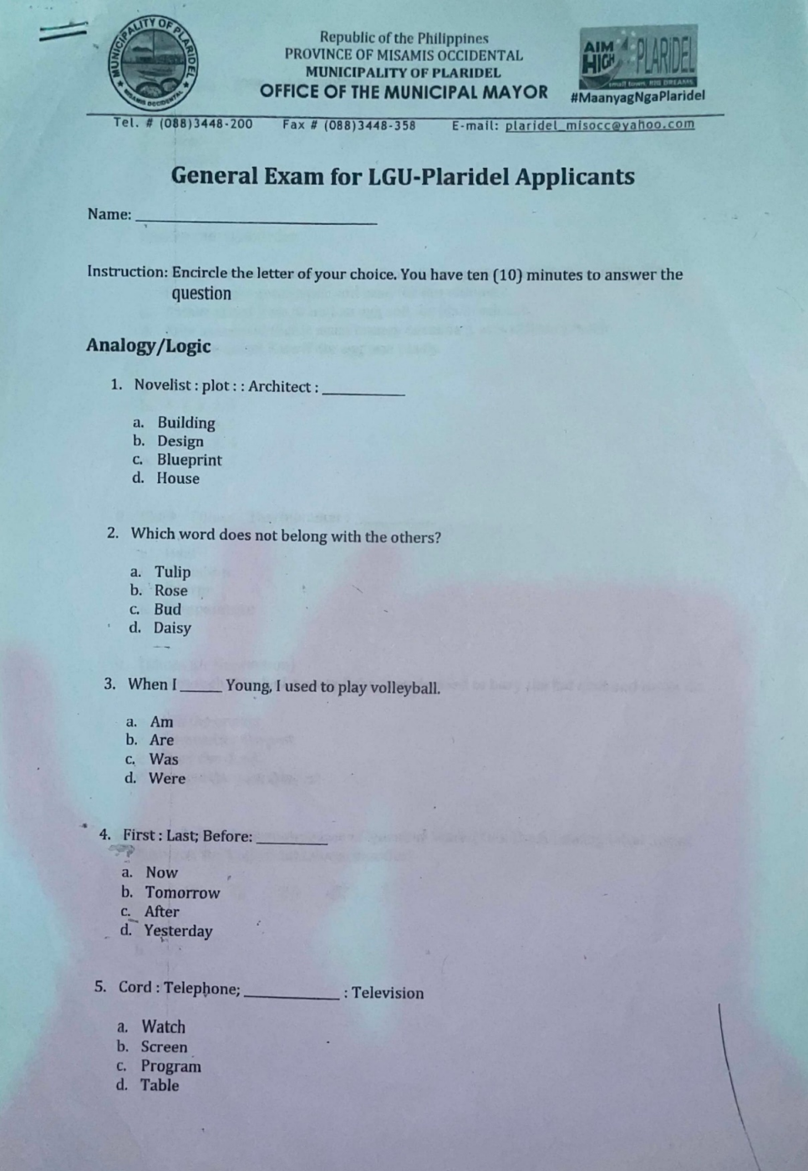



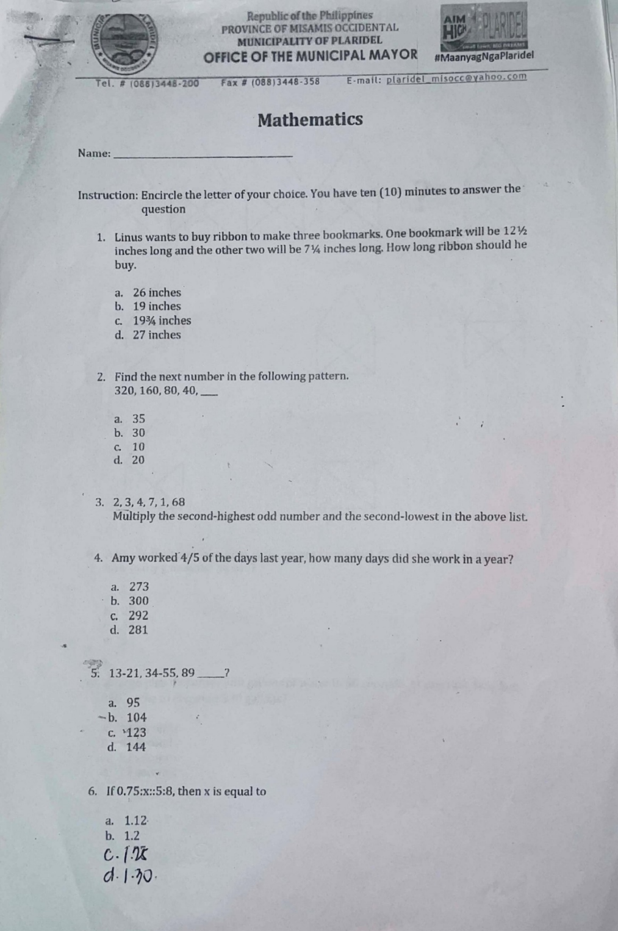



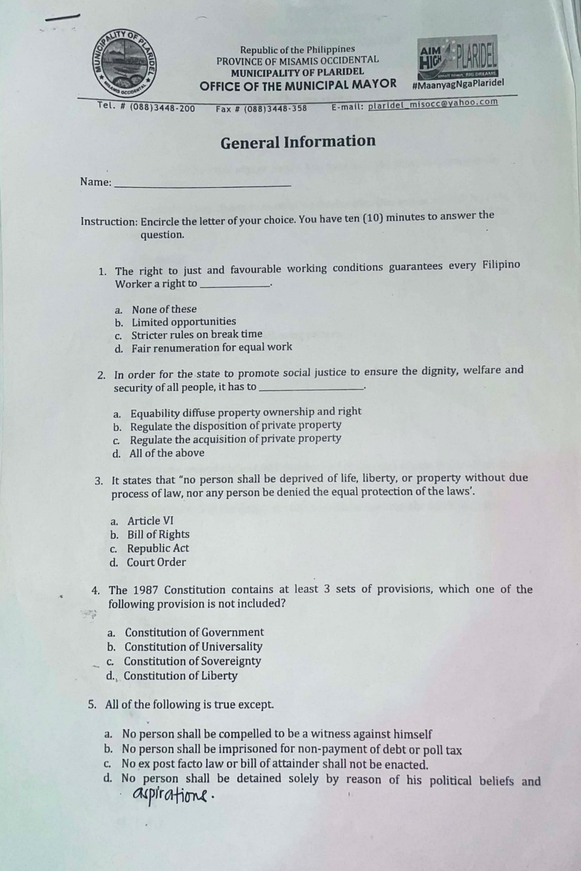

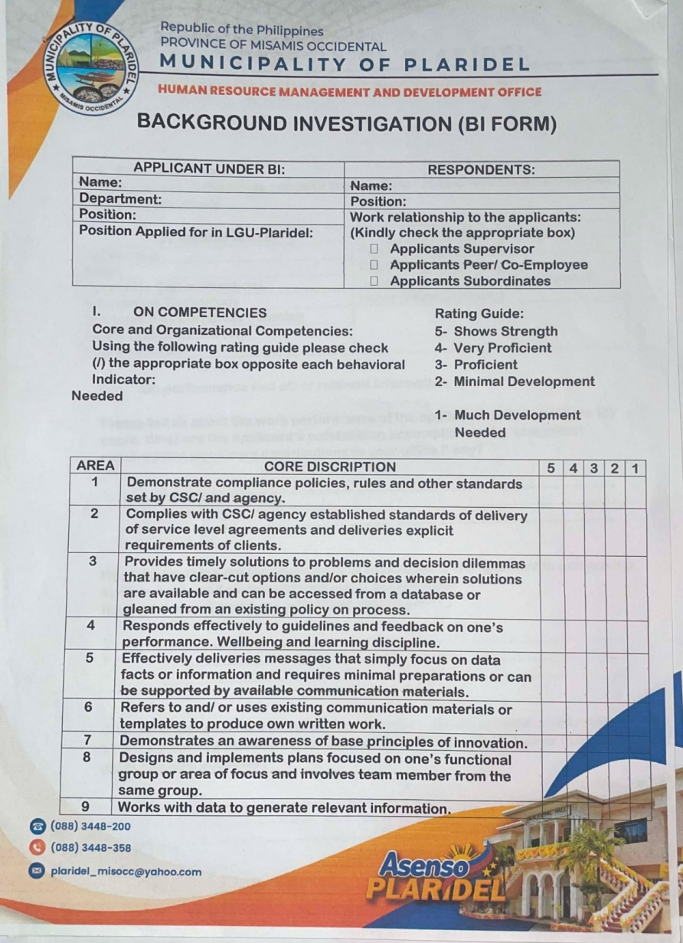

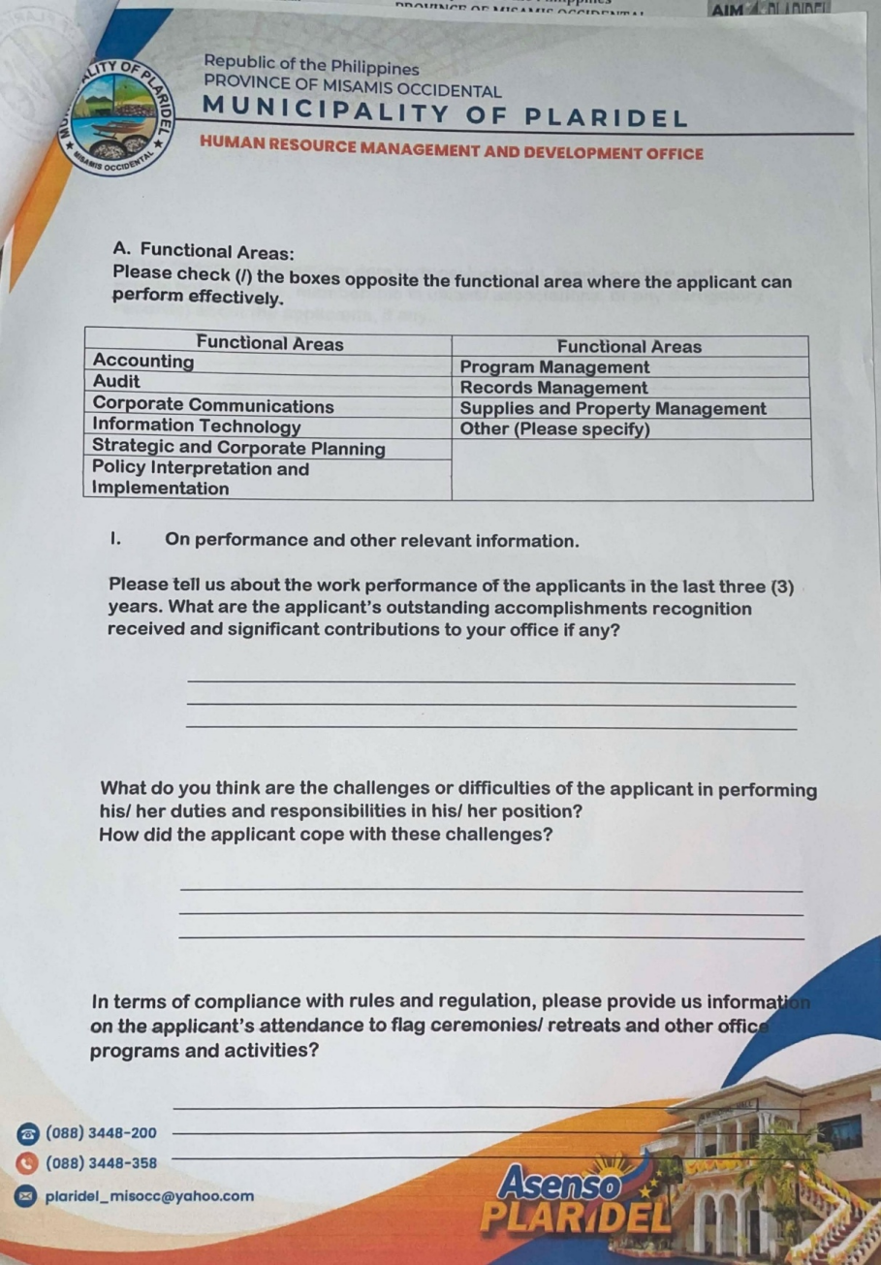

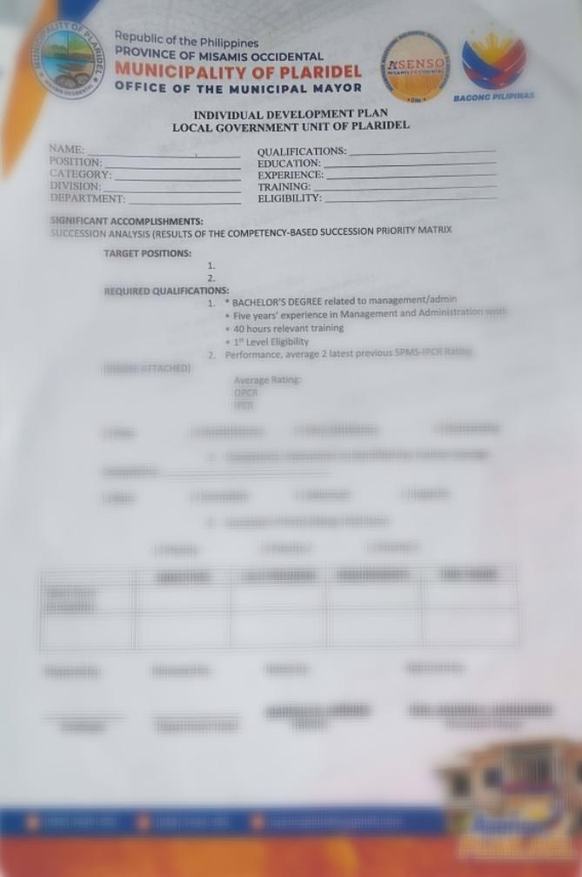

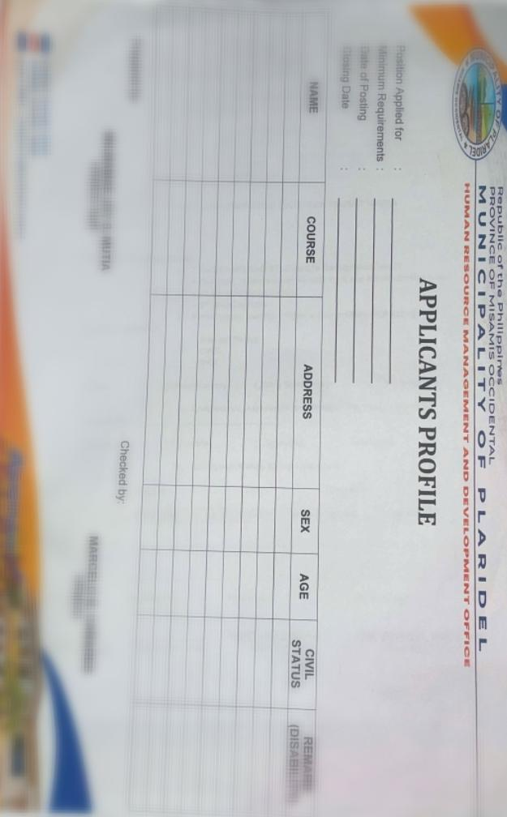

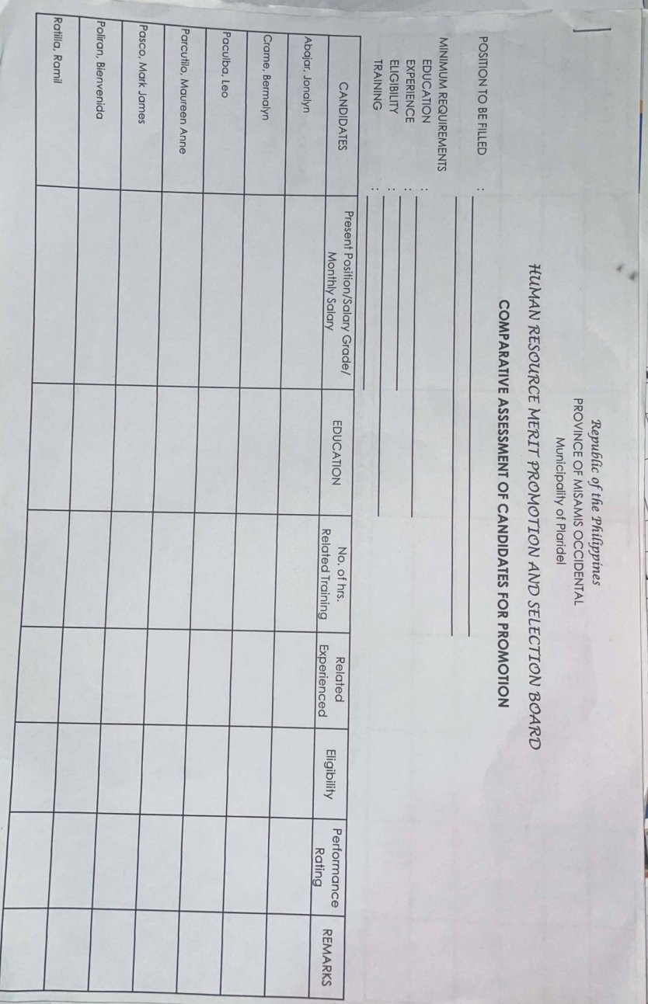

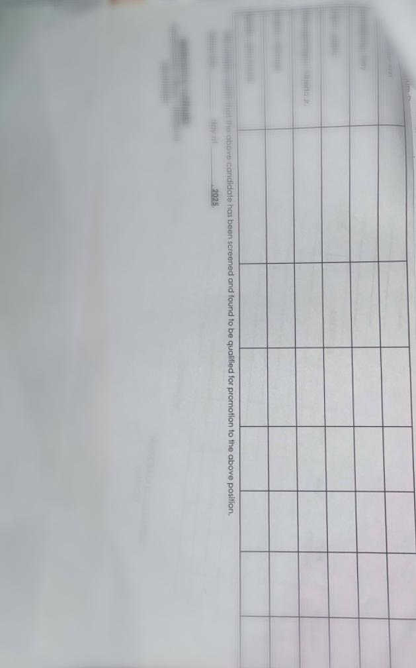

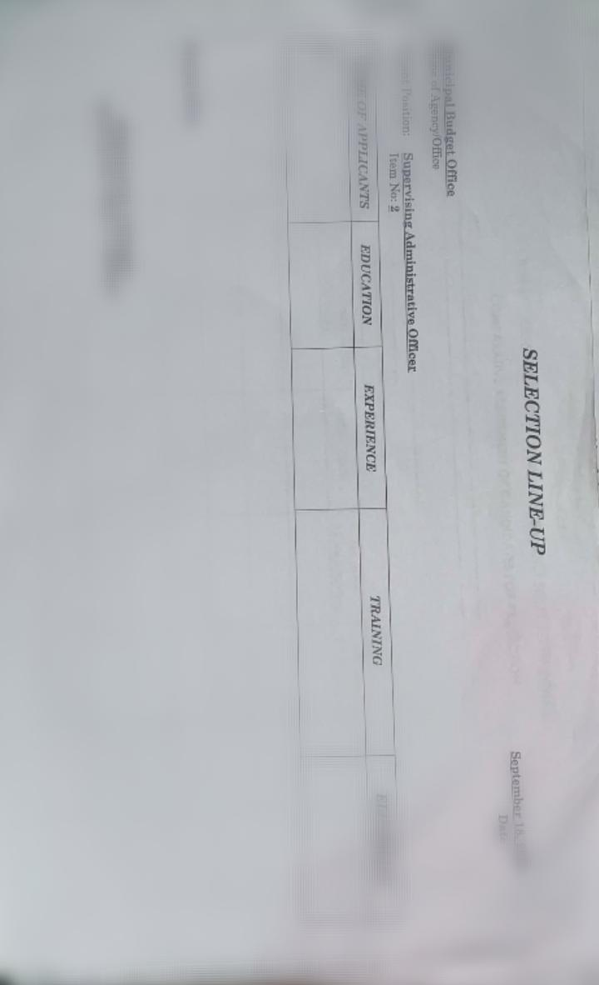

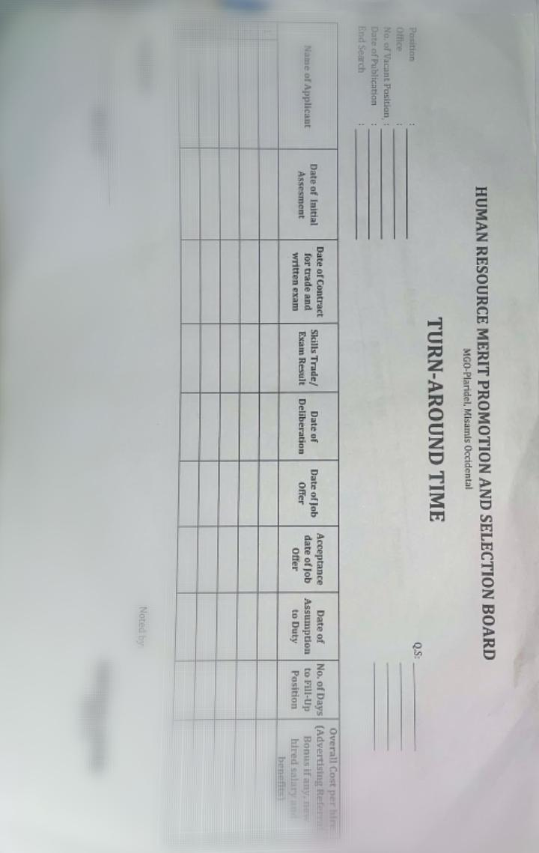

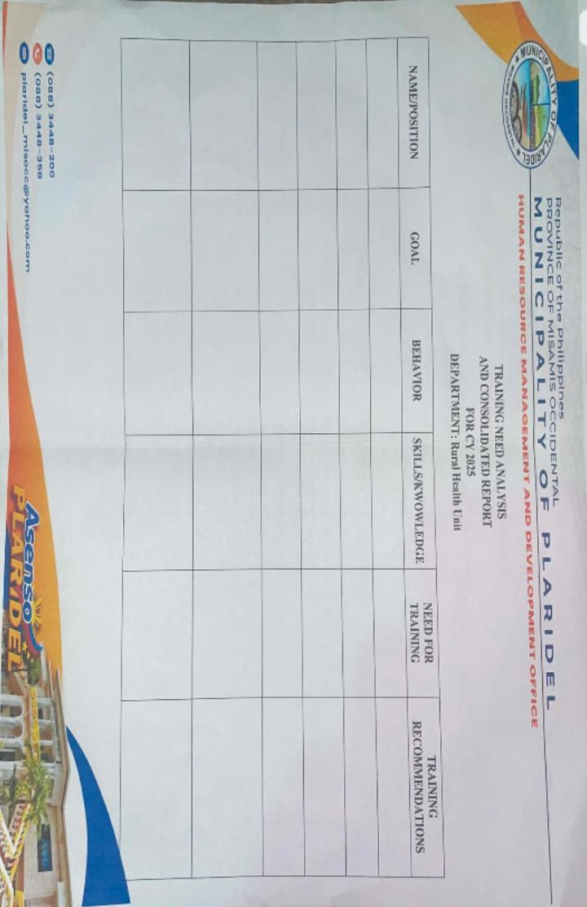

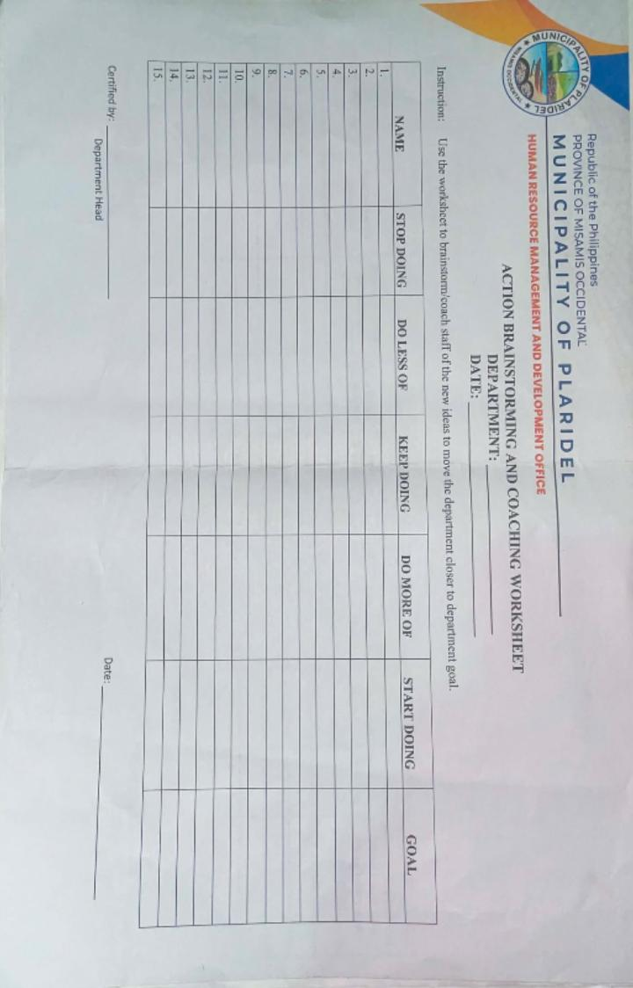
LGU PLARIDEL DEPARTMENT HEADS/ FOCAL
- Yting , Bynn Jessa H. - OIC. GSO - Ria Govenn Maquiling
- Bazar, Sheryll Kaye M. - OIC. MBO - Renelyn P.Gulahab
- Guigayoma , Juliet N. - MLCRO - Rica V. Libutan
- Palionay , Jocelyn L. - Chief of Hospital - Venus G. Aranding
- Hamili- Uy, Louvenice D. - Municipal Health Officer - Arlene Pesidor
- Cotales , Julie Ann D. - Municipal Accountant - Ria Rose A. Timado
- Cañares , Marcelo B. - Administrative officer V (HRMO III) - Jane Bongcawel
- Almirol , Nelda - OIC Municipal Engineer - Cherjun Dods R. Dumaloan
- Nisnisan , Perie B. - OIC Meedo/ BPLO & IAS - Mhelou Ann Bait
- Mnalod, Piojay B. - OIC MENRO/ TMU - April A. Tumaroy
- Racho, Liezl A. - MSWDO - Peachie D. Parcutilo
- Sinconiegue , Melisa - MAO - Anne Rose P. Daguinotas
- Cabiles, Gemma - PESO - Jason Laranjo
- Fernandez, Febie Rose A. - Secretary to the Sangguniang Bayan - Zenaida Palangan
- Lamban , Elmer - OIC MDRRMO - April A. Tumaroy
- Rabosa , Jacynth Marie T. - Supervising Public Utilities Regulation - Patricia Redillas
- Jumawan, Harvey - MPDO - Fe M. Sugano
- Omandam , Madilyn Jay V. - MASSO. OIC - Marites B. Bayon-on
- Kaamino-Handumon , Thea Janica Gwenn C. - Municipal Administrator - Welejaida Him
- Lorna Balios - Genely V. Manlod

