CHAPTER IV

RESULTS AND DISSCUSSIONS

- Discussions
This study aimed to develop DocuTrack, the digital document tracking and routing module of UNITY PILLAR, for government offices. The module focuses on electronic document registration, configurable routing, monitoring, review, and recording of document transactions. It is intended to address difficulties in manual document processing, including delayed routing, misplaced files, limited status visibility, and reliance on paper-based follow-up. The following discussions present the major objectives of the study and explain how the documented DocuTrack functions respond to the identified needs.
Discussion No. 1. To provide a centralized digital platform for document registration, submission, and storage.
The document creation and submission features allow authorized personnel to record document information, attach supporting files, and prepare documents for electronic processing. A centralized record is intended to make transaction information easier to locate and to reduce dependence on manually updated logbooks. Document-scanning capabilities should be described as a completed result only after verifying them in the actual system.
Discussion No. 2. To facilitate organized document routing, review, and approval across authorized personnel.
DocuTrack is designed to support a configurable sequence of document-processing steps. Based on the workflow described in Chapter III, designated personnel can receive assigned documents, provide remarks, and perform permitted actions such as approval, forwarding, returning, or rejection. Workflow configurations and role-based permissions help determine who is allowed to act at each stage. The documented design supports accountability by associating document actions with the users responsible for them.
Discussion No. 3. To provide document status monitoring, transaction history, and timely updates.
The document tracking and history functions are intended to let authorized personnel view the current status of a document, its assigned reviewer, and the actions recorded during processing. Notification functions are designed to inform users about assignments or relevant changes. These functions may help reduce repeated manual inquiries; however, the pilot questionnaires alone cannot establish actual reductions in processing time or delays.

4.2 Screen Design
This section presents the DocuTrack interfaces by feature and user role. Like the format used in the companion UNITY PILLAR manuscript, each screen is identified with a numbered figure and followed by a brief description of its purpose. The researchers should replace the labeled screenshot spaces with actual captures from the working DocuTrack application. The feature descriptions are based on Chapter III; functions not yet implemented or verified must be revised or omitted before final submission.

4.2.1 System Login and Authentication

Figure 20. DocuTrack Login Interface

Figure 20 shows the DocuTrack login interface for authorized personnel. Registered users enter their credentials to access system functions associated with their accounts. Access restrictions help ensure that confidential documents and administrative controls are available only to permitted users.

4.2.2 Administrator Dashboard
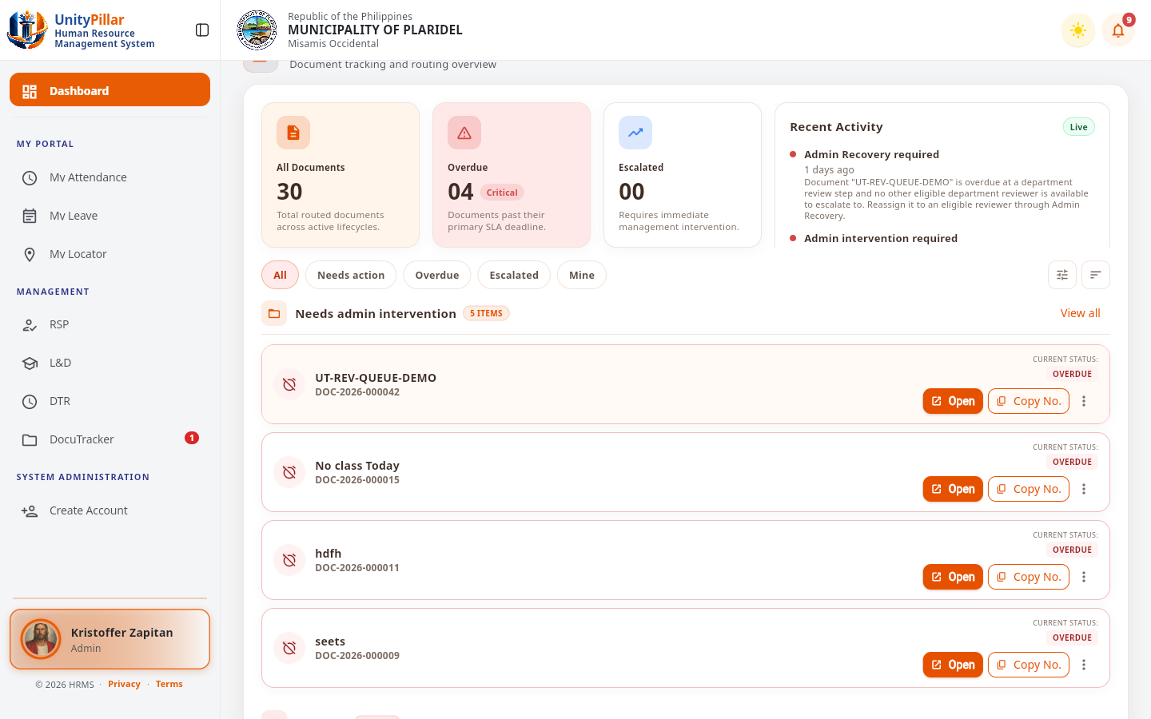
Figure 21. DocuTrack Administrator Dashboard

Figure 21 shows the administrator dashboard, which provides access to document management, workflow settings, pending routing activities, and other administrative functions. The dashboard is intended to let authorized personnel navigate between the main document-processing tasks.

4.2.3 Employee Dashboard
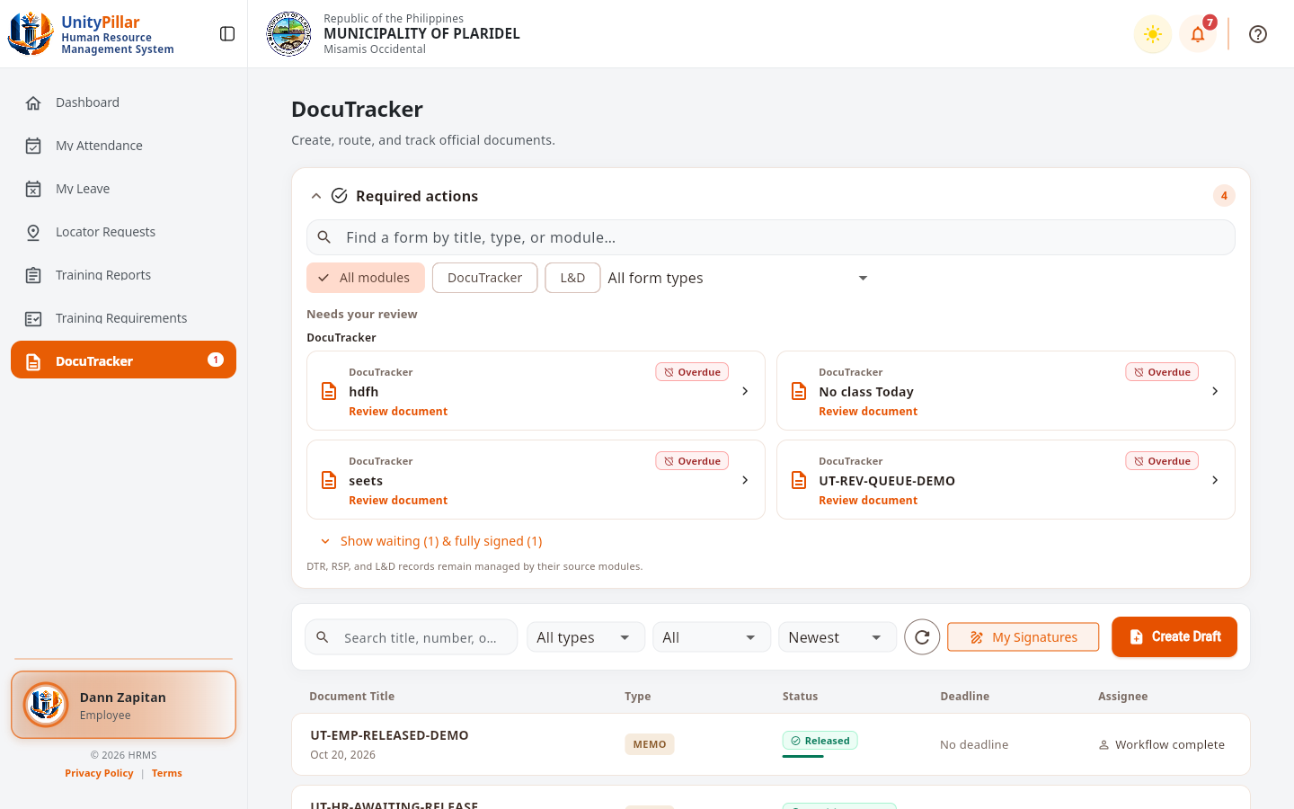
Figure 22. DocuTrack Employee Dashboard

Figure 22 shows the employee DocuTracker home with Required actions, document list filters, My Signatures, and Create Draft for the signed-in employee account.

4.2.4 Document Creation and Submission
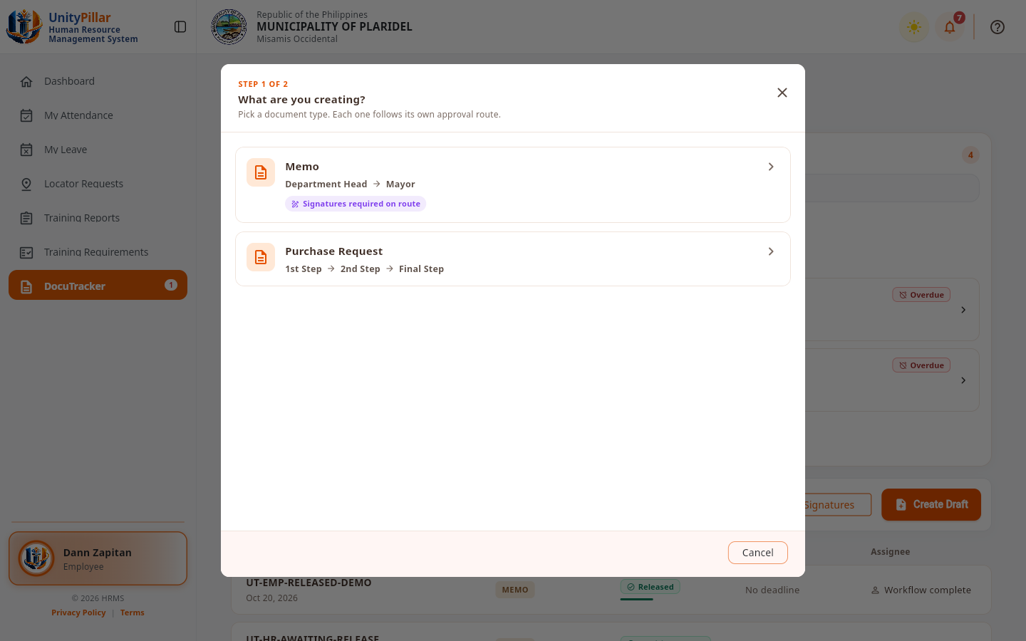
Figure 23. Document Creation and Submission Interface

Figure 23 shows the Create Draft document-type picker used when starting a Memo or Purchase Request in DocuTracker.

4.2.5 Document Management and File Attachments
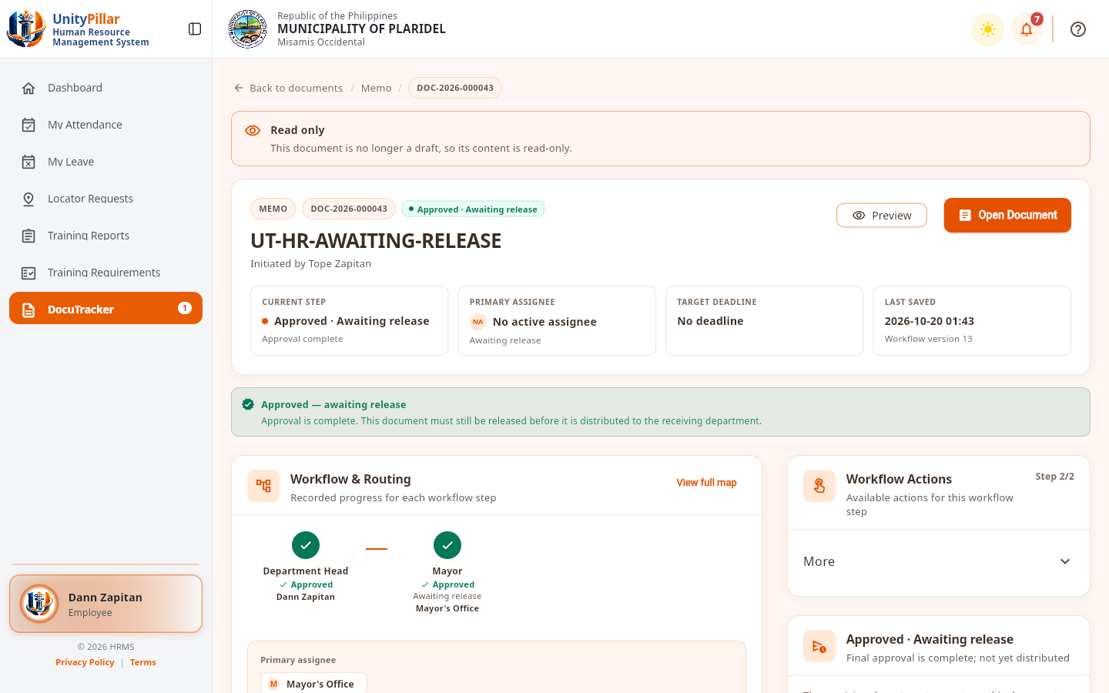
Figure 24. Document Management and File Attachments Interface

Figure 24 shows the document management section, including access to recorded document details and supporting attachments. The interface helps personnel organize files associated with each transaction, subject to their access permissions.

4.2.6 Document Routing and Workflow Configuration
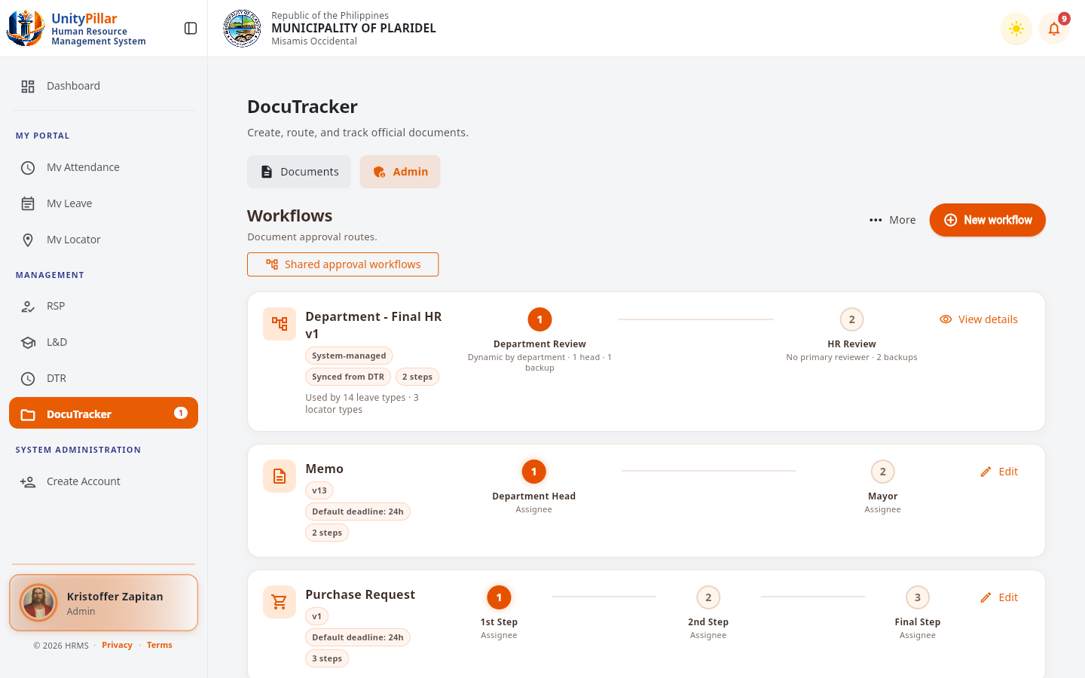
Figure 25. Workflow Configuration and Routing Interface

Figure 25 shows the workflow and routing interface used to define or follow document-processing steps. Administrators may configure assignees, routing order, and relevant workflow rules, while authorized users can route documents according to those configurations.

4.2.7 Document Review and Approval
Figure 26. Document Review and Approval Interface

Figure 26 shows the reviewer interface, which is intended for examining assigned documents and recording actions such as approval, forwarding, returning, or rejection. Reviewers may add remarks were permitted. The interface helps connect a decision with its corresponding document record.

4.2.8 Document Tracking and Status Monitoring
Figure 27. Document Status Tracking Interface

Figure 27 shows the document tracking screen, which provides an overview of the document status, its current assignee, and its progress through the routing workflow. This helps users identify where a document is in the process and whether additional action is needed.

4.2.9 Notifications and Status Updates

Figure 28. Document Notifications Interface

Figure 28 shows the notifications interface for document-related updates, such as new assignments, review decisions, and pending actions. Clear notices help users recognize changes affecting documents within their assigned responsibilities.

4.2.10 User Roles and Permissions Management
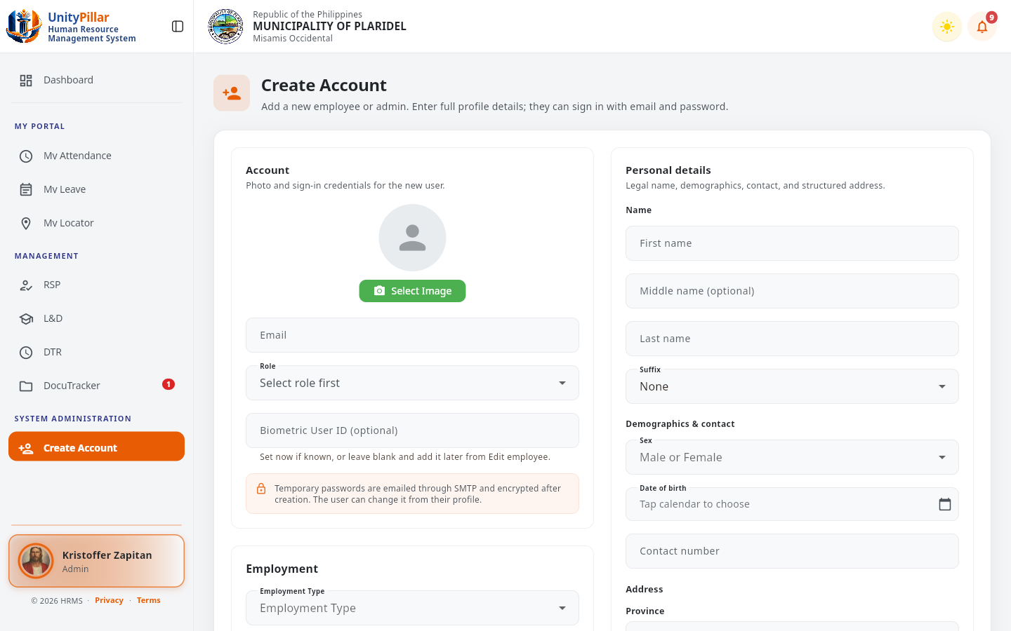
Figure 29. User Roles and Permissions Interface

Figure 29 shows the administrative access and permissions interface. The system is designed to restrict document actions and workflow settings according to assigned authority, protecting administrative functions from unauthorized changes.

4.2.11 Document Search and Filtering
Figure 30. Document Search and Filtering Interface

Figure 30 shows the document search and filtering functions. Authorized personnel can use available search criteria to locate records and review relevant status information without examining each transaction individually.

4.2.12 Document History and Audit Trail

Figure 31. Document History and Audit Trail Interface

Figure 31 shows the document history or audit trail, which records key workflow activities and the users associated with those actions. This information supports traceability of document movement, decisions, and subsequent changes.

4.2.13 Overdue Document Monitoring and Escalation
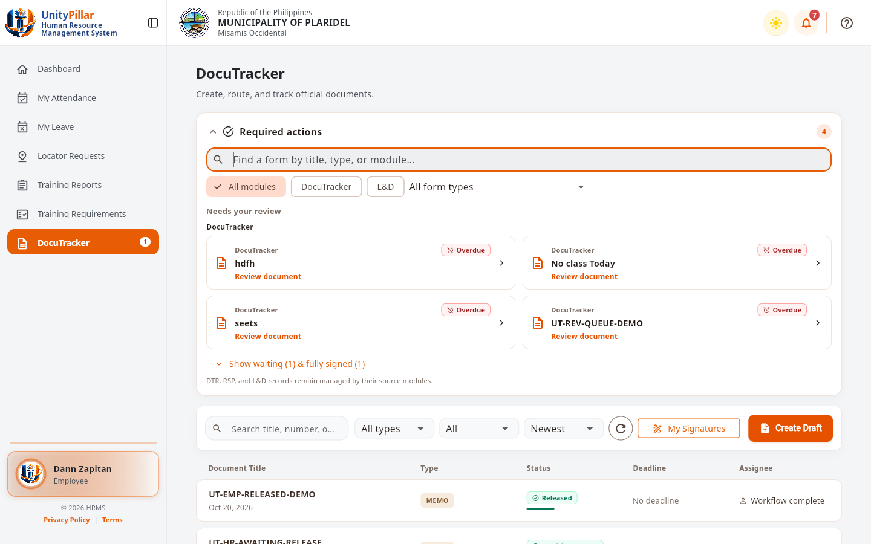
Figure 32. Overdue Document Monitoring Interface

Figure 32 shows overdue DocuTracker items highlighted for follow-up in Required actions and on the document overview.

4.2.14 Document Archiving and Records Management

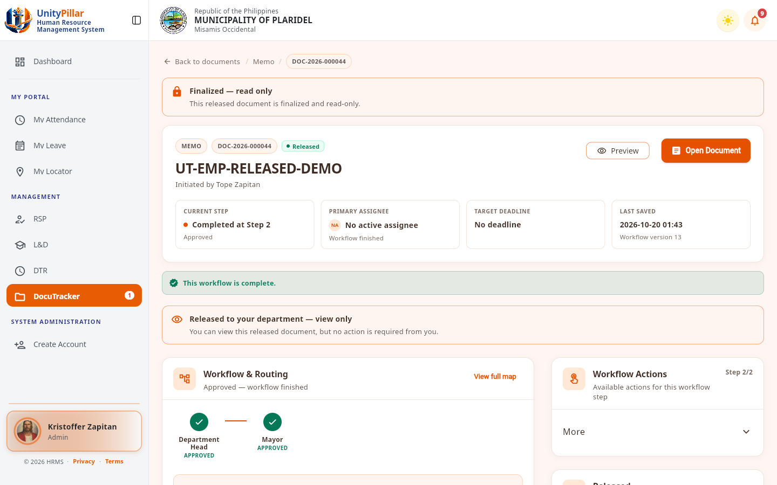
INSERT ACTUAL DOCUTRACK SCREENSHOT HERE
Completed and Archived Document Records Interface
Figure 33 shows a completed and released document record that remains available after workflow processing. Advanced archival retention functions beyond this completed-record view are not claimed here.
Figure 33 is reserved for the completed or archived document-record view. The study design includes maintaining historical records after processing, but any advanced archiving or retention function should be documented only if it has been implemented.

4.2.15 Reports and Document Transaction Monitoring

Figure 34. Document Transaction Reports Interface

Figure 34 shows the DocuTracker monitoring summary with document volume, overdue and escalated counts, and recent activity. Separate printable report generators beyond this dashboard summary are not claimed here.
4.2.16 Required Actions Queue
Figure 35. DocuTrack Required Actions Interface
Figure 35 shows the Required actions queue with overdue review items for the signed-in employee, including search and module filters.
4.2.17 Document Detail and Release Status
Figure 36. Document Detail and Release Status Interface
Figure 36 shows employee document detail with approved/awaiting-release status, workflow steps, and related metadata.
4.2.18 Memo Assignment and Signatories
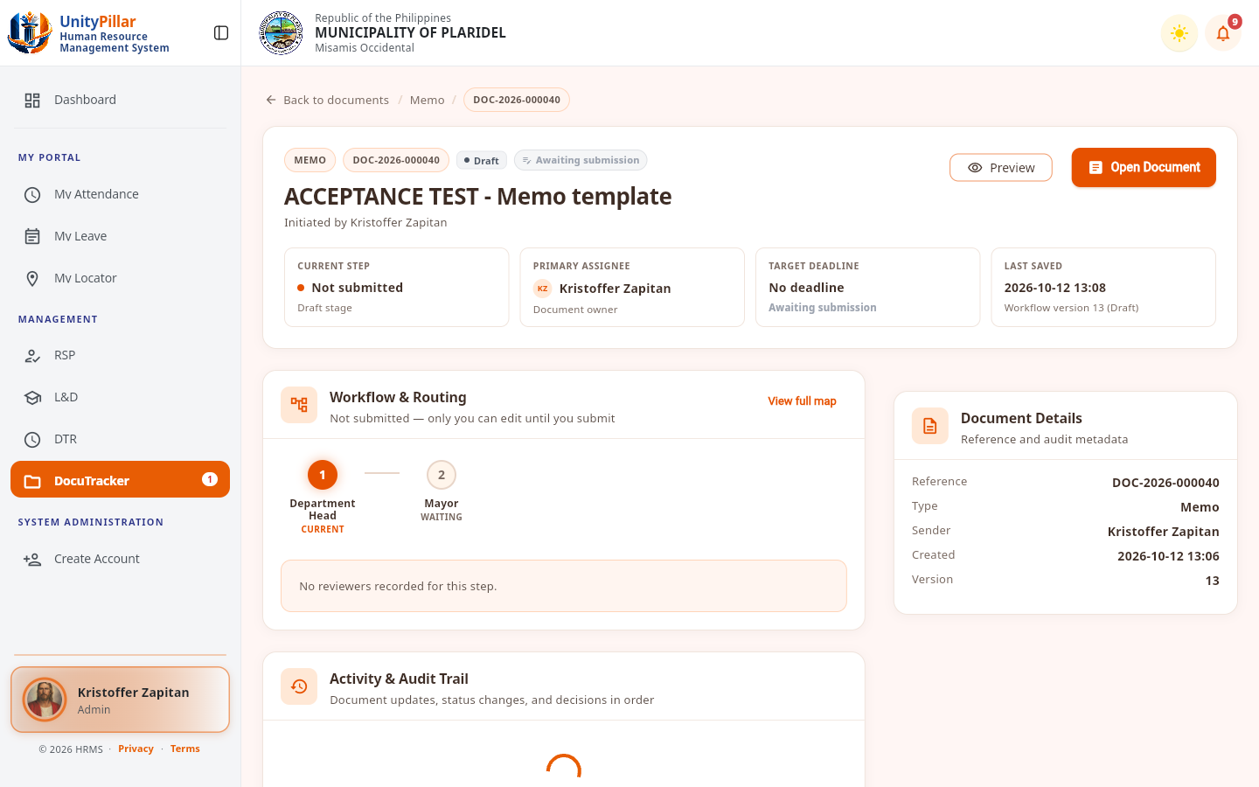
Figure 37. Memo Assignment and Signatories Interface
Figure 37 shows memo assignment and signatory information used during document preparation and approval.

4.3 Testing and Results
This section presents the preliminary results of the DocuTrack pilot-testing questionnaires. Six identifiable questionnaires were provided: three Employee Respondent Forms and three HR/Admin and Operational Personnel Forms. The respondents rated their experience using a five-point scale, from 5 (Strongly Agree) to 1 (Strongly Disagree). The evaluation covers Functional Suitability, Usability, and Performance Efficiency. The Employee questionnaire contains 15 statements, while the HR/Admin questionnaire contains 20 statements. Unlike the interviews discussed in Chapter III, these pilot-testing forms evaluate the developed module from the respondents’ perspective.
The weighted mean was computed using the formula: Mean = Σ(f × x) / N, where f is the frequency of a rating, x is the numerical rating, and N is the number of valid responses for the statement. For provisional interpretation, scores from 4.21 to 5.00 are Strongly Agree, 3.41 to 4.20 Agree, 2.61 to 3.40 Neutral, 1.81 to 2.60 Disagree, and 1.00 to 1.80 Strongly Disagree. The original questionnaires must be checked before the results are submitted as final.
A. Functional Suitability Results
Functional suitability evaluates whether the system provides appropriate document actions and performs tasks such as document handling, workflow routing, review, and access control in a manner consistent with assigned roles.

Table 6. Functional Suitability Results – Employee Respondents
Question | Weighted Mean | Interpretation
The system correctly displays documents assigned or available to me. | 4.00 | Agree
The system allows me to open and review documents assigned to me. | 4.67 | Strongly Agree
The system allows me to add remarks or action notes when permitted. | 4.67 | Strongly Agree
The system allows me to update or route an assigned document using actions allowed by the workflow. | 4.67 | Strongly Agree
The system prevents me from acting on documents or workflow steps that are not allowed for my role. | 4.00 | Agree
Overall Weighted Mean | 4.40 | Strongly Agree

Question | Weighted Mean | Interpretation
The system allows authorized personnel to create and save document records correctly. | 4.33 | Strongly Agree
The system allows authorized personnel to upload and attach required document files successfully. | 4.67 | Strongly Agree
The system allows authorized personnel to assign or route documents to the appropriate employee or office. | 4.67 | Strongly Agree
The system correctly displays the current assignee, workflow status, and document action history. | 4.67 | Strongly Agree
The system allows authorized personnel to locate document records using the available search and filtering functions. | 4.67 | Strongly Agree
The system correctly applies workflow and permission rules when administrative actions are performed. | 4.67 | Strongly Agree
The system provides the information needed to review document assignments, routing, status, and history. | 4.33 | Strongly Agree
Administrative actions are limited according to the user’s assigned authority. | 4.33 | Strongly Agree
Table 7. Functional Suitability Results – HR/Admin Respondents

Interpretation: The employee respondents obtained a functional-suitability mean of 4.40, and HR/Admin respondents obtained a mean of 4.54. Both fall within the provisional
“Strongly Agree” category. These results indicate favorable respondent assessments of the available document functions and authorized workflow actions during pilot testing.
B. Usability Results
Usability evaluates whether users can understand menus, labels, current workflow information, and feedback messages, and whether they can complete their assigned tasks with minimal assistance.

Table 8. Usability Results – Employee Respondents
Question | Weighted Mean | Interpretation
The system’s DocuTracker menus and navigation are easy to understand. | 4.00 | Agree
The labels, buttons, status labels, and workflow instructions clearly describe their purpose. | 4.33 | Strongly Agree
The current assignee, workflow status, and document history are easy to understand. | 4.33 | Strongly Agree
The system provides clear messages when an action succeeds, fails, or is restricted. | 4.00 | Agree
I can perform my assigned DocuTracker Employee tasks with minimal assistance. | 3.67 | Agree
Overall Weighted Mean | 4.07 | Agree

Table 9. Usability Results – HR/Admin Respondents
Question | Weighted Mean | Interpretation
The system’s menus and administrative DocuTracker functions are easy to locate. | 4.00 | Agree
The labels, buttons, filters, status indicators, and instructions clearly describe their purpose. | 4.33 | Strongly Agree
Document registration, file attachment, assignment, and routing can be completed without unnecessary steps. | 4.33 | Strongly Agree
The system provides clear confirmation, validation, and restriction messages after each action. | 4.00 | Agree
The document status, current assignee, and action history are easy to understand. | 4.00 | Agree
I can perform my assigned DocuTracker administrative tasks with minimal assistance. | 4.00 | Agree
Overall Weighted Mean | 4.11 | Agree

Interpretation: The employee usability mean was 4.07, and the HR/Admin usability mean was 4.11, both interpreted provisionally as “Agree.” These ratings are lower than the functional-suitability means and suggest that navigation, instructions, and task guidance are practical areas for further refinement.
C. Performance Efficiency Results
Performance efficiency concerns users’ perceptions of loading time, responsiveness, saving actions, file operations, and completion of ordinary document workflow tasks.

Table 10. Performance Efficiency Results – Employee Respondents
Question | Weighted Mean | Interpretation
The system loads my assigned documents and document records within an acceptable amount of time. | 4.33 | Strongly Agree
The system opens document details and attached files within an acceptable amount of time. | 4.50 | Strongly Agree
Remarks, workflow actions, and status updates are saved within an acceptable amount of time. | 4.67 | Strongly Agree
The system remains responsive while I move between DocuTracker pages and document records. | 4.33 | Strongly Agree
The system responds to my Employees actions without noticeable delays during the assigned tasks. | 4.33 | Strongly Agree
Overall Weighted Mean | 4.43 | Strongly Agree

Table 11. Performance Efficiency Results – HR/Admin Respondents
Question | Weighted Mean | Interpretation
Document lists and document records load within an acceptable amount of time. | 4.00 | Agree
Document files can be uploaded and opened within an acceptable amount of time. | 4.00 | Agree
The system processes document assignment, routing, and workflow actions within an acceptable amount of time. | 4.00 | Agree
Search and filtering results are displayed within an acceptable amount of time. | 4.00 | Agree
The system remains responsive while working with multiple document records. | 4.00 | Agree
The system performs reliably during normal daily DocuTracker operations. | 4.00 | Agree
Overall Weighted Mean | 4.00 | Agree

Interpretation: The employee performance-efficiency mean was 4.43, interpreted as “Strongly Agree,” based on 14 visible ratings. The HR/Admin mean was 4.00, interpreted as “Agree,” based on 12 visible ratings. These are user ratings and should not be presented as actual system response-time measurements.
D. Overall Pilot Testing Results
Table 12. Overall Pilot Testing Summary
Respondent Group | Valid Ratings | Mean | Interpretation
Employee | 44 | 4.30 | Strongly Agree
HR/Admin and Operational Personnel | 54 | 4.28 | Strongly Agree
Combined valid ratings | 98 | 4.29 | Strongly Agree

The overall pooled mean of the 98 visible ratings was 4.29, provisionally interpreted as “Strongly Agree.” Of the 105 possible responses on six questionnaire forms, seven are missing from the available photographs: one Employee Performance Efficiency response (Item 12) and the six HR/Admin Performance Efficiency responses on one respondent’s form. The combined value pools distinct questionnaire statements and is therefore only a descriptive summary, not a standardized comparison of the two roles.
The results suggest that the six respondents generally evaluated the DocuTrack module positively in terms of its documented functionality, usability, and performance during the pilot activities. Nevertheless, the small respondent group, differences between the questionnaires, and missing marks limit the strength of the conclusions. More extensive testing, complete response verification, and actual system screenshots are recommended before final manuscript submission.

