INTEGRATED HRMS: A BIOMETRIC-BASED DAILY TIME RECORD (DTR) AND ATTENDANCE MONITORING

A Capstone Project and Research Study
Presented to the
Department of Information Technology
University of Science and Technology of Southern Philippines
Oroquieta City


In Partial Fulfillment of the Requirements for
Capstone Project and Research Study Leading to the Degree in
Bachelor of Science in Information Technology

EARL CONRAD D. BALA
DENIELA MARY C. BUSTAMANTE
MARK GERARD O. TAÑEDO
APPLE JEAN A. TIZON

April 2026
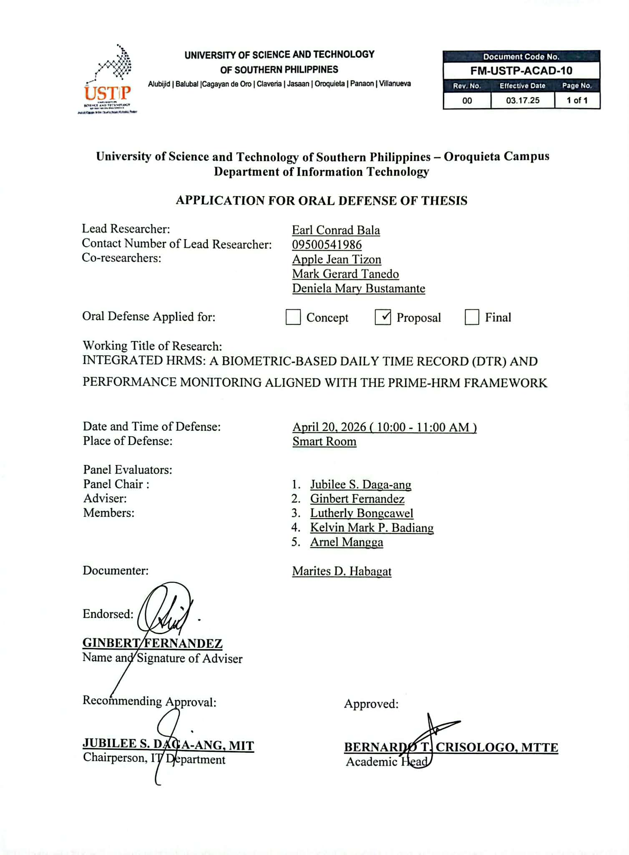
APPROVAL SHEET

TABLE OF CONTENTS

INTEGRATED HRMS: A BIOMETRIC-BASED DAILY TIME RECORD (DTR) AND ATTENDANCE MONITORING i
APPROVAL SHEET ii
TABLE OF CONTENTS iii
List of Figures v
List of Tables vi
CHAPTER I 1
1.1 Background of the Study 1
1.2 Statement of the Problem 3
1.3. General Objective 4
1.3.2 Specific Objectives 4
1.4. Significance of Study 5
1.5. Scope and Limitations of the Study 6
1.6 Definition of Terms 8
CHAPTER II 10
2.1 Review of Related Literature 10
2.2 Review of Related Application 16
2.2.1. Operational Framework of the Municipality of Plaridel 16
2.2.2. The Enhanced Attendance Monitoring System (EAMS) uses biometric fingerprint 16
2.2.3. Facial Recognition Attendance System 17
2.2.4. Biometric Payroll and Attendance System 17
2.3 Synthesis and Gap Analysis 21
CHAPTER III 27
3.1 Research Methodology 27
3.2 Data Gathering Procedure 29
3.2.1 Research Instrument 31
3.2.2 Sampling Method 33
3.2.3 Statistical Treatment of Data 33
3.3 Description of the Current System (Information Gathering) 36
3.4 System Architecture and Development 38
3.4.1 Overview of the Proposed System 41
3.4.2 System Objectives 42
3.4.3 System Tools Requirements 43
3.4.4 System Flow/Functions 46
3.4.5 Scope and Limitations of the System 69
3.4.6 Calendar of Activities 70
3.5 Conceptual Design and Implementation 70
3.5.1 Database Design 72
3.5.2 System Design 86
Context Diagram 89
Data Flow Diagram (DFD) 91
REFERENCES: 93
APPENDICES 97

List of Figures
Figure 1. Agile Methodology 19
Figure 2. System Architecture and Development Diagram 29
Figure 3. System Flow Chart (Log In) 37
Figure 4. System Flow Diagram (Admin) 38
Figure 5. System Flow Diagram (Employee) 39
Figure 6. Biometric Attendance Recording Flow 41
Figure 7. Attendance Log Import via VAT File Flow 42
Figure 8. Timekeeping Algorithm 44
Figure 9. Data Processing Flow 45
Figure 10. Leave Filing and Approval Flow 47
Figure 11. Locator Slip Filing and Approval Flow 49
Figure 12. Monthly Accrual Flow 50
Figure 13. Biometric Attendance Real-Time Monitoring Sequence Diagram 52
Figure 14. ERD for Employee and Attendance Configuration 59
Figure 15. DTR Report Generation Sequence Diagram 61
Figure 16. Attendance and DTR ERD 63
Figure 17. Leave Management ERD 65
Figure 18. ERD System Database Design 67
Figure 19. Use Case Diagram 70
Figure 19. Context Diagram 71
Figure 20. Data Flow Diagram (DFD) 72

List of Tables
Table 1. Comparison of the related systems 14
Table 2. Gap Analysis 16
Table 3. Likert Scale Interpretation Guide 25
Table 4. Programming Languages 31
Table 5. Frontend/Frameworks 32
Table 6. Backend Technologies 32
Table 7. Hardware Requirements 32
Table 8. Software Requirements 33
Table 9. Calendar of Activities 56

CHAPTER I
INTRODUCTION

1.1 Background of the Study
Human Resource Management (HRM) is an important function in public institutions because it helps ensure that employees perform their duties efficiently and responsibly. In Philippine local government units (LGUs), HR practices are guided by the PRIME-HRM framework, which aims to improve the quality of public service and strengthen compliance with Civil Service Commission standards. One key area under this framework is attendance monitoring, since regularity and punctuality are basic expectations for government employees.
The Daily Time Record (DTR) is used to document the time-in and time-out of employees on a daily basis. It records employee attendance and is used for leave verification, payroll preparation, and compliance reporting as basis. Moreover, by the use of automation in human resource management has made administrative activities like tracking attendance and processing payroll much more efficient. Automated technologies help businesses cut down on manual work, make fewer mistakes, and make basic HR tasks easier (Adabala, 2021).

In the Municipality of Plaridel, biometric device already exists, to keep track of when employees come to work. However, the data generated from these devices are not fully integrated into a centralized and automated system. Late minutes and undertime working hours of employee are reviewed and computed manually. Additionally, approved leave records such as vacation leave and sick leave are not automatically reflected in DTR summaries. As a result, HR personnel manually verify attendance logs and prepare reports, which consumes time and may lead to delays or inconsistencies.
Additionally, the lack of automation in consolidating attendance records limits real-time monitoring and makes the process more reactive than proactive. Instead of having immediate access to updated attendance information, HR staff must rely on manual checking and compilation. Also, manual attendance systems often need records to be taken out and working hours to be calculated by hand, which can take a long time and be wrong (Sogoni, 2023).
The study aims to provide a centralized system for DTR that provides real-time attendance monitoring and automates the computation of lates and total rendered working hours of employees. This study is part of the development of an Integrated Human Resource management system composed of several modules aligned with the PRIME-HRM framework. However, the primary focus of this research is the is the Daily Time Record (DTR) module, which handles employee attendance and monitoring.

1.2 Statement of the Problem
The main problem of this study is the lack of a centralized and automated Daily Time Record (DTR) system for managing and monitoring employee attendance in the Municipality of Plaridel. Although a biometric device is present and currently used to record employee time-in and time-out, the attendance logs generated by these devices are not directly connected to a centralized system that can automatically compute lates, undertime and total rendered working hours of employee and allow real-time monitoring. As a result, several attendance-related tasks still need to be done manually, which may lead to delays, possible errors, and difficulty in monitoring attendance as it happens. HR personnel still need to review and compute, arrange employee attendance records and manually compute late minutes and total undertime. In addition, approved leave records such as vacation leave and sick leave are not automatically reflected in the DTR summaries.
Specifically, this study seeks to answer the following:
- How can a centralized and automated DTR system be designed to integrate biometric attendance, leave management, and real-time monitoring?
- How can a timekeeping algorithm be implemented and developed to accurately compute attendance metrics such as late minutes, undertime and their deductions, and total working hours based on predefined schedules or shifts and policies?
- How can the developed HRMS-DTR system be tested and evaluated in terms of its functionality, usability, and performance?

1.3. General Objective
The primary objective of this study is to develop a Daily Time Record (DTR) module that combines biometric attendance data into a single platform, Integrated with the other module of the four Pillars of HRMS. The system's goal is to make it easier to record, real-time monitoring, and report on employee attendance in the Municipality of Plaridel.

1.3.2 Specific Objectives
Specifically, this study aims to:
- To design a centralized and automated Daily Time Record system that integrates biometric attendance, leave and locator slip management, and reporting functions.
- To develop and implement a timekeeping algorithm that automates the process of biometric logs and computes attendance metrics and deduction for late, undertime and working hours based on assigned schedules and policies.
- To test and evaluate the developed HRMS-DTR system in terms of functionality, usability, and performance based on the ISO/IEC 25010 Software Quality Model.

1.4. Significance of Study
The accomplishment of this study would be greatly beneficial to the following stakeholders:
Employees. A more precise and orderly record of their attendance will help government workers. The system can keep better and more accurate records of their time in, time out, and allowed leaves.
Human Resource Office. The system will help the Human Resource Office Manage attendance records more efficiently. By providing real-time monitoring, automating computation of late minutes and consolidating attendance records and exportable in pdf, spreadsheet or word document, HR personnel can reduce the time and effort spent on manual processing and report preparation.
Municipal Government Administration. The study aims to help the local government do a better job of handling things using a centralized and digital system. By making attendance tracking more open, accurate, and useful, it might help the government keep better track of its employees.
Future Researchers. This study may function as a reference repository for forthcoming capstone projects and for academics intending to create analogous systems pertaining to attendance monitoring, human resource management, or digital transformation in public offices.

1.5. Scope and Limitations of the Study
Scope:
The study’s scope focuses on the development of a centralized and automated Daily Time Record (DTR). The system is designed to improve the management and monitoring of employee attendance records from biometric devices into a single platform. It aims to reflect the time-in, time-out through real-time monitoring for HR personnel, including the computation of late minutes, undertime, and total rendered working hours, as well as the generation of attendance reports. The technology proposed will allow HR staff to see and manage the attendance records for all employees from one central dashboard. It will show daily attendance logs, monthly summaries, late minutes and undertime that are automatically calculated based on the work schedule that has been set up. The system will also show the employee's attendance record with approved leave records, such as sick leave, maternity leave, vacation leave and other types of leave forms in HR. In addition, the study covers the basic management of employee information related to attendance monitoring and report generation to support the Human Resource Office in reviewing employee attendance. The system is designed to provide organized record keeping and easier access to attendance data for the Human Resource Office.
Limitations:
This study is limited to the development of the Daily Time Record (DTR) system focused on attendance monitoring and processing for the Human Resource Management System of the Municipality of Plaridel. The system is limited to tracking employee attendance, including presence, absences, late minutes, undertime, and the generation of attendance reports and summaries. Other Human Resource functions such as payroll processing, recruitment, performance evaluation, and training management are not included in the current implementation. The system also depends on the proper functioning of biometric devices for accurate data capture, any hardware issues or failures in recording logs may affect the reliability of attendance records. In addition, synchronization between the local server and cloud server requires a stable internet connection, and connectivity delays may result in temporary inconsistencies in remote data access. Moreover, the system was tested only within the Municipality of Plaridel, and its performance and applicability may vary when implemented in other municipalities or organizations with different workflows and requirements.

1.6 Definition of Terms
Administrator (HR/Admin). This refers to the authorized system user that is responsible for managing attendance records, viewing logs, approving requests, and generating DTR reports.
Attendance Monitoring. This refers to the process of tracking, viewing, and managing employee attendance records in real-time through the system.
Biometric Attendance Log. This refers to the raw time-in and time-out logs or data of employees that are captured from the biometric device, which serves as the primary input for attendance processing in the system.
Biometric Device. This refers to the hardware used to capture the employee attendance through fingerprint recognition, which sends logs to the system for processing.
Daily Time Record (DTR). In this study, this term refers to the system generated record of an employee’s attendance, including the time-in, time-out, late minutes, working hours, late minutes and undertime, based on the processed biometric logs and attendance policies.
Data Synchronization. This refers to the process of transferring or updating data between the local database and the cloud server to ensure consistency and remote accessibility.
Employee. This refers to the system user who records attendance through the biometric device, and can view personal DTR records and submit leave or locator slip requests.
Leave Integration. This refers to the automatic inclusion approved leave records into the DTR to ensure accurate classification of absences.
Real-Time Monitoring. This refers to the system’s ability to display the updated or processed attendance data shortly after it is synchronized from the biometric device.
Timekeeping Algorithm. This refers to the set of system rules and process used to interpret the biometric logs and compute attendance metrics such as undertime, late, and total working hours based on the assigned shifts or schedules, and policies.

CHAPTER II
REVIEW OF RELATED LITERATURE AND RELATED SYSTEMS

2.1 Review of Related Literature
Digital and Automated Attendance Monitoring Systems
Digital attendance monitoring systems are used to reduce the limitations of manual recording, such as delayed encoding, inaccurate entries, duplicate records, and difficulty in preparing reports. Ishaq and Bibi (2023) explained that RFID-based smart attendance systems can automate attendance by allowing users to register attendance through RFID cards, reducing problems commonly found in manual processes such as wasted time, proxy attendance, and lost attendance sheets. This supports the need for an automated HRMS-DTR because the proposed system is intended to lessen manual encoding and provide more reliable attendance records.
Automation is also relevant to human resource operations because attendance data is often used for payroll, performance monitoring, and administrative decision-making. Jalaman and Encarnacion (2024) proposed an improved payroll management system with face recognition and attendance monitoring technology. Their study noted that traditional payroll systems are affected by payroll errors, delays, and lack of transparency, while a system with biometric attendance and automated payroll processing can improve accuracy, fairness, and employee trust. For the proposed HRMS-DTR, this supports the integration of attendance records with DTR computation and report generation.
Manual Attendance Monitoring System
Manual attendance tracking remains a common source of inefficiency because it depends heavily on paper forms, spreadsheets, and repeated encoding by staff. Dassanayake and Wanniarachchi (2021) discussed that manual attendance systems can result in attendance fraud, weak monitoring, and delayed feedback to students. Although their study focused on an educational setting, the same issue can occur in offices where attendance data must be encoded and checked manually. In the context of the Municipality of Plaridel, manual processing of tardiness, undertime, and leave-related records can delay the preparation of accurate DTR summaries.
Manual procedures also make it difficult to connect attendance with other HR functions. When leave records, attendance logs, and DTR summaries are stored separately, HR personnel must compare records manually before reports can be finalized. This creates a gap that supports the development of a centralized HRMS-DTR system with automated computation, leave integration, and report generation.

Biometric Attendance Monitoring Systems
Biometric attendance systems use unique physical characteristics, such as fingerprints or facial features, to verify the identity of the person recording attendance. Rivera (2021) developed an Enhanced Attendance Monitoring System using biometric fingerprint recognition for Callang National High School in Isabela, Philippines. The system recorded employee data, handled leave management, tracked attendance, provided dashboard monitoring, and generated employee DTRs. The study reported that the system saved time compared with manual processing and improved attendance monitoring through automated records.
A related public-sector study by Mapingulila, Onyancha, and Mbua (2024) examined the contribution of biometric fingerprint technology in reducing unauthorized absenteeism among employees in public organizations in Moshi Municipality, Tanzania. Their findings showed that public employees perceived biometric fingerprint technology as a reliable method for improving attendance management, accountability, and productivity. The study also emphasized the importance of clear communication with employees regarding the purpose, benefits, and safeguards of biometric technology.
Gomez-Barrero et al. (2021) also highlighted that the COVID-19 period created challenges for contact-based biometric systems, such as fingerprint recognition, while encouraging further research on contactless biometric methods such as iris, periocular, touchless fingerprint, and vein-based authentication. This shows that biometric systems must consider not only accuracy but also safety, privacy, and the suitability of the technology to the work environment.
Rukhiran, Wong-In, and Netinant (2023) further showed that user acceptance is important when biometric recognition technologies are used for attendance-related activities. Their study used the Technology Acceptance Model and emphasized factors such as perceived usefulness and ease of use. This is relevant to the proposed HRMS-DTR because even if a system is technically functional, its effectiveness still depends on whether HR personnel and employees can use it properly and trust the process.
Facial Recognition Attendance Monitoring Systems
Facial recognition is a contactless biometric approach that can automatically detect and recognize a person using a camera and stored facial data. Amulya, Jahnavi, Trupthi, Divya, and Kalpitha (2021) presented an online attendance system using machine learning algorithms. Their system used face detection and recognition to mark attendance automatically and reduce the time and effort required for manual updating. The study also noted the possibility of proxy attendance in manual systems and presented face recognition as a more secure alternative.
Mukherjee, Manish, and Natrajan (2022) proposed an employee attendance system based on facial recognition. Their study showed that face recognition can be applied to employee attendance tracking and can reduce the need for manual attendance recording. However, facial recognition systems must still consider lighting conditions, image quality, privacy, and proper database management to maintain accuracy and user trust.
Fuady and Hidayat (2025) examined a dual-mode attendance and payroll system using face recognition and QR code technology. Their study supports the idea that combining attendance technologies with payroll-related processing can improve efficiency and accuracy. However, systems that focus mainly on attendance and payroll still have limitations if they do not include leave filing, leave accrual, locator slip management, and complete DTR reporting.
RFID-based Attendance Monitoring System
Radio Frequency Identification (RFID) is another technology used in automated attendance monitoring. Ishaq and Bibi (2023) reviewed IoT-based smart attendance systems using RFID and found that RFID can provide an efficient and secure alternative to manual signatures. By scanning an RFID card, attendance can be recorded faster and with fewer manual errors. This supports the general move from paper-based attendance records to automated attendance technologies.
Reynoso, Derada, Arconado, and Ligzon (2025) developed an RFID-based attendance monitoring system with SMS notification and data analytics. Their study described RFID as a practical method for capturing attendance data quickly through card scanning and for generating attendance-related reports. Although the study focused on a school environment, its use of automated recording, notification, and analytics is related to the reporting and monitoring needs of HR offices.

Cloud-Based and Real-Time Attendance Management
Aside from biometric and RFID technologies, recent studies also emphasize the value of centralized and cloud-supported attendance systems. Latifian et al. (2022) conducted a systematic literature review on employee attendance management systems based on cloud computing. The study found that cloud infrastructure can positively support employee attendance management by improving data processing, storage, and accessibility. However, because the full article may require access through Cambridge Core, it was used only as supporting background and not as a main replacement source in this revised chapter.
For the proposed HRMS-DTR, real-time monitoring is important because HR personnel need to view attendance status, tardiness, undertime, and leave-related information without waiting for manual monthly consolidation. A centralized system can reduce repeated encoding, help verify employee attendance faster, and provide a clearer basis for DTR generation and HR reporting.

2.2 Review of Related Application

2.2.1. Operational Framework of the Municipality of Plaridel
- The Municipal Government of Plaridel currently uses biometric devices to record employee attendance. However, several HR processes remain manual or spreadsheet-based. HR personnel still need to process tardiness, undertime, rendered hours, leave records, and DTR summaries separately. Because attendance and leave records are not fully integrated, report preparation may be delayed and may require repeated checking. This situation supports the need for a centralized HRMS-DTR system that can connect biometric attendance, leave management, locator slips, automated DTR computation, real-time monitoring, and report generation
2.2.2. The Enhanced Attendance Monitoring System (EAMS) uses biometric fingerprint
- The Enhanced Attendance Monitoring System developed by Rivera (2021) used biometric fingerprint recognition to record employee attendance, manage employee information, handle leave management, provide dashboard monitoring, and generate DTR reports. Its strength is its use of fingerprint biometrics and automated reporting. However, for the needs of the proposed HRMS-DTR, the related system is still limited because it does not fully address configurable attendance policies, locator slip management, leave accrual monitoring, and hybrid local-cloud synchronization.

2.2.3. Facial Recognition Attendance System
- Facial recognition attendance systems, such as those discussed by Amulya et al. (2021), Mukherjee et al. (2022), and Fuady and Hidayat (2025), can automate attendance recording through camera-based recognition. These systems are useful because they reduce manual recording and can provide contactless attendance monitoring. However, most facial recognition systems focus mainly on identifying users and recording attendance. They usually do not provide complete HR functions such as leave filing and approval, locator slip management, leave accrual, configurable attendance rules, and complete DTR reporting.

2.2.4. Biometric Payroll and Attendance System
- The biometric payroll and attendance system proposed by Jalaman and Encarnacion (2024) combines face recognition, attendance monitoring, and payroll-related processing. This type of system supports attendance accuracy and payroll transparency. However, its main focus remains payroll and attendance, while the proposed HRMS-DTR requires wider HR functions such as real-time attendance dashboard, locator slip management, leave accrual, leave filing and approval, and automated DTR computation based on municipal attendance rules.

2.2.5 RFID-Based Attendance Monitoring System
- RFID-based attendance systems allow users to record attendance by scanning RFID cards. Ishaq and Bibi (2023) and Reynoso et al. (2025) showed that RFID can reduce manual attendance problems, improve speed, and support report generation. However, RFID systems normally depend on card possession, meaning that another person may scan a card if strict controls are not implemented. In addition, RFID attendance systems are usually not designed as complete HRMS solutions with leave management, DTR computation, and attendance policy configuration
Table 1. Comparison of Related Systems
TITLE | Biometric Attendance / RFID | Automated DTR Computation | Leave Integration | Real-Time Monitoring | Report Generation | Locator Slip | Leave Accrual
Existing Biometric System (Plaridel) | Partial | ❌ | ❌ | ❌ | Basic / Manual | ❌ | ❌
EAMS (Rivera, 2021) | ✔ | ✔ | ✔ | ✔ | ✔ | ❌ | ❌
Facial Recognition System (Amulya et al., 2021) | ✔ | Partial | ❌ | Partial | Partial | ❌ | ❌
RFID-Based Attendance Systems (Ishaq & Bibi, 2023; Reynoso et al., 2025) | RFID-based | Partial | ❌ | Partial | ✔ | ❌ | ❌
Biometric Payroll System (Jalaman & Encarnacion, 2024) | ✔ | Partial | Partial | ✔ | ✔ | ❌ | ❌
Proposed HRMS-DTR System | ✔ | ✔ | ✔ | ✔ | ✔ | ✔ | ✔

Table 1 compares related systems based on the major features needed by the proposed HRMS-DTR. The comparison shows that existing systems provide useful attendance automation features, but most of them focus on only one area, such as biometric attendance, RFID attendance, payroll, or report generation. The proposed HRMS-DTR addresses the gap by combining biometric attendance, attendance records, automated DTR computation, leave integration, real-time monitoring, report generation, locator slip management, and leave accrual tracking in one system.

2.3 Synthesis and Gap Analysis
The reviewed studies show that automated attendance systems improve accuracy, reduce manual work, prevent proxy attendance, and support faster report generation. Biometric and RFID technologies also help replace paper-based attendance processes with more organized digital systems.
However, many existing systems focus only on attendance recording and lack integrated HR functions such as leave management, locator slips, attendance policies, monthly DTR computation, and report generation.
This gap supports the development of the proposed HRMS-DTR system for the Municipality of Plaridel, which integrates biometric attendance, leave management, automated DTR computation, real-time monitoring, locator slips, leave accrual, and report generation in one centralized system.
Table 2. Gap Analysis
No. | Research Title | Key Contribution | Identified Gap
1 | Enhanced Attendance Monitoring System using Biometric Fingerprint Recognition (Rivera, 2021) | Uses fingerprint recognition, employee records, leave management, dashboard monitoring, and DTR generation | Does not fully address locator slip management, configurable attendance policies, leave accrual, and hybrid local-cloud synchronization.
2 | Biometrics in the Era of COVID-19: Challenges and Opportunities (Gomez-Barrero et al., 2021) | Highlighted the importance of secure and contactless biometric authentication technologies. | Focused mainly on biometric authentication and security rather than HRMS integration and attendance management.
3 | Online Attendance System using Machine Learning Algorithms (Amulya et al., 2021) | Automated attendance recording using facial recognition and machine learning technologies. | Focused mainly on attendance recording. Did not include leave management, real-time monitoring, and centralized HR functionalities.
4 | Contribution of Biometric Fingerprint in Reducing Unauthorized Absenteeism (Mapingulila et al., 2024) | Shows that biometric fingerprint technology can support accountability and reduce unauthorized absenteeism in public organizations. | Focuses on absenteeism and employee perception, not on complete HRMS-DTR processing and report generation.
5 | RFID-Based Attendance Monitoring System with SMS Notification and Data Analytics (Reynoso et al., 2025) | Combines RFID attendance, SMS notification, and analytics for faster monitoring and reports. | Designed mainly for attendance monitoring; lacks complete HRMS functions such as leave approval, DTR computation, and locator slips.
6 | Employee Satisfaction on Compensation System with Face Recognition and Attendance Monitoring (Jalaman & Encarnacion, 2024) | Links face recognition attendance with payroll transparency and automated processing. | Focused on payroll and attendance; lacks complete HRMS-DTR features such as leave accrual and locator slip management.
7 | IoT Based Smart Attendance System Using RFID (Ishaq & Bibi, 2023) | Reviews RFID attendance systems that reduce time wasting, proxy attendance, and lost attendance sheets. | RFID systems solve attendance capture but do not provide a full HRMS-DTR workflow.
8 | Current Attendance Monitoring System of the Municipality of Plaridel | Uses biometric devices for attendance recording and basic report generation. | Attendance computation, leave integration, and attendance monitoring are still manually processed.

Table 2 presents the gap analysis of the reviewed literature and systems. The analysis shows that the proposed HRMS-DTR system is needed because existing studies and applications do not fully combine attendance automation, DTR computation, leave integration, locator slip processing, leave accrual monitoring, real-time dashboards, and report generation in one centralized system.

CHAPTER III
METHODOLOGY

3.1 Research Methodology
This chapter presents the methodology used in the proposed HRMS-DTR system. The study focuses on designing, and evaluating a centralized and real-time Daily Time Record (DTR) system that addresses the attendance monitoring needs of the Municipality of Plaridel.
To achieve the objectives of the study, the researchers utilized the Agile software development methodology, which supports iterative development and continuous improvement of the system. Agile was selected because it allows the system to be developed in phases, enabling the researchers to refine features based on user requirements feedback.
Figure 1. Agile Methodology
The development of the system followed these agile phases:
Planning Phase. In this phase, the researchers identified the main problem, defined the objectives of the study, and determined the scope of the system. Initial coordination with the Human Resource Office was conducted to understand the need for a centralized and automated DTR system.
Analysis Phase. This phase involved gathering and analyzing system requirements through interviews, observations, and document analysis. The researchers examined the current process, including biometric log retrieval, manual DTR computation, policies, and leave management practices. The findings from this phase served as the basis for system design.
Design Phase. In this phase, the overall structure of the system was planned. This includes system architecture, database design, and user interface design. The design focused on integrating biometric attendance, leave management, and DTR processing into a single platform.
Development Phase. During this phase, the timekeeping algorithm was implemented to automatically process biometric logs and compute attendance metrics based on the defined or assigned schedules and policies.
Testing and Evaluation Phase. In this phase, the developed system was tested by selected users, including employees and potential users of the system. The respondents were asked to evaluate the system’s functionality, usability, and performance by using the system and answering a survey questionnaire based on the ISO/IEC 25010 Software Quality Model. The collected responses were analyzed using weighted mean to determine the level of acceptability of the system.
Deployment (Cutover) Phase. This phase represents the planned transition of the system from development to actual operational use. It includes final system preparation, user orientation, and initial deployment setup to ensure readiness for implementation in the organization.

3.2 Data Gathering Procedure
To assess the effectiveness of the proposed Integrated Human Resource Management System (HRMS), particularly its Biometric-Based Daily Time Record (DTR) module, in resolving the existing challenges in attendance monitoring within the Municipality of Plaridel, the researchers employed a qualitative data collection approach. The following methods were used during the requirements analysis phase to gather pertinent data:
Key Informant Interviews. Semi-structured interviews were conducted with key stakeholders, including Human Resources personnel and employees tasked with attendance monitoring and report generation. These interviews helped the researchers understand the current workflow and identify the challenges encountered in Daily Time Record (DTR) management, including:
  - Manual calculation of late minutes and undertime
  - Delays in report generation related to attendance data
  - Lack of real-time access to employees attendance data
  - Difficulties in integrating approved leave records into attendance summaries
Consequently, these discussions helped the researchers identify system requirements, user expectations, and potential improvements that the proposed system could provide in improving efficiency and accuracy.
Observation Method. The researchers observed the current procedures performed by the Human Resource Office in handling biometric attendance records. This included the collection, verification, and processing of biometric logs and attendance summaries.
Through observation, the researchers identified:
- The current process of handling biometric attendance data
- The step-by-step process of validating employee time entries
- The manual creation of Daily Time Record (DTR) summaries and reports
- The particular junctures where delays and inaccuracies commonly occur
This methodological framework helped the researchers identify inefficiencies and deficiencies in the current process that the proposed system aims to improve.
Document and Record Analysis. The researchers gathered and examined relevant attendance-related documents and records, including Daily Time Record (DTR) forms, biometric attendance logs, monthly attendance summaries, and leave records such as vacation and sick leave. This review helped the researchers to identify the essential data fields needed for the system to work properly. This analysis also provided a clearer understanding of the existing attendance and leave processes, which helped establish the rules for calculating tardiness and total working hours. Furthermore, the findings guided the design of the system’s database structure and standardized report formats. The collected data also helped ensure that the proposed system addressed the operational needs of the Human Resource Office by supporting efficient, accurate, and real-time attendance processing.

3.2.1 Research Instrument
To gather the necessary data systematically, the researchers will use specific instruments. These instruments are designed to assess both user work processes and the system's technical requirements.
Semi-Structured Interview Guide. A semi-structured interview guide was the main tool used in this study. This guide was used in face-to-face interviews with the Human Resource (HR) Administrator. The guide included open-ended questions. This investigation aimed to gather detailed information about the current attendance monitoring system. This study examined several aspects, including how biometric systems tracked employee attendance, the manual calculation of lateness and hours worked, the creation of Daily Time Record (DTR) reports, and the handling of leave requests.
The interview questions were designed to assess the existing workflow, pinpoint operational difficulties, and ascertain the system specifications necessary for automation and integration, specifically targeting inefficiencies in manual processes, delays in report production, and the absence of real-time monitoring capabilities. The semi-structured interview methodology's inherent flexibility allowed the researchers to ask clarifying questions and explore participants' responses more thoroughly. This approach proved invaluable in elucidating the HR Office's operational dynamics, the obstacles it encountered, and the intricacies involved in database design.
Document Analysis Guide. To complement the interview guide, the researchers employed a straightforward documents analysis guide to examine extant attendance-related documentation, including Daily Time Record (DTR) forms, biometric logs, and leave records. This instrument facilitated the extraction of pertinent data fields, the identification of computational methodologies, and the verification of information obtained during the interviews.

3.2.2 Sampling Method
The researchers used purposive sampling to choose participants for data collection. This method was chosen because the study focused on a specific system, including attendance monitoring and Daily Time Record (DTR) processing. This required a detailed understanding of how these processes worked. The HR Administrator was selected as the sole participant for a reason: they shoulder the direct responsibility for managing attendance records. This includes verifying biometric data, calculating tardiness and hours worked, generating DTR reports, and handling leave requests. Because of their hands-on role in every aspect of attendance and leave management, the HR Administrator possesses the most pertinent and comprehensive knowledge of the current system. The data collected proved to be both precise and reliable, making it ideally suited for the operational requirements of the proposed HRMS-DTR system.

3.2.3 Statistical Treatment of Data
To analyze the data gathered in evaluating the developed Human Resource Management System with Daily Time Record monitoring, leave management, and attendance-related functions, the researchers will use both quantitative and qualitative methods. Since the respondents of the study are composed of HR/Admin personnel and selected employees, the data from the survey questionnaire will be analyzed using the weighted mean, while the interview responses will be treated through thematic analysis.
For the quantitative data, the researchers will use the weighted mean to determine the level of acceptability of the system based on the ISO/IEC 25010 Software Quality Model. The respondents’ answers in the questionnaire will be measured using a 5-point Likert scale. The formula for weighted mean is expressed as:
$$\overline{x}=\frac{∑fx}{N}$$
Where:
- x̄ = Weighted Mean
- $∑fx$ = Sum of the products of the frequency and the unit weight
- N = Total number of respondents
The interpretation of the computed weighted mean will follow this scale:

Table 3. Likert Scale Interpretation Guide
Range | Mean Score | Qualitative Interpretation
5 | 4.50 – 5.00 | Highly Acceptable (Strongly Agree)
4 | 3.50 – 4.49 | Acceptable (Agree)
3 | 2.50 – 3.49 | Moderately Acceptable (Neutral)
2 | 1.50 – 2.49 | Less Acceptable (Disagree)
1 | 1.00 – 1.49 | Not Acceptable (Strongly Disagree)

To describe the distribution of respondents, frequency and percentage may also be used. This will identify how many respondents belong to the HR/Admin Group and how many are selected employees. The formula for percentage is:
$$P=\frac{f}{N}×100$$Where:
- P is the percentage,
- f is the frequency
- N is the total number of respondents

3.3 Description of the Current System (Information Gathering)
The Municipality of Plaridel uses a biometric device to track employee attendance. However, the complete attendance monitoring and Daily Time Record (DTR) management processes are only partially automated and not fully integrated into a single system. Information from interviews with the Human Resource (HR) Administrator shows that the current process requires collecting biometric attendance data. This data is then manually processed to create attendance summaries and reports.
Employees currently use biometric devices to record their arrival and departure times, which creates the initial attendance logs. These logs, however, aren't automatically integrated into a central database or system for later analysis. Consequently, HR personnel are required to manually collect, review, and verify attendance data. The computation of late minutes, undertime, and total working hours is also performed manually or with the aid of basic tools such as spreadsheets, which increases the likelihood of human error and inconsistencies in reporting.
Moreover, generating Daily Time Record (DTR) reports is a labor-intensive task. HR staff are tasked with gathering attendance data, calculating hours worked, and then formatting everything into the necessary reports for both record-keeping and regulatory purposes. This manual method slows down report creation and hampers the HR department's capacity to track attendance as it happens. Beyond tracking attendance, the existing leave application process isn't seamlessly connected to the attendance system. When leave is approved, be it vacation or sick leave, the records don't automatically update the DTR summaries. This forces HR staff to manually compare leave records with attendance logs. This extra step increases their workload and opens the door to mistakes, like incorrectly recording absences.
Furthermore, the current system lacks the ability to monitor attendance in real-time and provide a central location for accessing this data. As a result, human resources staff depend on periodic reviews and manual record-keeping, which means they don't have immediate access to employee attendance information.
Consequently, this impedes the efficiency of attendance management, rendering the process more reactive than proactive.
The current system, as it functions now, is characterized by fragmented processes, manual calculations, and a lack of complete integration between biometric devices, attendance records, and leave management systems. These deficiencies underscore a definitive need for a fully automated system. Such a system would facilitate more efficient attendance monitoring, reduce administrative workload, and enhance the accuracy and efficacy of Daily Time Record (DTR) management.

3.4 System Architecture and Development
The proposed HRMS-DTR system follows a multi-tier client-server architecture designed to support efficient data processing, user interaction, and system integration. This architecture organizes system components to support attendance monitoring and management. Therefore, basic function such as attendance tracking, leave request management, and report generation are integrated within the system to ensure efficient operations and responsive user interaction.
The system is composed of three main layers:
Presentation Layer – This layer represents the user interface of the system where employees and HR administrators interact using mobile or web applications.
Application Logic Layer – This layer handles the core system processes, including attendance processing, DTR computation, and system operations. It manages the communication between the user interface and the database.
Data Access Layer – This layer is responsible for storing and managing system data. It includes the local database and cloud server, which support data storage, retrieval, and synchronization.
The interaction between these layers ensures that data flows efficiently from user input to system processing and storage. The architecture also supports synchronization between local and cloud environments to allow remote access and maintain data consistency.
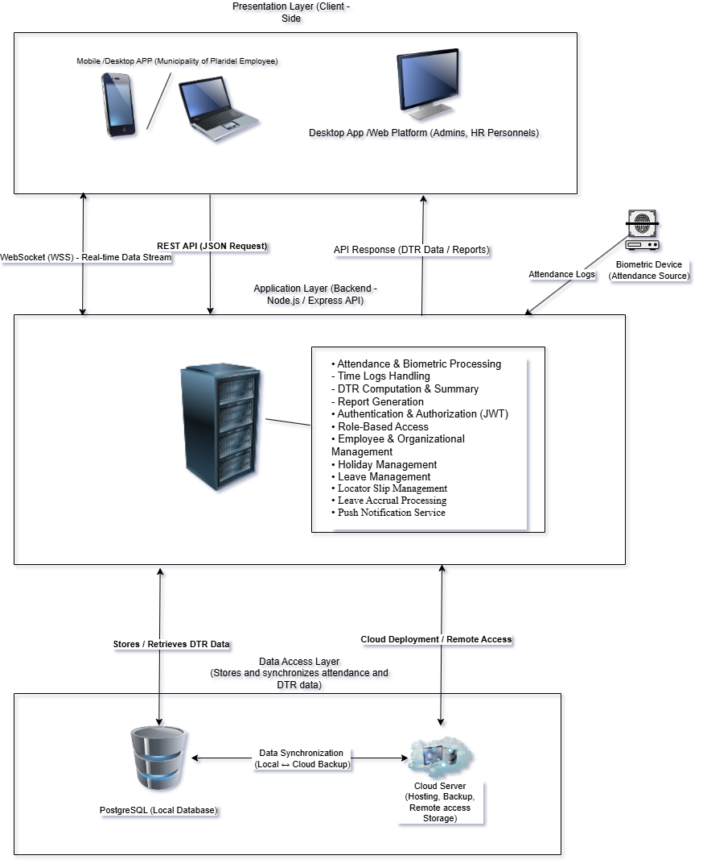
Figure 2. System Architecture and Development Diagram
Figure 2 shows the overall architecture of the HRMS-DTR system. It shows the interaction between the client side, backend server, database, biometric device, and cloud server for attendance processing and monitoring.

3.4.1 Overview of the Proposed System
The proposed system is an Integrated Human Resource Management System (HRMS) that focuses on the Daily Time Record (DTR) module. It is designed to improve the attendance monitoring process of the Municipality of Plaridel by providing a centralized and automated platform.
The system integrates biometric attendance, leave management, and report generation into a single system. It allows employees to view their attendance records and submit requests, while HR administrators can monitor attendance, manage records, and generate reports. The system also supports other HR-related functions such as locator slips and policy management. Overall, the system aims to reduce manual processing, improve accuracy, and provide real-time access to attendance information.

3.4.2 System Objectives
General Objective:
The main objective of this system is to implement an Integrated Human Resource Management System (HRMS) that focuses on the Daily Time Record (DTR) module. This system helps to make it easier to keep track of employee’s attendance, leave records and etc., in the Municipality of Plaridel by centralizing and automating the process. It will also make a real-time calculation better and more precise.
Specific Objectives:
The system development is guided by the following specific functional goals:
- The system is designed to provide a centralized platform that integrates biometric attendance, leave management, and reporting functions.
- The system is developed to implement a timekeeping algorithm that automatically processes the attendance logs and compute late minutes, undertime, total working hours, and corresponding deductions based on the assigned schedule policies.
- The system is evaluated to ensure its functionality, usability, and performance based on the user feedback and the ISO/IEC 25010 Software Quality Model.

3.4.3 System Tools Requirements
The development of the proposed HRMS-DTR system utilizes a combination of programming languages for both frontend and backend components, as well as database management and system integration.
Programming Language
Table 4. Programming Language
Programming Language | Version
Dart | 3.10.8
JavaScript | ES2020+
Python | 3.14.3
Table 4 displays the programming languages that the team aims to use in developing the system. These languages are utilized to support both frontend and backend functionalities, including system logic, data processing, and integration with external components such as the biometric device.
Frontend Tools / Frameworks
Table 5. Frontend/Frameworks
Tool | Version
Flutter | 3.38.9
HTML5 | 5.0
CSS3 | 3.0
Table 4 presents the frontend technologies and frameworks used to develop the user interface of the system, ensuring a responsive and user-friendly experience for both employees and administrators.
Backend Technologies
Table 6. Backend Technologies
Tool | Version
Node.js | 22.19.0
Express.js | 4.21.0
Table 6 presents the backend technologies used in the system, which handle data processing, system logic, and communication between the user interface and the database.
Hardware Requirements
Table 7. Hardware Requirements
Component | Specifications
Server Processor (CPU) | Minimum 4-Core/8-Thread
Server Storage | Minimum 256 GB SSD
Server Memory (RAM) | Minimum 8 GB RAM
Mobile Processor | Minimum Quad-Core Processor
Mobile Memory (RAM) | Minimum 3 GB RAM
Mobile Storage | Minimum 100 MB available space
Web Client Processor | Minimum Intel Core I3
Web Client Memory (RAM) | Minimum 4 GB RAM
Web Client Display | Minimum resolution of 1280x720  (720p) monitor
Biometric Device | ZKTeco or similar
LAN Cable (Ethernet) | Cat5e or Cat6 Ethernet cable for device-to-network connection
Network Connectivity | Stable Internet connection
Table 7 presents the hardware requirements that the team intends to use in development and design process
Software Requirements
Table 8. Software Requirements
Application | Version
Visual Studio Code/Cursor (IDE) | Latest Version
Android Studio | Meerkat Feature Drop2024.3.2 Patch 1
PostgreSQL | Latest Stable
GitHub | Latest Version
Chrome/Web Browser | Latest Version
Git Bash | version 2.49.0
Kamatera VPS | Latest Version
Table 8 presents the software tools and technologies used in the development of the HRMS-DTR system. These tools support system development, database management, deployment, and overall system functionality.

3.4.4 System Flow/Functions
The proposed HRMS-DTR system operates through a continuous and connected flow of processes that handle employee attendance, leave management, and report generation. The system is designed to simplify the workflow of the Human Resource (HR) office while also providing employees with easy access to their own attendance information. The system overall flow can be understood in three main stages: Attendance Recording, Data Processing, and Monitoring & Reporting.
In the first step, the employees will use the biometric device to log their time in and out, which is then sent to the system automatically. The backend server receives these biometric logs. Employees can also use their mobile or desktop app to access the system and see or monitor their attendance records and submit leave request when needed. In addition, employees may file locator slips when they need to leave the workplace temporarily for important purposes. The request is submitted through the system and reviewed by the administrator. Once approved, the locator slip is recorded and may influence attendance interpretation for the specified period. Leave records are also automated, allowing the system to calculate the amount of leave each employee earns and adjust their balance on a regular basis, such as monthly. The updated information is then stored in the database and reflected in the employee’s records. In addition, manual import of attendance logs through file upload (e.g., VAT file) is supported, enabling the HR administrator to upload attendance data when direct synchronization from the biometric device is not available.
On the second part, the data that has been collected was processed by the backend. The backend organizes raw attendance logs and computes important values such as late minutes, undertime or overtime, and total working hours based on assigned work schedules and attendance policies. If an employee has an approved leave, this information is automatically integrated into the attendance record to ensure that absences are properly classified. All processed data are then stored in the database and synchronized with the cloud server for backup and remote access. In addition to local operations, the platform supports remote data submission through the cloud server. Leave requests and attendance logs submitted remotely are first stored in the cloud and then synchronized with the local database, where they are processed and updated. Likewise, records created locally are synced to the cloud to ensure accessibility for remote users.
To further explain how attendance computations are performed, the system applies a timekeeping algorithm described as follows:
Timekeeping Algorithm
The proposed HRMS-DTR system utilizes a timekeeping algorithm to automatically process biometric attendance logs and compute employee attendance records. The algorithm ensures that time-in and time-out data are dynamically evaluated against assigned work schedules, grace period, and configurable attendance policies.
The system performs the following computations:
Late Minutes:
Late Minutes = Actual Time-In − (Scheduled Start Time + Grace Period)
Undertime:
Undertime = Scheduled End Time – Actual Time-Out
Total Working Hours:
Total Working Hours = (Time-Out – Time-In) – Break Time
Equivalent Day (Hours):
Equivalent Day = Total Deduction Minutes ÷ (Work Hours per Day × 60)
Equivalent Day (Minutes):
Equivalent Day = Total Minutes ÷ 480
These formulas ensure accurate and standardized computation of attendance records and deductions within the system.
For the final part, the Daily Time Record (DTR) system provides functionalities like monitoring and reporting. The system allows also the generation for the Daily Time Record (DTR) reports, which can be exported into different formats for the documentation and for compliance. If the system makes any updates, such as attendance records/logs or for leave approvals, are immediately showed up all around the platform, to make sure that both employees and administrators have an accurate access and up-to-date information. Also, the system also provides HR administrators to access and to have their own personal attendance and leave features. Through "My Attendance" and "My Leave" sections. HR administrators may view personal attendance records, monitors attendance summaries, and also submit leave requests the same as a regular employee. This ensures that the accounts of the administrator remain part of the attendance and leave processes while maintaining elevated management permissions.
In general, the flow is designed to create a smooth and automated process, starting from attendance recording up to report generation. By reducing the need for manual work and integrating multiple functions into a single platform, the proposed HRMS-DTR system helps manage employee attendance more accurately and reliably.
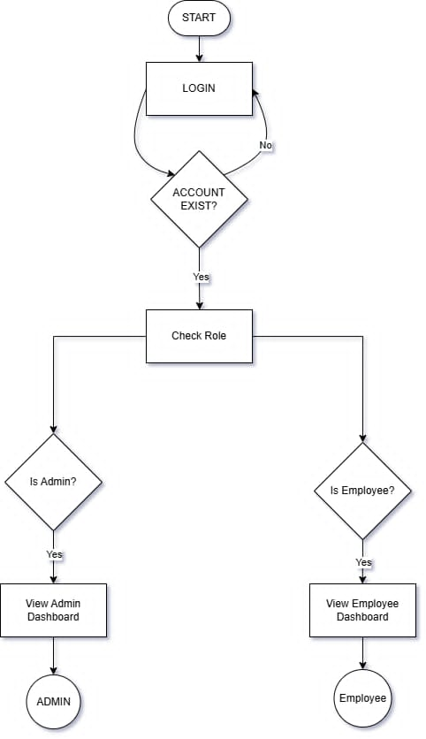
Figure 3. System Flow Chart (Log In)

Figure 3 shows the login and role-based access flow of the system. After login, the system verifies the account and checks the user role. Admin users are directed to the Admin Dashboard, while the employees are redirected to the Employee Dashboard.
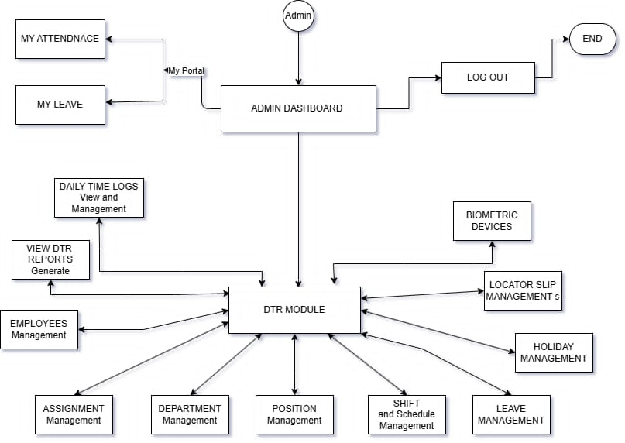
Figure 4. System Diagram (Admin)

Figure 4 presents the Admin Dashboard flow of the system. The Administrator can access different modules such as attendance, leave, employee, department, position, holiday, and locator slip management through the DTR Module. Admin dashboard also allows viewing daily time logs, generating DTR reports, managing biometrics, and logging out of the system.
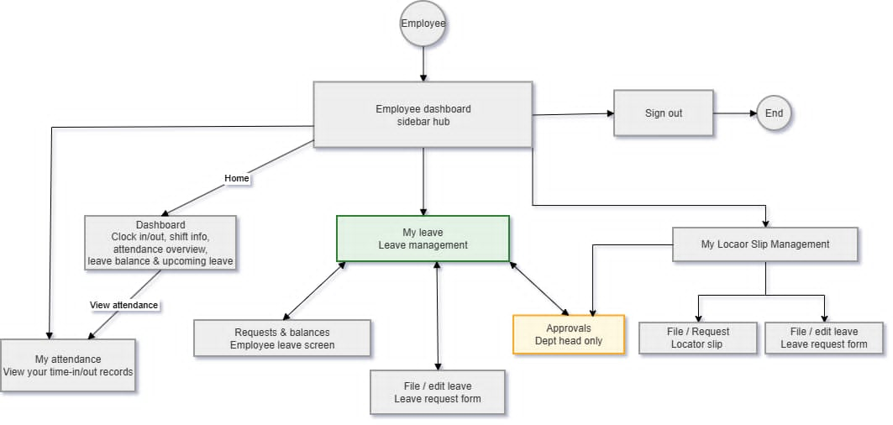
Figure 5. System Diagram (Eployee)
Figure 5 shows the Employee Dashboard flow of the system. Employees can access their attendance records, leave management, locator slip management, and requests forms through the dashboard. The system also allows employees to view leave balances, submit requests, and sign out of the system.
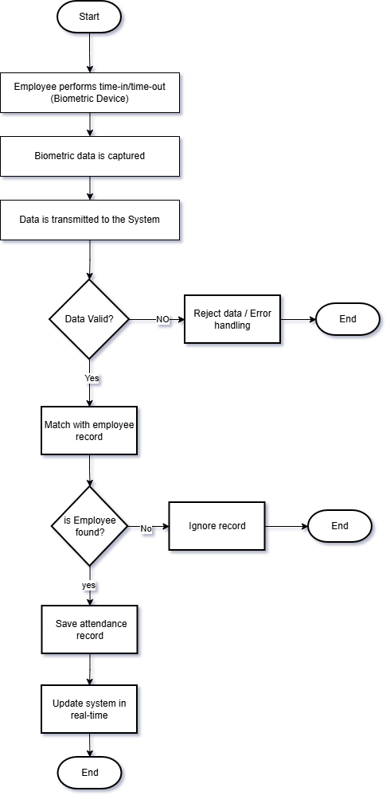
Figure 6. Biometric Attendance Recording Flow
Figure 6 presents the attendance recording flow of the system. The process starts when an employee their time-in or time-out using the biometrics device. The system captures and validates the attendance data, matches it with employee records, and saves the attendance log for real-time monitoring.
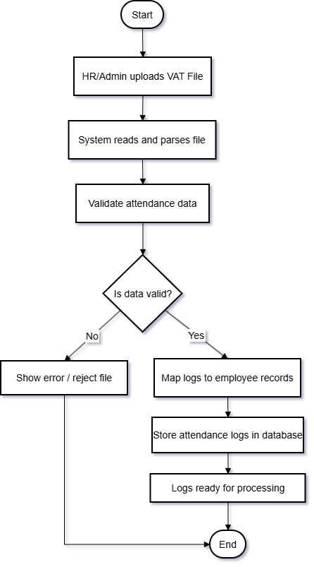
Figure 7. Attendance Log Import via VAT File Flow
Figure 7 shows the process of importing attendance logs into the system through a VAT file. The uploaded attendance records are validated, processed, and stored in the database for attendance computation and monitoring.
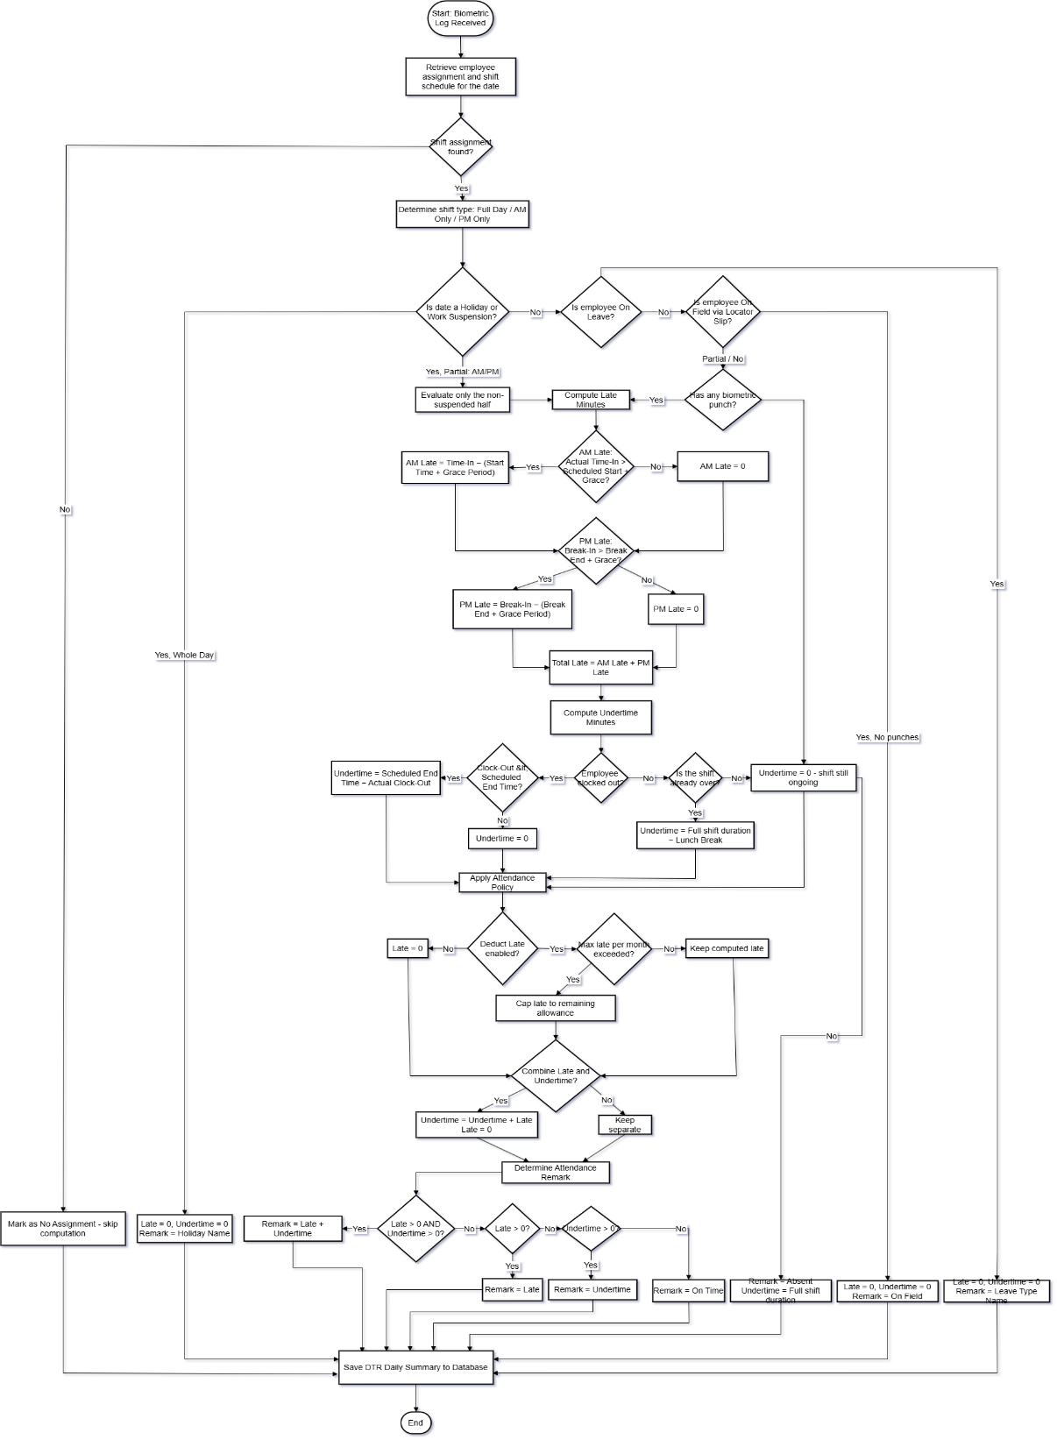
Figure 8. Timekeeping Algorithm
Figure 8 shows that system processes the biometric logs, check schedules, leave records, holidays, and attendance policies, then computes late minutes and undertime before saving the final DTR summary in the database.
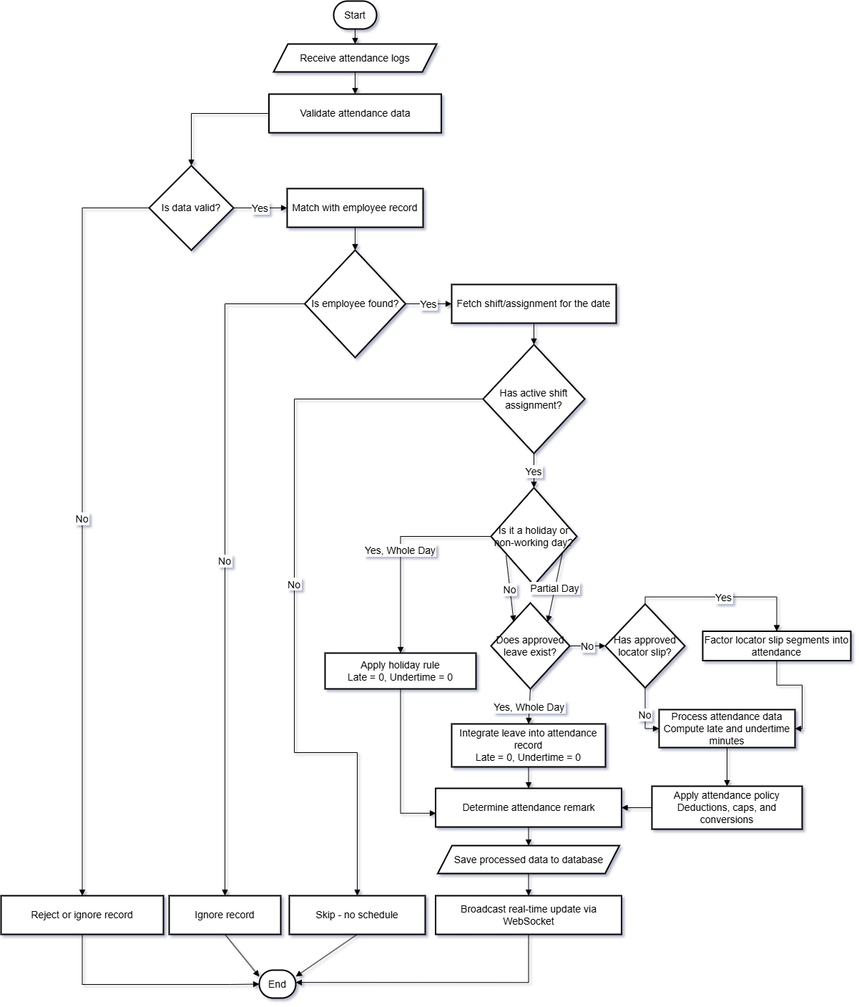
Figure 9. Data Processing Flow
Figure 9 shows the attendance processing flow of the proposed HRMS-DTR system. The system validates attendance logs, checks employee schedules, leave records, holidays, and locator slips, then computes late minutes and undertime before saving the processed DTR data to the database.

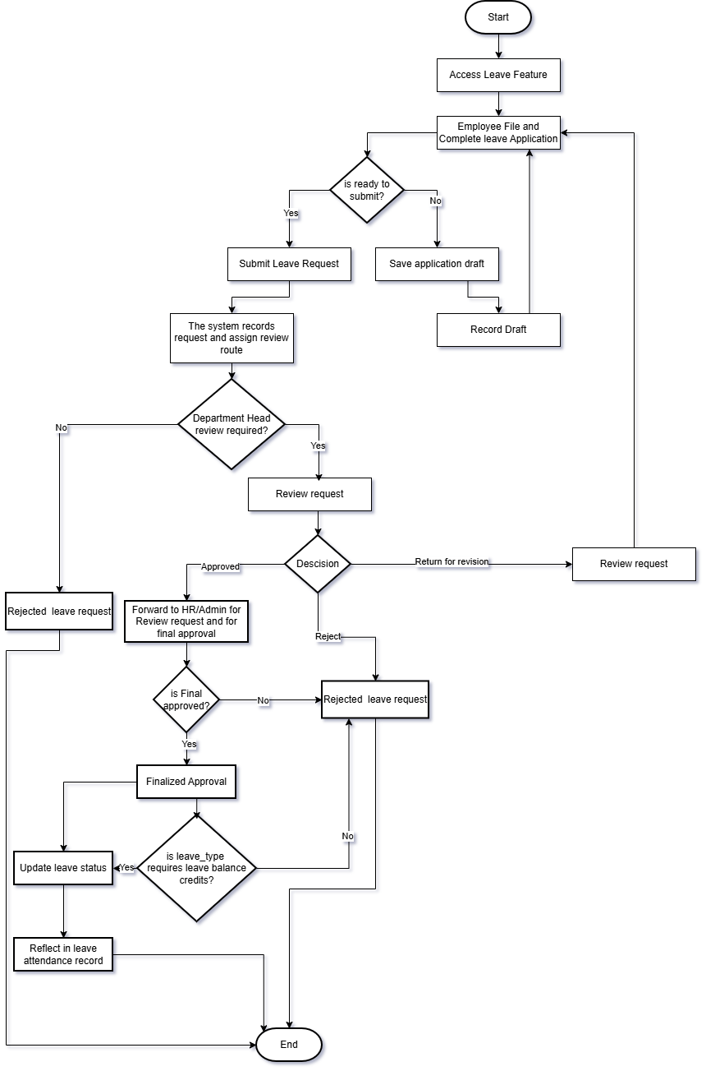
Figure 10. Leave Filing and Approval Flow
Figure 10 shows the leave filing and approval flow of the system. Employees submit leave requests, which are reviewed and approved by the Department Head or HR/Admin. Once approved, the system updates the leave balance and reflects the leave in the attendance record.

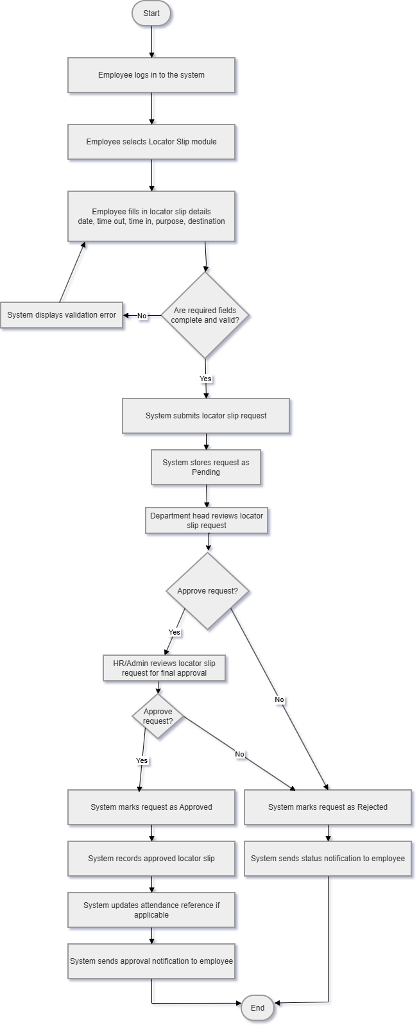
Figure 11. Locator Slip Filing and Approval Flow
Figure 11 shows the process of submitting and approving locator slip requests. The system validates the request, routes it for approval, records the approved locator slip, and updates attendance records when applicable.
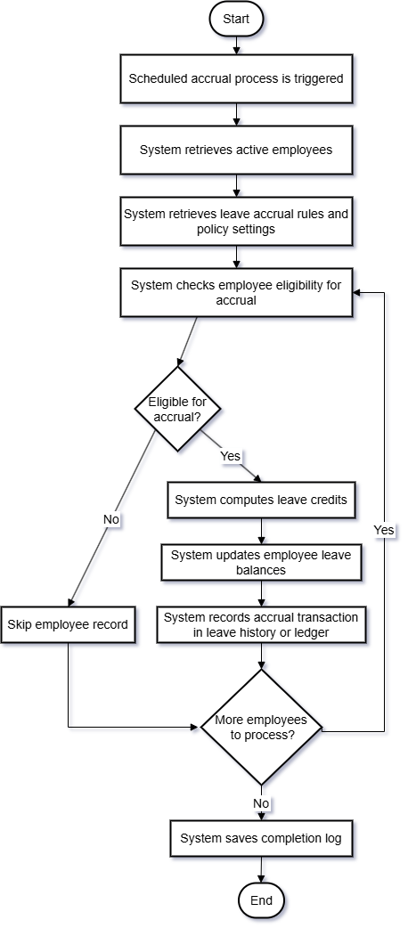
Figure 12. Monthly Accrual Flow

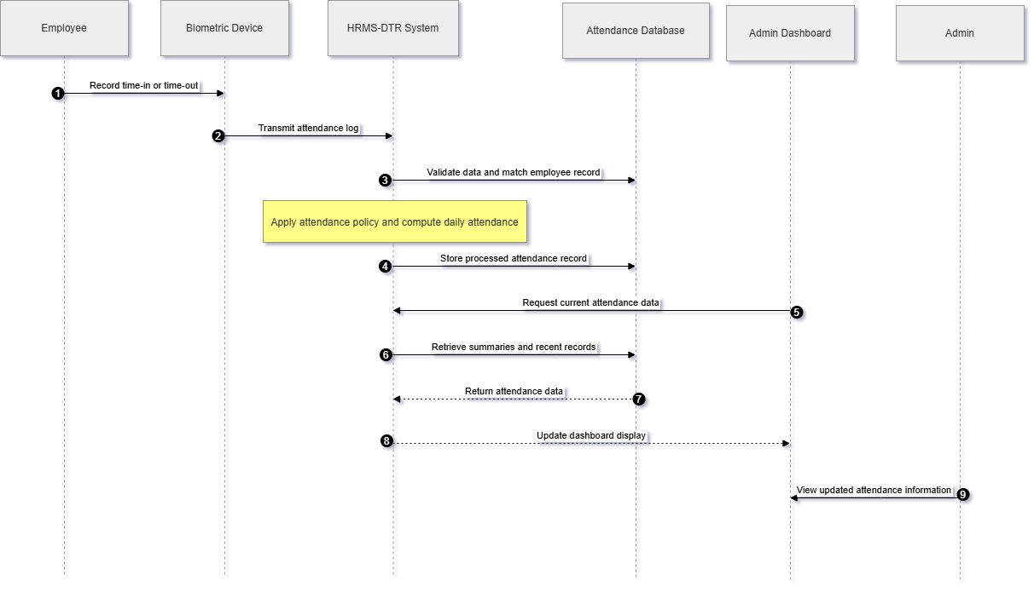
Figure 12 shows the monthly leave accrual flow of the system. The system automatically checks employee eligibility, computes leave credits, updates leave balances, and records accrual transaction in the leave history.
Figure13. Biometric Attendance Real-Time Monitoring Sequence Diagram
Figure 13 presents the biometric attendance real-time monitoring sequence of the system. It shows how attendance logs from the biometric device are processed, stored, and updated in real-time for viewing by the HR/Admin.

3.4.5 Scope and Limitations of the System
The proposed HRMS-DTR system focuses on automating employee attendance monitoring biometric integration and centralized data management. It allows employees to record attendance, view their records and submit leave and locator slips requests. The system processes attendance logs, computes late minutes, undertime, and total working hours using a timekeeping algorithm, and generates Daily Time Record (DTR) reports. It also provides an administrative interface for managing employee data, attendance policies, leave approvals, and report generation. Furthermore, the system considers the provisions of the Data Privacy Act of 2012 (RA 10173) by promoting secure handling, storage, and management of employee attendance and leave records.
The system is limited to attendance monitoring and does not include full Human Resource Management functionalities such as payroll processing, recruitment, and performance evaluation. It depends on the availability and accuracy of biometric devices for capturing attendance logs. The system requires an internet connection for data synchronization between the local and cloud servers. In addition, the system does not support real-time GPS tracking or location-based attendance verification. Testing of the system was conducted in a controlled environment and may not fully represent all real-world conditions.

3.4.6 Calendar of Activities
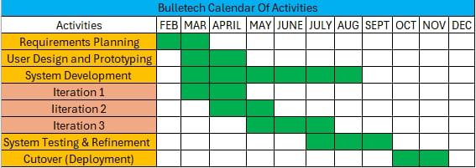
Table 9. Calendar of Activities
Table 9 displays the calendar of activities for the development of the proposed HRMS-DTR system. It outlines the major phases of the project, including planning, analysis, design, development, testing, and documentation.

3.5 Conceptual Design and Implementation
The main goal of the proposed HRMS-DTR system's conceptual design is to improve how attendance is recorded, processed, and managed within the Municipality of Plaridel. This system is purposefully developed to address existing issues, such as the manual calculation of attendance data, the lag in report generation, the lack of real-time monitoring functionalities, and the integration challenges between leave records and attendance data. To address these issues, the system offers a centralized platform that integrates biometric attendance, leave management, and DTR reporting functionalities.
The system is structured around a client-server architecture; employees and HR administrators access the system via mobile or web interfaces, while the backend is responsible for data processing and storage. Attendance logs generated by the biometric device are automatically processed in accordance with established schedules and attendance policies, with the outcomes being reflected in real time. Employees can also access their records and submit leave requests through the system.
The Agile methodology was employed by the researchers during the development phase. This iterative approach facilitated the system's staged development, enabling continuous testing and refinement of features in response to user feedback. Consequently, the system was improved to ensure its functionality, usability, and alignment with the Human Resource Office's operational processes. Furthermore, the system uses a local-first consistency model, designating the local database as the primary source of truth, thereby reducing potential data conflicts between local and cloud-based environments.

3.5.1 Database Design
The HRMS-DTR system's database design uses a relational database model. This model is used to organize, store, and manage the different types of data the system needs. A well-structured database is crucial for the proposed system, which handles employee information, attendance records, leave requests, scheduling, and the creation of reports. This database is designed to keep all these records organized, interconnected, and readily accessible. PostgreSQL is the chosen database management system for the system. The choice of this database is based on its reliable storage, strong data integrity, and its ability to manage interconnected records across different modules.
The database's design includes several connected modules, which together support the system's main functions. The user table is the core of the database, holding essential information about both employees and administrators. This table serves as the central hub for all other system records. Attendance, leave requests, notifications, assignments, and audit logs all tie back to individual users, serving as the core reference point. This is where user roles are also kept, enabling role-based access control throughout the system.
The HR office's operations are deeply intertwined with the reference tables housed within the database. These tables provide essential information about departments, job titles, and work shifts. Essentially, these systems pinpoint an employee's department, their specific job, and their scheduled work hours. The assignments table serves as a link, pairing an employee with their department, position, and shift. This connection allows the system to identify the appropriate work schedule when handling attendance. Furthermore, attendance policies and the assignment of these policies are used to set and enforce the rules for calculating attendance. These rules include things like late arrivals, early departures, daily work hours, and other attendance-related requirements.
The attendance management system's database is structured around a series of interconnected tables. The biometric_attendance_logs table serves as the repository for raw attendance data, which is directly imported from the biometric device. In contrast, the dtr_logs table is designed to structure this data, specifically recording time-in and time-out entries. These initial records serve as the basis for the system's processed attendance outcomes, which are subsequently stored within the dtr_daily_summary table. This table furnishes a detailed daily summary, including time in, time out, total working hours, late minutes, undertime minutes, and the overall attendance status. Essentially, this table is a key result of the attendance processing, showing the calculated daily attendance for each employee.
The leave system's operation depends on a database, which is built using several key tables. These tables include leave_types, leave_requests, leave_balances, and leave_request_history. Together, these tables constitute the foundation of our leave request system, storing all the critical data. Each leave request is carefully documented, including the leave type, the exact dates, the remaining balance, its approval status, and its position in the approval process. Precise tracking of time off is vital, which is why these requests are integrated with attendance processing, using the daily DTR summary. This connection ensures that absences are correctly categorized. The system simplifies everything, removing the need for those tedious manual checks that used to be required to match up leave requests with attendance data.
The database tracks accrued leave, and these balances are updated in real-time. The locator_slips table, however, functions differently. The table keeps tabs on employee relocation requests. It records the date and time each one is submitted, the reason behind the move, and the final decision on approval. These tables are interconnected with attendance and leave records, maintaining consistent alignment throughout the system.
Supplementary tables, when added, greatly enhance both the system's dependability and its overall reach. Take the holidays table, for instance; it's a key component for pinpointing dates that could potentially impact attendance figures. The biometric devices table offers a glimpse into the devices in use. These are the very tools we're leveraging to monitor employee attendance. Requests to amend attendance records are stored in the dtr_corrections table. And, to maintain integrity and ensure thorough oversight, the database employs audit logs. These logs precisely document key actions. Concurrently, user notifications keep everyone updated on system-generated information concerning leave, DTR, and other operational aspects. Moreover, the auth_refresh_tokens table is in place to facilitate secure session management.
Within the hybrid model, the local database serves as the primary repository, encompassing and overseeing all critical data. Conversely, the cloud database maintains synchronized replicas of particular tables, including those pertaining to leave requests and attendance records, thereby facilitating remote accessibility. Data integrity is maintained through synchronization protocols, ensuring that updates from both the local and cloud-based sources are incorporated into the local database.
The database's architecture was primarily dictated by the project's central objective: the development of a centralized, automated Human Resource Management System-Daily Time Record (HRMS-DTR) system. By structuring relevant data within interrelated tables, the database design enables accurate attendance processing, efficient leave record management, and the reliable production of DTR reports. Moreover, this design inherently supports the system's ability to grow and simplifies maintenance, especially as more HR functions are added later.

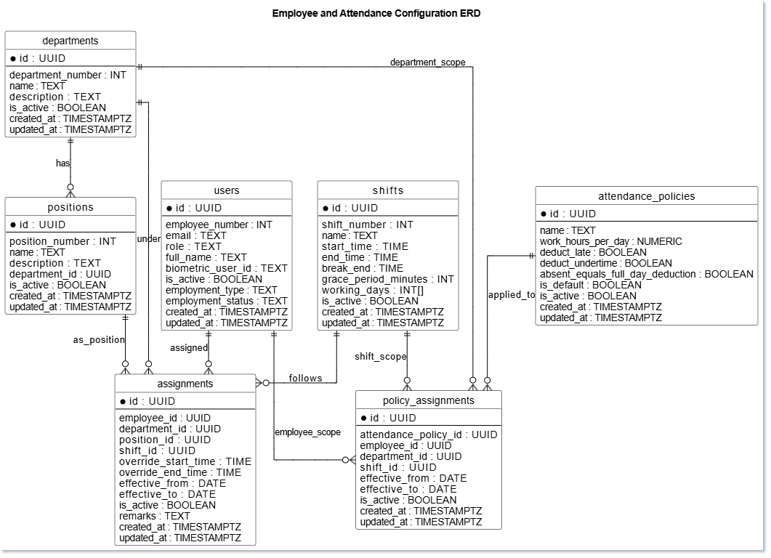

Figure 14. ERD for Employee and Attendance Configuration

Figure 14 shows how employees, departments, positions, shifts, assignments, and attendance policies are connected to support attendance management and processing.

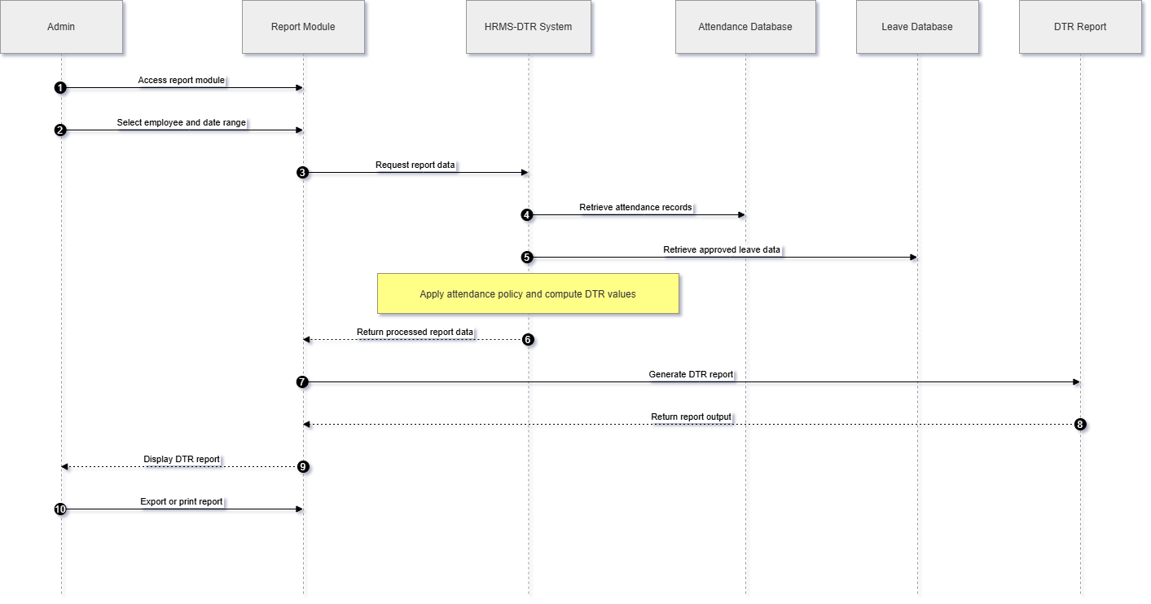
Figure 15. DTR Report Generation Sequence Diagram
Figure 15 shows the DTR report generation flow of the proposed HRMS-DTR system, where attendance and leave records are processed to generate the employee DTR report.

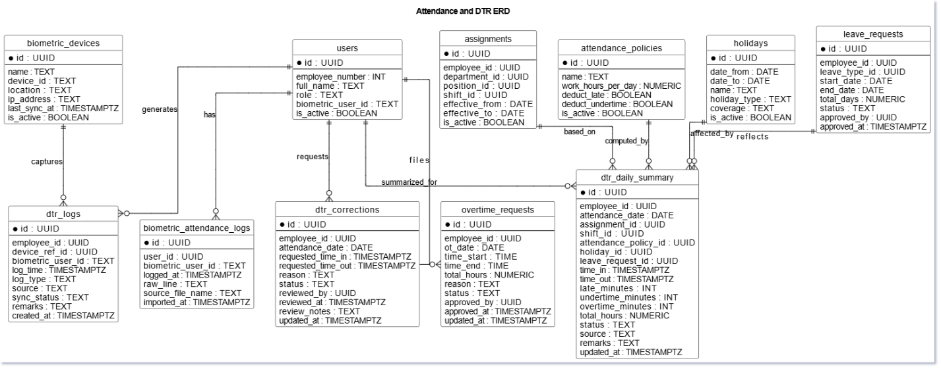
Figure 16. Attendance and DTR ERD

.
Figure 16 shows the relationship between the system’s attendance, leave, and DTR records. It explains how biometric logs, employee schedules, attendance policies, holidays, and leave requests are connected to generate and manage the employee Daily Time Record (DTR).

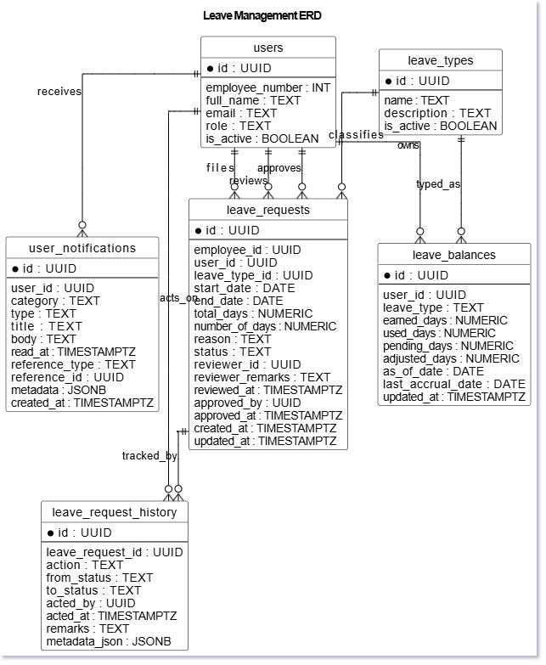

Figure 17. Leave Management ERD
Figure 17 presents the relationship between users, leave requests, leave balances, leave types, notifications, and leave history records. It shows how the system manages leave filing, approval, tracking, and balance monitoring.

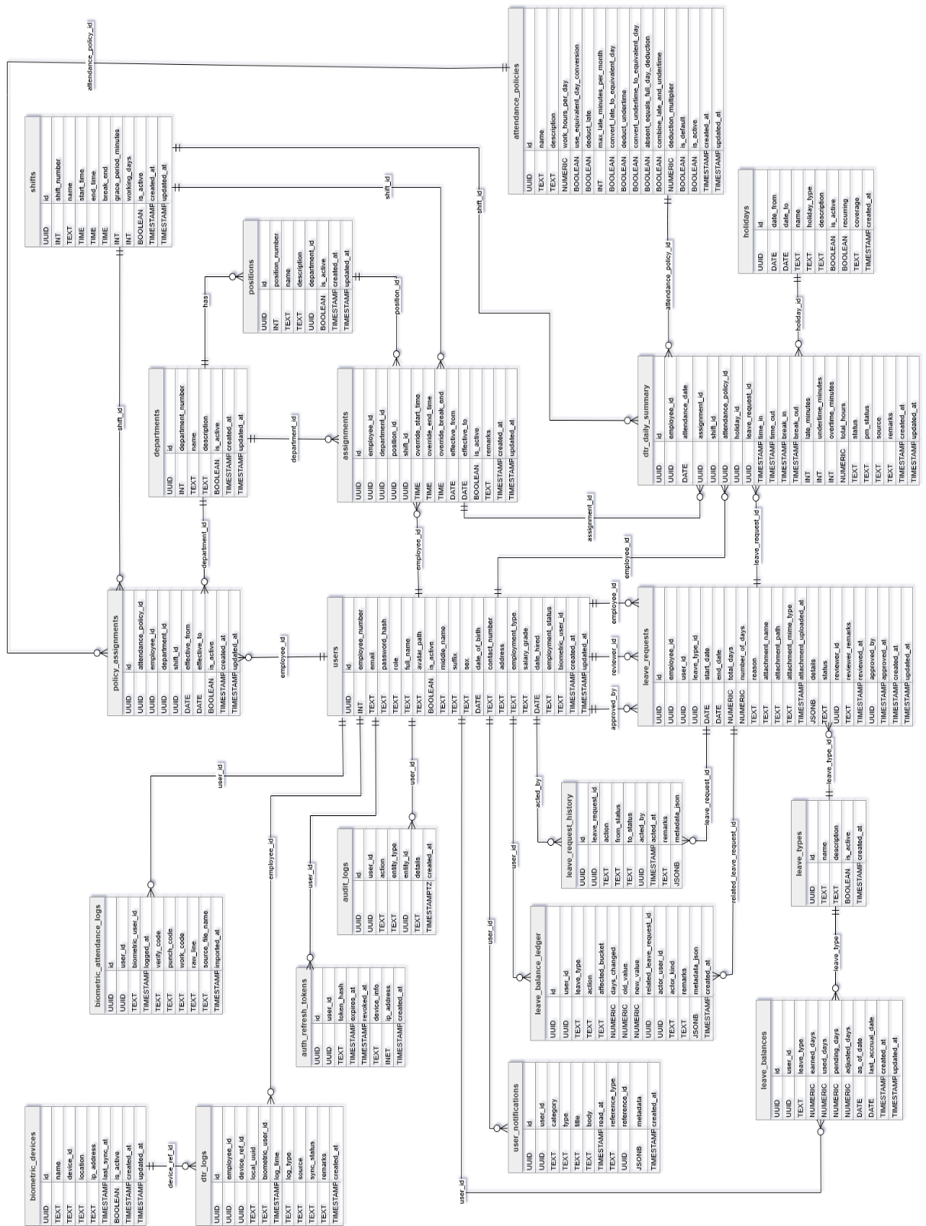
Figure 18. ERD System Database Design

Figure 18 presents the Entity-Relationship Diagram (ERD) of the proposed HRMS-DTR system, showing the main database entities and their relationships. It illustrates how employee, attendance, leave, and configuration data are interconnected to support accurate processing and report generation.

3.5.2 System Design
The system design for the proposed HRMS-DTR serves as the architectural plan for the system before it's fully built. It shows how different users will interact with the system and how the main modules support the overall attendance and leave management processes. This stage is important because it provides a clear view of the system boundaries, the major actors involved, and the functions that each user is allowed to perform.
The system's architecture centers on two key user roles: Employees and HR Administrators. Employees benefit from features that enable them to access their attendance records, keep tabs on their DTR summaries, and submit leave applications.
HR Administrators wield a range of administrative tools. They can track attendance as it happens, manage employee records, and approve leave requests – all in a day's work. The system further allows for the establishment of attendance policies and the creation of daily time record (DTR) reports. HR Administrators, like all employees, can access their own attendance and leave records through the system. This is accomplished through the "My Attendance" and "My Leave" areas, both integrated into the admin interface. The Daily Time Record (DTR) process is supported by a number of core modules, each playing a vital role. These modules are responsible for employee management, department setup, position management, shift scheduling, holiday management, assignment management, and configuring attendance policies. Though not the system's primary focus, these modules are indispensable. Accurate attendance tracking and efficient record management hinge on these key elements.
Precisely defining user interactions and system functions ensures that the proposed HRMS-DTR system accurately reflects the Municipality of Plaridel's current workflow. This alignment is crucial for establishing a more centralized, precise, and efficient attendance management process.
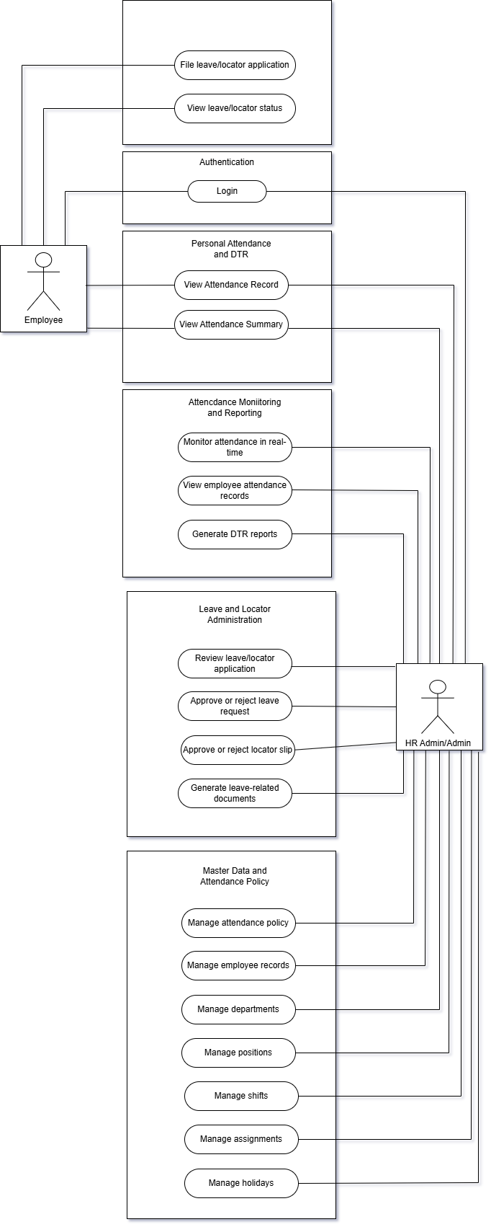
Figure 19. Use Case Diagram
Figure 19 presents Use Case Diagram of the System. It shows the interactions of the Employee and HR Administrator with the system, including attendance viewing, leave and locator slip management, attendance monitoring, report generation, and policy administration.

Context Diagram
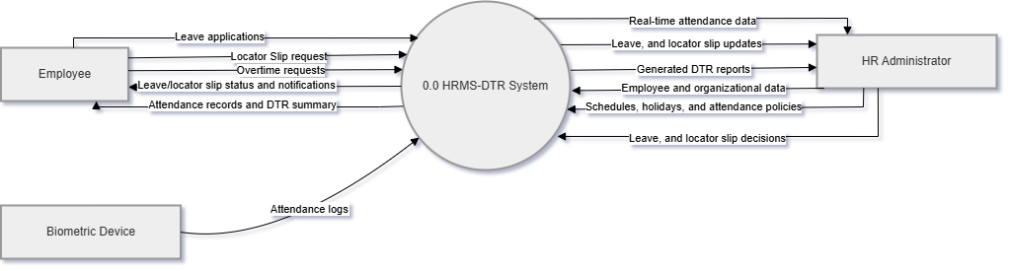
Figure 20. Context Diagram

Figure 20 presents the interaction between the HRMS-DTR system and its external entities, including the Employee, HR Administrator, and Biometric Device. It shows how attendance, leave, locator slip, and reporting data are exchanged within the system for processing and monitoring.

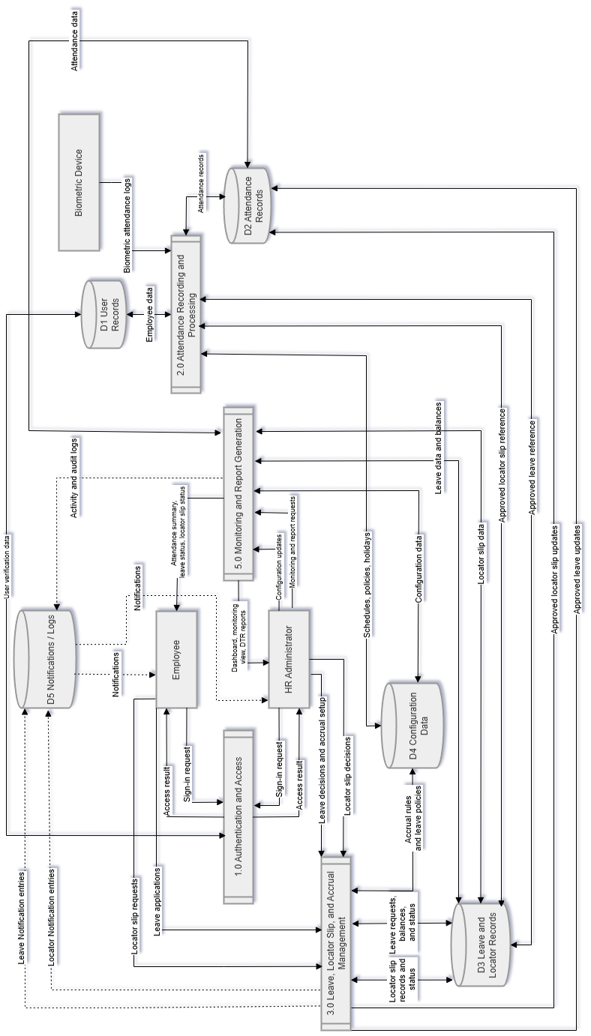
Figure 21. Data Flow Diagram (DFD)
Figure 21 illustrates how data flows within the HRMS-DTR system. It shows how inputs such as attendance logs, leave requests, and locator slips are processed and transformed into outputs like attendance records, DTR reports, and monitoring information.

Data Flow Diagram (DFD)
The Data Flow Diagram shows how data moves through the HRMS-DTR system and how it is turned into useful information. It presents the main processes involved, such as recording attendance, managing leave and locator slips, computing DTR, and generating reports.
The system gathers data from three main sources: employees, the HR administrator, and the biometric device. When employees use the biometric device, their time in and out is automatically recorded and saved as attendance records. They can also send HR requests like leave applications or locator slips. At the same time, the administrator is responsible for setting up and managing key details such as work schedules, holidays, attendance policies, and approval decisions to ensure everything works smoothly.
The system then checks the data and links it to the right employee records. The DFD also processes the information based on the set schedules, attendance rules, holidays, and any approved leave. After processing, the results are saved in the database and used for different purposes, like viewing in the dashboard, checking records by employees, and making DTR reports. In short, the DFD shows how raw data from the system is organized and turned into useful information that helps HR keep track of attendance and make decisions more easily.

REFERENCES:

Amulya, R., Jahnavi, S., Trupthi, B. V., Divya, P., & Kalpitha, N. (2021). Online attendance system using machine learning algorithms. International Journal of Engineering Research & Technology, NCETER-2021, 9(11). https://www.ijert.org/online-attendance-system-using-machine-learning-algorithms

Fuady, A. F., & Hidayat, A. T. (2025). Assessing the impact of face recognition and QR code-based attendance systems on payroll processing and business efficiency. Journal of Information Systems Engineering and Digital Economy, 3(4). https://doi.org/10.62386/jised.v3i4.190

Gomez-Barrero, M., Drozdowski, P., Rathgeb, C., Patino, J., Todisco, M., Nautsch, A., Damer, N., Priesnitz, J., Evans, N., & Busch, C. (2021). Biometrics in the era of COVID-19: Challenges and opportunities. arXiv. https://doi.org/10.48550/arXiv.2102.09258

Ishaq, K., & Bibi, S. (2023). IoT based smart attendance system using RFID: A systematic literature review. arXiv. https://doi.org/10.48550/arXiv.2308.02591

Jalaman, J. R. C., & Encarnacion, R. E. (2024). Employee satisfaction on compensation system: Basis for an improved payroll management system with face recognition and attendance monitoring technology. International Journal of Advanced Research in Science, Communication and Technology, 4(4), 516-516. https://ijarsct.co.in/A19070.pdf

Mapingulila, H., Onyancha, H., & Mbua, F. (2024). Contribution of biometric fingerprint in reducing prevalence of unauthorized absenteeism among employees in public organizations in Moshi Municipality. Business Management and Strategy, 15(2), 219-242. https://doi.org/10.5296/bms.v15i2.22257

Mukherjee, K., Manish, K. M. M., & Natrajan, G. (2022). Employee attendance system based on facial recognition. International Journal of Health Sciences, 6(S5), 5054-5069. https://doi.org/10.53730/ijhs.v6nS5.9736
Reynoso, M. M., Derada, L. M. B., Arconado, A. T. G., & Ligzon, A. (2025). RFID-based attendance monitoring system with SMS notification and data analytics. In M. G. Flores (Ed.), Information technology: Cross-platform application and development (pp. 325-350). Institute of Industry and Academic Research Incorporated. https://iiari.org/wp-content/uploads/Ch3.12.-RFID-based-Attendance-Monitoring-System-with-SMS-Notification-and-Data-Analytics.pdf

Rivera, R. B. (2021). Enhanced attendance monitoring system using biometric fingerprint recognition. International Journal of Recent Technology and Engineering, 9(5), 1-4. https://doi.org/10.35940/ijrte.E5070.019521

Rukhiran, M., Wong-In, S., & Netinant, P. (2023). User acceptance factors related to biometric recognition technologies of examination attendance in higher education: TAM model. Sustainability, 15(4), 3092. https://doi.org/10.3390/su15043092

Dassanayake, D. M. T. S., & Wanniarachchi, W. A. A. M. (2021). Challenges of manual attendance system towards student motivation. General Sir John Kotelawala Defence University. https://ir.kdu.ac.lk/handle/345/5245

APPENDICES
Appendix A: Semi-Structured Interview Guide:
This interview guide was developed to gather relevant information regarding the current attendance monitoring process, challenges in Daily Time Record (DTR) computation, and system requirements for the proposed HRMS-DTR system. The questions are designed to obtain insights from key stakeholders, particularly the Human Resource (HR) personnel who are directly involved in attendance management, record processing, and report generation.
For HR Administrator / HR Personnel
- Can you describe the current process of recording and monitoring employee attendance in your office?
- How do you currently retrieve or obtain attendance logs from the biometric device?
- What tools or methods do you use to transfer or process biometric attendance data (e.g., USB export, software, manual encoding)?
- What forms or documents are currently used in managing attendance and leave (e.g., DTR forms, leave forms, locator slips)?
- How do you currently compute employee Daily Time Records (DTR), including late minutes, undertime, and total working hours?
- What challenges do you encounter when processing attendance data from the biometric device?
- How are leave applications currently managed, and how are they reflected in attendance records?
- What difficulties do you experience in generating attendance reports or DTR summaries?
- Does your current system support real-time monitoring of attendance? If not, what issues does this cause?
- How do you handle errors such as missing, incomplete, or incorrect biometric logs?
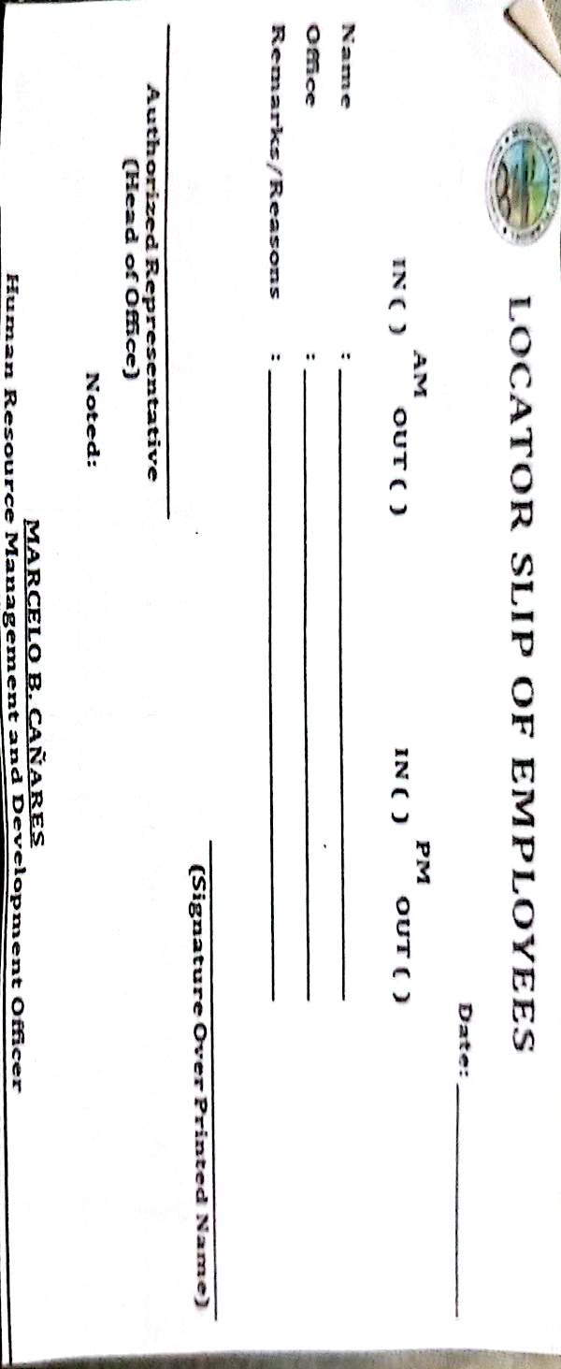
- What improvements or features would you like to have in an automated attendance and DTR system?

Appendix B. Sample Documents and Records

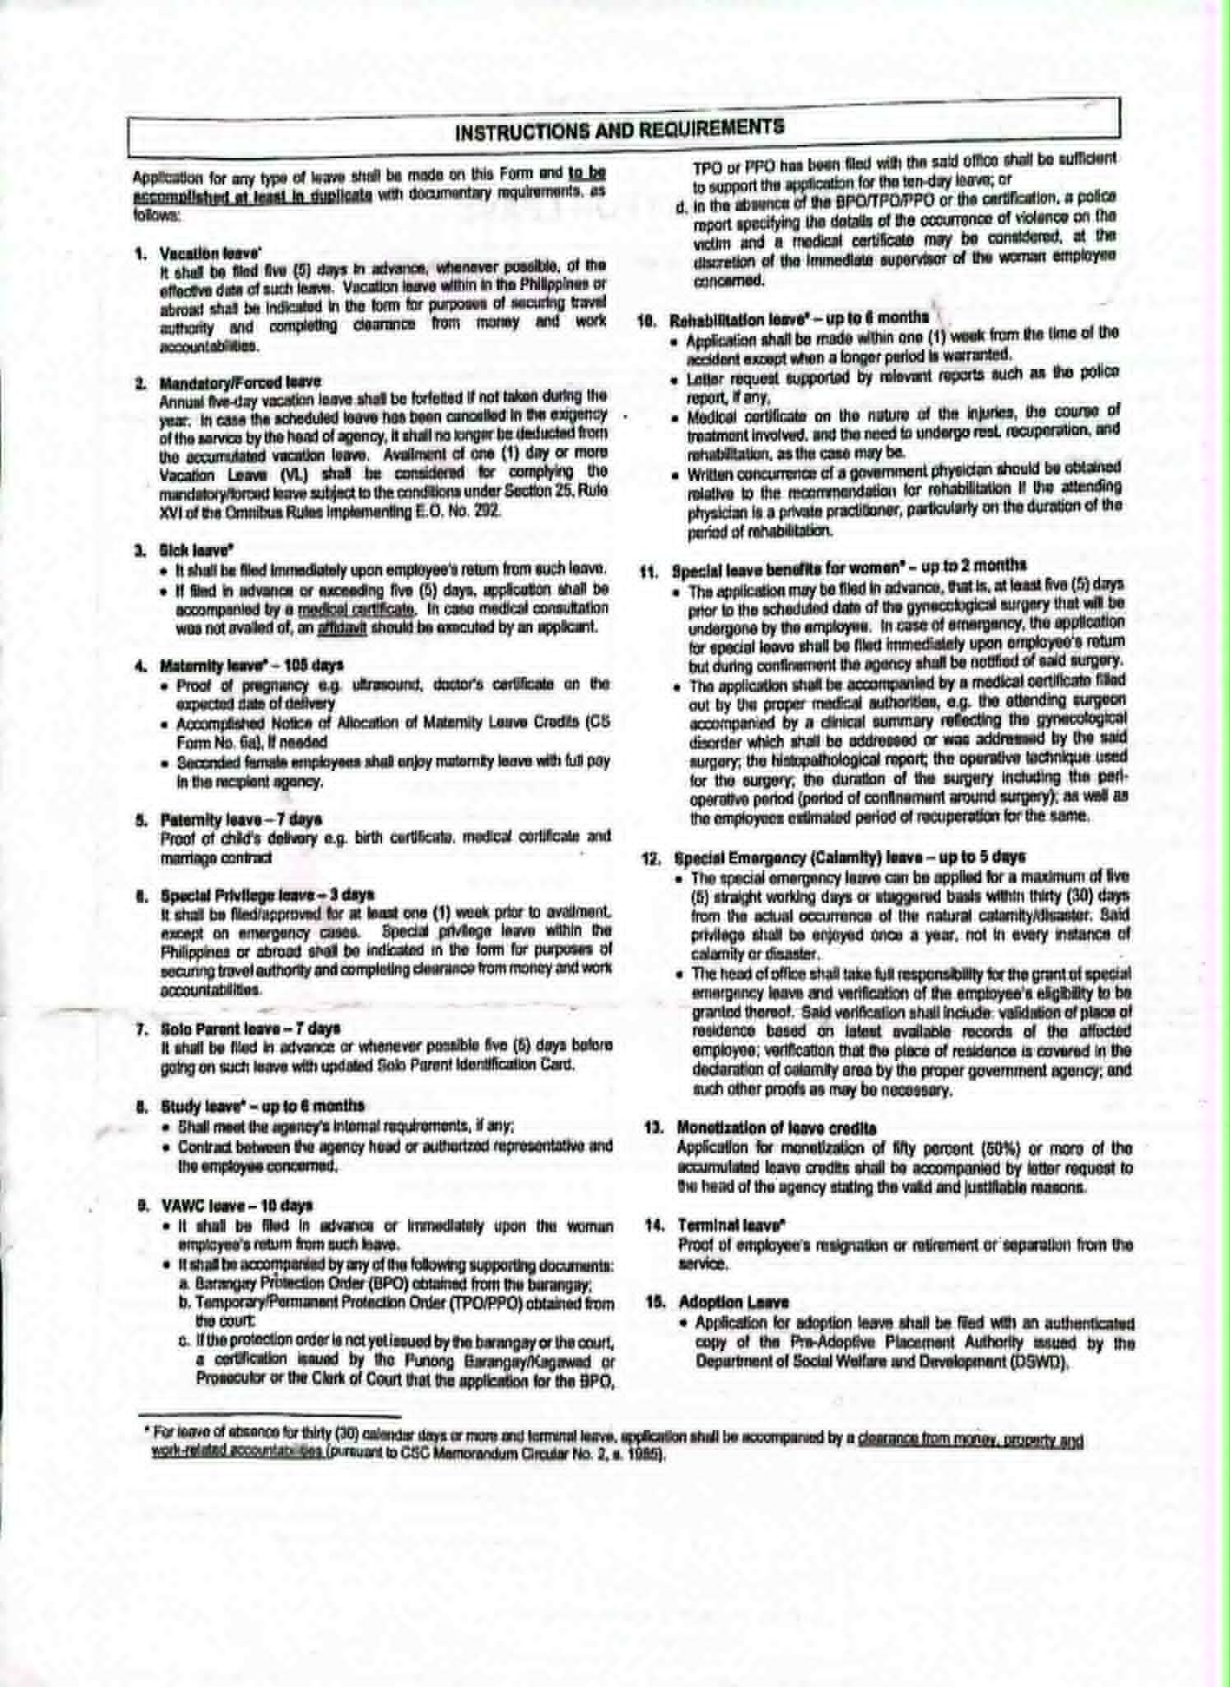
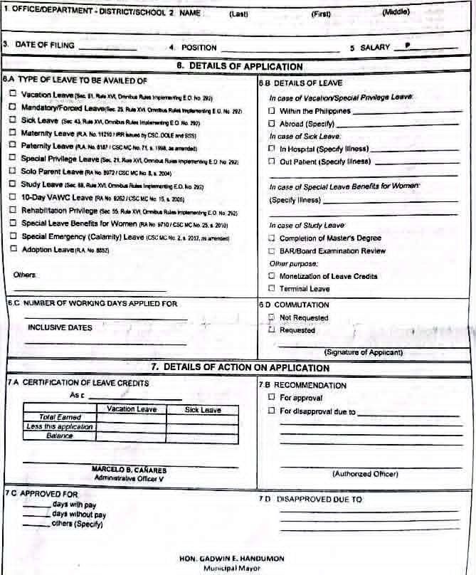

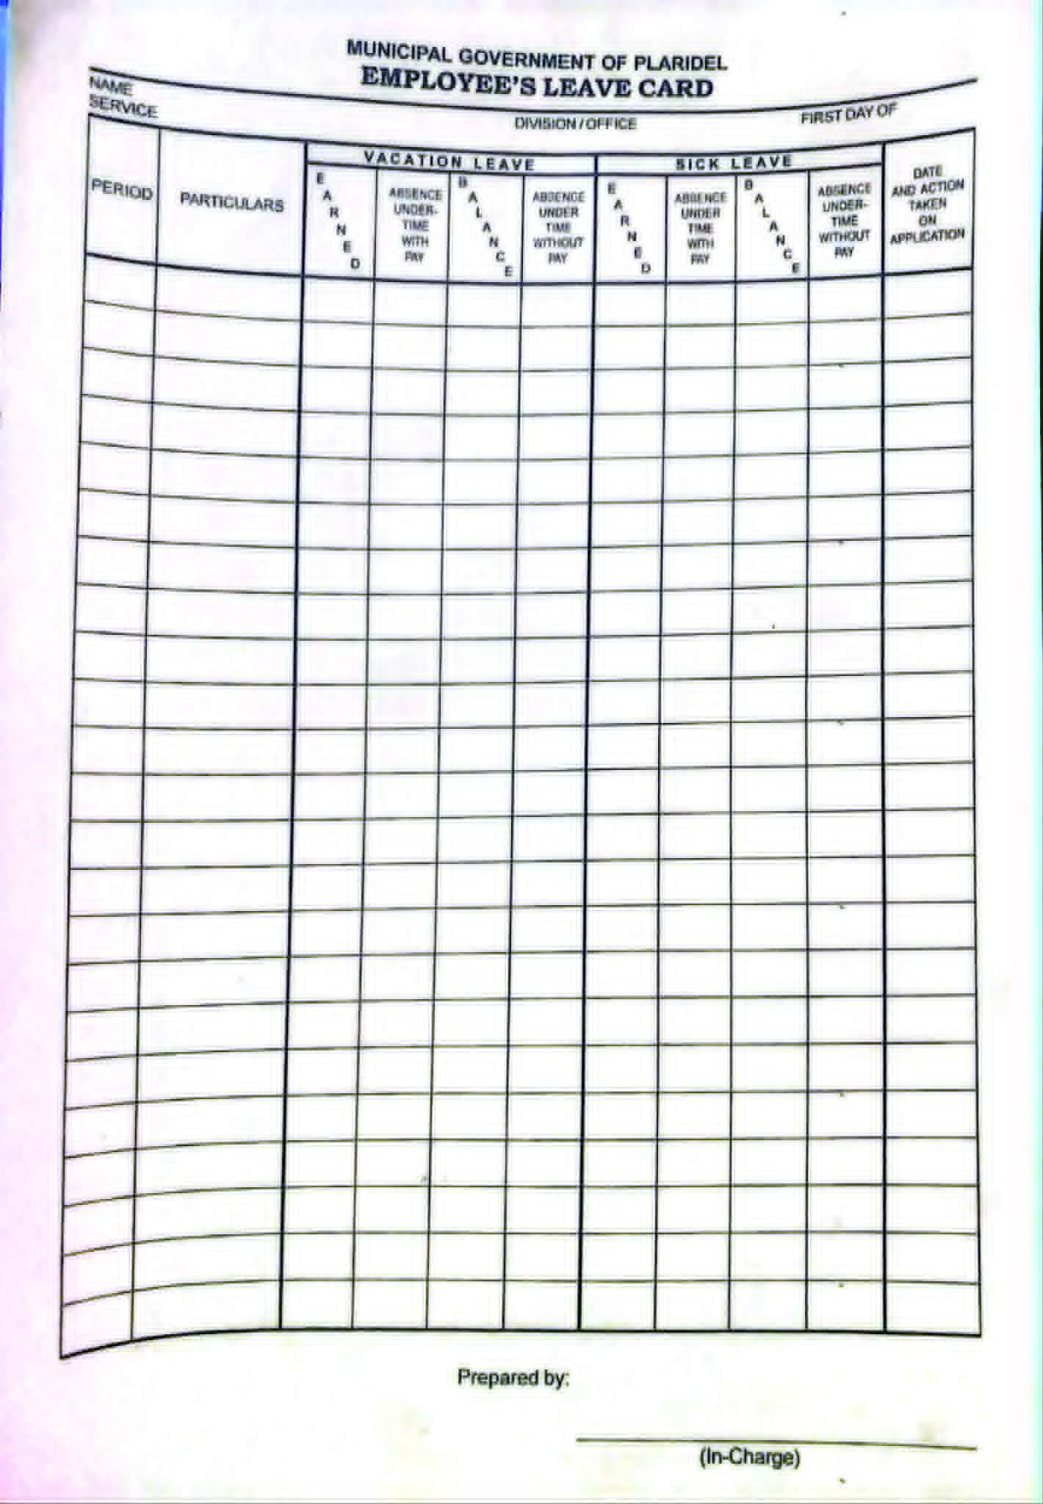
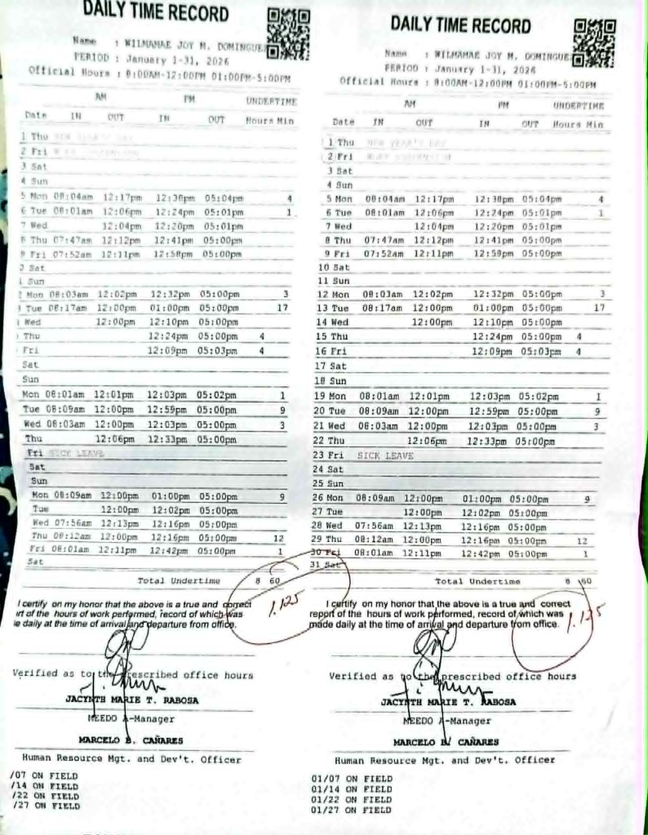
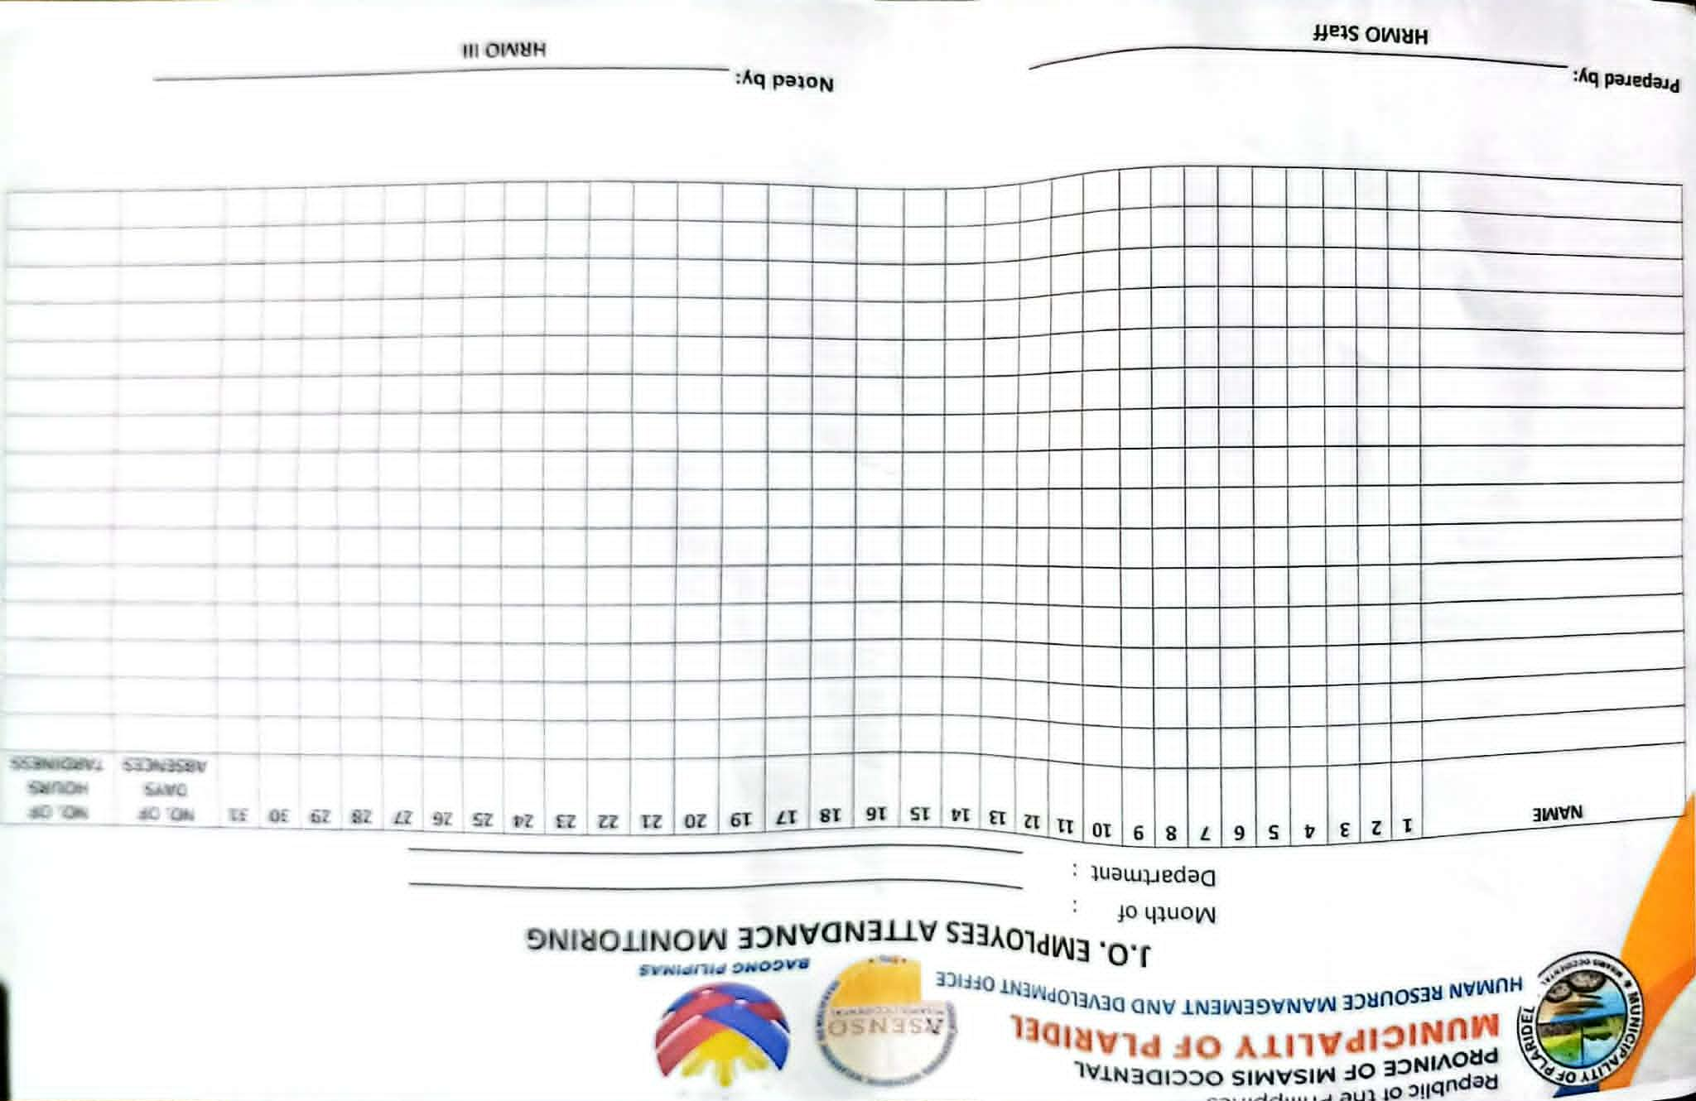
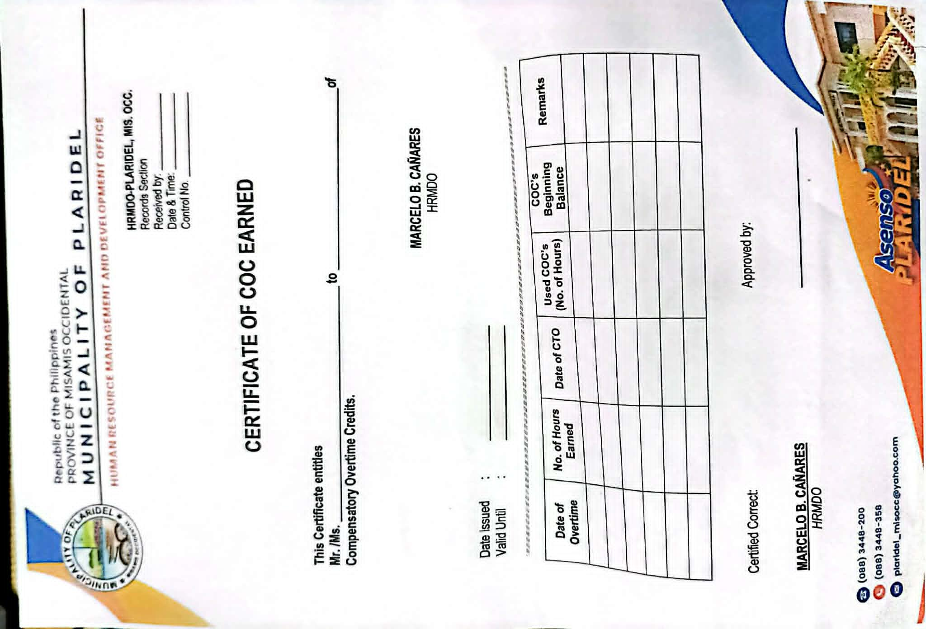
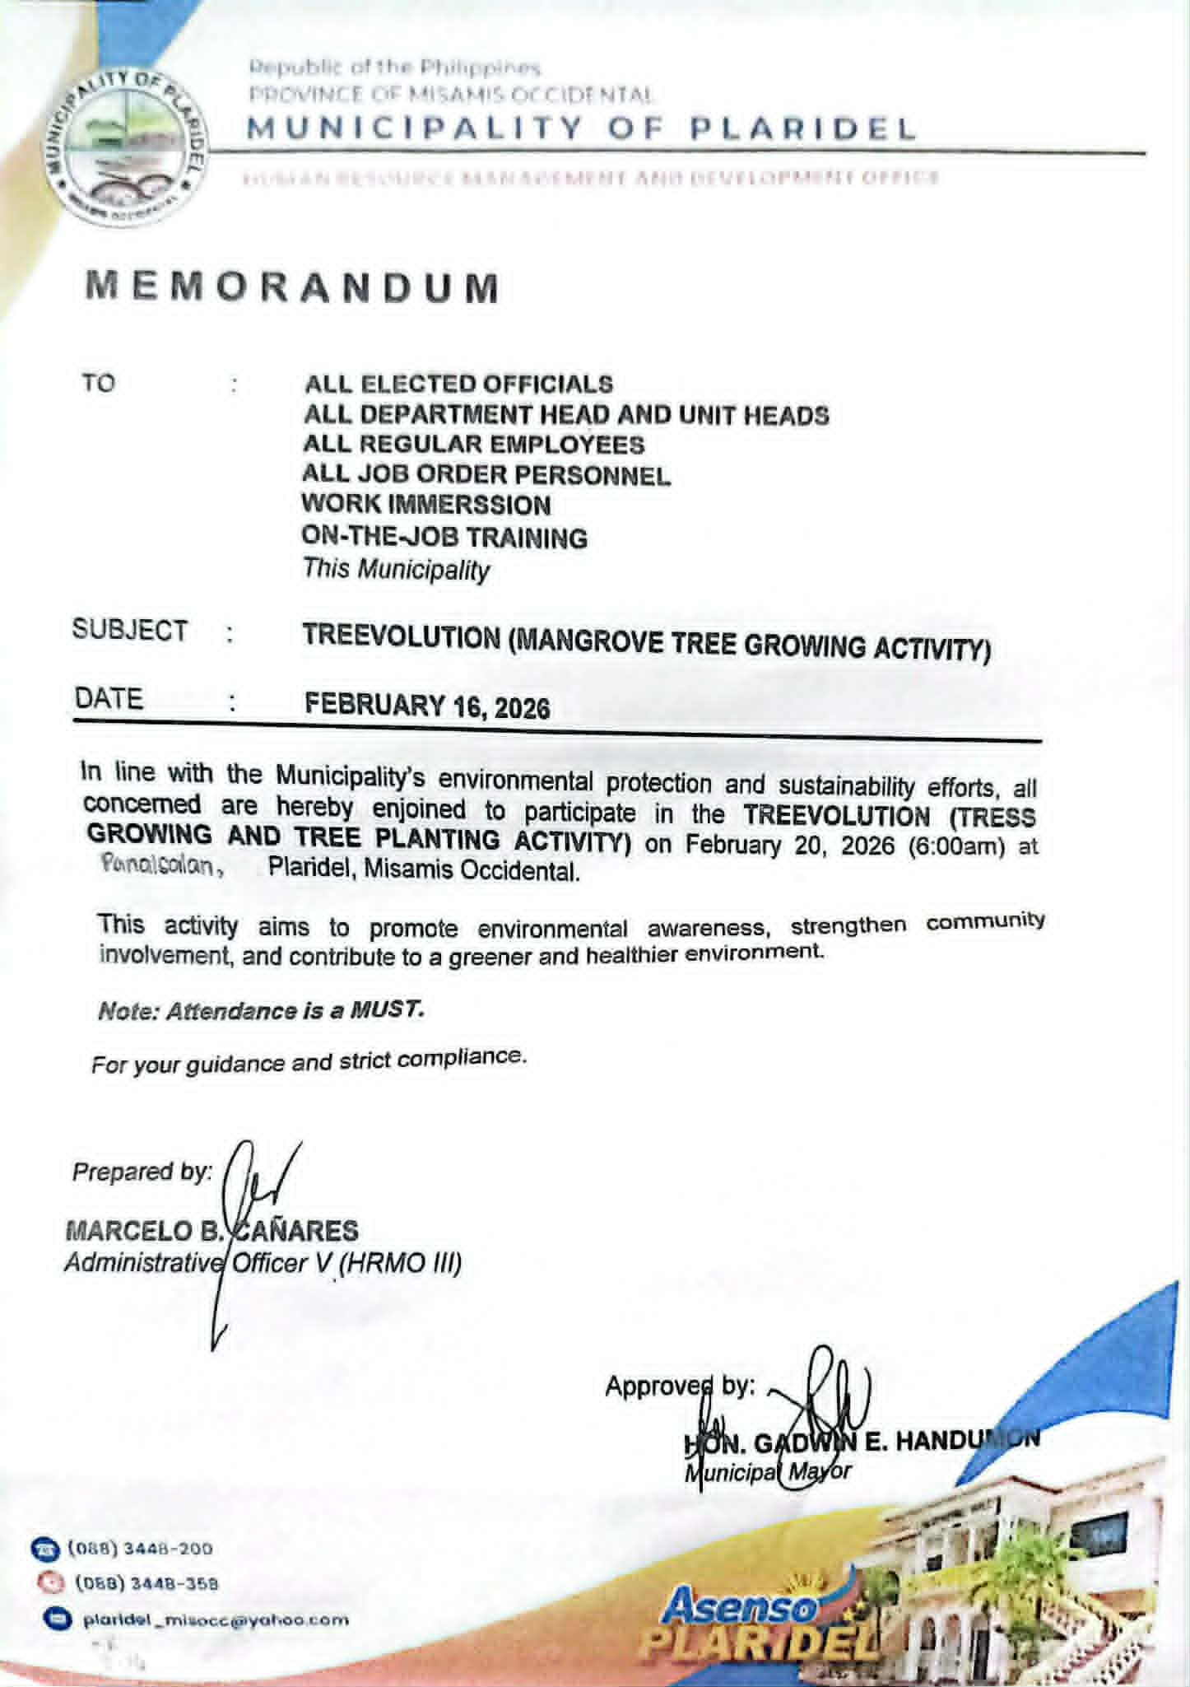
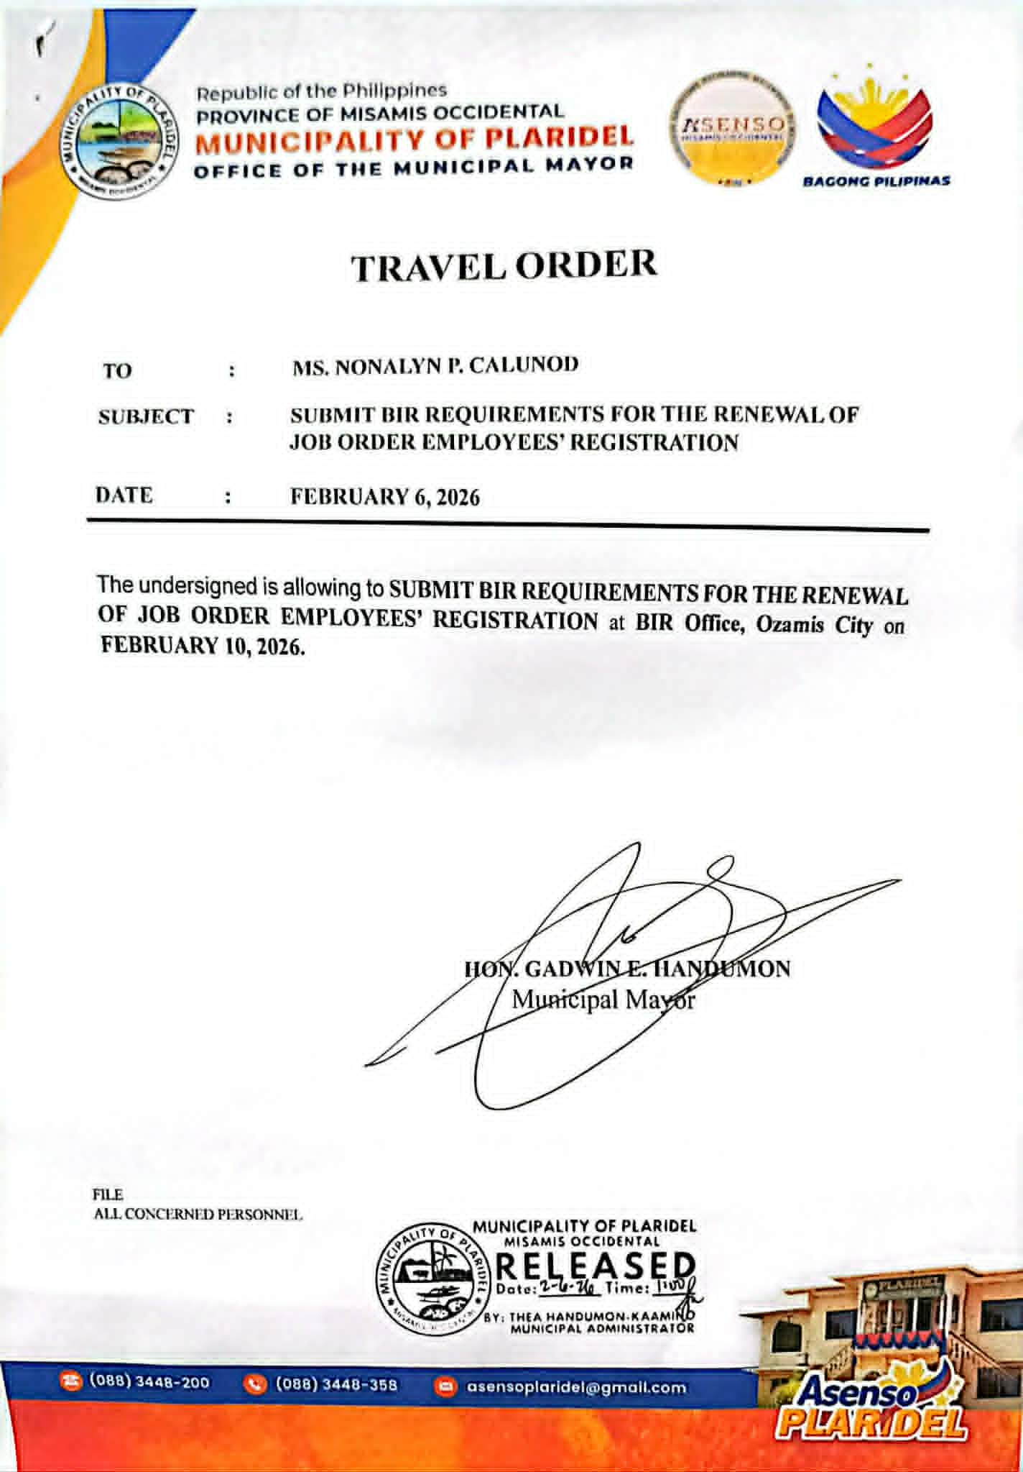
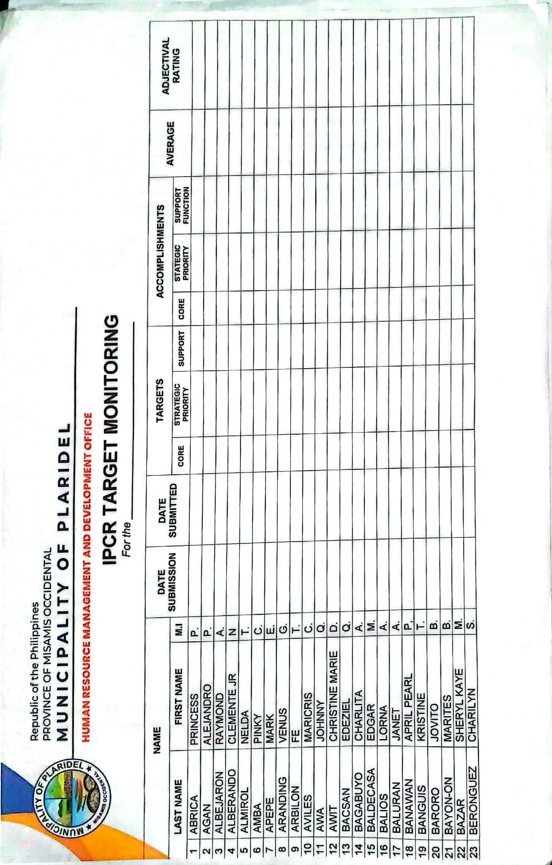
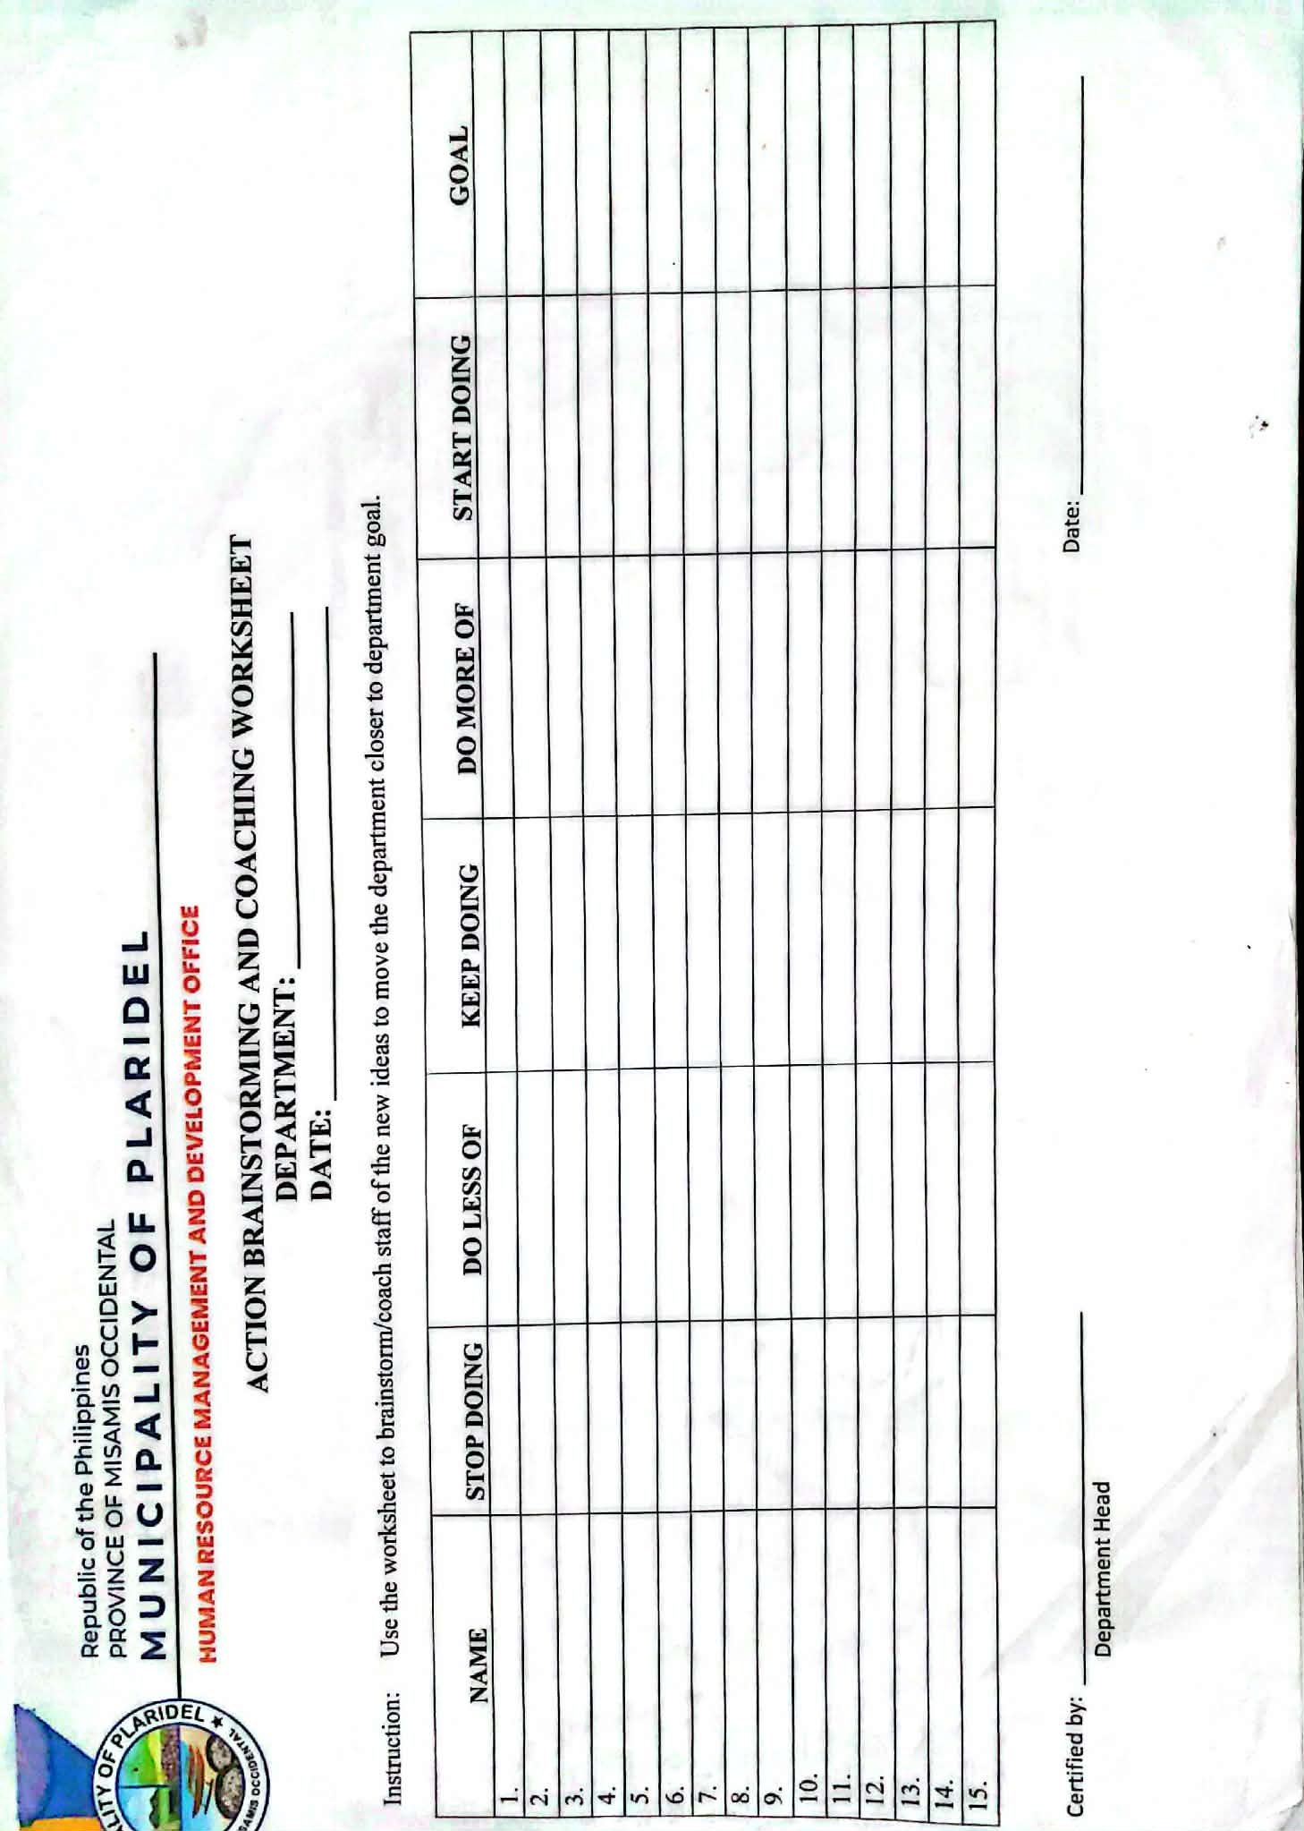
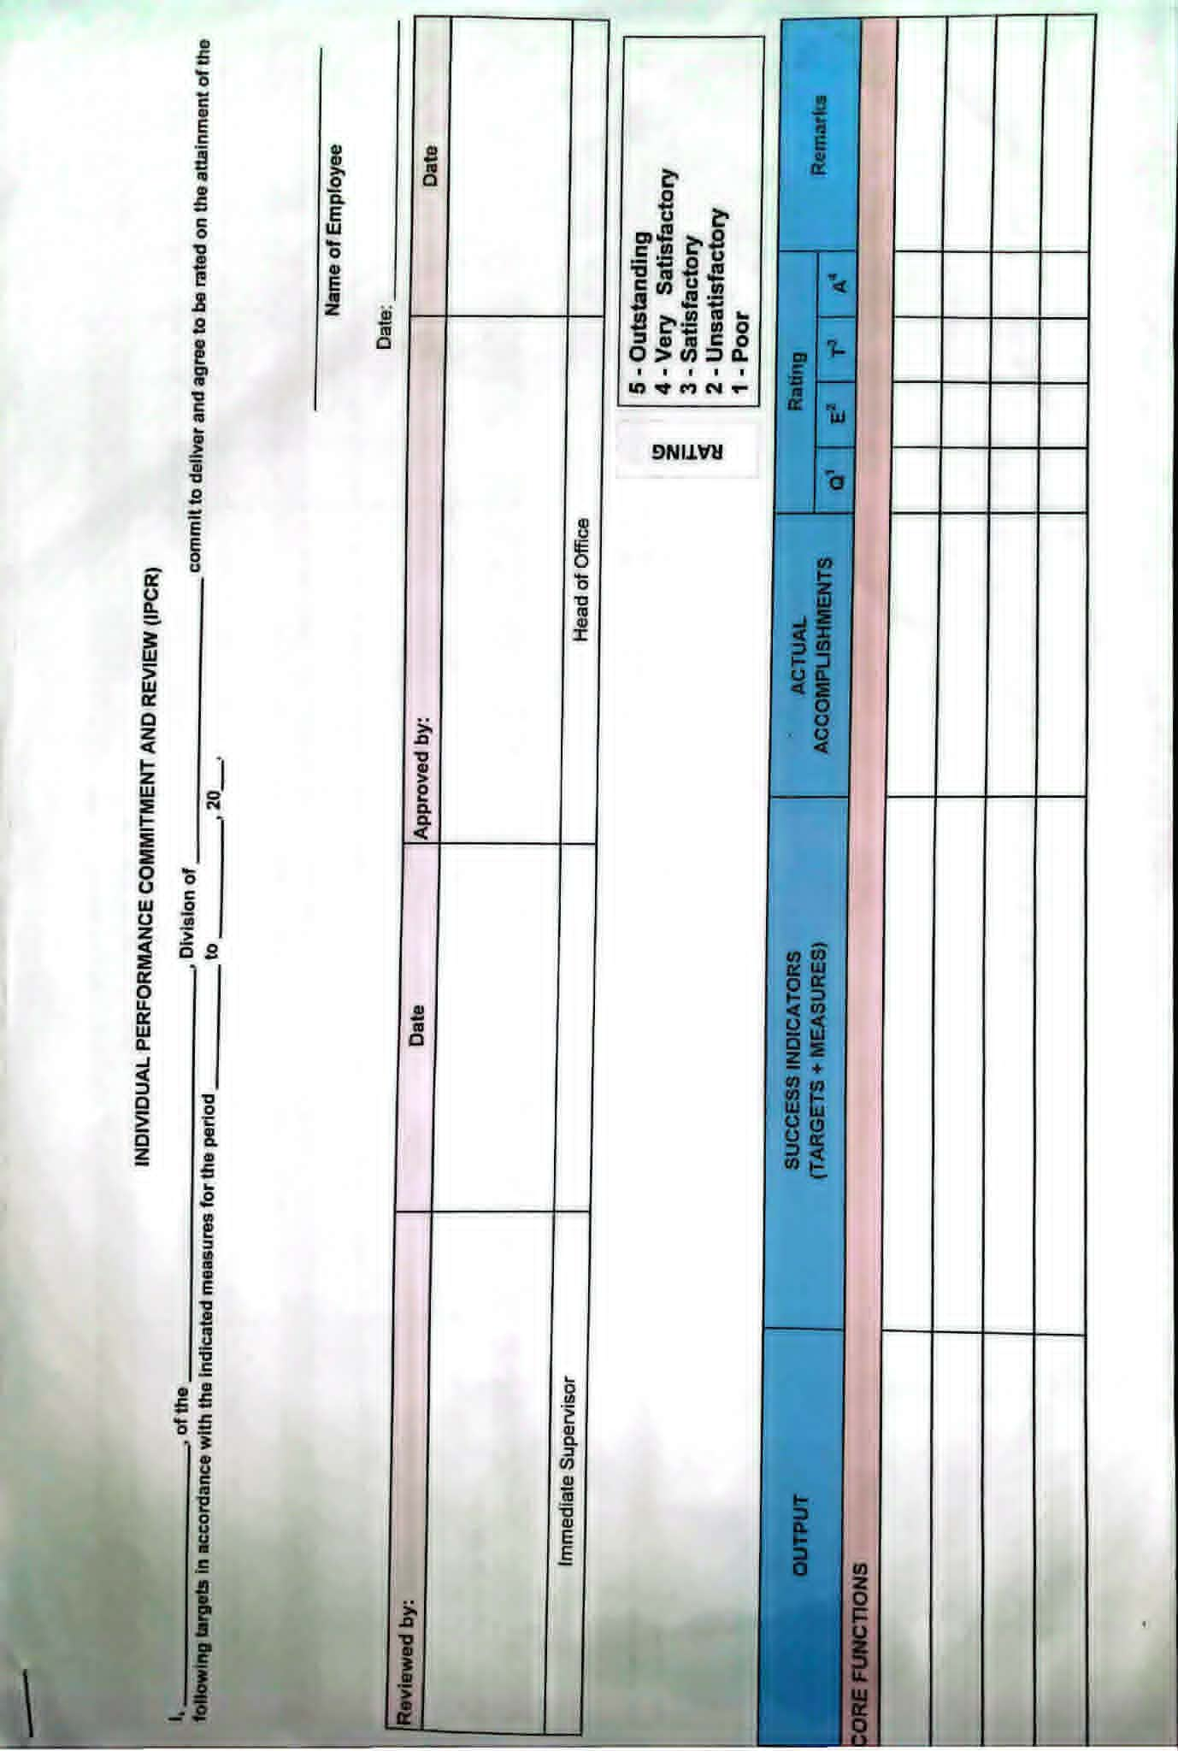
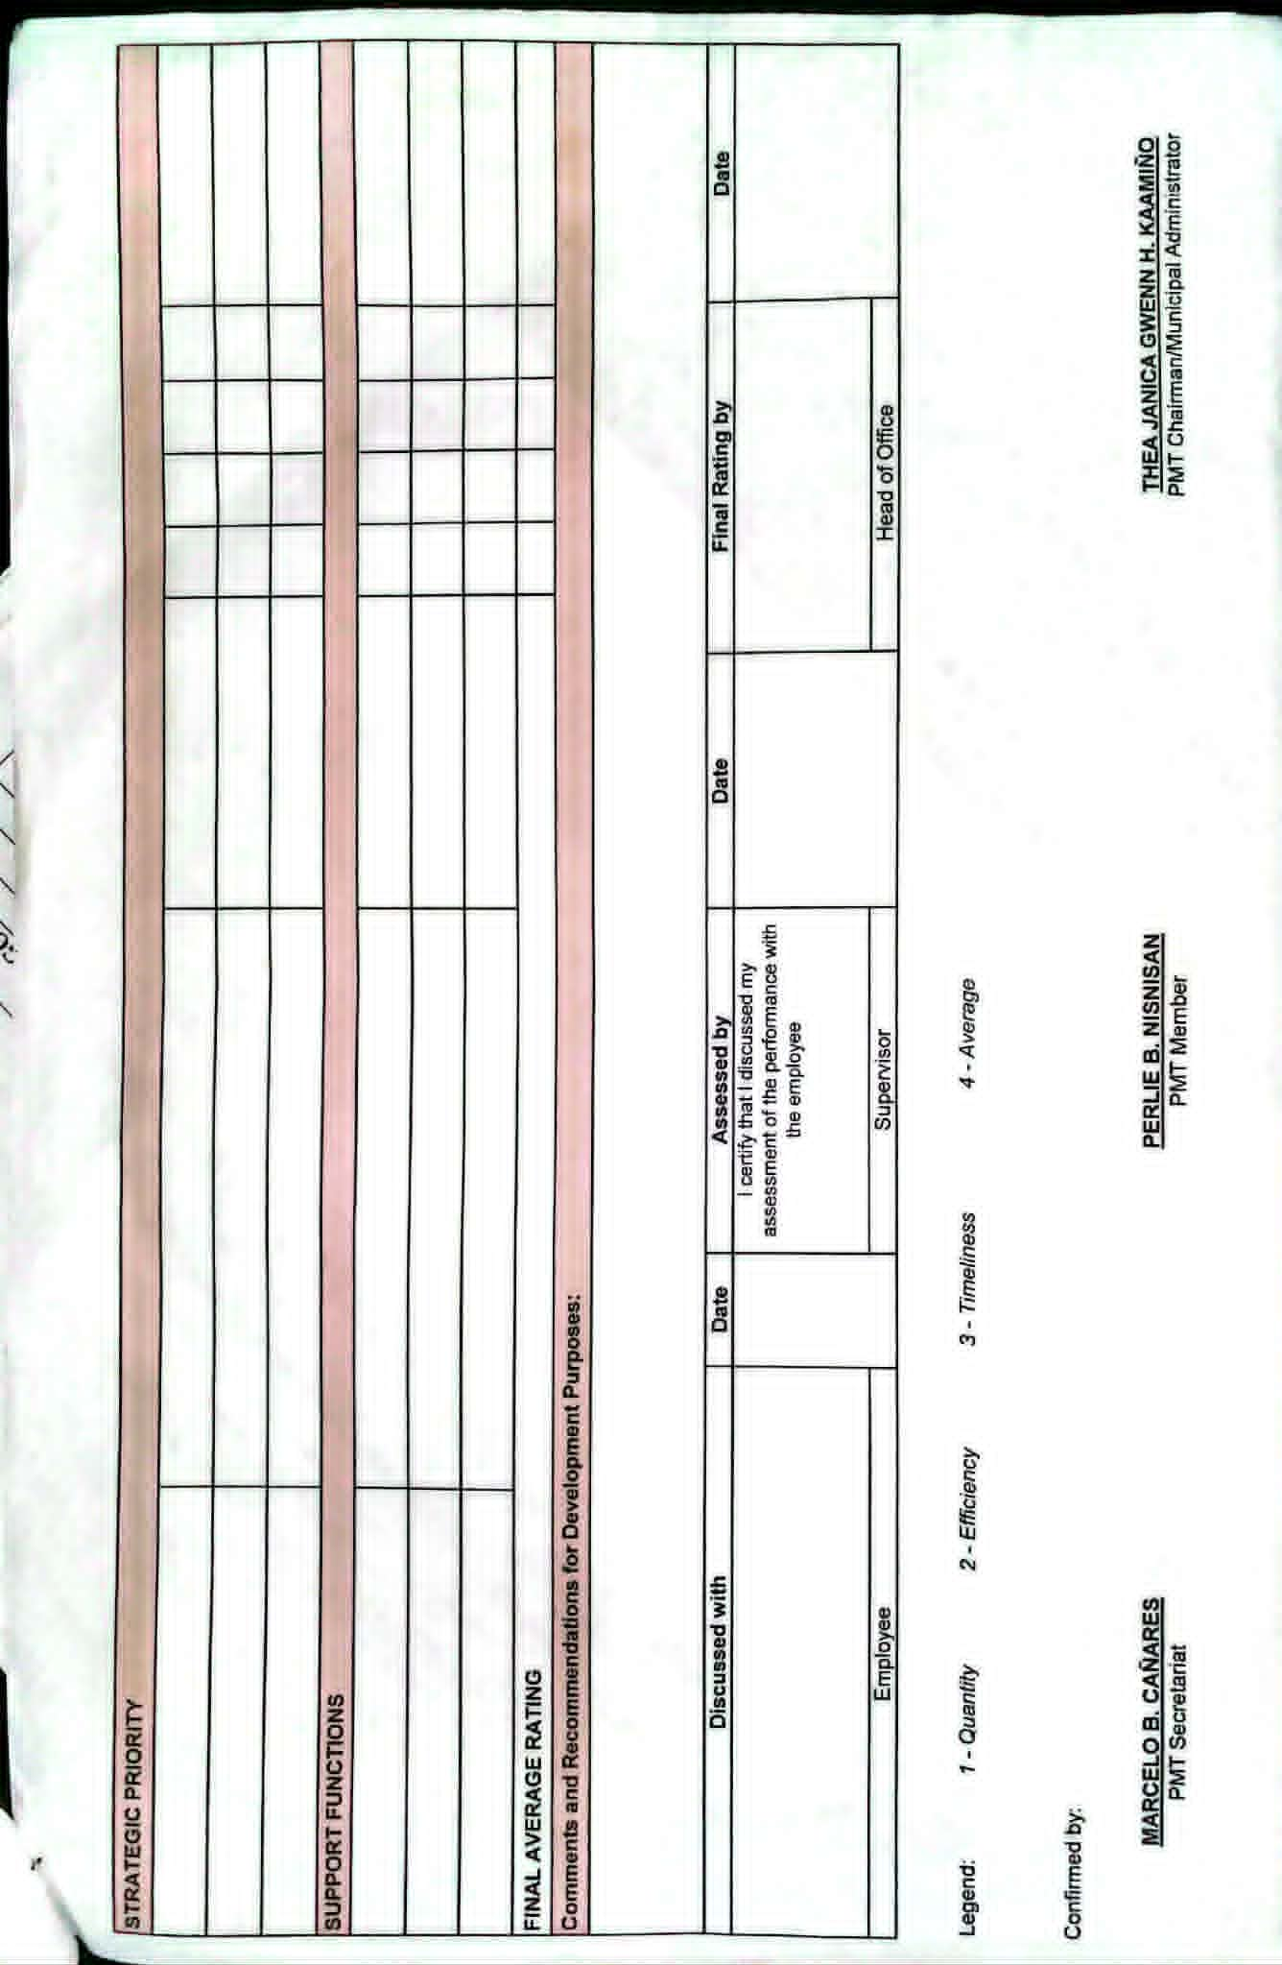
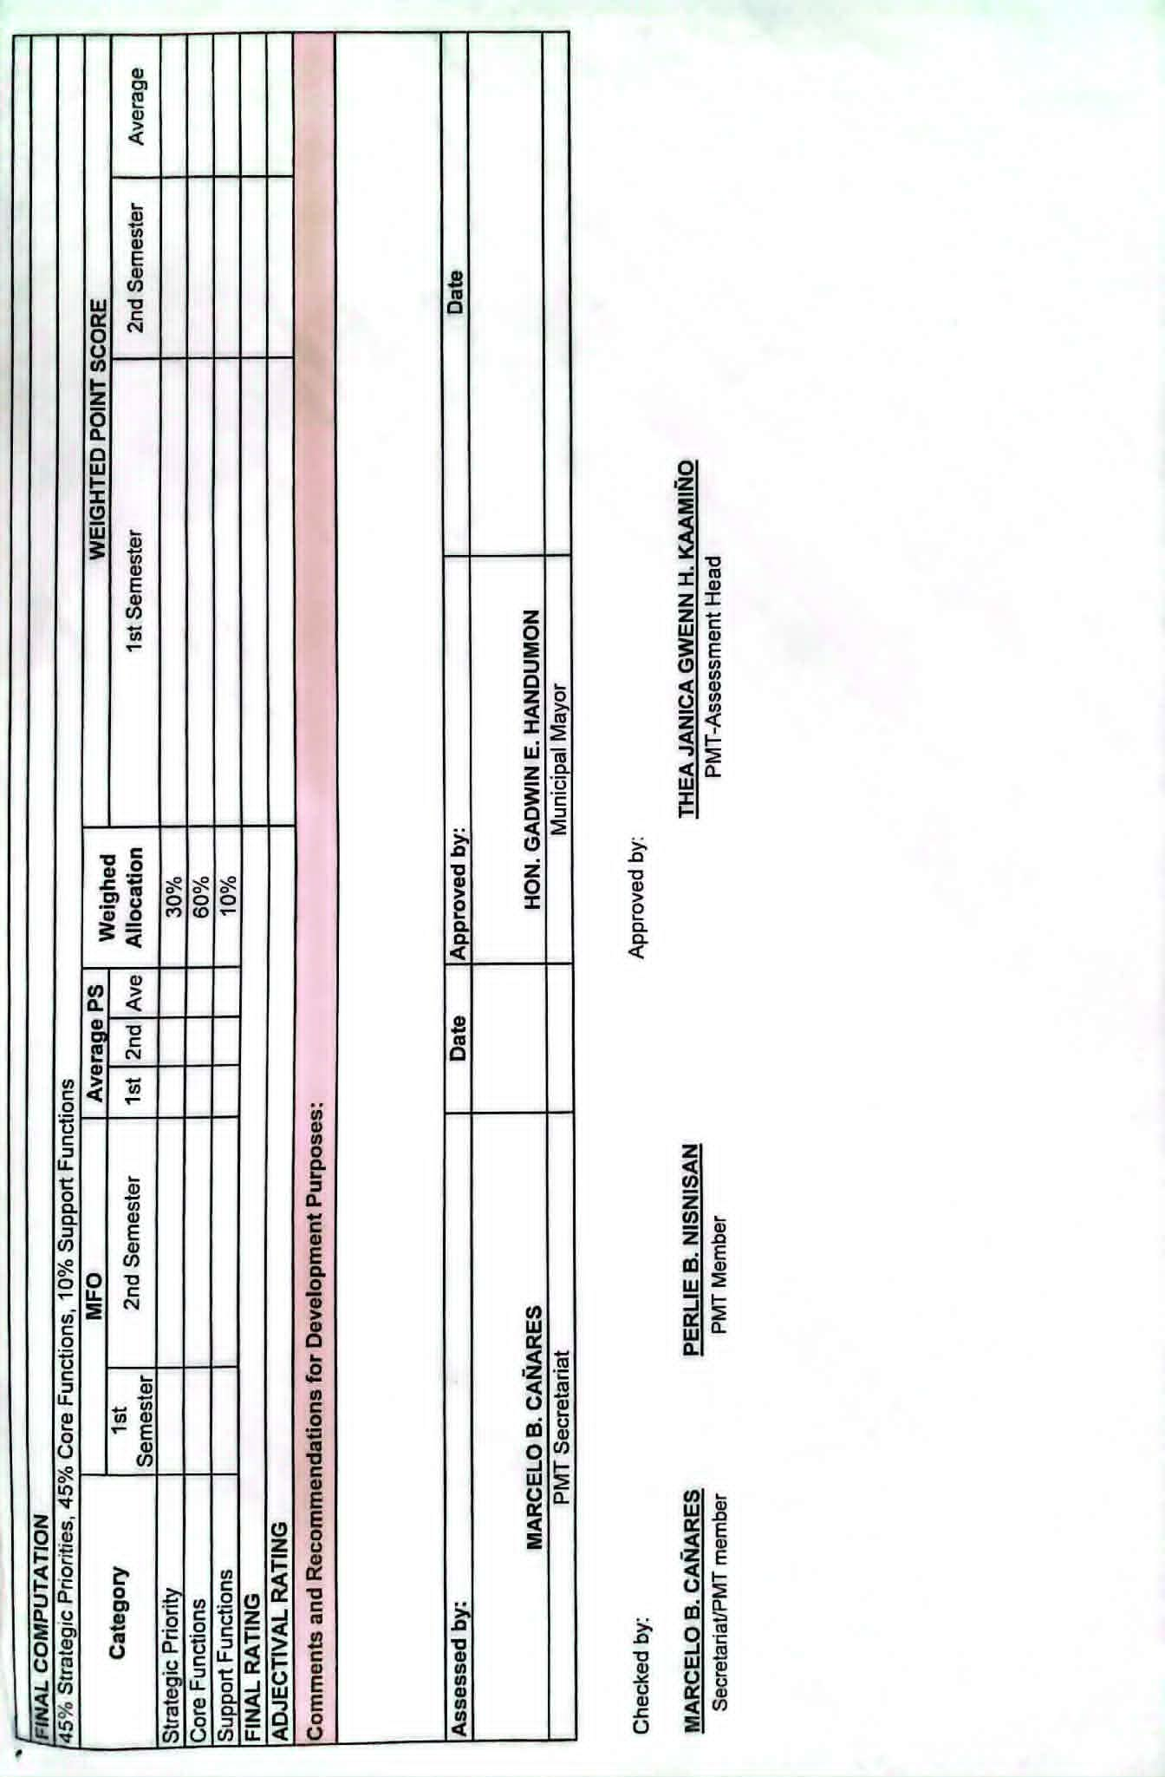
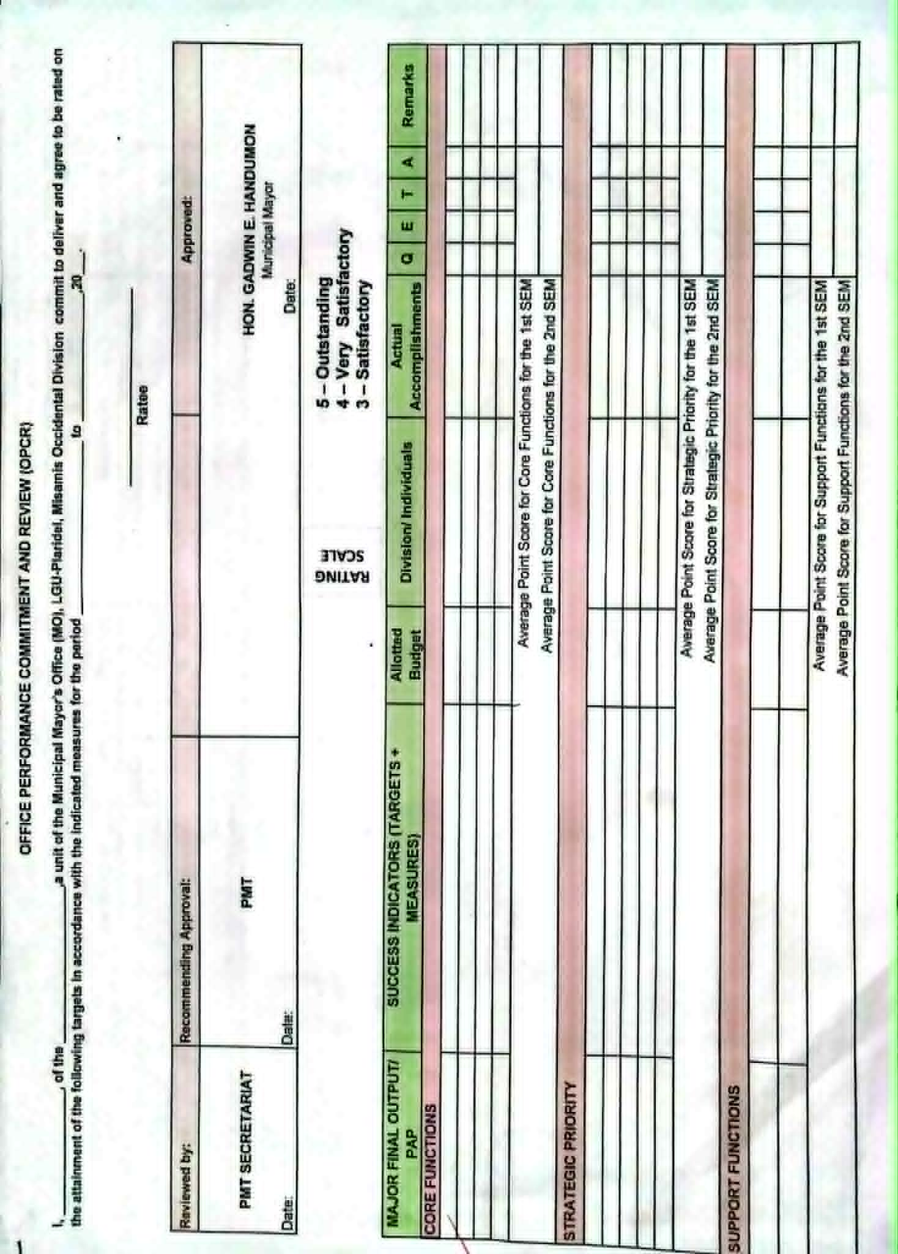

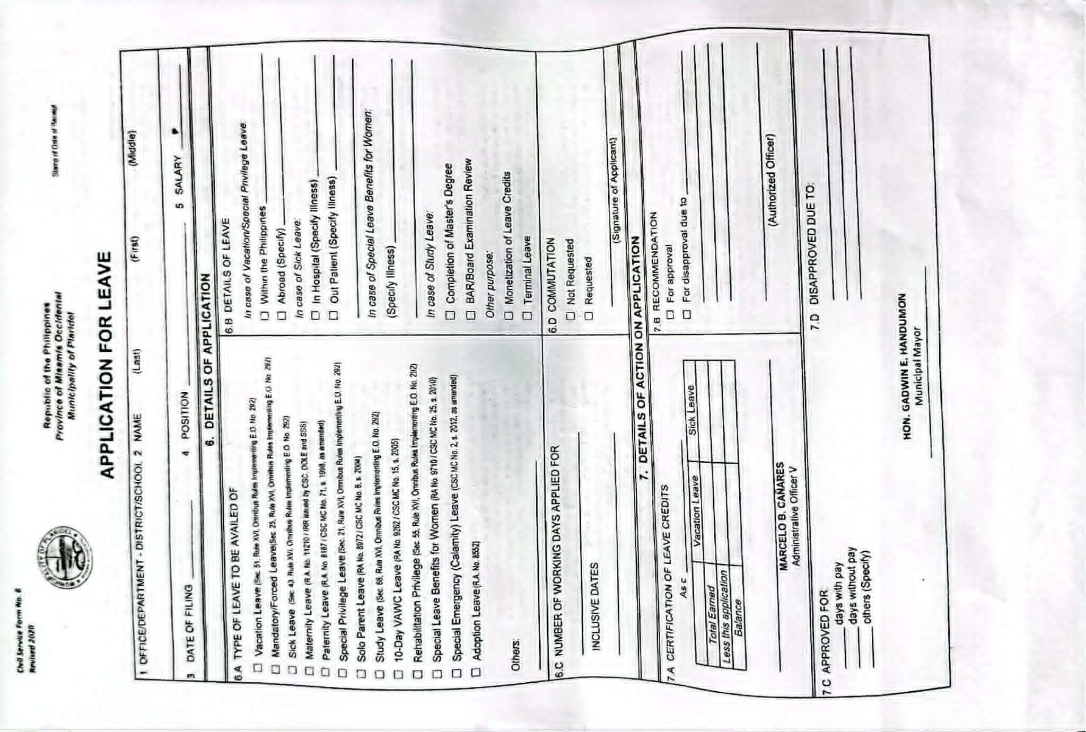
Appendix C: Approved Consent/Letters

Appendix D. Summary of Interview Responses
Respondent: Human Resource Administrator
Organization: Municipality of Plaridel
Purpose: Requirements Gathering for the Proposed HRMS-DTR System

Table 4. Response
Interview Question | Summary of Response
1. Can you describe the current process of recording and monitoring employee attendance in your office? | Employees record their attendance using biometric devices. HR personnel retrieve the attendance logs and import them into the municipality's current attendance system for processing and monitoring.
2. How do you currently retrieve or obtain attendance logs from the biometric device? | Attendance logs are transferred from the biometric device using a USB flash drive and are then imported into the current attendance system used by the HR office.
3. What tools or methods do you use to transfer or process biometric attendance data? | The HR office uses a USB flash drive to extract attendance logs from the biometric device and imports the files into the existing attendance system for review and processing..
4. What forms or documents are currently used in managing attendance and leave? | The office uses Daily Time Record (DTR) forms, leave application forms, locator slip forms, biometric attendance logs, and attendance summaries.
5. How do you currently compute employee Daily Time Records (DTR), including late minutes, undertime, and total working hours? | Attendance logs are imported into the current attendance system after being transferred from the biometric device through a USB flash drive. The system records attendance data, but HR personnel still manually compute and verify the deduction of total undertime and other attendance-related adjustments before preparing attendance summaries and reports
6. What challenges do you encounter when processing attendance data from the biometric device? | The process requires manually transferring attendance logs using a USB flash drive and reviewing records before they can be used for reporting. This can be time-consuming and may delay attendance monitoring and report preparation.
7. How are leave applications currently managed, and how are they reflected in attendance records? | Leave applications are processed separately from attendance records. HR personnel manually verify approved leave requests and compare them with attendance logs before updating attendance summaries.
8. What difficulties do you experience in generating attendance reports or DTR summaries? | Preparing reports requires manual consolidation of attendance logs, leave records, and attendance computations, which can be time-consuming.
9. Does your current system support real-time monitoring of attendance? If not, what issues does this cause? | No. Attendance information is reviewed after logs are collected and processed, making it difficult to monitor attendance immediately and respond to attendance concerns in real time.
10. How do you handle errors such as missing, incomplete, or incorrect biometric logs? | HR personnel manually verify attendance records, review supporting documents, and make necessary corrections before finalizing reports.
11. What improvements or features would you like to have in an automated attendance and DTR system? | The HR office would like a centralized system that integrates biometric attendance, leave management, locator slips, automated DTR computation, real-time monitoring, and report generation.

