CAPSTONE PROJECT WEEKLY ACCOMPLISHMENT REPORT
Team Name: SysIgnite Section: 3D Date: September 7-11, 2026
Project Title: DocuTrack: An Integrated HRMS for Digital Document Tracking and Routing in Government Offices

Accomplishment for the week
Task / Activity | Description of Work Done | Output / Evidence
Workflow Step Reordering Compatibility | Corrected the DocuTracker workflow builder's step-reordering callback for compatibility with the current Flutter reorderable-list API. | 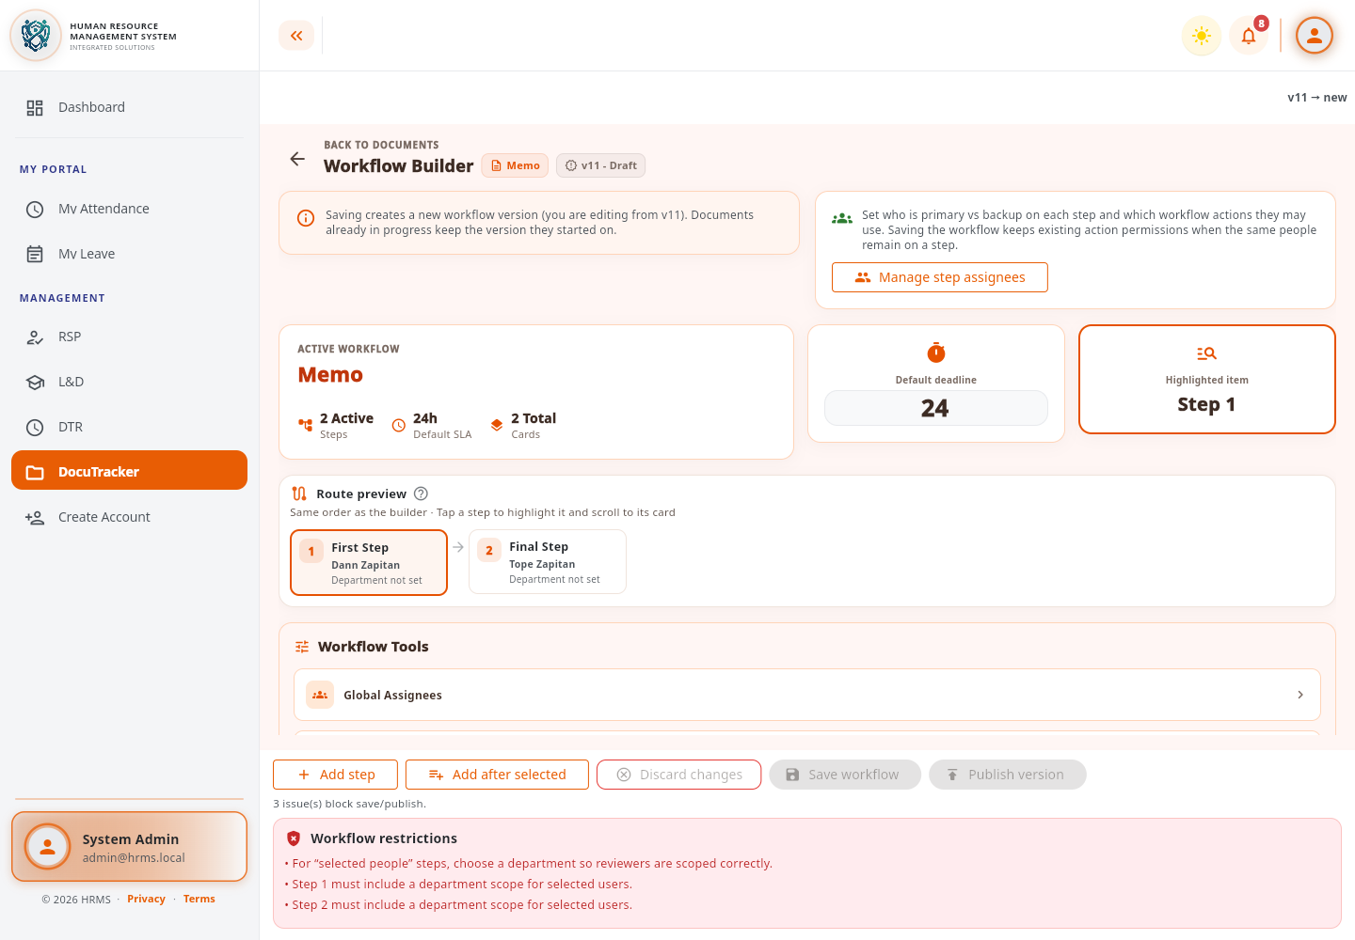
Permission Governance Layout Correction | Corrected the permission editor's effective-preview layout to display access results and rule references consistently without conflicting nested scrolling. | 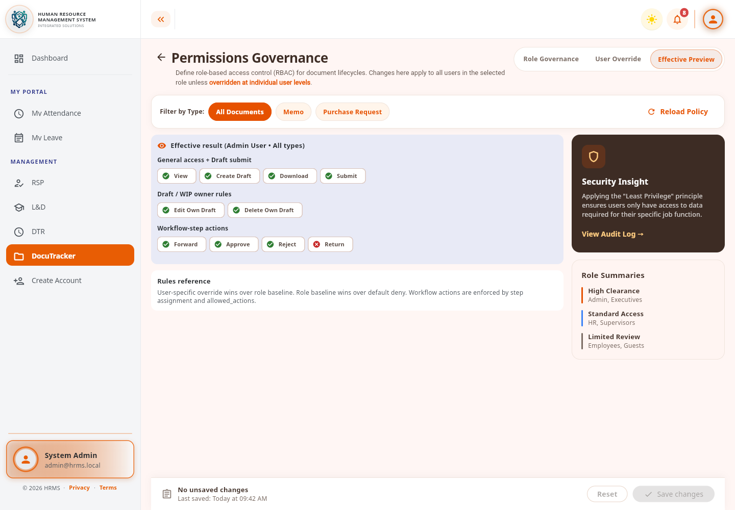
DocuTracker Permission Testing and Validation | Ran and updated focused Flutter widget tests for permission governance and workflow-editor behavior after the compatibility fixes. | 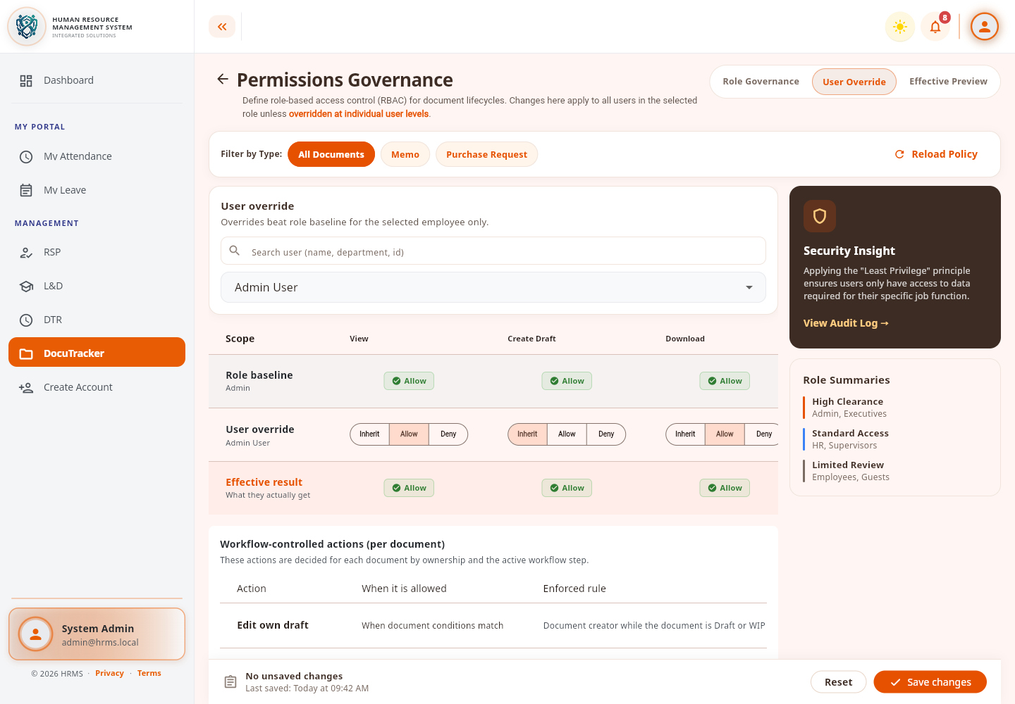

Individual Contribution
Team Member | Contribution
Dann Kristoffer D. Zapitan | Corrected DocuTracker workflow reordering and permission-governance layout issues, then updated and ran the related Flutter widget tests.
Cathrina Gallemit | Tested the system and provided feedback on the implemented features.
Ryza Mae Bongcac | Tested DocuTracker functions and contributed to reviewing the project output.
Edgar Jr. Tac-an | Assisted in system testing and contributed general feedback for improvement.

Issues Encountered and actions taken
Issues / Concerns | Action Taken
Workflow-step reordering did not match the current Flutter callback behavior. | Replaced the outdated reorder callback usage and corrected the step-index handling.
The effective-permission preview used a nested scrolling layout that caused display and test issues. | Changed the preview content to a column-based layout so the result and rules reference render together.
Existing widget-test expectations no longer matched the corrected DocuTracker screens. | Updated the focused permission and workflow tests and reviewed the resulting interface states.

Plan for the next week
Plans for Next Week | Expected Output
Continue validating workflow reordering, saving, publishing, and permission controls. | Stable and responsive DocuTracker workflow-administration controls.
Review focused test results and remaining Flutter compatibility findings. | Verified DocuTracker tests and documented any remaining corrections.

Adviser's Remarks

Reviewed by:
Mr. Ginbert A. Fernandez
Capstone Project Adviser
Date Signed:

