DESCO/NESCO Prepaid
- Show account balance, last recharge amount with date with owner detail
- Recharge history (list view & chart view, download as excel & pdf)
- Daily consumption (list view & chart view download as excel & pdf)
- Monthly consumption (list view & chart view download as excel & pdf)
- Customer Certificate (view & download as pdf)
- Notification when minimum balance crosses
- Recharge option with different payment gateway

DESCO/NESCO Postpaid
- Show due bill amount with month with owner detail
- Monthly bill history (list view & chart view, download as excel & pdf)
- Daily consumption (list view & chart view download as excel & pdf)
- Monthly consumption (list view & chart view download as excel & pdf)
- Customer Certificate (view & download as pdf)
- Notification when new bill generated, before {n} days of due date to remind to pay
- Bill pay option with different payment gateway

Show account balance, last recharge amount with date with owner detail
Prepaid
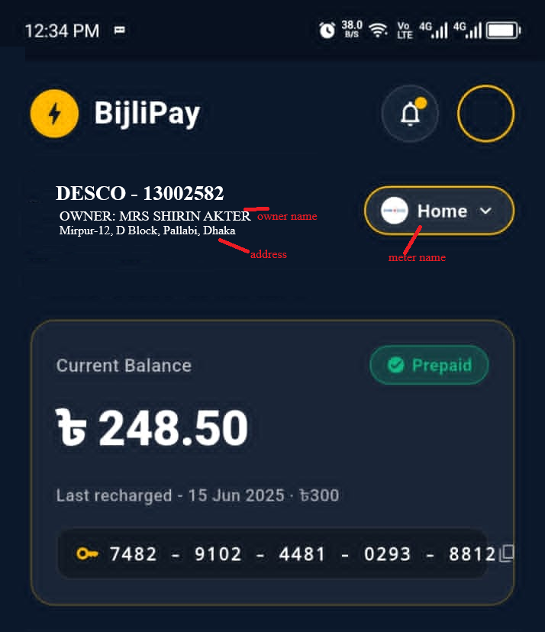

Postpaid
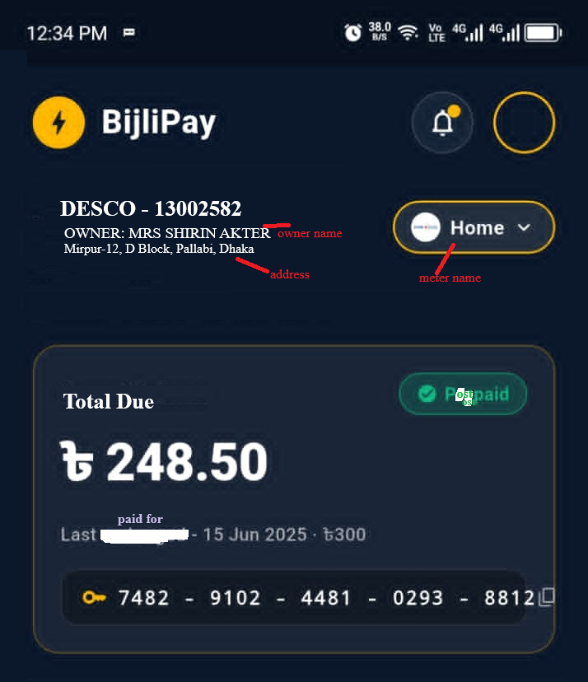

Recharge history (list view & chart view, download as excel & pdf)
List view
S/L | Recharge Date | Recharge Amount | Media | Status | Detail | Tk
1 | 31-08-2026 | 690 | ROCKET | Success | Energy Cost:  Meter Rent:  Demand Charge:  PFC Charge:  VAT:  Debt Paid:  Rebate:  Total:  Est. Unit: | 494.21  40.00  126.00  0.00  32.86  0.00  -3.07  690.00  90.44 kwh
Download excel/pdf view
S/L | Recharge Date | Recharge Amount | Media | Status | Energy Cost | Meter Rent | Demand Charge | PFC Charge | VAT | Debt Paid | Rebate | Est. Unit
1 | 31-08-2026 | 690 | ROCKET | Success | 494.21 | 40.0 | 126.00 | 0.00 | 32.86 | 0.00 | -3.07 | 90.44

Chart view
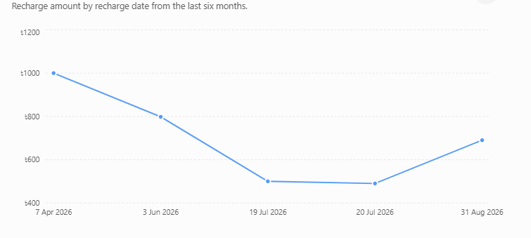

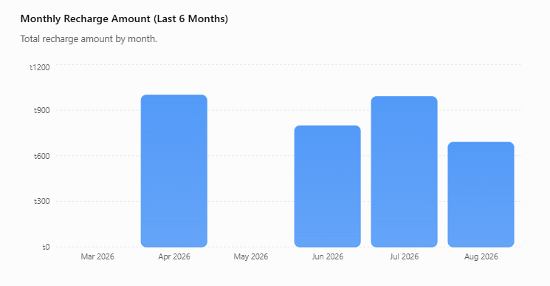

Daily consumption (list view & chart view download as excel & pdf)
List view & download view
Date | Unit (kwh) | Unit Price (tk) | Cost(tk)
31-08-2026 | 12 | 6 | 72
30-08-2026 | 10 | 6 | 60
…

Chart view
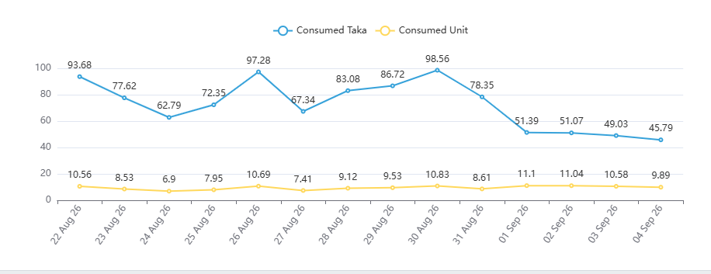

Monthly consumption (list view & chart view download as excel & pdf)
List view & download view
Month | Consumed Unit (kwh) | Cost(tk)
August 2026 | 120 | 720
July 2026 | 100 | 600
…

Chart view
