Armani Middle East Trading
Data Science Technical Assessment
Complete project description, step by step
Prepared by Hamidreza Nademi
Technical Assessment: Data Science | Armani Middle East Trading

Contents
1. About this document
1.1 How to read it
1.2 Conventions used in this document
2. Business context and the assignment
2.1 The company and the data
2.2 The three business problems
2.3 The four parts and what each delivers
2.4 How the parts depend on each other
2.5 Four working principles
3. The solution at a glance
3.1 The story in one page
3.2 Headline results
3.3 The key insight, in plain words
3.4 What was built
4. Part 1: Data engineering
4.1 Goal and the question it answers
4.2 Concepts used in this chapter
4.3 Step 1: Understand the raw file (exploratory analysis)
4.4 Step 2: Nine data challenges and how each was treated
4.5 Step 3: The key discovery: stock caps sales
4.6 Step 4: The ETL pipeline, stage by stage
4.7 Step 5: The database
4.8 Step 6: Measuring data quality before and after
4.9 Step 7: Proving that the pipeline works
4.10 Outputs, assumptions, limits and hand-over
5. Part 2 (a): Pre-processing for forecasting
5.1 Goal and the question it answers
5.2 Forecasting concepts used in Part 2
5.3 Step 1: Classify every week by stock censoring
5.4 Step 2: Is the company's forecast a usable measure of demand?
5.5 Step 3: Reconstruct demand (the target column demand_est)
5.6 Step 4: What drives demand? (evidence for the features)
5.7 Step 5: The 30 products at a glance
5.8 Step 6: Feature engineering
5.9 Outputs, assumptions and hand-over
6. Part 2 (b): How the forecasting models were built and tested
6.1 What is predicted
6.2 Why a rolling backtest instead of one train/test split
6.3 Three data sets: training, validation and test
6.4 Metrics
6.5 The 13 candidate models
6.6 How each model family works, and what to expect from it
6.7 Tuning the free parameters
6.8 Guarding against leakage: a checklist
7. Part 2 (c): Results, the winning model and the forecast
7.1 The tournament results
7.2 Stability: error by test and by horizon
7.3 The winning model explained
7.4 Segment results
7.5 Forecast ranges (P10 to P90)
7.6 The 26-week forecast
7.7 Outputs, assumptions and limits of Part 2
8. Part 3: KPI dashboard
8.1 Goal and the question it answers
8.2 Architecture and design principles
8.3 The eight tabs
8.4 The KPIs: definitions with worked examples
8.5 What the KPIs say (last 52 weeks)
8.6 The credit-risk rating A to E
8.7 Alerts
8.8 How the dashboard was tested
8.9 Running and deploying
8.10 Assumptions, limits and hand-over
9. Part 4 (a): The pricing idea and the pricing engine
9.1 Goal and the three questions
9.2 Concepts used in this part
9.3 Four data insights that shape the idea
9.4 The idea
9.5 The engine at a glance
9.6 The six rules in detail
9.7 The parameters
9.8 Question 1: demand-based adjustments (peaks and lulls)
9.9 Question 2: inventory and seasonality sensitivity
9.10 Question 3: competitive and credit-risk guardrails
10. Part 4 (b): Testing the engine, results and next steps
10.1 The central difficulty: unknown price sensitivity
10.2 How the engine was evaluated
10.3 Results
10.4 Sensitivity of the result
10.5 The plan by product
10.6 The nineteen automatic checks
10.7 Beyond price: stock and credit actions
10.8 Pilots before roll-out
10.9 Deliverables of Part 4
10.10 Assumptions and limits of Part 4
11. Assumptions, decisions, limits and reproduction
11.1 Assumptions register
11.2 Decision log: what was chosen, what was rejected and why
11.3 Main limitations and risks
11.4 What would come next
11.5 Repository, outputs and how to reproduce
11.6 Summary of all automatic checks
11.7 Note on AI assistance
11.8 Glossary

1. About this document
This document explains the whole Data Science technical assessment for Armani Middle East Trading in depth and step by step. It is written for a reader who knows nothing about the project and wants to understand not only what was built, but also why every decision was taken, what alternatives were considered, how every result was checked, and where the limits are. Every technical term is explained when it first appears, the main numbers are given so that results can be verified, and a glossary at the end collects the vocabulary.
The document follows the order of the work. Chapter 2 gives the business context and the assignment. Chapter 3 gives the whole solution on a few pages. Chapters 4 to 10 describe the four parts in detail: Part 1 (data engineering), Part 2 (demand forecasting, in three chapters), Part 3 (the KPI dashboard) and Part 4 (dynamic pricing and risk strategy, in two chapters). Chapter 11 collects the assumptions, the limitations, the decision log and the instructions for reproducing everything.

1.1 How to read it
If you have | Read
10 minutes | Chapter 3 (the solution at a glance)
1 hour | Chapter 3, then the first and last section of every part chapter (goal, and assumptions and limits)
A full evening | Everything in order. Each part chapter starts with the question it answers and ends with what it hands to the next part
Interest in one topic only | Data quality: chapter 4. Forecast method: chapters 5 to 7. KPIs and credit rating: chapter 8. Pricing rules: chapters 9 and 10

1.2 Conventions used in this document
• All amounts are in US dollars. M means million and K means thousand.
• Week numbers refer to the data: week 1 is the first week in the file, week 260 the last one, and weeks 261 to 286 are the weeks to be forecast.
• Names of columns, tables and files are written exactly as in the project, for example demand_est or fact_weekly_sales.
• A percentage that is a model error is a percentage of demand (see the definition of WAPE); a percentage in a price rule is a change relative to today's price.
• Numbers are rounded for reading; the notebooks and Excel workbooks contain the exact values.

2. Business context and the assignment

2.1 The company and the data
Armani Middle East Trading is a trading company that buys and sells 30 food commodities, for example rice, wheat, sugar, vegetable oils, milk powder, spices, tea and coffee. Commodity trading has thin margins: the company buys a product, holds it in stock for a while and sells it at a small mark-up. Two things therefore decide profit: having the right stock at the right time (too little means lost sales, too much means money tied up and storage cost), and setting prices and credit terms that earn money without scaring customers away or taking on customers who do not pay.
The assignment provides one Excel file, Sample_Data.xlsx, with weekly data: one row per product per week, for 30 products and 260 weeks (five years). The file has 7,839 rows: 7,800 expected rows (30 products x 260 weeks) plus 39 duplicated rows. There are 13 columns:
Column | Meaning | Remark
Week | Week number, 1 to 260 | The file has no calendar dates
Product | Commodity name, for example Rice - Basmati | 30 distinct names, no spelling variants
Sales_Units | Units sold in the week | Missing in 16 rows
Price_Per_Unit | Selling price per unit | Varies only about 4% within a product
Cost_of_Goods_Sold_COGS | Acquisition cost per unit | Price is 1.20 to 1.35 times cost for every product
Revenue | Sales_Units x Price_Per_Unit | Reproduces exactly
Gross_Profit | Revenue minus units sold x unit cost | Reproduces exactly
Gross_Profit_Margin | Gross_Profit / Revenue | Reproduces exactly
Operating_Profit | Profit after operating expenses | The expenses themselves are not given
Inventory_Level | Stock in units | Timing is not documented (see Part 1)
Inventory_Turnover_Ratio | A turnover ratio | Definition is not documented
Revenue_Growth | Week-over-week revenue growth | 897 infinite values
Demand_Forecast | The company's existing (legacy) forecast | Missing in 609 rows

What the file does not contain is as important as what it contains: there are no calendar dates, no customers, no invoices or payment terms, no competitor prices, no promotions and no information about purchasing. Everywhere the solution needs such information it makes an explicit, labelled assumption.

2.2 The three business problems
• Demand volatility: seasonality and supply swings make commodity demand hard to predict, so stock is wrong in both directions: some products run out while others pile up.
• Static prices: fixed prices miss revenue in busy weeks and leave stock unsold in quiet ones.
• Credit and liquidity risk: sales terms must balance growth against the risk of non-payment and the cost of money tied up in stock and in unpaid invoices.

2.3 The four parts and what each delivers
Part | Question | Deliverable
1. Data engineering | Can the data be trusted, and what does each column really measure? | Exploratory analysis, an ETL pipeline and a SQLite star-schema database
2. Forecasting | How much will customers want in each of the next 26 weeks? | Pre-processing, 13 compared models, a 26-week forecast with uncertainty ranges
3. Dashboard | Which KPIs and alerts help a manager decide? | An interactive dashboard with financial, operational and credit KPIs
4. Pricing and risk | Where can price earn money, and what could go wrong? | A rule-based pricing engine, guardrails, impact analysis, a pilot plan and a written rulebook

2.4 How the parts depend on each other
The parts form one chain, and each link uses the output of the previous one. Part 2 cannot forecast demand until Part 1 has shown what the sales numbers really measure. Part 3 needs the clean database of Part 1 and the forecast of Part 2. Part 4 needs the forecast of Part 2, the credit rating of Part 3 and the stock history of Part 1, and it writes its price plan back into the dashboard. A mistake early in the chain would spread to every later part, which is why so much care went into Part 1.

2.5 Four working principles
Four habits guided every decision in the project. They explain almost everything that follows:
1. Diagnose before modelling: understand what the data measures before choosing a method. Most of the value of this project comes from one diagnosis (stock limits sales), not from a clever algorithm.
2. Test on unseen data: every choice (a model, a parameter, a rule) is judged on weeks that were not used to make the choice.
3. Simple unless proven otherwise: a complex model must beat a plain rule to earn its place. A plain rule that is explained in one sentence is easier to trust, audit and maintain.
4. State and stress assumptions: where data is missing the project assumes openly, and shows the range of outcomes under different assumptions instead of one optimistic number.

3. The solution at a glance

3.1 The story in one page
1. The data looked messy: duplicates, missing values, odd pile-ups of values at exactly 1,500 and 2,500, weeks with zero sales, 'infinite' growth values. Instead of simply deleting the oddities, they were flagged and investigated.
2. The investigation revealed the key finding: sales in a week are limited by the stock available at the start of that week (the previous row's inventory). In other words, sales = min(demand, stock). In 53 percent of product-weeks stock limited sales, so observed sales understate what customers wanted.
3. Therefore the forecast target is demand, not sales. Demand was reconstructed for the weeks where stock hid it (the column demand_est). The company's own forecast, which looked poor against sales, turned out to be a good demand signal.
4. A simple structural model (product level x growth x seasonal factor) forecast the next 26 weeks better than machine learning and classic statistics in four rolling backtests: average miss 4.57 percent (6.64 percent on weeks where demand was observed directly).
5. The dashboard turns the data and the forecast into KPIs and alerts: the service level is only 60 percent, 43.2 million dollars of sales were lost in the last 52 weeks, and five products hold 10.8 million dollars of excess stock.
6. The pricing engine raises prices only where stock sells out anyway, protects itself against the unknown price sensitivity, and obeys strict guardrails: about +1.3 million dollars of profit in 26 weeks, positive in every scenario tested. The biggest value, however, is in stock planning, not in price.

3.2 Headline results
Area | Result
Data | 7,839 raw rows became 7,800 clean product-weeks; 39 duplicates dropped; 16 missing sales recovered; data-quality index 79.7 to 99.7
Stock effect | 53% of product-weeks are stock-limited or out of stock; about 39% of demand (6.2 million units) was not served
Forecast accuracy | WAPE 4.57% (MAE 97 units, MAPE 5.03%); 6.64% on weeks where demand was observed; best simple rule 5.28%
Forecast | About 2.0 million units in weeks 261-286 (+2.8% against the same weeks a year earlier); likely range 1.84-2.15 million
Revenue potential | 64.6 million dollars if every demanded unit could be sold; 35.8 million at historical stock levels; 28.7 million (44%) unserved
Dashboard | Revenue 65.4 million dollars (+3.3%), gross margin 21.5%, service level 60%, 35 alerts (16 high)
Pricing | +1.26 million dollars profit in 26 weeks (planning case); range 1.15-1.30 million; replay of the last 52 weeks +1.43 million
Over-stock | 5 products hold 64 to 370 weeks of stock: 10.8 million dollars tied up, about 1.3 million a year to carry

3.3 The key insight, in plain words
The key insight
The company does not have a demand problem; it has an availability problem. Customers want about 40 percent more than the company manages to serve, because for most products stock runs out. At the same time five products hold years of stock. So the largest gains come from putting stock where demand is; pricing adds a smaller, safe gain on top.

3.4 What was built
Part | Notebook (latest version) | Main outputs
1 | part1_eda_v1.3, part1_etl_pipeline_v1.2 | Exploratory findings; SQLite star schema; data-quality scorecard; 15 exception tests
2 | part2_preprocessing_v1.1, part2_forecasting_v1.2 | Reconstructed demand; 13-model comparison; 26-week forecast with P10-P90 ranges
3 | part3_dashboard_v1.1 | Streamlit application with 8 tabs; data mart; 24 automatic tests
4 | part4_pricing_v1.1 | 780 recommended prices; rulebook (Word); impact, sensitivity and 19 checks; pilot design

Every part is a Jupyter notebook; each notebook writes its outputs into a folder with the same name (one Excel workbook with the Summary sheet first, figures and, where relevant, a database). Only the latest version of each notebook is in the root folder; earlier versions are in the history folder. The presentation deck is Armani_Data_Science_Presentation.pptx. Instructions for running everything are in chapter 11.

4. Part 1: Data engineering

4.1 Goal and the question it answers
Every later number depends on this part, so the goal is twofold: (a) understand exactly what the raw file contains and what each column really measures, and (b) build a repeatable pipeline that cleans the data, keeps an audit trail and stores the result in a database that is easy to query. The question this part answers is: can the data be trusted, and what does each column really measure?

4.2 Concepts used in this chapter
Concept | Plain explanation
Grain | What one row of a table represents. Here: one product in one week. Knowing the grain tells how many rows to expect (30 x 260 = 7,800) and what a duplicate is.
ETL (extract, transform, load) | The process that reads raw data, cleans and reshapes it, and stores it in a database. A pipeline is the same process written as repeatable code.
Staging table | An untouched copy of the raw data inside the database. Because it is kept, every correction can be traced back to the original value.
Quarantine table | A table that holds rows that cannot be used, together with the reason. Bad rows are never silently dropped and never reach the clean table.
Star schema | A database design with one central fact table of measurements (here weekly sales) surrounded by dimension tables that describe them (products, dates).
Idempotent load | Running the load twice gives the same database as running it once. Together with a single transaction (all or nothing) it makes the pipeline safe to repeat.
Flag | A 0/1 column that marks a row as special (for example 'stock-out week') without changing or deleting it.
Winsorising | Limiting extreme values to a boundary. Here a modelling copy of sales is clipped at the product's median plus or minus four robust standard deviations; the original column is kept.
Data quality dimension | A way to measure quality: completeness (nothing missing), uniqueness (no duplicates), validity (values make sense), consistency (formulas hold).

4.3 Step 1: Understand the raw file (exploratory analysis)
The exploratory notebook only reads the file; it changes nothing. Its purpose is to find out what is in the file before deciding what to do with it. It works through six questions in order: What is the size and the grain? Is anything missing? Is anything duplicated? Do the formulas inside the file hold? Are the values valid? Are there outliers or business signals? The results:
Check | Finding | First interpretation
Grain and size | One row per product per week; 30 products, weeks 1-260; 7,839 rows instead of 7,800 | 39 extra rows must be duplicates or errors
Duplicates | 39 exact duplicate rows; every duplicated (week, product) key is an exact copy | Safe to drop one copy
Missing values | Sales_Units missing in 16 rows (Revenue present); Demand_Forecast missing in 609 rows (7.8%), spread evenly over the five years; other columns complete | Sales can be recovered; the forecast gaps are random
Revenue and profit formulas | Revenue = Sales x Price, Gross_Profit and Gross_Profit_Margin reproduce for 100% of rows | The financial columns are reliable
Revenue_Growth | 897 values are 'infinite' (growth after a zero-revenue week); 87% of the rest equal the week-over-week change | Must be recomputed
Inventory_Turnover_Ratio | Matches neither sales / inventory (35%) nor sales x cost / inventory (24%); clipped at 1.0 in 2,842 rows | Definition unknown; must be redefined
Zero-sales weeks | 1,333 weeks (17%) with zero sales and zero revenue; runs of 1 week typically, at most 6; only 431 have zero inventory in the same row | Suspicious: why zero sales if stock exists?
Impossible rows | 905 rows with zero inventory but positive sales | Looks like corruption, but see 4.5
Pile-ups | Sales exactly 1,500 or 2,500 in 2,116 rows; inventory exactly 0, 1,500 or 2,500 in 4,161 rows | Values are cut off at fixed limits
Outliers | 23 sales values with a robust z-score above 4 within their product | Few; probably real peaks
Inventory profile | 7 products hold more than 5 weeks of stock on average (up to 185 weeks) | Not errors: real inventory risk
Business signals | Price is 1.20 to 1.35 times cost for every product; the legacy forecast correlates only 0.21 with sales; seasonality looks weak at first sight (index 0.87-1.23) | Little pricing signal; the forecast looks poor (see Part 2 for the twist)

Several of these facts look like errors. The lesson of this step is: do not delete what you do not understand. The zero-sales weeks, the pile-ups and the 'impossible' rows turned out to be the most informative part of the file.
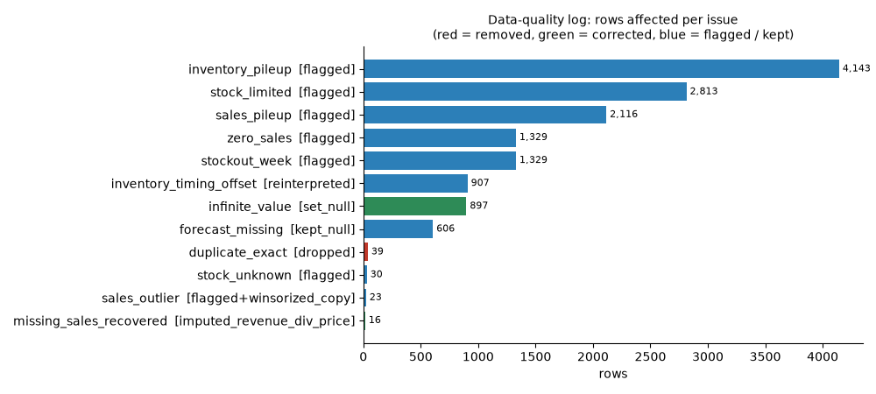
Figure 1. The data-quality issues found in the raw file and how many rows each affects.

4.4 Step 2: Nine data challenges and how each was treated
The guiding rule for all treatments: fix what is provably wrong, flag what is merely unusual, never delete information whose meaning is not yet understood. For each challenge the reasoning is given below.

Challenge 1: exact duplicate rows (39)
What was seen: 39 rows that repeat another row in every column. Why it matters: a repeated week would be counted twice in sales, revenue and every KPI. Options: keep all (wrong), drop all copies including the original (loses a week), keep the first copy (correct). Decision: keep the first occurrence and drop the others; the number dropped is written to the data-quality log. If the copies had conflicting values (same week and product, different numbers) they would be quarantined because no rule can say which is right; the pipeline handles that case and a test proves it, but this file has none.

Challenge 2: missing Sales_Units (16)
What was seen: 16 rows without units sold, although Revenue and Price are present. Because Revenue = Sales x Price exactly, the missing value can be recovered as ROUND(Revenue / Price). The recovered rows carry the flag flag_sales_imputed so a later analysis can exclude them if needed. The same rule also recovers a corrupt text value such as 'abc'.

Challenge 3: missing legacy forecast (606 after de-duplication)
What was seen: the company's forecast is empty in 7.8 percent of rows. Why not fill them in? The legacy forecast is used later as a benchmark and as one ingredient of the demand estimate. Filling it with an average would invent a number that looks like company knowledge. Decision: keep it empty, flag it (flag_forecast_missing), and let Part 2 handle the gaps explicitly (where the forecast is missing, the seasonal model alone is used).

Challenge 4: infinite revenue growth (897)
What was seen: the growth column contains infinity wherever the previous week had zero revenue (division by zero). Growth after a zero week is undefined, not infinite. Decision: set these to NULL and recompute growth from the clean revenue; the original is kept in revenue_growth_src. The zero-revenue weeks themselves are the stock-outs discussed below.

Challenge 5: inconsistent derived fields
What was seen: only 36.6 percent of the derived values (revenue, gross profit, margin, growth, turnover) matched their definition in every row, mainly because of the infinite growth and the undocumented turnover ratio. Decision: recompute all derived fields from the clean inputs with explicit definitions (for example inventory turnover = units sold / stock available for those sales). The original turnover ratio is kept as inventory_turnover_src. After this step 100 percent of derived values reproduce, which is a prerequisite for KPIs that can be audited.

Challenge 6: inventory in the 'wrong' week (907 rows)
What was seen: 907 rows (after de-duplication) with zero inventory but positive sales. A shop cannot sell what it does not have, so either the data is corrupt or the inventory column has a different timing than assumed. The next section shows that the second explanation is correct. Decision: add a column stock_available_for_sales = the previous row's inventory (per product), and use it everywhere.

Challenge 7: pile-ups and zero-sales weeks
What was seen: sales exactly 1,500 or 2,500 in about a quarter of the rows, inventory exactly 0, 1,500 or 2,500 in more than half, and 1,329 weeks with zero sales. Values that stick to round limits are the signature of a cap, not of random demand. Decision: flag them (flag_sales_pileup, flag_inventory_pileup, flag_zero_sales) and keep every row. They are not errors; they are the stock caps that explain the sales pattern.

Challenge 8: outliers (23)
What was seen: 23 sales values far from the product's usual level (robust z-score above 4). Extreme values may be real peaks, so they are not removed. Decision: flag them, add a winsorised copy sales_units_winsorized for models that are sensitive to extremes, and leave the original untouched.

Challenge 9: no dates, customers or competitors
What was seen: the file has week numbers but no calendar dates, and no customer, invoice or competitor information. Decision: a synthetic calendar (week 1 = Monday 6 January 2020, 260 consecutive weeks) so that seasonal logic can be expressed; no result depends on the actual start date, but statements such as 'peak in week 13' mean 'position 13 in the 52-week cycle'. For credit and competitors, labelled scenario inputs are used in Parts 3 and 4.
# | Challenge | Rows | Treatment | Reason
1 | Exact duplicate rows | 39 | Dropped, first kept | Repeats double-count sales
2 | Missing Sales_Units | 16 | Recovered as Revenue / Price; flagged | Value is determinable
3 | Missing legacy forecast | 606 | Kept empty; flagged | Imputing invents a baseline
4 | Infinite revenue growth | 897 | NULL; recomputed | Undefined, not infinite
5 | Inconsistent derived fields | all | Recomputed from clean inputs | KPIs must reproduce
6 | Inventory in the 'wrong' week | 907 | Previous row's inventory = stock available | Explains zero stock with sales
7 | Pile-ups, zero-sales weeks | 2,116 / 4,143 / 1,329 | Flagged, kept | They are stock caps
8 | Outliers | 23 | Flagged; winsorised copy | May be real peaks
9 | No dates, customers, competitors | - | Synthetic calendar; labelled scenarios | Nothing invented silently

4.5 Step 3: The key discovery: stock caps sales
The 905 'impossible' rows triggered a hypothesis: maybe the inventory column is recorded in a way that makes the stock that limits this week's sales equal to the previous row's inventory. A hypothesis is only useful if it can be tested, so four predictions were derived from it and checked:
1. If sales are limited by the previous row's inventory, then the correlation between sales in week t and inventory in week t-1 should be high and the correlation with inventory in other weeks low. Result: 0.85 at lag 1 for the 23 normal-stock products, against values between 0 and 0.15 at every other lag.
2. After moving the inventory one row forward, no row should show sales above the available stock. Result: zero rows violate it.
3. Every week with zero available stock should have zero sales. Result: all 1,329 stock-out weeks have zero sales.
4. Where sales are cut off by stock, sales should equal the stock exactly, producing pile-ups at the stock levels 1,500 and 2,500. Result: in 2,813 further weeks sales equal the available stock exactly.
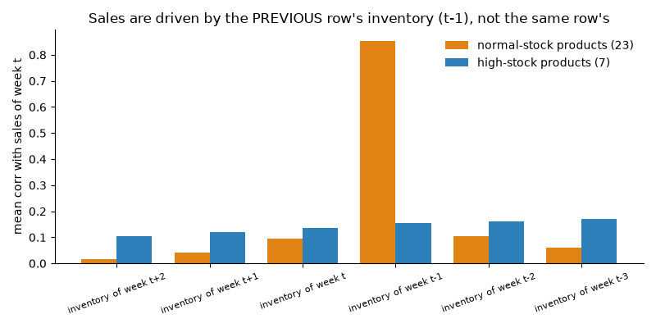
Figure 2. Sales follow the previous week's inventory, not the same week's. Orange: 23 normal-stock products; blue: 7 high-stock products.
The seven high-stock products show a flat pattern: their stock is so large that it never limits sales, which is itself a confirmation (their sales do not track inventory because inventory is never the binding constraint).
Consequence
sales = min(demand, stock available). In 53 percent of product-weeks (1,329 stock-outs + 2,813 stock-limited weeks, out of 7,800) stock limits sales, so sales are a censored (cut-off) measure of demand. A forecast of raw sales would forecast stock availability. This finding drives Parts 2, 3 and 4: the forecast target is reconstructed demand, the dashboard reports service level and lost revenue, and the pricing engine treats a product that will sell out as scarce.

4.6 Step 4: The ETL pipeline, stage by stage
The pipeline is a notebook that runs the following stages. Each stage is designed so that nothing is lost and everything can be traced.
1. Extract. Check that the file exists and is readable, and that it has the 13 required columns; otherwise a typed exception stops the load (ExtractError for a missing or unreadable file, SchemaError for a missing column). Store an untouched copy of every raw row in the staging table stg_sales_raw.
2. Validate. Every row is checked against explicit rules: a valid week number, a known product, a positive price, non-negative sales, inventory present. A row that violates a rule goes to the quarantine table with the rule name and the raw row as JSON. The reason codes are non_positive_unit_price, missing_product, invalid_week, sales_unrecoverable, negative_sales_units, missing_inventory_level and conflicting_duplicate_key. In this file zero rows were quarantined; the rules are proven by the exception tests in 4.9.
3. De-duplicate. Exact duplicates are dropped (39) and counted in the data-quality log; duplicates with conflicting values would be quarantined.
4. Recover. Missing sales are recovered as Revenue / Price and flagged. A corrupt non-numeric forecast such as 'n/a' is set to NULL and logged.
5. Clean and derive. Infinite growth becomes NULL; revenue, gross profit, margin, growth and turnover are recomputed; new columns are added: stock_available_for_sales, the winsorised sales copy, implied operating expenses (gross profit minus operating profit), the product category and the inventory profile.
6. Flag. Nine flag columns are set: imputed sales, zero sales, sales pile-up, inventory pile-up, stock-out week, stock-limited week, stock unknown (first week of a product), sales outlier and forecast missing.
7. Load. The star schema is written inside one transaction (all or nothing). The run is recorded in the run log, and the load is idempotent.
Flag | Rows | Share of fact table | Meaning
flag_sales_imputed | 16 | 0.21% | Sales recovered as Revenue / Price
flag_zero_sales | 1,329 | 17.04% | Sales = 0 (always a stock-out week)
flag_sales_pileup | 2,116 | 27.13% | Sales exactly 1,500 or 2,500
flag_inventory_pileup | 4,143 | 53.12% | Inventory exactly 0, 1,500 or 2,500
flag_stockout_week | 1,329 | 17.04% | Stock available = 0, so sales are forced to 0
flag_stock_limited | 2,813 | 36.06% | Sales equal stock available (> 0): demand is cut off
flag_stock_unknown | 30 | 0.38% | First week of a product: no previous inventory
flag_sales_outlier | 23 | 0.29% | Robust z-score above 4
flag_forecast_missing | 606 | 7.77% | Legacy forecast missing

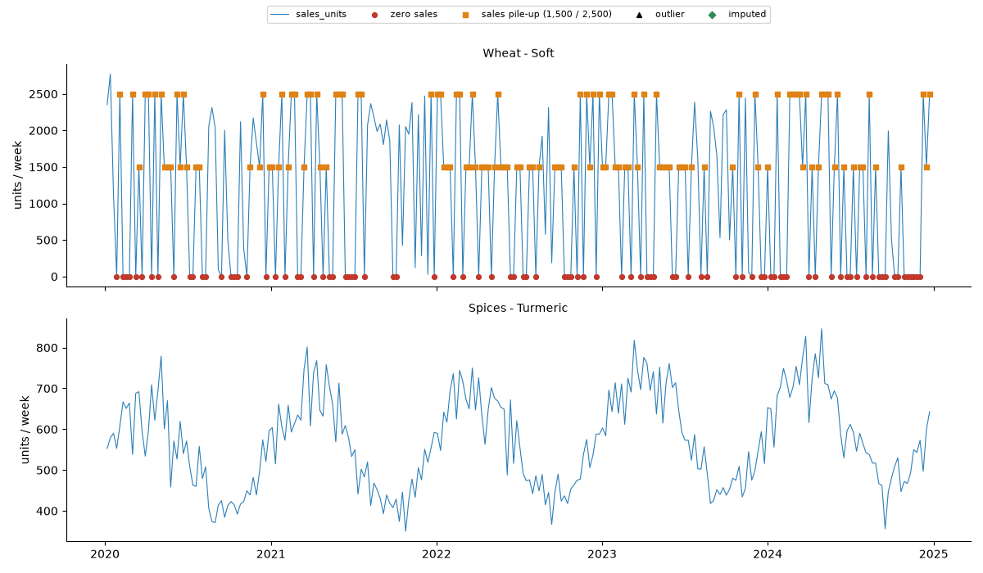
Figure 3. Examples of flagged weeks: sales stuck at the stock caps and weeks with zero sales.

4.7 Step 5: The database
The database is SQLite, a single file that needs no server. A star schema separates descriptive tables (dimensions) from the measurements (the fact table), so that every later question is a simple query: join the fact table to the product and date tables and group.
Table | Rows | Content
dim_product | 30 | Product name, category (8 categories derived from the product name: an assumption), variant (the part after ' - '), inventory profile: 'high_stock' when mean inventory is more than 5 times mean weekly sales (7 products), otherwise 'normal' (23 products)
dim_date | 260 | A synthetic Monday start date, week end date, year, quarter, month, month name, week of year (1-52), season (northern hemisphere) and year index (1-5)
fact_weekly_sales | 7,800 | Units sold (and a winsorised copy), unit price, unit cost, inventory level, stock available for sales, legacy forecast, revenue, gross profit, operating profit, implied opex, margin, turnover, growth (recomputed and original) and the nine flags
stg_sales_raw | 7,839 | The untouched copy of the raw file
data_quality_log | - | Every correction with the number of rows affected
quarantine_rows | 0 | Rejected rows with the reason and the raw row as JSON
etl_run_log | - | One row per run: time, counts, status

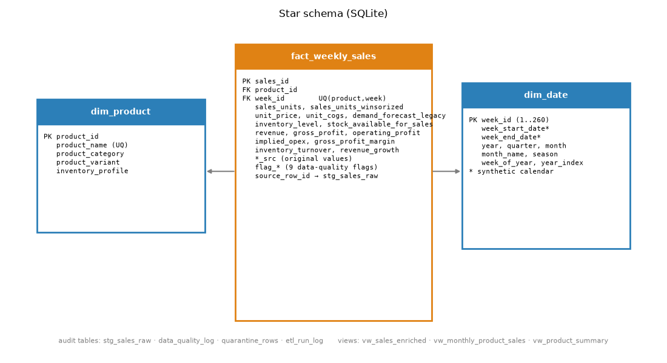
Figure 4. The star schema.
Example of why this design helps: revenue and gross margin by category and quarter is one query that joins fact_weekly_sales to dim_product (category) and dim_date (quarter) and sums revenue and gross profit; no text parsing or date arithmetic is needed in later parts.

4.8 Step 6: Measuring data quality before and after
Quality is measured on five dimensions. Each is the share of values (or rows) that satisfy a rule, so the scorecard can be recomputed by anyone:
Dimension | Rule | Raw file | Database
Completeness | Base fields are not empty | 98.4% | 98.5%
Uniqueness | No duplicate (product, week) key | 99.5% | 100%
Validity | Values finite, non-negative, price above cost | 88.6% | 100%
Derived-field consistency | Revenue, profit, margin, growth and turnover match their definitions | 36.6% | 100%
Stock plausibility | Sales do not exceed the stock available for them | 75.4% | 100%
Integrity index | Mean of the five dimensions | 79.7% | 99.7%

Completeness stays at 98.5 percent because the 606 missing legacy forecasts are deliberately kept empty (see challenge 3); every other dimension reaches 100 percent.
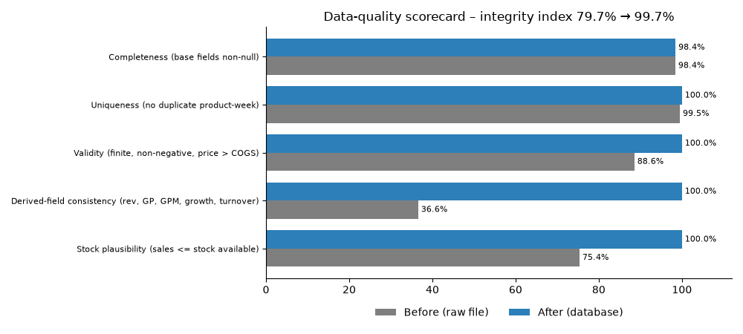
Figure 5. The data-quality scorecard before and after the pipeline.

4.9 Step 7: Proving that the pipeline works
Two sets of tests protect the pipeline. They exist because a pipeline that was only run on clean data has never really been tested.

Fifteen exception tests
The pipeline is run on a deliberately corrupted copy of the file, and each injected problem must be handled in the intended way:
Injected problem | Expected handling | Result
Non-positive unit price | Row quarantined (non_positive_unit_price) | Pass
Missing product | Row quarantined (missing_product) | Pass
Invalid week (two cases) | Row quarantined (invalid_week) | Pass
Sales unrecoverable (no revenue to recover from) | Row quarantined (sales_unrecoverable) | Pass
Negative sales units | Row quarantined (negative_sales_units) | Pass
Missing inventory level | Row quarantined (missing_inventory_level) | Pass
Conflicting duplicate key | Row quarantined (conflicting_duplicate_key) | Pass
Corrupt text 'abc' in sales | Recovered from revenue / price | Pass
Corrupt text 'n/a' in forecast | Set to NULL and logged | Pass
Exact duplicate row | Dropped (1) | Pass
Bad rows | Never reach the fact table (0) | Pass
Missing input file | ExtractError | Pass
Missing column | SchemaError | Pass
Unreadable file | ExtractError | Pass

Sixteen validation checks
After the real load the database is compared with the source: fact rows = products x weeks (7,800); 30 product rows and 260 date rows; staging = fact + duplicates + quarantined = 7,839 and equals the raw row count; no foreign-key violations; no duplicate (product, week) keys; no NULL sales; no sale above the stock available for it; every stock-out week has zero sales; revenue equals units x price and gross profit equals revenue minus units x cost in every row; no infinite growth values; total revenue in the database equals the total computed independently with pandas to the cent; flag counts equal the pandas counts; and the data-quality log agrees with the quarantine table. All pass.

4.10 Outputs, assumptions, limits and hand-over
• Outputs: the database armani_trade, the SQL schema, an Excel workbook (8 sheets, Summary first: Summary, Scorecard, Flags, Inventory_Timing, Exception_Tests, Validation, Data_Dictionary, Assumptions), five figures and a run log.
• Assumption: dates are synthetic (week 1 = 6 January 2020). Seasonal findings are relative to the 52-week cycle, not to real months.
• Assumption: product categories are derived from product names (there is no category column).
• Assumption: the stock that limits a week's sales is the previous row's inventory (verified by four predictions in 4.5).
• Limit: Inventory_Turnover_Ratio had no documented definition; it was recomputed with an explicit definition and the original kept.
• Hand-over to Part 2: a clean fact table with stock_available_for_sales, the censoring flags and the legacy forecast. The decisive information passed on is that sales are censored by stock.

5. Part 2 (a): Pre-processing for forecasting

5.1 Goal and the question it answers
The goal of Part 2 is to forecast the demand of each of the 30 products for each of the next 26 weeks (weeks 261 to 286), with a range of likely outcomes. It is not trivial because of the finding in Part 1: observed sales are not demand. The work therefore has two stages. This chapter covers the first stage, pre-processing: build a trustworthy forecast target and understand what drives demand. The next two chapters cover modelling (how models were compared and tuned) and the results.

5.2 Forecasting concepts used in Part 2
Concept | Plain explanation
Forecast horizon | How far ahead the forecast looks. Here 26 weeks, for 30 products: 780 forecasts.
Level | How big a product normally is: its typical weekly demand.
Trend | A slow drift up or down over the years. Here about +2.8% a year.
Seasonality | A pattern that repeats every year: some weeks are busier than others. Here all 30 products are busy and quiet at the same times of year.
Seasonal factor | A multiplier for a week of the year: 1.00 is a normal week, 1.25 is 25% busier, 0.75 is 25% quieter.
Fourier terms | A way to write a repeating yearly curve as a sum of a few smooth waves (sine and cosine). The order K is the number of waves: K=1 gives one smooth rise and fall, higher K allows more detail.
Logarithm (log) scale | Working with the logarithm of demand turns multiplication into addition: level x trend x season becomes level + trend + season. It also makes size differences between products comparable.
Censoring | When a measurement is cut off at a limit: sales cannot exceed stock, so sales are a censored view of demand.
Free parameter | A model setting that must be chosen (for example K). It is not learned by the model itself.
Cross-validation | Choosing a setting by repeatedly hiding part of the training data, predicting it, and keeping the setting that predicts the hidden part best.
Over-fitting | A model that follows noise in the training data and then predicts new data badly. Models with few parameters over-fit less.

5.3 Step 1: Classify every week by stock censoring
Because sales = min(demand, stock available), each product-week falls into one of four types. The type tells how much can be known about the demand of that week:
Type | Rule | Weeks | Share | What is known about demand
Unconstrained | sales < stock available | 3,628 | 46.5% | Demand equals the observed sales
Stock-limited | sales = stock available (> 0) | 2,813 | 36.1% | Demand is at least the sales
Stock-out | stock available = 0 | 1,329 | 17.0% | Sales are 0; demand is hidden but positive
Stock unknown | first week of a product | 30 | 0.4% | No previous inventory exists

The 7 high-stock products are almost never capped (98.8 percent of their weeks are unconstrained), while the 23 normal-stock products are capped about two-thirds of the time (only 30.6 percent unconstrained). The unconstrained weeks are special: there demand is known exactly. They are used later as 'truth cells' to validate the reconstruction and to score models honestly.
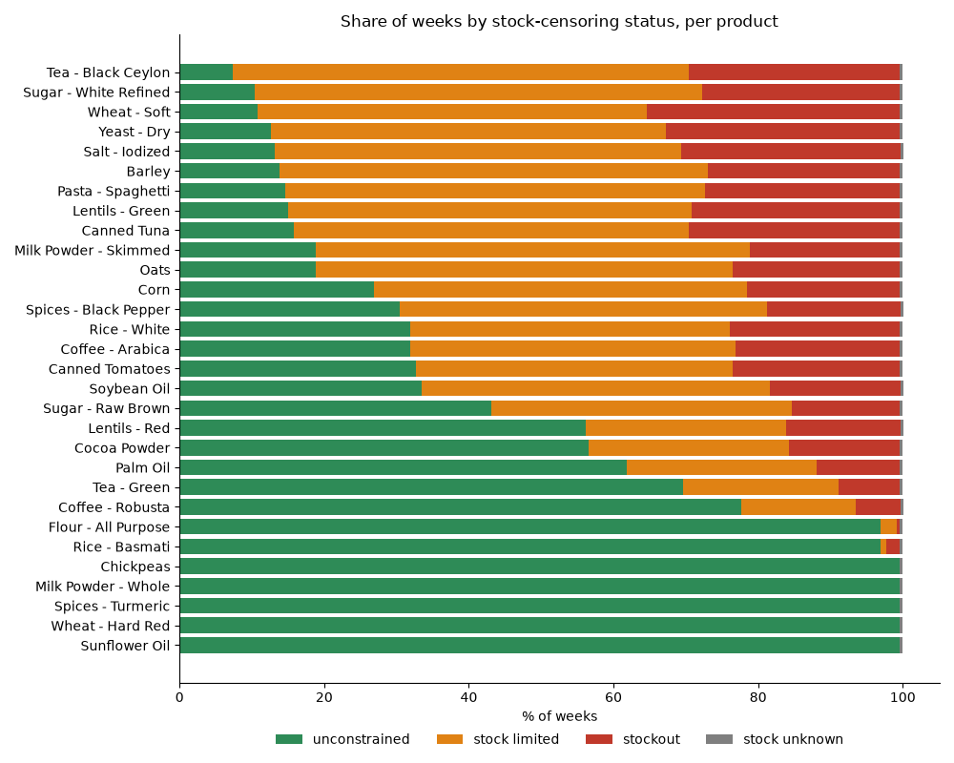
Figure 6. Share of weeks of each type for every product.

5.4 Step 2: Is the company's forecast a usable measure of demand?
The file contains the company's own forecast (Demand_Forecast, called the legacy forecast here). In Part 1 its correlation with sales was only 0.21, which suggests it is poor. But that comparison used censored sales: a forecast of true demand should be above sales in weeks when stock ran out. The fair test uses only unconstrained weeks, where sales equal demand:
Measure (3,347 unconstrained weeks) | Value
Correlation with true demand | 0.97
Bias | -0.35% (practically none)
Mean absolute percentage error (MAPE) | 7.9%
Mean absolute error | 111 units
Spread of the ratio forecast / demand | about 10% (multiplicative noise)

On unconstrained weeks the legacy forecast is therefore unbiased with about 10 percent noise: a good, noisy measure of demand. On censored weeks it is mostly above the observed sales, exactly as a demand measure should be. It was never a bad forecast; it was being compared with the wrong target. This matters because it can be used as an ingredient of the demand estimate (606 values are missing and are handled below).
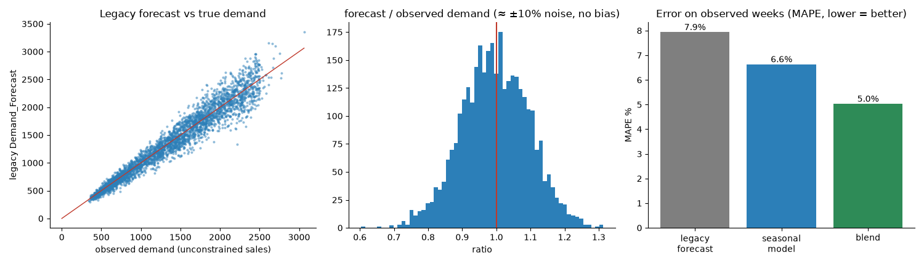
Figure 7. The legacy forecast against true demand on unconstrained weeks.

5.5 Step 3: Reconstruct demand (the target column demand_est)
For every product-week a demand estimate demand_est is computed according to the week type:
Week type | demand_est | Source label | Rows
Unconstrained | observed sales | observed | 3,628
Censored or unknown, legacy forecast available | max(sales, 0.40 x legacy forecast + 0.60 x seasonal model) | forecast_blend | 3,847
Censored or unknown, legacy forecast missing | max(sales, seasonal model) | model_only | 325

The max() guarantees that the estimate is never below what was actually sold. The seasonal model that supplies the second ingredient is described next, and then the blend weight.

The seasonal model
A simple log-linear model: log demand = product level + shared trend + a shared yearly curve written with Fourier terms. It uses all 30 products at once to estimate the curve and one level per product. It is trained on 'reliable' demand values: the observed sales in unconstrained weeks and, in censored weeks where the legacy forecast exists, the larger of the legacy forecast and the sales. Fitting one curve on thousands of weeks and 30 products smooths over most of the week-specific noise of the legacy forecast. Its two free parameters, the Fourier order K (1 to 10) and whether the trend is shared or per product, were chosen by blocked five-fold cross-validation: the weeks are cut into contiguous 4-week blocks, the blocks are assigned at random to five folds, each fold is hidden in turn, and the model is scored on the hidden weeks where demand was observed (unconstrained weeks). The setting with the lowest error is kept, applying the one-standard-error rule: prefer the simplest setting whose error is within one standard error of the best. Result: K = 2 with a shared trend (cross-validated MAPE 6.66 percent). Any K from 1 to 10 with a shared trend lies within 0.03 points, so the exact choice matters little; a trend per product is never better, which supports a shared trend.
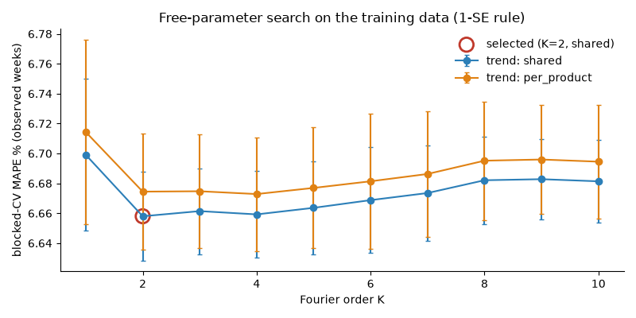
Figure 8. Cross-validated error for each Fourier order and trend structure.

The blend weight
The legacy forecast knows week-specific information (a promotion, a delay, a customer order) that a smooth seasonal model cannot know; the seasonal model, on the other hand, averages the noise away over many weeks and products. A weighted average of the two is better than either. The weight 0.40 on the legacy forecast was fitted on out-of-fold model predictions on unconstrained weeks (the model never uses the week it predicts) and confirmed on products not used for fitting (0.40 and 0.40). How good is each ingredient, and the blend? Tested on the unconstrained weeks, where demand is known:
Method | Error (MAPE) | Mean absolute error (units) | Correlation with truth
Legacy forecast alone | 7.9% | 111 | 0.97
Seasonal model alone (out-of-fold) | 6.6% | 91 | 0.98
Blend 0.40 / 0.60 | 5.0% | 70 | 0.99

Three real rows
Three real rows of the dataset (all Barley) show the three cases:
Case | Barley week | Sales | Stock available | Legacy forecast | Seasonal model | demand_est
Unconstrained | 28 | 2,201 | 2,500 | 2,211 | 2,343 | 2,201 (= sales)
Stock-limited | 2 | 2,500 | 2,500 | 2,733 | 2,611 | 2,659 (+6.4% above sales)
Stock-out | 4 | 0 | 0 | 3,195 | 2,758 | 2,925

In week 28 stock (2,500) was above the sales (2,201), so the week is unconstrained and demand equals sales. In week 2 sales exactly equal the stock, so demand is at least 2,500: the blend gives 0.40 x 2,733 + 0.60 x 2,611 = about 2,659, which is above the sales, so 2,659 is used. In week 4 stock was zero and nothing was sold, yet the blend says customers wanted about 2,925 units.
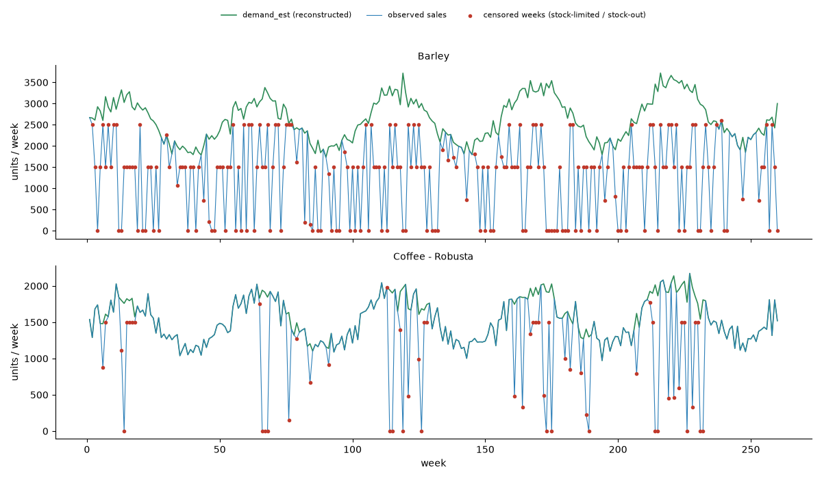
Figure 9. Observed sales (capped) and reconstructed demand for example products.

What the reconstruction says
The estimated lost demand is about 6.2 million units, 39 percent of the reconstructed demand. The table shows the products with the largest shares lost (full list in the workbook):
Product | Sales (units) | Reconstructed demand | Lost share
Yeast - Dry | 341,199 | 781,762 | 56%
Wheat - Soft | 310,244 | 708,409 | 56%
Tea - Black Ceylon | 352,734 | 794,072 | 56%
Salt - Iodized | 323,530 | 704,660 | 54%
Lentils - Green | 353,996 | 752,204 | 53%
Sugar - White Refined | 356,535 | 744,286 | 52%

Caveat
Unconstrained weeks are slightly biased toward lower demand (they are, by construction, the weeks where demand was below stock). The blend weight is a single low-risk parameter, but the accuracy of the blend on censored weeks is an estimate. For this reason model accuracy is later reported both on all weeks and on unconstrained weeks only, which does not depend on the reconstruction at all.

5.6 Step 4: What drives demand? (evidence for the features)
Before building a model it pays to find out what demand depends on. Each candidate driver was tested with evidence:

Calendar effects
For each metric (demand, price, cost, unit margin, stock level) the share of variance explained by week of year, month, quarter or season was compared with a permutation null: the labels are shuffled within each product 100 times and the explained share is recomputed, which shows how much 'explanation' appears by pure chance. Week of year explains 78 percent (7 high-stock products) to 86 percent (23 normal-stock products) of the variance of demand; price, cost and unit margin have no calendar effect; stock level has only a small one (5 percent). Because the dates are synthetic, 'month' and 'season' labels are illustrative; the 52-week position is what matters.
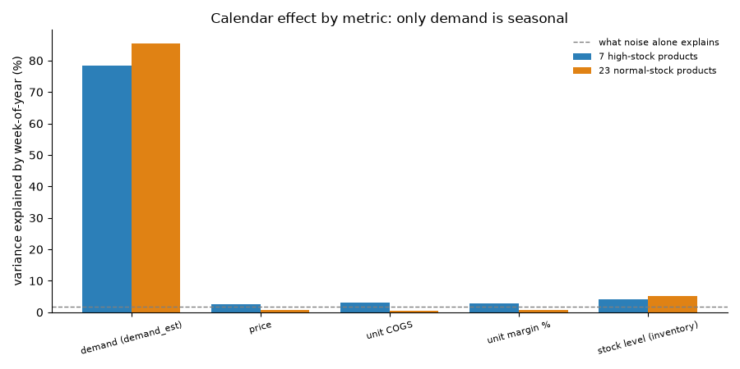
Figure 10. Share of variance explained by the calendar, compared with chance.

One shared seasonal curve
The 52-week demand profiles of all 30 products correlate 0.97 on average (minimum 0.94). All products are busy and quiet at the same times of the year. The shared curve peaks in week 13 (25 percent above a normal week) and is quietest in week 38 (25 percent below), a swing of 1.67 times between the quietest and the busiest week. Clustering products by profile shape (silhouette 0.31) adds little because the shapes are almost identical.
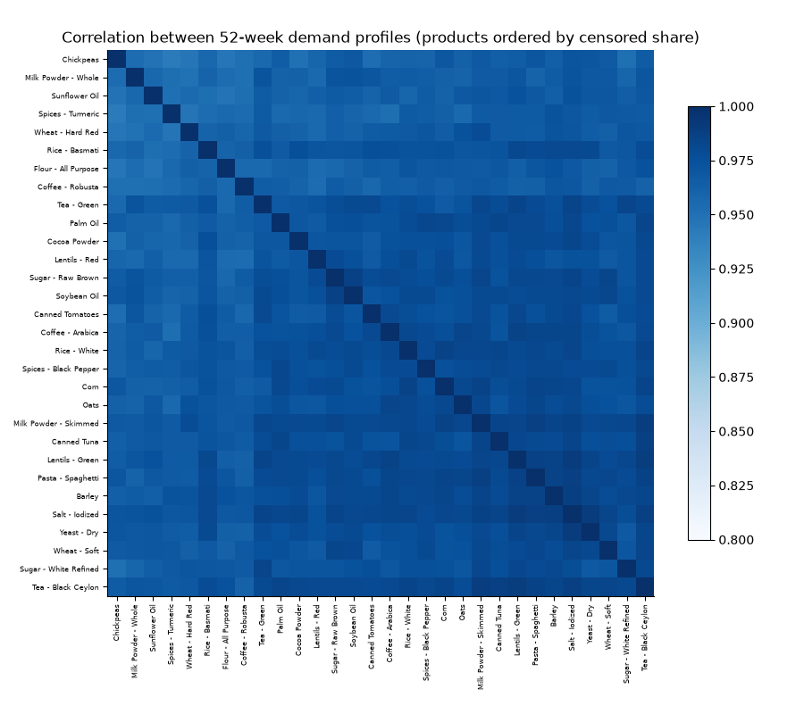
Figure 11. Correlation of the yearly profiles between products (all high).
Week of the year | Seasonal factor | Against a normal week
1 | 1.03 | +3%
5 | 1.14 | +14%
9 | 1.23 | +23%
13 | 1.25 | +25%
17 | 1.22 | +22%
21 | 1.14 | +14%
26 | 1.00 | -0%
30 | 0.88 | -12%
34 | 0.79 | -21%
38 | 0.75 | -25%
42 | 0.77 | -23%
46 | 0.83 | -17%
50 | 0.94 | -6%

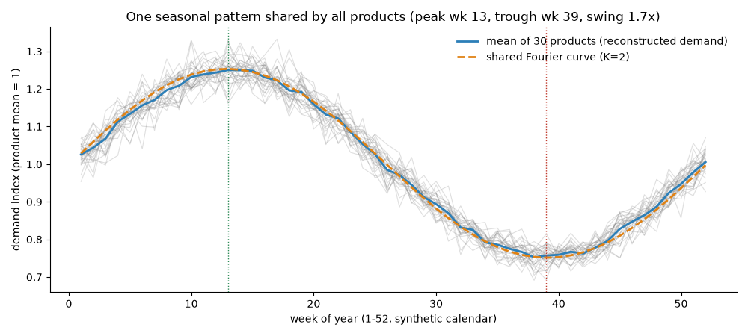
Figure 12. The shared seasonal curve: empirical index and model index.

Trend
Growth of about 2.8 percent a year (last 52 weeks against the 52 before). A seasonal-trend decomposition (STL) of total demand gives a seasonal strength of 1.00 and a trend strength of 0.92 on a scale where 1 means fully explained.

Stock regimes
Products differ in how often their sales are capped. K-means clustering on three numbers per product (stock-out rate, capped-week rate and stock cover) gives 2 regimes (silhouette 0.67). They describe how often sales are capped, which matters for risk in Parts 3 and 4, not for the shape of demand.

Price and cost
A within-product regression of log demand on log price (controlling for product level, season and trend, with errors clustered by product) gives a price effect of -0.017 with a 95 percent interval of -0.056 to +0.021. Price varies only 4 percent within a product, so the data cannot show how demand reacts to price. The effect of cost on demand is 0.046. There is no measurable price effect in this data, so price is not used as a feature. This finding returns in Part 4.

Stock level
True demand should not depend on stock; stock only caps sales. A check confirms that reconstructed demand is not related to stock levels once capping is accounted for, so stock is not a demand feature either.

5.7 Step 5: The 30 products at a glance
The table summarises the products used in the forecast. 'Capped weeks' is the share of weeks that were stock-limited or out of stock; 'Lost demand' is the estimated share of demand not served; 'Growth' is the product's own yearly growth.
Product | Category | Stock profile | Regime | Mean weekly demand (units) | Capped weeks | Lost demand | Growth a year
Tea - Black Ceylon | Beverages & Cocoa | normal | R2 | 3,054 | 92% | 56% | +2.4%
Yeast - Dry | Spices & Seasonings | normal | R2 | 3,007 | 87% | 56% | +2.8%
Lentils - Green | Pulses | normal | R2 | 2,893 | 85% | 53% | +2.6%
Pasta - Spaghetti | Cereals & Grains | normal | R2 | 2,875 | 85% | 51% | +2.7%
Sugar - White Refined | Sugar | normal | R2 | 2,863 | 89% | 52% | +3.1%
Canned Tuna | Canned Foods | normal | R2 | 2,796 | 84% | 52% | +2.6%
Wheat - Soft | Cereals & Grains | normal | R2 | 2,725 | 89% | 56% | +2.9%
Salt - Iodized | Spices & Seasonings | normal | R2 | 2,710 | 86% | 54% | +2.6%
Barley | Cereals & Grains | normal | R2 | 2,630 | 86% | 49% | +3.1%
Milk Powder - Skimmed | Dairy | normal | R2 | 2,556 | 81% | 44% | +3.2%
Oats | Cereals & Grains | normal | R2 | 2,537 | 81% | 45% | +3.2%
Corn | Cereals & Grains | normal | R2 | 2,312 | 73% | 40% | +3.1%
Spices - Black Pepper | Spices & Seasonings | normal | R2 | 2,275 | 69% | 37% | +2.5%
Coffee - Arabica | Beverages & Cocoa | normal | R2 | 2,256 | 68% | 40% | +2.7%
Soybean Oil | Oils & Fats | normal | R2 | 2,249 | 66% | 39% | +2.7%
Rice - White | Cereals & Grains | normal | R2 | 2,190 | 68% | 41% | +3.2%
Canned Tomatoes | Canned Foods | normal | R2 | 2,187 | 67% | 40% | +2.4%
Sugar - Raw Brown | Sugar | normal | R2 | 2,046 | 56% | 32% | +2.8%
Palm Oil | Oils & Fats | normal | R2 | 1,981 | 38% | 25% | +2.6%
Cocoa Powder | Beverages & Cocoa | normal | R2 | 1,906 | 43% | 27% | +2.0%
Lentils - Red | Pulses | normal | R2 | 1,754 | 44% | 27% | +2.8%
Tea - Green | Beverages & Cocoa | normal | R2 | 1,710 | 30% | 19% | +3.0%
Coffee - Robusta | Beverages & Cocoa | normal | R1 | 1,547 | 22% | 14% | +2.9%
Flour - All Purpose | Cereals & Grains | high | R1 | 1,351 | 3% | 2% | +2.9%
Rice - Basmati | Cereals & Grains | high | R1 | 1,232 | 3% | 3% | +2.8%
Chickpeas | Pulses | high | R1 | 1,039 | 0% | 0% | +3.0%
Milk Powder - Whole | Dairy | high | R1 | 803 | 0% | 0% | +2.8%
Sunflower Oil | Oils & Fats | high | R1 | 764 | 0% | 0% | +2.5%
Spices - Turmeric | Spices & Seasonings | high | R1 | 571 | 0% | 0% | +3.3%
Wheat - Hard Red | Cereals & Grains | high | R1 | 555 | 0% | 0% | +3.1%

5.8 Step 6: Feature engineering
Feature engineering means building the input columns that give a model the information it needs in a form it can use. In this project features were built in three layers, each with a purpose. The rules for all layers: only information known at the forecast origin is ever used, and the legacy forecast is never a model input (it only helps to build the target).

Layer A: data and stock features (built in the ETL)
The most important feature of the whole project is stock_available_for_sales, the previous row's inventory. It turned an apparent data error into the explanation of the sales pattern. Together with the censoring status (unconstrained, stock-limited, stock-out, unknown) and the flags for stock-outs, caps, pile-ups, imputed values and outliers, it tells every later step how much to trust a given row. Recomputed margin, growth and turnover and the winsorised sales copy belong to this layer.

Layer B: target and structure (built in pre-processing)
demand_est (with its source label and the uplift above sales in percent), the seasonal-model prediction, calendar fields derived from the synthetic dates (week of year, quarter, season, year index), the stock regime (k-means) and the high-stock / normal-stock profile, and product descriptors such as mean demand, variability and the share of capped weeks.

Layer C: model inputs (built in the forecasting notebook)
The winning structural model needs only three things: a product level, a trend and sine and cosine pairs of the week of the year. The machine-learning model (LightGBM) receives a richer set known at the forecast origin: the horizon (1 to 26 weeks ahead), week of year and its sine and cosine terms (three pairs), a trend index, the demand of the same week last year and of its two neighbouring weeks, the average demand of the last 13, 26 and 52 weeks, the last observed value, and product, segment, regime and category codes. Its target is demand expressed relative to the product's 52-week level, which removes product size and lets one model serve all products.
Layer | Built in | Features | Purpose
A. Data and stock | ETL | stock_available_for_sales; censor status; nine flags; recomputed margin, growth and turnover; winsorised sales | What does each sales number measure?
B. Target and structure | Pre-processing | demand_est and its source; seasonal-model prediction; calendar fields; stock regime; stock profile; product descriptors | The target and the product descriptors
C. Model inputs | Forecasting | Structural: level, shared trend, sine/cosine of week. LightGBM: horizon, week of year (+ sin/cos), trend index, same week last year and neighbours, 13/26/52-week levels, last value, product / segment / regime / category codes; target relative to the 52-week level | Simple structure against a richer learner

What the learner relied on
The feature importance of the LightGBM model (share of gain) confirms the earlier evidence: week of year 45.6 percent, the first seasonal sine term 31.9 percent, last year's neighbouring weeks 10.7 percent, the second cosine term 6.8 percent, last year's same week 2.9 percent and the third sine term 1.7 percent. Together these carry about 95 percent of the importance. Product size, level features and category codes carry almost nothing once the target is relative to the 52-week level. In plain words: even a flexible learner discovers that season and last year's pattern are what matter, which supports using a simple structure built on exactly those two things.
Feature | Share of importance
Week of year | 45.6%
Seasonal term sin 1 | 31.9%
Last year, neighbouring weeks | 10.7%
Seasonal term cos 2 | 6.8%
Last year, same week | 2.9%
Seasonal term sin 3 | 1.7%
All other features together | 0.4%

5.9 Outputs, assumptions and hand-over
• Outputs: the forecast dataset database (demand_panel with 7,800 rows, product_profile, calendar_future with the 26 future weeks, last_known prices and costs, seasonal_curve, parameters) and an Excel workbook (8 sheets: Summary, Censoring_Overall, Legacy_Validation, Reconstruction_Validation, Param_Search_CV, Lost_Demand_By_Product, Seasonal_Curve, Assumptions).
• Assumption: the legacy forecast is a noisy unbiased measure of demand (validated on unconstrained weeks only).
• Assumption: demand in capped weeks is at least the sales and is well described by the blend of the legacy forecast and the seasonal model.
• Limit: unconstrained weeks lean toward lower demand, so the accuracy of the reconstruction on censored weeks is an estimate.
• Hand-over to the modelling stage: one target column (demand_est), a calendar for the 26 future weeks, the last known price and cost per product, and the evidence that season, last year's pattern and product size are what matter.

6. Part 2 (b): How the forecasting models were built and tested

6.1 What is predicted
The predicted column is demand_est: the number of units customers wanted for each product in each week, 26 weeks ahead and for 30 products (780 forecasts). The inputs of the models are the past values of demand_est, the week of the year and the product. The legacy forecast is excluded from the models to avoid leakage: it was used to help build the target, so feeding it to a model would let the model borrow part of the answer.
Forecasting demand (not sales) is the central design decision of Part 2. It means that a model is asked how many units customers want, and the dashboard and pricing engine then combine this with stock to say how many units can actually be sold.

6.2 Why a rolling backtest instead of one train/test split
A forecast is judged by how well it predicts weeks that were not used to build it. The typical way to measure this is one split: train on the first part of the data, test on the rest. With seasonal data this is risky, and a different design was chosen.
• One split gives one number that depends on which weeks fall in the test window. With strong seasonality (a swing of 1.67 times between the quietest and the busiest week) an easy season flatters a model and a hard season punishes it. The ranking of models could change simply by moving the cut.
• A random split (hiding random weeks) is worse: the neighbouring weeks of a hidden week are in the training data, and so is the same week of other years, so the model is graded on weeks it has practically seen. This is called leakage.
• The real task is 'learn from everything up to today, forecast the next 26 weeks'. The test should look exactly like that task, and it should be repeated at several dates to see whether the result is stable.
The chosen design is a rolling-origin backtest. An origin is the last week of data that the model is allowed to see. At each of four origins (weeks 156, 182, 208 and 234) the model learns from weeks 1 to the origin and forecasts the next 26 weeks, which are then compared with what really happened. The final forecast follows the same logic with origin 260.
Test | Learns from weeks | Years of history | Forecasts weeks | Part of the year tested | Forecasts made
Test 1 | 1-156 | 3.0 | 157-182 | weeks 1-26 of the year | 780
Test 2 | 1-182 | 3.5 | 183-208 | weeks 27-52 | 780
Test 3 | 1-208 | 4.0 | 209-234 | weeks 1-26 | 780
Test 4 | 1-234 | 4.5 | 235-260 | weeks 27-52 | 780
Final forecast | 1-260 | 5.0 | 261-286 | weeks 1-26 (next year) | 780 (no actuals yet)

The origins were chosen 26 weeks apart so that the test windows alternate between the first and the second half of the year: every part of the season (the peak and the lull) is tested twice. Together the four tests give 4 x 26 x 30 = 3,120 test forecasts and four error numbers instead of one, which also reveals how stable a model is.
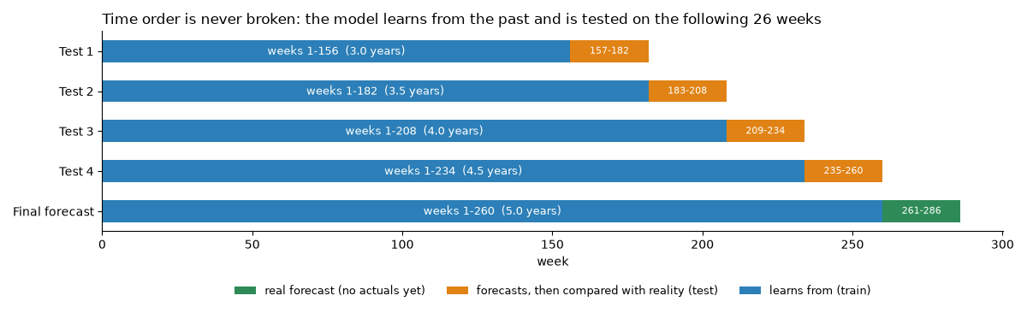
Figure 13. Time order is never broken: each test learns from the past and is scored on the next 26 weeks.

6.3 Three data sets: training, validation and test
Inside this design there are three roles for data. They never overlap:
Role | Which weeks | Purpose
Training | All weeks up to the origin, except the validation windows during tuning | The model learns its parameters (levels, trend, seasonal coefficients, tree structure)
Validation | The last 52 weeks before the origin, used as two inner 26-week windows (origin minus 52, origin minus 26), or as a trailing 26-week block | Choose the free parameters (for example K): each candidate is trained on the weeks before a validation window and scored on it
Test | The 26 weeks after the origin | Score the final, tuned model once. Test weeks never influence any setting

After tuning, the chosen setting is refitted on all training weeks (including the validation weeks) and only then makes its test forecast. This is the standard way to use all available history without letting the test weeks leak into the choices.

6.4 Metrics
• WAPE (weighted absolute percentage error) = sum of absolute errors / sum of actual demand. It is the primary metric because it weights errors by volume, so a big product counts more than a small one, and it stays stable when some weeks are small. A WAPE of 4.6 percent means that the forecast is wrong by 4.6 units in every 100 units of demand.
• MAE (mean absolute error) is the average miss in units. RMSE is the square root of the mean squared error; it punishes large misses more. MAPE (mean absolute percentage error) is the average of the percentage miss per product-week, reported because the assignment asks for it. MASE compares the error with that of a seasonal-naive forecast on the training weeks: below 1 means better than seasonal naive. Bias is the systematic tendency to over- or under-forecast.
• Paired bootstrap: to test whether the difference between two models is real, the 30 products are resampled with replacement 2,000 times and the difference in WAPE is recomputed each time; if the 95 percent interval of the difference excludes zero, the difference is real.
• Truth-cell WAPE: the same error measured only on unconstrained weeks, where demand equals observed sales. It does not depend on the demand reconstruction at all, and so protects against the criticism that the project graded itself on its own target.

6.5 The 13 candidate models
Thirteen models compete in the tournament. They cover the families that a forecasting practitioner would try, from rules of thumb to machine learning. All of them are given the same data, the same four tests and the same tuning discipline.
Code | Model | How it works | Free parameters
snaive | Seasonal naive | Forecast = demand of the same week last year | None
mean52 | Last-52-week mean | Forecast = average of the last 52 weeks (ignores season) | None
idx52 | Mean x shared seasonal index | Last-52-week mean times the shared seasonal factor of the week | None
recipe | Plain recipe: size x season x growth | Size = last-52-week mean; season = shared factor; growth = yearly growth (last 52 weeks against the 52 before) applied to the forecast week | None
ets | Holt-Winters (per product) | Exponential smoothing with a yearly seasonal pattern (52 weeks), fitted separately for each product | Trend none or damped; seasonality additive or multiplicative (by AICc)
sarimax | SARIMAX with Fourier terms (per product) | Regression of log demand on Fourier seasonal terms and a trend, with ARMA errors, per product | K in {2, 3}; ARMA order (1,0,0) or (1,0,1) (by AICc)
struct | Structural, pooled | One model for all 30 products: log demand = product level + trend + shared Fourier seasonality | K 1-8; trend shared or per product (inner CV)
struct_seg | Structural per segment | The same structural model fitted separately for the 7 high-stock and the 23 normal-stock products | As above, per segment
lgbm | LightGBM (global) | Gradient-boosted trees; one row per (origin, horizon, product); target relative to the 52-week level | Leaves, learning rate, min leaf size, feature fraction, L2, number of trees
lgbm_seg | LightGBM per segment | The same, trained per segment | As above
prophet | Prophet (per product) | A decomposable trend plus yearly seasonality model | Changepoint prior, Fourier order, additive or multiplicative
ens_mean | Average of 5 models | Mean of Holt-Winters, SARIMAX, structural, LightGBM and Prophet | None
ens_wf | Walk-forward average of the best 3 | Mean of the 3 models with the lowest error in earlier tests only (all 5 in the first test) | Which 3 (chosen from earlier tests)

6.6 How each model family works, and what to expect from it

Rules of thumb (baselines)
These involve no fitting. They are included on purpose: a complex model must beat a plain rule to deserve use. Seasonal naive repeats last year; it is the standard benchmark for seasonal data but it copies last year's noise. The last-52-week mean ignores the season and should be poor in a seasonal business. The mean times a shared seasonal index adds the season and is a strong baseline. The plain recipe adds yearly growth to it.

Classic statistics
Holt-Winters keeps a smoothed level, an optional trend and a yearly seasonal pattern for each product separately; it adapts to each product but has many parameters to estimate from five years of weekly data, so it tends to follow noise. SARIMAX fits a regression on yearly sine/cosine terms and a trend, and models the left-over errors with an ARMA process; it is a more flexible way to express the same seasonal idea per product.

The structural model
It pools all products: one set of seasonal coefficients shared by everybody, one trend, and one level per product. The shared seasonal curve is estimated from 30 products and five years at once, so it is very stable; each product only needs its level estimated. It is explained fully in chapter 7. The per-segment version fits the curve separately for high-stock and normal-stock products; the data shows that the two segments share the same shape, so the extra flexibility adds nothing.

Machine learning
LightGBM builds many small decision trees, each correcting the errors of the previous ones. Here one model is trained on rows 'product x origin x horizon' with features known at the origin (see 5.8). It can learn any pattern, including ones that are not there, so it needs careful tuning. Prophet, a model developed for business time series, decomposes a series into a trend with change points and a yearly seasonal pattern; it is run for each product separately.

Ensembles
Averaging forecasts often reduces error because different models make different mistakes. The fixed average uses five declared members. The walk-forward version chooses its three best members using only tests that happened before the one being forecast, so that the selection itself cannot leak information.

6.7 Tuning the free parameters
A free parameter is a model setting that is not learned by the model itself and has to be chosen. How these are chosen is where many forecasting projects quietly cheat, for example by picking the setting that scores best on the test weeks. Here every setting was chosen only on validation windows inside the training weeks:
Model | Free parameters searched | Chosen on | Selected
Demand reconstruction | Fourier order K 1-10, trend shared or per product; blend weight | Blocked 5-fold CV (4-week blocks), 1-SE rule; out-of-fold fit | K = 2, shared; weight 0.40
Structural (winner) | Fourier order K 1-8, trend shared or per product (16 combinations) | Two inner windows (T-52, T-26), WAPE | K = 3, shared trend (final fit)
Holt-Winters | Trend none or damped; seasonality additive or multiplicative (4 combinations) | AICc, per product | Per product
SARIMAX | Fourier K in {2, 3}; ARMA order (1,0,0) or (1,0,1) (4 combinations) | AICc, per product | K 2-3, (1,0,1)
LightGBM | Leaves {7, 15, 31}; learning rate {0.03, 0.08}; min leaf {20, 80}; feature fraction {0.7, 1}; L2 {0, 5} (10 random configurations); up to 1,500 trees | Trailing 26-week validation block with early stopping (50 rounds); trees refitted with 15% headroom | 7 leaves, rate 0.03, min leaf 80, feature fraction 0.7
Prophet | Changepoint prior 0.01 or 0.1; Fourier order 2 or 4; additive or multiplicative (8 combinations) | Inner CV on 6 sample products (3 high-stock, 3 normal), origins T-52 and T-26 | Prior 0.01, order 2
Ensembles | Members of the average; the top 3 of the walk-forward version | Earlier tests only | Structural, structural per segment, SARIMAX

AICc, the criterion used for Holt-Winters and SARIMAX, balances fit and complexity: it rewards a model that fits well but penalises one that needs many parameters. The 'inner CV' for the structural model works like this: for each of the 16 candidate settings, train on the weeks before origin minus 52 and score the next 26 weeks, then train on the weeks before origin minus 26 and score the next 26 weeks; average the two WAPE values; keep the best setting. The test weeks after the origin are never touched.
Why this matters
Every competitor received the same careful tuning, so the comparison in the next chapter is fair: the winning model did not win because the others were handicapped.

6.8 Guarding against leakage: a checklist
• Each model and each tuning step only sees weeks up to the origin.
• The legacy forecast is never a model input.
• Features use only information known at the origin (for example the demand of the same week last year is known, the demand of the week being forecast is not).
• The blend weight and the seasonal-model parameters of the reconstruction are chosen by cross-validation on training data and scored on observed weeks.
• The walk-forward ensemble chooses its members from earlier tests only.
• Accuracy is also reported on unconstrained weeks, which do not depend on the reconstruction.

7. Part 2 (c): Results, the winning model and the forecast

7.1 The tournament results
All 13 models were run on the same four tests (3,120 test forecasts each) with the tuning described in chapter 6. The table shows the average over the four tests. The last column is the WAPE measured only on unconstrained weeks (truth cells), where demand equals observed sales.
Model | WAPE | MAE | RMSE | MAPE | MASE | Bias | WAPE on unconstrained weeks
Shared-curve structural (pooled) - winner | 4.57% | 97 | 129 | 5.03% | 0.69 | +0.07% | 6.64%
Structural per segment | 4.57% | 97 | 129 | 5.04% | 0.69 | +0.02% | 6.63%
Ensemble: walk-forward top-3 | 4.61% | 98 | 130 | 5.06% | 0.69 | -0.13% | 6.63%
SARIMAX + Fourier (per product) | 4.68% | 99 | 132 | 5.14% | 0.70 | +0.00% | 6.74%
Ensemble: mean of 5 models | 4.69% | 99 | 132 | 5.14% | 0.71 | -0.28% | 6.70%
Plain recipe: size x season x growth | 4.72% | 100 | 132 | 5.14% | 0.71 | -0.66% | 6.62%
Prophet (per product) | 4.76% | 100 | 134 | 5.23% | 0.71 | +0.07% | 6.80%
LightGBM global | 4.78% | 101 | 135 | 5.24% | 0.72 | +0.10% | 6.81%
LightGBM per segment | 4.90% | 103 | 136 | 5.47% | 0.74 | -0.06% | 7.03%
Mean x shared seasonal index (best simple rule) | 5.28% | 112 | 145 | 5.56% | 0.79 | -2.70% | 6.81%
Holt-Winters (per product) | 5.55% | 118 | 153 | 5.95% | 0.83 | -1.63% | 7.36%
Seasonal naive (same week last year) | 6.96% | 147 | 191 | 7.39% | 1.03 | -2.72% | 8.81%
Last-52-week mean | 16.83% | 356 | 430 | 17.21% | 2.41 | +0.57% | 17.28%

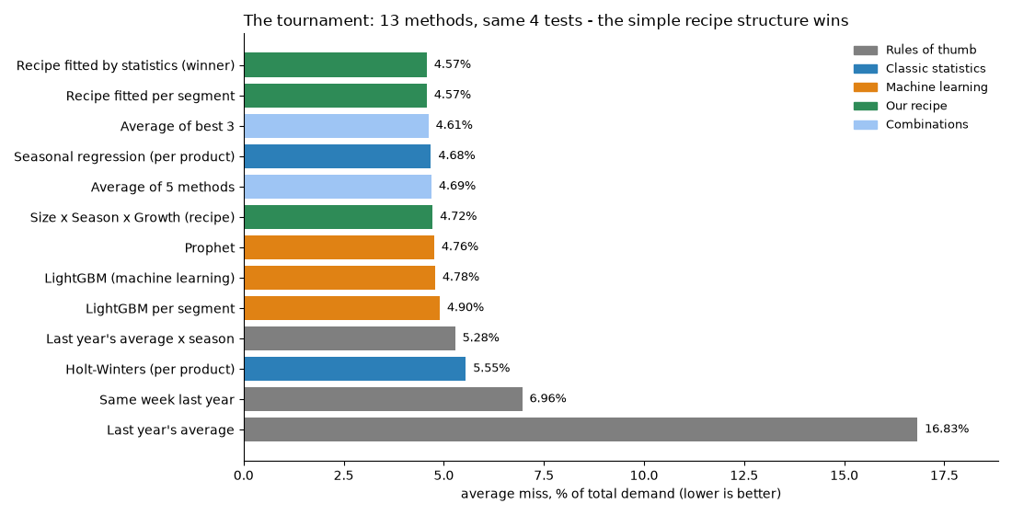
Figure 14. The tournament: 13 methods on the same four tests.

How to read the results
• The winner is 13 percent better than the best simple rule (5.28 percent) and 34 percent better than 'same week last year'. A paired bootstrap confirms it: the difference to the best simple rule is -0.72 percentage points with a 95 percent interval of -0.80 to -0.63, so zero is far outside. Against the runner-up (the same model fitted per segment) the difference is 0.00 (interval -0.01 to +0.01): a tie, so the simpler pooled model was selected.
• Machine learning does not win. LightGBM (4.78 percent) and Prophet (4.76 percent) are close but behind; Holt-Winters is worse than the simple rule. The reason is in the data: demand is governed by one shared seasonal curve, a level per product and a slow trend, which a structural model estimates from all products at once. Flexible learners must discover the same structure from less information per parameter.
• On unconstrained weeks the top models are practically tied between 6.6 and 6.8 percent: what matters is the structure of the problem, not the complexity of the model.
• The honest accuracy to quote is the truth-cell figure, 6.64 percent. The 4.57 percent is lower because reconstructed demand is smoother than reality in capped weeks (it is built from a smooth model), which makes those weeks easier to predict.
• Bias is almost zero for the winner (+0.07 percent): it neither over- nor under-forecasts on average. The simple baselines under-forecast by 2.7 percent.
• MASE of 0.69 means the winner's error is 31 percent smaller than the error of a seasonal-naive forecast measured on the training weeks.

7.2 Stability: error by test and by horizon
A good model must be good in every test, not only on average. The winner against three reference models in each of the four tests:
Test weeks | Structural (winner) | LightGBM | Mean x season index | Seasonal naive
157-182 | 4.32% | 4.62% | 5.09% | 6.75%
183-208 | 5.05% | 5.17% | 5.64% | 7.34%
209-234 | 4.31% | 4.51% | 5.09% | 6.36%
235-260 | 4.61% | 4.83% | 5.29% | 7.38%

The winner is best in every test, and its error varies between 4.3 and 5.1 percent (standard deviation over tests 0.35 points). The error also depends on how far ahead the forecast looks. It is higher in the first four weeks than for weeks 14 to 26, because the model assumes a smooth seasonal curve and the week-to-week noise is largest relative to that curve in the near term:
Model | Weeks 1-4 ahead | Weeks 5-13 ahead | Weeks 14-26 ahead
Structural, pooled (winner) | 4.88% | 4.66% | 4.43%
LightGBM | 5.08% | 4.86% | 4.65%
Prophet | 4.97% | 4.80% | 4.68%
Holt-Winters | 5.83% | 5.50% | 5.49%
Seasonal naive | 7.43% | 6.92% | 6.84%

7.3 The winning model explained
The winning model is the shared-curve structural model. In plain words: the demand of a product in a week equals the product's normal size, times a growth factor, times a seasonal factor.
demand(product, week) = product level x growth trend x seasonal factor
log demand = level + trend + sum over k of [ a_k sin(2 pi k week / 52) + b_k cos(2 pi k week / 52) ]
Part | Plain meaning | How it was found in the data
Product level | How big the product normally is: one number per product (30 numbers) | Products differ 5.5 times in size, from 555 units a week (Wheat - Hard Red) to 3,054 (Tea - Black Ceylon), so every product needs its own size
Growth trend | Is the business slowly growing? One shared yearly slope for all products, about +2.8% a year | Year-on-year comparison (last 52 weeks against the 52 before) and an STL trend strength of 0.92
Seasonal factor | A multiplier for the week of the year: 1.00 is a normal week, 1.25 means 25% busier. The same curve for all products | Week of year explains 78-86% of demand variance against a permutation null; the 30 products correlate 0.97; peak in week 13 (+25%), quiet week 38 (-25%)

How it is fitted. The model works in logarithms, where the three parts simply add up. The seasonal curve is written with K pairs of sine and cosine waves of the week of the year (K = 3 in the final fit), so it has 2K = 6 seasonal numbers. The coefficients are found by ordinary least squares on all 30 products and all training weeks at once. Because a model in logarithms predicts the typical value rather than the average, a small correction (the 'smearing' factor, the exponential of half the residual variance) is applied when converting back to units; it is close to 1.00 (for example 1.002).
Why it is hard to beat. With K = 3 the model learns only 30 levels + 1 trend + 6 seasonal coefficients = 37 numbers from 7,800 observations. Because all products share the curve, each seasonal coefficient is estimated from thousands of observations, so there is very little room to over-fit. A per-product model such as Holt-Winters must estimate its own seasonal pattern from five points per week of the year.

A worked example: Barley
Test 4 learns from weeks 1 to 234 and forecasts weeks 235 to 260 (the inner validation chose K = 2 there). For the first forecast week, week 235 (week 27 of the year), the model gives:
Step | Value | Meaning
Product level of Barley | 2,579 units | Barley's normal weekly size at the middle of the data period
Trend multiplier at week 235 | x 1.057 | About 5.7% above the middle of the period, from +2.8% a year growth
Seasonal multiplier for week-of-year 27 | x 0.983 | Week 27 is a slightly quiet week (1.7% below normal)
Smearing correction | x 1.002 | Converting from logarithms back to units
Forecast | 2,579 x 1.057 x 0.983 x 1.002 = 2,687 units
Actual demand_est | 2,505 units | The forecast is 7% too high in this week

Over the 26 test weeks the average miss is 4.8 percent for Barley and 4.6 percent for all products: single weeks can miss by 7 percent, but the errors average out because the model has no systematic bias. The plain recipe below expresses the same idea without statistics: Barley's average of the last 52 weeks (2,760 units) times the season (0.96) times growth (1.014) gives 2,690.
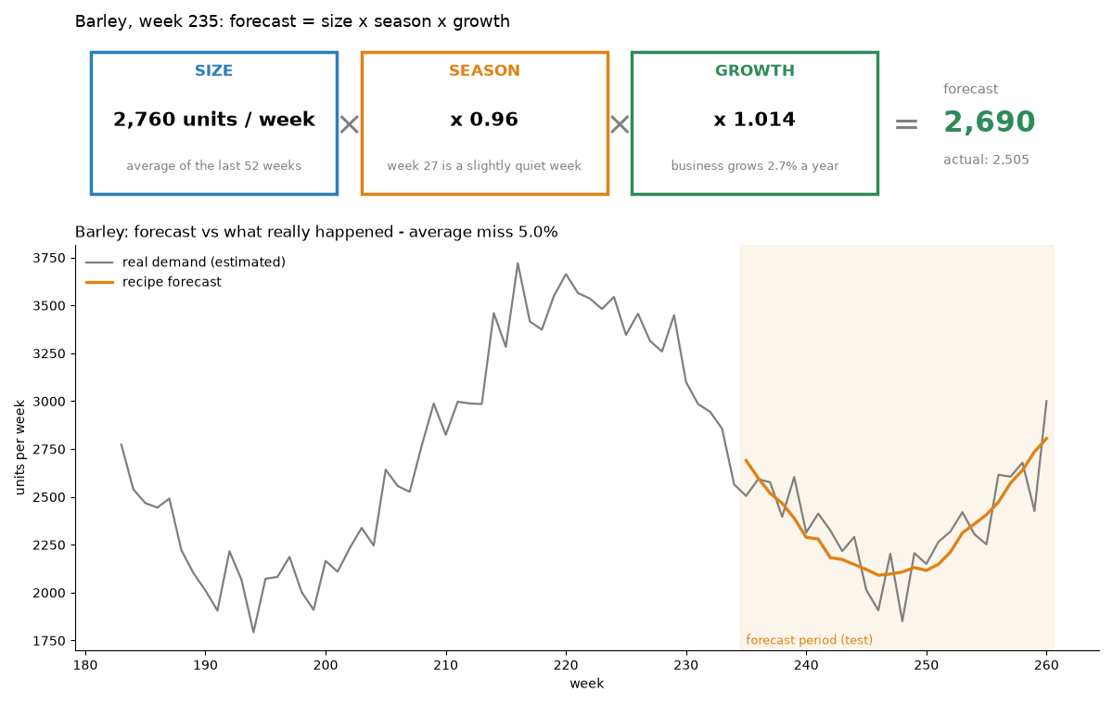
Figure 15. The same idea in its plain-recipe form for Barley: size x season x growth, and the forecast against what happened.

7.4 Segment results
By segment the winner has a WAPE of 4.35 percent for the 23 normal-stock products and 6.53 percent for the 7 high-stock products. The high-stock products have a higher error because for them every week is an unconstrained week: their demand is observed directly with all its noise, whereas the reconstructed demand of the normal-stock products is smoother. The two segments share the same seasonal shape, which is why fitting them separately (the per-segment model) gives no gain.

7.5 Forecast ranges (P10 to P90)
A forecast without a range invites false confidence. For every product-week the model gives a likely range from a low case (P10) to a high case (P90). They are computed from the ratios actual / forecast that the selected model produced in the backtests, taken by segment and by horizon bucket (weeks 1-4, 5-13, 14-26); the 10th and 90th percentiles of those ratios are applied to the new point forecast. The ranges were validated by leave-one-test-out coverage: the share of actual weeks that fall between P10 and P90 should be 80 percent.
Segment | Share of actuals inside P10-P90 (target 80%)
High-stock products | 79.95%
Normal-stock products | 80.14%
All products | 80.10%

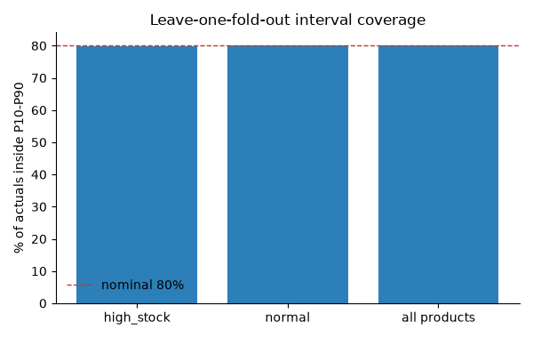
Figure 16. Coverage of the forecast ranges in the backtests.

7.6 The 26-week forecast
The selected model is refitted on all 260 weeks (all parameters re-tuned) and forecasts weeks 261 to 286. Total demand is about 1.998 million units, 2.8 percent above the same 26 weeks a year earlier. (It is about 40 percent above the preceding 26 weeks because those weeks are the seasonal low; that is season, not growth.) The likely range for the total is 1.84 to 2.15 million units. Weekly demand for all products together rises from about 67,700 units in week 261 to a peak of about 83,300 units in week 273 (the seasonal peak) and falls to about 66,500 units in week 286.
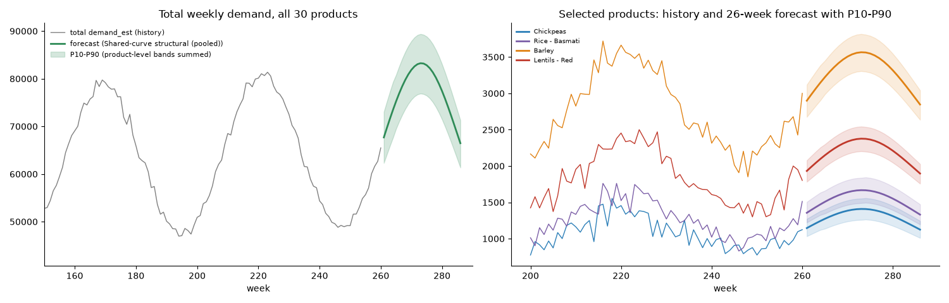
Figure 17. The 26-week forecast with the P10-P90 range (left: all products; right: selected products with history).

From units to dollars: how 64.6 million and 28.7 million are computed
Revenue potential. For every product-week, the forecast demand (P50) is multiplied by the product's last-13-week average price, and the 780 results are added: 1.998 million units give 64.6 million dollars. This is the revenue if every unit demanded could be sold.
Unserved revenue. Future stock is unknown, so for each product-week the units sold are simulated as min(demand, stock), with stock drawn from that product's own last 104 weeks of stock available for sales. The expected units sold are 1.09 million, worth 35.8 million dollars. The difference, 28.7 million dollars or 44 percent, is demand that the historical stock levels would not serve. It is a risk view, not a prediction, because purchasing can change.
Step | Value
Forecast demand, 780 product-weeks | 1,997,953 units
x each product's last-13-week average price | -
= Revenue potential | 64.6 million dollars
Expected units sold at historical stock levels (simulation) | 1,093,377 units
= Expected sales revenue | 35.8 million dollars
Unserved revenue = 64.6 - 35.8 | 28.7 million dollars (44%)

Example, Barley week 1: forecast 2,899 units x 7.447 dollars = 21,589 dollars of potential revenue. The stock history lets about 1,397 units sell, worth 10,406 dollars; the remaining 1,494 units, worth 11,182 dollars, would be lost (the probability that stock is below demand is 96 percent). The pattern is the same across products: the products with the largest unserved share are Yeast - Dry (67 percent), Wheat - Soft (67 percent) and Lentils - Green (64 percent); the over-stocked products (Wheat - Hard Red, Chickpeas, Spices - Turmeric) have no unserved demand at all.

7.7 Outputs, assumptions and limits of Part 2
• Outputs: the forecast results database (fact_demand_forecast with P10/P50/P90, expected revenue, stock scenario, expected lost units; model comparison; backtest metrics by test; feature importance) and an Excel workbook (8 sheets: Summary, Model_Comparison, By_Horizon, Train_Test_Split, Final_Forecast, Final_Forecast_Total, Interval_Coverage, Assumptions), plus ten figures.
• Assumption: demand in capped weeks is reconstructed, so accuracy on those weeks is an estimate; the truth-cell WAPE (6.64 percent) is the honest figure.
• Assumption: future stock follows each product's own last 104 weeks; prices and costs stay at their last-13-week average; no promotions are modelled.
• Assumption: dates are synthetic; 'peak in week 13' refers to the position in the 52-week cycle.
• Limit: price is not a demand driver in this data (no measurable effect), so the forecast does not use price. If the company changes its pricing a lot, the forecast would have to be re-examined.
• Limit: the forecast assumes the seasonal shape and the growth of the past five years continue. Structural change (a new competitor, a supply shock) would not be anticipated; the P10-P90 range reflects past forecast errors only.
• Hand-over to Parts 3 and 4: the forecast database with the 780 forecasts, ranges and the stock scenario.

8. Part 3: KPI dashboard

8.1 Goal and the question it answers
The question of Part 3 is: which KPIs and alerts help a manager decide, and how can they be seen in one place? The dashboard turns the clean data of Part 1 and the forecast of Part 2 into financial, operational and credit KPIs, a forward view and rule-based alerts. It is an interactive web application (Streamlit with Plotly charts) that can run on a laptop or be deployed on a server. Its structure follows the questions of a decision-maker: how are we doing financially, how well do we serve customers and manage stock, how risky is credit, what is coming, and what needs action now.

8.2 Architecture and design principles
• A notebook builds a small data mart (history, forecast, products, credit assumptions) from the ETL and forecast databases, tests it, writes the application file and takes the screenshots.
• The application reads only the data mart (one SQLite file), never the raw data, so it starts fast and every number can be traced to the databases of Parts 1 and 2. Part 4 later adds its pricing tables to the same file, which fills the Pricing tab.
• Eight tabs: Overview, Financial, Stock and service, Customer credit (scenario), Forecast, Pricing, Alerts, Notes. Every tab opens with a one-sentence bottom line so that the message comes before the detail.
• Filters in the sidebar (period, stock segment, category and product) apply to the tabs; alert thresholds can be changed and the alert list updates.
• Plain labels are used instead of statistical jargon: 'demand served (service level)', 'days of stock (DSI)', 'estimated customer demand', 'likely range (P10-P90)'.
• Colours are a validated palette (blue, orange, aqua) with status colours for alerts; the layout works on a laptop screen.
• Honesty about assumptions: everything that depends on assumptions (credit) is labelled 'scenario' wherever it appears.
Data mart table | Content
hist | Weekly history per product (7,800 rows): units, demand_est, price, cost, revenue, profit, inventory, censor status, lost units and lost revenue
fcst | The 780 forecast rows: P10/P50/P90 demand, revenue potential, expected sales at historical stock, expected lost units
products | 30 products with category, segment and stock regime
credit_defaults | The credit assumptions per category (terms, share on credit, delay, default rate)
meta | Dates, model name, accuracy figures and other notes
price_plan, pricing_products, pricing_scenarios, pricing_actions, pricing_meta | Added by Part 4: the price plan, per-product results, scenario results, over-stock and credit actions

8.3 The eight tabs

Overview
The first screen. A blue bottom-line sentence says that margins are stable (21.5 percent gross) but 39.8 percent of customer demand went unserved because products ran out of stock (about 43.2 million dollars of sales), while five products hold far more than 26 weeks of stock. Below it, eight KPI cards (revenue, gross margin, operating profit, demand served, stock turnover, days of stock, DSO and the worst default-risk rating), a short list of what the numbers say, revenue by 13-week quarter together with the 26-week forecast, the top alerts, and the weekly units sold against estimated customer demand and the forecast with its likely range.
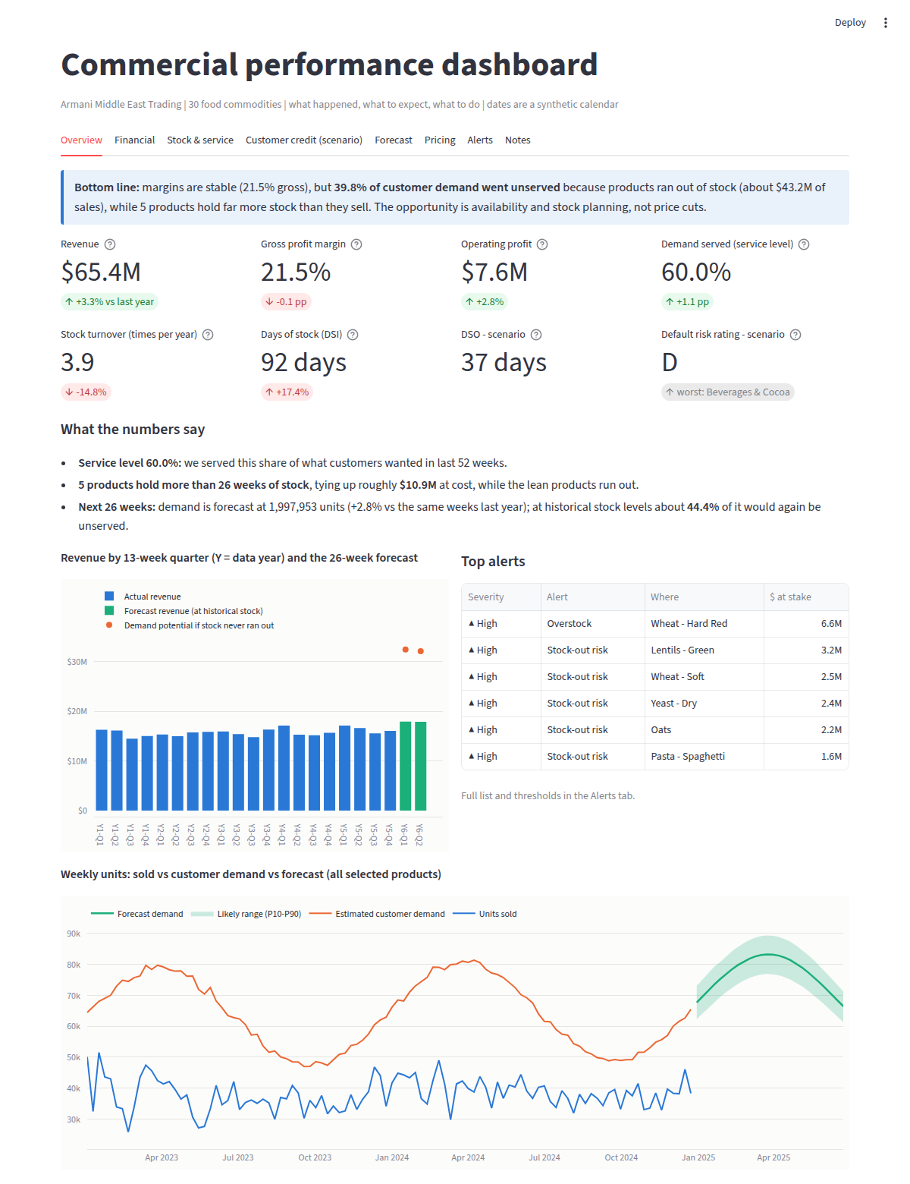
Figure 18. The Overview tab.

Financial
Revenue, gross profit and operating profit by quarter, the waterfall from revenue to operating profit (revenue, minus cost of goods sold, equals gross profit; minus implied operating expenses, equals operating profit), operating margin over time, and a table by category. The message: margins are almost identical across categories (21 to 22 percent) and stable over time, so profit follows volume, which in turn depends on stock availability.
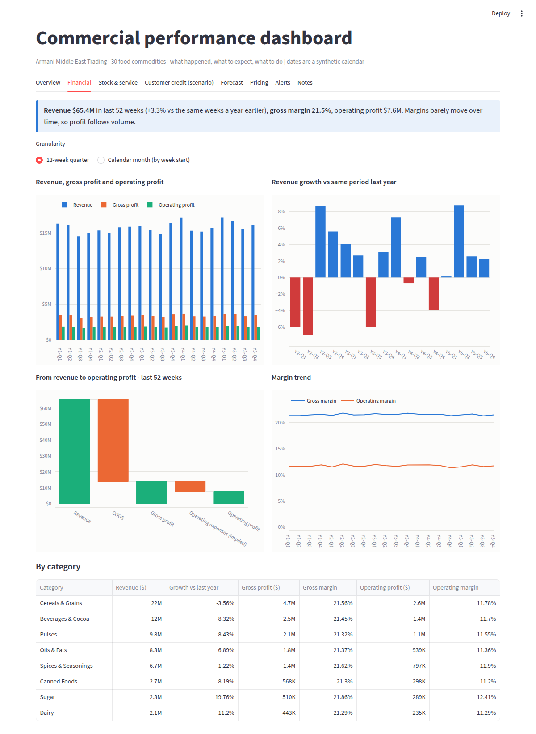
Figure 19. The Financial tab.

Stock and service
Inventory turnover, days of stock (DSI), weeks of stock, service level and revenue lost to stock limits; weeks of stock by product (orange bars exceed the 26-week limit), revenue achieved against lost by category, lost revenue by quarter and stock segment, and a product-level inventory table. It makes the 'two worlds' visible: 23 lean products with about one week of cover that sell out, and 5 to 7 over-stocked products.
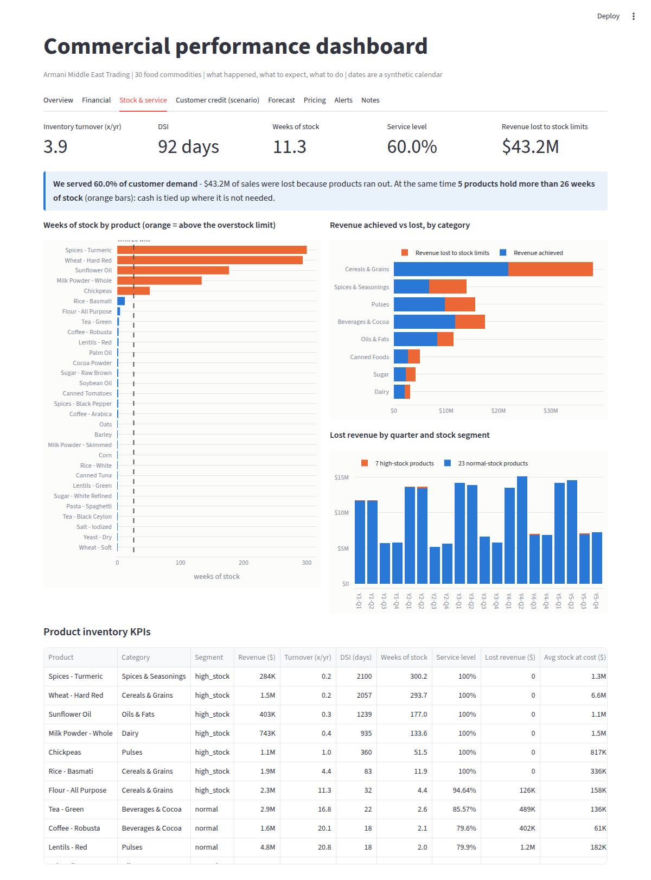
Figure 20. The Stock and service tab.

Customer credit (scenario)
An editable table of credit assumptions per category (payment terms, share of sales on credit, average payment delay, annual default rate), the resulting DSO, receivables, expected credit loss and number of categories rated D or E, the risk score and rating per category, and a scoring table with the four component scores. A yellow banner states that this is a scenario layer based on assumptions, not data. Changing an assumption updates every figure.
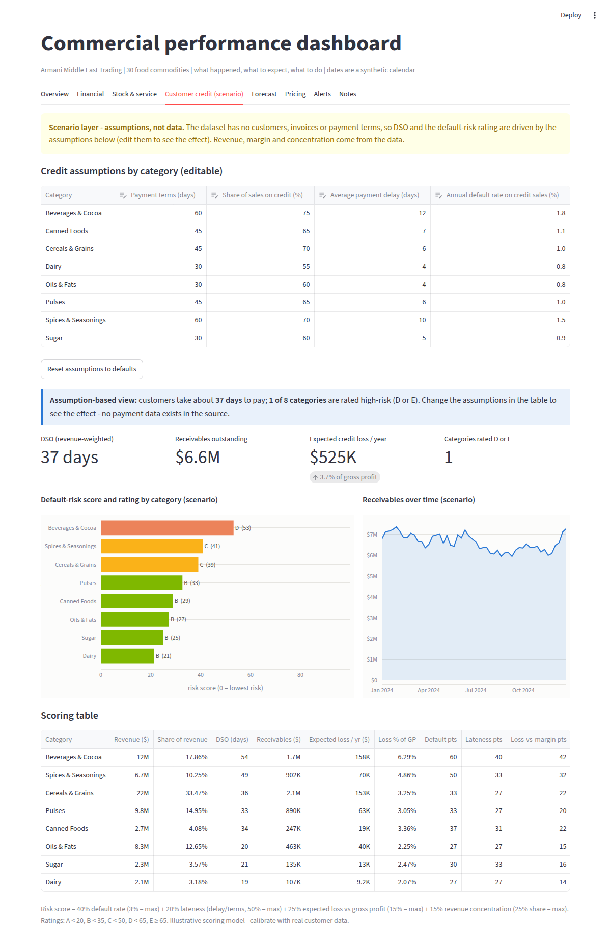
Figure 21. The Customer credit tab (scenario).

Forecast
The 26-week forecast for the whole company, a category or a single product, with the likely range, the stock scenario (revenue potential 64.6 million dollars, expected revenue at historical stock 35.8 million, 28.7 million at risk), a table by 13-week quarter, a download of the weekly forecast as CSV and a note on the model and its accuracy (4.6 percent on reconstructed demand, 6.6 percent on weeks where demand was observed directly).
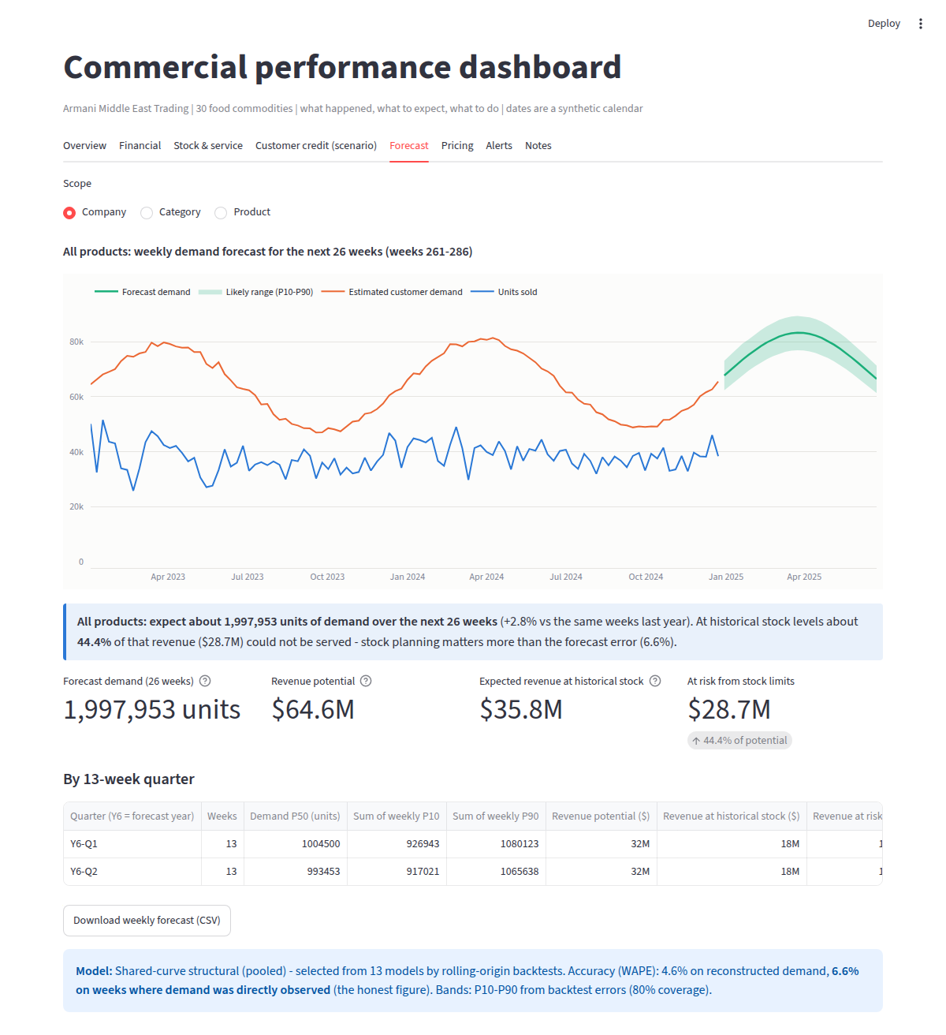
Figure 22. The Forecast tab.

Pricing
Added by Part 4: the recommended price for every product and week, the expected money impact under different customer reactions and the over-stocked products with their actions. If the Part 4 tables are missing the tab shows a placeholder, so Part 3 works on its own.
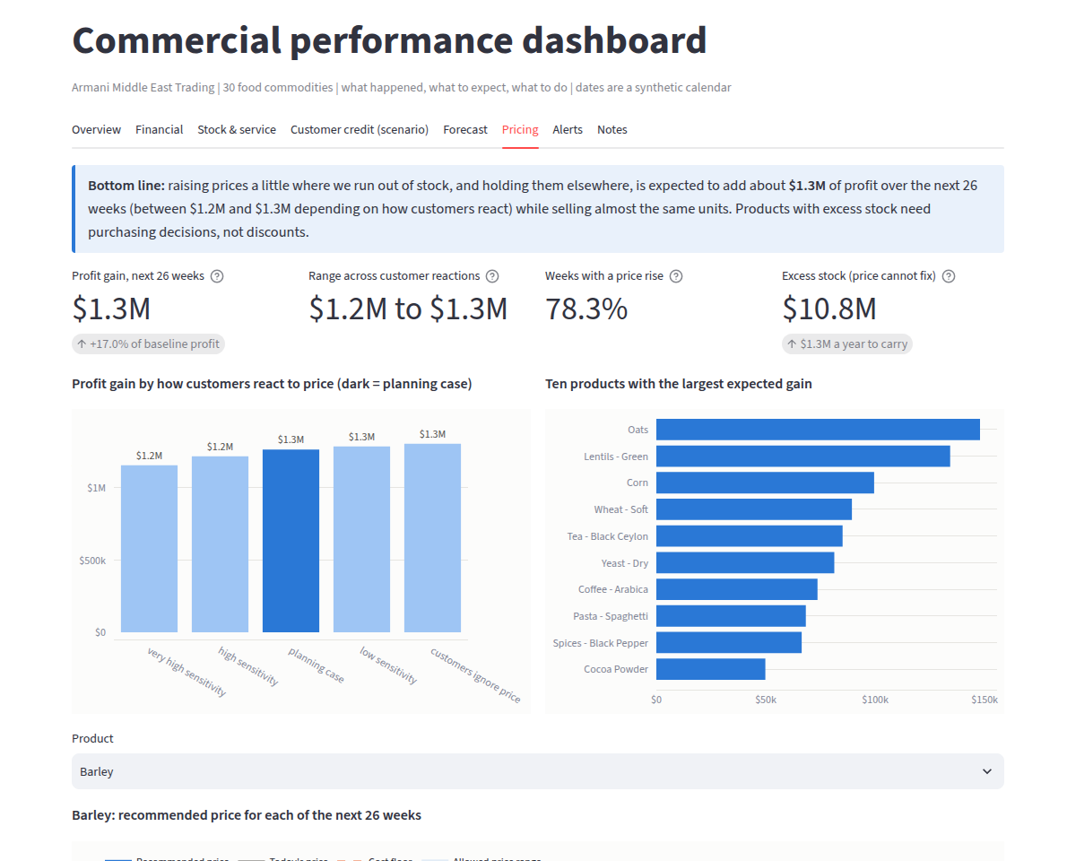
Figure 23. The Pricing tab (after Part 4 has run).

Alerts
The list of rule-based alerts with severity, scope (company, category or product), the metric and its threshold, the money at stake and a recommended action. Thresholds are editable in the sidebar.
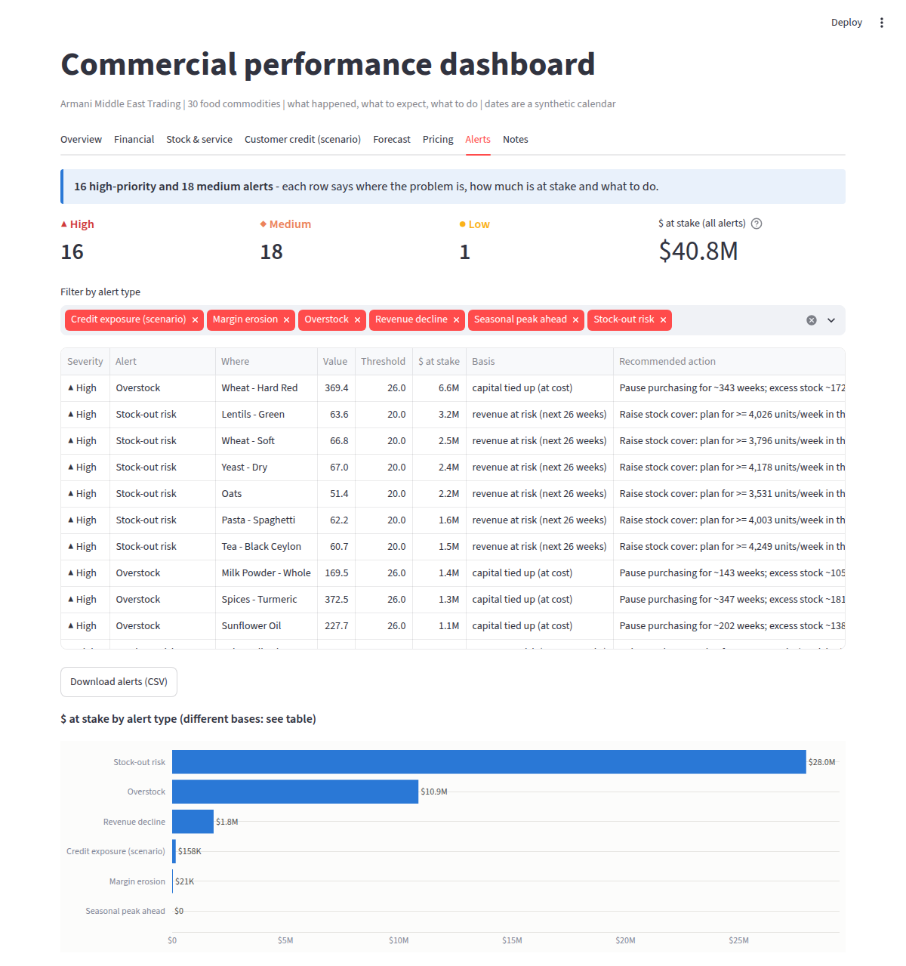
Figure 24. The Alerts tab.

Notes
Definitions of every KPI, the data sources, the assumptions and the limits, so that a reader of the dashboard never has to guess what a number means.

8.4 The KPIs: definitions with worked examples
KPI | Domain | Definition
Revenue | Financial | Sum of units sold x price (reproduced for 100% of rows in the ETL)
Gross profit margin | Financial | Sum of gross profit / sum of revenue (ratio of sums, not mean of ratios)
Operating profit and margin | Financial | As given in the data; operating expenses are not provided, so implied opex = gross profit - operating profit
Revenue growth | Financial | Revenue of the selected weeks against the same weeks 52 weeks earlier
Inventory turnover | Operational | Annualised COGS / average inventory at cost (inventory = stock available during each week)
Days sales of inventory (DSI) | Operational | Average inventory at cost / COGS per day
Weeks of cover | Operational | Average stock units / average weekly reconstructed demand
Service level (fill rate) | Operational | Units sold / reconstructed demand
Lost revenue | Operational | Sum of max(demand - sales, 0) x price: demand not served because of stock-outs or stock caps
DSO (days sales outstanding) | Credit (scenario) | Credit share x (payment terms + average delay), revenue-weighted over categories
Receivables | Credit (scenario) | Daily revenue x DSO per category
Expected credit loss | Credit (scenario) | Credit share x annual default rate x annualised revenue
Default-risk rating A-E | Credit (scenario) | From a risk score; explained in 8.6

Worked examples with the real numbers of the last 52 weeks. Service level: units sold divided by reconstructed demand gives 60.0 percent, so 40.0 percent of demand was not served. Lost revenue: the demand that was not served, valued at the price of each week, adds up to 43.2 million dollars. Days of stock: average inventory at cost divided by cost of goods sold per day is 92 days, which corresponds to a turnover of about 3.9 times a year (365 / 92 = 4.0; the small difference comes from the averaging of weekly values). A ratio of sums is used for margins because a mean of weekly ratios would give a tiny week the same weight as a large week.

8.5 What the KPIs say (last 52 weeks)
KPI | Value | Reading
Revenue | 65.4 million dollars | +3.3% against the previous 52 weeks
Gross margin | 21.5% | Stable across quarters and categories (21-22%): the lever is volume and stock, not price
Operating profit | 7.6 million dollars (11.7%) | Implied operating expenses 6.4 million dollars
Inventory turnover / DSI | 3.9x / 92 days | The average hides two worlds: 23 lean products with about 1 week of cover and 7 over-stocked ones (up to 370 weeks)
Service level | 60% | 40% of demand value is not served
Lost revenue | 43.2 million dollars | Reconstructed demand minus sales, at price
DSO / expected credit loss (scenario) | 37 days / 0.52 million dollars a year | Worst rating D (Beverages and Cocoa)

By category (last 52 weeks):
Category | Products | Revenue | Growth | Gross margin | Service level | Weeks of cover | Lost revenue
Cereals & Grains | 9 | 21.9M | -3.6% | 21.6% | 58% | 10.5 | 16.2M
Beverages & Cocoa | 5 | 11.7M | +8.3% | 21.4% | 65% | 1.2 | 5.8M
Pulses | 3 | 9.8M | +8.4% | 21.3% | 67% | 10.2 | 5.8M
Oils & Fats | 3 | 8.3M | +6.9% | 21.4% | 75% | 28.2 | 3.1M
Spices & Seasonings | 4 | 6.7M | -1.2% | 21.6% | 49% | 20.6 | 7.2M
Canned Foods | 2 | 2.7M | +8.2% | 21.3% | 53% | 0.6 | 2.3M
Sugar | 2 | 2.3M | +19.8% | 21.9% | 56% | 0.7 | 1.8M
Dairy | 2 | 2.1M | +11.2% | 21.3% | 67% | 32.4 | 1.0M

Reading the table: gross margin is 21 to 22 percent everywhere, so the categories differ in volume and availability, not in margin. Cereals and Grains is the largest category (21.9 million dollars) and is shrinking (-3.6 percent) while serving only 58 percent of demand and carrying about 10.5 weeks of cover on average (a mix of products with almost no stock and Wheat - Hard Red with 369 weeks). Beverages and Cocoa grows 8.3 percent and has the fastest turnover.

8.6 The credit-risk rating A to E
What it is: a single letter that summarises how risky it is to sell on credit in a product category: A is the lowest risk, E the highest. Why it is useful: managers cannot read four numbers for every category, and the letter lets the system act: it raises alerts and it switches pricing rules in Part 4.
The inputs are scenario assumptions per category, because the data has no customers, invoices or payment terms. They are editable in the application and labelled as assumptions:
Category | Payment terms (days) | Share on credit | Average delay (days) | Annual default rate | DSO (days) | Risk score | Rating
Beverages & Cocoa | 60 | 75% | 12 | 1.8% | 54 | 53 | D
Spices & Seasonings | 60 | 70% | 10 | 1.5% | 49 | 41 | C
Cereals & Grains | 45 | 70% | 6 | 1.0% | 36 | 39 | C
Pulses | 45 | 65% | 6 | 1.0% | 33 | 33 | B
Canned Foods | 45 | 65% | 7 | 1.1% | 34 | 29 | B
Oils & Fats | 30 | 60% | 4 | 0.8% | 20 | 27 | B
Sugar | 30 | 60% | 5 | 0.9% | 21 | 25 | B
Dairy | 30 | 55% | 4 | 0.8% | 19 | 21 | B

From the inputs a risk score between 0 and 100 is built as a weighted sum of four component scores, each scaled to 0-100 and capped:
risk score = 0.40 x default score + 0.20 x lateness score + 0.25 x buffer score + 0.15 x concentration score
Component | Weight | Scaled to 0-100 as | Maximum score when | Why it is included
Default rate | 40% | annual default rate / 3% | default rate is 3% or more | The most direct measure of the chance of not being paid
Lateness | 20% | (average delay / payment terms) / 50% | delay is half of the terms or more | Slow payers tie up cash and often become defaulters
Loss versus margin (buffer) | 25% | expected credit loss as a share of gross profit / 15% | loss is 15% of gross profit or more | Shows whether the margin can absorb the expected losses
Concentration | 15% | category share of revenue / 25% | category is 25% of revenue or more | A problem in a large category hurts the whole company

Bands: A below 20, B below 35, C below 50, D below 65, E 65 or above. Worked example, Beverages and Cocoa: default score 1.8% / 3% = 60; lateness score (12 / 60) / 0.5 = 40; buffer score: expected loss is 6.3 percent of gross profit, 6.3 / 15 = 42; concentration score: 17.9 percent of revenue, 17.9 / 25 = 71. Risk score = 0.40 x 60 + 0.20 x 40 + 0.25 x 42 + 0.15 x 71 = 53, so the rating is D. It has long terms (60 days), many credit sales (75 percent), the longest delay and a large share of revenue.
The other credit figures follow from the same inputs. DSO = share on credit x (terms + delay) = 0.75 x (60 + 12) = 54 days. Receivables = daily revenue x DSO = 11.67 million / 364 x 54 = 1.73 million dollars. Expected annual credit loss = share on credit x default rate x annual revenue = 0.75 x 1.8% x 11.67 million = 157.6 thousand dollars. Company-wide the expected credit loss is about 0.52 million dollars a year and the revenue-weighted DSO is 37 days.
Why it matters: the rating raises credit alerts in the dashboard and sets the pricing rules of Part 4 (C: markdown capped at 5 percent; D and E: no markdowns, a risk premium and 15 days shorter terms). It is an illustrative scoring model; its structure is transparent and ready to be calibrated with real payment history, for example by replacing the assumed default rates with observed ones.

8.7 Alerts
Alerts are rules with editable thresholds, so a manager can tune sensitivity. Each alert shows the place, the metric, the money at stake and a recommended action.
Alert | Default threshold | Example result
Overstock | More than 26 weeks of stock | 5 products; Wheat - Hard Red: 369 weeks, 6.6 million dollars of capital tied up (at cost); action: pause purchasing for about 343 weeks, promote or liquidate the excess
Stock-out risk | More than 20% of forecast revenue not served | 21 products; Lentils - Green: 64% unserved, 3.2 million dollars at risk; action: plan for at least 4,026 units a week (P90) in the next 8 weeks
Revenue decline | More than 10% below the same weeks last year | 4 products, for example Rice - White -29% and Wheat - Soft -37%
Margin erosion | Gross margin down more than 1 point (13 weeks against the previous 52) | 3 products, for example Salt - Iodized (down 1.6 points): COGS rose faster than price
Credit exposure (scenario) | Expected credit loss above 6% of gross profit, or DSO above 55 days | Beverages and Cocoa: DSO 54 days, loss 6.3% of gross profit; action: tighten terms, require credit insurance, focus collections
Seasonal peak ahead | Forecast peak more than 25% above the last 13 weeks | 1 low alert: demand peaks in week 273 (+50% against recent weeks); pre-build stock and confirm logistics capacity

At default thresholds there are 35 alerts: 16 high, 18 medium and 1 low. The 16 high-priority alerts, sorted by money at stake (value = weeks of stock for overstock, percent of forecast revenue unserved for stock-out risk, expected loss as percent of gross profit for credit):
Alert type | Where | Value | At stake
Overstock | Wheat - Hard Red | 369 | 6.6M
Stock-out risk | Lentils - Green | 64 | 3.2M
Stock-out risk | Wheat - Soft | 67 | 2.5M
Stock-out risk | Yeast - Dry | 67 | 2.4M
Stock-out risk | Oats | 51 | 2.2M
Stock-out risk | Pasta - Spaghetti | 62 | 1.6M
Stock-out risk | Tea - Black Ceylon | 61 | 1.5M
Overstock | Milk Powder - Whole | 169 | 1.4M
Overstock | Spices - Turmeric | 373 | 1.3M
Overstock | Sunflower Oil | 228 | 1.1M
Stock-out risk | Salt - Iodized | 62 | 956K
Stock-out risk | Sugar - White Refined | 63 | 917K
Stock-out risk | Canned Tuna | 63 | 821K
Stock-out risk | Milk Powder - Skimmed | 53 | 726K
Stock-out risk | Barley | 56 | 360K
Credit exposure | Beverages & Cocoa | 6 | 158K

8.8 How the dashboard was tested
Twenty-four automatic tests passed. They exist because a dashboard that shows wrong numbers confidently is worse than none.
Group | Tests | What is checked
Reconciliation with the ETL database | 6 | Revenue, gross profit, operating profit and units for all weeks, and for the last 52 weeks, and revenue by category equal the values in the ETL database to the cent
Hand calculations | 4 | The 12 KPI formulas (revenue, margins, turnover, DSI, service level, weeks of cover, lost share) equal a hand calculation; average stock ignores the unknown first week; year-over-year growth is right on a constructed series (+10 percent) and 'n/a' without a year of history
Credit formulas | 4 | DSO, receivables and expected loss are right on small hand-made inputs (for example 25 days, 357 dollars, 52 dollars); ratings are monotonic in the risk score
Alerts | 4 | Alerts have valid severity, non-negative money at stake and an action; overstock and stock-out alerts equal an independent recomputation; raising a threshold removes its alerts
Forecast | 1 | The forecast in the application equals the forecast database (sum of P50 = 1,997,953 units, 780 rows = 30 products x 26 weeks)
Application | 5 | The application runs without exceptions on all eight tabs with default filters, after changing the period to 13 weeks, with only the 7 high-stock products, after switching the segment, and it handles an empty product selection with a warning, not an error

8.9 Running and deploying
• Locally: install the requirements of the dashboard folder and run streamlit run part3_dashboard_v1.1/dashboard_app_v1.1.py.
• Deployment: for example on Streamlit Community Cloud, point to the repository and use part3_dashboard_v1.1/dashboard_app_v1.1.py as the main file. The data mart file is committed with the application, so no raw data is needed. A run guide (RUN_DASHBOARD_v1.1.md) is included.
• Order: run the Part 3 notebook before Part 4, because Part 4 appends its tables to the data mart and re-running Part 3 recreates the file.

8.10 Assumptions, limits and hand-over
• The credit layer is a scenario: there are no receivables, customers or payment terms in the data. Every credit figure is labelled as assumption-based.
• Operating expenses are not provided; implied opex is gross profit minus operating profit.
• Lost revenue and service level depend on the reconstructed demand and are therefore estimates.
• Alert thresholds are defaults that should be agreed with management.
• Hand-over to Part 4: the data mart with the credit ratings and the history, to which the pricing tables are added.

9. Part 4 (a): The pricing idea and the pricing engine

9.1 Goal and the three questions
The assignment asks for a documented algorithm that adjusts prices using the forecast, the stock and the risks. In particular, it must answer three questions:
1. Demand-based adjustments: how prices scale during forecast demand peaks or lulls.
2. Inventory and seasonality sensitivity: the pricing rules for high-stock against low-stock products during peak and off-peak seasons.
3. Competitive and credit-risk guardrails: how competitive prices are ensured and how credit risk is respected.
This chapter first derives the idea from the data (9.2 to 9.4), then describes the engine step by step (9.5 to 9.7), and then answers the three questions explicitly (9.8 to 9.10). Chapter 10 shows how the engine was tested and what it is worth.

9.2 Concepts used in this part
Concept | Plain explanation
Price sensitivity (elasticity) | How much demand falls when price rises. A value of -1 means that a 1 percent price rise lowers demand by 1 percent; -3 means 3 percent; 0 means customers ignore price.
Scarce, balanced, surplus | A product-week is scarce when the stock history cannot cover the forecast demand (more than 5 percent of demand cannot be served), surplus when cover exceeds 26 weeks of demand, and balanced otherwise.
Unserved share g | The share of expected demand that cannot be served from stock. 52 percent means that only 48 percent of demand can be served.
Reference price P0 | Today's price: the product's average price over the last 13 weeks.
Season (peak, normal, off-peak) | From the shared seasonal curve: peak when the seasonal factor is at or above 1.10, off-peak when at or below 0.90, normal otherwise.
Simulation | Drawing many possible futures (here 1,000) of demand and stock and averaging the outcome, to measure expected profit under uncertainty.
Guardrail | A hard limit that no recommended price may cross.
Planning case | The reference assumption for price sensitivity (-1) used to report the main money figures.

9.3 Four data insights that shape the idea
The idea is derived from what the earlier parts showed, not from general theory:
1. 78 percent of the forecast product-weeks are scarce. The stock history cannot cover forecast demand, so these products sell out whatever the price is. (Part 2 and Part 3: 44 percent of forecast revenue is not served.)
2. Demand swings about 25 percent above and below normal over the year, so scarcity is strongest in peak weeks and weakest in lulls.
3. Five products hold 64 to 370 weeks of stock (10.8 million dollars at cost). Discounting is only interesting there, and only if it pays; and it cannot be the main tool for stock of that size.
4. Prices vary only 4 percent within a product, so the data cannot show how customers react to price: the estimated effect is -0.017 with a 95 percent interval of -0.056 to +0.021, which includes zero. Any pricing rule that depends on a particular price sensitivity would be a guess.

9.4 The idea
The pricing idea
Raise the price where stock sells out anyway, because then the units sold are set by the stock and the extra price is pure profit. Do not rely on the unknown price sensitivity. Discount only if it provably pays. Keep strict guardrails.

Why this is attractive: if a product will sell out anyway, a higher price does not reduce the units sold (they are limited by stock), so every extra dollar per unit is extra profit; no knowledge of price sensitivity is needed for this argument. It only fails if the higher price is so high that customers would buy fewer units than the stock, and that risk is controlled by a protection rule (rule 2) that assumes customers are twice as sensitive as the planning case.
Each product-week is classified: Scarce (78 percent of the plan: part of the forecast demand cannot be served), Balanced (5 percent: stock covers demand) and Surplus (17 percent: more than 26 weeks of stock). The actions: raise the price in scarce weeks up to 8 percent, only as far as the same units still sell; hold the price in balanced weeks; in surplus weeks consider a markdown only if profit rises, otherwise fix purchasing.
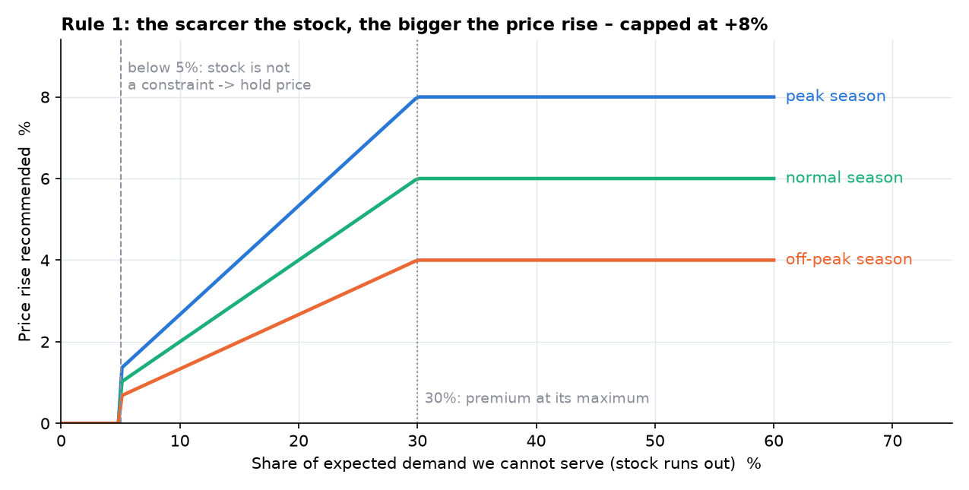
Figure 25. The scarcity rule: the price rise grows with the unserved share of demand and with the season.

9.5 The engine at a glance
The engine is a set of rules that turn the forecast into one price for each of the 780 product-weeks (30 products x 26 weeks), together with the reason. The inputs for every product-week are the forecast demand with its P10-P90 range, the stock expected to be available (a simulation from each product's own last 104 weeks of stock), the season on the shared seasonal curve, and the credit rating of the category. All numbers used by the rules are parameters collected in one dictionary, so that they can be changed in one place and their effect can be tested.
Step | Rule | Effect on the price
1 | Scarcity premium | Raise: 0 to +8%
2 | Sell-out protection | Cap the rise from step 1
3 | Surplus markdown | Lower: 0 to -10%, only if it pays
4 | Credit risk | No markdown and a premium for D/E; markdown cap for C
5 | Guardrails | Clip to cost floor, market band and weekly step
6 | Final price | Assemble and record the reason

9.6 The six rules in detail

Rule 1: scarcity premium
Purpose: charge more when part of the demand cannot be served. Let g be the share of expected demand that the stock cannot serve. If g is 5 percent or less, stock is not a constraint and there is no premium. Above that the premium grows linearly with g until g reaches 30 percent, and it is scaled by the season so that the full premium is used only in a peak:
rise u = 8% x min(1, g / 30%) x m(season), only if g > 5%; m = 1.00 (peak), 0.75 (normal), 0.50 (off-peak)
Unserved demand g | Peak (x 1.0) | Normal (x 0.75) | Off-peak (x 0.5)
5% or less | 0% | 0% | 0%
10% | +2.7% | +2.0% | +1.3%
20% | +5.3% | +4.0% | +2.7%
30% or more | +8.0% | +6.0% | +4.0%

Why 8 percent and 30 percent? They are policy parameters: 8 percent is a modest premium (the price is 1.20 to 1.35 times cost, so margins are 17 to 26 percent), and 30 percent unserved demand is a clear sign of scarcity. Both are varied in the sensitivity tests of chapter 10; the result is not sensitive to the 30 percent threshold.

Rule 2: sell-out protection
Purpose: protect the units sold against an unknown price sensitivity. The rise from rule 1 is reduced to the largest rise M for which the expected units sold stay at least 99 percent of the baseline even if customers were twice as price-sensitive as the planning case (price sensitivity -2). The expectation is computed by simulation: 1,000 draws of demand (from a distribution fitted to the forecast's P10-P90 range) and of available stock (from the product's own history), and in each draw units sold = min(demand scaled by M to the power -2, stock):
largest M <= 1 + u such that E[ min( D x M^(-2), S ) ] >= 99% of E[ min( D, S ) ]
Intuition: if stock is so short that even a lower demand still exceeds it, a higher price changes nothing in units, so M can be large; if stock is close to demand, demand lost to a higher price becomes units lost, and M is held down. Rule 2 is the insurance against rule 1.

Rule 3: surplus markdown
Purpose: consider a discount for over-stocked products, but only if it pays for itself. A markdown is considered only for products with more than 26 weeks of cover and no scarcity. Its depth grows with the excess cover (full depth at 104 weeks, four times the 26-week limit) and is scaled by the season so that no discount is given in a demand peak:
depth d = 10% x min(1, ln(cover / 26) / ln(4)) x lull(season), lull = 1.0 (off-peak), 0.5 (normal), 0 (peak)
Weeks of cover | Off-peak | Normal | Peak
26 or less | 0% | 0% | 0%
52 | 5.0% | 2.5% | 0%
78 | 7.9% | 4.0% | 0%
104 or more | 10.0% | 5.0% | 0%

The markdown is applied only if the simulated profit at the planning sensitivity (-1), including the saving in carrying cost of the stock sold, is higher with the markdown than without it. The break-even sensitivity (how price-sensitive customers would have to be for the markdown to pay) is reported for every candidate. Result: no markdown paid (see chapter 10).

Rule 4: credit risk
Purpose: make credit-risky customers pay for the risk and avoid giving them discounts. The rule uses the rating of the product's category (chapter 8):
Rating | Rule
A, B | No change: normal rules
C | Markdown capped at 5%
D, E | No markdown; a risk premium on the price; payment terms recommended 15 days shorter

risk premium = share on credit x annual default rate + DSO / 365 x 8% funding cost
The first term covers the expected loss from defaults, the second the cost of money tied up in unpaid invoices. For Beverages and Cocoa (D): 0.75 x 1.8% + 54 / 365 x 8% = 1.35% + 1.18% = 2.5%. Shortening the terms by 15 days lowers DSO and frees working capital: about 361 thousand dollars for this category.

Rule 5: guardrails
Purpose: hard limits that no price may cross, whatever the other rules say. They are explained in 9.10.
floor = COGS x (1 + 5% + 12% x 4/52) / (1 - expected credit loss); 0.92 x P0 <= price <= 1.10 x P0; |price_t / price_(t-1) - 1| <= 3%

Rule 6: final price and the reason
The price is assembled in this order: start at the reference price P0; apply the scarcity premium limited by the sell-out protection (rules 1 and 2) or, for surplus products, the profit-tested markdown (rule 3); apply the credit rule (rule 4); then clip to the cost floor, the competitive band and the weekly step (rule 5). For every product-week the plan records the state, the premium allowed by rules 1 and 2, the credit premium, the markdown applied, the limits that were binding and a plain-language reason. This makes every price explainable in one sentence, which is what makes the engine auditable. The largest rise in the plan is +10 percent (the band limit) and the average rise over scarce weeks is +4.9 percent.

9.7 The parameters
Parameter | Default | Meaning | Type
U_MAX | 8% | Largest scarcity premium | Policy
GAP_MIN | 5% | Unserved share below which stock is not a constraint | Policy
G_FULL | 30% | Unserved share at which the premium is maximal | Policy
SEASON_MULT | 1.00 / 0.75 / 0.50 | Share of the premium used in peak / normal / off-peak | Policy
PEAK_IDX / OFFPEAK_IDX | 1.10 / 0.90 | Seasonal-curve levels that define peak and off-peak | Data-derived
EPS_PLAN | -1 | Planning price sensitivity | Assumption
EPS_STRESS | -2 | Stress sensitivity used by the sell-out protection | Assumption
VOL_TOL | 1% | Units accepted to be lost because of a premium | Policy
D_MAX / COVER_MAX / COVER_FULL | 10% / 26 / 104 | Largest markdown; weeks of cover where markdowns start / are deepest | Policy
LULL | 1.0 / 0.5 / 0 | Share of the markdown used in off-peak / normal / peak | Policy
MD_CAP_C | 5% | Markdown cap for rating C | Policy
TERMS_CUT_DAYS | 15 | Recommended payment-terms cut for D/E | Policy
FUND_RATE | 8% a year | Cost of money tied up in unpaid invoices | Assumption
MIN_MARKUP | 5% | Minimum markup on cost in the price floor | Policy
CARRY_ANNUAL / CARRY_FLOOR_WEEKS | 12% a year / 4 | Holding cost of stock; weeks of it included in the floor | Assumption / policy
BAND_UP / BAND_DOWN | +10% / -8% | Competitive band around P0 (no competitor data: proxy) | Assumption
STEP_MAX | 3% | Largest weekly price change | Policy
SIM_N / SEED | 1,000 / 42 | Simulation draws and random seed (the engine is deterministic) | Technical

Types: 'policy' parameters are management choices, 'assumption' parameters are guesses that data or pilots should replace, 'data-derived' parameters come from the data.

9.8 Question 1: demand-based adjustments (peaks and lulls)
The price rise scales with how scarce the product is (g) and how strong the season is (m). In a peak with 30 percent or more unserved demand the rise is the full 8 percent; in a lull it is 4 percent; below 5 percent unserved demand there is no rise. The weekly step limit keeps the path smooth.
Worked example: Barley, week 1 (normal season). Only 48 percent of its expected demand can be served, so g = 52 percent. Rule 1: 8% x min(1, 52/30) x 0.75 = +6.0 percent. Rule 2: the simulation shows that the largest rise keeping expected units within 1 percent of the baseline, even with customers twice as sensitive, is +4.5 percent. Rule 5: the weekly step limit allows only +3 percent over today's price. The final price is 7.447 x 1.03 = 7.67 dollars. Over the 26 weeks the forecast demand rises from 2,900 units to a peak of about 3,570 in week 13 and falls back; the price follows: weeks 1 to 3 (normal) are limited by the weekly step, weeks 5 to 22 (peak) sit at the +8 percent cap (8.04 dollars), and as the season turns in weeks 23 to 26 the premium eases toward +4 percent (7.75 dollars).
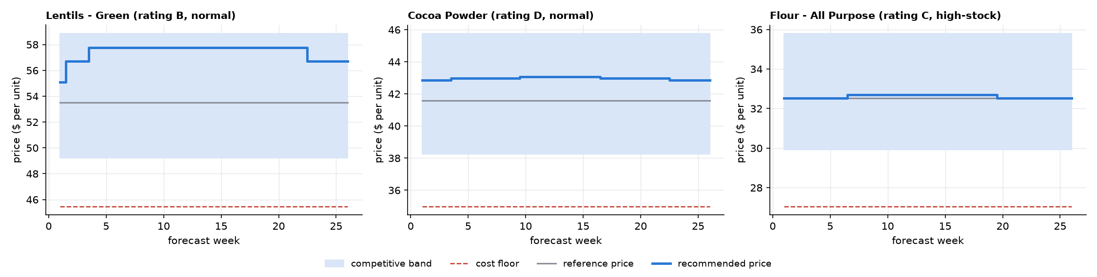
Figure 26. Recommended price paths for example products (blue band: competitive band; dashed: cost floor; grey: reference price).

9.9 Question 2: inventory and seasonality sensitivity
Product type | Peak season | Normal season | Off-peak season
Lean products (stock below demand; 78% of the plan) | Premium up to +8% | Premium up to +6% | Premium up to +4%
High-stock products (over 26 weeks of cover; 17%, 5 products) | Hold the price (no markdown in a peak) | Markdown up to 5%, only if profit rises | Markdown up to 10%, only if profit rises

• Lean products: stock, not price, limits sales, so the premium is almost free money. It is largest in a peak and smallest in a lull.
• High-stock products never get a premium. A markdown is considered only outside peaks, scaled by how far cover exceeds 26 weeks (full depth at 104 weeks), and only if simulated profit rises. In the tests no markdown paid at the planning sensitivity.
• Price cannot fix 64 to 370 weeks of stock: clearing it within a year would need cuts of 17 to 49 percent even if customers were very price-sensitive (-3), and 43 to 87 percent at the planning sensitivity, which would be below cost. Carrying the excess costs about 1.3 million dollars a year, more than the whole pricing gain. The right actions are non-price: stop purchasing until stock is below 26 weeks of demand, and offer bulk or export deals.
Over-stocked product | Weeks of cover | Capital tied up | Carrying cost a year | Price cut needed to clear in a year (e = -3 / e = -1)
Wheat - Hard Red | 369 | 6.53M | 784K | 49% / 87%
Milk Powder - Whole | 170 | 1.38M | 166K | 36% / 73%
Spices - Turmeric | 372 | 1.28M | 154K | 49% / 87%
Sunflower Oil | 228 | 1.05M | 126K | 41% / 80%
Chickpeas | 64 | 0.52M | 63K | 17% / 42%

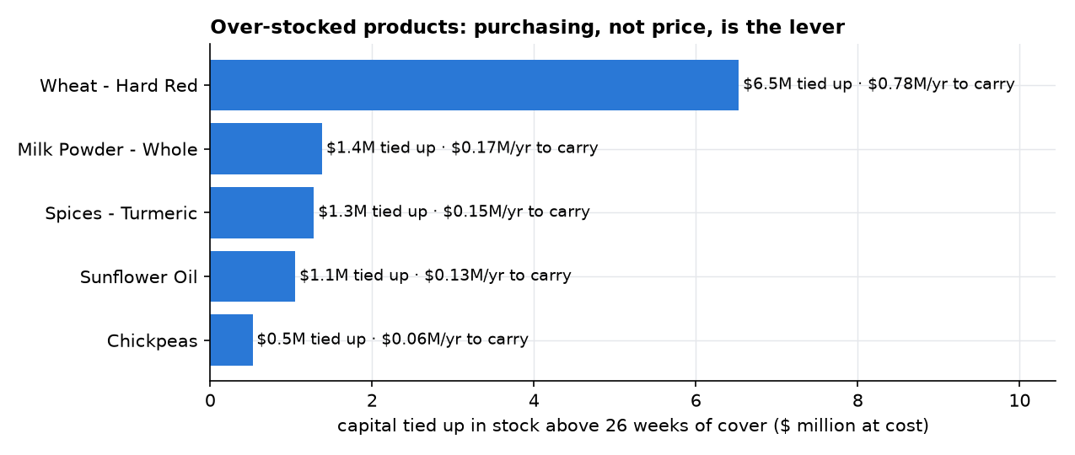
Figure 27. Capital tied up above 26 weeks of stock.

9.10 Question 3: competitive and credit-risk guardrails

Competitive and cost guardrails
• Cost floor: no sale is loss-making. Floor = cost x (1 + 5 percent markup + carrying cost of four weeks at 12 percent a year) / (1 - expected credit loss). For Barley: cost 5.877 x 1.0592 = 6.225, divided by (1 - 0.7 percent expected credit loss) = 6.27 dollars.
• Competitive band: the price stays within 0.92 and 1.10 times the reference price (for Barley 6.85 to 8.19 dollars). The data has no competitor prices, so the 13-week average price is the proxy for the market; the band is an adjustable parameter to be replaced by observed competitor prices. The band keeps the company close to the market in both directions: a price far above it would lose customers to competitors, a price far below it would give margin away.
• Weekly step: at most 3 percent from one week to the next, so customers never see price shocks and the plan can be executed.

Credit-risk guardrails
• Ratings A and B follow the normal rules.
• Rating C: markdown capped at 5 percent.
• Ratings D and E: no markdowns at all, a risk premium that covers default loss and funding cost (2.5 percent for Beverages and Cocoa), and recommended payment terms 15 days shorter, which frees about 361 thousand dollars of cash.
• In the plan, Beverages and Cocoa (the only D category) has 390 price-weeks; none of them is below the reference price.

Which limit applied
For every price the plan records which limits were binding: 'sell-out protection', 'weekly step limit', 'competitive band' or none. Across the 611 scarce product-weeks: no limit binds in 250 (the full premium of rule 1 applies), the sell-out protection binds in 333, the competitive band caps 19 (at +10 percent) and the weekly step binds in 16, mostly in week 1, when prices move away from today's price (in week 1, of the 23 scarce products, 15 are limited by the sell-out protection and 15 by the weekly step, 7 of them by both). This makes the guardrails visible and testable.
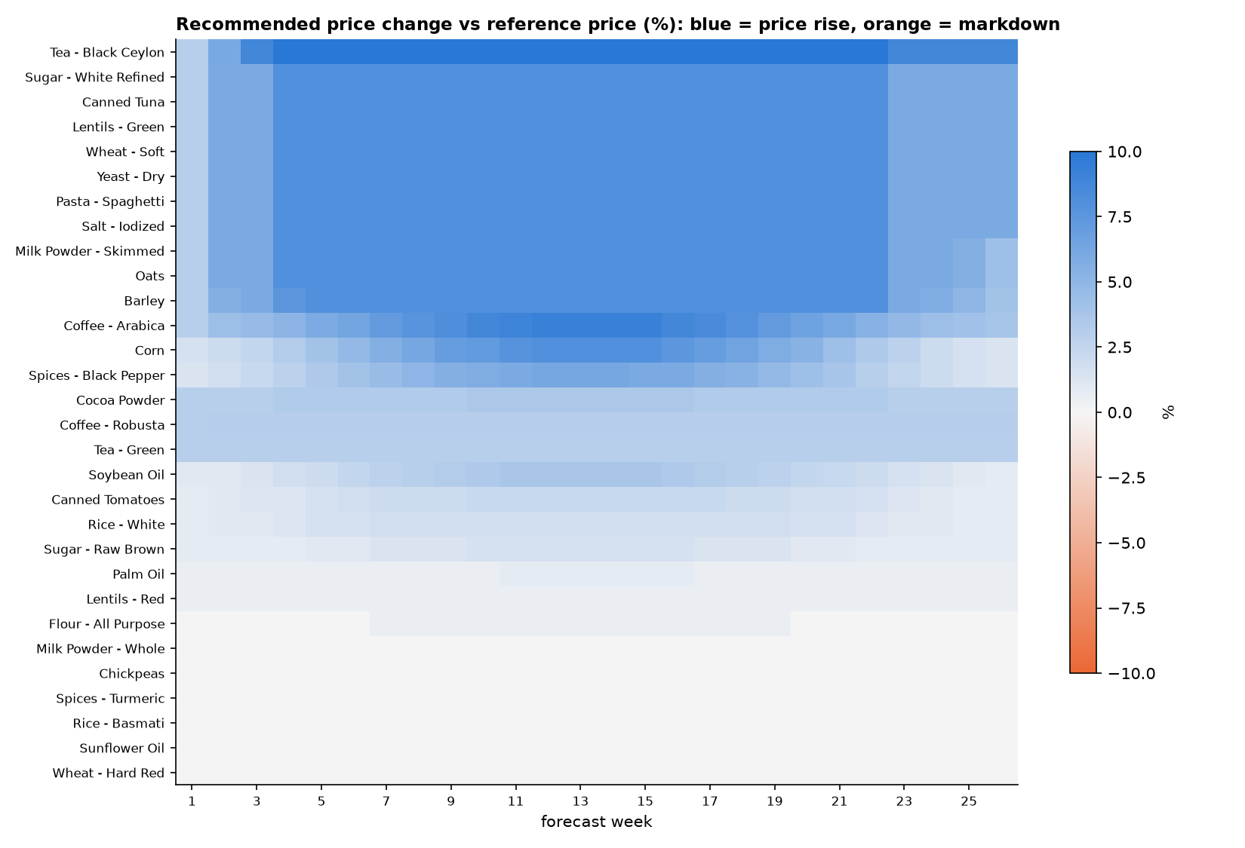
Figure 28. The recommended price change for every product and week of the 26-week plan (blue: rise, orange: markdown).

10. Part 4 (b): Testing the engine, results and next steps

10.1 The central difficulty: unknown price sensitivity
To say what a pricing engine is worth, one has to know how customers react to price. This data cannot say: prices vary only 4 percent within a product, and the estimated price effect is -0.017 with a 95 percent interval from -0.056 to +0.021, which includes zero (chapter 5). Pretending to know the price sensitivity would make every money figure a guess presented as a fact.
The approach taken was therefore: (1) design the engine so that its gain barely depends on the price sensitivity (it raises prices only where stock sells out anyway, and protects itself against customers twice as sensitive as the planning case); (2) report the result as a range over price sensitivities from 0 to -3, not as one number; (3) test that the claim 'the gain barely depends on it' is true; and (4) propose pilots that measure the real sensitivity.

10.2 How the engine was evaluated
In every test, the engine and the do-nothing alternative (holding today's price) are compared on exactly the same simulated demand and stock, so the difference is purely the pricing. Profit means gross profit minus expected credit loss.
1. Simulation. For each product-week, 1,000 draws of demand (a lognormal distribution whose median is the forecast and whose spread is read from the P10-P90 range) and of stock available (from the product's own last 104 weeks). The same random draws are used with and without the engine ('common random numbers'), which makes the comparison stable. Demand responds to price as D x (P / P0)^e, and units sold = min(demand, stock). The simulated do-nothing baseline reproduces the expected sales of Part 2 within 0.07 percent, which confirms that the simulation is consistent with the forecast.
2. Stress the sensitivity. The simulation is repeated for price sensitivities e = 0 (customers ignore price), -0.5, -1 (planning case), -2 and -3 (very price-sensitive). The result is a range.
3. Replay the past. The last 52 weeks are replayed in two blocks of 26 weeks. For each block the decisions are taken at the block's start (weeks 208 and 234) using only information available at that time: prices and stock history up to that week and a naive 'same week last year' forecast, which is deliberately worse than the real forecast. The prices are then evaluated against what happened. A check proves that no information after the decision week is used.
4. Stress the inputs. Sixteen one-at-a-time variations of the engine's parameters (largest premium, unserved share for the full premium, weekly step, units accepted to lose, protection strictness) and a test where real demand is only 80, 60 or 50 percent of the reconstructed estimate.
5. Nineteen automatic checks (10.6).

10.3 Results
Next 26 weeks (weeks 261 to 286), engine against holding today's price. The baseline profit is about 7.5 million dollars. Amounts in millions of dollars.
Customer reaction (price sensitivity e) | Units sold | Revenue change | Gross profit change | Profit change after credit loss | Profit change, % of baseline
Very high (-3) | -1.60% | +0.68M | +1.16M | +1.15M | +15.5%
High (-2) | -0.95% | +0.94M | +1.22M | +1.22M | +16.3%
Planning case (-1) | -0.44% | +1.14M | +1.27M | +1.26M | +17.0%
Low (-0.5) | -0.21% | +1.23M | +1.29M | +1.28M | +17.2%
Customers ignore price (0) | 0.00% | +1.32M | +1.32M | +1.30M | +17.5%

Replay of the last 52 weeks with information available at the time only. The baseline profit is about 13.5 million dollars.
Customer reaction (price sensitivity e) | Units sold | Profit change after credit loss | % of baseline (13.5M)
Very high (-3) | -1.58% | +1.27M | +9.4%
High (-2) | -1.03% | +1.35M | +10.0%
Planning case (-1) | -0.51% | +1.43M | +10.6%
Low (-0.5) | -0.26% | +1.47M | +10.9%
Customers ignore price (0) | 0.00% | +1.51M | +11.2%

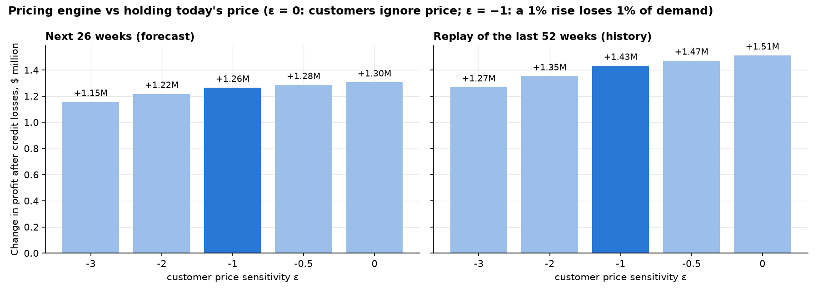
Figure 29. Profit gain of the engine against holding today's price, by customer reaction.
• The planning-case gain of 1.26 million dollars in 26 weeks is 17 percent of the baseline profit. The range over all customer reactions is 1.15 to 1.30 million dollars: the gain barely depends on price sensitivity, as designed.
• Units sold change by only -0.44 percent in the planning case: the engine earns more per unit while selling almost the same units, because it raises prices where stock is the limit.
• Where the gain comes from (planning case): scarcity pricing 1.13 million dollars and the credit-risk rule 0.14 million dollars. No markdown is applied.
• The replay with a naive forecast gives 1.43 million dollars over 52 weeks, 10.6 percent of the baseline. Even with a worse forecast and only past information, the engine would have added profit in both halves of the year.
• The benefit falls as customers become more price-sensitive, and if customers ignore price the engine can only add profit; both are checked automatically.

10.4 Sensitivity of the result
One parameter at a time was varied (all others at their defaults). The table shows the 26-week profit gain at the planning sensitivity (e = -1), in dollars; the default values are marked.
Parameter | Value | Profit gain (planning case)
Largest premium U_MAX | 4% | 834,547
 | 6% | 1,067,542
 | 8% (default) | 1,263,583
 | 10% | 1,427,764
Unserved share for full premium G_FULL | 20% | 1,263,583
 | 30% (default) | 1,263,583
 | 50% | 1,261,324
Weekly step STEP_MAX | 2% | 1,248,387
 | 3% (default) | 1,263,583
 | 5% | 1,272,621
Units accepted to lose VOL_TOL | 0% | 634,836
 | 1% (default) | 1,263,583
 | 3% | 1,637,722
Protection strictness EPS_STRESS | -1 | 1,523,664
 | -2 (default) | 1,263,583
 | -3 | 1,115,256

• Every variation stays positive (0.63 to 1.64 million dollars): the result does not hinge on a lucky setting.
• The unserved share at which the premium reaches its maximum hardly matters (the products that are scarce are very scarce).
• The two parameters that matter are the largest premium and the number of units the company accepts to lose. They are management choices, not data questions. If no loss of units is accepted (0 percent) the gain halves, because the protection then blocks most of the premium; accepting 3 percent raises it to 1.64 million dollars. The default of 1 percent is a deliberately cautious middle.
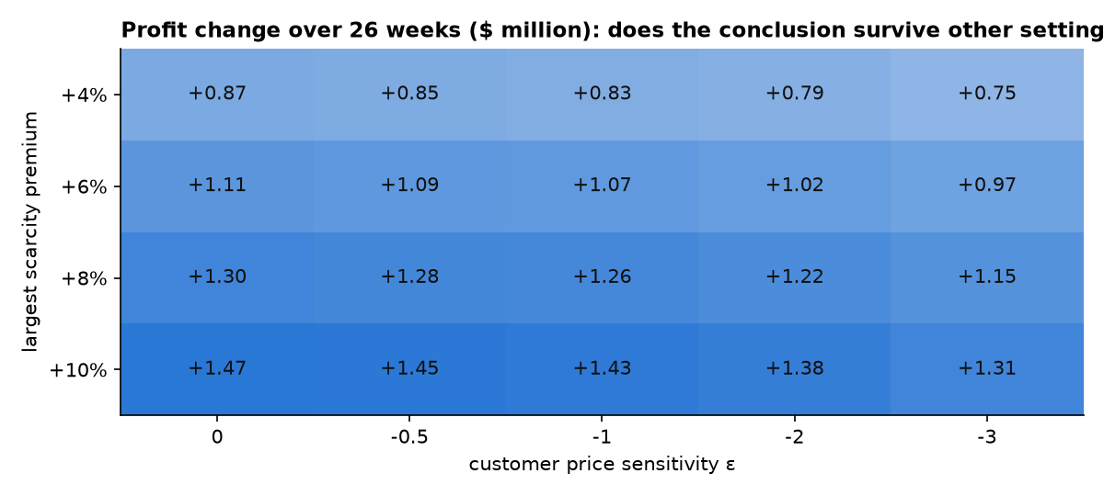
Figure 30. Sensitivity of the profit gain to the engine's parameters.

What if the reconstructed demand is too high?
The money figures rest on the reconstructed demand. If the true demand were lower than the estimate, the number of scarce products and the premium would shrink. The test scales demand down:
True demand vs estimate | Profit gain e = 0 | e = -1 (planning) | e = -3 | Units change (e = -1)
100% | 1,304,280 | 1,263,584 | 1,154,885 | -0.44%
80% | 1,252,515 | 1,155,261 | 872,702 | -1.14%
60% | 1,104,625 | 938,689 | 610,863 | -2.37%

At 60 percent of the estimate, the planning-case gain is still 0.94 million dollars (at 50 percent, 0.82 million). The engine remains profitable under the harshest demand assumption tested.

10.5 The plan by product
The table lists every product with its credit rating (of its category), the number of weeks classified scarce / balanced / surplus out of 26, the average price change over the 26 weeks and the profit gain in the planning case. It is sorted by profit gain. The five surplus products (weeks 0/0/26) are held at today's price and show no gain.
Product | Rating | Weeks scarce / balanced / surplus | Average price change | Profit gain, planning case ($)
Oats | C | 26/0/0 | +7.3% | 147,895
Lentils - Green | B | 26/0/0 | +7.3% | 134,254
Corn | C | 26/0/0 | +5.0% | 99,512
Wheat - Soft | C | 26/0/0 | +7.3% | 89,360
Tea - Black Ceylon | D | 26/0/0 | +9.3% | 85,101
Yeast - Dry | C | 26/0/0 | +7.3% | 81,309
Coffee - Arabica | D | 26/0/0 | +6.7% | 73,642
Pasta - Spaghetti | C | 26/0/0 | +7.3% | 68,305
Spices - Black Pepper | C | 26/0/0 | +4.1% | 66,415
Cocoa Powder | D | 26/0/0 | +3.3% | 49,810
Milk Powder - Skimmed | B | 26/0/0 | +7.3% | 47,059
Salt - Iodized | C | 26/0/0 | +7.3% | 42,746
Soybean Oil | B | 26/0/0 | +2.5% | 41,427
Tea - Green | D | 26/0/0 | +3.0% | 40,980
Sugar - White Refined | B | 26/0/0 | +7.3% | 38,760
Canned Tuna | B | 26/0/0 | +7.3% | 35,462
Rice - White | C | 26/0/0 | +1.4% | 30,945
Coffee - Robusta | D | 26/0/0 | +3.0% | 23,568
Barley | C | 26/0/0 | +7.2% | 19,177
Canned Tomatoes | B | 26/0/0 | +1.7% | 13,938
Palm Oil | B | 26/0/0 | +0.6% | 12,725
Lentils - Red | B | 26/0/0 | +0.5% | 11,852
Sugar - Raw Brown | B | 26/0/0 | +1.1% | 6,494
Flour - All Purpose | C | 13/13/0 | +0.2% | 2,849
Milk Powder - Whole | B | 0/0/26 | +0.0% | 0
Chickpeas | B | 0/0/26 | +0.0% | 0
Spices - Turmeric | C | 0/0/26 | +0.0% | 0
Rice - Basmati | C | 0/26/0 | +0.0% | 0
Sunflower Oil | B | 0/0/26 | +0.0% | 0
Wheat - Hard Red | C | 0/0/26 | +0.0% | 0

10.6 The nineteen automatic checks
Group | Checks
Completeness | The plan has 30 products x 26 weeks with no missing price; the replay has 30 x 52
Guardrails | Every price is within the competitive band (2,340 prices: minimum -0.01 percent, maximum +10.00 percent); every price is above the cost floor (smallest margin over the floor 1.30 dollars); no price moves more than 3 percent from the previous week (largest move 3.00 percent)
Credit rules | D/E categories never below the reference price (390 price-weeks); rating C markdown never deeper than 5 percent (1,014 price-weeks); no markdown in any peak-season week
Hand calculations | Rule 1: 30 percent unserved in a peak gives +8.0 percent, 15 percent in a normal season gives +3.0 percent, 4 percent gives 0; rule 3: 104 weeks of cover off-peak gives -10 percent, 26 weeks gives 0, 52 weeks gives -5 percent, peak gives 0
Logic | Rule 1 is monotone (more unserved demand never lowers the premium, in every season); peak premium is at least normal at least off-peak at the same scarcity; the engine is deterministic (re-running gives identical prices)
Simulation and evaluation | The simulated baseline reproduces the Part 2 expected sales within 5 percent (actual -0.07 percent); the replay uses only information available at decision time; the benefit falls as customers become more price-sensitive; if customers ignore price the engine can only add profit; with scarcity-only pricing and stressed customers (e = -2) the expected units sold fall by only 0.47 percent; the money impact of the 780 rows equals the sum over products

10.7 Beyond price: stock and credit actions
A pricing engine must know when price is the wrong tool. Two groups of actions come from the analysis and are worth more than the pricing gain:
• Over-stock: five products hold 64 to 370 weeks of stock, 10.8 million dollars at cost, costing about 1.3 million dollars a year to carry. The action is to stop purchasing until stock is below 26 weeks of demand and to offer bulk or export deals; a price cut cannot clear this stock (9.9). Wheat - Hard Red alone is 6.5 million dollars.
• Lean products: 78 percent of product-weeks are scarce, and 44 percent of forecast revenue is unserved at historical stock levels. The dashboard alerts give the stock to plan for (the P90 forecast for the next 8 weeks). A pricing gain is only worth having if the company keeps selling, so raising stock cover for lean products comes first.
• Credit: Beverages and Cocoa is rated D in the credit scenario. No discounts, a risk premium of 2.5 percent and payment terms 15 days shorter, which frees about 361 thousand dollars of cash.

10.8 Pilots before roll-out
Two assumptions remain open: price sensitivity and competitor prices. Two pilots replace them with measurements. Note that for products that sell out, units sold equal the stock, so a price test there only shows whether they still sell out; real price sensitivity can only be measured on products with ample stock.
Pilot | Question | Design | Success / output
A (8 weeks) | Do scarce products still sell out at a higher price? | 6 scarce products at +3 percent and +5 percent, with matched control products | Units within 1 percent of the control and stock still sells out
B (8 weeks) | How price-sensitive are customers? | High-stock products with price +3 percent or -3 percent in random weeks (weekly demand noise about 8 percent) | A measured price sensitivity that replaces the planning assumption (update EPS_PLAN and EPS_STRESS)

Data to request next: customer invoices and payment history (to replace the credit scenario) and competitor price observations (to replace the 13-week average proxy).

10.9 Deliverables of Part 4
• The notebook part4_pricing_v1.1 with the rulebook (Section 2), the 26-week plan, the 52-week replay, the money impact as a range, the sensitivity analyses, the stock and credit actions, the pilot design and the checks.
• A Word document, pricing_rulebook_v1.1.docx, that documents the mathematical rules and algorithmic logic of the pricing engine for managers (the assignment's documentation deliverable).
• An Excel workbook with 8 sheets (Summary, Rulebook, Price_Plan, Plan_By_Product, ROI_Impact, Sensitivity, Stock_And_Credit_Actions, Safety_Checks) and six figures.
• The price-plan tables in the dashboard database, which fill the Pricing tab of the dashboard.

10.10 Assumptions and limits of Part 4
• Price sensitivity is not identifiable from the data (effect -0.017, 95 percent interval -0.056 to +0.021); the planning value -1 and the protection value -2 are assumptions, and results are shown from 0 to -3.
• No competitor prices: the 13-week average price with a band of -8 percent and +10 percent is the proxy for the market. Competitors' reactions to the company's prices are not modelled.
• Credit ratings come from scenario inputs. Holding cost 12 percent a year and funding cost 8 percent a year are assumptions.
• The engine works per product-week; effects between products (for example substitution between two types of rice) and customer- or channel-level pricing are not modelled and would need customer data.
• Future stock is simulated from each product's own history; the money impact depends on the reconstructed demand (tested down to 50 percent of the estimate).
• Business practice matters: in a B2B commodity business long-term customers and contracts may limit how often and how much prices can change. The weekly step limit and the cap of 8 percent are the engine's answer, and the pilots test the commercial reaction before roll-out.

11. Assumptions, decisions, limits and reproduction

11.1 Assumptions register
Every assumption of the project is listed here with the reason it was made and how it is checked or replaced. An assumption is not a weakness if it is visible, reasoned and replaceable.
Assumption | Part | Why it was made | How it is checked or replaced
Synthetic calendar: week 1 = Monday 6 January 2020 | 1-4 | The file has week numbers only | Real dates replace it; no result depends on the start date; seasonal statements refer to the 52-week cycle
Product categories derived from product names | 1, 3 | No category column in the file | Replace with the company's own classification
Sales = min(demand, stock available); stock available = previous row's inventory | 1-4 | Zero stock gives zero sales; pile-ups sit at the stock caps | Verified by four predictions: zero violations in the database
The legacy forecast is a usable, noisy, unbiased demand signal | 2 | Bias -0.4% and correlation 0.97 on weeks where the truth is known | Blend weight learned out-of-fold; accuracy also reported on unconstrained weeks
Demand in capped weeks is at least sales and equals the blend of legacy forecast and seasonal model | 2 | Demand there is not observed | Truth-cell WAPE (6.64%) reported as the honest accuracy
One seasonal curve shared by all products | 2 | Profiles correlate 0.97; per-segment fits give no gain | Tested: the per-segment model ties with the pooled model
Future stock follows each product's own last 104 weeks | 2, 4 | Future purchasing is unknown | Dashboard shows the stock-limited and the unconstrained view; stock planning changes the picture
Prices and costs stay at their last-13-week average; no promotions | 2, 4 | No information on future prices | Parameters; re-run with new prices
Credit terms, payment delays, share on credit and default rates per category | 3, 4 | No customer, invoice or payment data | Editable in the dashboard; replace with payment history
Price sensitivity -1 (planning) and -2 (protection) | 4 | Price barely varies (4%), so the data cannot measure it | Results shown from 0 to -3; Pilot B measures it
Competitive band 0.92-1.10 x reference price | 4 | No competitor data | Adjustable; replace with observed competitor prices
Holding cost 12% and funding cost 8% a year | 4 | Standard cost-of-capital levels | Adjustable; replace with the company's rates
Alert thresholds (26 weeks, 20%, 10%, 1 point, 6%, 55 days, 25%) | 3 | Reasonable defaults | Editable in the dashboard; to be agreed with management

11.2 Decision log: what was chosen, what was rejected and why
Decision | Alternatives considered | Choice and reason
What to do with odd values (pile-ups, zero weeks, 'impossible' rows) | Delete them as errors; replace them by estimates; keep and flag | Keep and flag. They are not errors but stock caps; deleting them would have hidden the key finding
Which column limits sales | Same-row inventory; previous row's inventory | Previous row's inventory: four testable predictions all hold; same-row inventory leaves 905 'impossible' rows
Forecast target | Observed sales; reconstructed demand | Reconstructed demand: sales are censored by stock; forecasting them would forecast stock availability
Legacy forecast | Ignore it; use as a model input; use to build the target | Use to build the target only (validated as unbiased on unconstrained weeks); never as a model input, to avoid leakage
Model validation | One train/test split; random cross-validation; rolling origin | Rolling origin with four tests: respects time order, tests every season twice, gives four numbers
Primary metric | MAPE, RMSE, WAPE | WAPE: weights by volume and is stable for small weeks; the other metrics are also reported
Pooled or per-segment model | One model for all products; separate models for high-stock and normal-stock products | Pooled: a statistical tie, and simpler
Machine learning or structure | LightGBM, Prophet, ensembles; structural model | Structural model: best accuracy and explainable in one sentence; ML was tuned as carefully but did not win
How to report accuracy | Accuracy on reconstructed demand only; also on unconstrained weeks | Both; the unconstrained-week figure (6.64%) is quoted as the honest one
Credit data | Invent customers; skip credit; scenario with editable assumptions | Scenario with editable, labelled assumptions and a transparent rating
Dashboard technology | BI tools; a Streamlit web app | Streamlit with Plotly: code-based, testable, deployable, versioned in the repository
Price sensitivity in pricing | Estimate it from the data; assume one value; design around it | Design the engine so that its gain barely depends on it, report a range and pilot to measure it
Markdown policy | Always discount over-stock; never; discount only if profit rises | Discount only if simulated profit rises, never in a peak; result: none applied
Where the money is | Pricing first; stock first | Stock first (28.7 million dollars of demand at risk and 10.8 million of excess stock), pricing second (about 1.3 million dollars)
Repository layout | Keep all versions in the root; keep only the latest in the root and the rest in history | Latest version in the root, earlier versions in a history folder: clean for reviewers, traceable for development

11.3 Main limitations and risks
• Demand in capped weeks is reconstructed, not observed. Mitigation: accuracy is also measured on unconstrained weeks; the pricing result is tested with demand at 50 to 60 percent of the estimate.
• Credit and competitor information do not exist in the data; those parts rest on labelled assumptions until real data and pilot results arrive.
• The forecast assumes that the seasonal shape and growth of the past five years continue. A structural change (a new competitor, a supply shock, a change in purchasing policy) would not be anticipated; the forecast ranges reflect past forecast errors only.
• Stock history reflects past purchasing decisions. If purchasing improves, the 'unserved' figures shrink; they are a risk view, not a prediction.
• Pricing recommendations ignore competitor reactions and substitution between products; they should be piloted before company-wide roll-out.
• Dates are synthetic, so statements about calendar months are illustrative.

11.4 What would come next
1. Run the two pilots and replace the planning price sensitivity with the measured one.
2. Replace the credit scenario with real invoice and payment data and recalibrate the rating.
3. Add competitor price observations and replace the band proxy.
4. Connect the forecast and the stock alerts to purchasing: plan purchases from the P90 forecast for lean products and stop purchases of the over-stocked ones.
5. Monitor the forecast: compare the forecast with actual demand every week, track WAPE on unconstrained weeks, and retrain when accuracy drifts.
6. Extend the pricing engine to customer and channel level when customer data exists.

11.5 Repository, outputs and how to reproduce
Notebook (latest version) | Output folder | Main outputs
part1_eda_v1.3 | part1_eda_v1.3 | Read-only exploratory analysis; 8-sheet workbook (Summary, Key_Stats, missing_values, duplicate_rows, outlier_counts, top_outliers, formula_checks, product_summary)
part1_etl_pipeline_v1.2 | part1_etl_pipeline_v1.2 | SQLite star schema (armani_trade), SQL schema, run log, figures; 8-sheet workbook (Summary, Scorecard, Flags, Inventory_Timing, Exception_Tests, Validation, Data_Dictionary, Assumptions)
part2_preprocessing_v1.1 | part2_preprocessing_v1.1 | Forecast dataset database; 8-sheet workbook (Summary, Censoring_Overall, Legacy_Validation, Reconstruction_Validation, Param_Search_CV, Lost_Demand_By_Product, Seasonal_Curve, Assumptions)
part2_forecasting_v1.2 | part2_forecasting_v1.2 | Forecast results database; 8-sheet workbook (Summary, Model_Comparison, By_Horizon, Train_Test_Split, Final_Forecast, Final_Forecast_Total, Interval_Coverage, Assumptions)
part3_dashboard_v1.1 | part3_dashboard_v1.1 | Streamlit application, data mart, screenshots; 8-sheet workbook (Summary, KPI_Definitions, KPI_By_Category, KPI_By_Product, Quarterly_Trend, Alerts_Default, Credit_Scenario, Checks)
part4_pricing_v1.1 | part4_pricing_v1.1 | Price plan, Word rulebook, figures; 8-sheet workbook (Summary, Rulebook, Price_Plan, Plan_By_Product, ROI_Impact, Sensitivity, Stock_And_Credit_Actions, Safety_Checks)

Conventions: every file starts with its part and ends with its version (for example part1_etl_pipeline_v1.2); a new version is a new notebook and the previous one moves to the history folder, which is for reference and is not meant to be re-run. Raw data stays in a git-ignored dataset folder.

Step-by-step reproduction
1. Create a Python environment and install the packages in requirements.txt (pandas, numpy, scipy, scikit-learn, statsmodels, lightgbm, prophet, matplotlib, openpyxl, streamlit, plotly, jupyter and others).
2. Create a folder named dataset in the repository root and put Sample_Data.xlsx in it (it is not committed).
3. Run the notebooks from the repository root in this order: part1_etl_pipeline_v1.2, part2_preprocessing_v1.1, part2_forecasting_v1.2 (the longest step: Prophet, LightGBM and the backtests), part3_dashboard_v1.1, part4_pricing_v1.1. Each needs the outputs of the previous ones. part1_eda_v1.3 is independent and optional.
4. Part 3 takes dashboard screenshots with a headless browser; install it once (playwright install chromium); the step is skipped if it is missing.
5. To see the dashboard: streamlit run part3_dashboard_v1.1/dashboard_app_v1.1.py.
6. Each notebook prints its automatic checks; all checks should pass (15 exception tests and 16 validation checks in Part 1, 24 tests in Part 3, 19 checks in Part 4).

11.6 Summary of all automatic checks
Part | Checks | What they prove
1 ETL | 15 exception tests + 16 validation checks | Bad input is handled as intended; the database reconciles with the source to the cent; no sale exceeds available stock
2 Forecast | Truth-cell scoring; paired bootstrap; leave-one-test-out coverage 80% | The ranking does not depend on the reconstruction; the winner is better than the best simple rule; the ranges are calibrated
3 Dashboard | 24 tests | KPIs equal the database and hand calculations; alerts equal an independent recomputation; the application runs on all tabs and filters
4 Pricing | 19 checks | Every price obeys the guardrails; rules behave monotonically; the engine is deterministic; the replay has no look-ahead; the simulation matches the Part 2 baseline

11.7 Note on AI assistance
The project was developed with an AI coding assistant (Claude Code). All analysis choices, assumptions and results are documented in the notebooks and in the change log, and were checked by running the code and the automatic tests described above. The author is responsible for the choices and can explain every step.

11.8 Glossary
Term | Meaning
Demand | How many units customers wanted in a week, including what could not be sold because stock ran out (column demand_est).
Censored (capped) week | A week where sales hit the stock level, or stock was zero, so true demand is hidden.
Unconstrained week / truth cell | A week where stock was enough, so sales equal demand.
Legacy forecast | The company's existing forecast in the file (Demand_Forecast).
Reconstruction | Estimating demand in censored weeks from the legacy forecast and the seasonal model.
Level, trend, seasonal factor | A product's normal size; its slow yearly growth; a multiplier for how busy a week of the year usually is (1.00 = normal).
Fourier terms | Sine and cosine waves that together describe a repeating yearly curve; K is the number of waves.
Free parameter / tuning | A model setting that has to be chosen; tuning chooses it on validation data, never on the test weeks.
Cross-validation | Choosing a setting by hiding parts of the training data in turn and keeping the setting that predicts the hidden parts best.
Backtest / rolling origin | Pretend it is an earlier date, forecast the following 26 weeks with only the data up to then, and compare with what really happened.
Leakage | Letting information from the future (or from the test weeks) influence a model or a choice, which makes results look better than they are.
WAPE | Weighted absolute percentage error: total absolute error divided by total demand.
MAE / RMSE / MAPE / MASE / bias | Mean absolute error; root mean squared error; mean absolute percentage error; error relative to seasonal naive; systematic over- or under-forecast.
Bootstrap | Resampling the products many times to see whether a difference between two models could be due to chance.
P10 / P90 | Low and high case: about 8 times out of 10 reality falls between them.
Ensemble | An average of the forecasts of several models.
Service level (fill rate) | Units sold divided by demand.
Lost revenue | Value of demand that could not be served because of stock limits.
DSO | Days sales outstanding: how long, on average, sales are unpaid.
DSI / weeks of cover | Days (weeks) of sales that the stock on hand would last.
Inventory turnover | How many times a year the stock is sold and replaced (annual cost of goods sold divided by average stock at cost).
Expected credit loss | Share on credit x default rate x revenue: the loss expected from non-payment.
Risk rating A-E | A letter from a 0-100 risk score: A lowest risk, E highest.
Price sensitivity (elasticity) | How much demand falls when price rises; -1 means a 1 percent price rise lowers demand by 1 percent.
Scarce / balanced / surplus | A product-week where stock is below demand / covers demand / exceeds 26 weeks of demand.
Scarcity premium | A price rise justified by the fact that the product will sell out anyway.
Sell-out protection | A cap on the premium so that expected units sold do not fall.
Markdown | A price reduction.
Guardrail | A hard limit that no recommended price may cross.
Replay | Applying the engine to past weeks using only information available at the time.
Pilot | A small controlled test in the real business before a full roll-out.
Star schema | A database design with one central fact table of measurements and surrounding dimension tables.
ETL | Extract, transform, load: the process that reads, cleans and stores data.
Idempotent | Running a process twice gives the same result as running it once.

