Armani Middle East Trading
Dynamic Pricing Framework – Rules and Algorithmic Logic
Technical Assessment · Part 4 · version 1.1

1. Summary
The price follows scarcity and season. We charge a little more when we expect to be unable to serve all the demand, we hold the price when stock covers demand, and we consider a discount only when stock is far above demand and the discount pays for itself. Every price is then checked against hard limits: a cost floor, a competitive band, a maximum weekly change and credit-risk rules.
State of a product-week | Meaning | What the engine does
Scarce | part of the expected demand cannot be served (stock runs out) | raise the price, more when scarcity is larger and in peak season, but only as far as the same units would still sell
Balanced | stock covers demand, no excess | hold the reference price
Surplus | more than 26 weeks of stock | markdown only if it pays for itself; otherwise hold and fix purchasing

Result for the next 26 weeks (30 products × 26 weeks = 780 prices): 78% of product-weeks are scarce (average price change +4.9%), 5% balanced and 17% surplus. Expected profit after credit losses rises by $1.3M (+17.0%) in the planning case, and by between $1.2M and $1.3M across all customer reactions tested.

2. Inputs and definitions
Symbol | Meaning | Source
P0 | Reference price: average selling price of the last 13 weeks | Part 2
D (P10 / P90) | Expected weekly demand with a low and a high case | Part 2 forecast
S | Stock available to sell; future stock is unknown, so the product's own last 104 weeks of stock levels are used | Parts 1–2
g (service gap) | Share of expected demand we cannot serve: g = 1 − E[min(D, S)] / E[D] | computed by simulation (1,000 draws)
Season | peak if the seasonal index ≥ 1.10, off-peak if ≤ 0.90, otherwise normal | Part 2 seasonal curve
Cover | weeks of stock = typical stock ÷ weekly demand | computed
ε (price sensitivity) | % change in demand for a +1% price change; unknown – planning case −1, stress case −2 | assumption
Rating A–E | credit-risk class of the product category | Part 3 assumptions

3. The rules

Rule 1 – Scarcity premium (demand-based adjustment)
The larger the share of demand we cannot serve, the larger the price rise, because customers who are turned away are not lost by a price rise. In peak season the full premium is used, in normal season 75% and in off-peak season 50%.
w = min(1, g / 0.30) if g > 5%, else 0
u = 8% × w × m(season), m = 1.00 (peak), 0.75 (normal), 0.50 (off-peak)
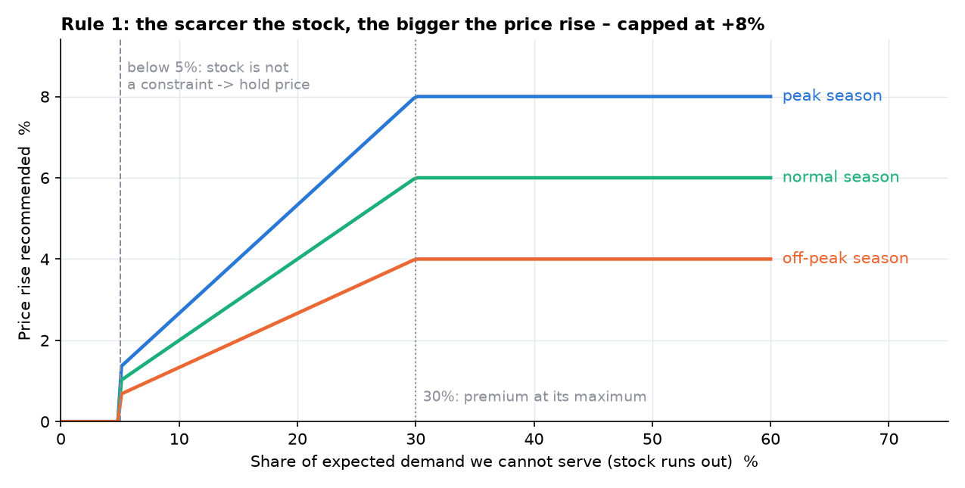
Figure 1 – Price rise recommended as a function of the share of demand that cannot be served.

Rule 2 – Sell-out protection
A rise is allowed only as far as we would still sell (almost) the same units, even if customers were twice as price-sensitive as assumed. This makes the scarcity premium independent of the price sensitivity, which cannot be measured from the data.
choose the largest M ≤ 1 + u such that E[min(D · M^(−2), S)] ≥ 99% × E[min(D, S)]

Rule 3 – Surplus and clearance (inventory sensitivity)
A markdown is considered only for products with more than 26 weeks of stock and no scarcity. It is deeper with more excess stock (up to −10% at 104 weeks or more) and only in quiet weeks. It is applied only if it pays for itself, including the holding cost saved on the extra units sold.
d = 10% × min(1, ln(cover / 26) / ln(104 / 26)) × lull(season), lull = 1 (off-peak), 0.5 (normal), 0 (peak)
apply the markdown only if Profit(P0 · (1 − d); ε = −1) > Profit(P0; ε = −1)

Rule 4 – Credit-risk rule
Ratings A and B: no change. Rating C: markdown capped at 5%. Ratings D and E: no markdowns, a risk premium on the price and a recommended shortening of payment terms by 15 days.
premium = share on credit × default rate + (DSO / 365) × 8% funding cost; target price × (1 + premium)

Rule 5 – Guardrails (competitive and profitability limits)
- Cost floor: price ≥ COGS × (1 + 5% minimum markup + 12% × 4/52 carrying cost) ÷ (1 − expected credit loss rate).
- Competitive band: 0.92 × P0 ≤ price ≤ 1.10 × P0. No competitor prices are available, so the 13-week average price stands in for the market.
- Stability: the price changes by at most ±3% from one week to the next.

Rule 6 – Final price
target = P0 × (1 + u_protected) × (1 + premium) × (1 − d) → raise to cost floor → keep inside band → limit weekly step

4. Behaviour by product type and season
 | Peak season | Normal season | Off-peak season
Low-stock product (sells out) | full premium, up to +8% | 75% of the premium | 50% of the premium
Balanced | hold P0 | hold P0 | hold P0
High-stock product (> 26 weeks) | hold P0 (no markdown in peaks) | markdown only if it pays (half strength) | markdown candidate, up to −10%, only if it pays

What the rules actually did when replayed on the last 52 weeks (average price change vs reference price):
Product type | Peak | Normal | Off-peak
Normal-stock products | +5.0% | +2.8% | +1.4%
High-stock products | +0.0% | +0.0% | +0.0%

5. Worked example
Barley, week of 2024-12-30 (normal season, credit rating C).
Step | What happens | Numbers
1 | Reference price and unit cost | $7.447 and $5.877
2 | Expected demand (low – high case) | 2,899 units (2,675 – 3,119)
3 | Units we expect to sell given the product's stock history | 1,391
4 | Service gap | 1 − 1,391 / 2,900 = 52% → Scarce
5 | Rule 1 premium | 8% × 1.00 × 0.75 = 6.0%
6 | Rule 2 sell-out protection | allowed premium 4.5% (units stay at 99.0% even at ε = −2)
7 | Rule 4 credit premium | rating C: 0.0%
8 | Rule 5 guardrails | floor $6.27; band $6.85 – $8.19; step limit ±3% of the previous price
9 | Recommended price | $7.670 (+3.0%) in week 1, reaching the target in the following weeks

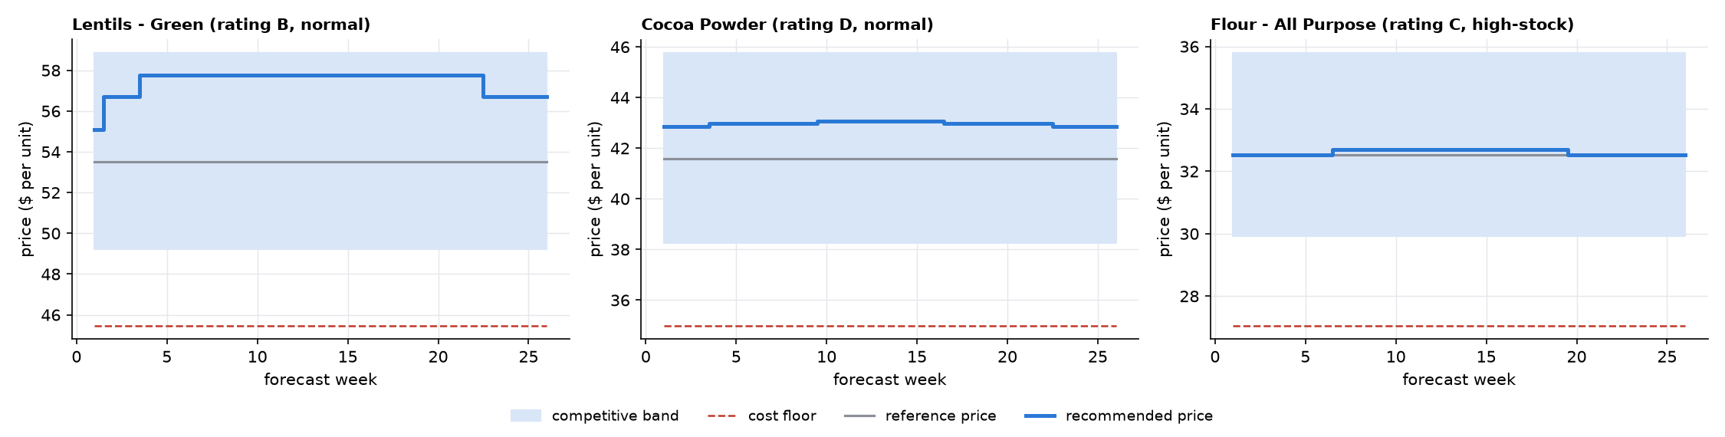
Figure 2 – Price paths of three products against the competitive band and the cost floor.

6. Parameters
All tunable values are defined in one place in the notebook. Type: policy = management choice, assumption = not measurable from the data, data-derived = read from the data.
Parameter | Default | Meaning | Type
U_MAX | 0.08 | Largest scarcity premium | policy
GAP_MIN | 0.05 | Unserved-demand share below which stock is not a constraint | policy
G_FULL | 0.3 | Unserved-demand share at which the premium is maximal | policy
SEASON_MULT | peak 1.00 / normal 0.75 / off-peak 0.50 | Share of the premium used in peak / normal / off-peak weeks | policy
PEAK_IDX / OFFPEAK_IDX | 1.1 / 0.9 | Seasonal-curve levels that define peak and off-peak weeks | data-derived
EPS_PLAN | -1.0 | Planning price sensitivity (-1 = demand falls 1% when price rises 1%) | assumption
EPS_STRESS | -2.0 | Stress price sensitivity used by the sell-out protection | assumption
VOL_TOL | 0.01 | Units we accept to lose because of a scarcity premium | policy
D_MAX / COVER_MAX / COVER_FULL | 0.1 / 26 / 104 | Largest markdown; weeks of cover where markdowns start / are deepest | policy
LULL | off-peak 1.0 / normal 0.5 / peak 0 | Share of the markdown used in off-peak / normal / peak weeks | policy
MD_CAP_C | 0.05 | Markdown cap for rating C | policy
TERMS_CUT_DAYS | 15 | Recommended payment-terms cut for rating D/E | policy
FUND_RATE | 0.08 | Annual cost of money tied up in unpaid invoices | assumption
MIN_MARKUP | 0.05 | Minimum markup on cost in the price floor | policy
CARRY_ANNUAL | 0.12 | Annual cost of holding stock, as share of cost | assumption
CARRY_FLOOR_WEEKS | 4 | Weeks of carrying cost included in the floor | policy
BAND_UP / BAND_DOWN | +0.1 / -0.08 | Competitive band around the reference price (no competitor data: proxy) | assumption
STEP_MAX | 0.03 | Largest price change from one week to the next | policy
SIM_N / SEED | 1000 / 42 | Simulation draws per product-week; random seed | technical

7. Evidence and expected impact

Price sensitivity cannot be estimated from the data
Within a product the price varies by only 4.0%. The estimated price effect is -0.017 with a 95% range of -0.056 to +0.021, which includes zero and cannot distinguish a low from a high sensitivity. The engine is therefore built not to depend on it (Rule 2), and the money impact is shown for several customer reactions.

Expected money impact (profit after expected credit losses, versus holding today's price)
Customer reaction (ε) | Units | Revenue | Profit gain, 26 weeks
0 (customers ignore price) | +0.00% | $1.3M | $1.3M (+17.5%)
-0.5 (low sensitivity) | -0.21% | $1.2M | $1.3M (+17.2%)
-1 (planning case) | -0.44% | $1.1M | $1.3M (+17.0%)
-2 (high sensitivity) | -0.95% | $936K | $1.2M (+16.3%)
-3 (very high sensitivity) | -1.60% | $676K | $1.2M (+15.5%)

Replay of the last 52 weeks with only the information available at the time: $1.4M in the planning case (+10.6%). If the true demand were only 60% of the estimate, the planning-case gain would still be $939K; at 50% it would be $818K.
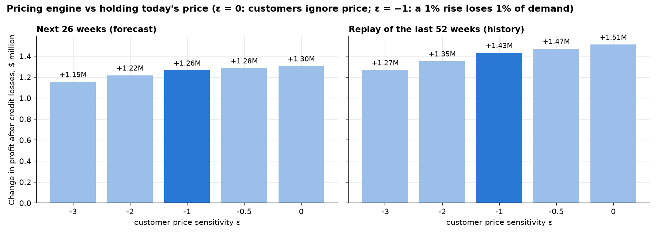
Figure 3 – Change in profit for the next 26 weeks and for the replay of the last 52 weeks.

Where price is not the lever
- Over-stock: 5 products hold more than 26 weeks of stock ($10.8M tied up, about $1.3M a year to carry). Selling the excess within a year by price alone would need cuts of 17–49% even for very price-sensitive customers, so purchasing must stop instead.
- Credit: Beverages & Cocoa (rating D/E, assumption-based): no discounts, 2.5% risk premium, and shorter terms would free about $361K of cash.
- Markdowns: 200 candidate markdowns were rejected because they would not pay for themselves; they would pay only if customers were about 3.8 times price-sensitive.

8. Verification
19 of 19 automatic checks pass on both the 26-week plan and the 52-week replay: competitive band, cost floor, weekly step, credit rules, no markdown in peak weeks, hand-calculated rule arithmetic, monotonic premium, deterministic results, no look-ahead in the replay, and reconciliation with the Part 2 forecast.

9. Assumptions and limits
- Price sensitivity: unknown; planning case −1, stress case −2, results shown from 0 to −3.
- Competitors: no competitor prices; the 13-week average price and the band are a proxy.
- Credit: ratings, DSO and default rates come from assumptions (no customer data).
- Future stock: simulated from each product's own last 104 weeks of stock.
- Demand: reconstructed in stock-limited weeks, so the replay is an estimate.
- Costs: unit cost held at its last-13-week average; holding cost 12% and funding cost 8% a year.
- Scope: prices per product-week; customer- or channel-specific pricing needs customer data.

10. Recommended next step
Run a pilot before a full roll-out. Pilot A (scarce products, +3% / +5% against matched controls) checks that stock still sells out. Pilot B (high-stock products, price ±3% in random weeks) measures real price sensitivity. Then update the planning and stress sensitivity (ε) and re-run the notebook.

