##### 文件制／修訂履歷

|  |  |  |  |  |  |
| --- | --- | --- | --- | --- | --- |
| 制／修訂  版次 | 制／修訂  日期 | 制／修訂  說明 | 作  者 | 核  准 | 備  註 |
| V0.0 | 2021/04/06 | 初版 | 林楷杰 |  |  |
| V1.1 | 2022/12/27 | 出版 | 林楷杰 |  |  |
| V2.0 | 2023/04/10 | 出版 | 林楷杰 |  |  |

|  |  |  |  |
| --- | --- | --- | --- |
| **報表代號** | L9134 | **報表名稱** | 暫收款傳票金額表 |
| **程式名稱** | 1. 前端：L9134.var 2. 電文定義檔：L9134.tim , L9134.tom , L9134_OC.tom 3. 後端：L9134.java , L9134Report.java , L9134Report2.java , L9134Report3.java , L9134Report4.java , L9134ServiceImpl.java | | |
| **報表底稿** | 有(暫收款對帳-日調結表) | | |
| **報表說明** | 產製  暫收款傳票金額表(累計)(PDF)  暫收款傳票金額表(明細)(Excel)  放款暫收款對帳明細表(Excel)  暫收款對帳-日調結表(Excel) | | |
| **流程說明** | 流程A：  交易選單  L6共同作業  →1 控制類  →L6101關帳作業  →產生L9134 暫收款傳票金額表  流程B：  交易選單  →L9報表作業  →1關帳報表  →L9134 暫收款傳票金額表 | | |
| **批次產製方式** | 1. 批次週期: 2. 批次時間: | | |
| **檔案格式** | Pdf、Excel | | |
| **是否須簽核** | 否 | | |

## Table

### 暫收款傳票金額表(累計)

* + 1. AcDetail 會計帳務明細檔

### 暫收款傳票金額表(明細)

* + 1. AcDetail 會計帳務明細檔
    2. CustMain 客戶主檔
    3. CdCode 共用代碼檔
    4. CdAcCode 會計科子細目設定檔

### 放款暫收款對帳明細表

* + 1. AcReceivable 會計銷帳檔
    2. CollList 法催紀錄清單檔
    3. CdCode 共用代碼檔
    4. CdAcCode 會計科子細目設定檔

### 暫收款對帳-日調結表

* + 1. AcMain 會計主檔
    2. AcDetail 會計帳務明細檔
    3. CustMain 客戶主檔
    4. CdCode 共用代碼檔
    5. CdAcCode 會計科子細目設定檔

### B功能說明

### 【輸入參數】:

#### 會計日期-起

##### 會計日期: 999/99/99 。

* 檢核: 合理日期且不得大於系統會計日期。

#### 會計日期-迄:

##### 會計日期: 999/99/99 。

* 檢核: 合理日期且小於等於會計日期-起。

### 【進表條件】:

會計明細(AcDetail)的會計日期區間，且業務科目為暫收款項目('T10','T11','T12','T13','TAM','TAV','TCK','TEM','THC','TLD','TMI','TRO','TSL')

### 【報表格式】:

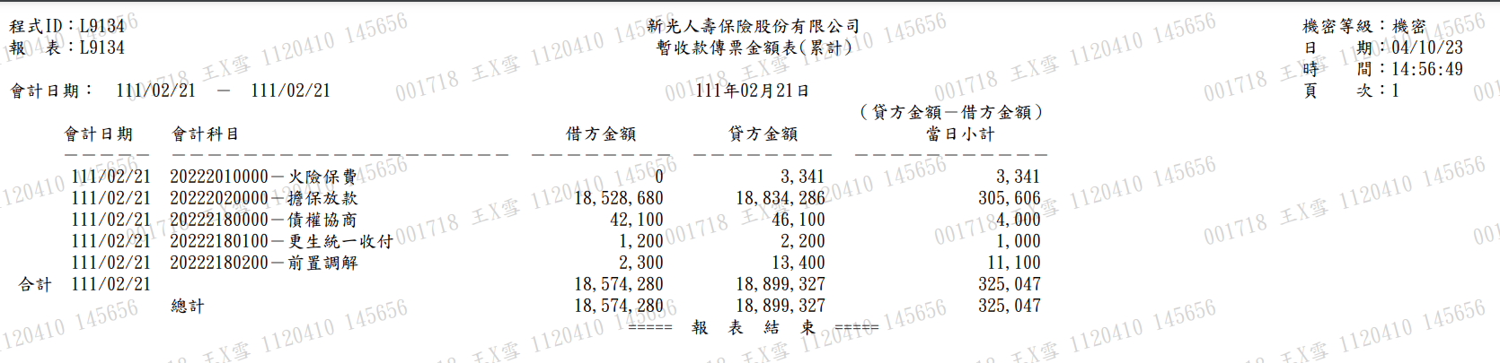暫收款傳票金額表(累計)

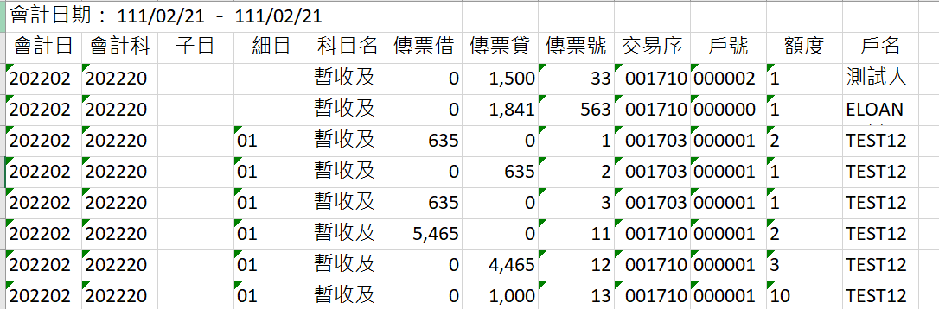暫收款傳票金額表(明細)

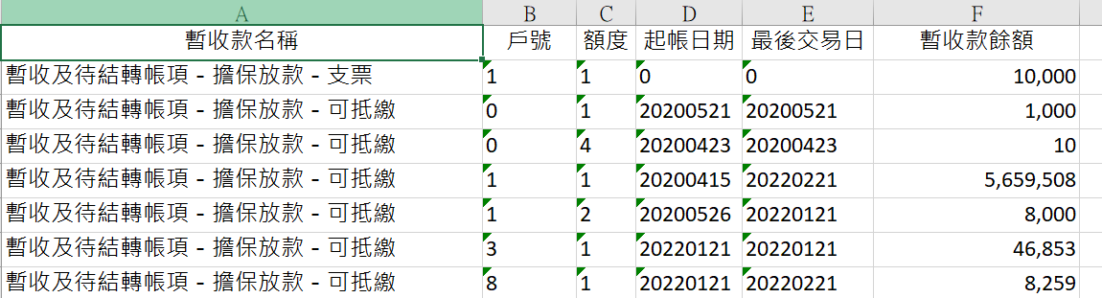放款暫收款對帳明細表

暫收款對帳-日調結表

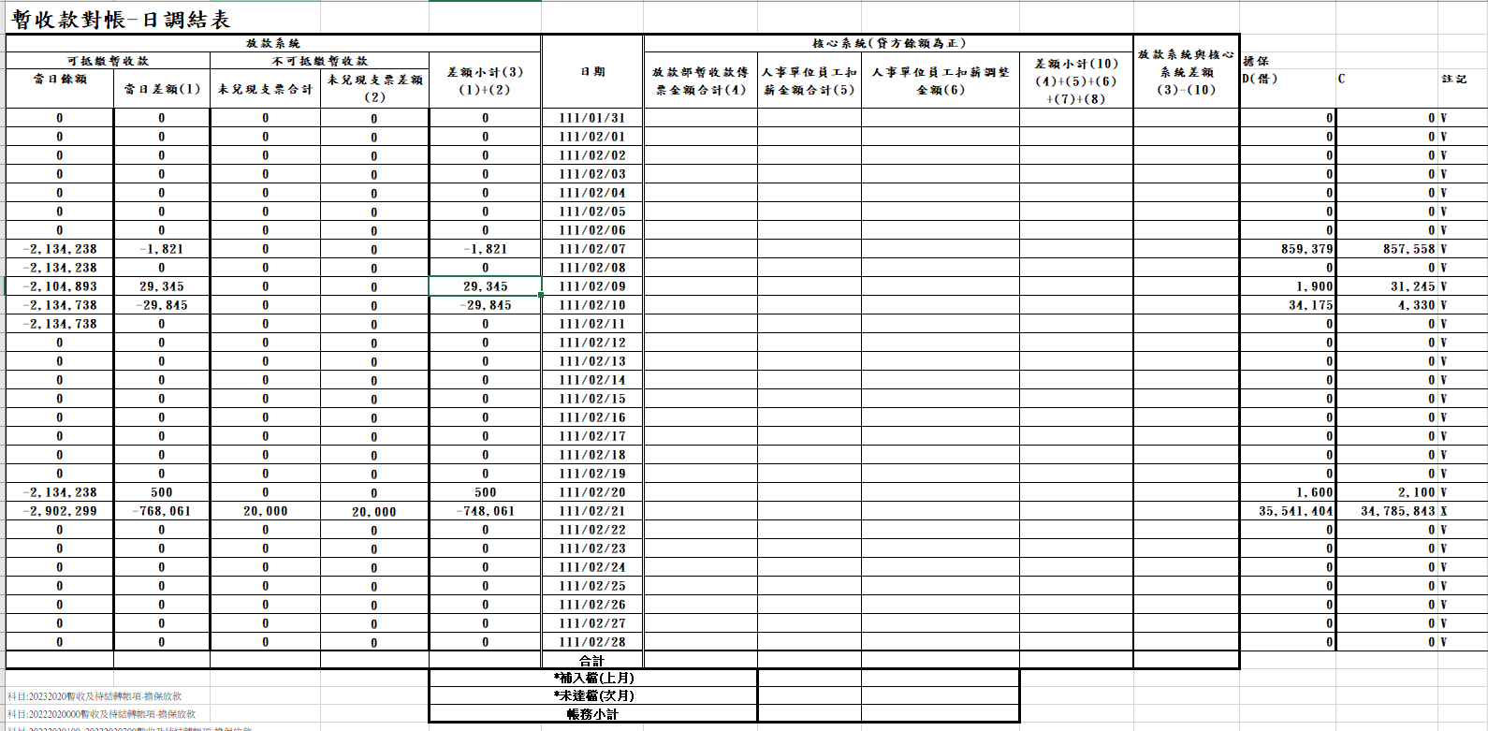



### 【列印順序】:

暫收款傳票金額表(累計)：

AcDate ASC,AcNoCode ASC

暫收款傳票金額表(明細)：

AcDate ASC,AcNoCode ASC,AcSubCode ASC,AcDtlCode ASC, SlipNo ASC, TitaTxtNo ASC

放款暫收款對帳明細表：

AcNoCode ASC,AcSubCode ASC,AcDtlCode ASC, CustNo ASC, FacmNo ASC

暫收款對帳-日調結表：

AcDate ASC

### 【跳頁方式】:

無。

### 【報表欄位】:

暫收款傳票金額表(累計)

|  |  |  |
| --- | --- | --- |
| 欄位 | 資料來源 | 說明 |
| 報表首 | | |
| 程式ID |  | 發動的交易代號 |
| 報表 |  | 報表代號 |
| 會計日期 | 畫面上輸入的日期範圍 | 格式：  YYY/MM/DD – YYY/MM/DD |
| 標題 |  | 固定值:  新光人壽保險股份有限公司  暫收款傳票金額表(累計) |
| 民國日期 |  | 格式：  YYY年MM月DD日 |
| 機密等級 |  | 機密 |
| 日期 |  | 報表產製日期  西元年MM/DD/YY |
| 時間 |  | 報表產製時間  HH:MM:SS |
| 頁次 |  |  |
| 明細 | | |
| 會計日期 | AcDetail.AcDate |  |
| 會計科目 | AcDetail.AcNoCode |  |
| 借方金額 | AcDetail.TxAmt | 借貸代號為D(借) |
| 貸方金額 | AcDetail.TxAmt | 借貸代號為C(貸) |
| 當日小計 |  | 借方金額-貸方金額 |
| 頁尾 | | |
| 合計 |  |  |
| 總計 |  |  |

暫收款傳票金額表(明細)

|  |  |  |
| --- | --- | --- |
| 欄位 | 資料來源 | 說明 |
| 報表首 | | |
| 會計日期 | 畫面上輸入的日期範圍 | 格式：  YYY/MM/DD – YYY/MM/DD |
| 明細 | | |
| 會計日期 | AcDetail.AcDate |  |
| 會計科目 | AcDetail.AcNoCode |  |
| 子目 | AcDetail.AcSubCode |  |
| 細目 | AcDetail.AcDtlCode |  |
| 科目名稱 | CdAcCode.AcNoItem+  CdAcCode. AcctItem |  |
| 傳票借方金額 | AcDetail.TxAmt | 借貸代號為D(借) |
| 傳票貸方金額 | AcDetail.TxAmt | 借貸代號為C(貸) |
| 傳票號碼 | AcDetail.SlipNo |  |
| 交易序號 | AcDetail.TitaTlrNo+  AcDetail.TitaTxtNo |  |
| 戶號 | AcDetail.CustNo |  |
| 額度 | AcDetail.FacmNo |  |
| 戶名 | CustMain.CustName |  |

放款暫收款對帳明細表：

|  |  |  |
| --- | --- | --- |
| 欄位 | 資料來源 | 說明 |
| 明細 | | |
| 暫收款名稱 | CdAcCode.AcNoItem |  |
| 戶號 | AcDetail.CustNo |  |
| 額度 | AcDetail.FacmNo |  |
| 起帳日期 | AcDetail.OpenAcDate |  |
| 最後交易日 | AcDetail.LastTxDate |  |
| 暫收款餘額 | AcDetail.RvBal |  |

暫收款對帳-日調結表：

|  |  |  |
| --- | --- | --- |
| 欄位 | 資料來源 | 說明 |
| 明細 | | |
| 可抵繳暫收款-  當日餘額 | AcMain.TdBal | 會計科目為  TAV(暫收款-可抵繳)  T10(債協暫收款-收款專戶) |
| 可抵繳暫收款-當日差額 | AcMain.TdBal-AcMain.YdBal | 會計科目為  TAV(暫收款-可抵繳)  T10(債協暫收款-收款專戶) |
| 不可抵繳暫收款-未兌現支票和計 | AcMain.TdBal | 會計科目為TCK(暫收款-支票) |
| 不可抵繳暫收款-未兌現支票差額 | AcMain.TdBal-AcMain.YdBal | 會計科目為TCK(暫收款-支票) |
| 差額小計 |  | 可抵繳暫收款-當日差額加上不可抵繳暫收款-未兌現支票差額 |
| 日期 | AcMain.AcDate |  |
| 擔保D(借) | AcDetail.TxAmt | 借貸代號為D(借)且  會計科目為  TAV(暫收款-可抵繳)  T10(債協暫收款-收款專戶)  TCK(暫收款-支票) |
| 擔保C(貸) | AcDetail.TxAmt | 借貸代號為C(貸)且  會計科目為  TAV(暫收款-可抵繳)  T10(債協暫收款-收款專戶)  TCK(暫收款-支票) |
| 註記 |  | 擔保借貸合計如果等於差額小計的話打勾，否則打叉 |

### SQL：

|  |
| --- |
| 暫收款傳票金額表(累計)：  WITH rawData AS (  SELECT "AcDate"  , "AcNoCode"  , SUM( CASE  WHEN "DbCr" = 'D'  THEN "TxAmt"  ELSE 0 END) AS "DrAmt"  , SUM( CASE  WHEN "DbCr" = 'C'  THEN "TxAmt"  ELSE 0 END) AS "CrAmt"  FROM "AcDetail"  WHERE "AcDate" >= :startDate  AND "AcDate" <= :endDate  AND "AcctCode" in  ('T10','T11','T12','T13',  'TAM','TAV','TCK','TEM',  'THC','TLD','TMI','TRO','TSL')  AND "EntAc" > 0  GROUP BY "AcDate"  , "AcNoCode"  )  SELECT "AcDate"  , "AcNoCode"  , "DrAmt"  , "CrAmt"  , "CrAmt" - "DrAmt" AS "DiffAmt"  FROM rawData  ORDER BY "AcDate"  , "AcNoCode"  暫收款傳票金額表(明細)：  SELECT AD."AcDate"  , AD."AcNoCode"  , AD."AcSubCode"  , AD."AcDtlCode"  , C."AcNoItem"  , C."AcctItem"  , CASE  WHEN AD."DbCr" = 'D'  THEN AD."TxAmt"  ELSE 0 END AS "DrAmt"  , CASE  WHEN AD."DbCr" = 'C'  THEN AD."TxAmt"  ELSE 0 END AS "CrAmt"  , AD."SlipNo"  , LPAD(AD."TitaTlrNo",6,0) || LPAD(AD."TitaTxtNo",7,0) AS "TitaTxtNo"  , LPAD(AD."CustNo",7,'0') AS "CustNo"  , AD."FacmNo"  , CM."CustName"  FROM "AcDetail" AD  LEFT JOIN "CustMain" CM ON CM."CustNo" = AD."CustNo"  AND AD."CustNo" != 0  LEFT JOIN "CdCode" CC ON CC."DefCode" = 'AcSubBookCode'  AND CC."Code" = AD."AcSubBookCode"  LEFT JOIN "CdAcCode" C ON C."AcNoCode" = AD."AcNoCode"  AND C."AcSubCode" = AD."AcSubCode"  AND C."AcDtlCode" = AD."AcDtlCode"  WHERE AD."AcDate" >= :startDate  AND AD."AcDate" <= :endDate  ND AD."AcctCode" in  ('T10','T11','T12','T13',  'TAM','TAV','TCK','TEM',  'THC','TLD','TMI','TRO','TSL')  ND AD."EntAc" > 0  ORDER BY AD."AcDate"  , AD."AcNoCode" ASC  , AD."AcSubCode" ASC  , AD."AcDtlCode" ASC  , AD."SlipNo" ASC  , AD."TitaTxtNo" ASC  放款暫收款對帳明細表：  SELECT C."AcNoItem"  , AC."AcNoCode"  , AC."AcSubCode"  , AC."AcDtlCode"  , AC."CustNo"  , AC."FacmNo"  , AC."OpenAcDate"  , AC."LastTxDate"  , AC."AcBal"  , AC."RvBal"  , CC."Item"  , NVL(CO."RenewCode",' ') AS "RenewCode"  FROM "AcReceivable" AC  LEFT JOIN "CdAcCode" C ON C."AcctCode" = AC."AcctCode"  LEFT JOIN "CdCode" CC ON CC."DefCode" = 'AcSubBookCode'  AND CC."Code" = AC."AcSubBookCode"  LEFT JOIN "CollList" CO ON CO."CustNo" = AC."CustNo"  AND CO."FacmNo" = AC."FacmNo"  where AC."AcctCode" in  ('T10','T11','T12','T13',  'TAM','TAV','TCK','TEM',  'THC','TLD','TMI','TRO','TSL')  AND AC."RvBal" > 0  ORDER BY AC."AcNoCode" ASC  , AC."AcSubCode" ASC  , AC."AcDtlCode" ASC  , AC."CustNo" ASC  , AC."FacmNo" ASC  暫收款對帳-日調結表：  select "AcDate"  , sum("TdBal") as "TdBal"  , sum("TdBal") - sum("YdBal") as "DifTdBal"  , sum("didTdal") as "didTdBal"  , sum("didTdal")- sum("didYdBal") as "didDifTdBal"  , sum("DrAmt") as "DrAmt" , sum("CrAmt") as "CrAmt"  from  (  select  :lastMonthEnd as "AcDate"  ,sum("YdBal") as "YdBal"  ,sum("TdBal") as "TdBal"  ,0 as "didYdBal"  ,0 as "didTdal"  , 0 as "DrAmt" , 0 as "CrAmt"  from "AcMain"  where "AcDate" = :acdate --// 抓上個月的月底日  AND "AcctCode" in ('TAV','T10')  union all  select  :lastMonthEnd as "AcDate"  , 0 as "YdBal"  , 0 as "TdBal"  ,sum("YdBal") as "didYdBal"  ,sum("TdBal") as "didTdal"  ,0 as "DrAmt" , 0 as "CrAmt"  from "AcMain"  where "AcDate" = :acdate --// 抓上個月的月底日  and "AcctCode" in ('TCK')  --for (int i = 1; i <= length; i++) {  union all  select  '" + rocYM + "" + '/' + "" + parse.IntegerToString(i, 2) + "' as "AcDate"  ,0 as "YdBal"  ,0 as "TdBal"  ,0 as "didYdBal"  ,0 as "didTdal"  ,0 as "DrAmt" , 0 as "CrAmt"  from dual  union all  select  '" + rocYM + "" + '/' + "" + parse.IntegerToString(i, 2) + "' as "AcDate"  ,sum("YdBal") as "YdBal"  ,sum("TdBal") as "TdBal"  , 0 as "didYdBal"  , 0 as "didTdal"  , 0 as "DrAmt" , 0 as "CrAmt"  from "AcMain"  where "AcDate" = " + bcYM + parse.IntegerToString(i, 2) + "  AND "AcctCode" in ('TAV','T10')  union all  select  '" + rocYM + "" + '/' + "" + parse.IntegerToString(i, 2) + "' as "AcDate"  ,0 as "YdBal"  ,0 as "TdBal"  , sum("YdBal") as "didYdBal"  , sum("TdBal") as "didTdal"  ,0 as "DrAmt" , 0 as "CrAmt"  from "AcMain"  where "AcctCode" in ('TCK')  and "AcDate" = " + bcYM + parse.IntegerToString(i, 2) + "  union all  select  '" + rocYM + "" + '/' + "" + parse.IntegerToString(i, 2) + "' as "AcDate"  ,0 as "YdBal"  ,0 as "TdBal"  ,0 as "didYdBal"  ,0 as "didTdal"  ,sum("DrAmt") as "DrAmt" , sum("CrAmt") as "CrAmt"  from (  select  CASE  WHEN AD."DbCr" = 'D'  THEN AD."TxAmt"  ELSE 0 END AS "DrAmt"  , CASE  WHEN AD."DbCr" = 'C'  THEN AD."TxAmt"  ELSE 0 END AS "CrAmt"  FROM "AcDetail" AD  LEFT JOIN "CustMain" CM ON CM."CustNo" = AD."CustNo"  AND AD."CustNo" != 0  LEFT JOIN "CdCode" CC ON CC."DefCode" = 'AcSubBookCode'  AND CC."Code" = AD."AcSubBookCode"  LEFT JOIN "CdAcCode" C ON C."AcNoCode" = AD."AcNoCode"  AND C."AcSubCode" = AD."AcSubCode"  AND C."AcDtlCode" = AD."AcDtlCode"  WHERE AD."AcDate" >=" + bcYM + parse.IntegerToString(i, 2) + "  AND AD."AcDate" <=" + bcYM + parse.IntegerToString(i, 2) + "  AND AD."AcctCode" in ('TAV','TCK','T10')  AND AD."EntAc" > 0  )  --}  )  group by "AcDate"  order by "AcDate" |

### 【樣張底稿】:

暫無。