文件制／修訂履歷

|  |  |  |  |  |  |
| --- | --- | --- | --- | --- | --- |
| 制／修訂  版次 | 制／修訂  日期 | 制／修訂  說明 | 作  者 | 核  准 | 備  註 |
| V2.0 | 2023/04/12 | 出版 | 林楷杰 |  |  |

|  |  |  |  |
| --- | --- | --- | --- |
| **報表代號** | L9137 | **報表名稱** | 放款餘額總表 |
| **程式名稱** | 1. 前端：L9137.var 2. 電文定義檔：L9137.tim , L9137.tom , L9137_OC.tom 3. 後端：L9137.java , L9137p.java ,L9137Report.java , L9137ServiceImpl.java | | |
| **報表底稿** | 無 | | |
| **報表說明** | 產製放款餘額總表 | | |
| **流程說明** | 流程A：  交易選單  L6共同作業  →1 控制類  →L6101關帳作業  →產生L9137 放款餘額總表  流程B：  交易選單  →L9報表作業  →1關帳報表  →L9137 放款餘額總表 | | |
| **批次產製方式** | 1. 批次週期: 2. 批次時間: | | |
| **檔案格式** | PDF | | |
| **是否須簽核** | 否 | | |

## Table

### LoanBorMain 放款主檔

### FacMain 額度主檔

### LoanOverdue 催收呆帳檔

### AcReceivable 會計銷帳檔

## 功能說明

### 【輸入參數】:

#### 報表類別:

##### 選項:

##### 0 放款餘額總表

##### 1 關係人放款餘額總表

##### 2 全部

### 【進表條件】:

會計日期(月底營業日)小於放款主檔撥款日期的資料。

### 【報表格式】:

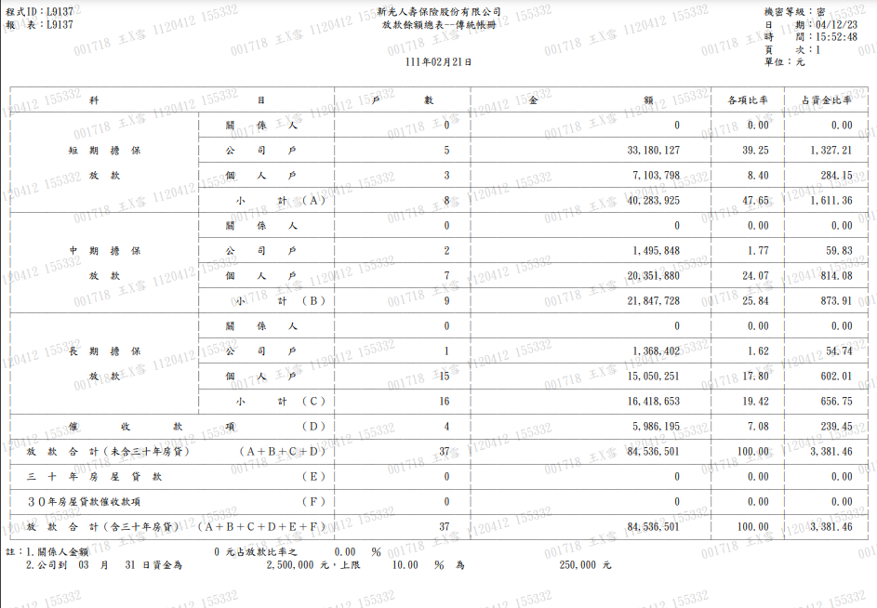



### 【列印順序】:

無

### 【跳頁方式】:

無

### 【報表欄位】:

|  |  |  |
| --- | --- | --- |
| 欄位 | 資料來源 | 說明 |
| 報表首 | | |
| 程式ID |  | 發動的交易代號 |
| 報表 |  | 報表代號 |
| 標題 |  | 固定值:  新光人壽保險股份有限公司  放款餘額總表 |
| 會計日期 |  | 格式：YYY年MM月DD日 |
| 機密等級 |  | 密 |
| 日期 |  | 報表產製日期  西元年MM/DD/YY |
| 時間 |  | 報表產製時間  HH:MM:SS |
| 頁數 |  |  |
| 明細 | | |
| 戶數 |  |  |
| 金額 |  |  |
| 各項比率 |  |  |
| 占資金比率 |  |  |

### 【SQL語法】:

|  |
| --- |
| 放款餘額總表  WITH loanData AS (  SELECT B."CustNo"  , B."FacmNo"  , B."BormNo"  , CASE  WHEN B."Status" IN (2,5,6,7,8,9)  THEN NVL(O."AcctCode",' ')  ELSE F."AcctCode" END AS "AcctCode"  , F."AcctCode" AS "FacAcctCode"  , CASE  WHEN B."Status" IN (0,4)  THEN B."LoanBal"  WHEN B."Status" IN (2,7)  THEN NVL(O."OvduBal",0)  ELSE 0 END AS "LoanBalance"  FROM "LoanBorMain" B  LEFT JOIN "FacMain" F ON F."CustNo" = B."CustNo"  AND F."FacmNo" = B."FacmNo"  LEFT JOIN "LoanOverdue" O ON O."CustNo" = B."CustNo"  AND O."FacmNo" = B."FacmNo"  AND O."BormNo" = B."BormNo"  AND O."OvduNo" = B."LastOvduNo"  AND B."Status" IN (2,5,6,7,8,9)  WHERE B."Status" in (0,1,2,3,4,5,6,7,8,9)  AND B."DrawdownDate" <= :TBSDYF  )  SELECT S."DetailSeq"  ,SUM(S."Counts") AS "Counts"  ,SUM(S."LoanBalance") AS "Amt"  FROM ( SELECT CASE  WHEN D."AcctCode" = '310' AND C."IsRelated" = 'Y' THEN 1  WHEN D."AcctCode" = '310' AND C."EntCode" IN ('1') THEN 2 // EntCode = 2  // 為企金自然人,算在個人戶  WHEN D."AcctCode" = '310' THEN 3  WHEN D."AcctCode" = '320' AND C."IsRelated" = 'Y' THEN 4  WHEN D."AcctCode" = '320' AND C."EntCode" IN ('1') THEN 5 // EntCode = 2  // 為企金自然人,算在個人戶  WHEN D."AcctCode" = '320' THEN 6  WHEN D."AcctCode" = '330' AND C."IsRelated" = 'Y' THEN 7  WHEN D."AcctCode" = '330' AND C."EntCode" IN ('1') THEN 8 // EntCode = 2  // 為企金自然人,算在個人戶  WHEN D."AcctCode" = '330' THEN 9  WHEN D."AcctCode" = '990' AND D."FacAcctCode" <> '340' THEN 10  WHEN D."AcctCode" = '340' THEN 11  WHEN D."AcctCode" = '990' AND D."FacAcctCode" = '340' THEN 12  ELSE 99 END AS "DetailSeq"  ,1 AS "Counts"  ,D."LoanBalance"  FROM ( SELECT D."AcctCode"  ,D."FacAcctCode"  ,D."CustNo"  ,D."FacmNo"  ,SUM(D."LoanBalance") AS "LoanBalance"  FROM loanData D  WHERE D."LoanBalance" > 0  GROUP BY D."AcctCode"  ,D."FacAcctCode"  ,D."CustNo"  ,D."FacmNo"  ) D  LEFT JOIN ( SELECT S0."CustNo"  ,S0."EntCode"  ,CASE  WHEN S0."IsRelated" > 0 THEN 'Y'  ELSE 'N' END AS "IsRelated"  FROM ( SELECT CM."CustNo"  ,NVL(CM."EntCode",'0') AS "EntCode"  ,COUNT(REL."Id") AS "IsRelated"  FROM "CustMain" CM  LEFT JOIN (  SELECT "EmpId" AS "Id"  FROM "LifeRelEmp"  UNION ALL  SELECT DISTINCT  CASE  WHEN "BusId" <> '-' THEN "BusId"  WHEN "RelId" <> '-' THEN "RelId"  WHEN "HeadId" <> '-' THEN "HeadId"  END AS "Id"  FROM "LifeRelHead"  WHERE "RelWithCompany" IN ('A','B')  AND "LoanBalance" > 0  ) REL ON REL."Id" = CM."CustId"  WHERE CM."CustNo" > 0  GROUP BY CM."CustNo",NVL(CM."EntCode",'0')  ) S0  ) C ON C."CustNo" = D."CustNo"  LEFT JOIN ( SELECT A0."AcctCode"  ,A0."CustNo"  ,A0."FacmNo"  ,A0."AcSubBookCode"  ,ROW_NUMBER() OVER (PARTITION BY A0."CustNo"  ,A0."FacmNo"  ORDER BY A0."AcctCode") AS "Seq"  FROM loanData D0  LEFT JOIN "AcReceivable" A0 ON A0."AcctCode" = D0."AcctCode"  AND A0."CustNo" = D0."CustNo"  AND A0."FacmNo" = D0."FacmNo"  AND SUBSTR(A0."RvNo",0,3) = LPAD(D0."BormNo",3,'0')  WHERE D0."LoanBalance" > 0  AND A0."AcctCode" IN ('310','320','330','340','990')  ) A ON A."AcctCode" = D."AcctCode"  AND A."CustNo" = D."CustNo"  AND A."FacmNo" = D."FacmNo"  AND A."Seq" = 1  WHERE D."LoanBalance" > 0  AND NVL(A.\"AcSubBookCode\",' ') LIKE :acSubBookCode  UNION ALL SELECT 1,0,0 FROM DUAL  UNION ALL SELECT 2,0,0 FROM DUAL  UNION ALL SELECT 3,0,0 FROM DUAL  UNION ALL SELECT 4,0,0 FROM DUAL  UNION ALL SELECT 5,0,0 FROM DUAL  UNION ALL SELECT 6,0,0 FROM DUAL  UNION ALL SELECT 7,0,0 FROM DUAL  UNION ALL SELECT 8,0,0 FROM DUAL  UNION ALL SELECT 9,0,0 FROM DUAL  UNION ALL SELECT 10,0,0 FROM DUAL  UNION ALL SELECT 11,0,0 FROM DUAL  UNION ALL SELECT 12,0,0 FROM DUAL  ) S  WHERE S."DetailSeq" <> 99  GROUP BY S."DetailSeq"  ORDER BY S."DetailSeq"  放款餘額總表(關係人)  WITH loanData AS (  SELECT B."CustNo"  , B."FacmNo"  , B."BormNo"  , CASE  WHEN B."Status" IN (2,5,6,7,8,9)  THEN NVL(O."AcctCode",' ')  ELSE F."AcctCode" END AS "AcctCode"  , F."AcctCode" AS "FacAcctCode"  , CASE  WHEN B."Status" IN (0,4)  THEN B."LoanBal"  WHEN B."Status" IN (2,7)  THEN NVL(O."OvduBal",0)  ELSE 0 END AS "LoanBalance"  FROM "LoanBorMain" B  LEFT JOIN "FacMain" F ON F."CustNo" = B."CustNo"  AND F."FacmNo" = B."FacmNo"  LEFT JOIN "LoanOverdue" O ON O."CustNo" = B."CustNo"  AND O."FacmNo" = B."FacmNo"  AND O."BormNo" = B."BormNo"  AND O."OvduNo" = B."LastOvduNo"  AND B."Status" IN (2,5,6,7,8,9)  WHERE B."Status" in (0,1,2,3,4,5,6,7,8,9)  AND B."DrawdownDate" <= :TBSDYF  )  SELECT S."DetailSeq"  ,SUM(S."Counts") AS "Counts"  ,SUM(S."LoanBalance") AS "Amt"  FROM ( SELECT CASE  WHEN C."IsRelated" = 'Y'  THEN CASE WHEN D."AcctCode" = '310' AND C."EntCode" IN ('1') THEN 2  WHEN D."AcctCode" = '310' THEN 3  WHEN D."AcctCode" = '320' AND C."EntCode" IN ('1') THEN 5  WHEN D."AcctCode" = '320' THEN 6  WHEN D."AcctCode" = '330' AND C."EntCode" IN ('1') THEN 8  WHEN D."AcctCode" = '330' THEN 9  WHEN D."AcctCode" = '340' AND C."EntCode" IN ('1') THEN 8  WHEN D."AcctCode" = '340' THEN 9  ELSE 990 END  ELSE 99 END AS "DetailSeq"  ,1 AS "Counts"  ,D."LoanBalance"  FROM ( SELECT D."AcctCode"  ,D."FacAcctCode"  ,D."CustNo"  ,D."FacmNo"  ,SUM(D."LoanBalance") AS "LoanBalance"  FROM loanData D  WHERE D."LoanBalance" > 0  GROUP BY D."AcctCode"  ,D."FacAcctCode"  ,D."CustNo"  ,D."FacmNo"  ) D  LEFT JOIN ( SELECT S0."CustNo"  ,S0."EntCode"  ,CASE WHEN S0."IsRelated" > 0  THEN 'Y'  ELSE 'N' END AS "IsRelated"  FROM ( SELECT CM."CustNo"  ,NVL(CM."EntCode",'0') AS "EntCode"  ,COUNT(REL."Id") AS "IsRelated"  FROM "CustMain" CM  LEFT JOIN (  SELECT "EmpId" AS "Id"  FROM "LifeRelEmp"  UNION ALL  SELECT DISTINCT  CASE  WHEN "BusId" <> '-' THEN "BusId"  WHEN "RelId" <> '-' THEN "RelId"  WHEN "HeadId" <> '-' THEN "HeadId"  END AS "Id"  FROM "LifeRelHead"  WHERE "RelWithCompany" IN ('A','B')  AND "LoanBalance" > 0  ) REL ON REL."Id" = CM."CustId"  WHERE CM."CustNo" > 0  GROUP BY CM."CustNo",NVL(CM."EntCode",'0')  ) S0  ) C ON C."CustNo" = D."CustNo"  LEFT JOIN ( SELECT A0."AcctCode"  ,A0."CustNo"  ,A0."FacmNo"  ,A0."AcSubBookCode"  ,ROW_NUMBER() OVER (PARTITION BY A0."CustNo"  ,A0."FacmNo"  ORDER BY A0."AcctCode") AS "Seq"  FROM loanData D0  LEFT JOIN "AcReceivable" A0 ON A0."AcctCode" = D0."AcctCode"  AND A0."CustNo" = D0."CustNo"  AND A0."FacmNo" = D0."FacmNo"  AND SUBSTR(A0."RvNo",0,3) = LPAD(D0."BormNo",3,'0')  WHERE D0."LoanBalance" > 0  AND A0."AcctCode" IN ('310','320','330','340','990')  ) A ON A."AcctCode" = D."AcctCode"  AND A."CustNo" = D."CustNo"  AND A."FacmNo" = D."FacmNo"  AND A."Seq" = 1  WHERE D."LoanBalance" > 0  AND NVL(A."AcctCode",' ') IN ('310','320','330','340','990')  AND NVL(A."AcSubBookCode",' ') LIKE :acSubBookCode  UNION ALL SELECT 1,0,0 FROM DUAL  UNION ALL SELECT 2,0,0 FROM DUAL  UNION ALL SELECT 3,0,0 FROM DUAL  UNION ALL SELECT 4,0,0 FROM DUAL  UNION ALL SELECT 5,0,0 FROM DUAL  UNION ALL SELECT 6,0,0 FROM DUAL  UNION ALL SELECT 7,0,0 FROM DUAL  UNION ALL SELECT 8,0,0 FROM DUAL  UNION ALL SELECT 9,0,0 FROM DUAL  ) S  WHERE S."DetailSeq" <> 99  GROUP BY S."DetailSeq"  ORDER BY S."DetailSeq" |

### 【樣張底稿】:

