文件制／修訂履歷

|  |  |  |  |  |  |
| --- | --- | --- | --- | --- | --- |
| 制／修訂  版次 | 制／修訂  日期 | 制／修訂  說明 | 作  者 | 核  准 | 備  註 |
| V2.0 | 2023/04/12 | 出版 | 林楷杰 |  |  |

|  |  |  |  |
| --- | --- | --- | --- |
| **報表代號** | L9138 | **報表名稱** | 放款授信日報表 |
| **程式名稱** | 1. 前端：L9138.var 2. 電文定義檔：L9138.tim , L9138.tom , L9138_OC.tom 3. 後端：L9138.java , L9138p.java ,L9138Report.java , L9138ServiceImpl.java | | |
| **報表底稿** | 無 | | |
| **報表說明** | 產製放款授信日報表 | | |
| **流程說明** | 流程A：  交易選單  L6共同作業  →1 控制類  →L6101關帳作業  →產生L9138 放款授信日報表  流程B：  交易選單  →L9報表作業  →1關帳報表  →L9138 放款授信日報表 | | |
| **批次產製方式** | 1. 批次週期: 2. 批次時間: | | |
| **檔案格式** | PDF | | |
| **是否須簽核** | 否 | | |

## Table

### AcDetail 會計帳務明細檔

### LoanBorMain 放款主檔

### CdAcCode 會計科子細目設定檔

### AcMain 會計主檔

### AcAcctCheck 會計業務檢核檔

## 功能說明

### 【輸入參數】:

#### 會計日期:

##### 格式：YYY/MM/DD

##### 檢核：合理日期且不大於系統會計日期

### 【進表條件】:

會計日期(月底營業日)等於會計帳務明細檔會計日期且會計科目(310、320、330、340)且非未入帳的資料。

**備註：**

CASE

WHEN M."RenewFlag" = 0

AND A."TitaTxCd" = 'L3100'

THEN CASE WHEN A."DbCr" = 'D' THEN 1 ELSE -1 END

ELSE 0

END AS "newCnt" --新撥款

,CASE

WHEN A."TitaTxCd" IN ('L3420','L3410')

AND JSON_VALUE(A."JsonFields",'$.CaseCloseCode') IN ('0')

THEN CASE WHEN A."DbCr" = 'C' THEN 1 ELSE -1 END

ELSE 0

END AS "endCnt" --結案

,CASE

WHEN M."RenewFlag" = 1

AND A."TitaTxCd" = 'L3100'

THEN CASE WHEN A."DbCr" = 'D' THEN 1 ELSE -1 END

ELSE 0

END AS "inExtCnt" -- 展入

,CASE

WHEN A."TitaTxCd" IN ('L3420','L3410')

AND JSON_VALUE(A."JsonFields",'$.CaseCloseCode') IN ('1')

THEN CASE WHEN A."DbCr" = 'C' THEN 1 ELSE -1 END

ELSE 0

END AS "outExtCnt" --展出

,CASE

WHEN M."RenewFlag" = 1

AND A."TitaTxCd" = 'L3100'

THEN CASE WHEN A."DbCr" = 'D' THEN A."TxAmt" ELSE -A."TxAmt" END

ELSE 0

END AS "extAmount" --展期金額

### 【報表格式】:

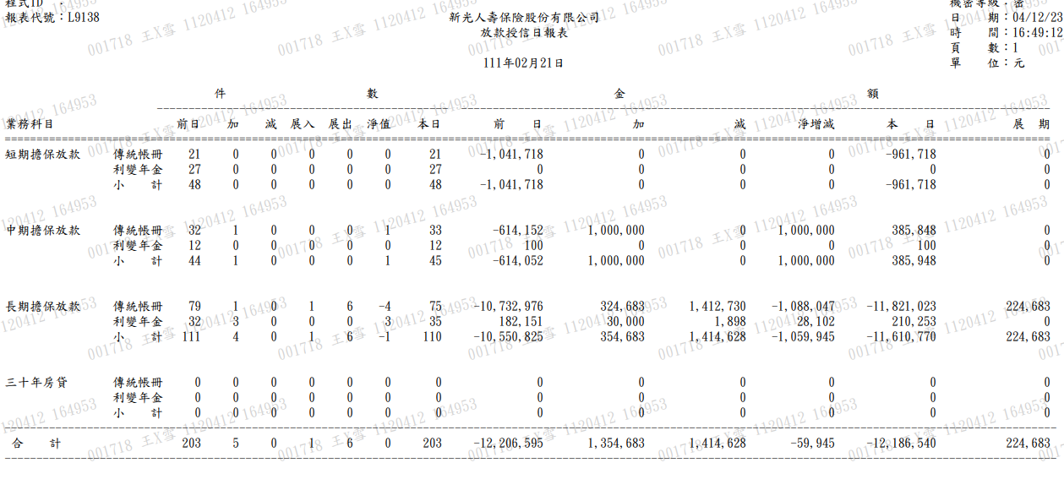



### 【列印順序】:

無

### 【跳頁方式】:

無

### 【報表欄位】:

|  |  |  |
| --- | --- | --- |
| 欄位 | 資料來源 | 說明 |
| 報表首 | | |
| 程式ID |  | 發動的交易代號 |
| 報表 |  | 報表代號 |
| 標題 |  | 固定值:  新光人壽保險股份有限公司  放款授信日報表 |
| 會計日期 |  | 格式：YYY年MM月DD日 |
| 機密等級 |  | 密 |
| 日期 |  | 報表產製日期  西元年MM/DD/YY |
| 時間 |  | 報表產製時間  HH:MM:SS |
| 頁數 |  |  |
| 明細 | | |
|  |  |  |
| 件數-前日 | AcAcctCheck.TdCnt –  AcDetail.(新撥款-結案+展入-展出) | 參考”進表條件”備註 |
| 件數-加 | AcDetail.新撥款 | 參考”進表條件”備註 |
| 件數-減 | AcDetail.結案 | 參考”進表條件”備註 |
| 件數-展入 | AcDetail.展入 | 參考”進表條件”備註 |
| 件數-展出 | AcDetail.展出 | 參考”進表條件”備註 |
| 件數-淨值 | AcDetail. (新撥款-結案+展入-展出) | 參考”進表條件”備註 |
| 件數-本日 | AcAcctCheck.TdCnt |  |
| 金額-前日 | AcMain.YdBal |  |
| 金額-加 | AcDetail.DbAmt |  |
| 金額-減 | AcDetail.CrAmt |  |
| 金額-淨增減 | AcDetail.DbAmt- AcDetail. CrAmt |  |
| 金額-本日 | AcMain.TdBal |  |
| 金額-展期 | AcDetail.展期金額 | 參考”進表條件”備註 |

### 【SQL語法】:

|  |
| --- |
| SELECT R."AcctItem"  ,R."AcSubBookCode"  ,NVL(AAC."TdCnt",0) - NVL(A."netWorth",0) AS "yCount"  ,NVL(A."newCnt",0) AS "newCnt"  ,NVL(A."endCnt",0) AS "endCnt"  ,NVL(A."inExtCnt",0) AS "inExtCnt"  ,NVL(A."outExtCnt",0) AS "outExtCnt"  ,NVL(A."netWorth",0) AS "netWorth"  ,NVL(AAC."TdCnt",0) AS "tCount"  ,NVL(M."YdBal",0) AS "YdBal"  ,NVL(AC."DbAmt",0) AS "DbAmt"  ,NVL(AC."CrAmt",0) AS "CrAmt"  ,NVL(AC."DbAmt",0) - NVL(AC."CrAmt",0) AS "netWorthAmt"  ,NVL(M."TdBal",0) AS "TdBal"  ,NVL(A."extAmount",0) AS "extAmount"  FROM (  SELECT A."AcctCode"  ,A."AcctItem"  ,B."Code"  ,B."Item" AS "AcSubBookCode"  FROM "CdAcCode" A  CROSS JOIN (  SELECT "Code"  ,"Item"  FROM "CdCode"  WHERE "DefCode" = 'AcSubBookCode'  AND "Code" IN ('00A','201')  ) B  WHERE A."AcctCode" IN ('310','320','330','340')  ) R  LEFT JOIN (  SELECT R."AcctCode"  ,R."AcSubBookCode"  ,SUM(R."newCnt") AS "newCnt"  ,SUM(R."endCnt") AS "endCnt"  ,SUM(R."inExtCnt") AS "inExtCnt"  ,SUM(R."outExtCnt") AS "outExtCnt"  ,SUM(R."newCnt" - R."endCnt" + R."inExtCnt" - R."outExtCnt") AS "netWorth"  ,SUM(R."extAmount") AS "extAmount"  FROM (  SELECT A."TitaTxtNo"  ,A."CustNo"  ,1 AS "Count"  ,A."FacmNo"  ,A."BormNo"  ,A."AcctCode"  ,A."AcSubBookCode"  ,CASE  WHEN M."RenewFlag" = 0  AND A."TitaTxCd" = 'L3100'  THEN CASE WHEN A."DbCr" = 'D' THEN 1 ELSE -1 END  ELSE 0  END AS "newCnt" --新撥款  ,CASE  WHEN A."TitaTxCd" IN ('L3420','L3410')  AND JSON_VALUE(A."JsonFields",'$.CaseCloseCode') IN ('0')  THEN CASE WHEN A."DbCr" = 'C' THEN 1 ELSE -1 END  ELSE 0  END AS "endCnt" --結案  ,CASE  WHEN M."RenewFlag" = 1  AND A."TitaTxCd" = 'L3100'  THEN CASE WHEN A."DbCr" = 'D' THEN 1 ELSE -1 END  ELSE 0  END AS "inExtCnt" -- 展入  ,CASE  WHEN A."TitaTxCd" IN ('L3420','L3410')  AND JSON_VALUE(A."JsonFields",'$.CaseCloseCode') IN ('1')  THEN CASE WHEN A."DbCr" = 'C' THEN 1 ELSE -1 END  ELSE 0  END AS "outExtCnt" --展出  ,CASE  WHEN M."RenewFlag" = 1  AND A."TitaTxCd" = 'L3100'  THEN CASE WHEN A."DbCr" = 'D' THEN A."TxAmt" ELSE -A."TxAmt" END  ELSE 0  END AS "extAmount" --展期金額  ,A."EntAc"  FROM "AcDetail" A  LEFT JOIN "LoanBorMain" M ON M."CustNo" = A."CustNo"  AND M."FacmNo" = A."FacmNo"  AND M."BormNo" = A."BormNo"  WHERE A."AcDate" = :today  AND A."AcctCode" IN ('310','320','330','340')  AND A."EntAc" > 0  ) R  GROUP BY R."AcctCode"  ,R."AcSubBookCode"  ) A ON A."AcctCode" = R."AcctCode"  AND A."AcSubBookCode" = R."Code"  LEFT JOIN (  SELECT AC."AcctCode"  ,AC."AcSubBookCode"  ,SUM(  CASE  WHEN AC."DbCr" = 'D'  THEN AC."TxAmt"  ELSE 0 END  ) AS "DbAmt"  ,SUM(  CASE  WHEN AC."DbCr" = 'C'  THEN AC."TxAmt"  ELSE 0 END  ) AS "CrAmt"  FROM "AcDetail" AC  WHERE AC."AcDate" = :today  AND AC."EntAc" > 0  AND AC."AcctCode" IN ('310','320','330','340')  GROUP BY AC."AcctCode"  ,AC."AcSubBookCode"  ) AC ON AC."AcctCode" = R."AcctCode"  AND AC."AcSubBookCode" = R."Code"  LEFT JOIN "AcMain" M ON M."AcctCode" = R."AcctCode"  AND M."AcSubBookCode" = R."Code"  AND M."AcDate" = :today  LEFT JOIN "AcAcctCheck" AAC ON AAC."AcctCode" = R."AcctCode"  AND AAC."AcSubBookCode" = R."Code"  AND AAC."AcDate" = :today  ORDER BY R."AcctCode" ASC  ,R."AcSubBookCode" ASC |

### 【樣張底稿】:

