文件制／修訂履歷

|  |  |  |  |  |  |
| --- | --- | --- | --- | --- | --- |
| 制／修訂  版次 | 制／修訂  日期 | 制／修訂  說明 | 作  者 | 核  准 | 備  註 |
| V0.0 | 2021/04/06 | 初版 | 林楷杰 |  |  |
| V1.1 | 2022/12/27 | 出版 | 林楷杰 |  |  |
| V2.0 | 2023/03/25 | 出版 | 盧羿樺 |  |  |

|  |  |  |  |
| --- | --- | --- | --- |
| **報表代號** | L9706 | **報表名稱** | 貸款餘額證明書 |
| **程式名稱** | 1. 前端：L9706.var 2. 電文定義檔：L9706.tim , L9706.tom , L9706_OC.tom 3. 後端：L9706.java , L9706Report.java , L9706ServiceImpl.java | | |
| **報表底稿** | 無 | | |
| **報表說明** | 產製貸款餘額證明書 | | |
| **流程說明** | 交易選單  →L9報表作業  →2隨機報表  →L9706 貸款餘額證明 | | |
| **批次產製方式** | 1. 批次週期: 2. 批次時間: | | |
| **檔案格式** | PDF | | |
| **是否須簽核** | 否 | | |

## Table

### LoanBorMain 放款主檔

## 功能說明

### 【輸入參數】:

#### 會計日期:

##### 日期: 999/99/99 ~ 999/99/99。

* 檢核:不得大於系統會計日期。

#### 戶號:

* 戶號: 9999999。
* 檢核:不得為0。

### 【進表條件】:

放款主檔的戶號符合輸入參數的戶號。

* 1. 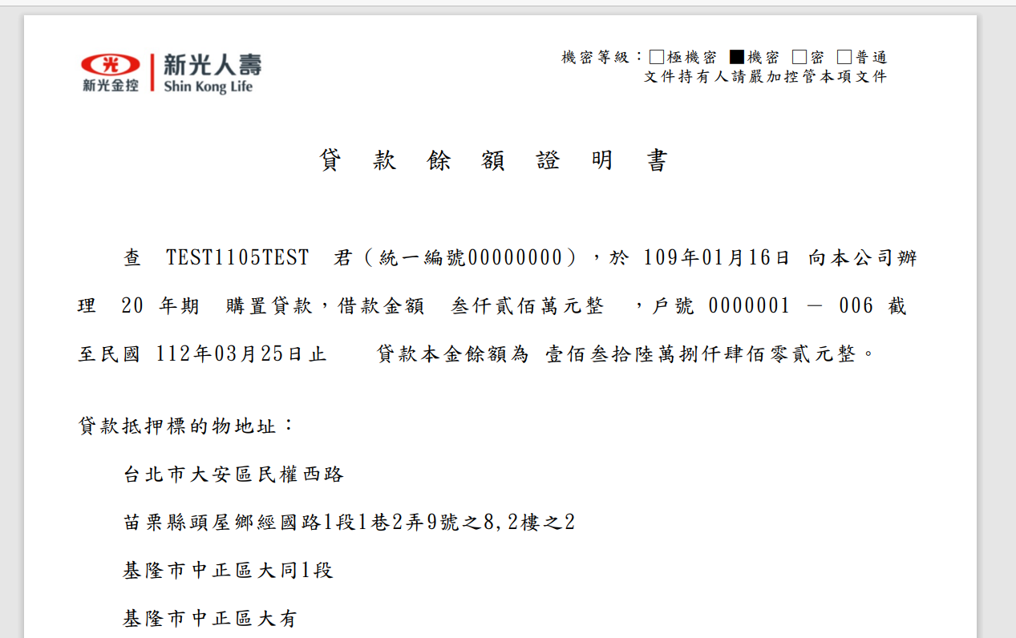【報表格式】:



* 1. 【列印順序】:

依額度由小到大

* 1. 【跳頁方式】:

無

### 【報表欄位】:

|  |  |  |
| --- | --- | --- |
| 欄位 | 資料來源 | 說明 |
| 報表首 | | |
| 標題 |  | 固定值  貸款餘額證明書 |
| 機密等級 |  | 固定值  普通 |
| 明細 | | |
| 戶名 | CustMain.CustName |  |
| 首撥日 | FacMain.FirstDrawdownDate |  |
| 借期(年) | FacMain.LoanTermYy |  |
| 借期(月) | FacMain.LoanTermMm |  |
| 借期(日) | FacMain.LoanTermDd |  |
| 核准金額 | FacMain.LineAmt |  |
| 戶號 | LoanBorMain.CustNo |  |
| 額度 | LoanBorMain.FacmNo |  |
| 餘額 | LoanBorMain.LoanBal |  |
| 頁尾 | | |
|  |  | 固定值  中華民國yyy年mm月dd日 |

### 【SQL語法】:

|  |
| --- |
| SELECT  "Fn_ParseEOL"(c."CustName", 0) "CustName",  f."FirstDrawdownDate" "FirstDrawdownDate",  f."LoanTermYy" "LoanTermYy",  f."LoanTermMm" "LoanTermMm",  f."LoanTermDd" "LoanTermDd",  SUM(f."LineAmt") "LineAmt",  m."CustNo" "CustNo",  m."FacmNo" "FacmNo",  SUM(M."LoanBal") "LoanBal", C."CustId" "CustId",  c."CuscCd" "CuscCd",  f."ProdNo" "ProdNo",  p."GovOfferFlag" "GovOfferFlag",  p."ProdName" "ProdName",  f."ApplNo" "ApplNo"  FROM  (  SELECT  m."CustNo",  m."FacmNo",  l."LoanBal"  FROM  (  SELECT  "CustNo","FacmNo" ,  "BormNo",  MAX("AcDate") as "AcDate"  FROM  "LoanBorTx"  WHERE  "CustNo" = :icustno  AND "AcDate" <= :iday  AND "TitaTxCd" IN (  'L3100',  'L3200',  'L3240',  'L3410',  'L3420'  ) and "BormNo" > 0  GROUP BY  "CustNo",  "FacmNo",  "BormNo"  ) m Left join "LoanBorMain" l ON m."CustNo" = l."CustNo"  AND m."FacmNo" = l."FacmNo"  AND m."BormNo" = l."BormNo"  ) m  LEFT JOIN "CustMain" c ON c."CustNo" = m."CustNo"  LEFT JOIN "FacMain" f ON f."CustNo" = m."CustNo"  AND f."FacmNo" = m."FacmNo"  LEFT JOIN "FacProd" p ON p."ProdNo" = f."ProdNo"  WHERE  m."LoanBal" >= 0  GROUP BY  "Fn_ParseEOL"(c."CustName", 0),  f."FirstDrawdownDate",  f."LoanTermYy",  f."LoanTermMm",  f."LoanTermDd",  m."CustNo",  m."FacmNo",  c."CustId",  c."CuscCd",  f."ProdNo",  p."GovOfferFlag",  p."ProdName",  f."ApplNo"  ORDER BY  "FacmNo" |

### 【樣張底稿】:

