文件制／修訂履歷

|  |  |  |  |  |  |
| --- | --- | --- | --- | --- | --- |
| 制／修訂  版次 | 制／修訂  日期 | 制／修訂  說明 | 作  者 | 核  准 | 備  註 |
| V0.0 | 2021/04/06 | 初版 | 林楷杰 |  |  |
| V1.1 | 2022/12/27 | 出版 | 林楷杰 |  |  |
| V2.0 | 2023/03/03 | 出版 | 盧羿樺 |  |  |

|  |  |  |  |
| --- | --- | --- | --- |
| **報表代號** | L9725 | **報表名稱** | 防制洗錢機構風險評估(IRA)定期量化撈件 |
| **程式名稱** | 1. 前端：L9725.var 2. 電文定義檔：L9725.tim , L9725.tom , L9725_OC.tom 3. 後端：L9725.java , L9725Report.java , L9725ServiceImpl.java | | |
| **報表底稿** | 無 | | |
| **報表說明** | 產製防制洗錢機構風險評估(IRA)定期量化撈件 | | |
| **流程說明** | 交易選單  →L9報表作業  →2隨機報表  →L9725 防制洗錢機構風險評估(IRA)定期量化撈件  →輸入年月迄日 | | |
| **批次產製方式** | 1. 批次週期: 2. 批次時間: | | |
| **檔案格式** | XLSX | | |
| **是否須簽核** | 否 | | |

## Table

### 表一:

* + 1. LoanBorMain 放款主檔
    2. CustMain 客戶資料主檔

### 表二:

* + 1. MonthlyLoanBal每月放款餘額檔
    2. LoanBorMain 放款主檔
    3. FacMain 額度主檔
    4. CustMain 客戶資料主檔

## 功能說明

### 【輸入參數】:

#### 年月日:

##### 年月起日: YYY/01/01

##### 預設值: 去年度1月1日。

##### 年月迄日: YYY/12/31

* 預設值: 去年度12月31日。

### 【進表條件】:

表一(D109040904A):

放款主檔的戶況為0正常、2催收戶、4逾期戶、7部分轉呆戶。

表二(D1110505B):

每月放款餘額檔的放款餘額大於0,年月等於輸入值

### 【報表格式】:

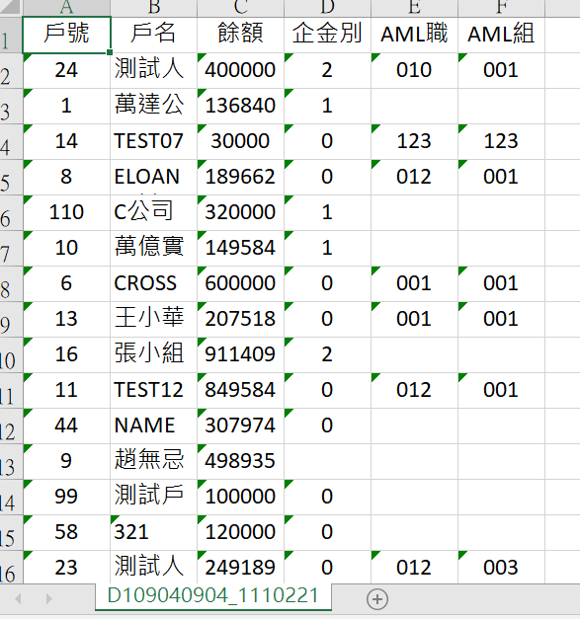



### 【列印順序】:

依戶號,額度由小到大

### 【跳頁方式】:

無

### 【報表欄位】:

表一:( D109040904A)

|  |  |  |
| --- | --- | --- |
| 欄位 | 資料來源 | 說明 |
| 報表首 | | |
| SheetName |  | 固定值  D109040904 |
| 明細 | | |
| 戶號 | LoanBorMain.CustNo |  |
| 戶名 | CustMain.CustName |  |
| 餘額 | LonaBorMain.LoanBal |  |
| 企金別 | CustMain.EntCode |  |
| AML職業別 | CustMain.AMLJobCode |  |
| AML組織 | CustMain.AMLGroup |  |
| 頁尾 | | |
| 無 |  |  |

表二:(D1110505B)

|  |  |  |
| --- | --- | --- |
| 欄位 | 資料來源 | 說明 |
| 報表首 | | |
| SheetName |  | 固定值  D1110505B |
| 明細 | | |
| 戶號 | MonthlyLoanBal.CustNo |  |
| 額度 | MonthlyLoanBal. FacmNo |  |
| 撥款 | MonthlyLoanBal. BormNo |  |
| 利率代碼 | FacMain. ProdNo |  |
| 撥款日 | LoanBorMain. DrawdownDate |  |
| 到期日 | LoanBorMain. MaturityDate |  |
| 核准額度 | FacMain. LineAmt |  |
| 餘額 | LoanBorMain. LoanBal |  |
| 計件代碼 | LoanBorMain. PieceCode |  |
| 戶別 | CustMain. CuscCd |  |
| 企金別 | CustMain. EntCode |  |
| 頁尾 | | |
| 無 |  |  |

### 【SQL語法】:

|  |
| --- |
| 表一:( D109040904A)  SELECT L."CustNo" -- 戶號  , C."CustName" -- 戶名  , L."LoanBal" -- 餘額  , C."EntCode" -- 企金別  , C."AMLJobCode" -- AML職業別  , C."AMLGroup" -- AML組織  FROM ( SELECT "CustNo"  , SUM("LoanBal") AS "LoanBal"  FROM "LoanBorMain"  WHERE "Status" IN (0,2,4,7)  GROUP BY "CustNo"  ) L  LEFT JOIN "CustMain" C ON C."CustNo" = L."CustNo"  表二:( D1110505B)  SELECT  ml."CustNo" AS "CustNo",  ml."FacmNo" AS "FacmNo",  ml."BormNo" AS "BormNo",  fm."ProdNo" AS "ProdNo",  lb."DrawdownDate" AS "DrawdownDate",  lb."MaturityDate" AS "MaturityDate",  fm."LineAmt" AS "LineAmt",  lb."LoanBal" AS "LoanBal",  lb."PieceCode" AS "PieceCode",  cm."CuscCd" AS "CuscCd",  cm."EntCode" AS "EntCode"  FROM  "MonthlyLoanBal" ml  LEFT JOIN "LoanBorMain" lb ON lb."CustNo" = ml."CustNo"  AND lb."FacmNo" = ml."FacmNo"  AND lb."BormNo" = ml."BormNo"  LEFT JOIN "FacMain" fm ON fm."CustNo" = ml."CustNo"  AND fm."FacmNo" = ml."FacmNo"  LEFT JOIN "CustMain" cm ON cm."CustNo" = ml."CustNo"  WHERE  ml."YearMonth" = :dateinputend  AND ml."LoanBalance" > 0  ORDER BY  "CustNo",  "FacmNo",  "BormNo" |

### 【樣張底稿】:

(此檔案為D109040904)

D109040904A檔案：內網(SharePoint: 05.廠商工作區/051.交付項目/報表區/IRA/111/D109040904A_1120112(原始)

D1110505B檔案：內網(SharePoint: 05.廠商工作區/051.交付項目/報表區/IRA/111/D1110505B_1120112(原始)