文件制／修訂履歷

|  |  |  |  |  |  |
| --- | --- | --- | --- | --- | --- |
| 制／修訂  版次 | 制／修訂  日期 | 制／修訂  說明 | 作  者 | 核  准 | 備  註 |
| V0.0 | 2021/04/06 | 初版 | 林楷杰 |  |  |
| V1.1 | 2022/12/27 | 出版 | 林楷杰 |  |  |
| V2.0 | 2023/03/23 | 出版 | 林楷杰 |  |  |

|  |  |  |  |
| --- | --- | --- | --- |
| **報表代號** | L9731 | **報表名稱** | 人工檢核工作表 |
| **程式名稱** | 1. 前端：L9731.var 2. 電文定義檔：L9731.tim , L9731.tom , L9731_OC.tom 3. 後端：L9731.java , L9731p.java , L9731Report.java , L9731ServiceImpl.java | | |
| **報表底稿** | 無 | | |
| **報表說明** | 產製放款餘額明細表  產製放款總歸戶明細表  產製五類資產檢核表  產製放款額度明細表 | | |
| **流程說明** | 交易選單  →L9報表作業  →2隨機報表  →L9731人工檢核工作表 | | |
| **批次產製方式** | 1. 批次週期:無 2. 批次時間:無 | | |
| **檔案格式** | EXCEL(XLSX) | | |
| **是否須簽核** | 否 | | |

## Table

### 放款總餘額明細表

* + 1. MonthlyLoanBal每月放款餘額檔
    2. CustMain客戶主檔
    3. LoanBorMain放款主檔
    4. LoanOverdue催收呆帳檔
    5. FacMain額度主檔
    6. MonthlyFacBal額度月報工作檔
    7. ClBuilding擔保品不動產建物檔

### 放款總歸戶明細表

1.2.1. MonthlyLoanBal每月放款餘額檔

1.2.2. BankRelationSelf金控利害關係人_關係人員工資料

1.2.3. BankRelationFamily金控利害關係人_關係人員工之親屬資料

1.2.4. BankRelationCompany金控利害關係人_關係企業資料

### 五類資產檢核表、放款額度明細表

1.3.1. MonthlyFacBal額度月報工作檔

1.3.2. CustMain客戶主檔

1.3.3. FacMain額度主檔

## 功能說明

### 【輸入參數】:

#### 年月份

##### 格式: YYY / MM。

##### 預設值：系統會計日年月 。

* 檢核: 必輸入，不超過系統會計日期年月。

### 【進表條件】:

放款餘額明細表：MonthlyLoanBal每月放款餘額檔為當前輸入年月份

放款總歸戶明細表：MonthlyLoanBal每月放款餘額檔為當前輸入年月份

五類資產檢核表：MonthlyFacBal額度月報工作檔為當前輸入年月份

放款額度明細表：MonthlyFacBal額度月報工作檔為當前輸入年月份

### 【報表格式】:

### 放款餘額明細表(L9731_底稿_人工檢核表4)：

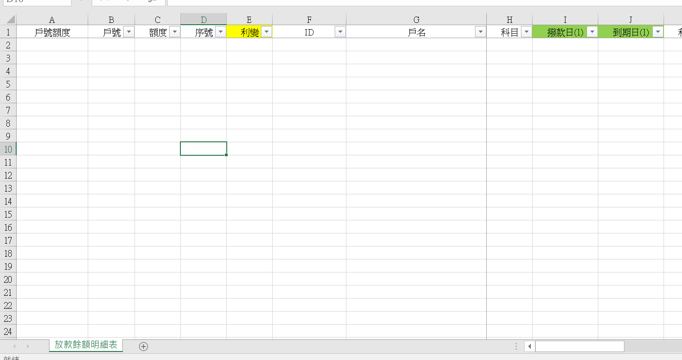



放款總歸戶明細表(L9731_底稿_人工檢核表2)：

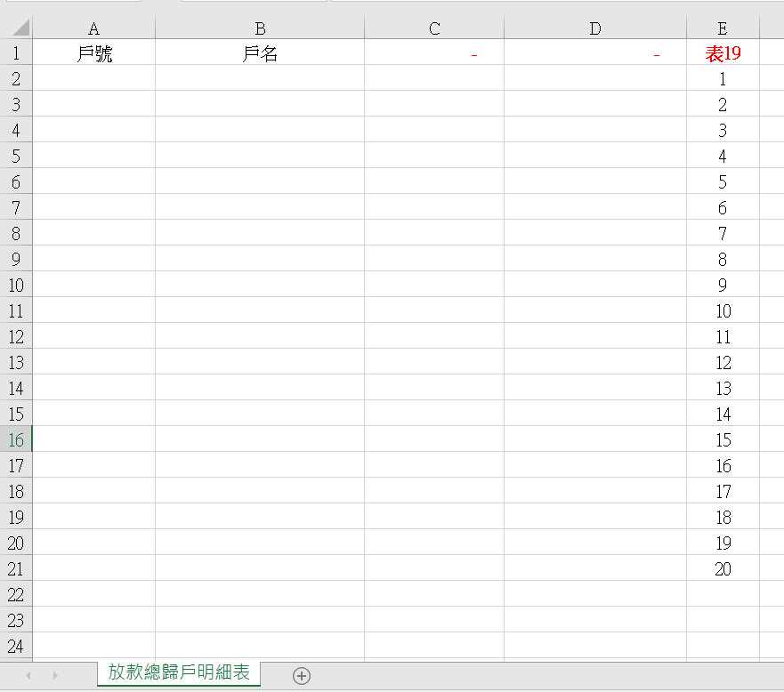



五類資產檢核表(L9731_底稿_人工檢核表1)：

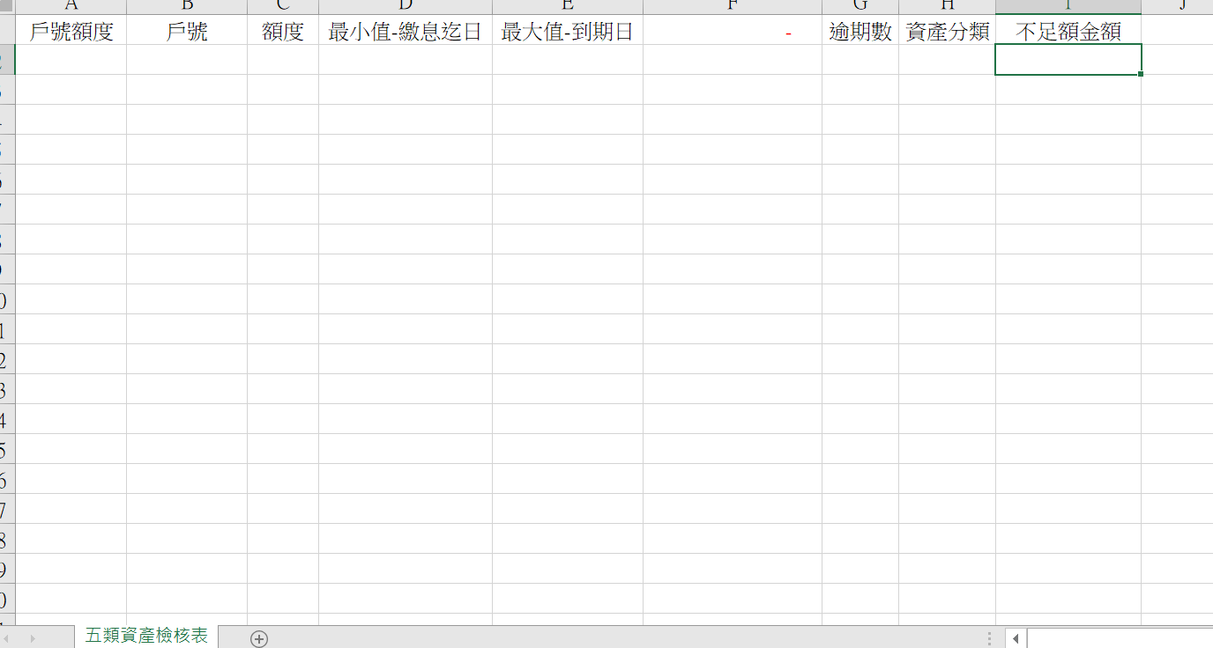



放款額度明細表(L9731_底稿_人工檢核表3)：

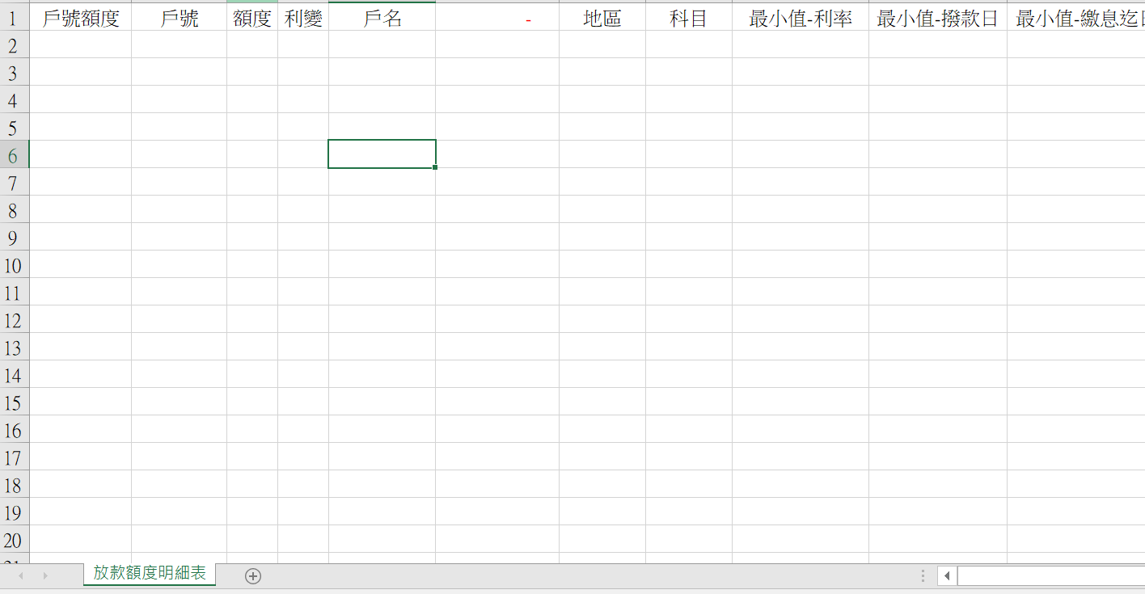



### 【列印順序】:

放款餘額明細表：依戶號小到大、額度小到大、撥款小到大。

放款總歸戶明細表： 依金額大到小。

五類資產檢核表： 依戶號小到大、額度小到大。

放款額度明細表： 依戶號小到大、額度小到大。

### 【跳頁方式】:

無

### 【報表欄位】:

放款餘額明細表

|  |  |  |
| --- | --- | --- |
| 欄位 | 資料來源 | 說明 |
| 戶號額度 |  |  |
| 戶號 | MonthlyLoanBal.CustNo |  |
| 額度 | MonthlyLoanBal.FacmNo |  |
| 序號 | MonthlyLoanBal.BormNo |  |
| 利變 | MonthlyLoanBal.AcSubBookCode |  |
| ID | CustMain.CustId |  |
| 戶名 | CustMain.CustMain |  |
| 科目 | MonthlyLoanBal.AcctCode |  |
| 撥款日 | LoanBorMain.DrawdownDate |  |
| 到期日 | LoanBorMain.MaturityDate |  |
| 利率 | MonthlyLoanBal.StoreRate |  |
| 繳息週期 | MonthlyLoanBal.PayIntFreq |  |
| 繳息迄日 | MonthlyLoanBal.PrevPayIntDate |  |
| 轉催收日期 | LoanOverdue.OvduDate |  |
| 資金用途別 | LoanBorMain.UsageCode |  |
| 核貸金額 | FacMain.LineAmt |  |
| 撥款金額 | LoanBorMain.DrawdownAmt |  |
| 放款餘額 | MonthlyLoanBal.LoanBalance |  |
| 擔保品地區別 | MonthlyLoanBal.CityCode |  |
| 擔保品地區別地址 | ClBuilding.BdLocation |  |
| 產品利率代碼 | MonthlyLoanBal .ProdNo |  |
| 初貸日 | FacMain.FirstDrawdownDate |  |
| 政策性_專案貸款 |  | 根據商品代碼判斷 |
| 擔保品類別 |  | 根據商品代碼判斷 |

放款總歸戶明細表

|  |  |  |
| --- | --- | --- |
| 欄位 | 資料來源 | 說明 |
| 戶號 | MonthlyLoanBal.CustNo |  |
| 戶名 | MonthlyLoanBal.FacmNo |  |
| ID | CustMain.CustId |  |
| 放款餘額 | MonthlyLoanBal.LoanBalance |  |

五類資產檢核表

|  |  |  |
| --- | --- | --- |
| 欄位 | 資料來源 | 說明 |
| 戶號額度 |  |  |
| 戶號 | MonthlyFacBal.CustNo |  |
| 額度 | MonthlyFacBal.FacmNo |  |
| 繳息迄日 | MonthlyFacBal.PrevIntDate |  |
| 到期日 | LoanBorMain.MaturityDate |  |
| 放款餘額 | MonthlyFacBal.PrinBalance |  |
| 逾期數 | MonthlyFacBal.OvduTerm |  |
| 資產分類 | MonthlyFacBal.AssetClass |  |
| 不足額金額 | MonthlyFacBal.LawAmount |  |

放款額度明細表

|  |  |  |
| --- | --- | --- |
| 欄位 | 資料來源 | 說明 |
| 戶號額度 |  |  |
| 戶號 | MonthlyFacBal.CustNo |  |
| 額度 | MonthlyFacBal.FacmNo |  |
| 利變 | MonthlyLoanBal.AcSubBookCode |  |
| 戶名 | CustMain.CustId |  |
| ID | CustMain.CustMain |  |
| 地區 | MonthlyFacBal.CityCode |  |
| 科目 | MonthlyFacBal.AcctCode |  |
| 利率 | MonthlyFacBal.StoreRate |  |
| 撥款日 | FacMain.FirstDrawdownDate |  |
| 繳息迄日 | MonthlyFacBal.PrevIntDate |  |
| 到期日 | FacMain.MaturityDate |  |
| 放款餘額 | MonthlyFacBal.LoanBalance |  |
| 逾期數 | MonthlyFacBal.OvduTerm |  |
| 資產評估 |  | 根據商品代碼與逾期期數判斷 |
| 資產分類 | MonthlyFacBal.AsserClass |  |
| 擔保品分類 |  | 根據商品代碼判斷 |
| 產品利率代碼 | MonthlyLoanBal.ProdNo |  |

### 【SQL語法】:

|  |
| --- |
| 放款餘額明細表：  SELECT M."CustNo" AS F0  ,M."FacmNo" AS F1  ,M."BormNo" AS F2  ,DECODE(M."AcSubBookCode",'00A',' ','A') AS F3  ,C."CustId" AS F4  ,"Fn_ParseEOL"(C."CustName", 0) AS F5  ,M."AcctCode" AS F6  ,L."DrawdownDate" AS F7  ,L."MaturityDate" AS F8  ,M."StoreRate" AS F9  ,L."PayIntFreq" AS F10  ,L."PrevPayIntDate" AS F11  ,NVL(O."OvduDate", 0) AS F12  ,L."UsageCode" AS F13  ,NVL(F."LineAmt",0) AS F14  ,NVL(L."DrawdownAmt",0) AS F15  ,M."LoanBalance" AS F16  ,M."CityCode" AS F17  ,CB."BdLocation" AS F18  ,M."ProdNo" AS F19  ,F."FirstDrawdownDate" AS F20  ,CASE  WHEN F."FirstDrawdownDate" >= 20100101  AND (MF."FacAcctCode" = 340 OR REGEXP_LIKE(M."ProdNo",'I[A-Z]') OR REGEXP_LIKE(M."ProdNo",'8[1-8]'))  THEN '**'  WHEN F."FirstDrawdownDate" < 20100101  AND (MF."FacAcctCode" = 340 OR REGEXP_LIKE(M."ProdNo",'I[A-Z]') OR REGEXP_LIKE(M."ProdNo",'8[1-8]'))  THEN '*'  ELSE ' ' END AS F21  ,CASE  WHEN (MF."FacAcctCode" = 340 OR REGEXP_LIKE(M."ProdNo",'I[A-Z]') OR REGEXP_LIKE(M."ProdNo",'8[1-8]'))  THEN 'Z'  WHEN M."ClCode1" IN (1,2)  THEN 'C'  WHEN M."ClCode1" IN (3)  THEN 'D'  ELSE 'C' END AS F22  FROM "MonthlyLoanBal" M  LEFT JOIN "CustMain" C ON C."CustNo" = M."CustNo"  LEFT JOIN "LoanBorMain" L ON L."CustNo" = M."CustNo"  AND L."FacmNo" = M."FacmNo"  AND L."BormNo" = M."BormNo"  LEFT JOIN "LoanOverdue" O ON O."CustNo" = M."CustNo"  AND O."FacmNo" = M."FacmNo"  AND O."BormNo" = M."BormNo"  LEFT JOIN "FacMain" F ON F."CustNo" = M."CustNo"  AND F."FacmNo" = M."FacmNo"  LEFT JOIN "MonthlyFacBal" MF ON MF."CustNo" = F."CustNo"  AND MF."FacmNo" = F."FacmNo"  AND MF."YearMonth" = M."YearMonth"  LEFT JOIN "ClBuilding" CB ON CB."ClCode1" = M."ClCode1"  AND CB."ClCode2" = M."ClCode2"  AND CB."ClNo" = M."ClNo"  WHERE M."YearMonth" = :yymm  AND M."LoanBalance" > 0  ORDER BY F0,F1,F2  放款總歸戶明細表  WITH "allMonthMaxLoan" AS ( //  SELECT M."CustNo" AS "CustNo"  ,MAX("MaxLoanBalance") AS "MaxLoanBal"  FROM(  SELECT "CustNo"  ,"YearMonth"  ,SUM("LoanBalance") AS "MaxLoanBalance"  FROM "MonthlyLoanBal"  WHERE TRUNC("YearMonth" / 100 ) = :year  AND "LoanBalance" > 0  GROUP BY "CustNo"  ,"YearMonth"  )M  GROUP BY M."CustNo"  ),"mainData" AS (  SELECT "CustNo" AS "CustNo"  ,SUM("LoanBalance") AS "TotalLoanBal"  FROM "MonthlyLoanBal"  WHERE "YearMonth" = :yymm  AND "LoanBalance" > 0  GROUP BY "CustNo"  ORDER BY SUM("LoanBalance") DESC  )  SELECT M."CustNo" AS F0  ,"Fn_ParseEOL"(C."CustName",0) AS F1  ,C."CustId" AS F2  ,M."TotalLoanBal" AS F3  FROM "mainData" M  LEFT JOIN "allMonthMaxLoan" M2 ON M2."CustNo" = M."CustNo"  LEFT JOIN "CustMain" C ON C."CustNo" = M."CustNo"  LEFT JOIN ( SELECT TO_CHAR("CustId") AS "RptId"  FROM "BankRelationSelf"  WHERE "LAW005" = '1'  UNION  SELECT TO_CHAR("RelationId") AS "RptId"  FROM "BankRelationFamily"  WHERE "LAW005" = '1'  UNION  SELECT TO_CHAR("CompanyId") AS "RptId"  FROM "BankRelationCompany"  WHERE "LAW005" = '1'  ) R ON R."RptId" = C."CustId"  ORDER BY M."TotalLoanBal" DESC  五類資產檢核表、放款額度明細表：  SELECT M."CustNo" AS F0  ,M."FacmNo" AS F1  ,DECODE(M."AcSubBookCode",'00A',' ','A') AS F2  ,"Fn_ParseEOL"(C."CustName", 0) AS F3  ,C."CustId" AS F4  ,M."CityCode" AS F5  ,M."AcctCode" AS F6  ,TO_CHAR(M."StoreRate",'0.00000') AS F7  ,F."FirstDrawdownDate" AS F8  ,M."PrevIntDate" AS F9  ,F."MaturityDate" AS F10  ,M."PrinBalance" AS F11  ,CASE  WHEN M."AcctCode" = 990 AND M."ProdNo" IN ('60','61','62') THEN '催協'  WHEN M."ProdNo" IN ('60','61','62') THEN '協'  WHEN M."AcctCode" = 990 THEN '催'  WHEN M."OvduTerm" IN (1,2,3,4,5) THEN TO_CHAR(M."OvduTerm", '9')  ELSE '0' END AS F12  ,CASE  WHEN M."AcctCode" = 990 AND M."ProdNo" IN ('60','61','62') THEN '催協'  WHEN M."ProdNo" IN ('60','61','62') THEN '協'  WHEN M."AcctCode" = 990 THEN '催'  ELSE ' ' END AS F13  ,M."AssetClass" AS F14  ,CASE  WHEN (M."FacAcctCode" = 340 OR REGEXP_LIKE(M."ProdNo",'I[A-Z]') OR REGEXP_LIKE(M."ProdNo",'8[1-8]'))  THEN 'Z'  WHEN M."ClCode1" IN (1,2)  THEN 'C'  WHEN M."ClCode1" IN (3)  THEN 'D'  ELSE 'C' END AS F15  ,M."ProdNo" AS F16  ,M."LawAmount" AS F17  FROM "MonthlyFacBal" M  LEFT JOIN "CustMain" C ON C."CustNo" = M."CustNo"  LEFT JOIN "FacMain" F ON F."CustNo" = M."CustNo"  AND F."FacmNo" = M."FacmNo"  WHERE M."YearMonth" = :yymm  AND M."PrinBalance" > 0  ORDER BY M."CustNo" ASC  ,M."FacmNo" ASC |

### 【樣張底稿】:

