文件制／修訂履歷

|  |  |  |  |  |  |
| --- | --- | --- | --- | --- | --- |
| 制／修訂  版次 | 制／修訂  日期 | 制／修訂  說明 | 作  者 | 核  准 | 備  註 |
| V2.0 | 2023/07/17 | 出版 | 林楷杰 |  |  |

|  |  |  |  |
| --- | --- | --- | --- |
| **報表代號** | L9747 | **報表名稱** | 公平待客銀扣二扣資料 |
| **程式名稱** | 1. 前端：L9747.var 2. 電文定義檔：L9747.tim , L9747.tom , L9747_OC.tom 3. 後端：L9747.java , L9747Report.java , L9747ServiceImpl.java | | |
| **報表底稿** | L9747_底稿_催收及呆帳戶暫收款明細表.xlsx | | |
| **報表說明** | 產製催收及呆帳戶暫收款明細表 | | |
| **流程說明** | 交易選單  →L9報表作業  →2隨機報表  →L9747催收及呆帳戶暫收款明細表 | | |
| **批次產製方式** | 1. 批次週期: 2. 批次時間: | | |
| **檔案格式** | xlsx | | |
| **是否須簽核** | 否 | | |

## Table

### AcReceivable 會計銷帳檔

### DailyLoanBal 每日放款餘額檔

### CustMain 客戶資料主檔

### CdCity 地區別代碼檔

### LoanBorMain 額度主檔

## 功能說明

### 【輸入參數】:

### 資料日期

### 日期格式：YYYMMDD

### 預 設 值：日曆日

### 檢 核：輸入值為合理日期

### 【進表條件】:

在會計銷帳檔(AcReceivable)的業務科目代號為TAV，未銷餘額大於0，且戶況為催收戶、呆帳戶的資料。

### 【報表格式】:

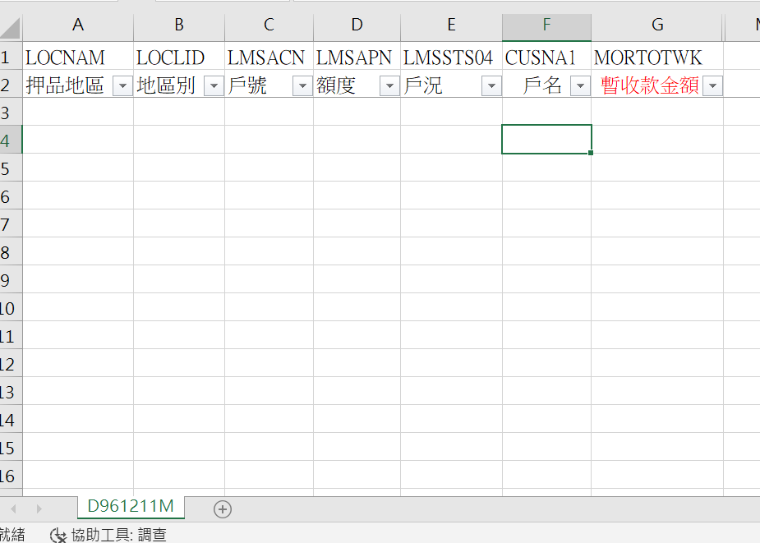

### 【列印順序】:

無。

### 【跳頁方式】:

無

### 【報表欄位】:

|  |  |  |
| --- | --- | --- |
| 欄位 | 資料來源 | 說明 |
| 報表首 | | |
| 明細 | | |
| 押品地區 | CdCity.CityItem |  |
| 地區別 | ClMain.CityCode |  |
| 戶號 | DailyLoanBal.CustNo |  |
| 額度 | DailyLoanBal.FacmNo |  |
| 戶況 | LoanBorMain.Status |  |
| 戶名 | CustMain.CustName |  |
| 暫收款金額 | AcReceivable.RvBal |  |
| 頁尾 | | |

### 【SQL語法】:

|  |
| --- |
| SELECT CT."CityItem"  ,v."CityCode"  ,v."CustNo"  ,v."FacmNo"  ,v."Status"  ,"Fn_ParseEOL"(C."CustName",0) AS "CustName"  ,A."RvBal"  FROM ( SELECT CL."CityCode" AS "CityCode"  ,MAX(L."Status") "Status"  ,D."CustNo" AS "CustNo"  ,MIN(D."FacmNo") "FacmNo"  FROM "DailyLoanBal" D  LEFT JOIN "LoanBorMain" L ON L."CustNo" = D."CustNo"  AND L."FacmNo" = D."FacmNo"  AND L."BormNo" = D."BormNo"  LEFT JOIN "ClFac" CF ON CF."CustNo" = L."CustNo"  AND CF."FacmNo" = L."FacmNo"  AND CF."MainFlag" = 'Y'  LEFT JOIN "ClMain" CL ON CL."ClCode1" = CF."ClCode1"  AND CL."ClCode2" = CF."ClCode2"  AND CL."ClNo" = CF."ClNo"  WHERE D."DataDate" = :dataday  AND D."LatestFlag" = 1  AND L."Status" IN (2,6)  GROUP BY CL."CityCode"  ,D."CustNo" ) v  LEFT JOIN ( SELECT "CustNo"  ,SUM("RvBal") "RvBal"  FROM "AcReceivable"  WHERE "AcctCode" = 'TAV'  GROUP BY "CustNo" ) A ON A."CustNo" = v."CustNo"  LEFT JOIN "CustMain" C ON C."CustNo" = v."CustNo"  LEFT JOIN "CdCity" CT ON CT."CityCode" = v."CityCode"  WHERE NVL(A."RvBal", 0) > 0; |

### 【樣張底稿】:

