**Importing Static Meshes into UDK**

**By Taylor Brent and Stephen Carlson**

1. Install the latest version of Blender (2.57b).
2. Open Blender. Select File > Load Factory Settings.  
   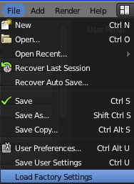
3. Open or create model of desired part.
4. Change to Object Mode.  
   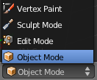
5. For each section of the model that needs a different material (may be only one):
   1. Select the part(s) that need that material by right-clicking while holding *SHIFT*.
   2. Press *CONTROL-J* to join the parts into one mesh.
   3. If necessary, expand the right side view so that Materials and Textures are visible by dragging outwards near the location of the red circle in the image below.  
      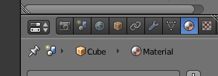

Materials

Textures

* 1. If the selected object does not already have its own material, select Add New Material from Materials; if the part needs a solid color, change the “Diffuse” color as desired.  
     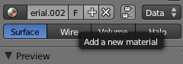 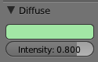
  2. Change to Edit Mode using the same menu as shown above (or by using *TAB*).
  3. Select all by pressing *A* until all parts are selected. **Only parts that were selected before entering Edit Mode can be selected here**.
  4. Move the mouse over the object and press *U*; select Reset.  
     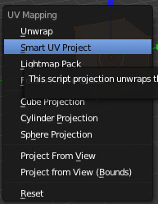
  5. Press *U* again; select Smart UV Project. Select OK (defaults are acceptable in most cases)
  6. In another view (preferably the bottom), open the UV Image Editor.  
     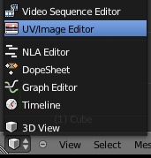
  7. Select UVs > Export UV Layout.  
     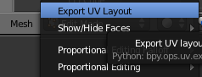  
     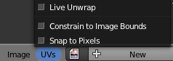
  8. Save the layout as a PNG file. Open the file in an image editor, and paste the desired textures into positions that overlay the location of the corresponding side in the UV map. When finished, save the result as a BMP (bitmap) or TGA (Targa) file.
     1. To see which face corresponds to a specified area in the UV map, enter Face Select Mode by clicking on the toolbar (near Edit Mode selector).

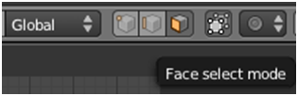

* + 1. Right click on the dot in the center of the desired face, and note the outline that appears in the UV/Image Editor.  
       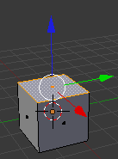 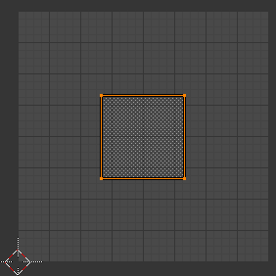
  1. To get a rough idea on whether things are in the right place, first select all, and then select Image > Open Image and navigate to the texture. It will appear overlaid on the UV map. (This step can be skipped after much experience with proper identification).  
     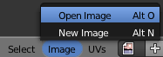
  2. (Optional) The UV map can also be manually edited if desired by right clicking on the shape to edit in the map and using *G* to move it or *S* to resize it. It may be desirable to use Face Selection Mode to move entire UV shapes instead of just vertices.  
     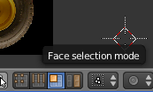
  3. Once the approximate locations are right, apply the texture properly by selecting Add New Texture from Textures. Change the type to Image or Movie.  
     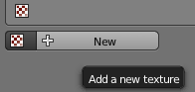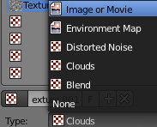
  4. Select Open Image and navigate to the desired image again.  
     
  5. Under the Mapping section, change Coordinates to UV and the Layer to the only option (usually UVTex). Then press *F12* (Render Image) and check the result.  
     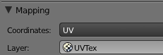
  6. Some textures may be flipped; change as necessary. It may be wise to save (*CONTROL-S*) when satisfied. Change back to Object Mode and repeat the steps above for each part.

1. When all parts have textures, change to Object Mode (if necessary) and select all (*A*) until all parts are selected. Save your model (it is very difficult to unjoin meshes) and press *CONTROL-J*.
2. The model is most likely not facing the right way or not centered.
   1. Select View > Back to view the model from the Unreal “front” direction. If this is wrong, press *R*, then the letter of the axis around which to rotate (*X*, *Y*, or *Z*), then hold *CONTROL* and move the mouse to rotate the object.  
      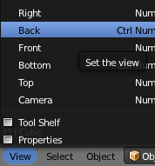 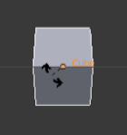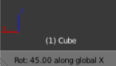
   2. If the model is not centered at the desired location, press *G* and move the mouse while holding *CONTROL* to relocate the object.
3. If the model needs a concave collision (it has a large internal void or indentation critical to function), now is the time to generate a collision for it. See [Porting a Generic Model into Unreal Ed](http://usarsim.sourceforge.net/wiki/index.php/Porting_a_Generic_Model_into_Unreal_Ed#Create_Collision) on the USARSim Wiki.
4. Select File > Export > Autodesk FBX.  
   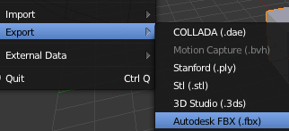
5. Under Export FBX, deselect Selected Objects, Empty, Camera, Lamp, and Enable Animation.  
   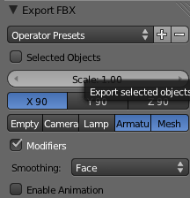
6. Most models are not built in Unreal’s coordinate system, which allocates 250 units per meter. A scale factor will probably be required, and it is likely to be different for each model. Experiment with different factors, or compare the object’s bounds to its real size to determine the factor.
7. Export the file. Open the UDK editor using the “editor.bat” file in the UDK distribution directory.
8. Select Import in the Generic Browser and navigate to the exported FBX file.  
   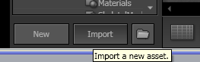
9. Select the package and the name of the file as appropriate. In Materials (scroll down), check Import Materials and Import Textures. Click OK to All and wait…  
   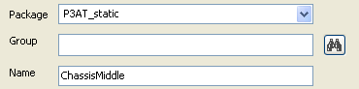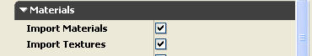
10. In the selected package, several (poorly named) materials and textures should appear along with the desired static mesh.
11. If textures are incorrect or missing, use Import to import the texture image file(s) again; give them the same name as the bad texture and select Replace or Yes when prompted.
12. If materials are missing texture references or have the wrong color, double-click on the affected material and modify the TextureSample or Constant nodes appropriately.
13. If no collision was generated before (a “NO COLLISION MODEL!” warning appears), double-click on the model to open the Static Mesh Editor. Select “Show Collision”, then select one of the options from the “Collision” menu to generate a collision model. Play around until satisfied, but remember that complicated models will slow down the game. Go as simple as possible while retaining function.  
    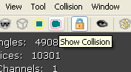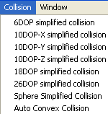
    1. **6DOP simplified collision**: A box. Surprisingly effective in many cases.
    2. **Sphere simplified collision**: A sphere. Rolls smoothly unlike many polygonal shapes.
    3. **26DOP simplified collision**: Generate a polygonal shape that does a pretty good job in most cases.
    4. **Auto convex collision**: If all else fails, use this option and mess with the values of the 3 sliders. Generally, set Allow Splits low (4), Max Hull Verts high (24), and leave Depth at its default.
14. Rename and group the materials and textures (right click > Move or Rename…) as necessary. Textures should end with “Tex” and materials should end with “Mat”; materials should be in a group named Materials and textures should be in a group named Textures.  
    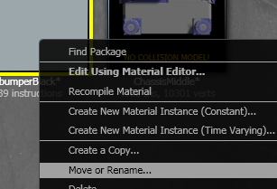 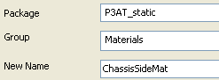
15. Save (right click > Save) the package. Enjoy!  
    