AWS Solutions Architect

AWS Cloud Computing Platform

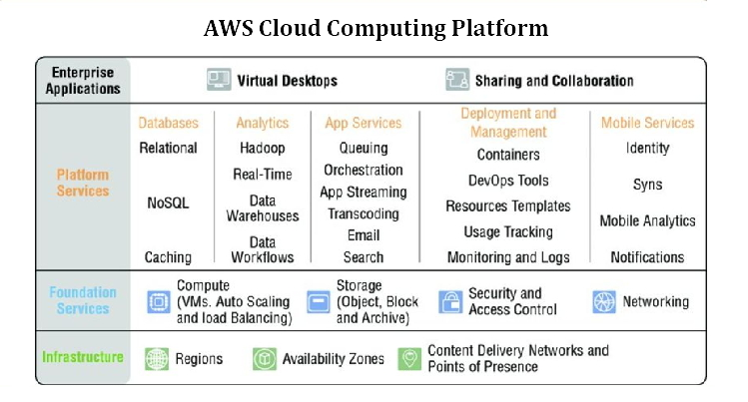

|  |  |  |  |  |  |
| --- | --- | --- | --- | --- | --- |
| Enterprise Applications | Virtual Desktops | | | Sharing and Collaboration | |
| Platform Services | Databases | Analytics | App Services | Deployment and Management | Mobile Services |
|  | Relational | Hadoop | Queuing |  |  |
|  | NoSQL |  |  |  |  |
|  | Caching |  |  |  |  |
| Foundation Services |  |  |  |  |  |
|  | Compute (VMs. Auto Scaling and Load Balancing | Storage (Object, Block and Archive) | Security and Access Control | Networking | |
| Infrastructure | Regions | Availability Zones | Content Delivery Networks and Points of Presence | | |

ACloudGuru Certification Course path for AWS Solutions Architect:

AWS Solutions Architect Associate – SAA-CO2

1. Designing resilient Architecture for Solutions Architects  
   Source: <https://learn.acloud.guru/course/2f2f600d-5ffe-4bd7-8406-fd04d29de611/dashboard>
2. High Availability & Scalability for Solutions Architects  
   Source: <https://acloud.guru/overview/59d0a824-d6b4-44aa-b37f-d8e32810b970?_ga=2.92000349.697153314.1612792517-1559496533.1597531996>
3. Networking and Compute for Associate Solutions Architects  
   Source: <https://learn.acloud.guru/course/1ea506a0-9e59-461f-840b-d9ba1ce98d8d/dashboard>
4. Application services for Associate AWS Solutions Architects  
   Source: <https://acloud.guru/overview/3cccfd2f-3a1a-434d-a1bf-f5312697f73a?_ga=2.150649841.697153314.1612792517-1559496533.1597531996>
5. Storage, Database, & Migration for Solutions Architects  
   Source: <https://acloud.guru/overview/cab21320-af77-4089-905b-cd91842b2998?_ga=2.188325743.697153314.1612792517-1559496533.1597531996>
6. Logging & Security for Associate Solutions Architects  
   Source: <https://acloud.guru/overview/af59ec1e-7cbf-4e2f-b13a-06ace26f9f0f?_ga=2.150649841.697153314.1612792517-1559496533.1597531996>

Practice Questions

Knowledge Hut:  
Source: <https://www.knowledgehut.com/practice-tests/aws-solutions-architect-associate>

|  |  |  |
| --- | --- | --- |
|  |  |  |
| 1 | To prevent in-flight tampering, all requests sent with API keys over REST or Query API should be sent over HTTPS connection.  Answer: True |  |
| 2 | Your AWS environment contains several reserved EC2 instances dedicated to a project that has just been cancelled. Your supervisor would like to recuperate cost for these reserved instances, but also does not want to lose the data just yet in case the project is revived next fiscal year. What can you do to minimize charges for these instances? Choose the 2 correct answers:  Answer:  Take snapshots of the EBS volumes and terminate the instances  Sell the instances on the AWS Reserved Instance Marketplace |  |
| 3 | You design an application that checks for new items in an S3 bucket once per hour. If new items exist, a message is added to an SQS queue. You have several EC2 instances which retrieve messages from the SQS queue, parse the file, and send you an email containing the relevant information from the file. You upload one test file to the bucket, wait a couple hours and find that you have hundreds of emails from the application. What is the most likely cause for this volume of email?  Answer: Your application does not issue a delete command to the SQS queue after processing the message.: |  |
| 4 | Which of the following is not a legitimate concern?  Answer:  US-East-1 is does not support Multi-AZ RDS deployments. |  |
| 5 | After setting up you first VPC peering connection between you and one of your client’s, the client requests that he now wants to be able to send traffic between instances in the peered VPCs using private IP addresses. What must you do to make this possible?  Answer:  Add a route to a route table that's associated with your VPC |  |
| 6 | You are the System Administrator for your company’s AWS account of approximately 200 IAM users. A new company policy has just been introduced that will change the access of 50 of the IAM users to have unlimited access to S3 buckets. How can you implement this effectively so that there is no need to apply the policy at the individual user level?  Answer:  Create an IAM group, add the 50 users, and apply the policy to group |  |
| 7 | An EC2 instance retrieves a message from an SQS queue, begins processing the message, then crashes. What happens to the message?  Answer:  When the message visibility timeout expires, the message becomes available for processing by other EC2 instances. |  |
| 8 | Which is an operational process performed by AWS for data security?  Answer:  Decommissioning of storage devices using industry-standard practices |  |
| 9 | Which statement is true about Amazon SQS? Choose the 2 correct answers:  Answer:  Amazon SQS guarantees delivery of AT LEAST 1 message but cannot guarantee message order; but does attempt  Amazon SQS (Simple Queue Service) guarantees delivery of AT LEAST 1 message but cannot guarantee it will not create duplicates |  |
| 10 | You’re building out an application on AWS that is running within a single region. However, you’re designing with disaster recovery in mind. Your intention is to build the application so that if the current region it is running in becomes unavailable, you can failover to another region. Part of your application relies heavily on pre-built AMI’s. In order to share those AMI’s with the region you’re using as a backup, what process would you take?  Answer:  Copy the AMI from the current region to another region, modify the auto scaling groups in the backup region to use the new AMI id in the backup region |  |
| 11 | While running an EC2 instance, you’ve been storing data on the root volume of the instance. However, in order to save money on the instance, you shut down the instance for the weekend. The following week, after starting the instance, you notice that all your work has been lost and is no longer available on the EC2 instance. What might be the cause of this?  Answer:  The EC2 instance was using instance store backed root volumes which are ephemeral and only live for the life of the instance |  |
| 12 | Your company has moved a legacy application from on-premise data centre to the cloud. The legacy application requires a static IP address being coded into the application which prevents you from deploying the application with high availability and fault tolerance using the ELB. Which steps would you take to apply high availability and fault tolerance to this application? Choose the 2 correct answers:  Answer:  Write a custom script that pings the health of the instance and if the instance stops responding, switches the elastic IP address to a standby instance  Ensure that the instance it's using has an elastic IP address assigned to it |  |
| 13 | Your company wants to backup the onsite file server to AWS but does not want to serve the files from S3 to your office network when files need accessed. Which service and setup would you use to accomplish this task?  Answer Use Amazon Storage Gateway and gateway-stored volumes to store the data locally and asynchronously backup point-in-time snapshots to S3: |  |
| 14 | While implementing a disaster recovery strategy in another region, you are attempting to move the data from one EBS volume to another in a separate region. What is the best way to do this? Keep in mind this is not a live production replication copy.  Answer:  Take a snapshot of the EBS volume and copy it to the desired region |  |