Data Structures and Algorithms

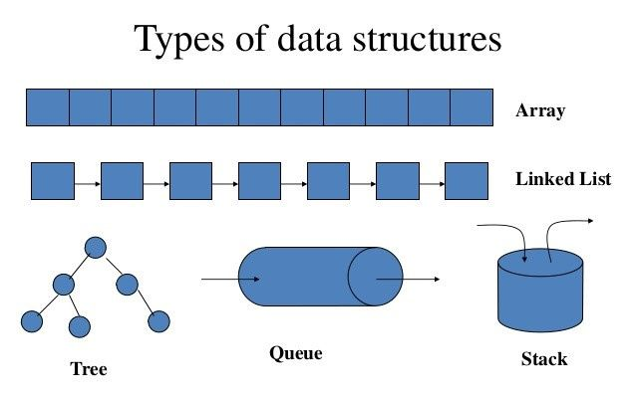

Asymptotic

O(n)2

|  |  |
| --- | --- |
|  |  |
|  | Time required to process is approximately the square of the amount of records / bytes / bits / etc.  “… the processing time required by the Algorithm will be the square of the data input.”  Time = O | ( records = n ) 2 |

Abstract thinking – Abstract Data Type (ADT)

Python and C#

Data Structure and Algorithms | Data Structure and Algorithms in C# | Csharp Data Structure

Source: <https://www.youtube.com/watch?v=605gJ5CeC5Y&list=PLg1RdNLpYTgBT-WBhNKmxLZoWY9TaoZdr>

Link(ed) List ADT [21:29]

* Simple
* Double
* Circular



