Handin#1 Restore screenshot

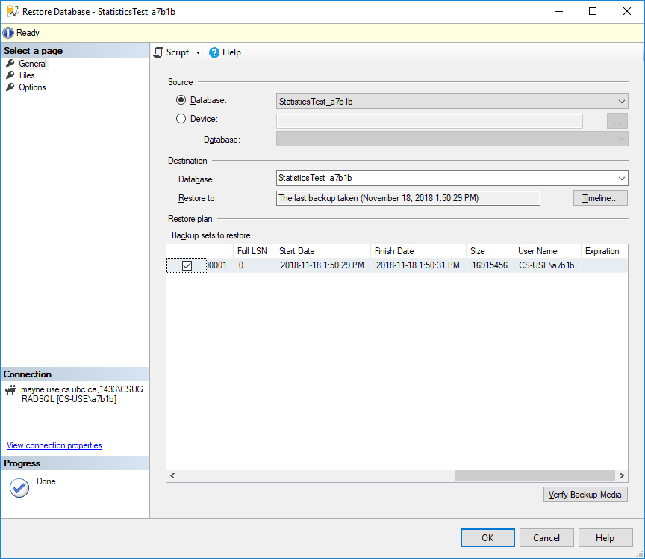

Handin#2 Non-clustered index

A non-clustered index is a structure of <key, pointer> pairs with each pointer points to the data page containing the key, where the logical order of the index does not match the physical order of the data page on the disk.

Generally, we build clustered index on columns that get used frequently (eg. in joining or selection), where the table doesn’t have frequent or massive inserts and updates.

Handin#3