**Final Project Report**

**NLP Chatbot Development using Dialogflow**



**Project Supervisor**

<<Abdullah Qamar>>

**Submitted By**

<<F24PROJECTB3B8C>>

**Software Projects & Research Section,**

**Department of Computer Sciences,**

**Virtual University of Pakistan**

|  |
| --- |
|  |



**CERTIFICATE**

This is to certify that <<Hafsa Javed>> (<<bc210414048>>) I have worked on and completed their Software Project at Software & Research Projects Section, Department of Computer Sciences, Virtual University of Pakistan in partial fulfillment of the requirement for the degree of BS in Computer Sciences under my guidance and supervision.

In our opinion, it is satisfactory and up to the mark and therefore fulfills the requirements of BS in Computer Sciences.

**Supervisor / Internal Examiner**

<<Abdullah Qamar>>

Supervisor,

Software Projects & Research Section,

Department of Computer Sciences

Virtual University of Pakistan

\_\_\_\_\_\_\_\_\_\_\_\_\_\_\_\_\_\_\_

(Signature)

**External Examiner/Subject Specialist**

<<External Supervisor Name>>

\_\_\_\_\_\_\_\_\_\_\_\_\_\_\_\_\_\_\_

(Signature)

**Accepted By:**

**\_\_\_\_\_\_\_\_\_\_\_\_\_**

(For office use)

**EXORDIUM**

**In the name of Allah, the Compassionate, the Merciful.**

**Praise be to Allah, Lord of Creation,**

**The Compassionate, the Merciful,**

**King of Judgment-day!**

**You alone we worship, and to You alone we pray for help,**

**Guide us to the straight path**

**The path of those who You have favored,**

**Not of those who have incurred Your wrath,**

**Nor of those who have gone astray.**

**DEDICATION**

This project is dedicated to my family for their unwavering support, encouragement, and belief in me throughout this journey. To my supervisor, Abdullah Qamar, whose valuable guidance and insights have been instrumental in shaping the direction of this project, I owe my deepest gratitude. I also dedicate this work to my friends and peers, whose motivation and collaboration have made this experience rewarding. This project is a reflection of all the support and inspiration I have received, and I am forever thankful for the opportunity to contribute to the field of technology through this chatbot development project.

**ACKNOWLEDGEMENT**

I would like to express my heartfelt gratitude to all those who have supported and guided me throughout the development of this project. First and foremost, I would like to thank my supervisor, Abdullah Qamar, for his constant support, expert advice, and encouragement, which were vital to the successful completion of this project. I also extend my sincere thanks to my family for their understanding and patience during the course of this work. Their emotional and moral support has been a source of strength. I am grateful to my friends and colleagues who provided valuable feedback and helped in overcoming challenges. Finally, I would like to thank the faculty and staff of the Software Projects & Research Section, Department of Computer Sciences at Virtual University of Pakistan, for providing the resources and opportunities that enabled me to undertake this project.

**PREFACE**

This report presents the culmination of my efforts in developing an NLP chatbot using Dialogflow, designed to enhance user interaction and streamline processes in the restaurant industry. The purpose of this project is to create a smart, efficient, and user-friendly chatbot capable of handling reservations, menu navigation, order placement, and customer support. The idea behind this project stems from the growing need for automation and artificial intelligence in everyday services, particularly in the restaurant sector. As technology continues to evolve, the importance of integrating AI to improve customer experiences has become increasingly evident. Through this project, I have explored various aspects of Natural Language Processing (NLP) and chatbot development, integrating them with a backend system using Flask and MySQL, while employing Dialogflow for seamless communication. The insights gained through this process have not only expanded my technical skills but also reinforced my passion for exploring innovative solutions in the field of AI and machine learning.

**TABLE OF CONTENTS**

|  |
| --- |
|  |

CHAPTER NO. 1

gathering & Analyzing info 10

1.1 Introduction

1.2 purpose

1.3 scope

1.4 definitions, acronyms and abbreviations

1.5 use cases and usage scenarios

1.5.1 Use Case Diagrams

1.5.2 Usage Scenarios

1.6 supplementary requirements

1.6.1 Usability

1.6.2 Reliability

1.6.3 Supportability

1.6.4 System Requirements

CHAPTER NO. 2

planning the project 17

2.1 Introduction

2.2 Methodology

* 1. Available Methodologies
  2. Chosen Methodology
  3. Reasons for Chosen Methodology
  4. Work Plan
  5. Project Structure
     1. Team Structure
     2. Project Schedule (Submission Calendar)

CHAPTER NO. 3

designing the project 23

3.1 Introduction

3.2 purpose

3.3 scope

* 1. definitions, acronyms and abbreviations
  2. Dynamic Model: Sequence Diagrams
  3. Object Model/Logical Model: Class Diagram
  4. Database Model (Database Diagram)
  5. Graphical User Interfaces

Chapter no.4

DEvelopment 34

4.1 Development plan (Architecture Diagram)

**<<Dear Students, you must take special care of page numbers, which are written against each Chapter and sub headings. You have to mention your own page numbers and correct one against each document heading. Make proper table of contents. Remember that if there are any new headings or you have included more headings in your documents then you also must write these in table of contents and modify table of contents according to your document’s material>>**

**<<Dear Students, before starting each chapter the following would be the title page for each chapter on a separate page>>**

**CHAPTER 1**

Gathering & Analyzing Info

#### 1.1 Introduction

This chapter outlines the fundamental steps involved in gathering and analyzing the essential information for developing a restaurant chatbot system. The project focuses on creating a user-friendly, automated chatbot that can effectively assist customers in various aspects of their dining experience, including making reservations, browsing menus, placing orders, and receiving customer support. The chatbot, leveraging Natural Language Processing (NLP) techniques, interacts with users in a conversational manner, providing a seamless and efficient experience. This chapter provides a comprehensive overview of the project's purpose, scope, and the key use cases that define its functionality. Additionally, it highlights the requirements for usability, reliability, and system support to ensure the chatbot meets both customer expectations and operational needs.

#### 1.2 Purpose

The purpose of this project is to develop a chatbot system for a restaurant that integrates Natural Language Processing (NLP) capabilities to streamline customer interactions. The chatbot is designed to facilitate various tasks such as making reservations, exploring the menu, placing orders, and providing customer support. By automating these processes, the system aims to enhance the customer experience, reduce the workload on staff, and improve overall operational efficiency. The chatbot will also provide a seamless and accessible interface for customers, ensuring that they can access the restaurant’s services easily through a web-based platform.

#### 1.3 Scope

The scope of this project is focused on developing an NLP-based chatbot specifically for a restaurant setting. The chatbot will be implemented on a web platform and will handle four main use cases: making reservations, navigating the menu, placing orders, and providing customer support. The system will integrate with the restaurant’s backend for reservation management, order tracking, and customer feedback collection. The chatbot will be designed to interact with customers in natural language, offering a personalized and efficient experience. The project does not extend to mobile applications, other platforms, or additional features beyond the core functionalities outlined. It also focuses solely on customer-facing functionalities, leaving out backend administrative processes for future work. The primary goal is to enhance user engagement and streamline the customer service process at the restaurant.

#### 1.4 Definitions, Acronyms, and Abbreviations

This section provides a list of key terms, acronyms, and abbreviations used throughout the report, along with their definitions to ensure clarity and a common understanding of the technical terms and concepts involved in the project.

**NLP**: Natural Language Processing - A branch of artificial intelligence that deals with the interaction between computers and humans through natural language.

**API**: Application Programming Interface - A set of rules that allows different software applications to communicate with each other.

**UI**: User Interface - The space where interactions between humans and computers occur.

**DBMS**: Database Management System - Software that handles the storage, retrieval, and updating of data in a database.

**JDBC**: Java Database Connectivity - An API in Java that allows Java programs to connect to databases.

**JWT**: JSON Web Token - A compact, URL-safe means of representing claims to be transferred between two parties.

**REST**: Representational State Transfer - An architectural style for designing networked applications, often used in web services.

**JSON**: JavaScript Object Notation - A lightweight data-interchange format that is easy for humans to read and write, and easy for machines to parse and generate.

#### 1.5 Use Cases and Usage Scenarios

In this section, we define the key use cases and their corresponding usage scenarios that describe the interactions between the system (restaurant chatbot) and the user (customer). Use cases represent the main functionalities that the system will provide, while usage scenarios provide a detailed, step-by-step explanation of how these functionalities are executed in real-world situations.

#### 1.5.1 Use Case Diagrams

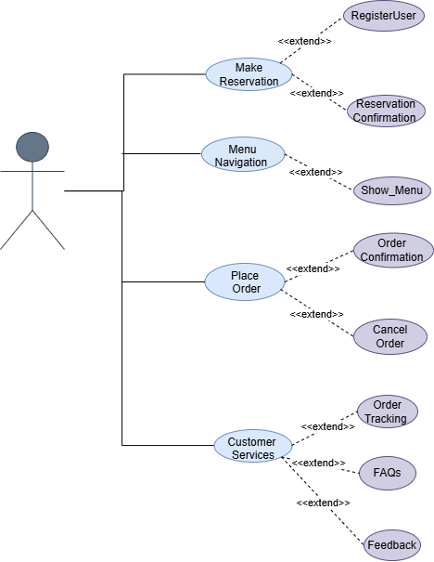

**1.5.2.**Usage Scenarios

|  |  |  |  |  |  |  |  |  |
| --- | --- | --- | --- | --- | --- | --- | --- | --- |
| **Use Case Title** | **Use Case ID** | **Actions** | **Description** | **Alternative Paths** | **Pre-Condition** | **Post-Condition** | **Author** | **Exceptions** |
| **Make Reservation** | UC001 | 1. Customer selects "Make Reservation."  2. Customer provides details (date, time, guests).  3. Chatbot confirms reservation. | Allows customers to create reservations easily. | - If modification intent is selected, customer updates reservation details. | Valid date, time, and guest information. System supports reservation processing. | Reservation is successfully made, updated, or canceled. | bc210414048 | Invalid or incomplete details provided. No available slots for the selected date/time. Reservation system error. |
| **Menu Navigation** | UC002 | 1. Customer selects "Menu Navigation."  2. Customer uses Explore intent to browse menu categories or search for specific items. | Enables customers to interactively browse the menu or search for specific items. | - If no input is provided, chatbot displays all menu categories. - Recommendations can be shown based on past orders or preferences. | Menu categories and items are pre-defined and available. | Menu is displayed, or relevant search results are provided to the customer. | bc210414048 | Menu data is unavailable or outdated. Search query fails to match menu items. System fails to retrieve menu data. |
| **Place Order** | UC003 | 1. Customer selects "Place Order."  2. Customer uses Modification intent to:   - Add items to the order. | Allows customers to add, remove, or modify items in their order. Consolidates these actions into a single Modification intent. | - If an item is unavailable, chatbot suggests alternatives. | Items are available and listed in the menu. System supports modifications | Order is successfully placed, modified, or is shared with the customer. | bc210414048 | Invalid input for order details. Items unavailable or out of stock. System fails to calculate or confirm the order. |
| **Customer Support** | UC004 | 1. Customer selects "Customer Support."  2. Customer interacts with intents: Track Order,FAQs, Feedback. 3. Chatbot resolves or escalates the issue. | Provides assistance to customers by resolving queries, tracking orders, answering FAQs, collecting feedback | - If Track Order is selected, chatbot provides current order status. - Feedback intent collects suggestions or complaints. | Customer has a query or issue requiring support. Chatbot can access order and feedback data. | Customer issue is resolved. Feedback is recorded. | bc210414048 | Order tracking fails due to incomplete data. Feedback submission fails. FAQs are outdated. |

#### 1.6 Supplementary Requirements

#### 1.6.1 Usability

The chatbot should be user-friendly, intuitive, and responsive across all devices. It should minimize input requirements and guide users through a simple process for booking reservations, viewing the menu, and placing orders.

#### ****1.6.2 Reliability****

The system must perform consistently with minimal downtime. It should handle errors effectively, offer backup and recovery, and ensure seamless functionality, especially during peak hours.

#### ****1.6.3 Supportability****

The system should be easy to maintain and upgrade, with modular design, clear documentation, and robust error logging for troubleshooting and performance monitoring.

#### 1.6.4 System Requirements

Key system requirements include:

**Hardware**: A server capable of handling requests and storing data.

**Software**: Windows Server, MySQL, Flask, HTML, CSS, JavaScript.

**Network**: Secure internet connection with HTTPS for data protection.

These requirements ensure the system’s performance, security, and ease of use.

**CHAPTER 2**

Planning the Project

#### ****2.1 Introduction****

The planning phase of any project is crucial to ensuring that the development process is well-organized, efficient, and on schedule. This chapter provides an overview of the planning stage for the restaurant-based NLP chatbot project. The focus will be on outlining the methodology used, available methodologies, the chosen approach for this project, and a detailed work plan that highlights key milestones. The planning chapter serves as the foundation for the execution phase, setting clear goals and timelines for the project's completion.

#### 2.2 Methodology

For the development of the restaurant-based chatbot, the **VU Process Model** was chosen. This model combines the structured, sequential approach of the **Waterfall model** with the flexibility and iterative nature of the **Spiral model**. The Waterfall model ensures clear, defined phases, while the Spiral model allows for iterative feedback and risk management. By combining both, the VU Process Model offers a balance of predictability and adaptability, making it ideal for this project. It ensures systematic development with the flexibility to refine and improve the system based on stakeholder feedback and emerging requirements.

#### 2.3 Available Methodologies

There are several project development methodologies available, each with its strengths and weaknesses. Some of the most common methodologies include:

**Waterfall Model**: A linear and sequential approach where each phase of the development process is completed before moving on to the next. It is simple but lacks flexibility to accommodate changes once the process starts.

**Agile Methodology**: Focuses on iterative development, where the project is broken down into smaller, manageable tasks. Frequent reviews and updates allow for flexibility and quick adaptation to changing requirements.

**Spiral Model**: Combines elements of both design and prototyping in stages, focusing on risk assessment and iterative development. It’s suitable for large, complex projects where risks need to be continuously evaluated.

**V-Model (Verification and Validation)**: A variation of the Waterfall model that emphasizes testing at each development stage. It is ideal for projects where high reliability and validation are crucial.

**RAD (Rapid Application Development)**: A methodology that prioritizes rapid prototyping and user feedback to build software quickly. It allows for the quick development of systems but may sacrifice long-term maintainability.

Each methodology has its place, but for the restaurant chatbot system, the **VU Process Model** was selected due to its combination of structured phases and iterative refinement, making it the most suitable approach for the project’s needs.

#### 2.4 Chosen Methodology

For the development of the restaurant-based chatbot system, the **VU Process Model** has been selected. This methodology is a combination of the **Waterfall** and **Spiral** models. The Waterfall model ensures a clear and structured approach, while the Spiral model provides flexibility and the ability to refine the system iteratively. This hybrid methodology helps in managing risks effectively and allows for gradual improvements as the project progresses.

The VU Process Model's combination of structured phases from Waterfall with the iterative, risk-mitigating approach of the Spiral model makes it ideal for projects requiring both clear milestones and flexibility for changes during development. This method ensures that the system evolves with constant feedback from stakeholders, reducing the risks of errors and ensuring the project meets user needs.

#### 2.5 Reasons for Chosen Methodology

The **VU Process Model** was chosen for the restaurant chatbot project due to several key advantages that align with the project’s requirements. These include:

**Clear Phases with Structured Progression**: The Waterfall aspect ensures that each phase (requirements gathering, design, implementation, and testing) is clearly defined and completed before moving to the next. This helps in maintaining project clarity and a linear flow.

**Iterative Development**: The Spiral model’s iterative nature allows for gradual refinements based on feedback and emerging needs, ensuring the project can adapt to changing requirements and unforeseen challenges. This is crucial for ensuring the chatbot meets user expectations.

**Risk Mitigation**: The Spiral model’s focus on risk analysis allows for the identification and management of potential risks at each stage of the project. This ensures that issues are addressed early, reducing the chances of failure.

**Balancing Flexibility and Predictability**: The methodology allows for a structured approach with clear deadlines while providing the flexibility to make adjustments based on stakeholder feedback or testing results. This balance is important in ensuring both timely delivery and system quality.

By combining these advantages, the VU Process Model ensures that the project progresses smoothly while being responsive to feedback, allowing for a robust and successful implementation of the restaurant chatbot.

#### 2.6 Work Plan

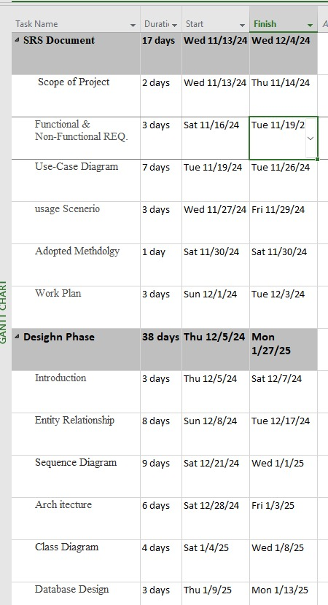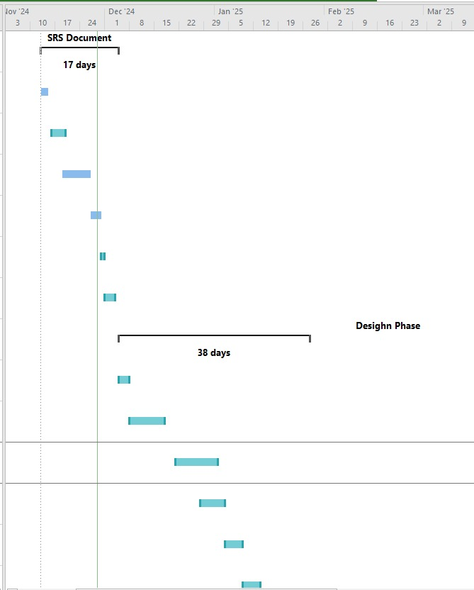

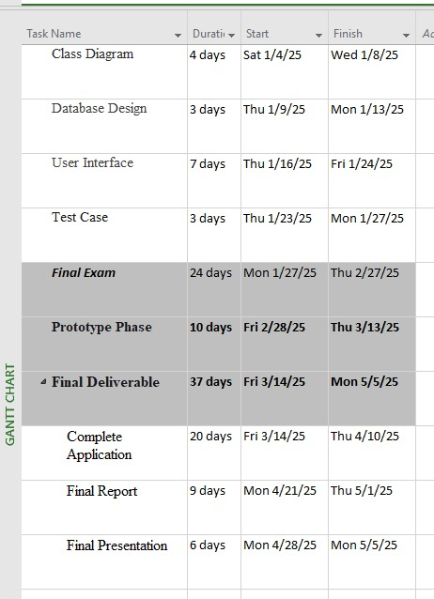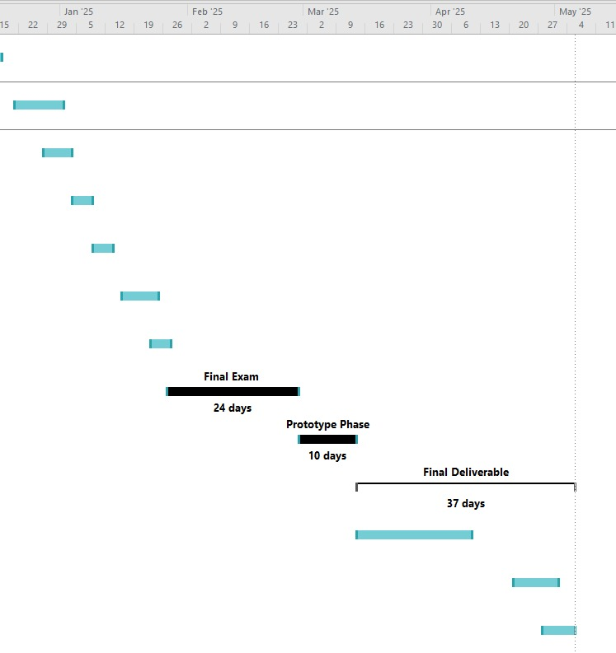

#### 2.7 Project Structure

#### 2.7.1 Team Structure

Supervisor: Abdullah Qamar

↑

Student: Hafsa Javed (BC210414048)

↑

VU Process Model

#### 2.7.2Project Schedule (Submission Calendar)

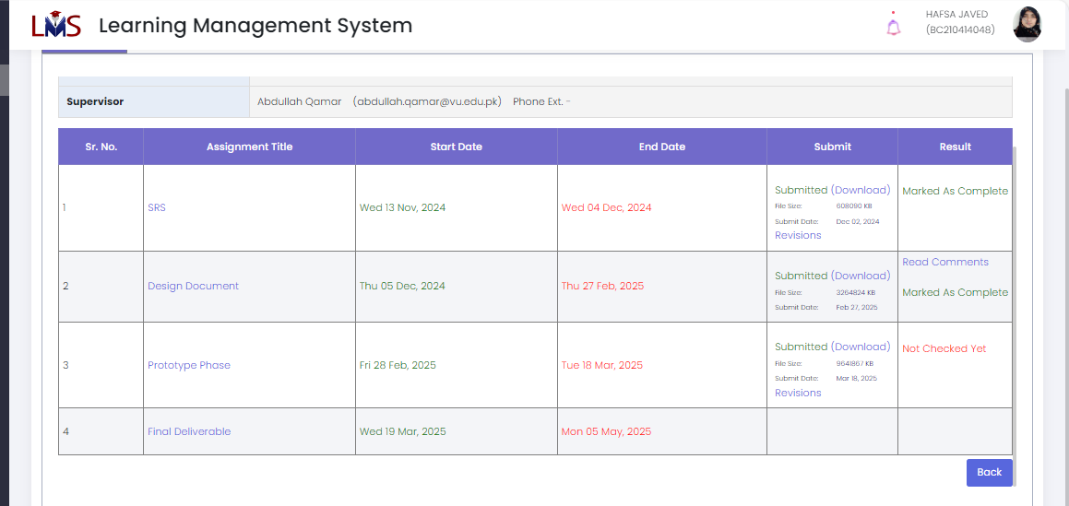

**CHAPTER 3**

Designing the Project

#### 3.1 Introduction

This chapter focuses on the design phase of the restaurant-based chatbot system. It outlines the system’s architecture, including sequence diagrams, class diagrams, database structure, and graphical user interface design. These design elements serve as a blueprint for development, ensuring that all functional and non-functional requirements are translated into a workable system.

#### 3.2 Purpose

The purpose of this design phase is to transform the collected requirements into detailed system architecture and visual models. For the restaurant chatbot system, the goal is to clearly define how different components such as the chatbot, database, and user interface will interact. This ensures smooth development and helps developers, testers, and stakeholders understand the system flow and structure.

#### 3.3 Scope

The scope of the design phase includes the creation of sequence diagrams, class diagrams, database diagrams, and graphical user interfaces for the restaurant chatbot system. These design components collectively define how users will interact with the system, how data will be processed and stored, and how various modules of the application will communicate with each other. This phase serves as the blueprint for implementation.

#### 3.4 Definitions, Acronyms, and Abbreviations

**GUI** – Graphical User Interface: The visual part of the software users interact with.

**SRS** -- Software Requirement Specification

**DBMS** – Database Management System: Software used to manage the database (MySQL in this project).

**UML** – Unified Modeling Language: A standard way to visualize system design (used for diagrams).

**JWT** – JSON Web Token: A method for secure user authentication and authorization.

**Dialogflow** – Google’s NLP platform used for building the chatbot.

**Flask** – A Python web framework used for backend development.

**XAMPP** – A local server used for managing and testing the MySQL database.

### 3.5 Dynamic Model: Sequence Diagrams

## **Sequence Diagram of user**

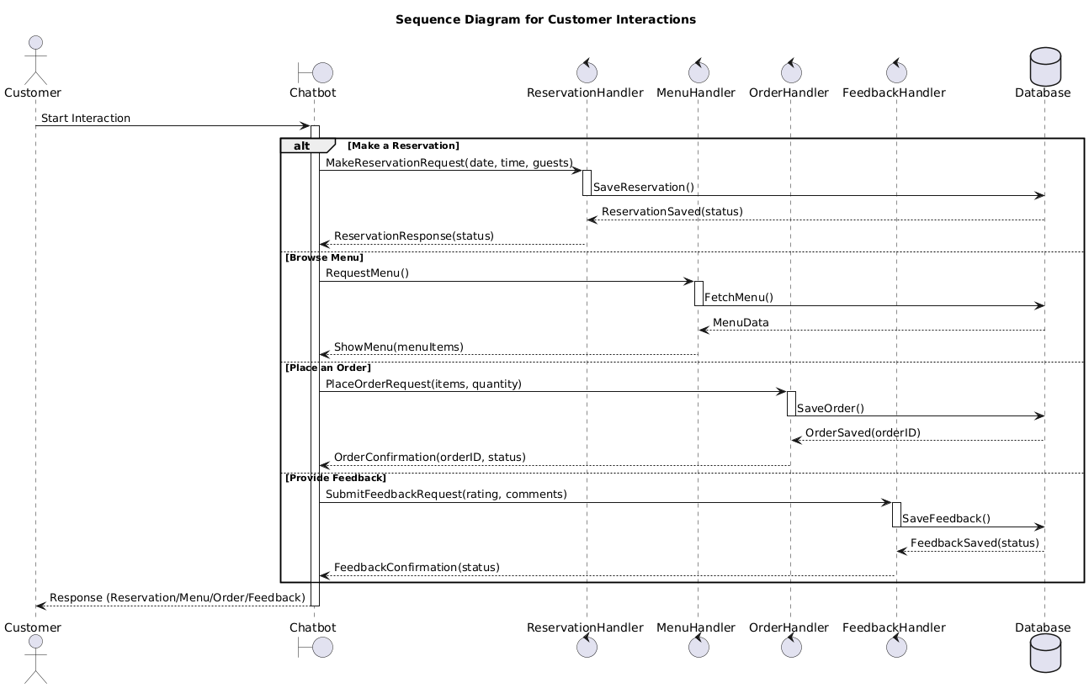

## **Sequence Diagram of Reservation**

**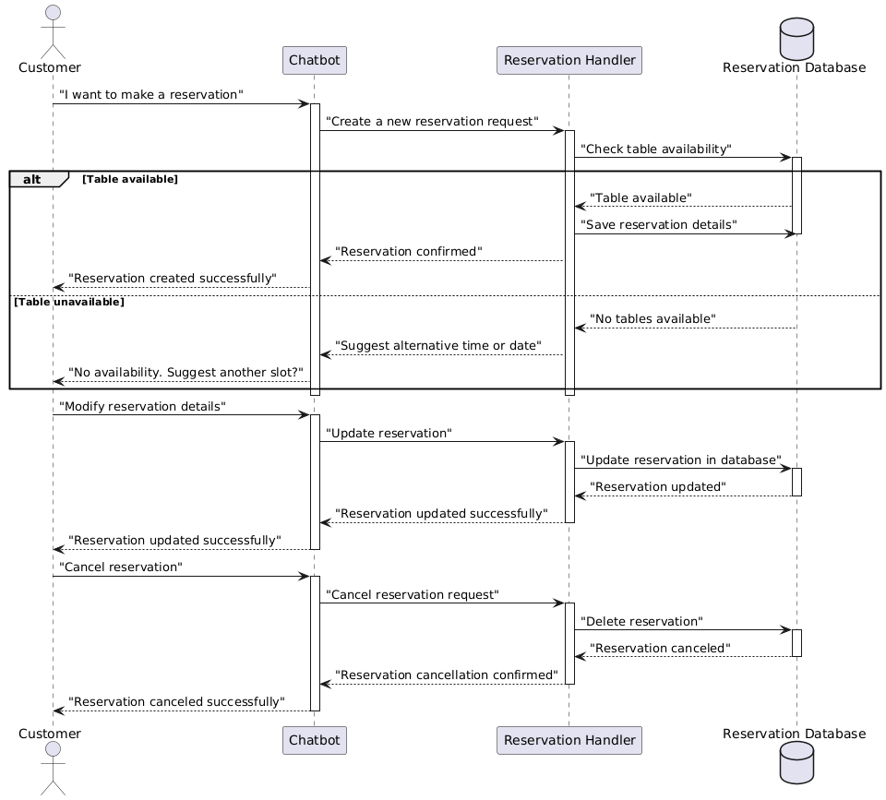**

**Sequence Diagram of order** 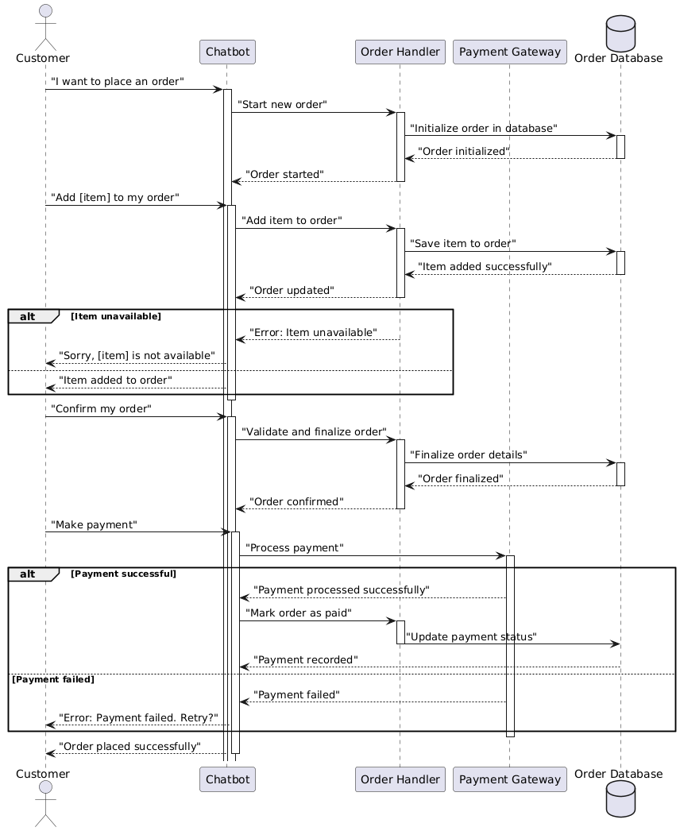

**Sequence Diagram of Menu**

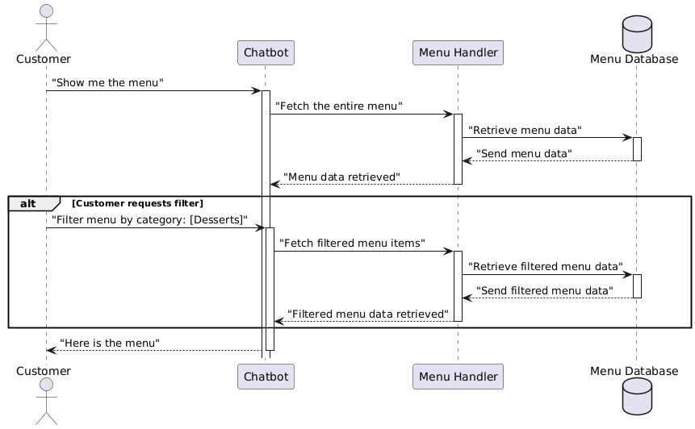

**Sequence Diagram of Feedback**

**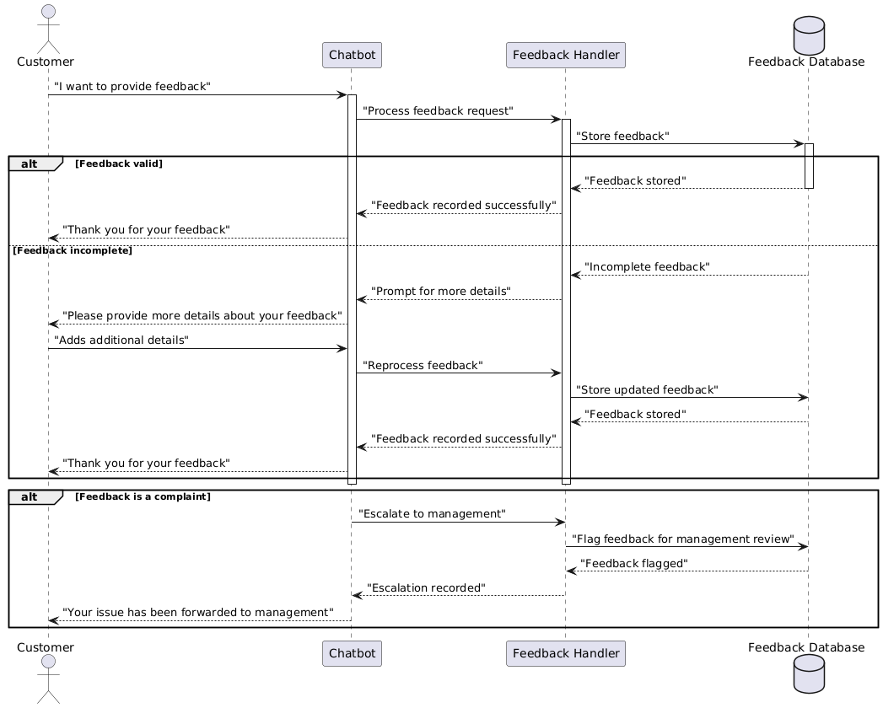**

#### 3.6 Object Model / Logical Model: Class Diagram

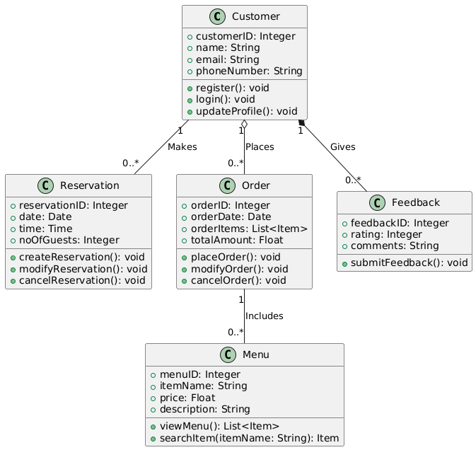

#### 3.7 Database Model (Database Diagram)

**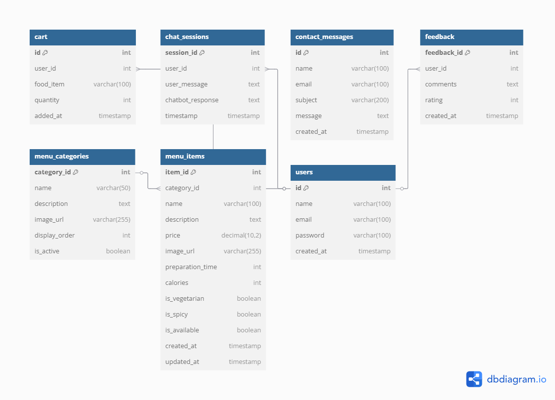**

**GUI**

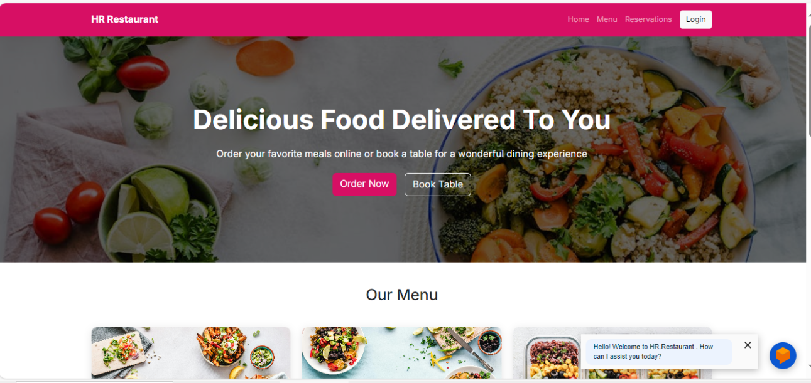

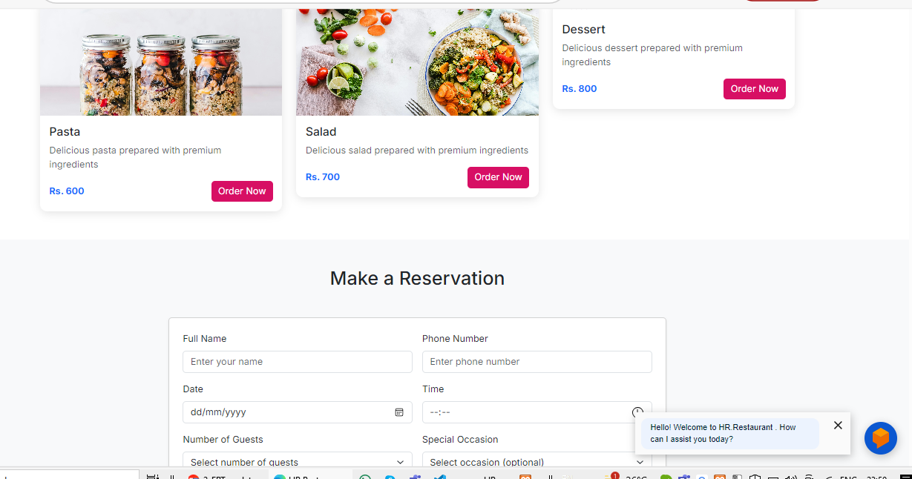

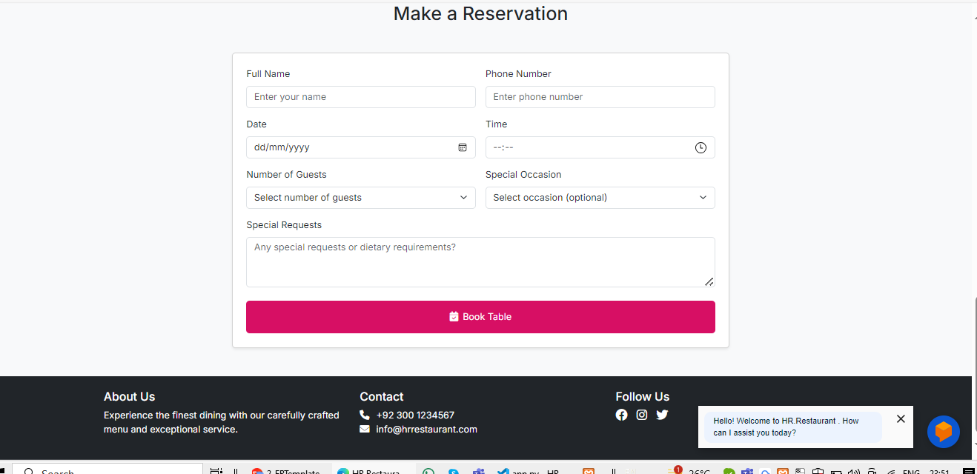

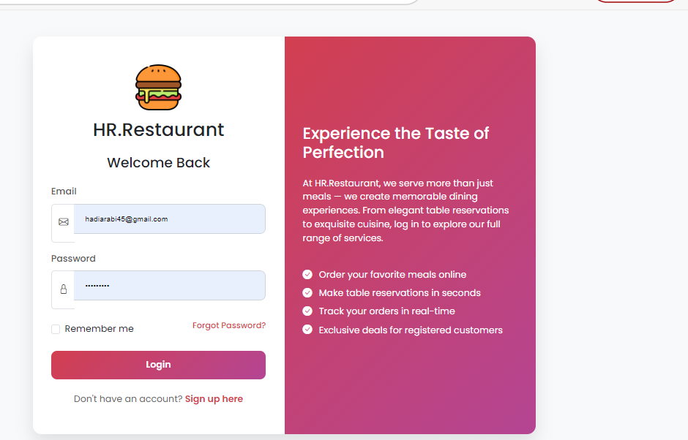

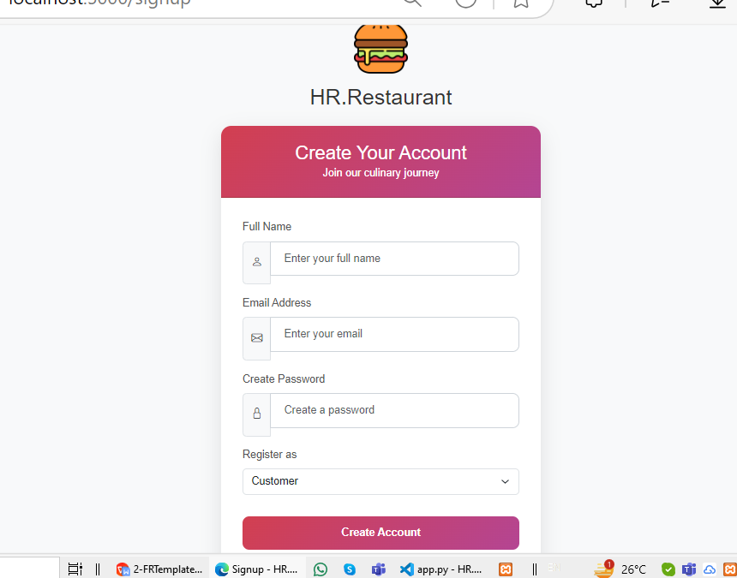

**CHAPTER 4**

Development

#### 4.1 Development plan (Architecture Diagram)

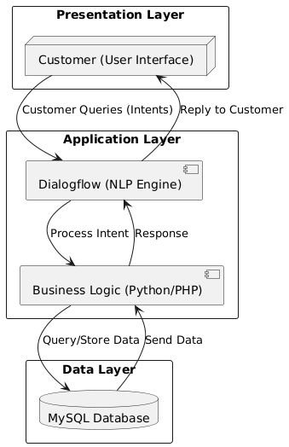

**REFERENCES**

Dialogflow Documentation: https://cloud.google.com/dialogflow

Flask Documentation: https://flask.palletsprojects.com

MySQL Documentation: [https://dev.mysql.com/doc/](https://dev.mysql.com/doc/" \t "_new)

Bootstrap Documentation: [https://getbootstrap.com](https://getbootstrap.com" \t "_new)