NLP Chatbot Development using Dialogflow

**Software Requirements Specification**

Version 1.0



**Group Id:** F24PROJECTB3B8C

**Supervisor Name :***Abdullah Qamar*

|  |  |  |  |
| --- | --- | --- | --- |
| **Date (dd/mm/yyyy)** | **Version** | **Description** | **Author** |
| 19/11/2024 | 1.0 | The purpose of this project is to develop an AI-powered restaurant chatbot using **Google Dialogflow**. This chatbot aims to enhance customer interaction and streamline restaurant operations by automating key tasks such as **Make reservations, menu navigation ,order-taking,**  and **customer support**. | **BC210414048** |
|  |  |  |  |
|  |  |  |  |
|  |  |  |  |

**Table of Contents**

1. Scope (of the project)
2. Functional Requirements Non Functional requirements
3. Use Case Diagram
4. Usage Scenarios
5. Adopted Methodology

6. Work Plan (Use MS Project to create Schedule/Work Plan)

SRS Document

## 1.Scope of the Project

The project involves developing an **AI-powered restaurant chatbot** using **Google Dialogflow** to automate key customer interactions. The chatbot will focus on tasks such as managing reservations, navigating menus, placing orders, and answering customer queries. It will provide a text-based conversational interface accessible via the **web platform**.

**Purpose**

The purpose of the project is to:

* Automate routine customer service tasks.
* Enhance customer experience through quick and accurate responses.
* Reduce the workload on restaurant staff by handling repetitive inquiries.

**Intended Functionalities**

* Table Reservations
* Menu Navigation
* Order Placement
* Customer Support

### ****2.Requirements****

### ****2.1 Functional Requirements****

The chatbot will be able to:

**Make Reservations**

Customer provides date, time, and number of guests

System confirms or suggests new timing

**Menu Navigation**

Customer can view and search menu items

Filter items (e.g., desserts, vegan, etc.)

**Place Orders**

Order items for dine-in or takeaway

View summary before confirming

**Customer Support**

Answer FAQs, track orders, accept feedback

Escalate complex issues to human staff

### ****2.2 Non-Functional Requirements****

These focus on how the system will perform and its quality attributes:

* **Performance**
  1. **Requirement**: The chatbot should respond quickly to user inputs (2-3 seconds maximum).
  2. **Activity**: Use fast and reliable hosting servers; optimize queries and responses in Dialogflow. Conduct load testing to ensure the system performs well under high traffic.
* **Scalability**
  1. **Requirement**: Handle multiple customer interactions simultaneously, especially during busy hours.
  2. **Activity**: Implement webhook to dynamically scale server resources during peak times.
* **Usability**
  1. **Requirement**: The chatbot must be simple and easy to use for all users.
  2. **Activity**: Perform user testing to identify areas of improvement in the design and flow. Provide clear instructions and error messages during interactions.
* **Security**
  1. **Requirement**: Protect customer data and ensure secure transactions.
  2. **Activity**: Use HTTPS for secure communication, encrypt sensitive data, and regularly update the system to patch vulnerabilities.
* **Accessibility**
  1. **Requirement**: The chatbot should work seamlessly on desktops, tablets, and smartphones.
  2. **Activity**: Test the chatbot on multiple devices and browsers to ensure compatibility. Adjust the layout for proper viewing on small screens.

### ****3. Use Case Diagram****

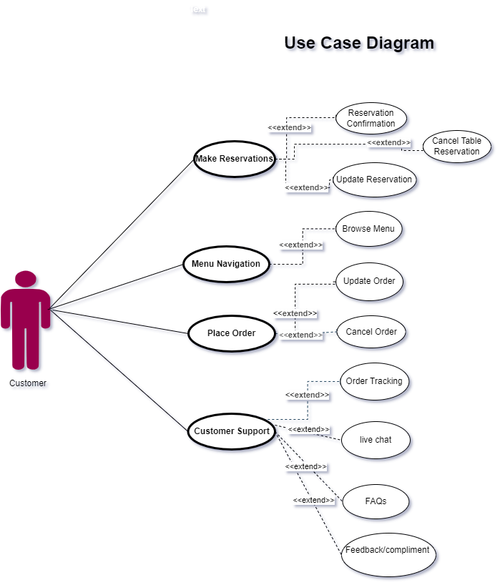

**4.**Usage Scenarios

|  |  |  |  |  |  |  |  |  |
| --- | --- | --- | --- | --- | --- | --- | --- | --- |
| **Use Case Title** | **Use Case ID** | **Actions** | **Description** | **Alternative Paths** | **Pre-Condition** | **Post-Condition** | **Author** | **Exceptions** |
| **Make Reservation** | UC001 | 1. Customer selects "Make Reservation."  2. Customer provides details (date, time, guests).  3. Chatbot confirms reservation.  4. Intents: Reservation Reminder, Update Reservation, Cancel Reservation. | Allows customers to create, modify, or cancel table reservations easily. | - If modification intent is selected, customer updates reservation details. - If cancel intent is selected, reservation is removed. | Valid date, time, and guest information. System supports reservation processing. | Reservation is successfully made, updated, or canceled. | bc210414048 | Invalid or incomplete details provided. No available slots for the selected date/time. Reservation system error. |
| **Menu Navigation** | UC002 | 1. Customer selects "Menu Navigation."  2. Customer uses Explore intent to browse menu categories or search for specific items. | Enables customers to interactively browse the menu or search for specific items. | - If no input is provided, chatbot displays all menu categories. - Recommendations can be shown based on past orders or preferences. | Menu categories and items are pre-defined and available. | Menu is displayed, or relevant search results are provided to the customer. | bc210414048 | Menu data is unavailable or outdated. Search query fails to match menu items. System fails to retrieve menu data. |
| **Place Order** | UC003 | 1. Customer selects "Place Order."  2. Customer uses Modification intent to:   - Add items to the order.   - Remove items from the order. 3. Chatbot calculates the total.  4. Customer confirms or cancels the order. | Allows customers to add, remove, or modify items in their order. Consolidates these actions into a single Modification intent. | - If an item is unavailable, chatbot suggests alternatives. - If the customer cancels, the order is cleared. | Items are available and listed in the menu. System supports modifications and cancellation. | Order is successfully placed, modified, or canceled. Order confirmation is shared with the customer. | bc210414048 | Invalid input for order details. Items unavailable or out of stock. System fails to calculate or confirm the order. |
| **Customer Support** | UC004 | 1. Customer selects "Customer Support."  2. Customer interacts with intents: Track Order, Live Chat, FAQs, Feedback. 3. Chatbot resolves or escalates the issue. | Provides assistance to customers by resolving queries, tracking orders, answering FAQs, collecting feedback, or escalating to live chat support for unresolved issues. | - If chatbot cannot resolve an issue, it connects to live support. - If Track Order is selected, chatbot provides current order status. - Feedback intent collects suggestions or complaints. | Customer has a query or issue requiring support. Chatbot can access order and feedback data. | Customer issue is resolved. Feedback is recorded. Live chat is initiated for unresolved queries. | bc210414048 | Order tracking fails due to incomplete data. No agents available for live chat. Feedback submission fails. FAQs are outdated. |

### ****5. Adopted Methodology****

### ****Adopted Methodology: VU Process Model****

For the development of the restaurant-based chatbot system, we have chosen the **VU Process Model**, which is a combination of the **Waterfall** and **Spiral** models. This methodology provides the structure of the Waterfall model while incorporating the flexibility and iterative nature of the Spiral model, making it suitable for projects that require gradual refinement and risk mitigation.

### Water fall model:

The waterfall model was first process model to be introduced. It is also referred to as a linear-sequential life cycle model. It is very simple to understand and use. In a waterfall model, each phase must be completed before the next phase can begin and there is no overlapping in the phases. Waterfall model is the earliest sdlc approach that was used for software development.

**Now we will discuss the spiral model**

### Spiral model:

**1.** To eliminate the risk that could be faced in development of software the use of spiral methodology is adopted. For example, the risk might be a resignation from the key person

**2.** Spiral model has two dimensions. One is radial dimension which represents the cumulative cost to date, and the other is angular dimension which represents the progress through the spiral.

## Vu process model:

This process model is combination of water fall and spiral model. This process model maximizes the quality of system and reduces the risk and disadvantages

### ****Why VU Process Model?****

The VU Process Model is ideal for this project because it:

· Clear steps

· Flexibility to improve

· Manages risks

· Structured + adaptable

### Rather

Our task is isolated as of now into various stages for example assembling and examining prerequisites stage, arranging stage, examination and configuration stage, improvement and last undertaking report stage, and last report/viva stage.

I will finish each stage in succession and will submit it to our supervisor. He will recommend us about the improvement in each stage before beginning the following stage. I will make improvement in that stage. This procedure will be embraced because of the winding idea of vu procedure model. At the point when the stage is well-improved and very much worked-out, and furthermore acknowledged by our supervisor then I will continue to next stage.

### ****Phases of the VU Process Model****

· **Requirements Gathering** – Understand what the chatbot must do

· **Design** – Plan chatbot flow and system structure

· **Prototype** – Build a basic version and test with feedback

· **Implementation** – Final development in Dialogflow

· **Testing** – Check if everything works properly

· **Deployment & Maintenance** – Make chatbot live and maintain it

窗体底端

### ****6. Work Plan****

