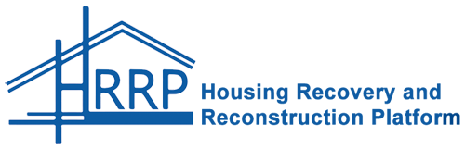
District Exhibition & Technical Workhop Report Rasuwa
Marking the third anniversary of the 2015 Gorkha Earthquake

Table of Contents
1.0 Background 3
2.0 Introduction 3
3.0 District Exhibition 3
3.1 Questions and Discussion During Exhibition 3
3.2 Materials Shared 4
3.3 Photos 5
4.0 Technical Workshop 6
4.1 Government & Partner Presentations 6
4.2 Groupwork Error! Bookmark not defined.
5.0 Conclusion & Action Points 8
6.0 Annexes 9
6.1 Annex 1: Participant List 9
6.2 Annex 2: Programme Agenda 11

- Background
The Housing Recovery and Reconstruction Platform (HRRP) was established to support the National Reconstruction Authority (NRA), Ministry of Urban Development (MoUD) and Ministry of Federal Affairs and Local Development (MoFALD) Central Level Program Implementation Units (CL-PIUs), other relevant government authorities, and Partner Organizations (POs) with coordination of the post-earthquake housing reconstruction. It is led by CRS Nepal, and other financial contributors include DFID, Caritas Nepal, Plan International, and Habitat for Humanity. HRRP is currently in its third phase beginning from March 2017 and will run until the end of February 2019.

In Rasuwa the HRRP District Representative is Rijan Gajurel, im.rasuwa@hrrpnepal.org, and the implementing partner is CRS Nepal. There are 24 Partner Organizations supporting the housing reconstruction. 11,633 households are eligible to receive the GoN housing reconstruction grant and 117 are eligible to receive the GoN retrofit grant. 10,673 have signed the PA with the GoN, 10673 have received the first tranche, 7788 have received the second tranche, and 3665 have received the third tranche.
- Introduction
The HRRP District Exhibition and Technical Workshop took place on 18 April 2018, at Langtang resource center ,Dhunche Rasuwa , with the following objectives:
- To promote and encourage experience sharing between all district stakeholders
- To document and discuss the technical challenges related to the housing reconstruction
- To collect ideas from district stakeholders on how to solve challenges
- To identify gaps and duplications in Socio-Technical Assistance in the district

The program was chaired by Mr. Madan Ala,MoFALD -DLPIU Chief, Rasuwa. Other participants included representatives from NRA Rasuwa, MoUD DLPIU, MoFALD DLPIU, and Partner Organizations. The full list of participants is provided in Annex 1 and the program schedule is provided in Annex 2.

This report provides an overview of the proceedings, as well as access to all the materials shared during the exhibition and workshop.
- District Exhibition
- Questions and Discussion During Exhibition
Some of the major discussion points during the exhibition were:
- Sharing activities progress by different partner's organization.
- HRRP team update reconstruction update to all the participant .Different challenges and way forward was discussed during that event.
- Information product was shared during event. Stone cutting machine, CSEB block were presented by Practical Action.

The most frequently asked questions were:
- Activities progress of partners organization .Challenges faced by them and the way forward.
- Impact at community level in reconstruction by the support from partner's organization.
- Reconstruction update of district and the main common challenges at community level.

- Materials Shared
Document Title | Organisation | Contact Details
Handout of NRA guidelines and procedure in reconstruction, impact at community of CSRC livelihood project. | CSRC / PIN | biswash@csrcnepal.org
Maps and infographics, One pager update, district profile. | HRRP | im.rasuwa@hrrpnepal.org
Activities update and impact at community level -One pager update . | Purakhi / ASF Nepal | Saran2000grg@gmail.com
Stone cutting machine , CSEB block , Activities update and impact at community level . | Practical Action | Keshab.nuwakot@gmail.com
Activities update and impact at community level -One pager update and other information product . | Nepal Red cross society | dewalpawan@gmail.com
Activities update and impact at community level -One pager update and other information product . | Om - Nepal | rameshdhunche@gmail.com
Activities update and impact at community level -One pager update and other information product. | Samaratan Purse | PTitung@samaratan.org
Activities update and impact at community level -One pager update and other information product. | Transparency Nepal | acharyabikash37@gmail.com
Activities update and impact at community level -One pager update and other information product. | Common feedback project
Activities update and impact at community level -One pager update and other information product. | GIZ | niraulakrish@gmail.com

- Photos
Photo 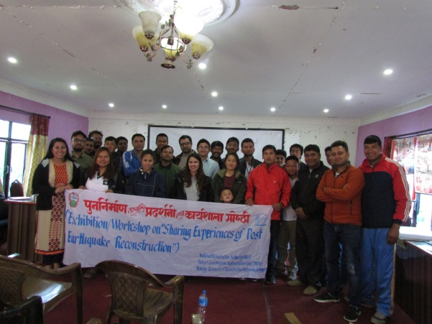 | Photo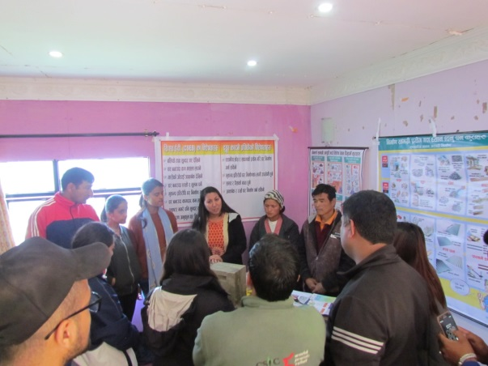
Caption: Group photo | Caption: supply chain team (pratical action and JJMS )sharing their products and experiences with participant.
Photo 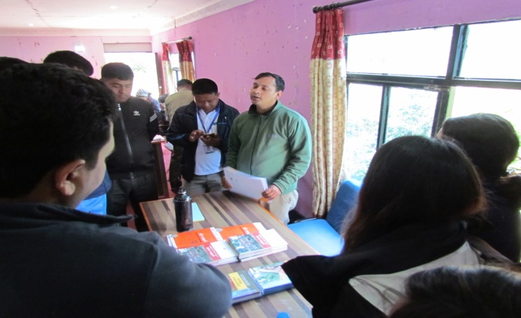 | Photo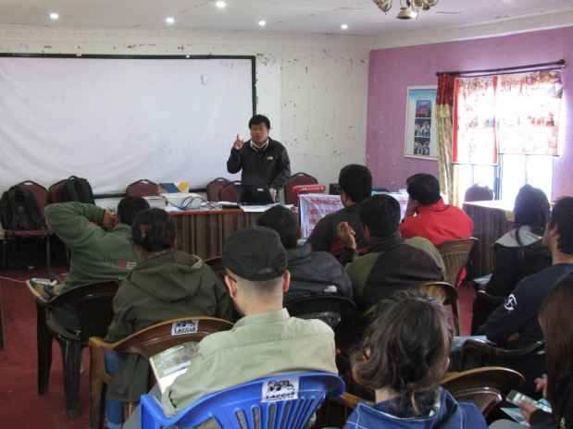
Caption : Durable Solution team ( PIN and CSRC ) sharing their activities status and different handbook to participant. | Caption: MoFALD DLPIU chief Mr .Madan Kumar Ale updating reconstruction update and support by partners organization .
Photo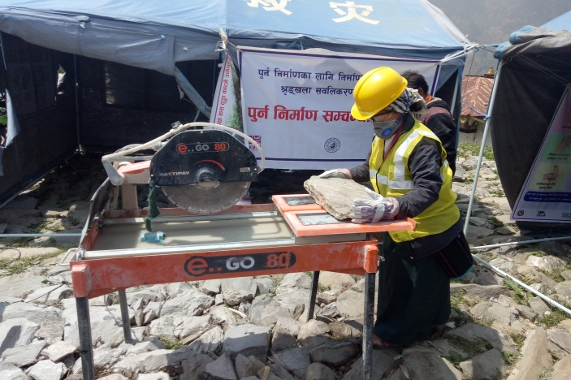 | Photo
Caption : Stone cutting by local female mason . | Caption

- Technical Workshop
The workshop began with a presentation from HRRP on the objectives of the workshop and a review of the outcomes from the technical workshops conducted in early 2017. The introduction also included sharing of the challenges and issues identified during joint monitoring visits conducted by MoUD DLPIU and HRRP.
- Government & Partner Presentations
The following presentations were delivered during the first part of the technical workshop:
Presentation Title | Presenter | Key Points
Activities update, challenges faced and way forward.  Presentation file | Mr.Keshab Aryal | - Major activities and output  - Status of demand aggregation  - Enterprise development (CSEB)  - Challenges and way forward
Resettlement and relocation update for displaced HHs | Bishwash Nepali | - Total number of HHs need to resettle.  - Number of HHs resettled till date .  - Update of durable solution
Activities update, challenges faced and way forward.  Presentation file. | Madhu Sudan Thapa | - Thulogaun brief  - Shelter construction update  - Beneficiaries profile  - Program Integration in Thulogaun  - Best Practices.  - Key issues and Challenges.  - Key learnings.  - Photograph.
Repair and reconstruction project (Technical support).  Wood treatment process | Saran Sing Gurung  Ajit Jha | - Briefing of project  - Scenario of project area.  - Technical support provided by ASF Nepal in Gatang.  - Wood treatment process .

Group work/Interaction (write a paragraph in case of interaction)

Interaction is focused on following topics:
- Noncompliance issue
- Most of the buildings built before the deployment of engineers to field are non-compliant in which owners are not ready to apply correction.
- However, the rate of non-compliance has been effectively reduced after the support from district support engineer.
- Many non-compliance issues are solved after the publication of Correction/Exception Manual and Hybrid Structure Manual.
- Major issue for applying correction is unavailability of trained masons for correction and retrofitting.
- Availability of Trained Mason
- 7 days mason training is not effective in community level.
- Sometimes, trained masons do follow the instructions of the owner rather than the technical standards they know.
- Very less trained mason is working in field.
- Few trained masons demand for unwantedly high wages simply because they are trained.
- Trained masons sometimes ignore newly amended rules and guidelines.
- Challenges with coordination with GoN bodies
- Lack of technical knowledge in beneficiaries and authority.
- political pressure to approve non-compliance buildings.
- Many buildings, built before the implementation of EQ Codes are very much contradictory to be approved for the second and third tranches.
- Land Less issue :
    - 844 HHs are listed as displaced from NRA and 154 HHs received land certificate from GoN.
    - Insufficient suitable land in district, HHs was relocated on Nuwakot district.

- Conclusion & Action Points
The district exhibition and technical workshop were well attended, and the active participation of all involved contributed to the success of the event. It provided a useful opportunity to bring all reconstruction actors together to reflect on the successes and challenges of the housing reconstruction to date, and to develop concrete action points to work on moving forward:

Action Point | Responsible | Timeframe
Coordination and regular activities update to EHRP , NRA . | Partners organization and HRRP | May , 2018
Monitoring visit on partners working area. | NRA , DCC , DLPIU ,EHRP ,HRRP | May ,2018

- Annexes
- Annex 1: Participant List
S.N. | Name | Gender | Organisation | Designation | Phone No. | Email
1 | Makunda Kumar Sha | Male | LACCoS | Wash engineer | 9849703739 | makundakumarsha@gmail.com
2 | Saroj Adhikary | Male | LACCoS | ED | 9851006342 | adhikarysaroj02@gmail.com
3 | Ajit Jha | Male | ASF / Paurakhi | ATA | 9801115536 | ajit.jha751@gmail.com
4 | Krishna Prasad Nirula | Male | GIZ | DDRCO | 985208300 | krishna.nirula@giz.de
5 | Madhu sudan Thapa | Male | NRCS | program Coordinator | 9841701531 | Madhu.thapa@nrcs.org
6 | Chandra Ale | Male | GIZ | District Coordinator | 9845580764 | Chandra.magar@giz.de
7 | Nisha Niraula | Female | PIN | project Coordinator | 9849671774 | Nisha.niraula@peopleinneed.cz
8 | Grishma Shrestha | Female | PIN | project Officer | 9818154831 | grishma.shrestha@peopleinneed.cz
9 | Madan pokhrel | Male | ASF /Pourakhi | Engineer | 9801115704 | madanpokhrel83@gmail.com
10 | Bishwash Nepal | Male | CSRC | District Advocary coordinator | 9851241866 | biswash@csrcnepal.org
11 | Pushpa Gurung | Female | PIN | Project Officer | 9860416979 | pushpa.gurung@peopleinneed.cz
12 | Saran Singh Gurung | Male | Pourakhi Nepal /ASF | Project officer | 9801115691 | saran2000grg@gmail.com
13 | Pawan Rana Magar | Male | UNRCO | RCA | 9840103996 | pwan.magar@gmail.com
14 | Kami Dindup | male | CSEB |  | 9843053539
15 | Ramesh tamang | Male | OM -Nepal | DSC | 9860235556 | tamang.rameshdhunche@gmail.com
16 | Samuel Limbu | Male | Om-Nepal |  | 9813201093
17 | Chhewang jhyalmo | Female |  |  | 9861583138
18 | Sabin Badha Magar | Male | ASF Nepal |  | 9810916782 | sabinbudhamagar@gmail.com
19 | Er.Prabhu Ram Pokhrel | Male | MoUD / CLPIU | M&E | 9851224243 | prabhupidge@gmail.com
20 | Rajendra Pyakural | male | NRA | IMO | 9860667886 | razeenpyakural33@gmail.com
21 | Bimal Acharya | Male | Cottage and small industry D.B | Accountant | 9851129290 | csidbrasuwa@gmail.com
22 | Shatrudhan Sha | Male | Batash foundation | Engineer | 9801818421 | shah.satrudhan1985@gmail.com
23 | Pradip Subedi | Male | DSC | Engineer | 9849626478 | mailtomepradip@gmail.com
24 | Jaya Bdr Bhandey | Male | GIZ | Engineer | 9860918820
25 | Anup Shrestha | Male | Build Change | Engineer | 9841342625 | anup@buidchange.org
26 | Deepak Saud | Male | HRRP | DMT - T C | 9806471656 | dmt.tech@hrrpnepal.org
27 | Resham Phuldel | Male | HRRP | IM expert | 9858421008 | resham@hrrpnepal.org
28 | Bikash Acharya | Male | Transparency Nepal | District Officer | 9851242523 | acharyabikash37@gmail.com
29 | Sonam Tamang | Male | NRCTC Nepal | DC | 9851258580 | tamangland2016@gmail.com
30 | Sumina Shrestha | Female | Pactical Action | DPO | 9851232663 | sumina.shrestha@pacticalaction.org.np
31 | Keshab Raj Aryal | Male | JJMS | PC | 9851099974 | keshab.nuwakot@yahoo.com
32 | Madan Kumar Ale magar | Male | DTO | district engineer | 9851145746 | madanale@yahoo.com
33 | Pramod Kumar Titung | Male | Samartan Purse | FP | 9849118316 | PTitung@samaratan.org
34 | Suroj Maharajan | Male | Samaritan Purse | Engineer | 9841669112 | surojmahajang91@gmail.com
35 | Jeevan Tamang | Male | GIZ | CF | 9849693434 | JeevanTamang019@gmail.com
36 | Lakpa Sherpa | Female | DLPIU | Engineer | 9861167605 | ar.lakpasherpa@gmail.com
37 | Keshave Gajurel | Male | NRA | OA | 9860009278 | keshav.gajurelza@gmail.com
38 | Prajwal KC | Male | NRA , DLPIU | DSE | 9851249222 | kcprazwal@gmail.com
39 | Keshav Adhikary | Male | Nepal Army | Engineer | 9845090568 | keshavadh42@gmail.com
40 | SanjivLama | Male | Nepal Bank | Asst.Branche Manager | 9849145696 | lamasanjiv44@gmail.com
41 | Rijan Gajurel | Male | HRRP | DIMO | 9851114937 | im.rasuwa@hrrpnepal.org
- Annex 2: Programme Agenda
Time | Description | Facilitator / Presenter
10-12:00 | Arrival and registration  District Exhibition | HRRP
12:30-1:00 | Introduction/Sharing of Objectives | HRRP
1:00-2:00 | Presentation from GoN/POs and M&E  -Progress Update  -Best practices and Challenges  -Way Forwards | HRRP
2:00-2:30 | Group Work/Interaction-Issue based  -Non-Compliant Issues  -Land Issues  -Lack of Trained masons  -By Laws | Group Leaders/HRRP
2:30-3:30 | Group Presentation/Discussion | Group leaders/HRRP
3:30-4:00 | Closing | Chair/HRRP
4:00 onwards | Hi-Tea

