Meeting Purpose: | Ward Level Coordination Meeting at Bhumlu Ward-2
Meeting Date: | 5th Feb 2020
Meeting Time: | 12:00PM-13:15PM
Meeting Location: | Simthali ward no 2 office, Bhumlu Gaupalika
Meeting Facilitator: | Ishor Neupane
Minutes Taken By: | Ishor Neupane
Summary of participants: | Total: 7 | Female: 0 | Male: 7

Discussion: (Items/Knowledge Shared)
Decisions:
- Discussion on beneficiary’s name change process and information sharing for changing beneficiaries name and status of processed document.
- Discussion about the those retrofit beneficiaries who were starting new house reconstruction and reached in DPC level. Discuses about the possible solution.
- Discuses with Community Forest Using Group about the plantation and needs of plantation and field survey.
- Two Ahaldanda committee forest user group are interested to plantation and ward representative is agreeing to implement the plantation project in this area. ICS program For this program ward is starting the selection of area and practice participant for ICS building training. And verify the needs and catch Mean area

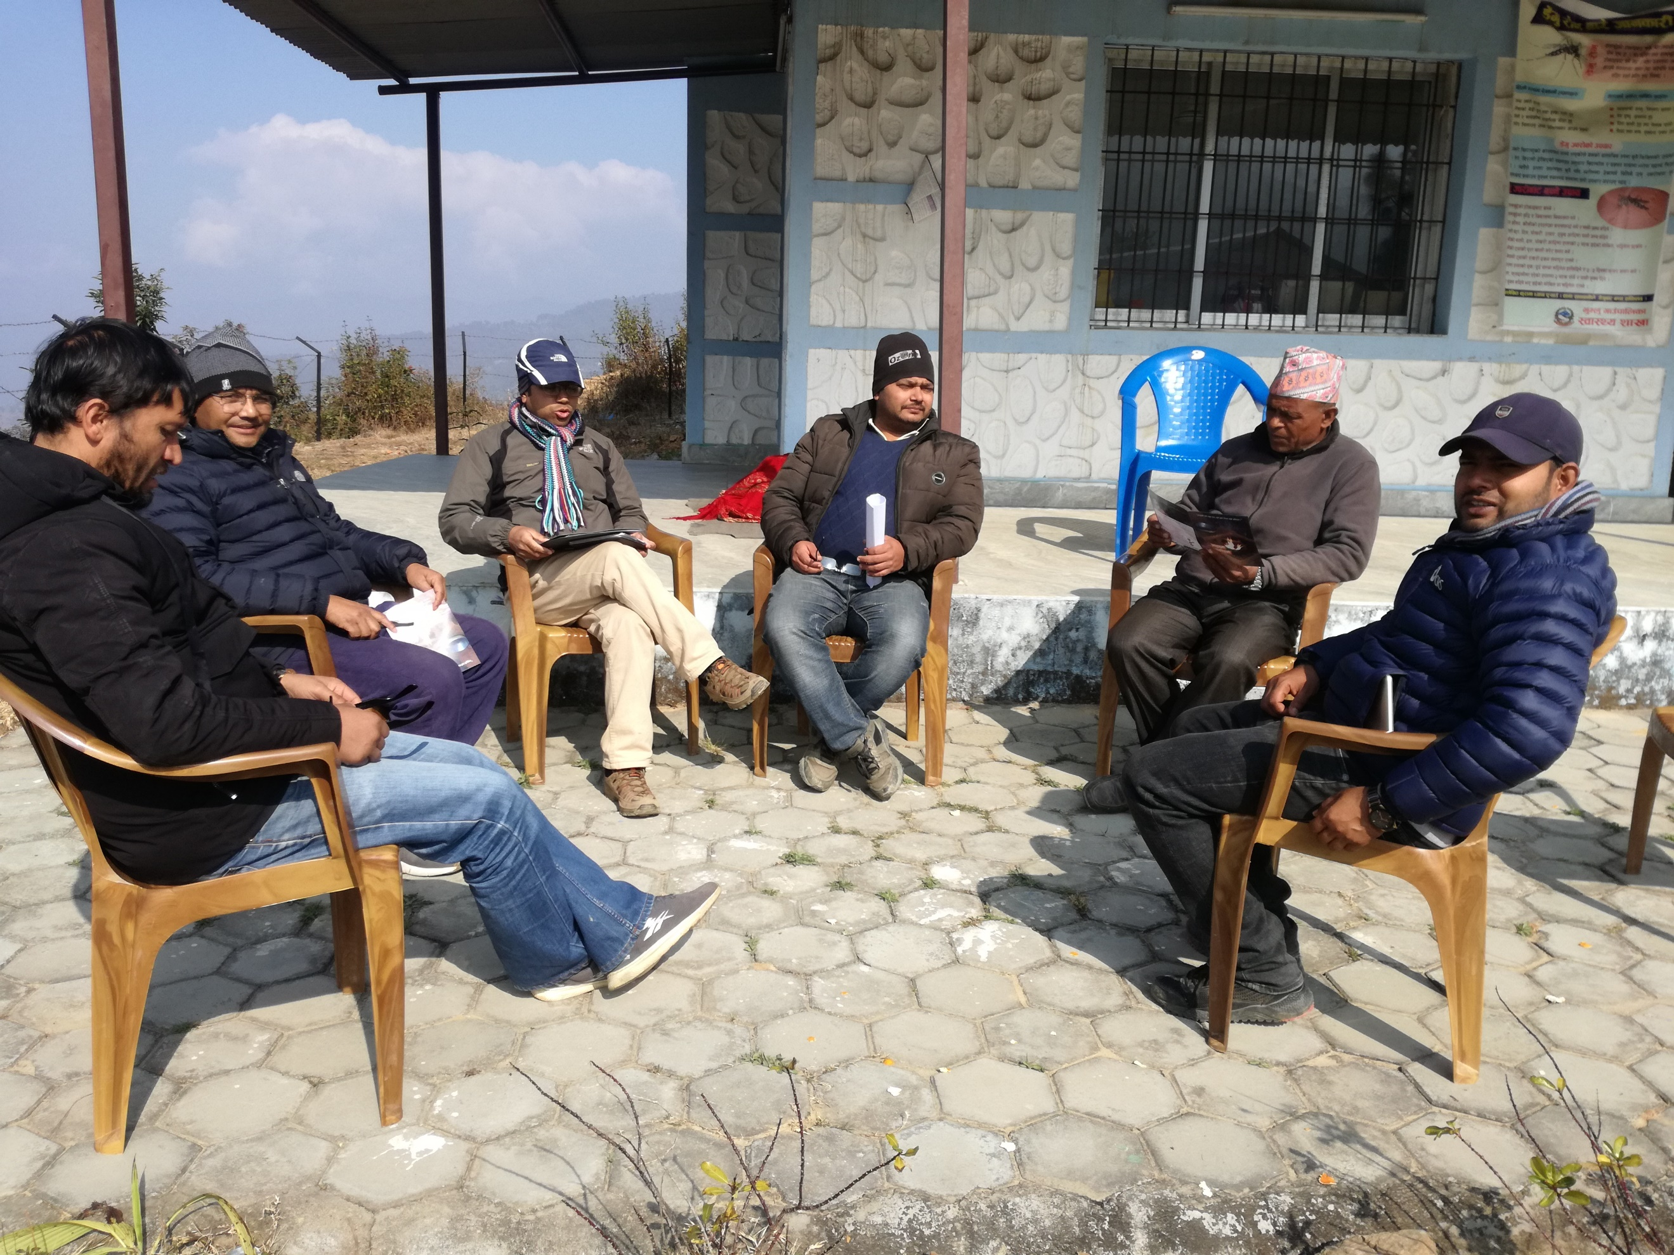

Next Steps/action points: | Person(s) Responsible | Due Date
Agreement and location identification | Ward Office | 25 Feb 20202
Social specialist and environment specialist are observed the field and project implement location for ICS and plantation Program. | Social / environment specialist -GMaLI | Feb 28 2020
Ward to prepare the documents of working areas, discussion with CSUG. And identified the location. | Ward Office | Feb 30 2020

Attendees | Gender | Organization | Designation | Phone No.
Chandra prasad Niraula | Male | DLPIU-GMaLI | Social specialist | 9851238523
Devi Raman Acharye | Male | DLPIU-GMaLI | Environment Specialist | 9851120667
Pradip Sharma | Male | DLPUI-Building | TC HRRP | 9851073208
Krishna Kumar Karki | Male | DLPUI-Building | Ward Chief | 9843630863
Ishor Neupane | Male | HRRP | IM | 9849572020
RajKumar Kunwar | Male | DLPIU-GMaLI | Coordinator | 9851238771
BabuRam Chaulagai | Male | Community forest group | Representative | -

