Meeting Purpose: | HRRP District Coordination Meeting
Meeting Date: | 02/06/2017
Meeting Time: | 12:00-2:30 PM
Meeting Location: | Hotel Araniko, Chautara
Meeting Facilitator: | Manisha Rai
Minutes Taken By: | Manisha Rai & Aarju Basnet

Discussion: (Items/Knowledge Shared)

- Introduction and Welcome
The meeting was started by welcoming the participants and was followed by their introduction. It was conducted in semi-formal structure in the presence of MoUD/DLPIU acting Chief Er. Tanka Prasad Gautam, representative from NRA, NRCS, UNDP, CDECF, Mercy Corps, CARE-N, CSRC, TGH, ARSOW-N, World Vision, Transparency Int. Nepal, Janahit GSS, CARITAS-N, DSE, SOS and WOREC.

- Presentation on Reconstruction Progress by HRRP (As of 31 Jan 2018)
Total Beneficiaries: 83,611
Total Partnership agreement: 78,149
First Tranche release: 77,926
No. of started construction: 50,374
Approved for Second Tranche: 40,350
Approved for Third Tranche: 5,486
No. of Completed houses: 9,816

- Progress and Update Sharing by each PO
All the POs shared the status of respective project/activities on reconstruction and NRA representative also briefed recent update/activities done by NRA in district.
Most of the POs reported water shortage as a challenge to reconstruction. Due to lack of water reconstruction is severely affected in many areas. Those areas where is not water/wash scheme projects, has not well reconstruction progress.
- CARITAS-N is extending TA activities in 2 more VDCs, Yamunadada and Sunkhani within a month (February 2018).

- ARSOW-N funded by World Vision is supporting to 35 households on retrofitting, 10 out of 35 is already completed and remaining are ongoing.

- CARE-N has plan of OJT, refresher training to masons and construction material support to targeted group.

- JGSS funded by CARITAS has extended project for next one year and will be reconstruction supporting activities in its working area.

- SOS is in the phase of completion of 177 houses as per target.

- ARSOW-TGH are providing 7 days training on, electrician and plumber (ongoing).

- NRCS is providing carpenter training (Ongoing)

- WOREC-N is waiting the way forward from GoN authorities since II tranche was on hold and decision has been in pipeline for a long time back. However, NRA and MoUD/CLPIU have inspected and reported in the field. Though almost 50% of targeted houses are completed, those have been adopted corrective measures because of the minimum requirement was not meet. Therefore, it was on pending to approve for tranche and still on process of decision from central GoN authorities.

- Construction materials support: ARSOW-TGH, is providing CGIs/Cement (blanket approach), UNDP is providing construction materials and tool kits to 50 targeted beneficiaries as top ups. CARE-N has also plan of construction materials support to the targeted (vulnerable criteria) beneficiaries (45).
- Mason training: CARE-N, CARITAS-N, NRCS have plan of mason training in this month.
- Support: CARITAS-N has provided internet package to DLPIU fields engineers in its 2 working VDCs for 6 months to help them to update timely MIS report from the field.

- Update from District- NRA
- Land ownership card distributed to 18 HHs from identified risk prone settlement of Gati VDC, to relocate them in Barhabise N.P. ward no. 3. Similarly, 43 HHs of Indrawati Ga.Pa. ward no. 1 have been received the land ownership card to move to safer land which is bought with the support grant provided by GoN.

- Challenges/issues Discussion
- Main challenges in reconstruction were discussed on following issues;
- Water insufficient for reconstruction: Due to this reason, many areas have not been progress of reconstruction.
- Less facility to transportation: Because of off-road and long distance from the market center, beneficiaries are facing the high transportation cost for building materials. Moreover, some of them have not affordable economic status to bear the transportation cost.
- Lack of trained manpower: One of the reasons of delaying to reconstruction is insufficient trained mason in the villages.
- DSE shared and discussed about non-compliant issues and pending files. Inspected files from Melamchi N.P. areas are in pending for approval due to beyond the minimum requirements. It is an issue regarding to technical assistance. It is a challenge that such issue found in the areas where POs presence is maximum in the areas.
Decisions Made: (What, Why, Impacts)
  - Coordination meeting will be organized in Rural/ Municipalities with Palika, DSE, DLPIU field engineers and POs.
  - DSE, HRRP will orient to the respective Palikas where non-compliant houses have been frequently found and inspected files are in pending for approval.
  - Priority to observation, monitoring and reporting in/from field level
Attendance
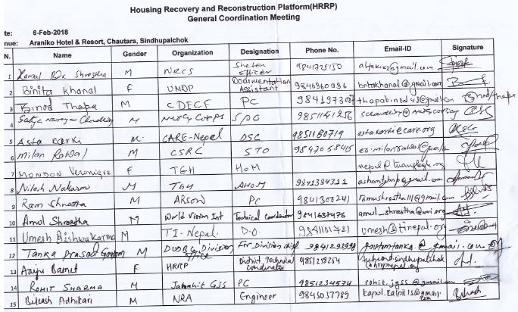
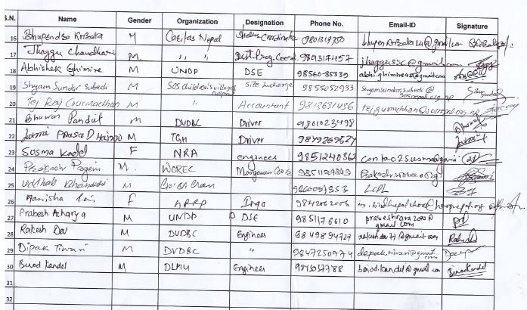
Name | Gender | Organization | Designation | Phone No. | Email
Kamal B. Shrestha | Male | NRCS | Shelter Officer | 9841725150 | alfa2@gmail.com
Binita Khanal | Female | UNDP | Documentation Officer | 9846360936 | bntakhanal@gmail.com
Binod Thapa | Male | CDECF | PC | 9841973007 | Thapabinod48@gmail.com
Satya N. Chaudhary | Male | Mercy corps | SPO | 9851141256 | schoudhary@mercycorps.org
Asta Karki | Male | CARE-N | DSC | 9851180719 | Asta.karki@care.org
Milan Rawal | Male | CSRC | STO | 9847058415 | Er.milanrawal@gmail.com
Mondon vewnigve | Female | TGH | HoM |  | nepal@tuanglagh.org
Nilesh Nakarmi | Male | TGH | AHoM | 9841384311 | ashomtghnp@gmail.com
Ram Shrestha | Male | ARSOW | PC | 9841300241 | Ramushrestha111@gmail.com
Amol Shrestha | Male | World vision Int | Technical Coord | 9841637476 | amul_shrestha@wvi.org
Umesh Bishwakarma | Male | TI-Nepal | DO | 9841101721 | umesh@tinepal.org
Tanka Prasad Gautam | Male | DUDBC, Division office | For division chief | 9841293998 | gautamtanka@gmail.com
Aarju Basnet | Female | HRRP | District T.C. | 9851218254 | Techcord.sindhupalchok@hrrpnepal.org
Rohit Sharma | Male | Janahit JSS | PC | 9851234574 | Rohit.jgss@gmail.com
Bikesh Adhikari | Male | NRA | Engineer | 9843037789 | Kapol.kalpit13@gmail.com
Bhupendra Koirala | Male | CARITAS-N | Shelter Coord. | 9801317750 | Bhupenkoirala14@gmail.com
Jhaggu Chaudhary | Male | CARITAS-N | District P.C. | 9801317457 | jhaggussc@gmail.com
Abhisek Ghimire | Male | UNDP | DSE | 9856035339 | Abhi.ghimire45@gmail.com
Shyam Sundar Subedi | Male | SOS Children V | Site Incharge | 9855052933 | shyamsundarsubedi@sosnepal.org.np
Tej Raj Gurmachhan | Male | SOS Children V | Accountant | 9813631436 | Tej.gurmchhan@sosnepal.org.np
Susma Kandel | Female | NRA | Engineer | 9851240362 | Contac2susma@gmail.com
Prakash Pangeni | Male | WOREC | Coordinator | 9851124849 | prakashpageni12@gmail.com
Manisha Rai | Female | HRRP | IMO | 9842062006 | Im.sindhupalchok@hrrpnepal.org
Prabesh Aacharya | Male | UNDP | DSE | 9851176610 | Prabeshrara2070@gmail.com
Rakesh Dev | Male | DLPIU | Engineer | 9849894727 | Rakeshdev77@gmail.com
Dipak Tiwari | Male | DLPIU | Engineer | 9847250774 | Dipak.tiwari@gmail.com
Binod Kandel | Male | DLPIU | Engineer | 9813037788 | Binod.kandel@gmail.com

